H-1B modernization

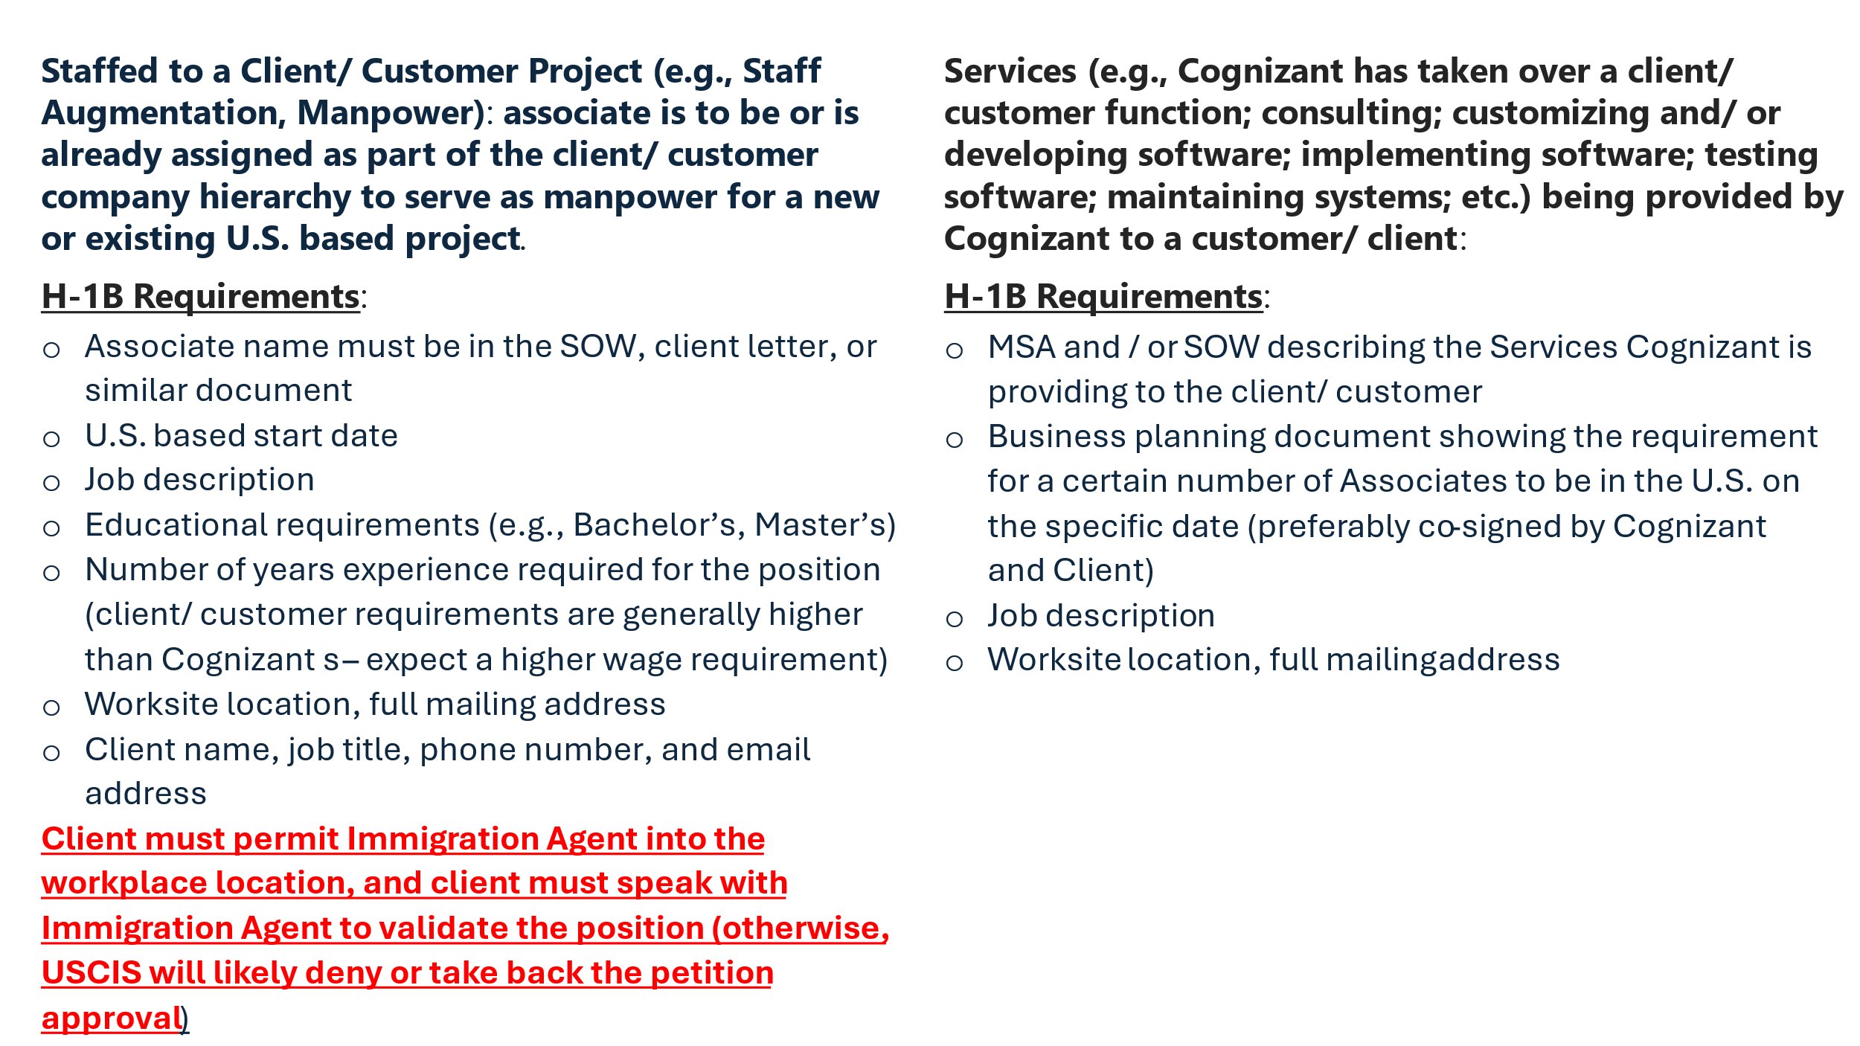

Position Information

Managers, responding to below questions is mandatory. Please respond to every question fully and truthfully. Any misrepresentation of the information and/or facts could result in disciplinary action up to and including termination of employment.

- What work has Cognizant contracted to provide to the customer (please specify either):
- Staff Aug – Manpower, OR
- IT - Consulting services

- If Cognizant is contracted to provide services to the customer, please provide a description of the services in layman’s language.

- Will the nominated associate be supervised by a Cognizant Manager for all their day-to-day activities? (Yes / NO)

- Will the nominated associate receive any work instruction on day-to-day activities directly from the client(s)? (Yes / NO)

- Is there a confirmed U.S. position for the nominated associate? (Yes / NO)

- Please provide the start date and end date of the nominated associate’s role in the project:
- Start Date: (MM/DD/YYYY)
- End Date: (MM/DD/YYYY)

- Will the nominated associate have any other ongoing U.S. projects with different clients at the same time? (Yes/No). If yes. Provide, Client name. Location, Start and end date.

- Please provide nominated associate’s primary roles and responsibility on this U.S. project.

- Will the nominated associate work as part of a Cognizant team at the same worksite location? If so, how many other Cognizant associates are on the same project at the same worksite location?

- If the nominated associate will undergo training from the client (Yes/No). If “Yes” please provide the list of training(s).

Manager Letter Guideline

GUIDANCE/ INSTRUCTIONS FOR U.S. BASED HIRING OR NOMINATING MANAGER/ HCM MANAGER FOR ASSOCIATES OR CANDIDATES BEING ASSIGNED TO A CLIENT ACCOUNT FOR WHICH COGNIZANT IS PROVIDING SERVICES (THIS DOCUMENT IS NOT TO BE USED FOR ROLES INVOLVING STAFF AUGMENTATION/ STAFFED TO A CLIENT PROJECT ROLE)

- You must provide true, accurate and correct information.
- Whether working at a Cognizant office/ RDC, Home office, or onsite in the U.S. at a client location, every H-1B associate must always: (1) receive assignments and be supervised directly by a Cognizant US based manager regardless of whether it is HCM manager or other Cognizant more senior subject matter expert (M band/ grade or above) who then updates the HCM manager on the H-1B associate’s duties/progress; and (2) use Cognizant tools, methods, platforms, frameworks or Cognizant body of knowledge/ best practice to do his/ her work.
- Associates sponsored for visa status should never receive or otherwise procure contracts (MSA, SOW, etc.) or client letters for the petition filing on their behalf.
- The HCM Hiring Manager takes ownership of obtaining approval and authorization from the U.S. based account manager that there is an in-fact U.S. assignment for the associate or candidate as of the date of nomination, supported by a business planning document to be provided to GM.
- Please provide description of the job duties using the addendum for technical roles.
- The following table provides the framework of Cognizant’s Band/ Grade mapping and H-1B program sponsorship. MOST IMPORTANTLY, if the role and responsibilities exceed or are less than what is specified for the nominated candidate/associate, please escalate to the onsite Global Mobility team:
Education & Experience Cognizant Job Requirement | Band/ Grade | Level of Responsibility: if the associate has more than the required experience that is not relevant to the role since the job itself requires the education and experience specified in the first column.
Bachelor’s in field related to the job, 2 years experience | Senior Associate | Qualified level position: requires a good understanding of the job duties/ job requirement. Senior Associates perform moderately complex tasks that require limited judgment. Managerial responsibilities/ tasks, team lead responsibilities are NOT permitted.
Bachelor’s or Master’s in field related to the work, 3 years experience | Manager | Experienced level position: requires a sound understanding of the job duties/ job requirements. Uses independent judgment and coordinate and/ or supervise other Cognizant associates.
Bachelor’s or Master’s in field related to the work, 4+ | Senior Manager and Above | Competent level position: requires sufficient understanding of the job duties/ job requirements to plan and conduct work using independent judgment. Senior Managers and above use advanced skills to solve unusual and complex problems. They may manage and/ or supervise Cognizant associates.

- IF THE TEMPLATED LANGUAGE DOES NOT MATCH YOUR ROLE AS IT RELATES TO THE ASSOCIATE, PLEASE ESCALATE TO THE GLOBAL MOBILITY TEAM LEAD.

[[Date: MM/DD/YYYY]]
Example: April/27/2025

United States Citizenship and Immigration Services
USCIS Service Center

Re: [[Associate Name as per passport]]

Dear Officer:

I offer this letter to detail the conditions of the direct, full-time, 40 hour per week employment of [[Associate Name as per passport]] in conjunction with Cognizant’s H-1B petition filing.

Work Activities

Mr./ Ms. Associate Name’s work activities will include:

 | Job Duties | Percentage of Time
1 | Perform analysis and recommend customized software solutions related to SAP Platform Modernization using SAP cloud platform, DevOps, and similar innovative technologies. Liaise with functional, technical system and security systems personnel to assess the configurations, coding, programs, and identify potential deficiencies for the purpose of determining challenges in implementing customized SAP solutions. The business intelligence will then be used to perform complex business functional requirements analysis, system and process design for purposes of the business operational decisions and connecting business functionalities within a platform.  Apply a quantitative approach to analyze the complex infrastructure, including modeling, iterative prototyping, and analysis tools) to define architecture and develop secure high performance cloud based solutions to enable users to access and complete business actions online on a secure consolidated platform.  Use cloud native development, micro-services architecture, operations and governance framework expertise to gather required technical data for purposes of formulating recommended customization of SAP applications for manufacturing operations. | 20
2
3
4
5
 | Total | 100

As detailed above, [Associate Name] will use advanced methods related to the Cognizant position, and the Cognizant position requires at minimum a Bachelor’s degree in a field of study that is directly related to position to successfully perform the job duties.

Selection of Employees and Control of Work

At all times, Cognizant remains the sole and direct employer of our talent, and has control over the work of its employees. It is Cognizant that selects which of its employees will conduct work activities, determines what activities those employees will perform, and supervises and controls the work of those employees. Cognizant is responsible for paying salaries, benefits, and expenses for its employees. In the course of controlling the work activities of employees, Cognizant managers use a multitude of communication media and tools to supervise and control the work of our employees, including in-person or via video conferencing, desktop video, VoIP, mobile phones, instant messaging tools as well as through Cognizant’s systems and tools.

Performance Reviews

The Performance Management Process at Cognizant is a structured, formal interaction between an employee and his or her manager. This process includes evaluating performance against set objectives and competencies applicable for that role, providing performance feedback, identifying development needs, and setting goals for the future. This on-going performance communication takes place between the employee and that employee’s manager, which results in a performance rating for the employee. The objective of the Performance Management Process is to fuel the success of Cognizant and its employees.

Please feel free to contact me for additional information. Thank you.

Sincerely,

FIRST NAME LAST NAME (Onsite Manager)
COGNIZANT JOB TITLE (As per Cognizant band)
PHONE NUMBER
EMAIL ADDRESS

