Paper Figures
Fig. 1. Pipeline block diagram.
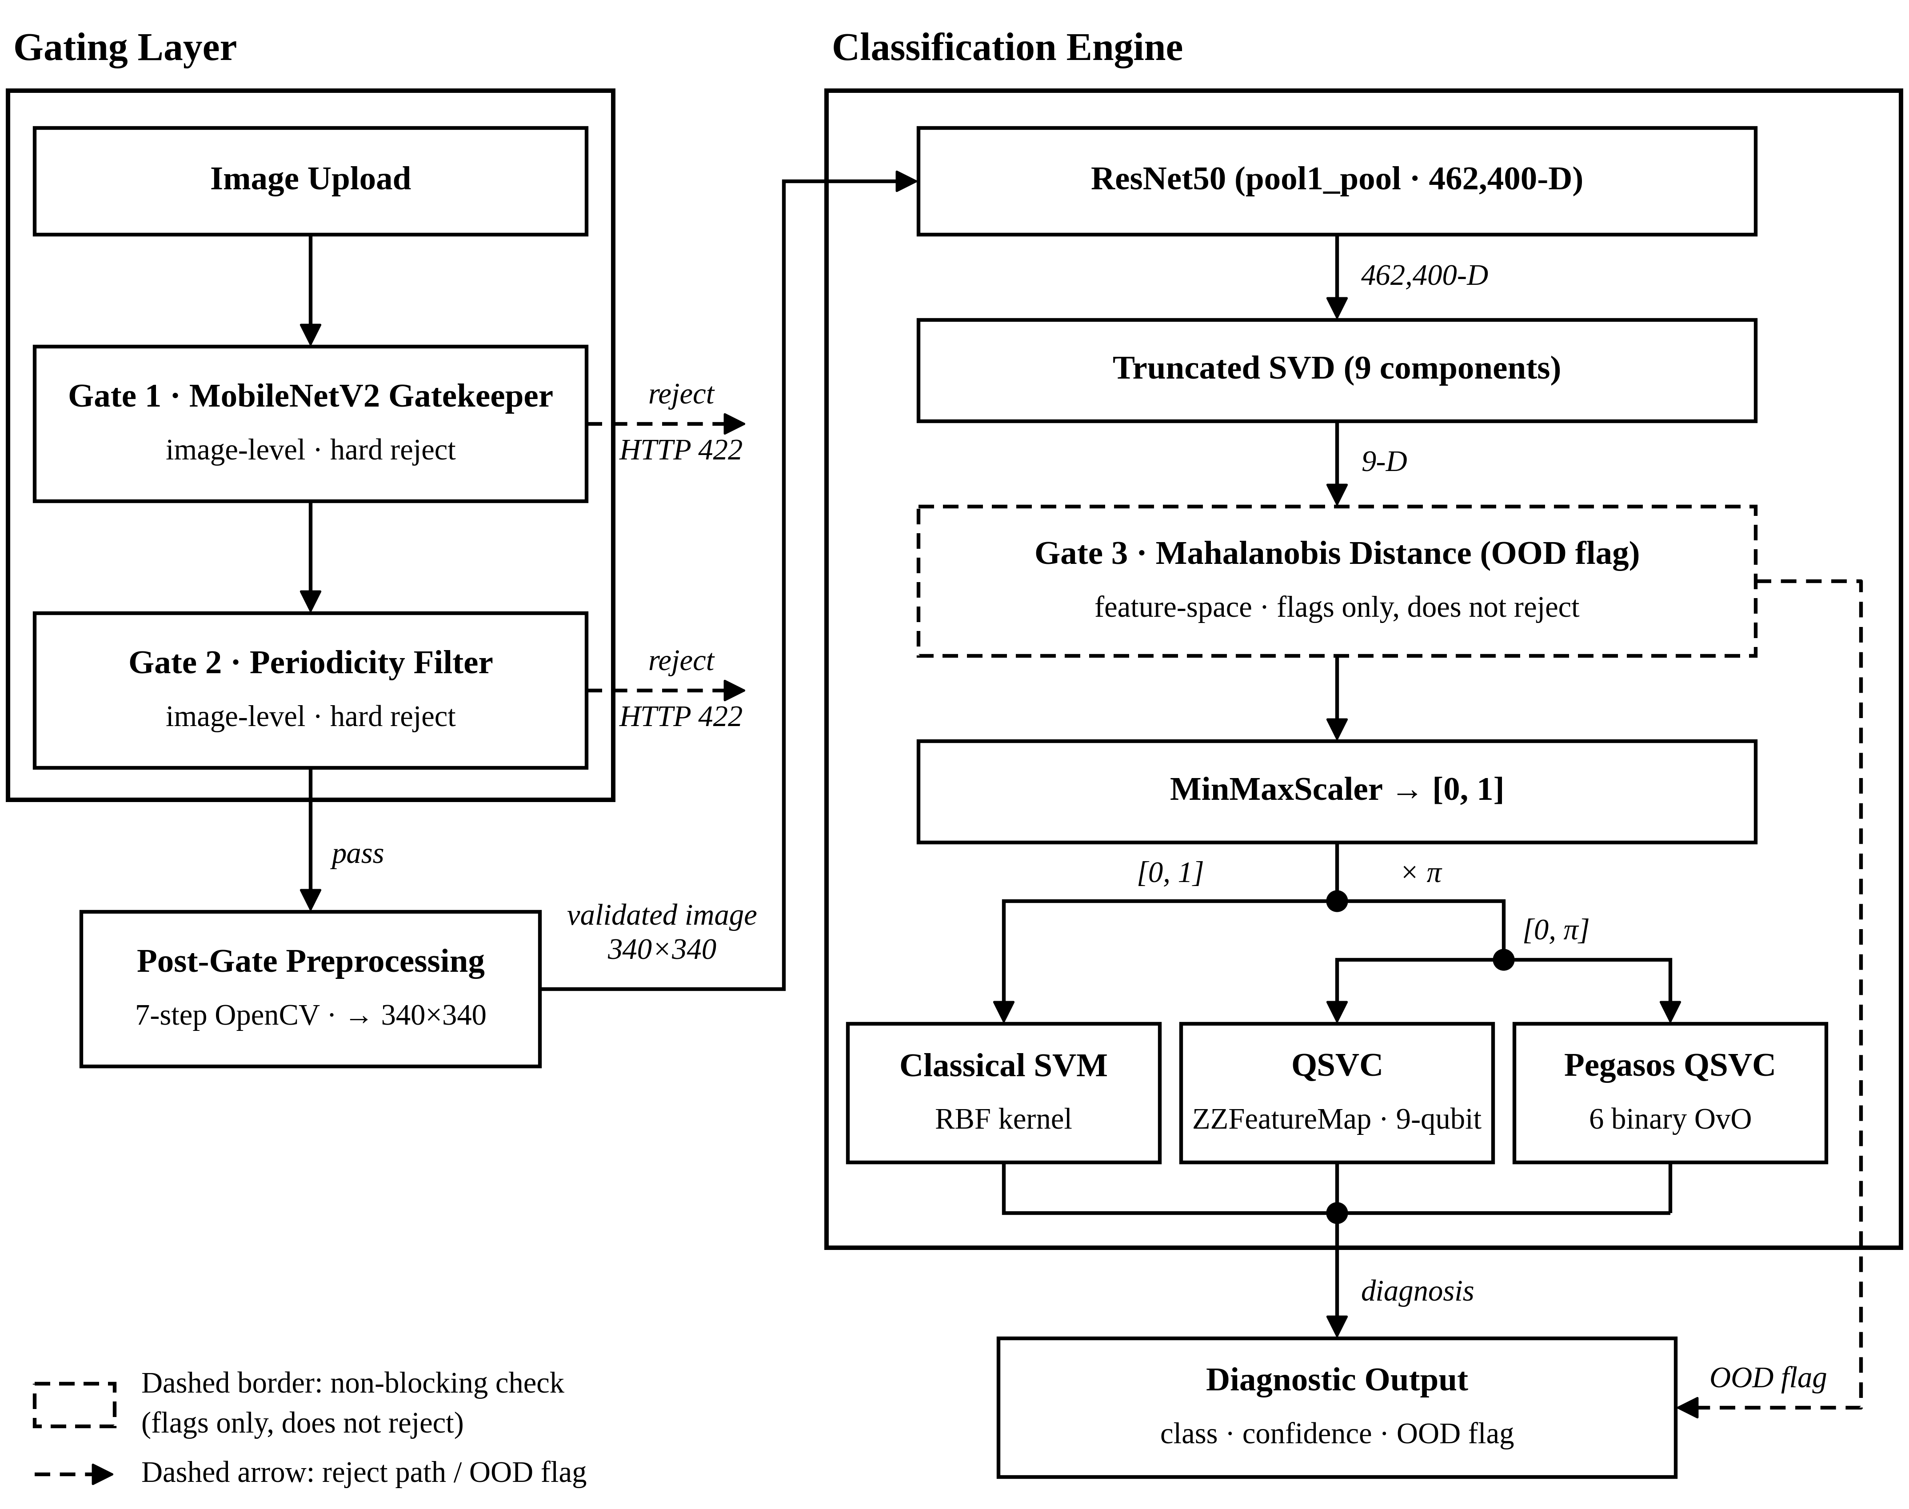
Fig. 2. Web application screens.
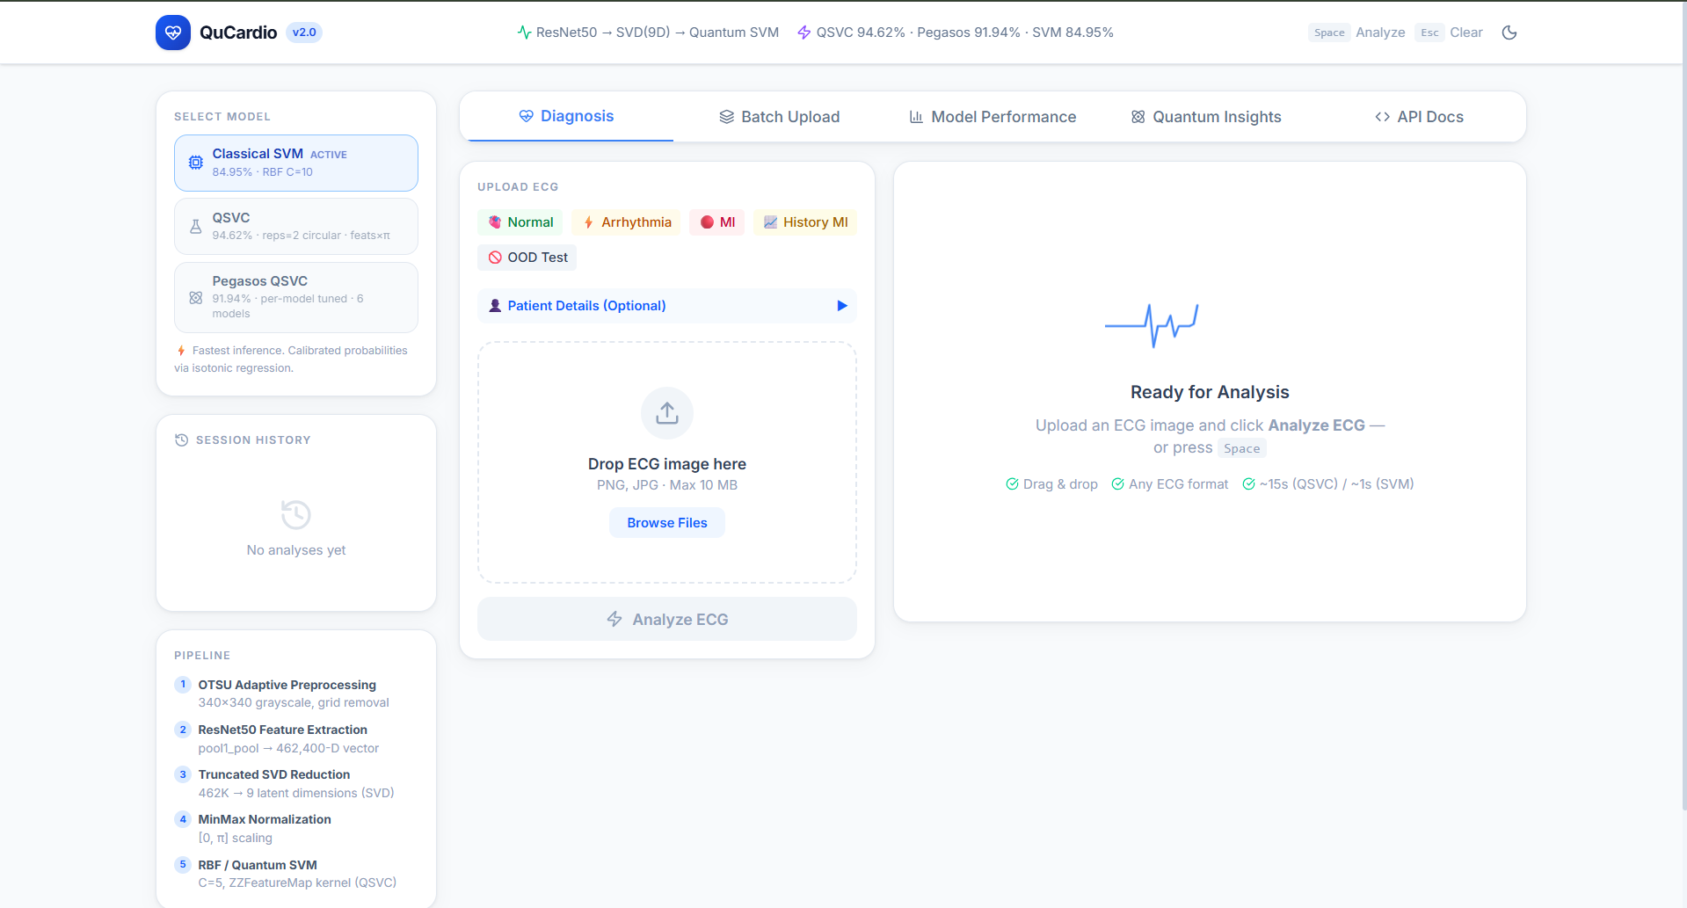
Fig. 3. Confusion matrix for the tuned QSVC.
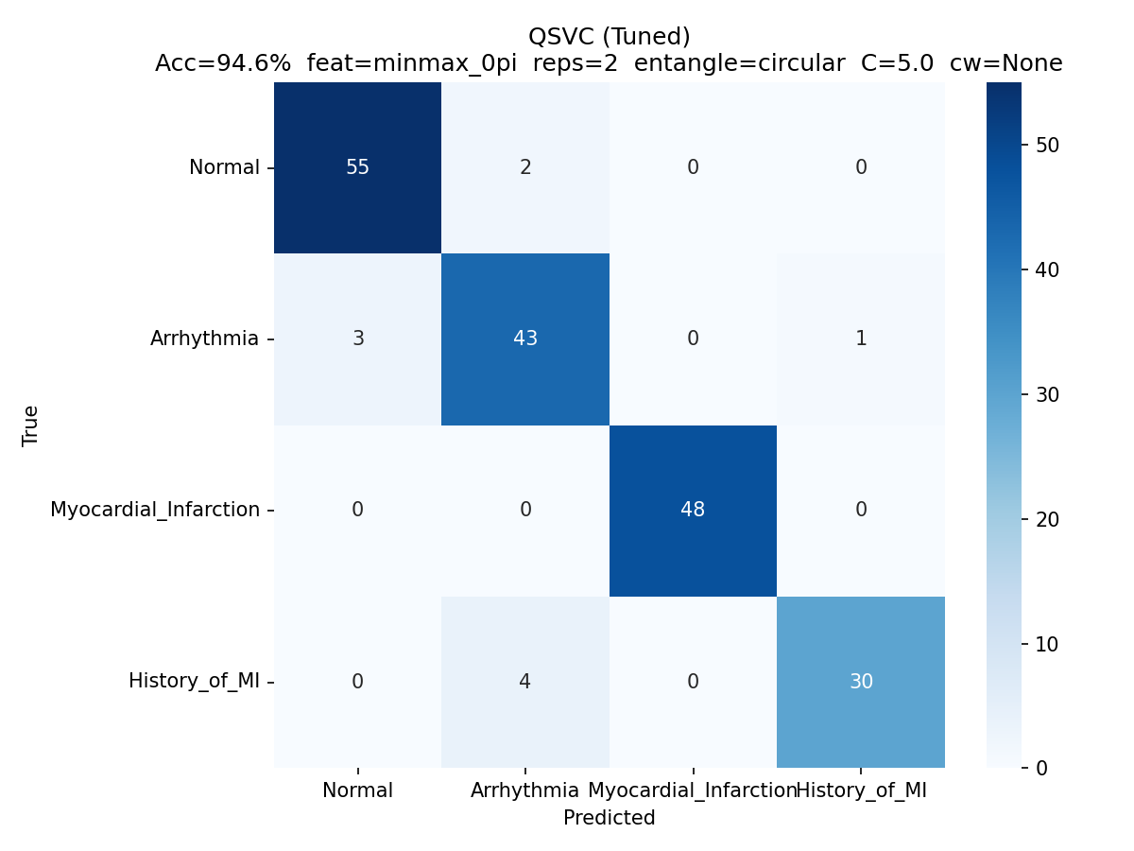
Fig. 4. ROC curves.
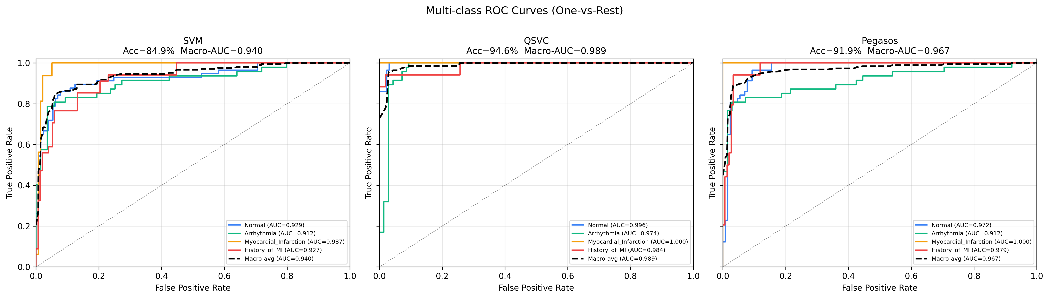
Fig. 5. Model accuracy under nine augmentation conditions.
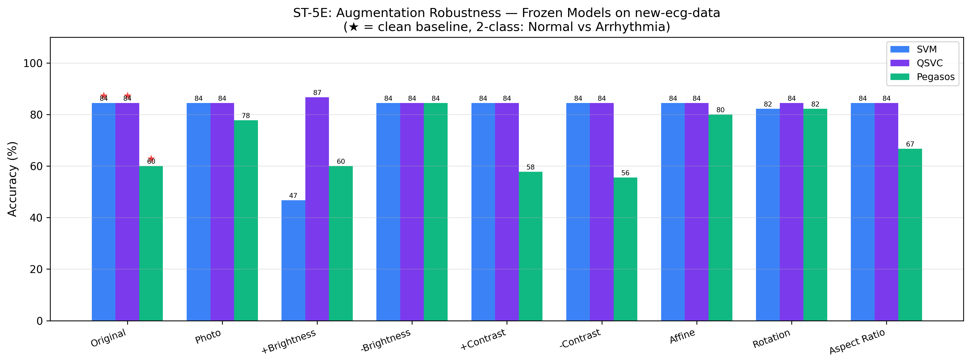
Fig. 6. QSVC accuracy across four feature encoding ranges.
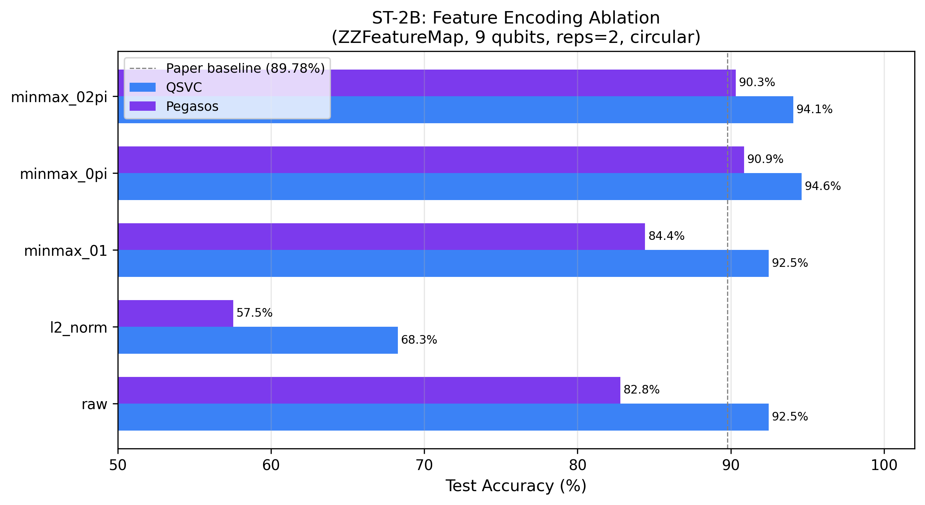
Fig. 7. QSVC accuracy for five entanglement topologies.
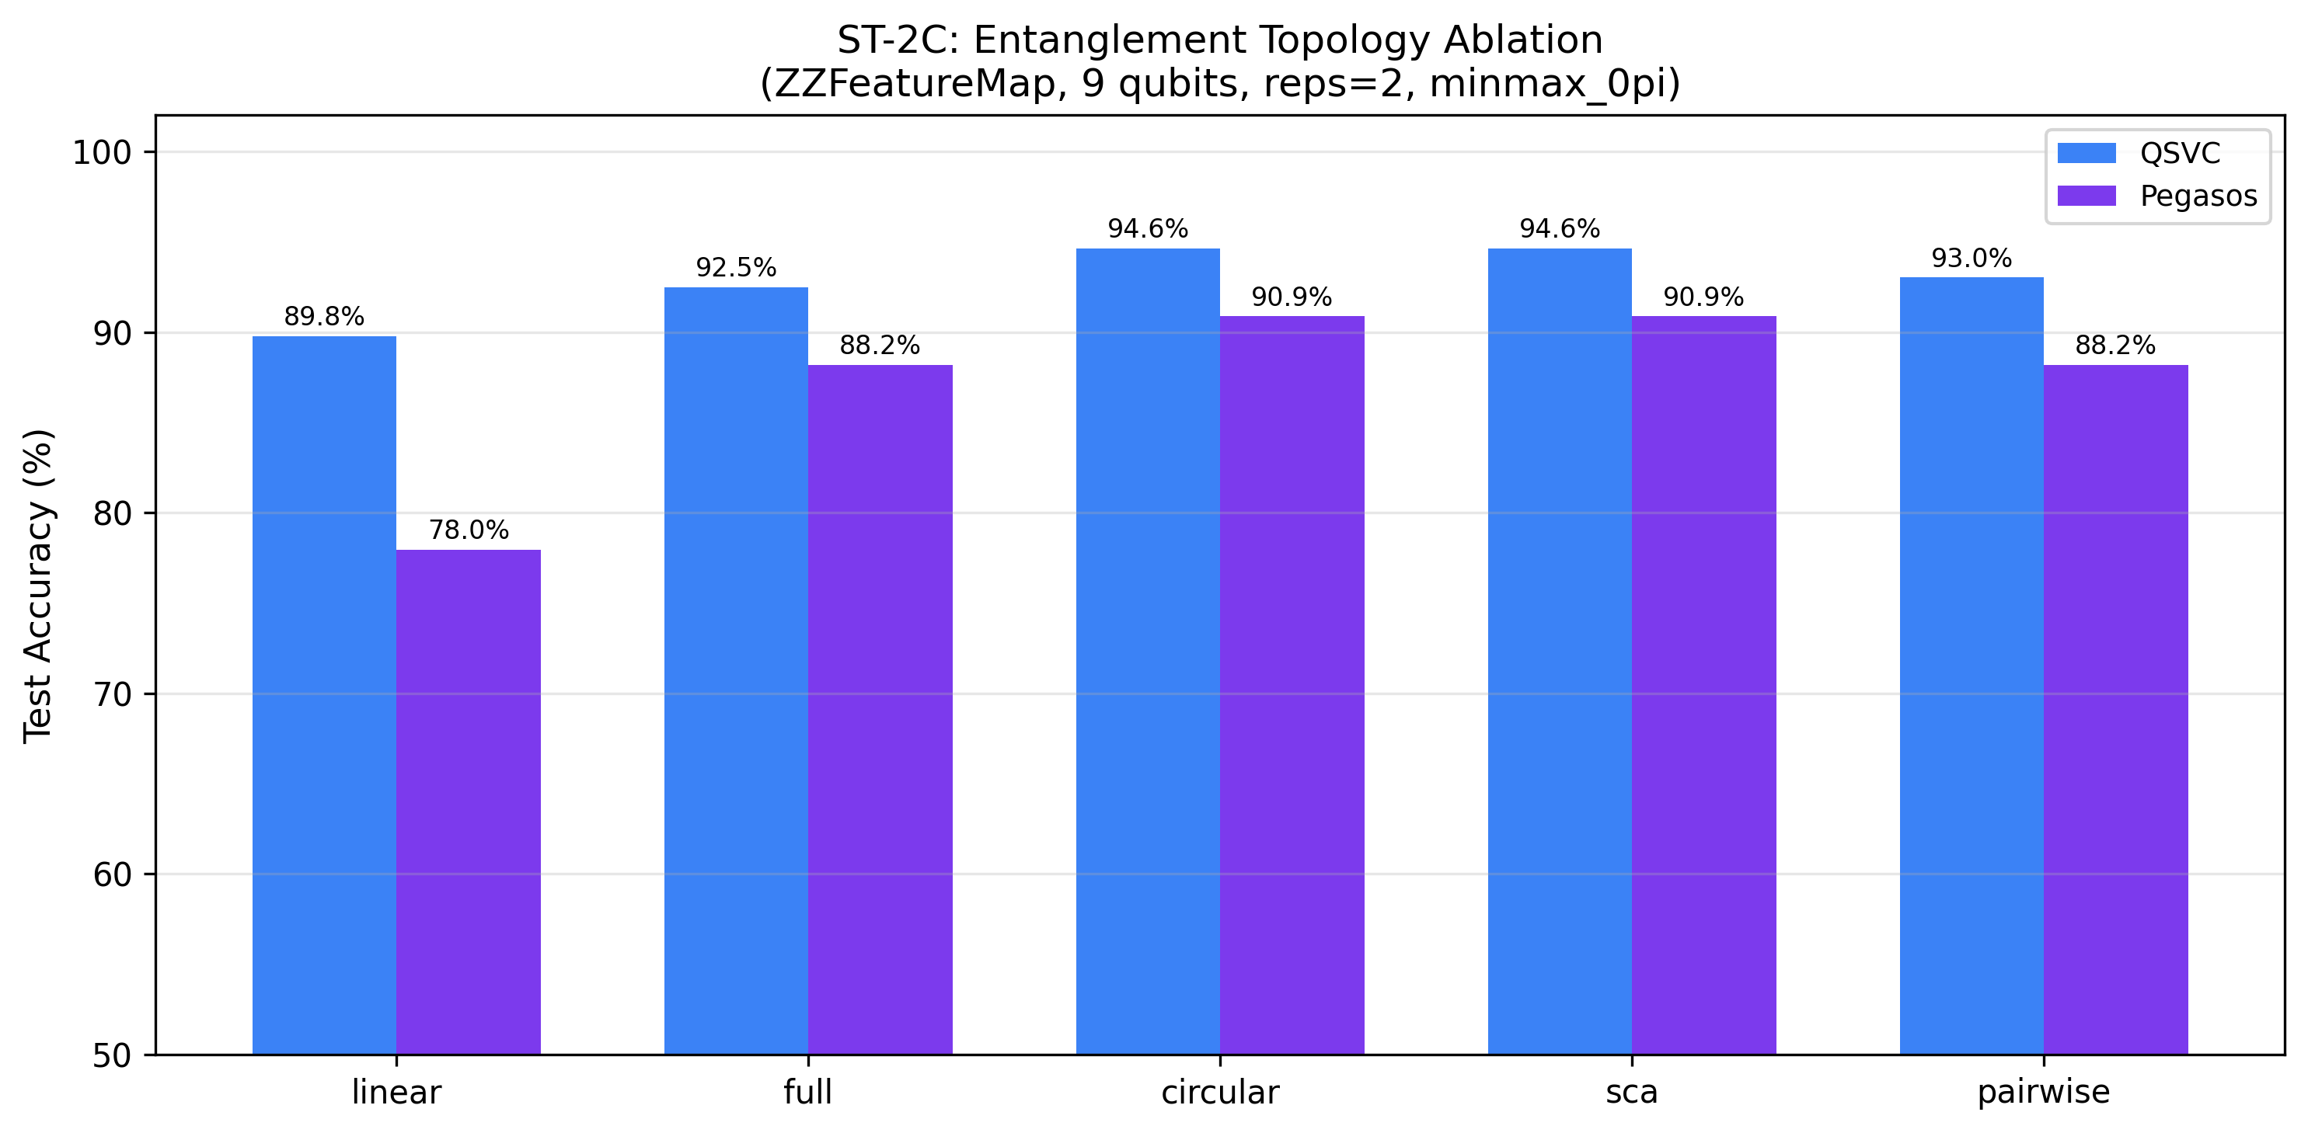
Fig. 8. QSVC accuracy for four Pauli feature map variants.
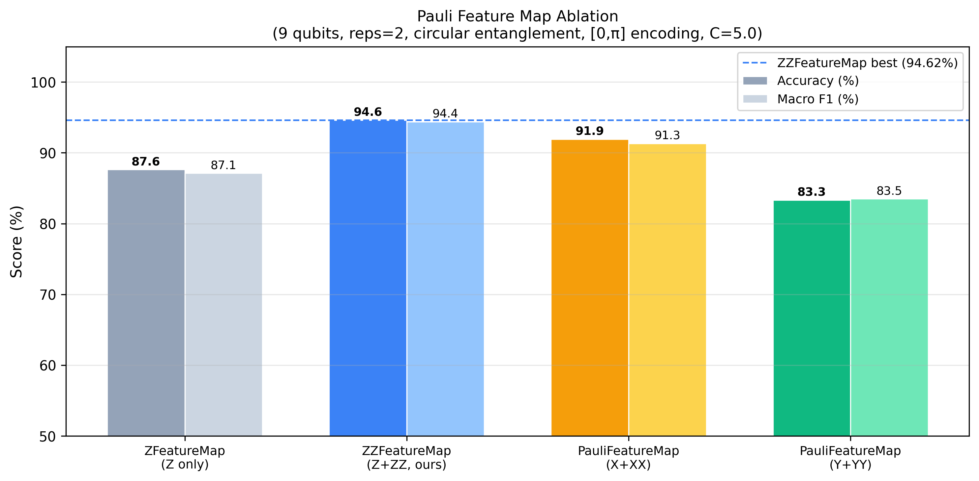
Fig. 9. (Top) QSVC accuracy versus SVD components; (Bottom) versus circuit repetitions.
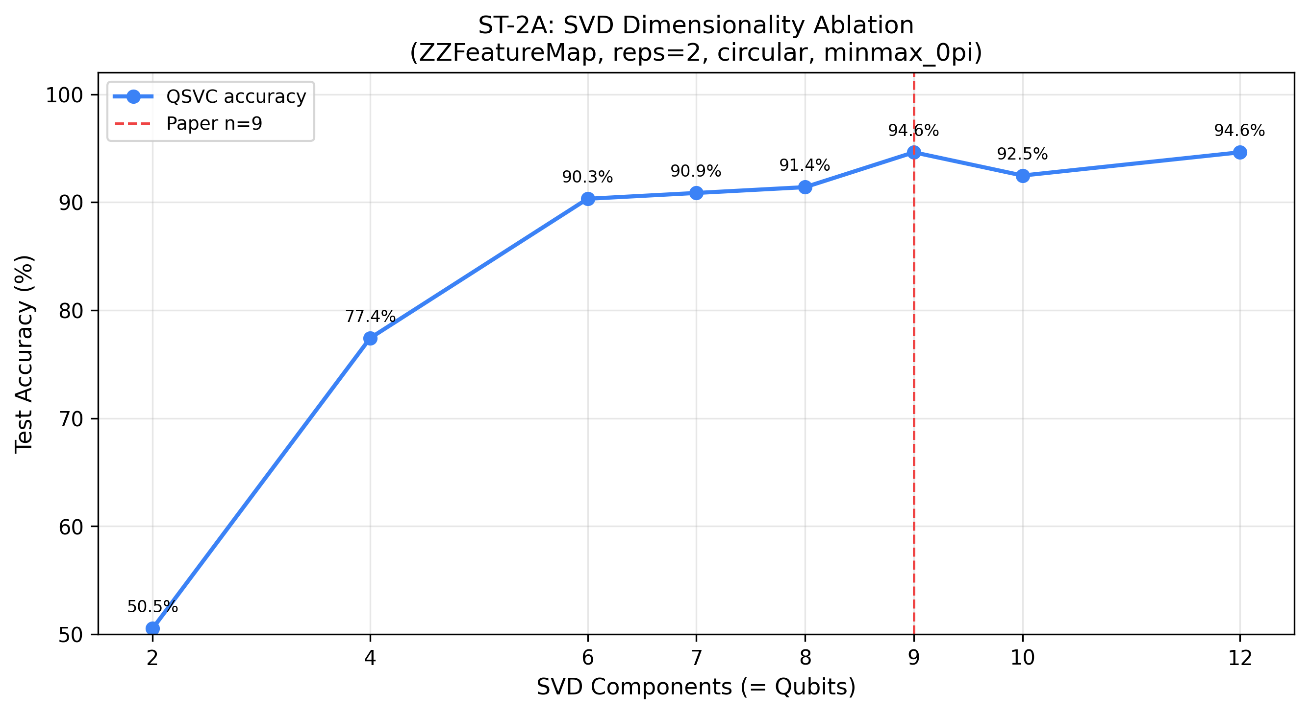
Fig. 9. (Bottom) Circuit repetitions.
