QuCardio Image Inventory

5.1 ECG Image Preprocessing
Figure 5.1: Side-by-side comparison of a raw clinical ECG scan and the resulting 340x340 preprocessed grayscale output
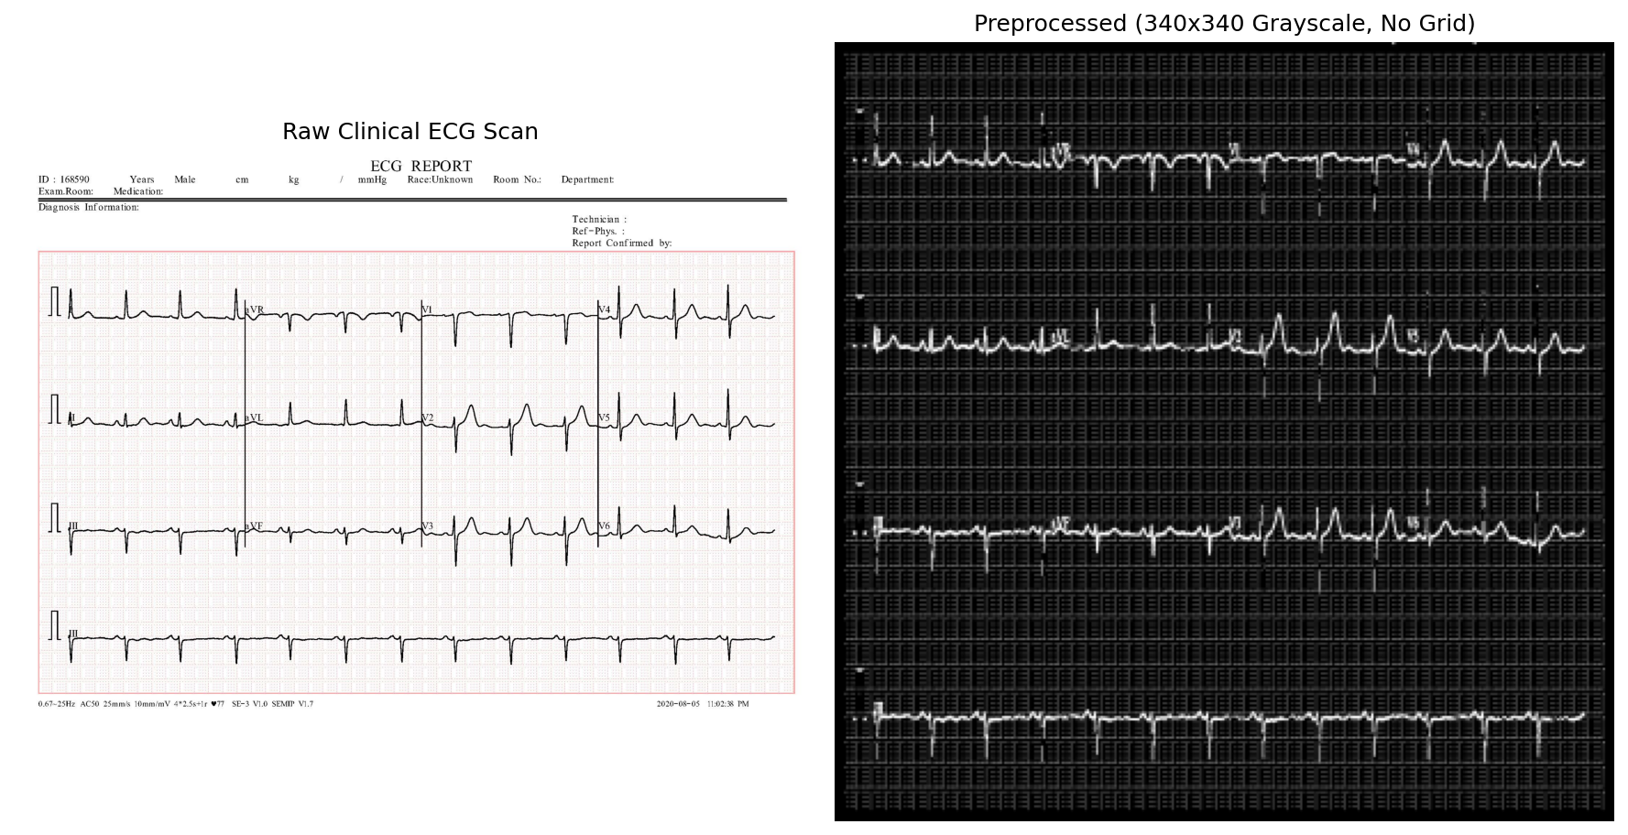

5.5 Quantum Support Vector Classifier
Figure 5.2: ZZFeatureMap circuit with 9 qubits, reps=2, circular entanglement

5.7 FastAPI Backend and React Frontend
Figure 5.7a: Main upload interface showing drag-and-drop ECG area and three model selector buttons
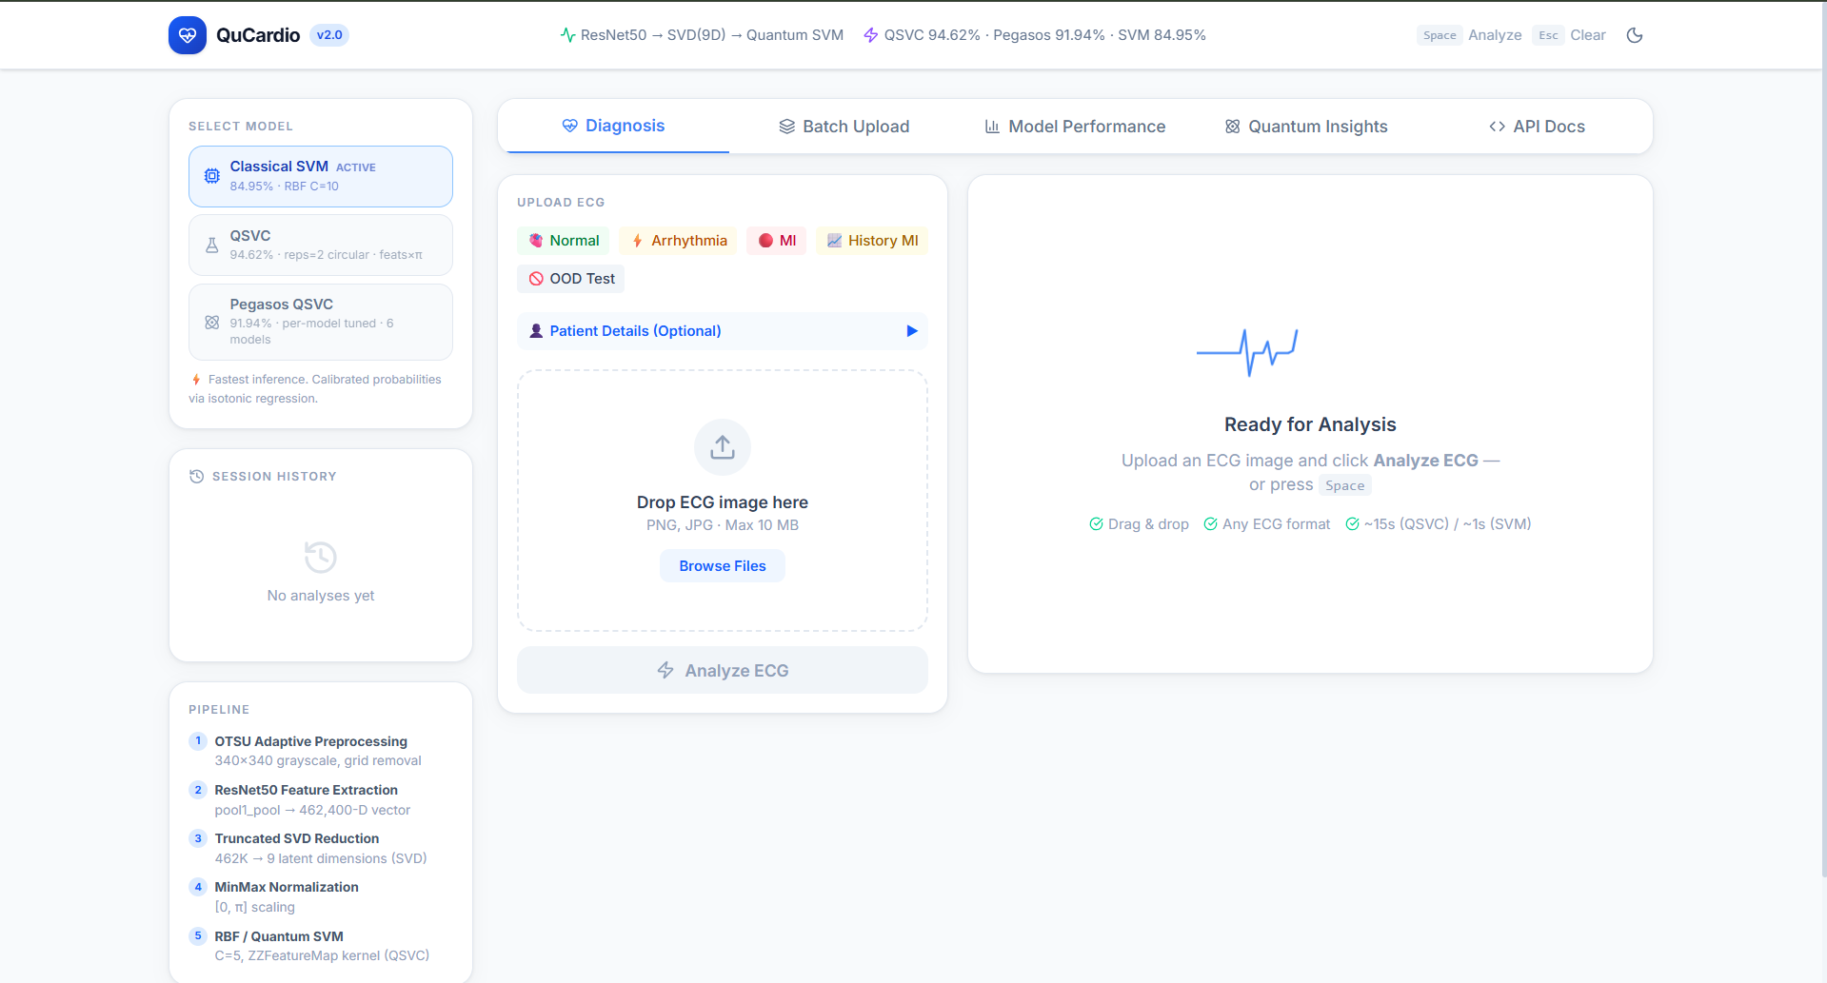
Figure 5.7b: Diagnosis result screen showing predicted class with severity color, confidence bar, per-class probability bars, preprocessed ECG thumbnail, and clinical recommendation text
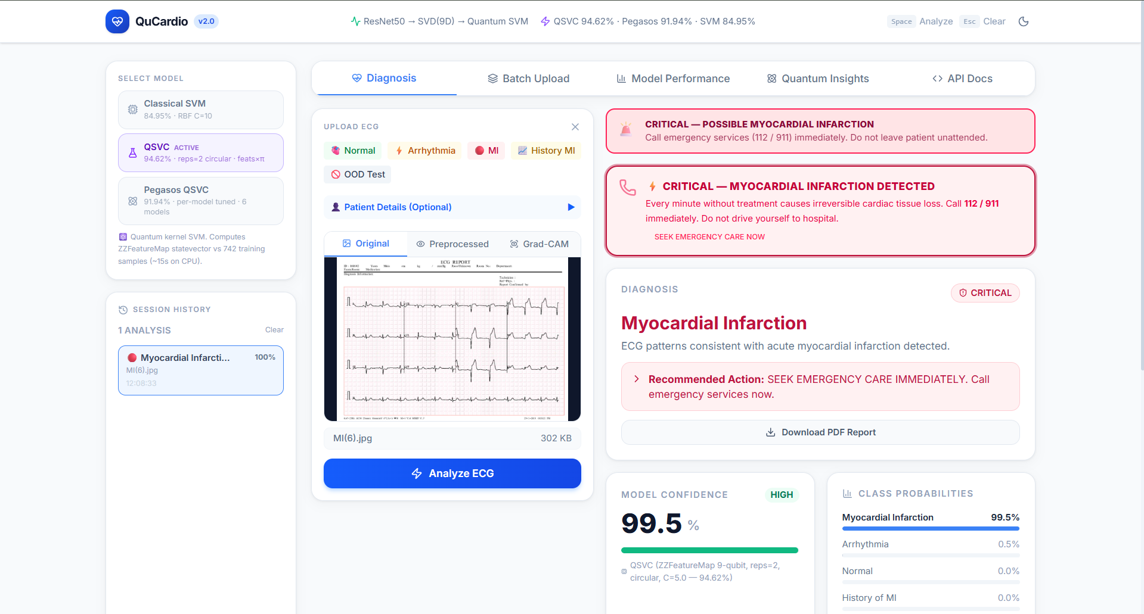
Figure 5.7c: Model Performance tab showing accuracy bar chart comparing all three classifiers against base paper values
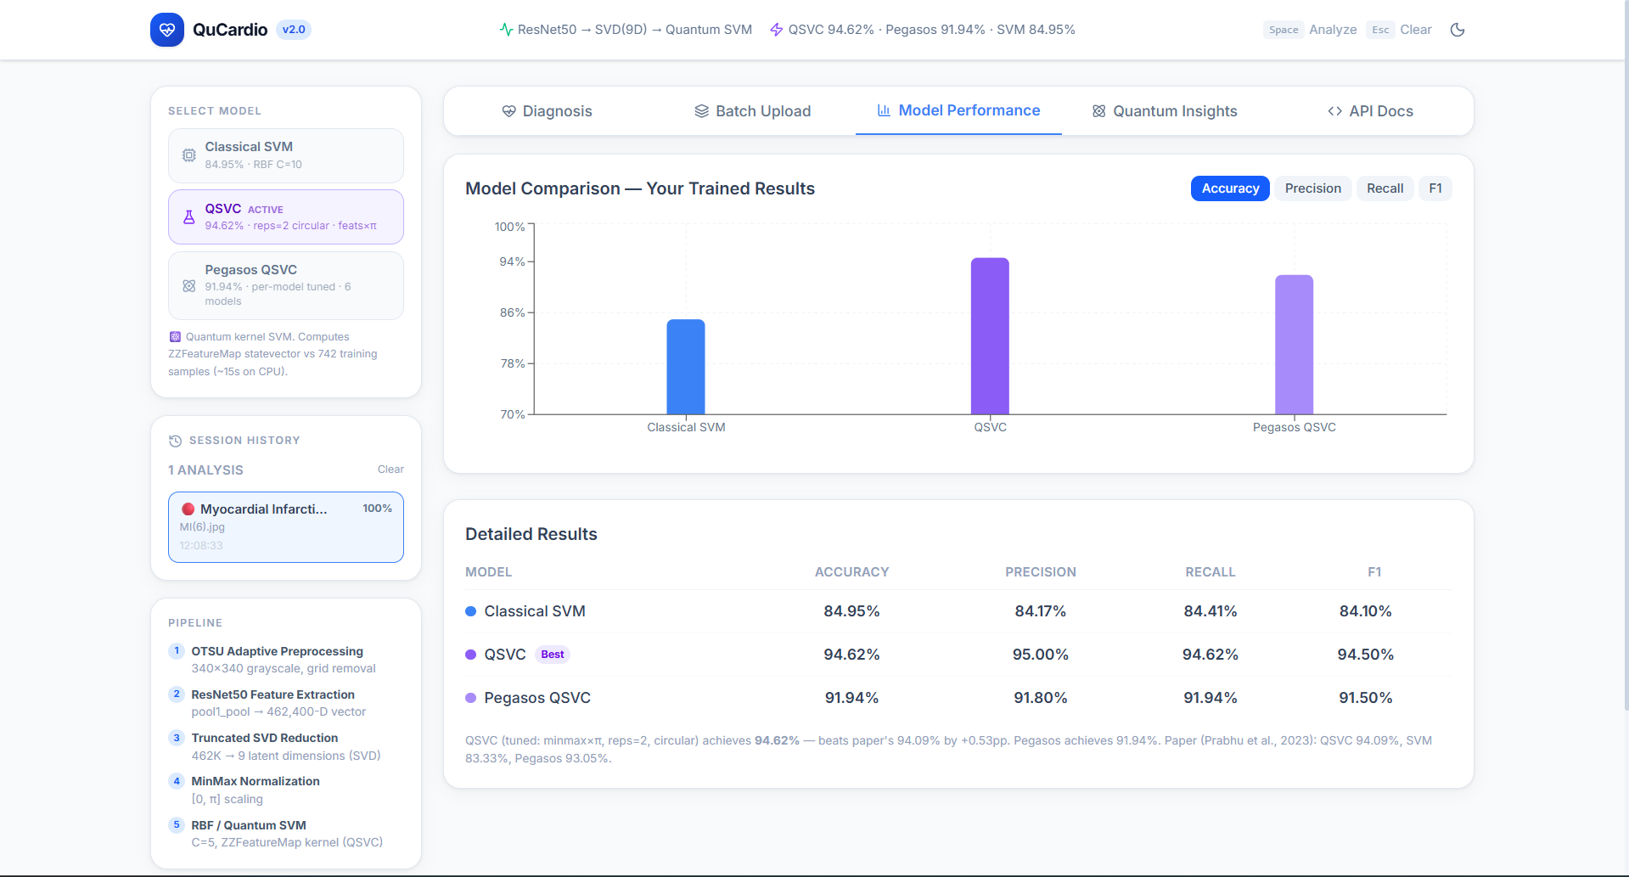

6.1 Model Performance Comparison
Figure 6.1: All Models Accuracy Comparison
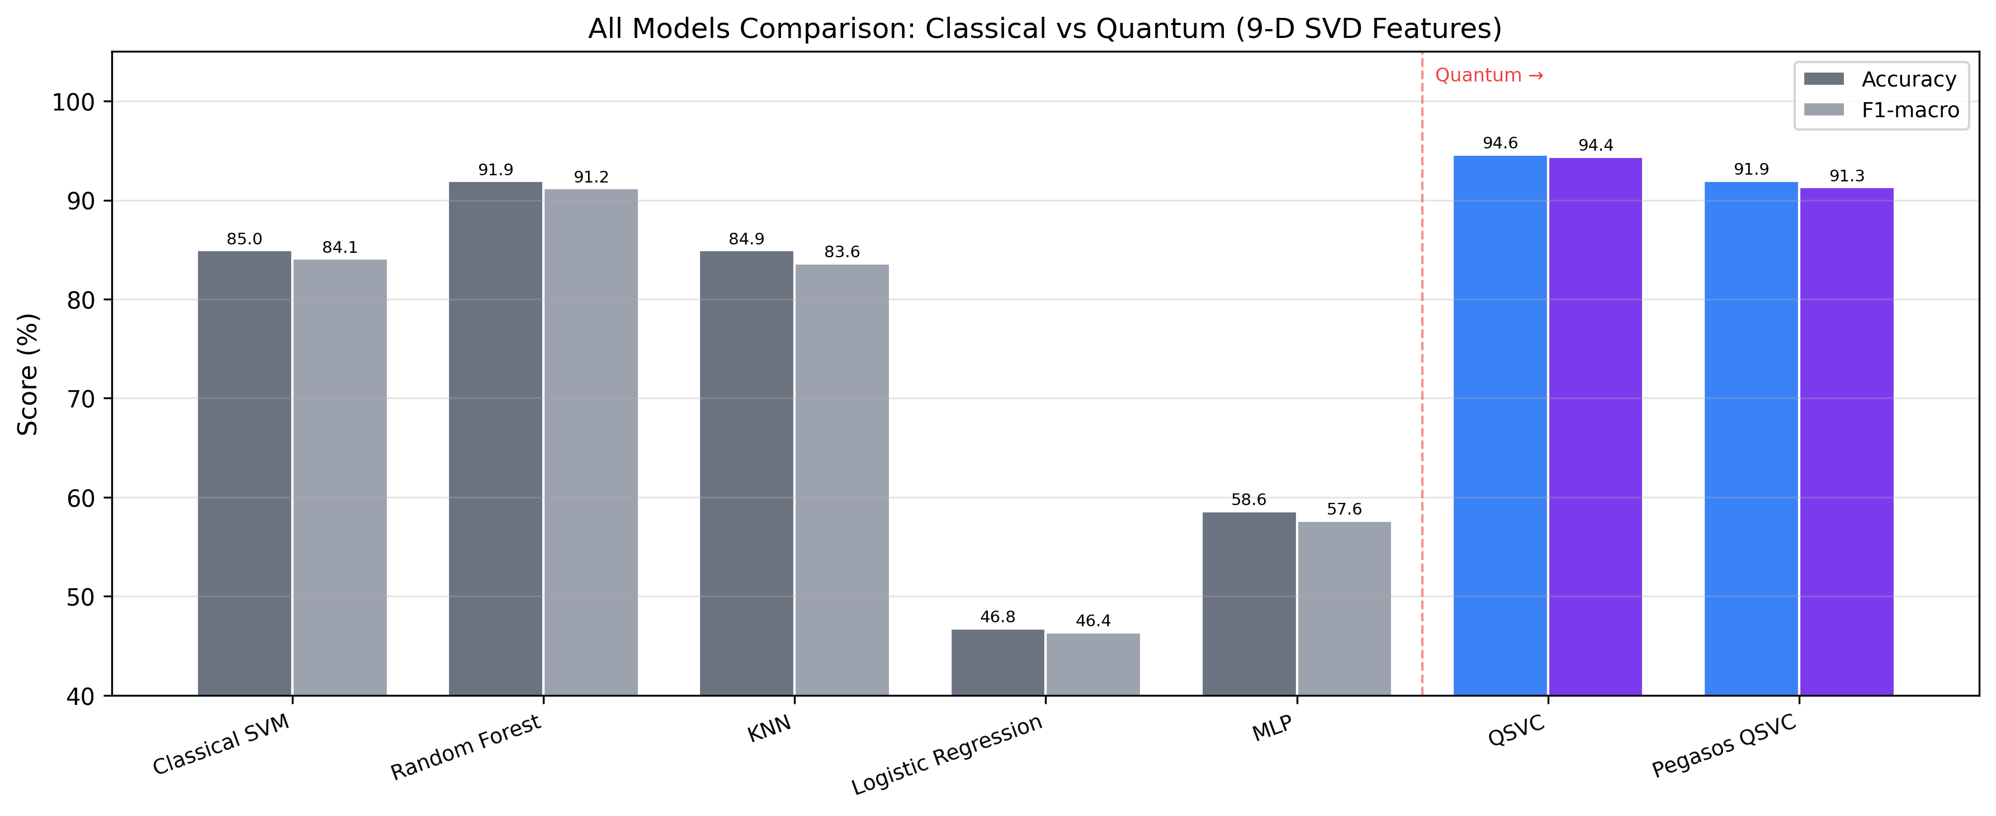
Figure 6.2: QSVC Confusion Matrix
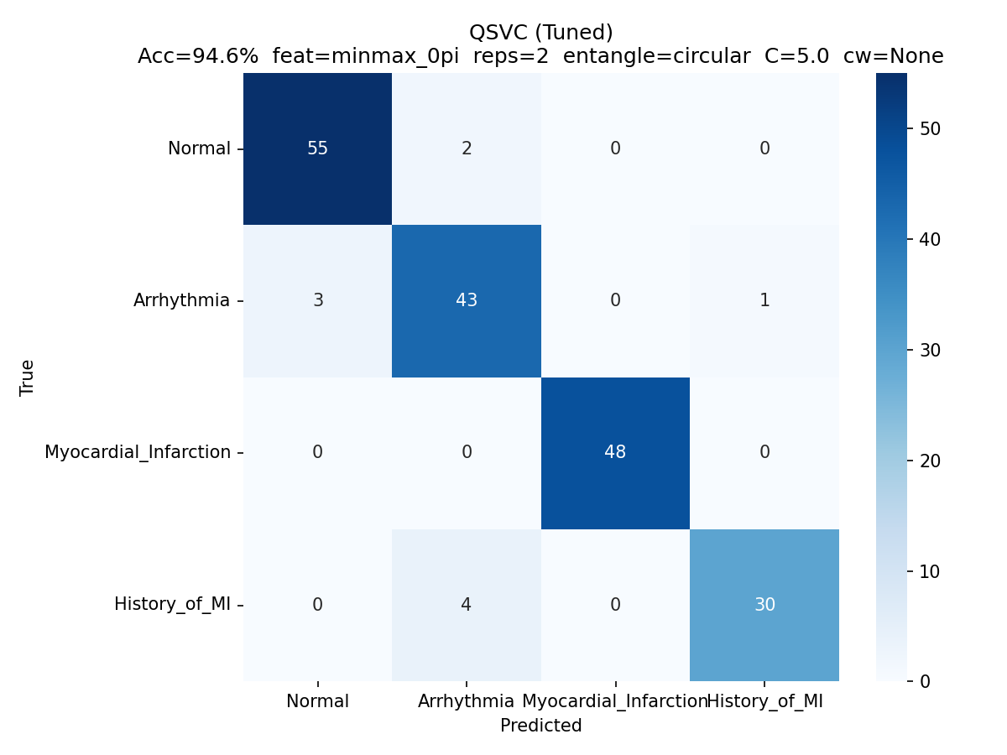
Figure 6.3: Pegasos Confusion Matrix
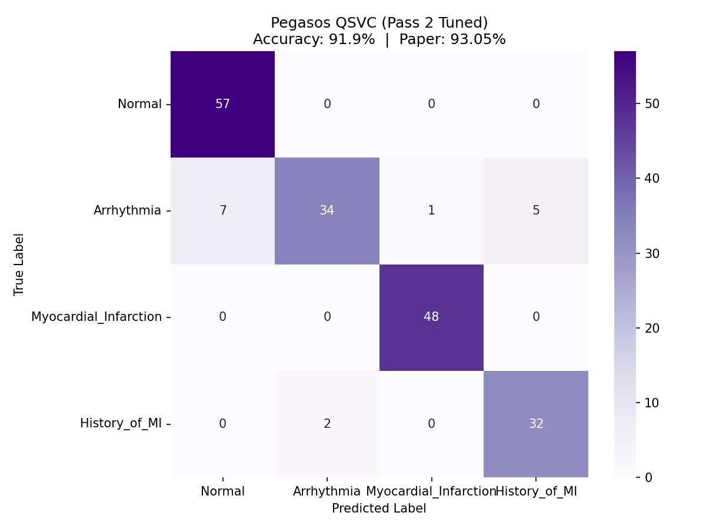

6.2 Feature Encoding and Entanglement Ablation
Figure 6.4: Feature Encoding Range Ablation
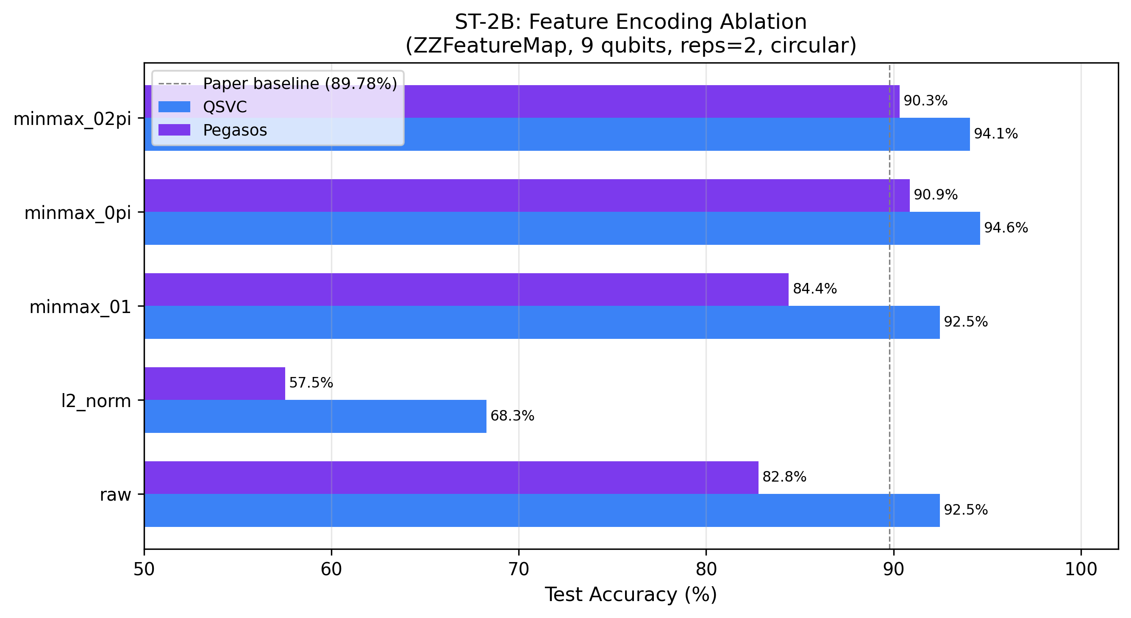
Figure 6.5: Entanglement Topology Ablation
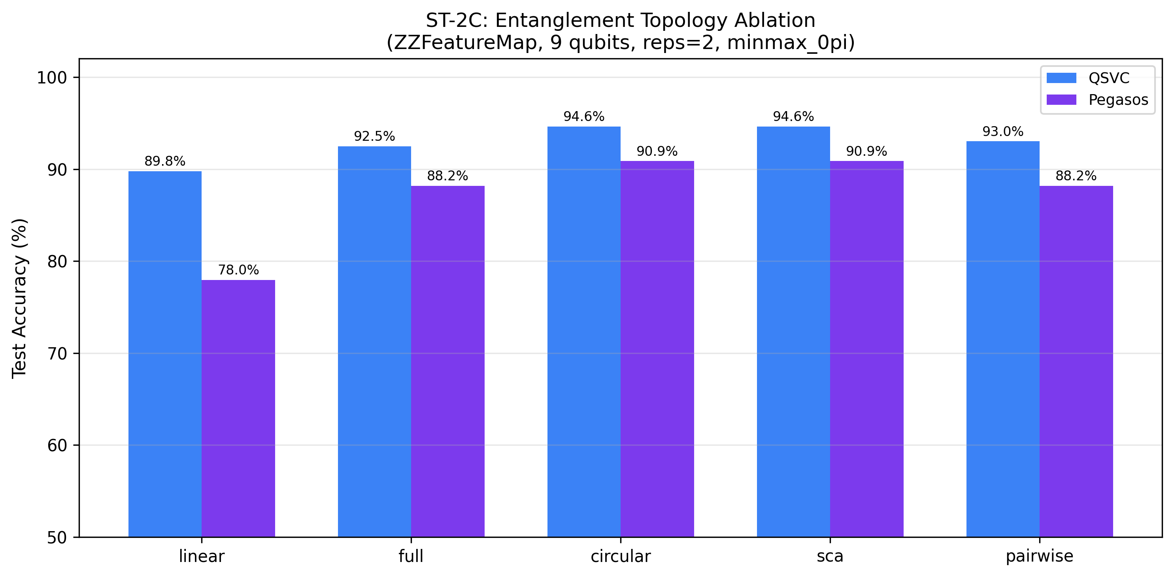

6.3 Pauli Feature Map Ablation
Figure 6.6: Pauli Feature Map Ablation
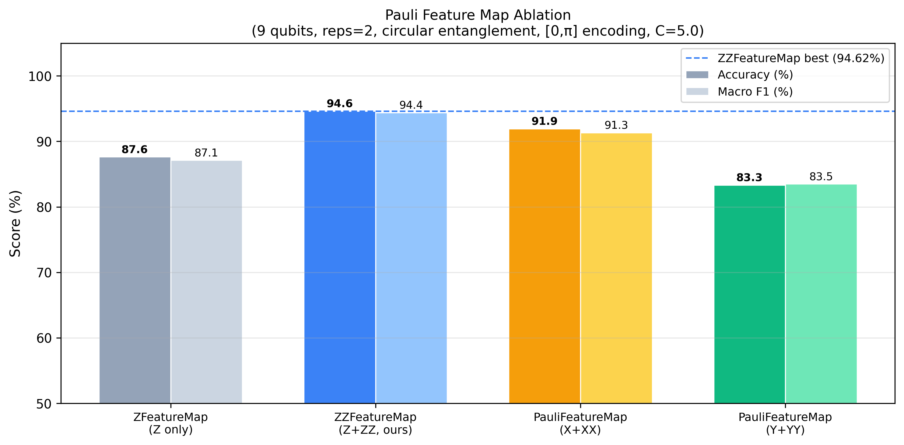

6.5 ROC-AUC and Calibration
Figure 6.7: ROC Curves All Models and Classes
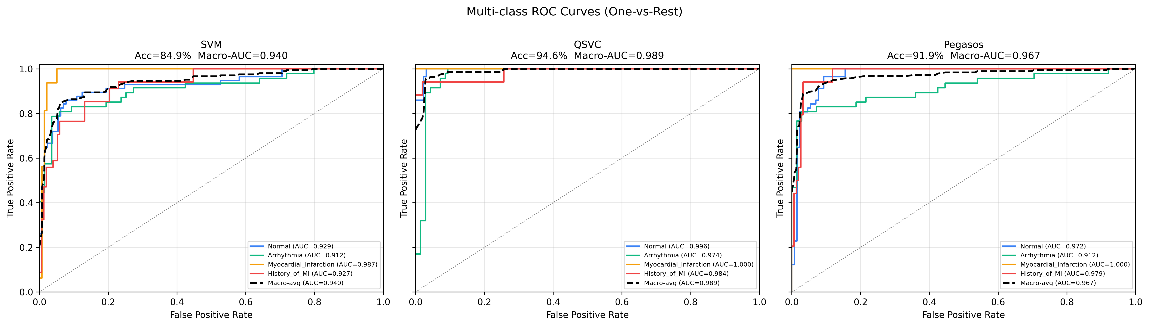
Figure 6.8: Confidence Calibration Curves
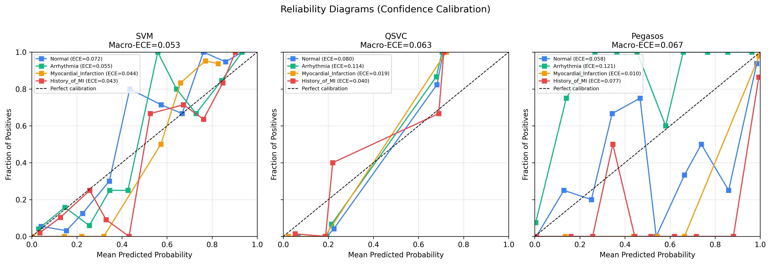

6.6 Augmentation Robustness
Figure 6.9: Augmentation Robustness Study
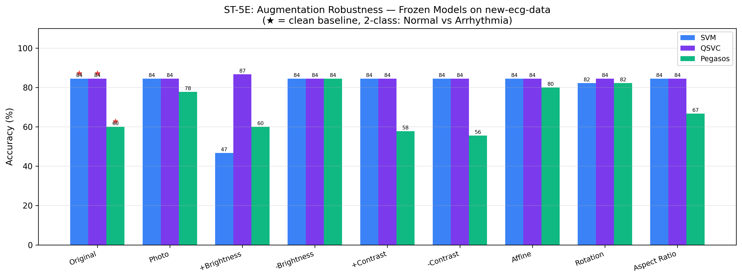

6.7 Cross-Dataset Generalization
Figure 6.10: QSVC Cross-Dataset CM
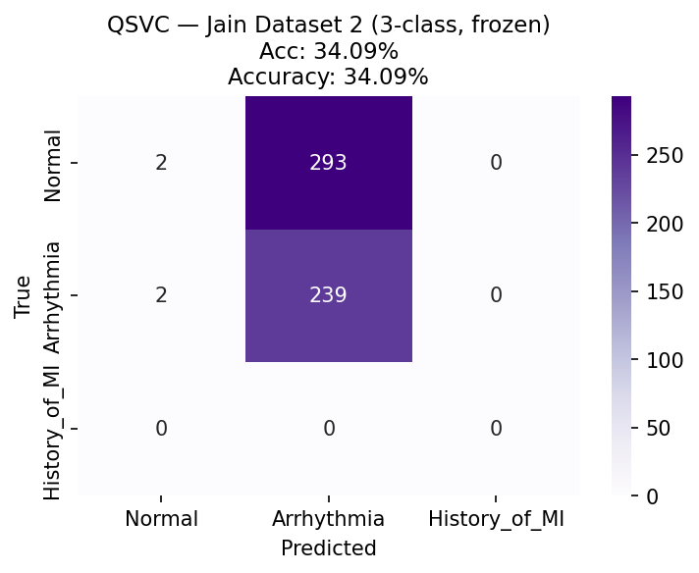
Figure 6.11: SVM Cross-Dataset CM
