QuCardio Report Figures (v9)
Figure 4.1: System architecture showing the offline training and online inference paths
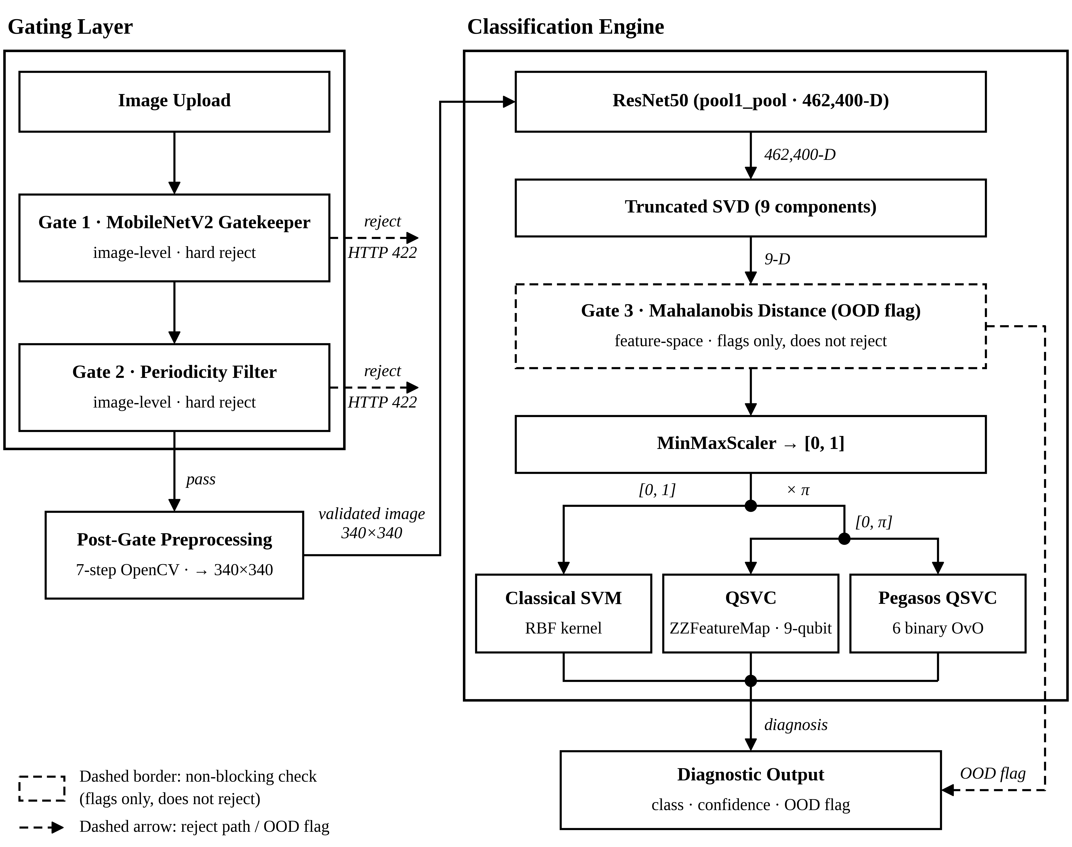
Figure 4.2: Use case diagram
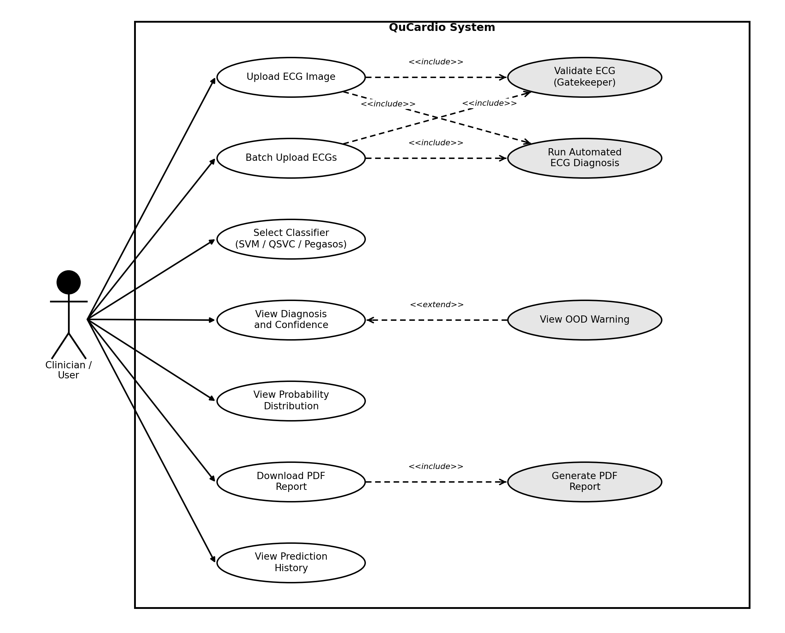
Figure 4.3: Level-1 data flow diagram
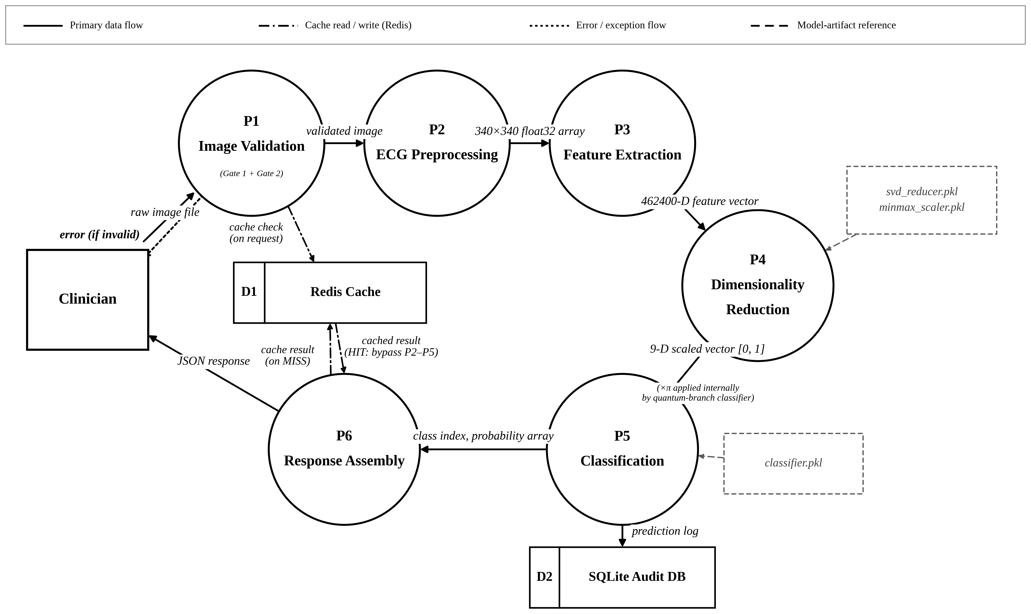
Figure 4.4: Class diagram
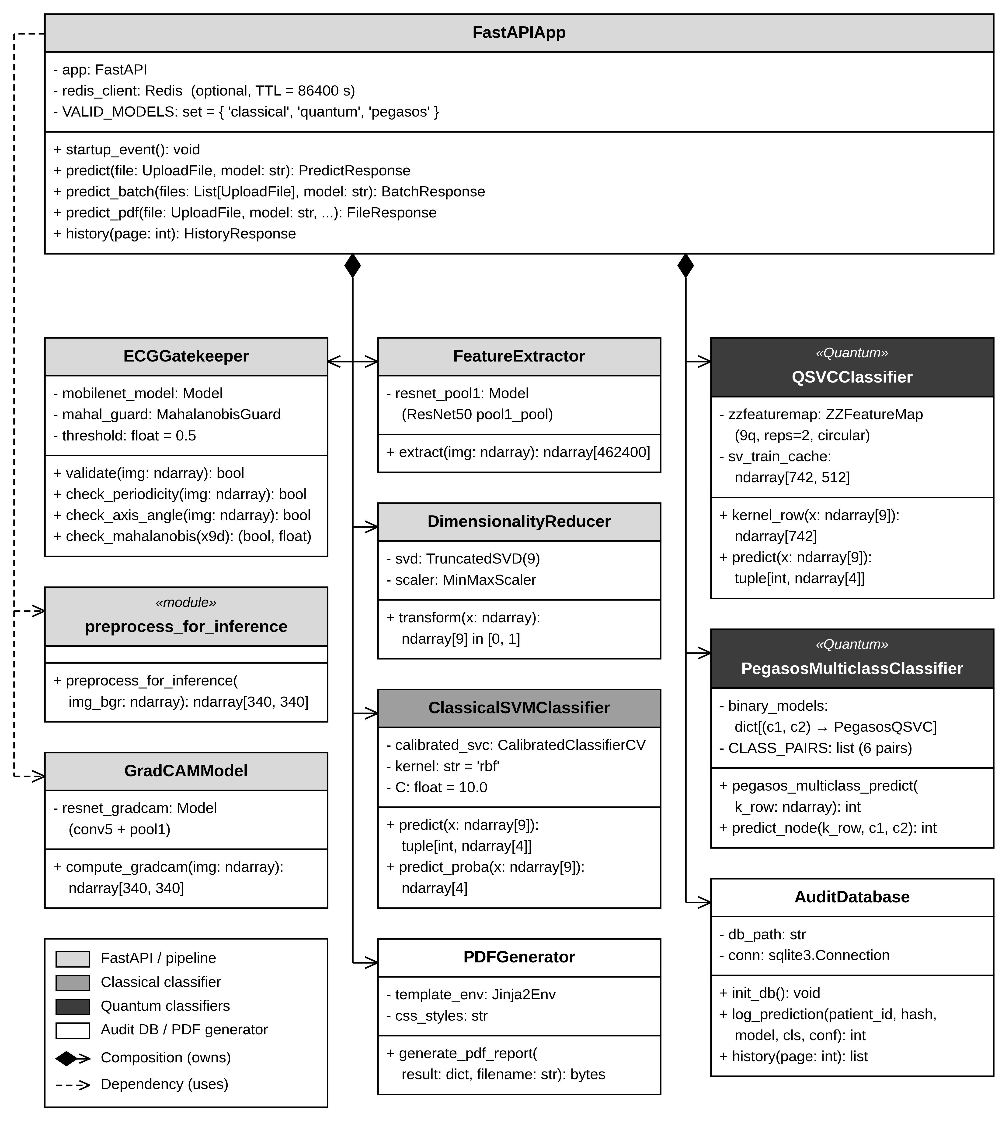
Figure 4.5: Sequence diagram for the POST /predict request
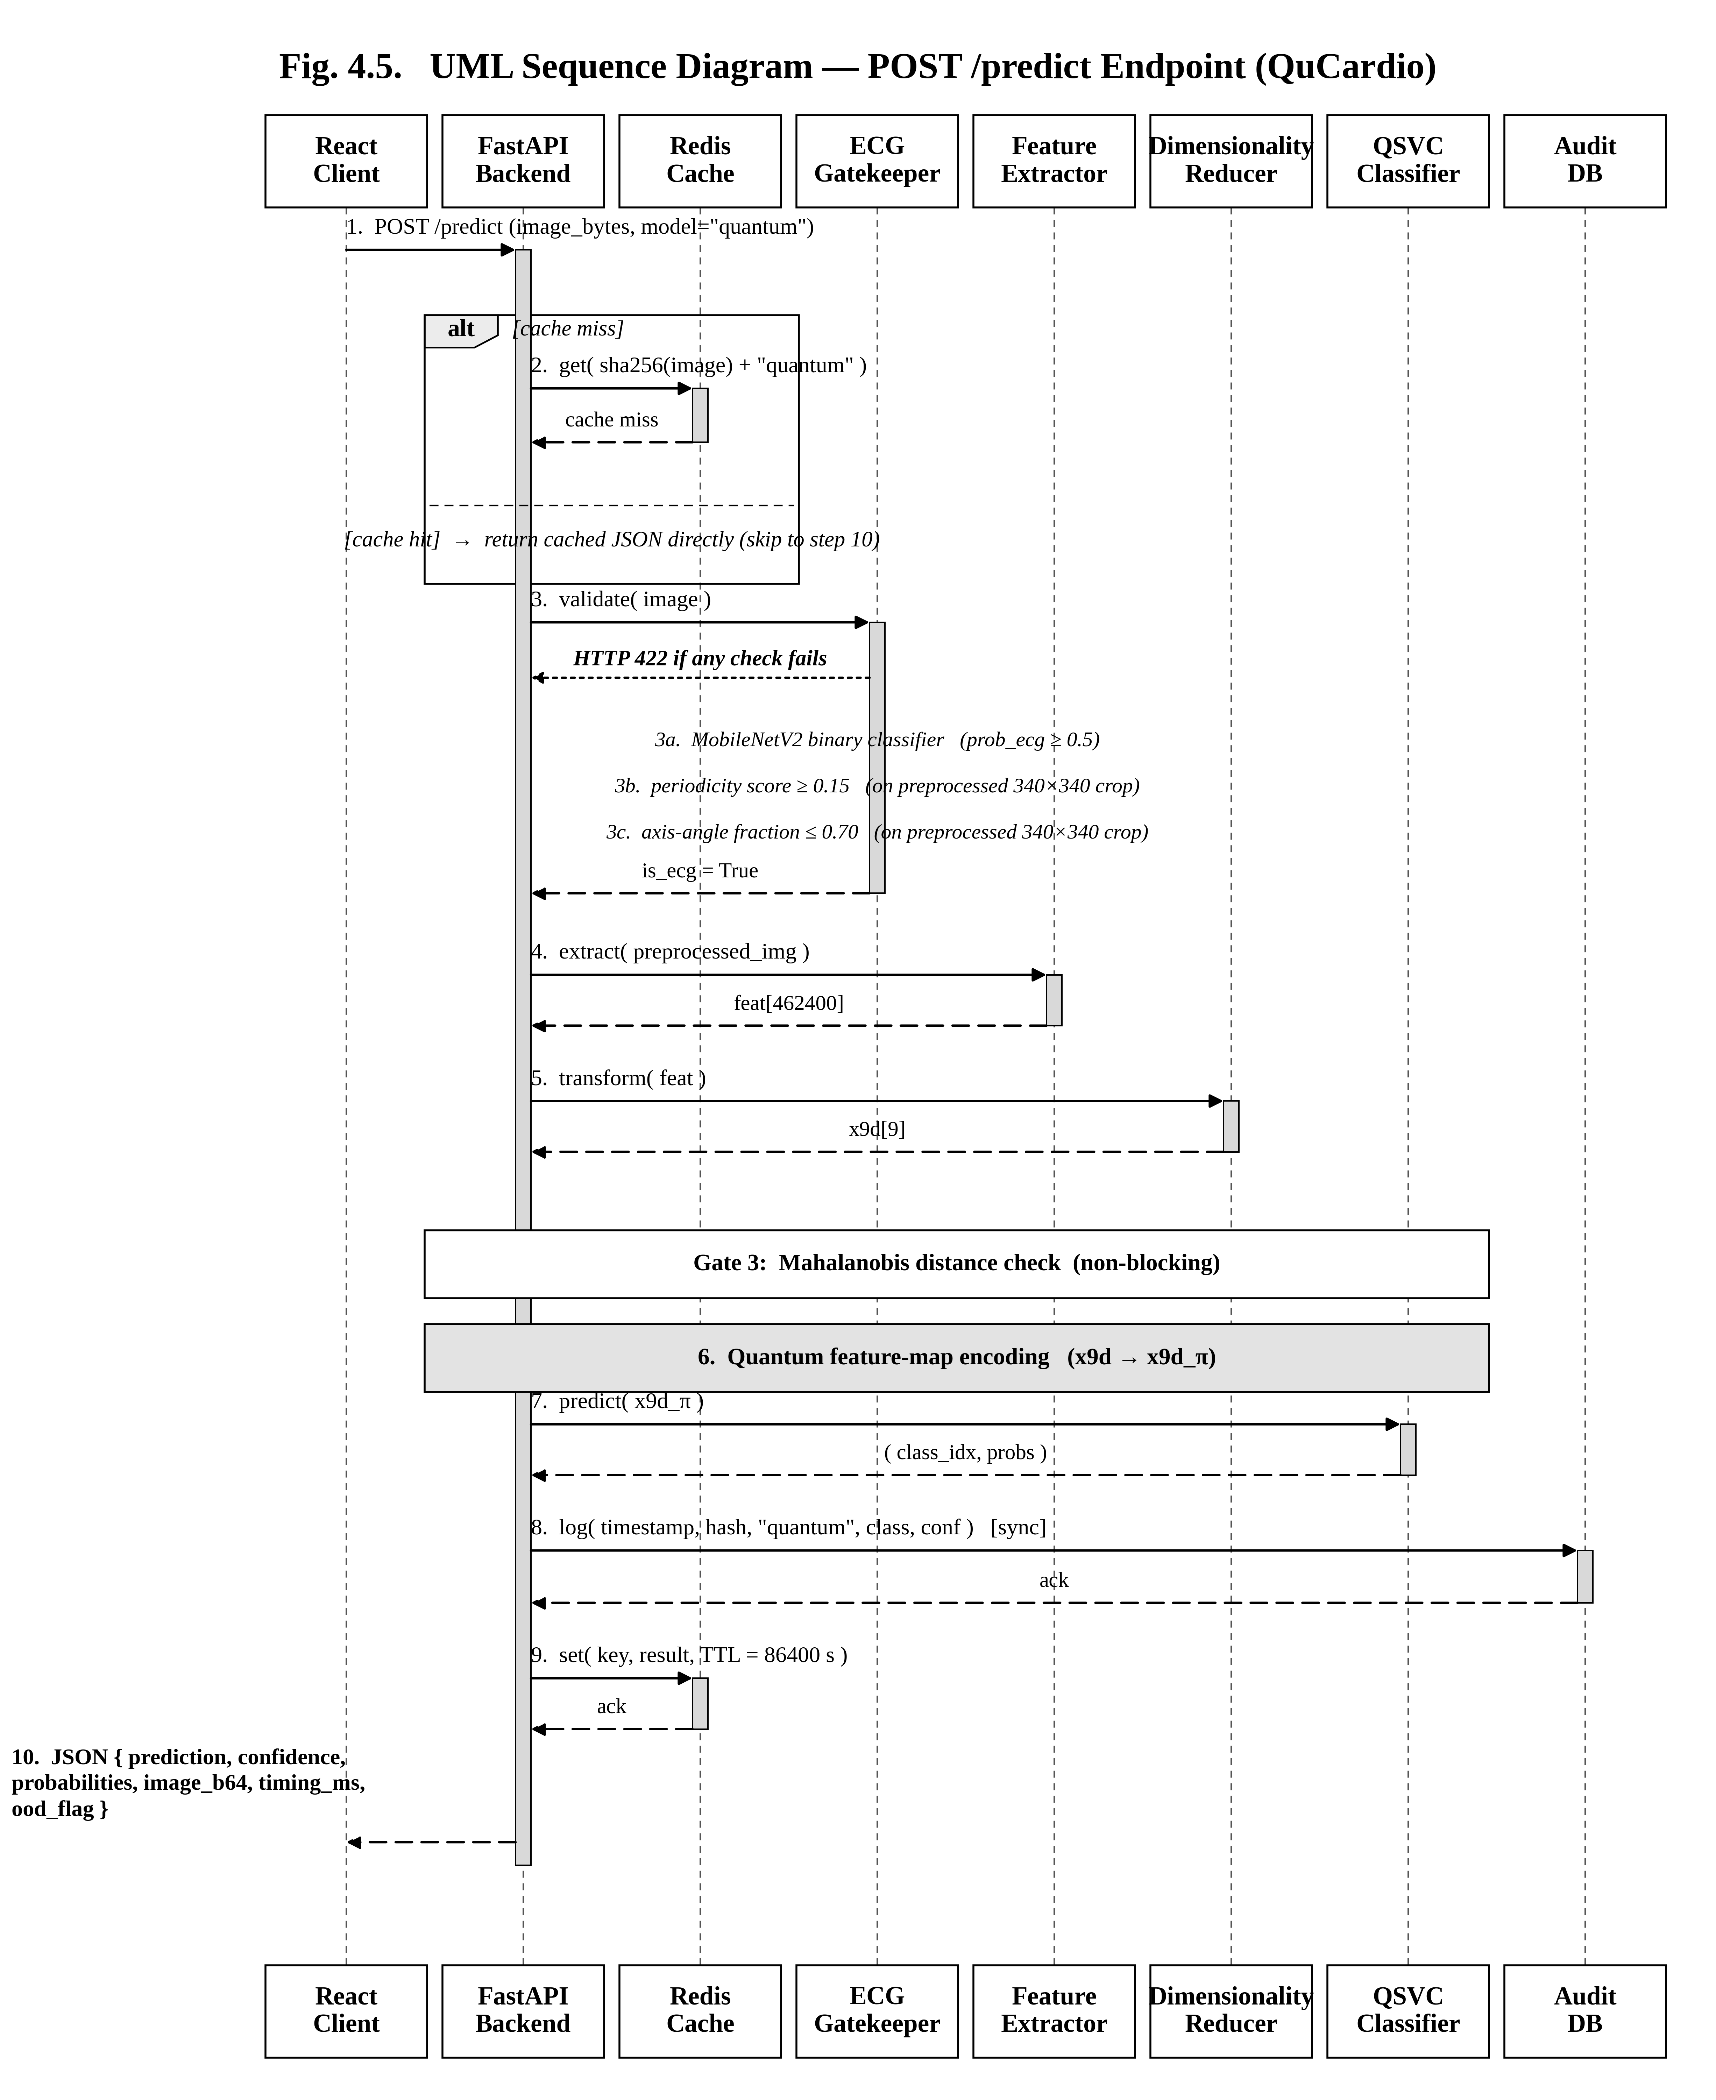
Figure 5.1: Raw clinical ECG scan and the resulting 340x340 preprocessed output
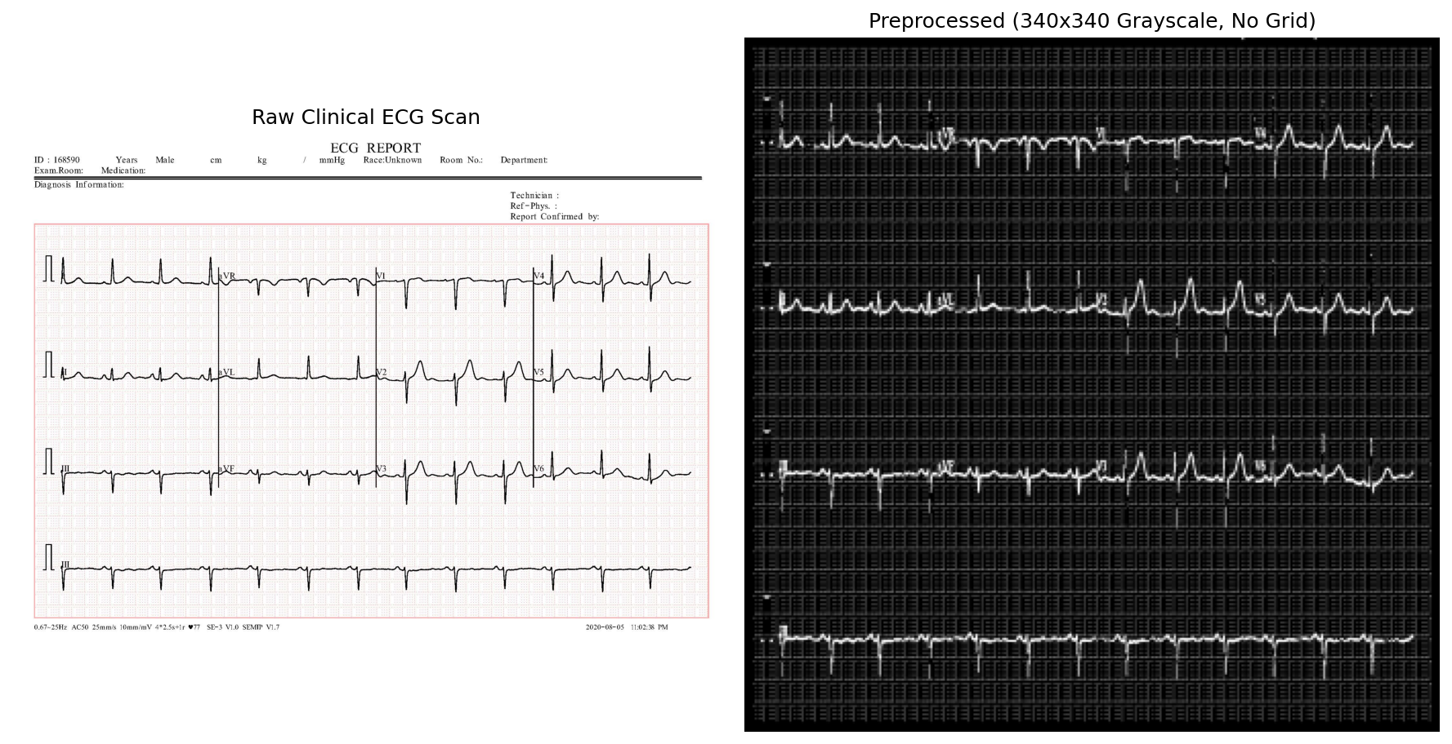
Figure 5.2: ZZFeatureMap circuit with nine qubits, reps = 2 and circular entanglement
Figure 5.3: Main upload interface with the drag-and-drop area and the three model selector buttons
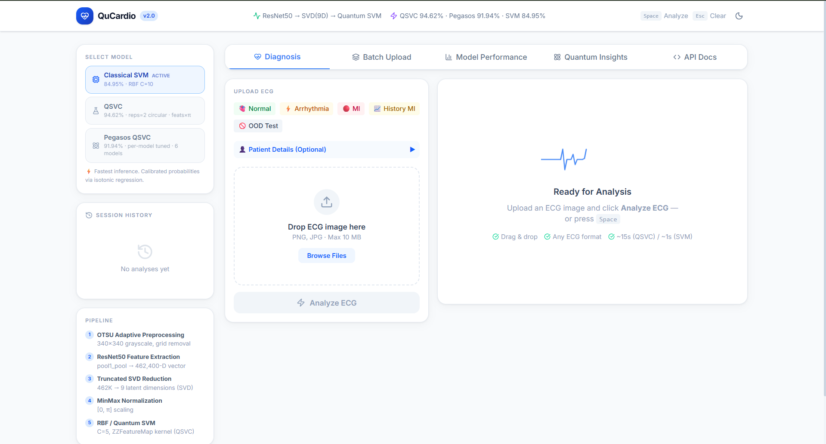
Figure 5.4: Diagnosis result screen showing the predicted class, the confidence bar, the per-class probability bars, the preprocessed ECG thumbnail and the clinical recommendation
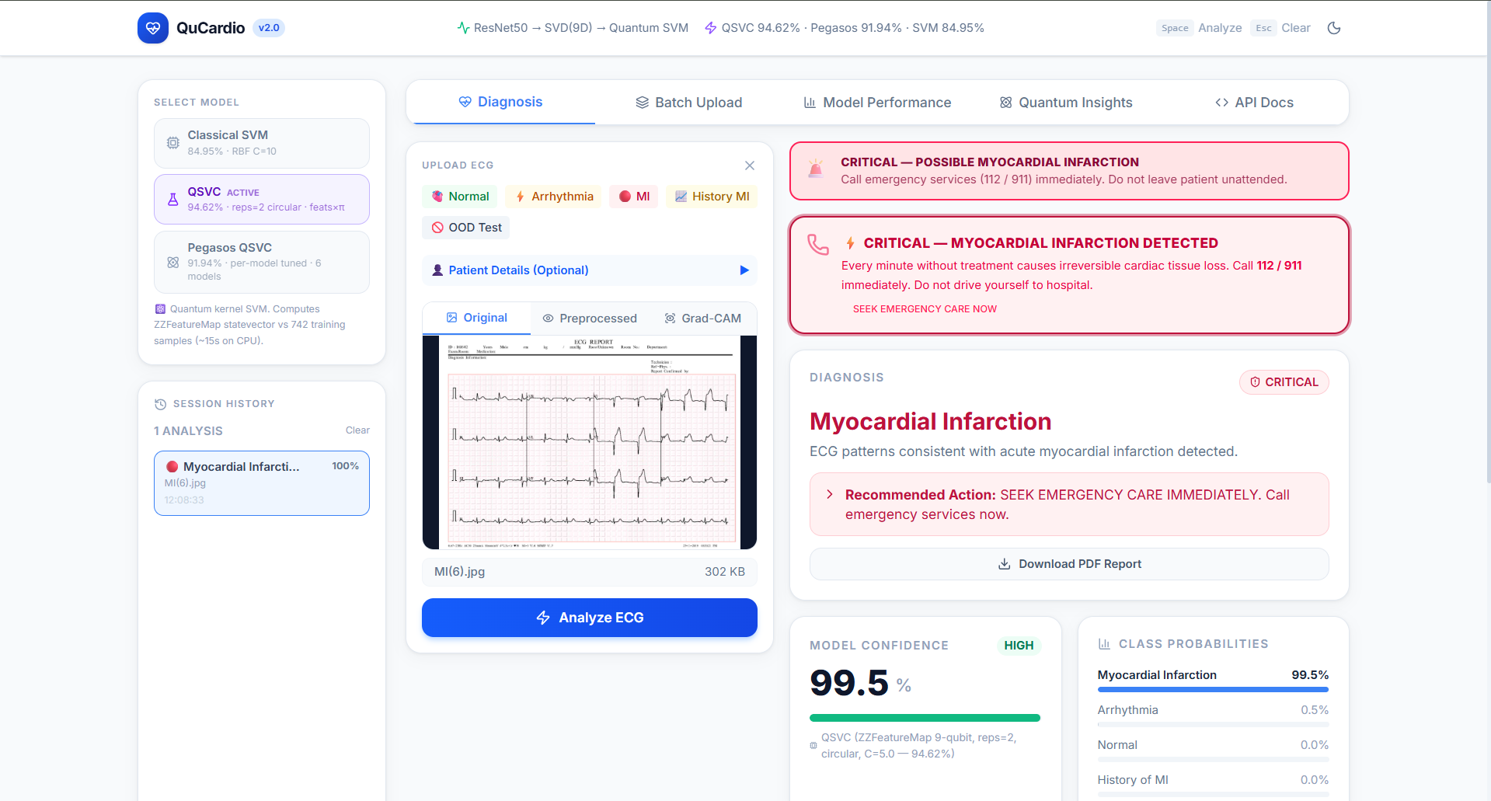
Figure 5.5: Model performance tab with the accuracy comparison chart for the three classifiers
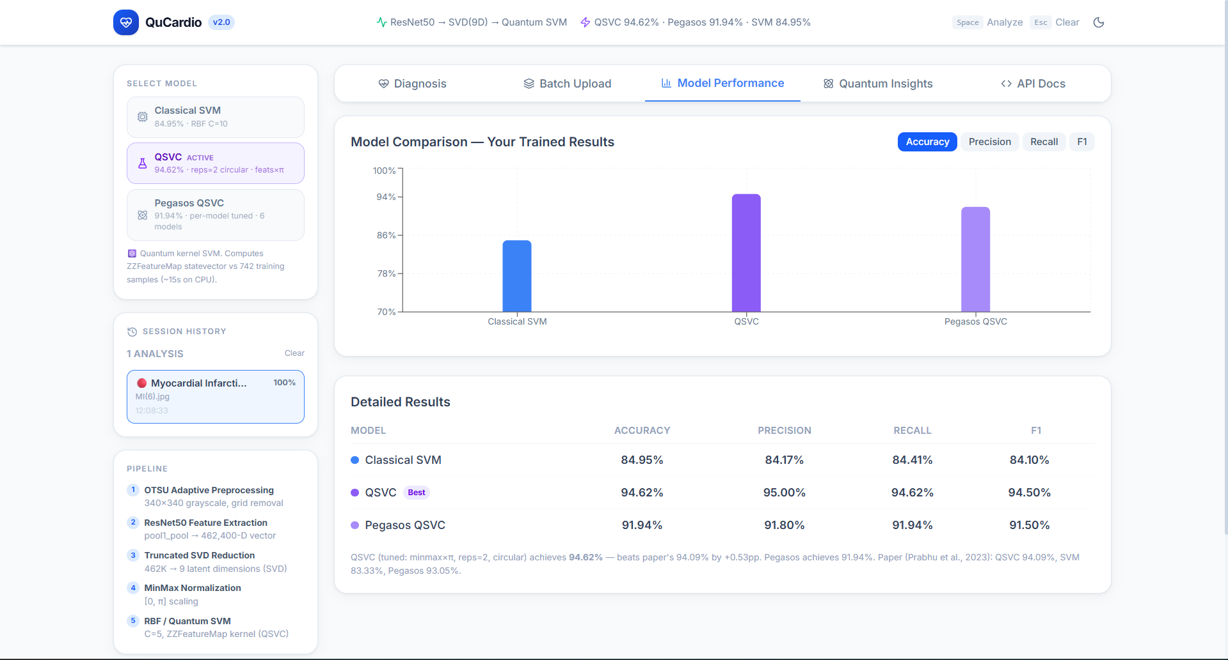
Figure 7.1: Accuracy comparison across all models
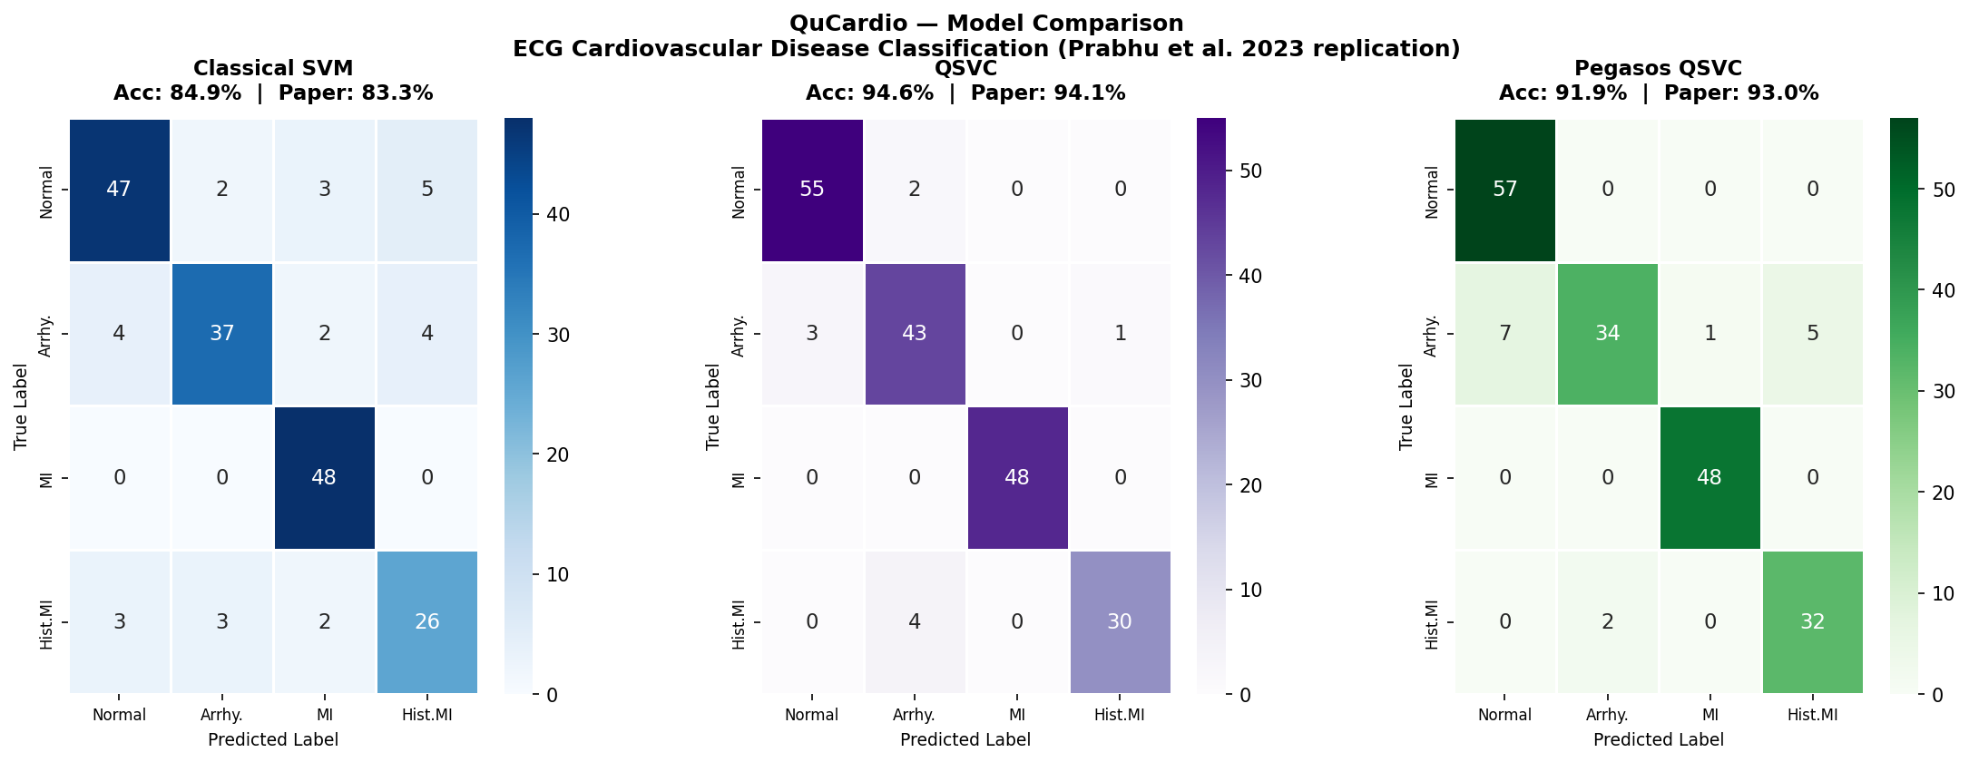
Figure 7.2: QSVC confusion matrix
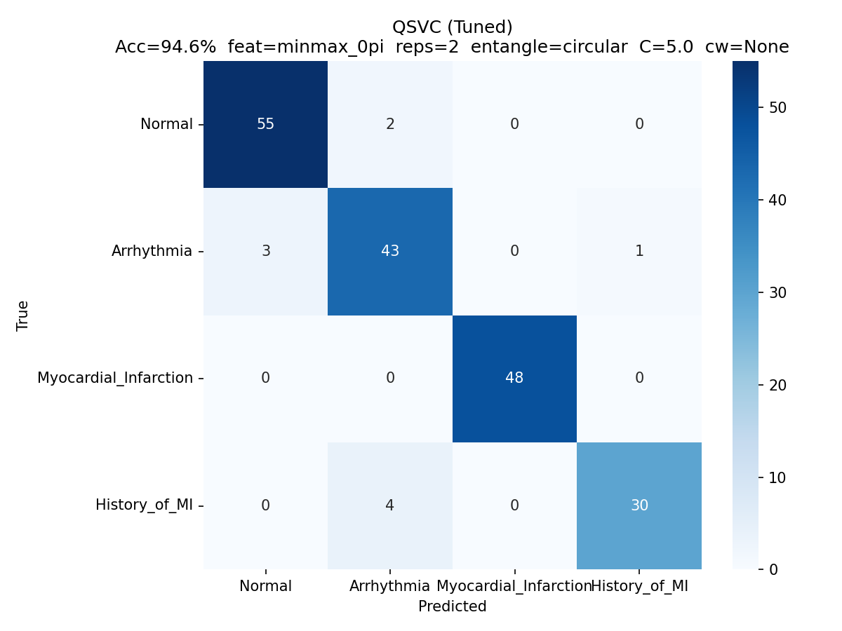
Figure 7.3: Pegasos QSVC confusion matrix
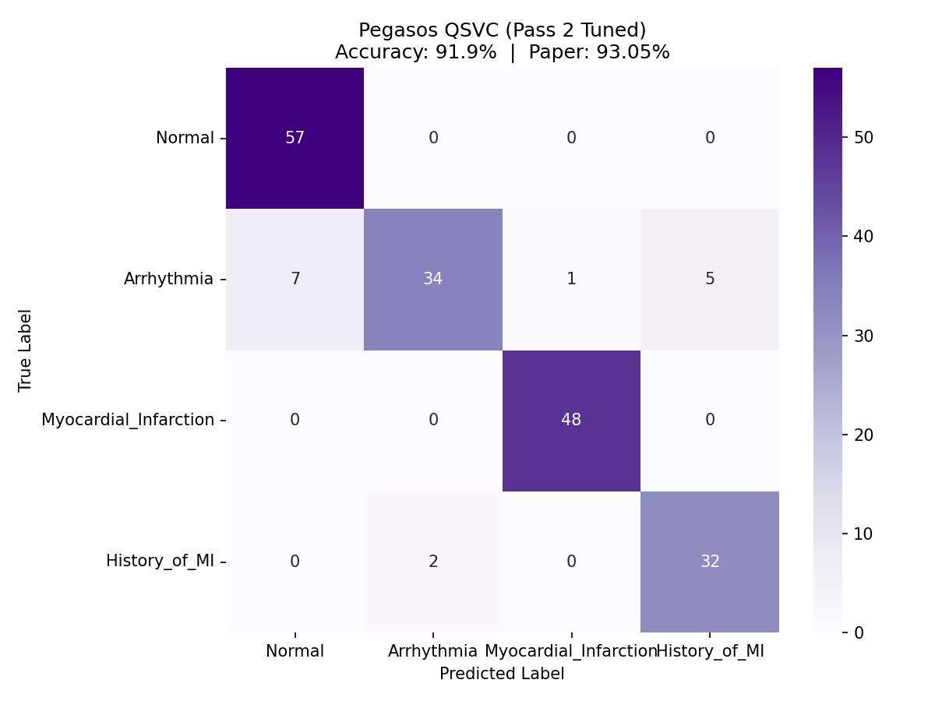
Figure 7.4: Feature encoding range ablation
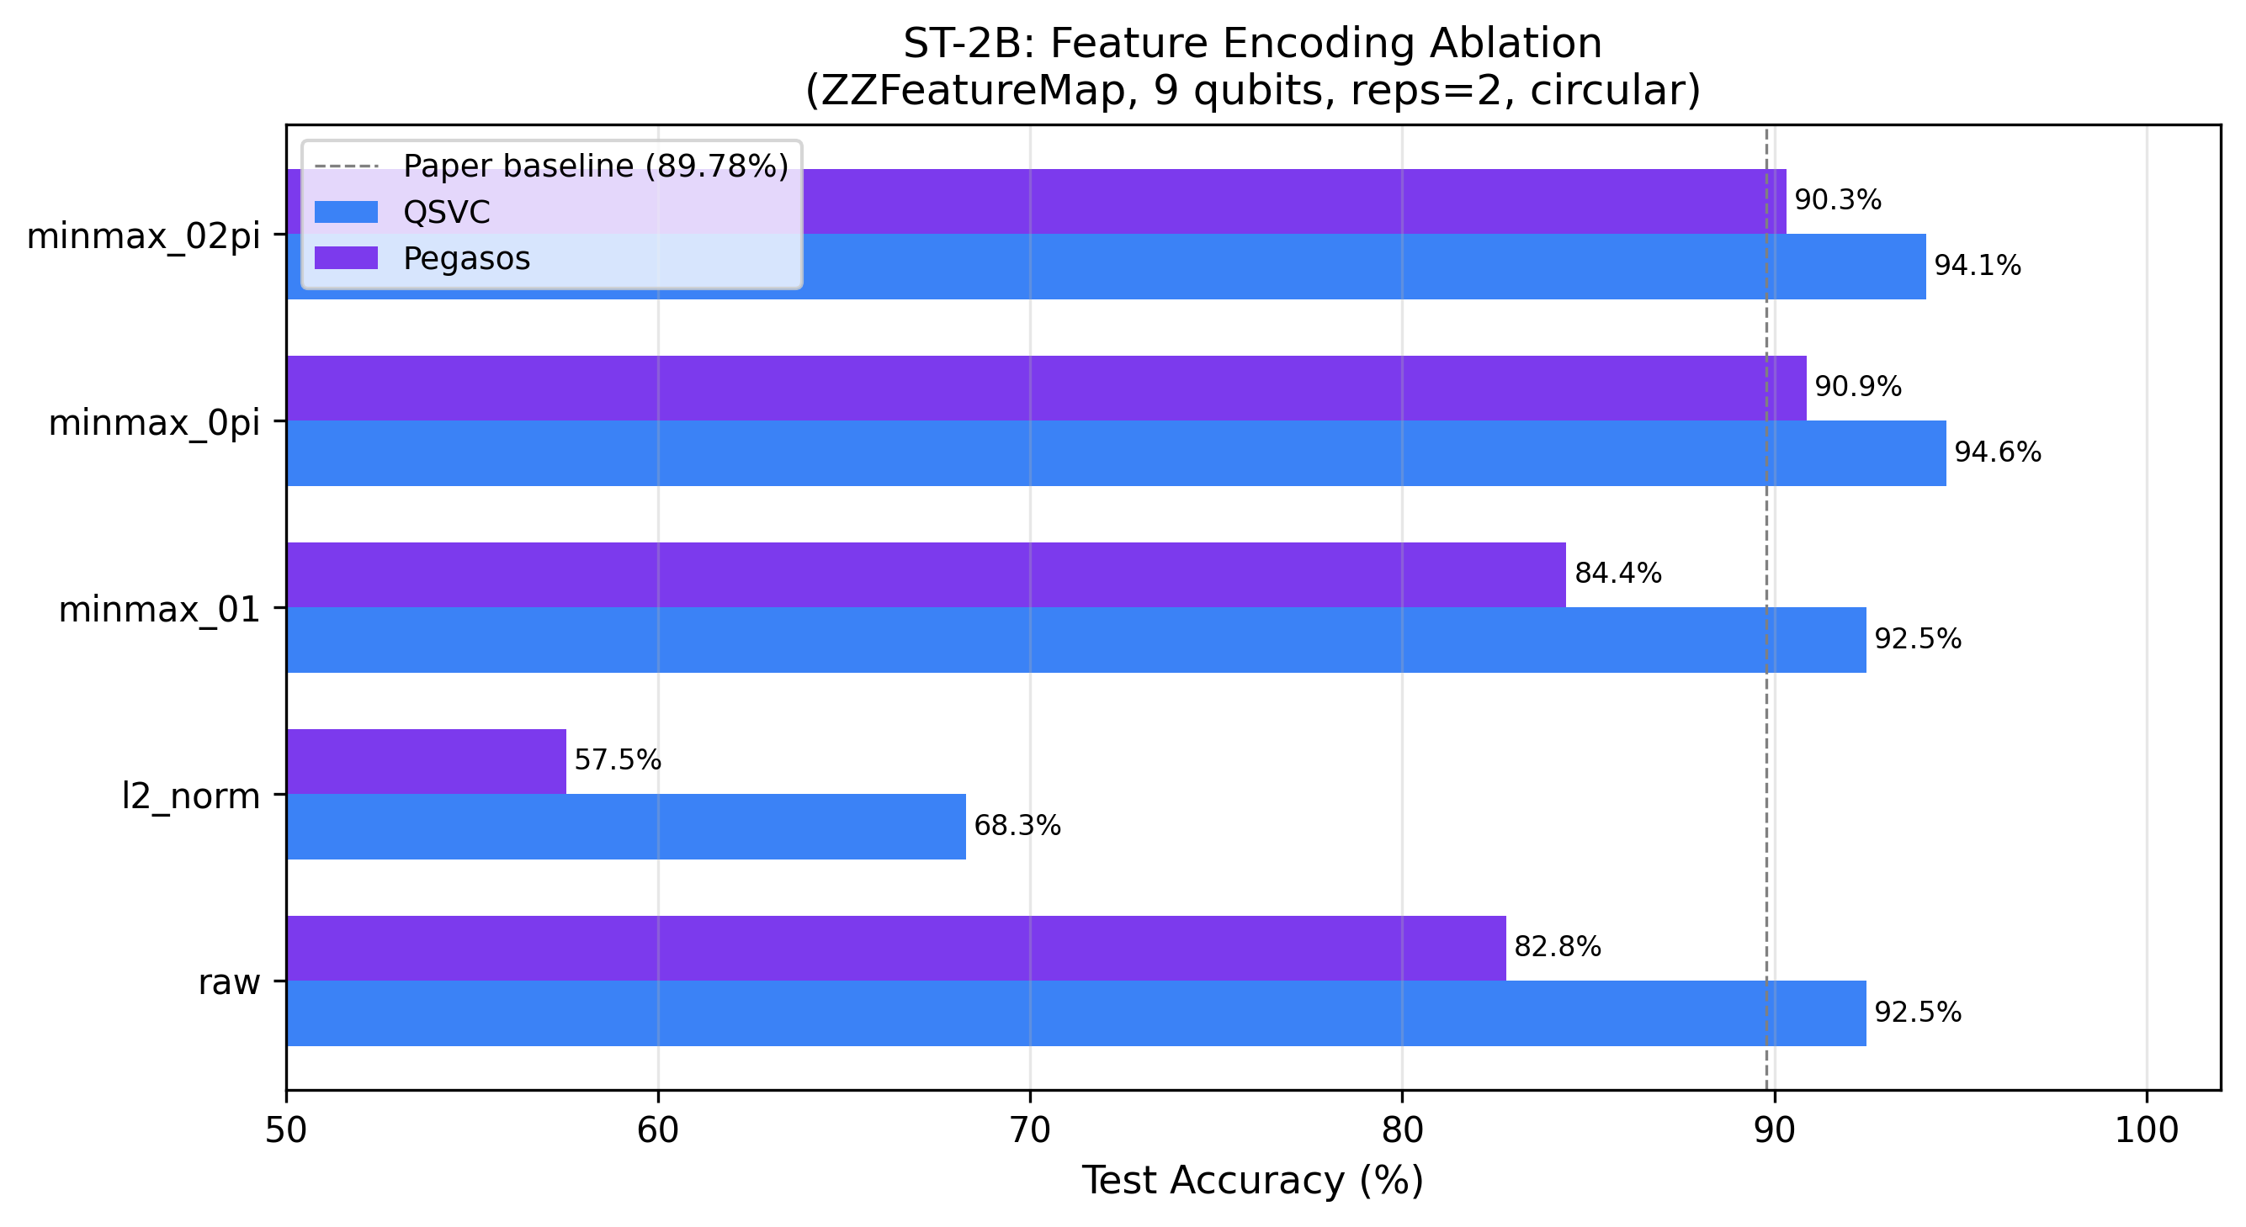
Figure 7.5: Entanglement topology ablation
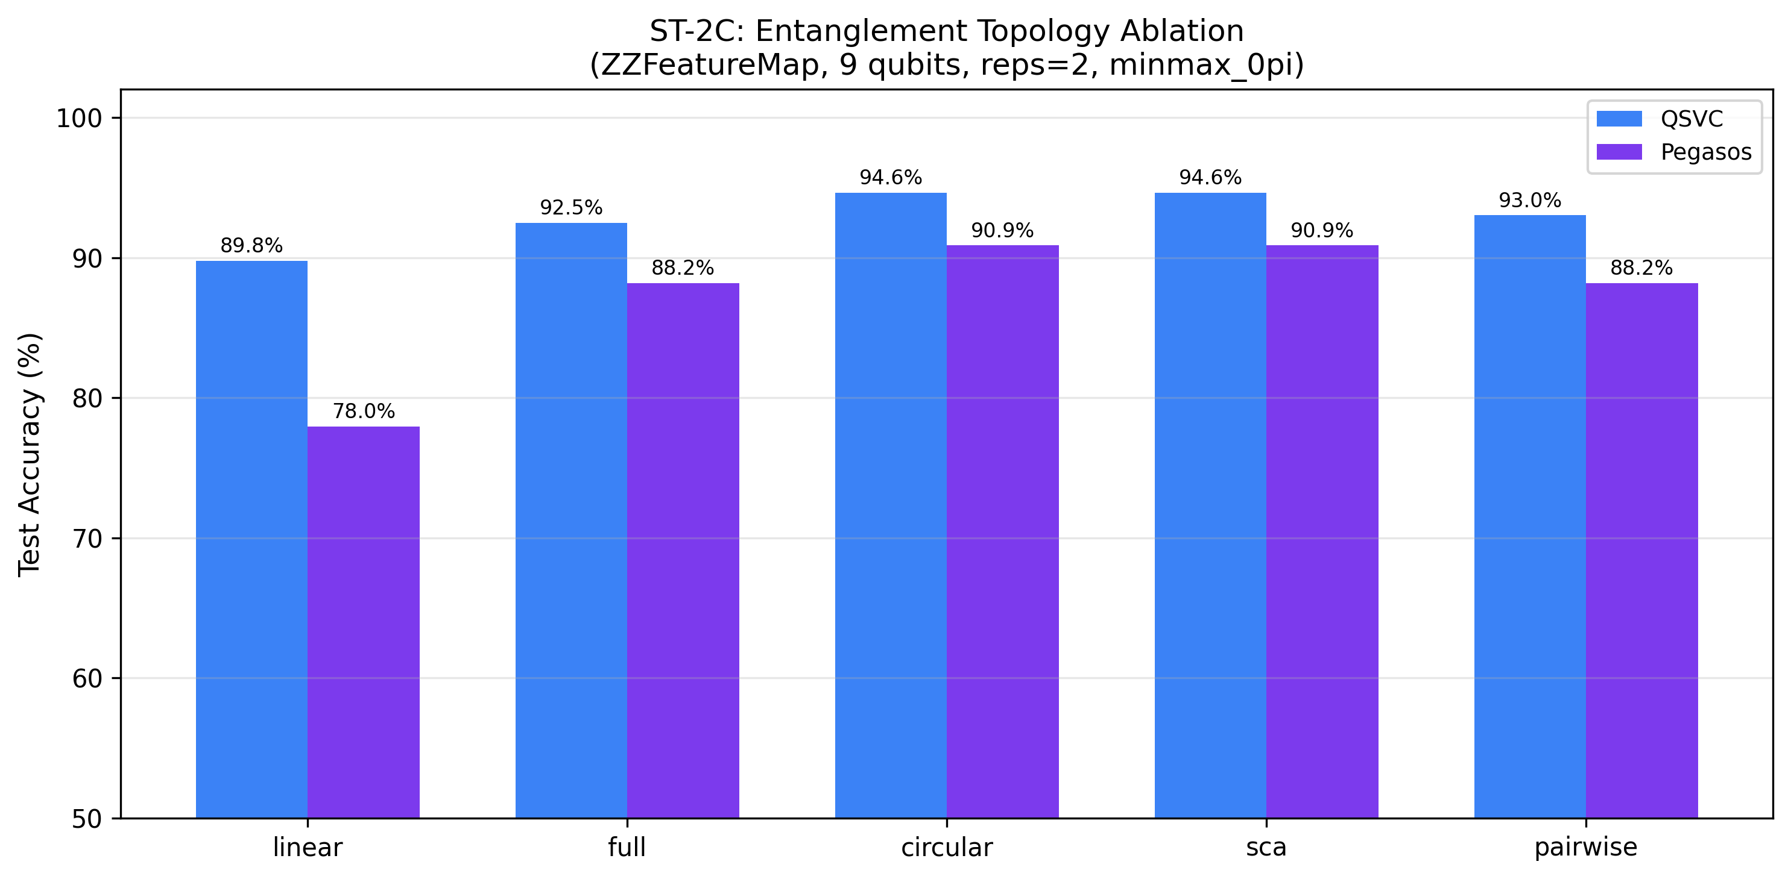
Figure 7.6: Pauli feature map ablation
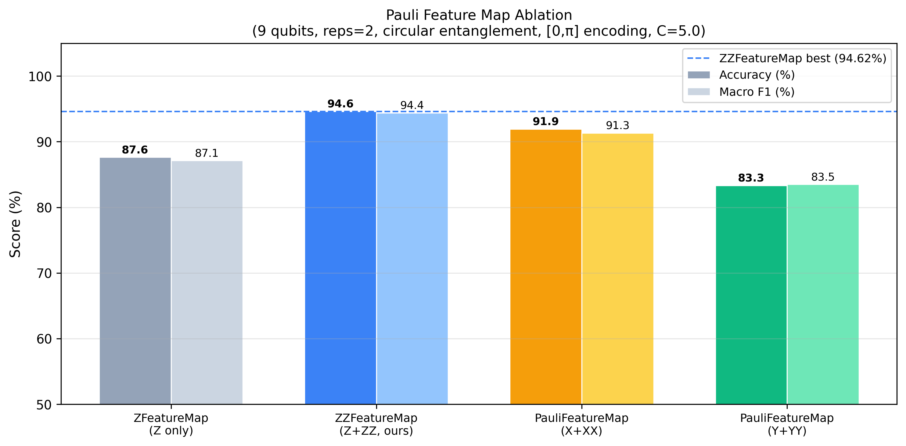
Figure 7.7: ROC curves for all models and classes
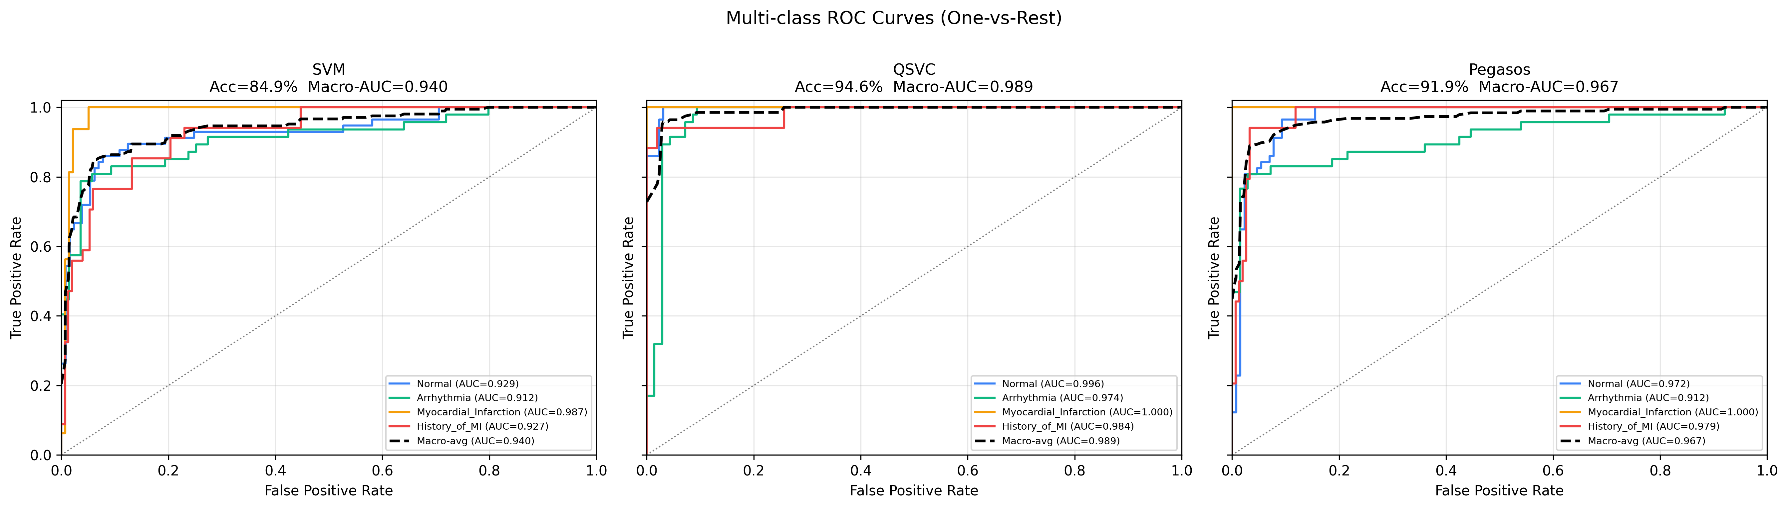
Figure 7.8: Confidence calibration curves
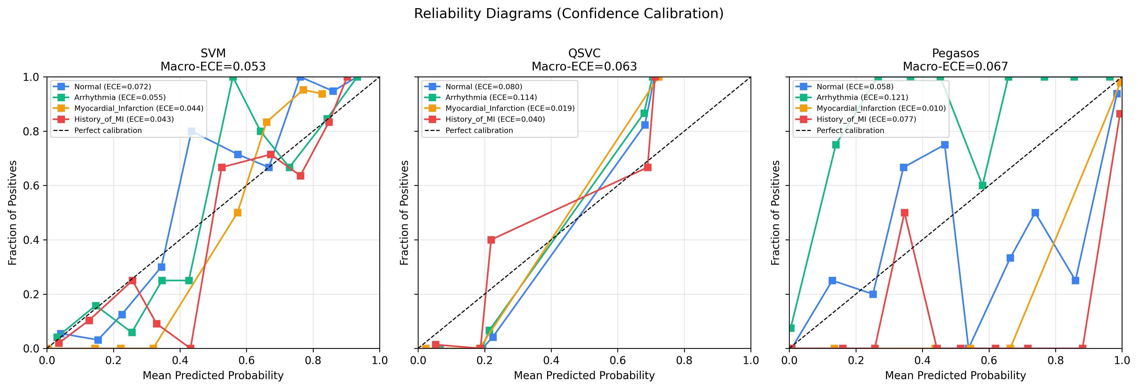
Figure 7.9: Augmentation robustness study
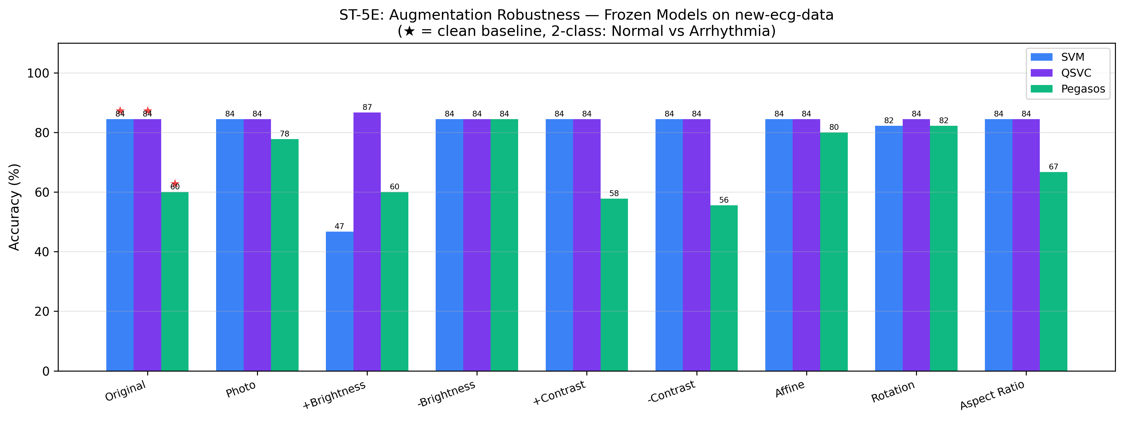
Figure 7.10: QSVC cross-dataset confusion matrix
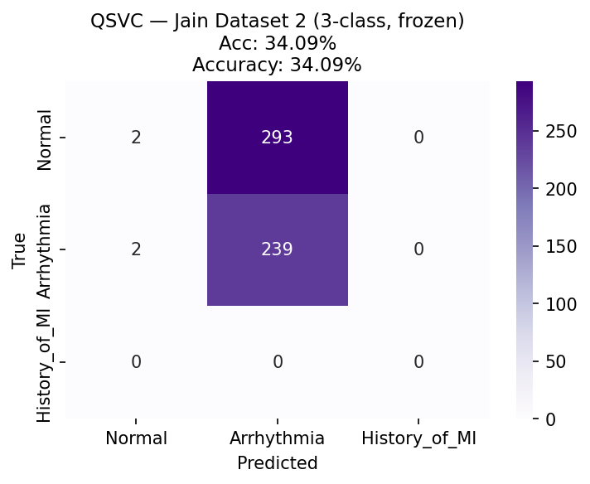
Figure 7.11: Classical SVM cross-dataset confusion matrix
