Global Weather API Specs

Version 1.0

Contents

1. Overview: 3

2. Technical design 3

i. Flow diagram 3

ii. Resources 4

## Overview:

The Global Weather API allows the user to query the weather conditions like temperature, wind speed, visibility and so on for the prominent cities around the globe. The API exposes an open source SOAP web service available over the internet as REST API. The API has to functionalities (resources), one to retrieve the list of all the prominent cities in a country and second the query the weather information of a given country and city combination.

## Technical design

Base URI: <http://localhost:8080/>

Version: v1.0

### Flow diagram

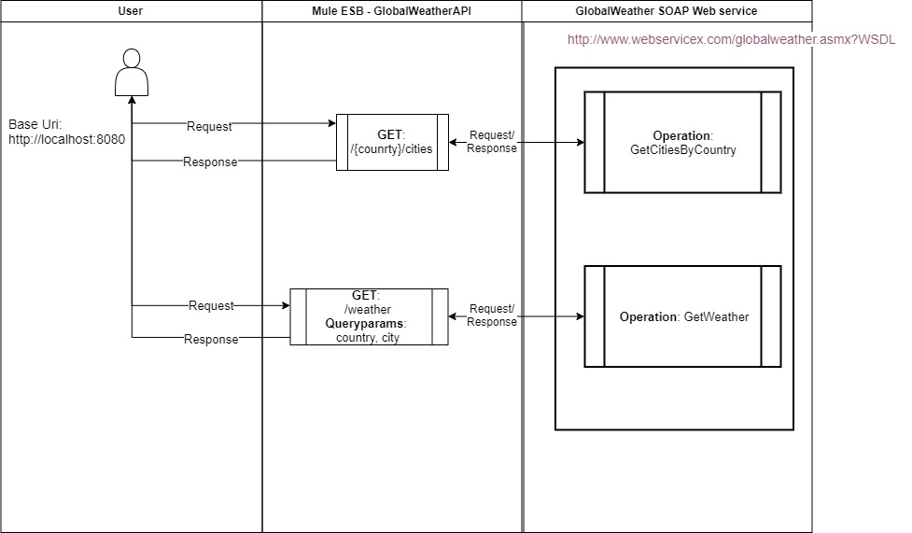

### Resources

#### Cities:

##### Request Description:

|  |  |  |  |
| --- | --- | --- | --- |
| **Field Name** | **Type** | **Required** | **Description** |
| country | *String* | *Required* | *Passed as URI parameter* |

##### Response Description:

Success Sample Response: 200 OK

{

“country”:”Australia”,

“cities”: ["Sydney", "Melbourne", "Brisbane"]

}

Error Sample Response: 400 Bad Request

{

"statusCode": "400",

"message": "Bad Request"

}

Error Sample Response: 404 Not Found

{

"statusCode": "404",

"message": "Data not found"

}

#### Weather:

##### Request Description:

|  |  |  |  |
| --- | --- | --- | --- |
| **Field Name** | **Type** | **Required** | **Description** |
| country | *String* | *Required* | *Passed as query parameter. Ex: Australia* |
| City | *String* | *Required* | *Passed as query parameter. Ex: Melbourne* |

##### Response Description:

Success Sample Response: 200 OK

{

"Location": "Sydney",

"Time": "10:00 AM",

"Wind": "5km per hour",

"Visibility": "10km",

"SkyCondition": "sunny",

"Temperature": "25",

"DewPoint": "2 C",

"RelativeHumidity": "35",

"Status": "Normal"

}

Error Sample Response: 400 Bad Request

{

"statusCode": "400",

"message": "Bad Request"

}

Error Sample Response: 404 Not Found

{

"statusCode": "404",

"message": "Data not found"

}