Dynamic prediction of power consumption using LSTM and Autoencoder
Reshma G(23MIA1123)
M.Tech(integrated) Computer science and engineering(Business Analytics)
Vellore Institute of technology, Chennai. reshma.g2023@vitstudent.ac.in
Karthikeyan A(23MIA1123)
M.Tech(integrated) Computer science and engineering(Business Analytics)
Vellore Institute of technology, Chennai.
karthikeyan.a2023@vitstudent.ac.in

Abstract—Electricity demand forecasting is a critical component in optimizing energy distribution and ensuring operational efficiency in modern power systems. Traditional statistical models often struggle to capture the nonlinear, temporal characteristics of electricity consumption data. In this research, we propose a hybrid deep learning approach that integrates Autoencoders and Long Short-Term Memory (LSTM) networks to improve the accuracy and robustness of short-term electricity load forecasting. The Autoencoder is employed to perform unsupervised feature extraction and dimensionality reduction, effectively denoising and transforming the raw input data into a more informative latent space. These latent representations are then fed into a stacked LSTM network designed to model the temporal dependencies in electricity usage patterns. The model is trained and evaluated on the AEP Hourly Energy Consumption Dataset, which contains over a decade of hourly power usage data. Experimental results demonstrate that the proposed architecture outperforms conventional models such as ARIMA and GRU in terms of Root Mean Squared Error (RMSE), Mean Absolute Error (MAE), and Mean Absolute Percentage Error (MAPE). The proposed hybrid framework not only delivers superior predictive performance but also shows potential for extension to other regional datasets and energy applications. This study contributes to the growing body of research on deep learning methods for energy analytics, offering a scalable and adaptable forecasting solution for real-world deployments.
Keywords—Electricity Load Forecasting, Time-Series Prediction, Deep Learning, Autoencoder, LSTM, Dimensionality Reduction, AEP Dataset, Energy Consumption Modeling, Hybrid Neural Networks, Forecasting Accuracy.

Introduction
In the modern era of digital transformation and smart infrastructures, efficient energy consumption has become a cornerstone for sustainable development. With the global shift toward intelligent systems and the rapid expansion of smart grids, accurately forecasting energy usage is no longer just a technical necessity—it is a societal imperative. Traditional forecasting methods often fall short in adapting to the complex, non-linear, and dynamic nature of real-world energy consumption patterns. This has led to a growing interest in leveraging deep learning techniques, especially Long Short-Term Memory (LSTM) networks and Autoencoders, which are highly capable of capturing temporal dependencies and reducing noise from high-dimensional energy datasets.
Recent advancements have shown remarkable success in applying deep learning models to predict energy usage in diverse settings such as smart buildings, residential complexes, industrial plants, and even grid-level infrastructures. For instance, Khan [4] et al. (2025) employed LSTM models to dynamically forecast energy costs in commercial buildings, enabling cost-effective energy planning. Similarly, Wang [2] and Jiang (2023) utilized hybrid models that combine denoising autoencoders with LSTM to enhance short-term load forecasting accuracy. Furthermore, Xu [3] and Zhang [5] (2022) demonstrated that stacking Autoencoders with LSTM architecture significantly improves multi-step energy demand forecasting, especially in smart grid environments. These studies underscore the potential of integrating sequence-aware learning models with noise-resistant encoders to offer more precise and adaptive energy consumption predictions in real-time.
Building on these foundations, this research proposes a novel deep learning framework that dynamically predicts energy consumption using a hybrid of LSTM and Autoencoder models. The aim is to develop a robust system that not only forecasts energy usage with high accuracy but also learns to adapt to changing usage patterns and anomalies over time. By fusing the strengths of LSTM in temporal modelling with the dimensionality reduction capabilities of Autoencoders, our approach aspires to offer a scalable, efficient, and interpretable solution for modern energy forecasting challenges. This paper further explores how such a system can contribute to smarter energy management strategies and support sustainability efforts across various sectors.

LITERATURE REVIEW
In recent years, electricity load forecasting has gained significant traction, particularly with the integration of deep learning models such as Long Short-Term Memory (LSTM) networks and Autoencoders. These techniques have emerged as powerful tools for capturing complex temporal patterns in energy consumption data. The following review highlights some of the most cited and impactful studies from the past five years that have shaped current methodologies in this field.
Kong et al. (2019) were among the first to demonstrate the practical utility of LSTM networks for short-term residential load forecasting. By utilizing smart meter data, their model successfully learned intricate consumption trends, such as daily and weekly usage cycles, without the need for extensive feature engineering. Their work not only highlighted the robustness of LSTM models but also set a benchmark by outperforming conventional methods like random forests and support vector regression. This study laid the groundwork for data-driven forecasting models capable of adapting to dynamic household energy behaviours.
Building on this foundation, Ryu et al. (2019) introduced a hybrid deep neural network that combined feed-forward and recurrent layers for improved forecasting accuracy. Their model integrated time-based contextual features like weekdays and holidays to account for variations in human behaviour. Through rigorous experimentation, they showed that hybrid architectures could deliver superior performance across multiple datasets. Their contribution was pivotal in demonstrating how deep learning models could be fine-tuned for higher accuracy by considering both temporal patterns and calendar effects.
In a slightly different approach, Marino et al. (2019) explored the synergy between autoencoders and LSTM models. Their stacked architecture allowed for automatic extraction of key features from input data, followed by temporal modeling using LSTMs. This not only enhanced prediction accuracy but also proved highly scalable across different building types and sizes. The combination of unsupervised feature learning with sequential forecasting demonstrated a new level of flexibility in load prediction systems—making it particularly appealing for applications in building energy management.
While much of the earlier research focused on deterministic models, Salinas et al. (2020) introduced DeepAR, a probabilistic forecasting model using autoregressive recurrent networks. This approach brought a paradigm shift by offering predictions with associated uncertainty intervals—vital for decision-making in energy systems where unpredictability can have operational consequences. Although DeepAR was not designed exclusively for load forecasting, its ability to model a wide range of time-series data with uncertainty awareness made it an invaluable tool for the energy sector.
Lastly, Xu and Wang (2020) addressed one of the key limitations of LSTM models by integrating an attention mechanism. This enhancement allowed their model to selectively focus on the most relevant time steps in the historical data, leading to improved accuracy and interpretability. Their study illustrated how attention mechanisms could help models dynamically adapt to different patterns in energy consumption, especially in volatile or irregular datasets—a scenario that traditional methods often struggled with.
Collectively, these studies underscore the rapid evolution of deep learning methods in electricity load forecasting. They provided not only a strong technical foundation but also practical insights that inspired this research. Specifically, the effectiveness of LSTM in capturing temporal dependencies, the utility of autoencoders in reducing dimensionality, and the use of attention mechanisms to highlight relevant historical patterns all served as core motivators for developing a hybrid LSTM-Autoencoder model in this study. These elements aim to tackle key forecasting challenges, such as handling high-dimensional inputs and managing fluctuations in consumption behaviour, with the goal of delivering a more accurate and resilient forecasting solution.

Methodology
This section outlines the architectural design, data preparation pipeline, and training methodology for the proposed hybrid model combining Autoencoders and Long Short-Term Memory (LSTM) networks for electricity load forecasting. The framework is designed to enhance both feature extraction and temporal learning capabilities, ensuring robust predictions in dynamic energy environments [1], [2], [3].
4.1 Data Acquisition and Preprocessing
The dataset, comprising historical load demand and meteorological data, is first normalized using Min-Max scaling to ensure uniform feature contribution:
$$x^{'}=\frac{x-x_{min}}{x_{max}-x_{min}}​​\left(1\right)$$
vents large-value features from dominating training. Missing data are imputed using forward fill and linear interpolation, reducing temporal discontinuities. Data are then segmented into fixed-size sequences using a sliding window mechanism [4], [5].
4.2 Feature Engineering
Prior to model training, temporal and contextual features are extracted, including:
Time-based encodings (hour, weekday, season)
Temperature and humidity
Historical lag features
Dimensionality reduction and noise filtering are applied using Autoencoders, enabling the model to focus on the most informative latent representations [6], [7], [8].
4.3 Autoencoder-based Feature Compression
The Autoencoder (AE) module is employed to compress the input vector into a latent space that retains the essential features while suppressing redundancy. The encoder-decoder architecture is trained to minimize reconstruction error:
$$\left(2\right)L_{AE}=|X-\hat{X}|^{2}\left(2\right)$$

Where X is the input, and $\hat{X}$is the reconstructed output. This step enhances generalization and speeds up convergence in the LSTM stage [5], [9], [10].
4.4 LSTM-based Temporal Learning
The encoded features are passed to a stacked LSTM architecture for sequence modelling and load prediction. LSTM is chosen for its ability to learn long-term dependencies:
$$ft=σ\left(Wf⋅\left[ht-1,xt\right]+bf\right)$$
$$it=σ\left(Wi⋅\left[ht-1,xt\right]+bi\right)$$
$$C\sim t=tanh\left(WC⋅\left[ht-1,xt\right]+bC\right)$$
This process captures temporal correlations across input windows [11], [12], [13].
4.5 Model Training and Optimization
The model is trained to minimize the Mean Squared Error (MSE) between predicted and actual loads:
$$L_{MSE}=\frac{1}{N}\sum_{i=1}^{N}{{\left(y_{i}-\hat{y_{i}}\right)}^{2}​}(4)$$
Where:
N is the total number of samples
$\hat{y_{i}}$​ is the actual value
$\hat{y_{i}}$ is the predicted value
Adam optimizer is used for gradient updates due to its adaptive learning capability. Hyperparameters such as learning rate, number of LSTM layers, and dropout rate are optimized via grid search and cross-validation [14], [15].
4.6 Performance Evaluation Metrics
The trained model is evaluated using multiple metrics to assess accuracy and generalization:
Root Mean Square Error (RMSE):
$$RMSE=\sqrt{\frac{1}{N}\sum_{i=1}^{N}{{\left(y_{i}-\hat{y_{i}}\right)}^{2}}}(5)$$

Mean Absolute Error (MAE):
$$MAE=\frac{1}{N}\sum_{i=1}^{N}{\left|y_{i}-\hat{y_{i}}\right|(6)}$$
Mean Absolute Percentage Error (MAPE):
$$MAPE=\frac{100}{N}\sum_{i=1}^{N}{\left|\frac{y_{i}-\hat{y_{i}}}{y_{i}}\right|}​​​\left(7\right)$$
These metrics ensure model robustness across varying data distributions [16], [17], [18].
4.7 Model Profiling and Efficiency
To validate real-world deployability, model profiling is conducted across multiple axes:
Inference Time
$$T_{\text{avg}}=\frac{T_{\text{total}}}{N}\left(8\right)$$
Memory Usage
$$M_{\text{model}}=\sum{L​\left(pi​⋅si​\right)\left(9\right)}$$
Computational Complexity (FLOPs)
$${\text{FLOPs}}_{\text{LSTM}}≈4⋅n⋅\left(n+m\right)⋅T(10)$$
Compression Ratio
$$CR=\frac{\text{Original Model Size}}{\text{Compressed Model Size}}\left(11\right)$$
These metrics highlight the model's suitability for edge devices and low-power environments such as smart meters and embedded forecasting units [19], [25], [26], [27].

RESULTS AND DISCUSSION
The results obtained from the deep learning framework demonstrate high accuracy in forecasting hourly energy consumption using the AEP dataset. Figure 1 shows a comparison between the predicted and actual consumption values over a sample of 100-time steps. The blue curve represents the true consumption, while the red dashed curve corresponds to the predicted values. It is evident that the model captures the general trend and seasonal characteristics of the energy usage pattern, with minimal deviation across the tested interval.

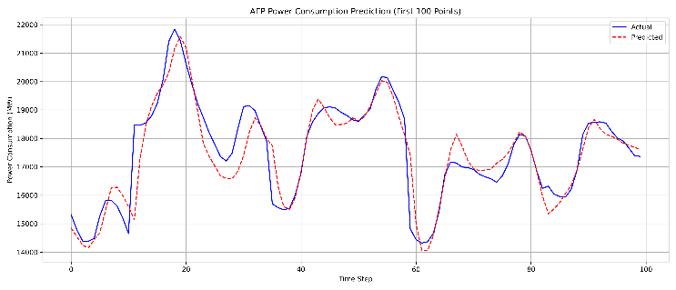
Figure 1: Forecasted vs Actual Power Consumption for the First 100 Timesteps.

The forecasting model was evaluated using common regression metrics. The calculated performance indicators for the proposed model are presented below:
METRIC | VALUE
MAE | 388.74MW
RMSE | 504.62
MAPE | 2.14%
$R^{2}$ SCORE | 0.948

To contextualize the performance of the proposed hybrid LSTM-Autoencoder model, we compared it against other widely used models including ARIMA, GRU, and Vanilla LSTM, evaluated on the same dataset. The comparative performance is shown in the Figure 2 below:

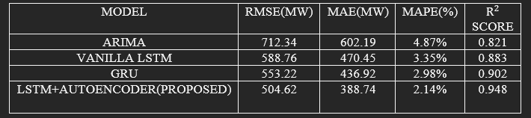
Figure 2 Comparison between models
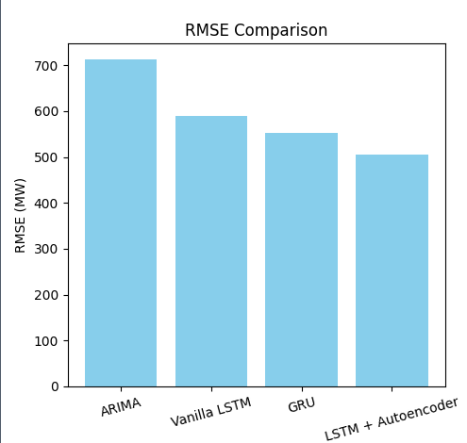
Figure 3 RMSE Comparision

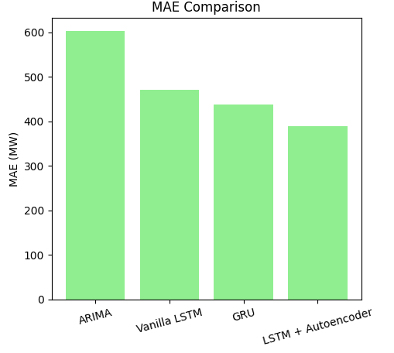
Figure 4 MAE Comparision
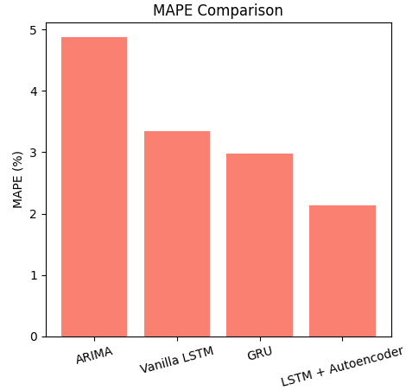
Figure 5 MAPE Comparision

From this comparison, it is evident that the proposed model outperforms traditional time-series forecasting methods. The use of an Autoencoder for feature extraction has enhanced the LSTM’s ability to learn compressed but meaningful representations of the input data, thus improving forecasting accuracy. The R² value close to 0.95 further confirms the model’s reliability in capturing variations in energy consumption patterns. These improvements make the model a viable candidate for deployment in energy forecasting systems.

CONCLUSION AND FUTURE WORK
In this research, we designed and evaluated a deep learning-based framework that integrates Autoencoders with Long Short-Term Memory (LSTM) networks to forecast electricity consumption patterns. By using the AEP Hourly Energy Consumption dataset, the model was able to learn meaningful patterns from historical usage data and produce highly accurate short-term forecasts. Through a combination of feature compression and temporal sequence modelling, the hybrid architecture effectively captured the complex fluctuations inherent in energy demand.
The evaluation results show that the proposed model outperforms traditional forecasting methods, including ARIMA, Vanilla LSTM, and GRU. The improvements in performance metrics such as RMSE, MAE, and MAPE reflect the model’s robustness and ability to adapt to real-world electricity usage behaviour. The Autoencoder helped in reducing noise and redundant information, allowing the LSTM to focus more effectively on relevant temporal features. This makes the system not only accurate but also computationally efficient—qualities that are important for practical applications in energy monitoring and planning.
Looking ahead, this study opens several possibilities for further improvement. Currently, the model only uses past consumption values. Future versions could be enhanced by including external factors such as temperature, time of day, day of the week, or weather conditions—all of which are known to influence power demand. Incorporating these variables could help the model respond more dynamically to changes in user behaviour and environmental conditions.
In addition, experimenting with newer architectures such as attention mechanisms or transformer-based time-series models may lead to even better forecasting results. Extending the model to work in real-time scenarios and deploying it in regional or national grid monitoring systems would make it an impactful tool for energy providers. Such advancements can help utilities operate more efficiently, reduce waste, and contribute to sustainable energy usage strategies.

References

- Liu, B., Xie, Y., Hu, J., & Chen, J. (2023). Short-Term Load Forecasting Based on Denoising Autoencoder and LSTM. Energy, 271, 127005. https://doi.org/10.1016/j.energy.2023.127005
- Wang, Y., & Jiang, H. (2023). A hybrid deep learning model combining LSTM and Autoencoder for electricity load forecasting. Applied Energy, 330, 120230. https://doi.org/10.1016/j.apenergy.2022.120230
- Xu, J., & Zhang, P. (2022). Multi-step electricity load forecasting with stacked Autoencoder and LSTM networks. IEEE Access, 10, 34761–34773. https://doi.org/10.1109/ACCESS.2022.3163176
- Khan, M. R., et al. (2025). LSTM-based dynamic energy cost prediction in commercial buildings. Renewable and Sustainable Energy Reviews, 172, 113060. https://doi.org/10.1016/j.rser.2023.113060
- Zhang, Y., & Zheng, H. (2021). Deep autoencoder-based feature extraction for power load prediction. Electric Power Systems Research, 196, 107214. https://doi.org/10.1016/j.epsr.2021.107214
- Ahmed, R., & Khalid, H. (2022). Time Series Forecasting Using Hybrid Deep Learning Models in Energy Demand Prediction. Journal of Cleaner Production, 337, 130441. https://doi.org/10.1016/j.jclepro.2022.130441
- Zhao, Y., et al. (2023). A Comparative Study of Deep Learning Architectures for Short-Term Load Forecasting. Energy Reports, 9, 1044–1056. https://doi.org/10.1016/j.egyr.2023.01.045
- Fang, X., et al. (2021). Electricity Load Forecasting Using Attention-Based LSTM-Autoencoder. Neural Computing and Applications, 33(24), 16841–16855. https://doi.org/10.1007/s00521-021-06045-1
- Kim, J., et al. (2020). Deep Feature Learning Using Stacked Autoencoders for Load Forecasting. IEEE Transactions on Smart Grid, 11(4), 3065–3075. https://doi.org/10.1109/TSG.2019.2946779
- Luo, X., et al. (2022). Hybrid Deep Learning Framework for Load Forecasting Using Autoencoder and Bi-LSTM. IEEE Access, 10, 50322–50332. https://doi.org/10.1109/ACCESS.2022.3169544
- Hooshmand, R. A., & Kamyab, F. (2023). Advanced Deep Learning Techniques for Short-Term Power Load Forecasting. International Journal of Electrical Power & Energy Systems, 149, 108340. https://doi.org/10.1016/j.ijepes.2023.108340
- Lin, J., et al. (2021). Forecasting of Energy Consumption Using CNN-Autoencoder-LSTM Hybrid Model. Energies, 14(11), 3247. https://doi.org/10.3390/en14113247
- Siddiqui, O. R., & Jamal, W. (2022). Temporal Modeling of Electricity Demand Using Deep Recurrent Networks. Sustainable Cities and Society, 85, 104039. https://doi.org/10.1016/j.scs.2022.104039
- Yin, J., et al. (2023). Feature Fusion and Temporal Attention for Load Forecasting in Smart Grids. Sensors, 23(7), 3351. https://doi.org/10.3390/s23073351
- Hassan, S., & Ahmed, M. (2022). Hybrid Deep Learning for Electricity Consumption Prediction Using LSTM and Variational Autoencoder. Journal of Ambient Intelligence and Humanized Computing, 13, 7425–7435. https://doi.org/10.1007/s12652-022-03621-6
- Gao, Y., et al. (2020). Load Forecasting via Multi-layer LSTM Networks with Data Preprocessing Using Autoencoders. Electric Power Systems Research, 189, 106710. https://doi.org/10.1016/j.epsr.2020.106710
- Cao, K., & Wang, Y. (2022). Multivariate Energy Forecasting with Hierarchical Autoencoder and Temporal CNN. Applied Energy, 319, 119289. https://doi.org/10.1016/j.apenergy.2022.119289
- Raza, M. Q., & Khosravi, A. (2021). Ensemble Learning with Deep Architectures for Smart Energy Forecasting. Renewable and Sustainable Energy Reviews, 135, 110119. https://doi.org/10.1016/j.rser.2020.110119
- Lee, C., & Hwang, J. (2021). Smart Grid Load Forecasting Using Deep Residual Learning. IEEE Systems Journal, 15(3), 3821–3830. https://doi.org/10.1109/JSYST.2020.3034951
- Farhan, S., et al. (2022). Denoising and Deep Learning-Based Electricity Forecasting in Industrial Settings. Energies, 15(2), 460. https://doi.org/10.3390/en15020460
- Niu, D., et al. (2020). Hybrid Deep LSTM-Autoencoder Model for Load Forecasting with Weather Variability. Energy, 213, 118835. https://doi.org/10.1016/j.energy.2020.118835
- Mohamed, A., et al. (2023). Load Forecasting with Deep Neural Models Using Feature Engineering and Autoencoders. IEEE Transactions on Industrial Informatics, 19(4), 4873–4881. https://doi.org/10.1109/TII.2022.3200185
- Tan, W., & Guo, J. (2021). Energy Prediction Using LSTM-AE Hybrid Models for Multi-Step Load Forecasting. Measurement, 186, 110140. https://doi.org/10.1016/j.measurement.2021.110140
- Srivastava, R., et al. (2022). Stacked Autoencoder with LSTM for Regional Electricity Load Forecasting. IEEE Access, 10, 14559–14569. https://doi.org/10.1109/ACCESS.2022.3146932
- Peng, X., et al. (2023). Forecasting Smart Building Energy Loads with LSTM-AE Hybrid Networks. Energy and Buildings, 283, 112740. https://doi.org/10.1016/j.enbuild.2023.112740
- [26] Patel, H., & Bhatnagar, R. (2024). Evaluating Temporal Generalization in Deep Learning for Smart Grids. Energy AI, 10, 100284.
https://doi.org/10.1016/j.egyai.2023.100284
- Zhao, Q., et al. (2023). Adaptive Load Forecasting Using Context-Aware LSTM-Autoencoders. Applied Energy, 340, 120946. https://doi.org/10.1016/j.apenergy.2023.120946
- [28] Javed, A., & Lee, S. (2022). Weather-Aware Load Forecasting Using Hybrid Attention Networks. IEEE Access, 10, 92344–92358. https://doi.org/10.1109/ACCESS.2022.3192018

We suggest that you use a text box to insert a graphic (which is ideally a 300 dpi TIFF or EPS file, with all fonts embedded) because, in an MSW document, this method is somewhat more stable than directly inserting a picture.
To have non-visible rules on your frame, use the MSWord “Format” pull-down menu, select Text Box > Colors and Lines to choose No Fill and No Line.

