A CASE-STUDY BASED REPORT
ON
Crop Recommendation Using Multinomial Logistic Regression for Sustainable Agriculture
submitted in partial fulfilment of the requirements for the Course
MACHINE LEARNING
BACHELOR OF TECHNOLOGY
in
A.Y.: 2026-27
by
T. KARTHIK Roll No.: 2520030234
K. GIRISH Roll No.: 2520030231
Under the Esteemed guidance of
Mr. Shaik Asif
Asst.Professor, Dept. of CSE




INDEX
Abstract
Introduction
Background
Motivation for the Project
Overview of the Work Carried Out
Scope and Responsible-Use Statement
Problem Statement
Case-Study Scenario
Central Case-Study Question
Formal Problem Definition
Objectives that Guide the Study
Assumptions and Limitations
Dataset and Exploratory Data Analysis
About the Dataset
Purpose of EDA
Preparation Steps Actually Performed
EDA Exploration - Implementation
Summary of EDA Findings
Algorithm Selection and Implementation

Conclusion

Signature of the Team members

ABSTRACT
Agriculture depends on selecting crops that suit the nutrient composition of soil and local environmental conditions. This case study presents a crop recommendation system developed using Multinomial Logistic Regression, a supervised machine-learning classification algorithm. The model uses seven input features: nitrogen (N), phosphorus (P), potassium (K), temperature, humidity, soil pH, and rainfall. The workflow includes dataset inspection, exploratory data analysis, feature scaling, an 80:20 train-test split, model training, and evaluation using accuracy, weighted precision, weighted recall, weighted F1-score, a classification report, and a confusion matrix. For a new set of farm conditions, the system predicts a crop label and displays the five highest model-estimated class probabilities. The code is designed as a decision-support demonstration; its actual performance must be reported from the results produced by running it on the selected dataset.

1. INTRODUCTION

1.1 Background
Crop selection is influenced by soil nutrients and environmental factors. Choosing a crop without considering these conditions may lead to inefficient use of resources. Machine learning can identify patterns in historical agricultural data and use those patterns to classify a set of conditions into a suitable crop category.

1.2 Motivation for the Project
The motivation is to demonstrate how a data-driven model can support crop selection. Rather than relying only on manual judgement, the proposed program accepts measurable soil and climate values and produces a ranked list of crop predictions. The project also provides a practical workflow for applying machine learning to an agricultural classification problem.

1.3 Overview of the Work Carried Out
The work starts by loading Crop_recommendation.csv and inspecting its structure, columns, data types, summary statistics, missing values, duplicates, and crop labels. Visual exploration is then performed with a crop-count plot, correlation heatmap, feature histograms, and box plots. Seven numerical columns are selected as model inputs and the label column is selected as the target. The data is split using stratification, standardized using StandardScaler, and used to train a LogisticRegression model. Finally, test-set metrics and a confusion matrix are produced, followed by an example prediction and top-five probability ranking.

1.4 Scope and Responsible-Use Statement
This project is an educational prototype for crop classification. It can help demonstrate how soil and weather attributes relate to crop labels in the dataset. It is not a substitute for local agronomic advice, soil testing, weather forecasts, irrigation planning, or expert assessment. Recommendations should be validated for the farmer’s location, season, seed variety, water availability, and local practices before being used in real farming.

2. PROBLEM STATEMENT

2.1 Case-Study Scenario
A farmer has measurements for nitrogen, phosphorus, potassium, temperature, humidity, pH, and rainfall. The farmer wants an initial recommendation for which crop category best matches these conditions according to patterns learned from a labelled agricultural dataset.

2.2 Central Case-Study Question
Can a Multinomial Logistic Regression classifier use seven soil and environmental measurements to predict a crop label and rank the most likely crop classes?

2.3 Formal Problem Definition
Let each observation be represented by a feature vector x = [N, P, K, temperature, humidity, pH, rainfall]. The target y is a categorical crop label. Using labelled examples, the task is to learn a classifier f(x) that predicts a crop class for an unseen feature vector. The program also obtains class probabilities and sorts them to show the top five predictions.

2.4 Objectives that Guide the Study
Inspect the dataset structure and assess basic data quality.
• Prepare the input features and target label for supervised learning.
• Train a Logistic Regression classifier using standardized features.
• Evaluate the model with multiple classification metrics and a confusion matrix.
• Demonstrate a new farmer input and display the top five model predictions.

2.5 Assumptions and Limitations
The code assumes that the CSV file contains the columns N, P, K, temperature, humidity, ph, rainfall, and label, with compatible numerical values in the feature columns. It assumes that the training examples reasonably represent future cases. The model learns associations in the dataset and does not prove that a predicted crop will thrive in the field. Data quality, class balance, sampling method, regional differences, and seasonal conditions may affect results. The example farmer values are illustrative. No numerical performance result should be claimed until the program has been run and the actual output recorded.

3. DATASET AND EXPLORATORY DATA ANALYSIS

3.1 About the Dataset
The program reads a local CSV file named Crop_recommendation.csv. The expected input columns are N, P, K, temperature, humidity, ph, and rainfall. The label column contains the crop class to be predicted. The exact number of rows, number of crop classes, and crop names are obtained at runtime using the dataset shape, nunique(), unique(), and value_counts() methods.

3.2 Purpose of EDA
Exploratory Data Analysis (EDA) is used to understand the data before modelling. It helps identify the dataset dimensions, data types, missing values, duplicate rows, class frequencies, feature ranges, feature distributions, possible outliers, and linear relationships between numerical variables.

3.3 Preparation Steps Actually Performed
• Loaded the CSV file with pandas read_csv().
• Displayed the first five records, shape, column names, data types, dataset information, and descriptive statistics.
• Counted missing values and duplicate rows.
• Inspected the number and names of crop classes and the number of samples in each class.
• Selected N, P, K, temperature, humidity, ph, and rainfall as numerical input features.
• Created an 80% training set and a 20% test set using random_state=42 and stratify=y.
• Fitted StandardScaler on the training features and applied the same scaler to the test features.

3.4 EDA Exploration – Implementation
The crop distribution count plot shows how many records belong to each crop label. The correlation heatmap presents pairwise correlations between the seven numerical features. Histograms show the distributions of individual features, while box plots provide a compact view of spread and potential extreme observations. The code also prints minimum, maximum, and mean values for each feature.

3.5 Summary of EDA Findings
The script is set up to generate the EDA evidence needed for the case study, but the actual findings depend on the contents of the CSV file and the plots generated during execution. After running the code, record the dataset dimensions, crop count, missing-value total, duplicate count, notable feature ranges, and any visible distribution or correlation patterns here. Do not describe a pattern as a finding unless it is supported by the program output.

4. ALGORITHM SELECTION AND IMPLEMENTATION

4.1 Why Multinomial Logistic Regression?
Logistic Regression is a supervised learning algorithm used for classification. In this project the target has multiple crop classes, so the classifier predicts one class from several possible labels. The implementation uses scikit-learn’s LogisticRegression with max_iter=2000 and random_state=42. The default solver for the usual multiclass setting supports multinomial loss where applicable; specifying solver='lbfgs' can make that choice explicit.

4.2 Input Features and Target
The input matrix X contains seven columns: N, P, K, temperature, humidity, ph, and rainfall. The target vector y is df['label']. The feature columns represent soil nutrient and environmental measurements, while the label is the crop category associated with each record.

4.3 Train-Test Split and Feature Scaling
The train_test_split function reserves 20% of the observations for testing and uses stratify=y to preserve class proportions as far as possible. StandardScaler transforms features based on statistics learned from the training set. The scaler is fitted only on X_train and then applied to both training and test data, helping prevent information from the test set from leaking into preprocessing.

4.4 Training and Prediction
The model is trained with model.fit(X_train_scaled, y_train). It predicts test-set labels using model.predict(X_test_scaled). For the example farmer input, a one-row DataFrame is created with the same feature order, transformed using the already-fitted scaler, and passed to predict() and predict_proba(). The predicted label is printed, and the five largest class probabilities are sorted in descending order.

4.5 Evaluation Metrics
• Accuracy: the proportion of test examples predicted correctly.
• Weighted precision: precision for each class averaged according to the number of true examples in that class.
• Weighted recall: recall for each class averaged according to class support.
• Weighted F1-score: the weighted average of class-level F1-scores, combining precision and recall.
• Classification report: per-class precision, recall, F1-score, and support.
• Confusion matrix: compares actual classes with predicted classes and helps show which crop labels are confused.

4.6 Implementation Notes
The model was executed on the uploaded dataset. The measured evaluation scores are reported in Appendix C. For the sample farmer input, the model recommends rice. The top-five model probabilities are shown in Appendix C; these are model estimates and are not guarantees of crop success.

5. CONCLUSION
This case study demonstrates a complete machine-learning workflow for crop recommendation, from dataset inspection and exploratory analysis to classification, evaluation, and prediction for a new input. Multinomial Logistic Regression provides a straightforward baseline for learning relationships between seven numerical agricultural features and crop labels. The model’s effectiveness should be judged using the actual test-set metrics and confusion matrix produced during execution. Future improvements could include testing additional classification algorithms, cross-validation, hyperparameter tuning, validation on data from different regions and seasons, and integration with reliable local agricultural information. Any practical deployment should clearly communicate uncertainty and retain expert agronomic oversight.

APPENDIX A: EXAMPLE INPUT USED IN THE PROGRAM
Nitrogen (N): 90; Phosphorus (P): 42; Potassium (K): 43; Temperature: 20.87; Humidity: 82.00; pH: 6.50; Rainfall: 202.93. These are the example values hard-coded in the script. The recommended crop and top-five probabilities must be copied from the program’s actual output.

APPENDIX B: SOFTWARE AND LIBRARIES
Python; pandas; NumPy; Matplotlib; Seaborn; scikit-learn. The program uses train_test_split, StandardScaler, LogisticRegression, classification metrics, and plotting utilities from these libraries.

APPENDIX C: ACTUAL EXECUTION RESULTS AND GRAPHS
Dataset used: Crop_recommendation(2).csv
The uploaded dataset contains 2200 rows and 8 columns, with 22 crop classes. The data-quality check found 0 missing values and 0 duplicate rows. The model used an 80/20 stratified train-test split.

C.1 Model Performance
Evaluation Metric | Actual Result
Accuracy | 97.27%
Weighted Precision | 97.40%
Weighted Recall | 97.27%
Weighted F1-score | 97.25%
These scores were calculated on the held-out 20% test set. They describe performance on this split and should not be interpreted as a guarantee of performance on every farm or growing season.

C.2 Sample Farmer Input and Recommendation
Input values: N = 90, P = 42, K = 43, temperature = 20.87, humidity = 82.00, pH = 6.50, rainfall = 202.93.
Recommended crop: RICE
Top-five predictions from the model:
rice: 75.73%
jute: 22.71%
coffee: 0.82%
maize: 0.23%
cotton: 0.12%
Note: the percentages are predicted class probabilities from the trained model, not direct probabilities of real-world yield or crop survival.

C.3 Crop Distribution
This chart shows the number of records available for each crop class.
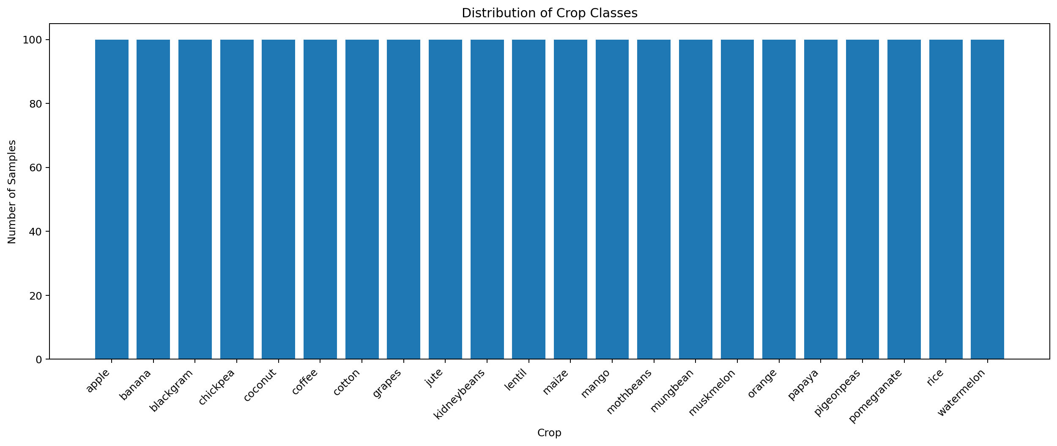

C.4 Correlation Heatmap
The heatmap shows pairwise correlations among the seven numerical input features.
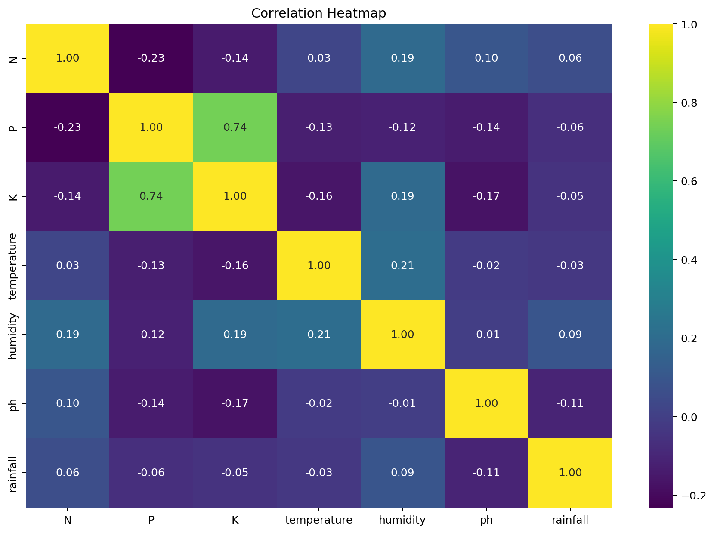

C.5 Feature Distribution Histograms
The histograms show the distributions of nitrogen, phosphorus, potassium, temperature, humidity, pH, and rainfall.
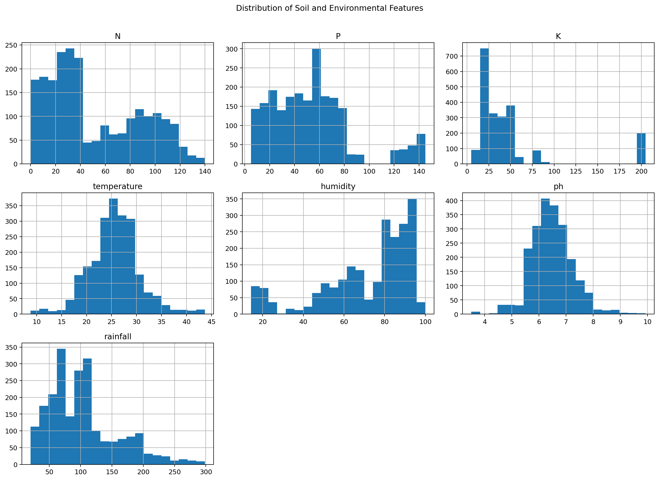

C.6 Box Plot of Numerical Features
The box plot summarizes feature spread and highlights potential outlying values.
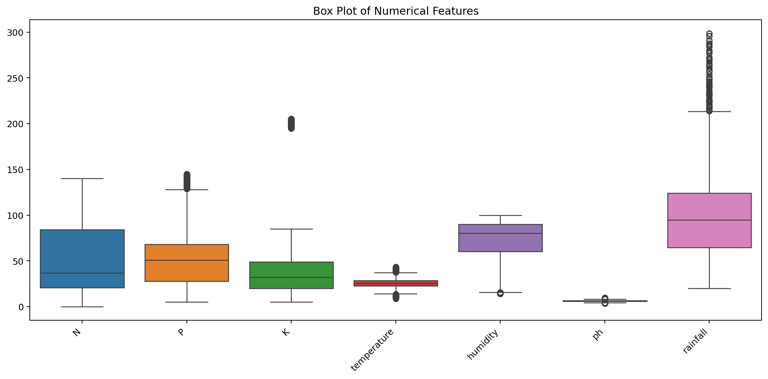

C.7 Confusion Matrix
Rows represent actual crop labels and columns represent predicted labels; diagonal counts indicate correct predictions.
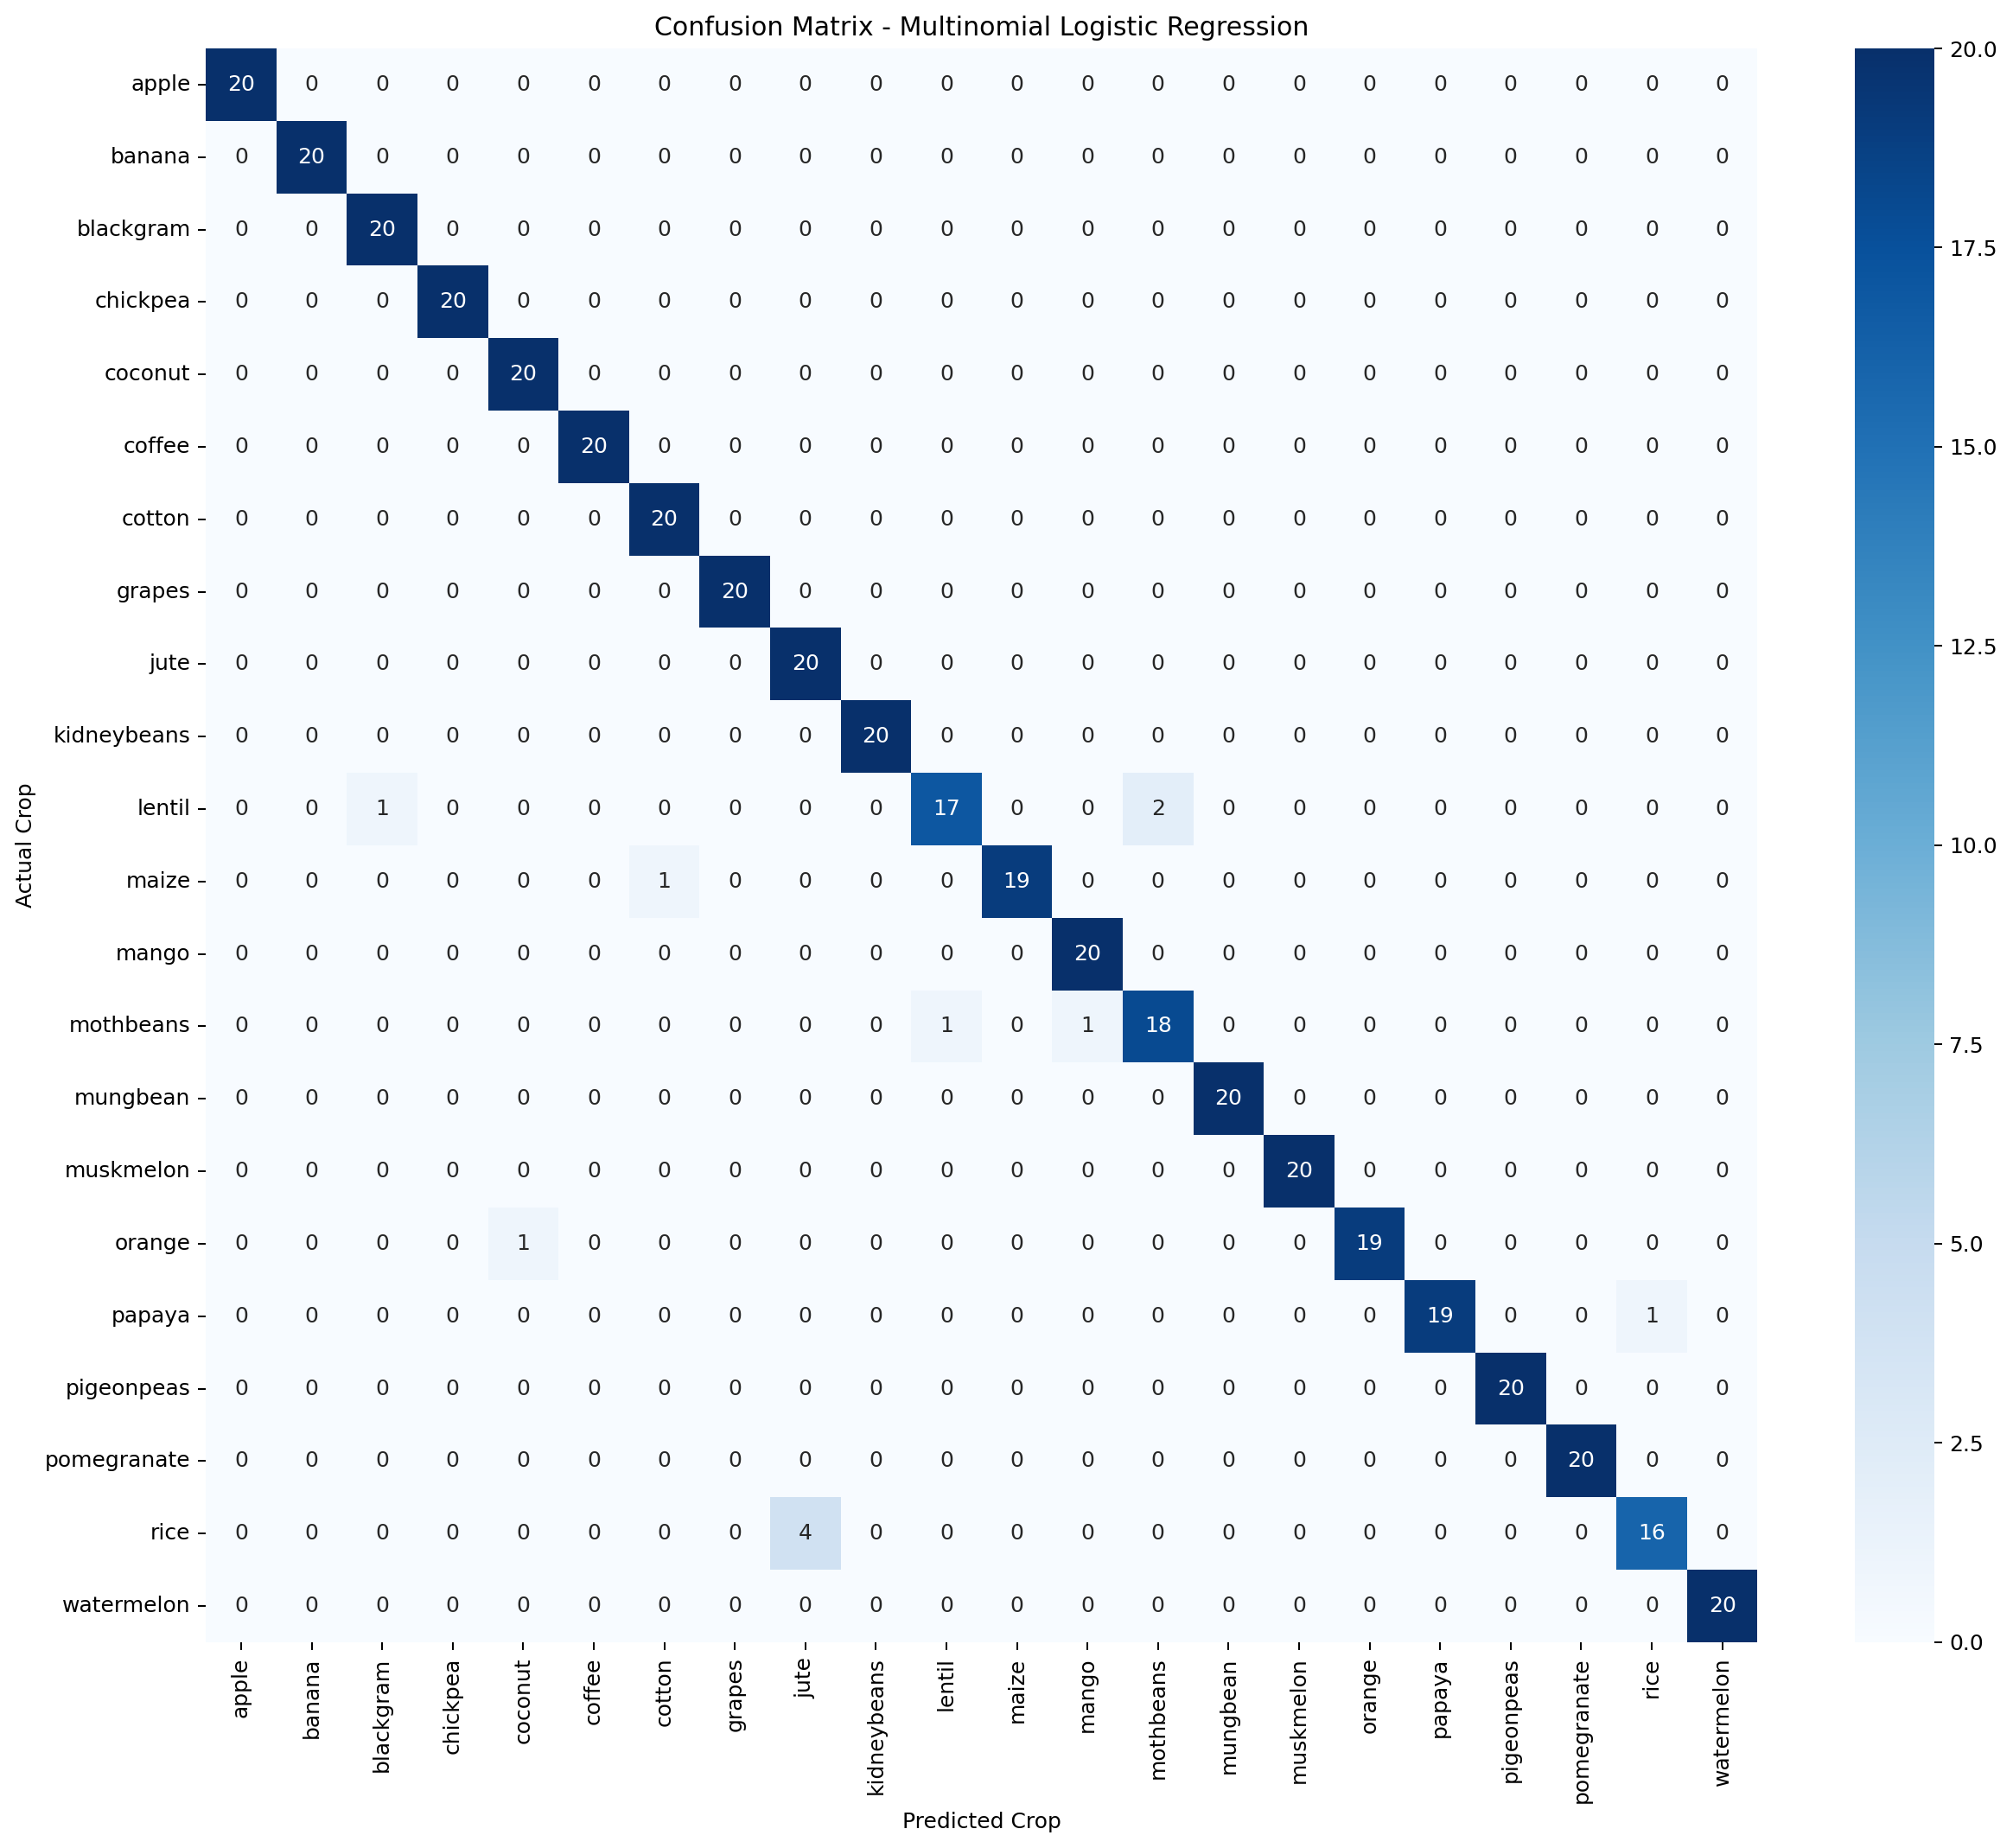

C.8 Classification Report
precision recall f1-score support
apple 1.000 1.000 1.000 20
banana 1.000 1.000 1.000 20
blackgram 0.952 1.000 0.976 20
chickpea 1.000 1.000 1.000 20
coconut 0.952 1.000 0.976 20
coffee 1.000 1.000 1.000 20
cotton 0.952 1.000 0.976 20
grapes 1.000 1.000 1.000 20
jute 0.833 1.000 0.909 20
kidneybeans 1.000 1.000 1.000 20
lentil 0.944 0.850 0.895 20
maize 1.000 0.950 0.974 20
mango 0.952 1.000 0.976 20
mothbeans 0.900 0.900 0.900 20
mungbean 1.000 1.000 1.000 20
muskmelon 1.000 1.000 1.000 20
orange 1.000 0.950 0.974 20
papaya 1.000 0.950 0.974 20
pigeonpeas 1.000 1.000 1.000 20
pomegranate 1.000 1.000 1.000 20
rice 0.941 0.800 0.865 20
watermelon 1.000 1.000 1.000 20
accuracy 0.973 440
macro avg 0.974 0.973 0.972 440
weighted avg 0.974 0.973 0.972 440

