WEEK-2
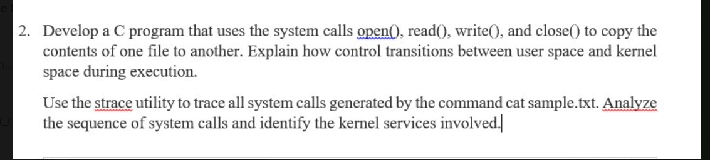

CODE:
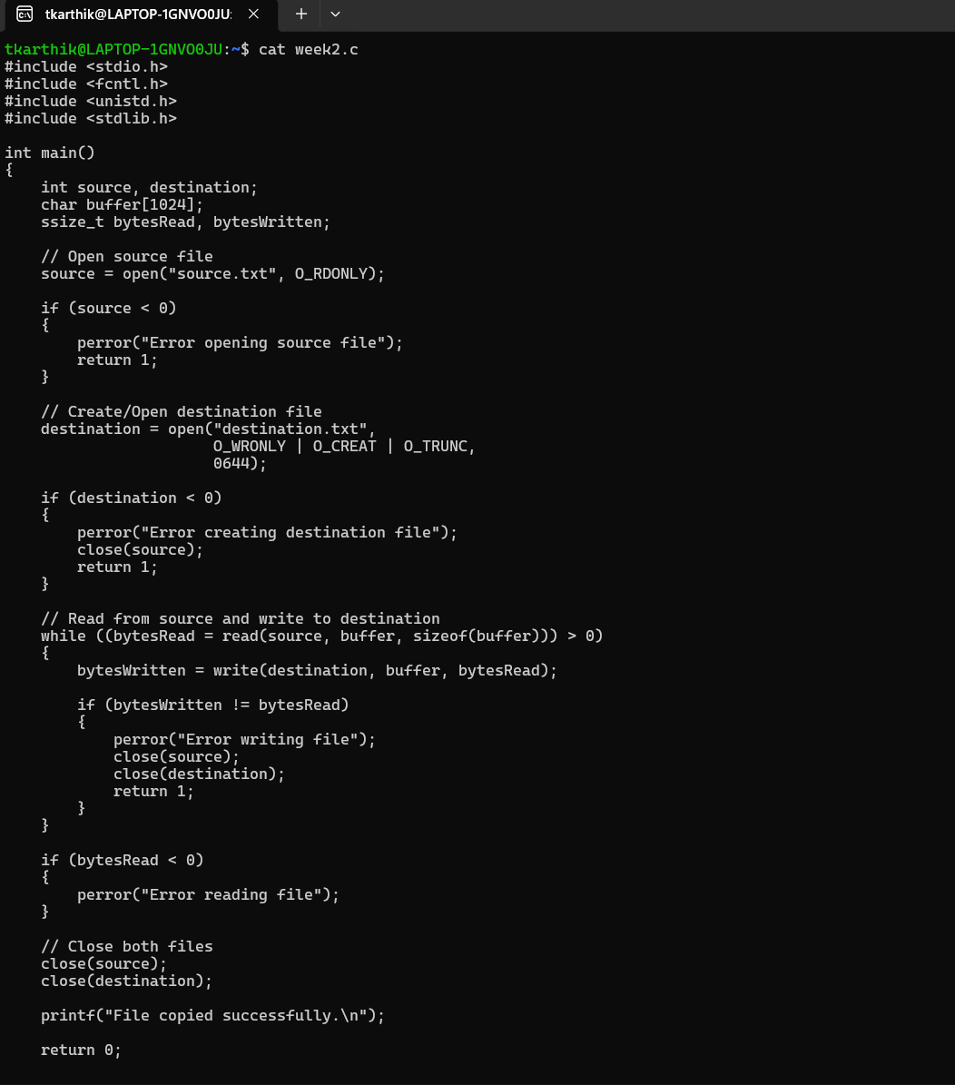
OUTPUT:
