WEEK-1
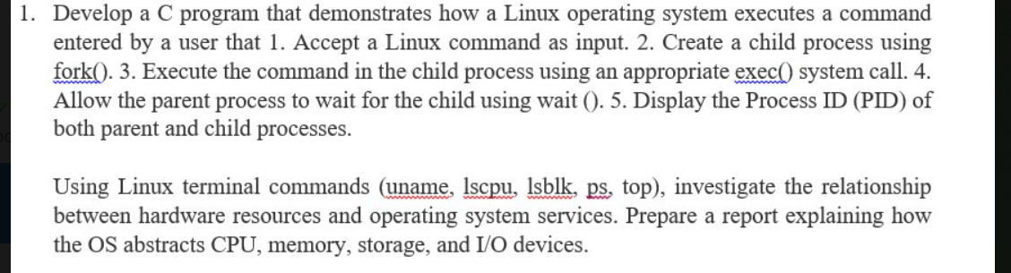

CODE:
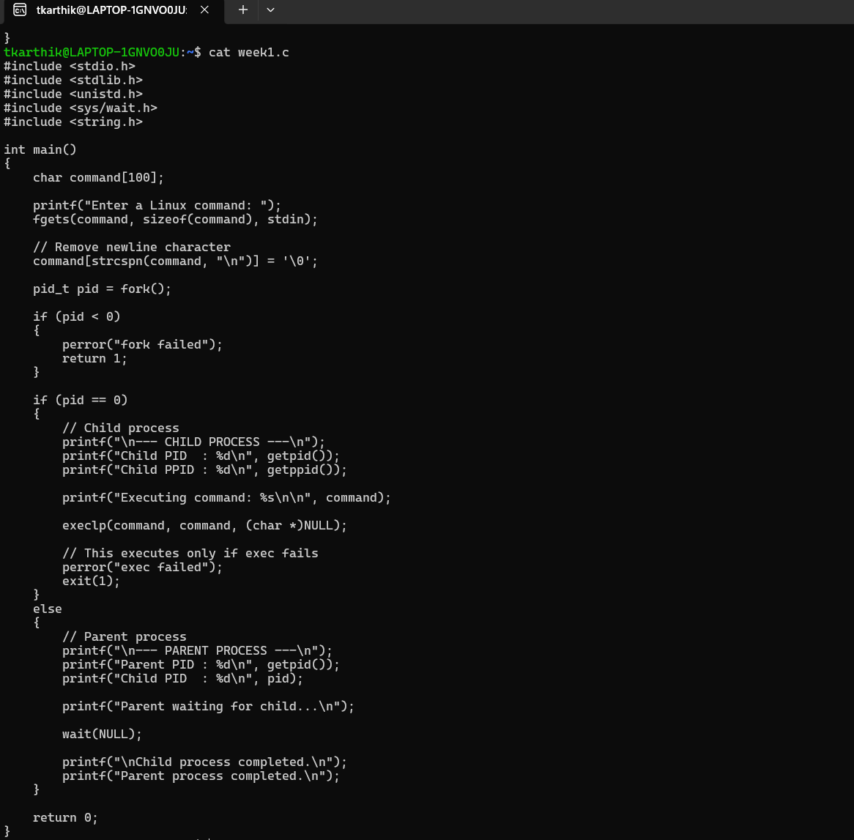

OUTPUT:
