Phishing Email Detection & Awareness Report
Task 2 – Future Interns Cyber Security Internship
Prepared By: Karthik Tangalapalli
Repository Name: FUTURE_CS_02

Objective
This report analyzes sample emails to identify phishing indicators and classify emails as Safe, Suspicious, or Phishing.

Email Analysis

Email 1: Dropbox Storage Email
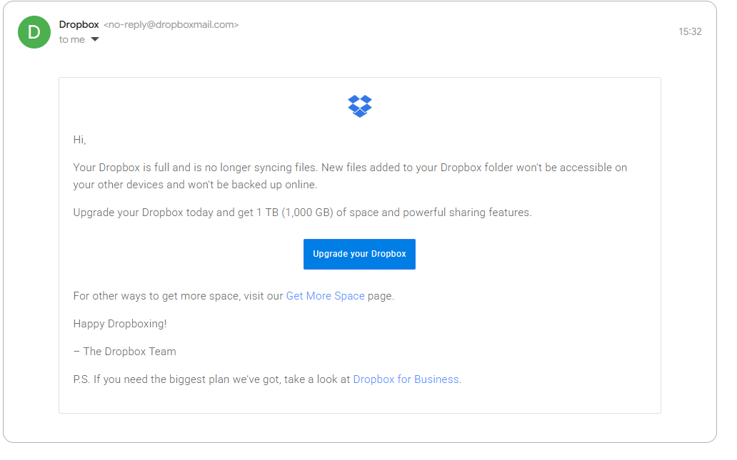
Classification | Safe
Indicators | Legitimate sender domain (dropboxmail.com), professional branding, and no obvious phishing indicators.
Risk Level | Low
Recommendation | Verify sender email, avoid suspicious links, and enable MFA.

Email 2: Fake Document Share Email
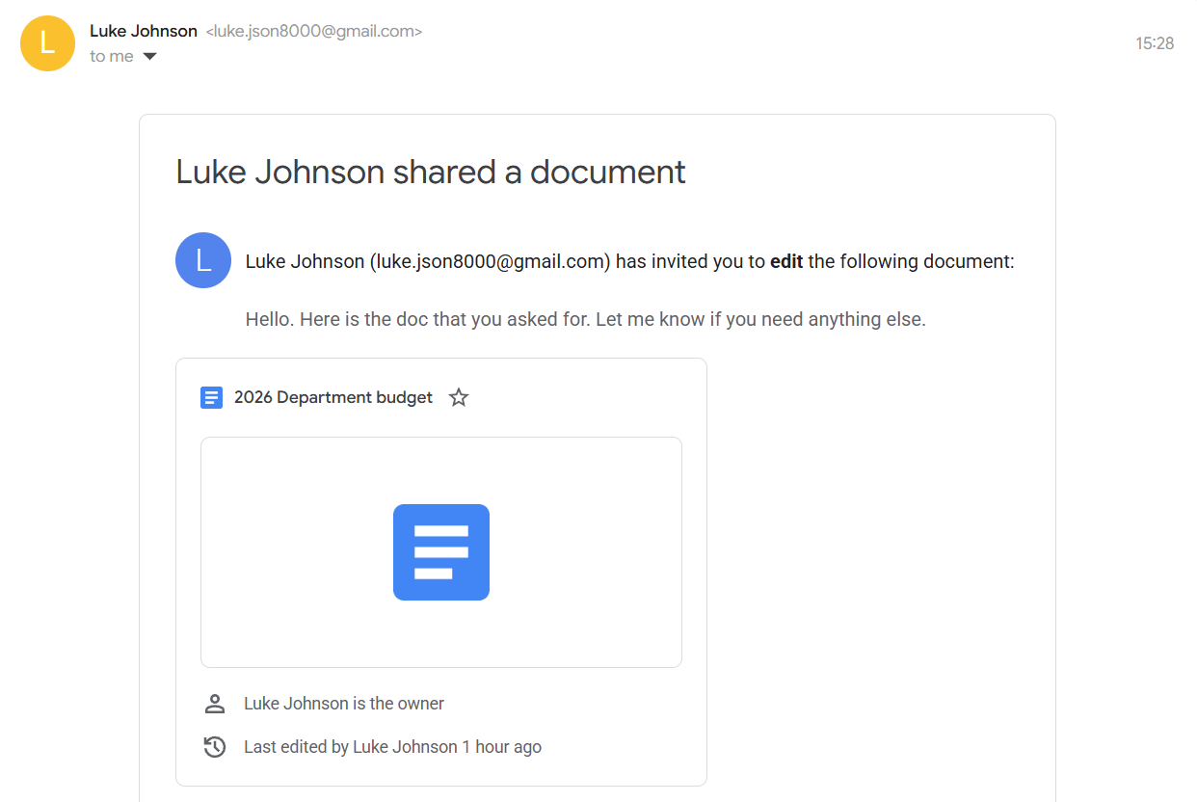
Classification | Phishing
Indicators | Unknown Gmail sender pretending to share a document to trick users into clicking malicious links.
Risk Level | High
Recommendation | Verify sender email, avoid suspicious links, and enable MFA.

Email 3: Fake Coca-Cola Prize Email
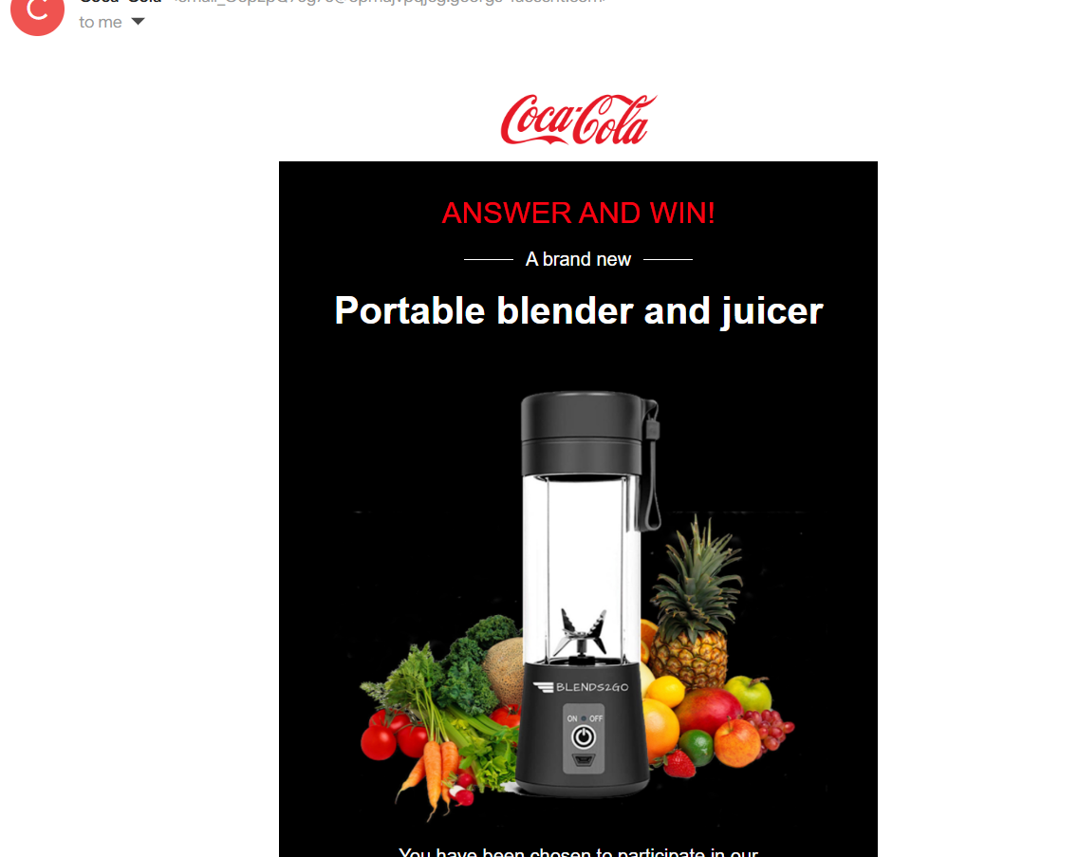
Classification | Phishing
Indicators | Uses reward/prize scam and brand impersonation to manipulate users.
Risk Level | High
Recommendation | Verify sender email, avoid suspicious links, and enable MFA.

Email 4: Fake PayPal Invoice Email
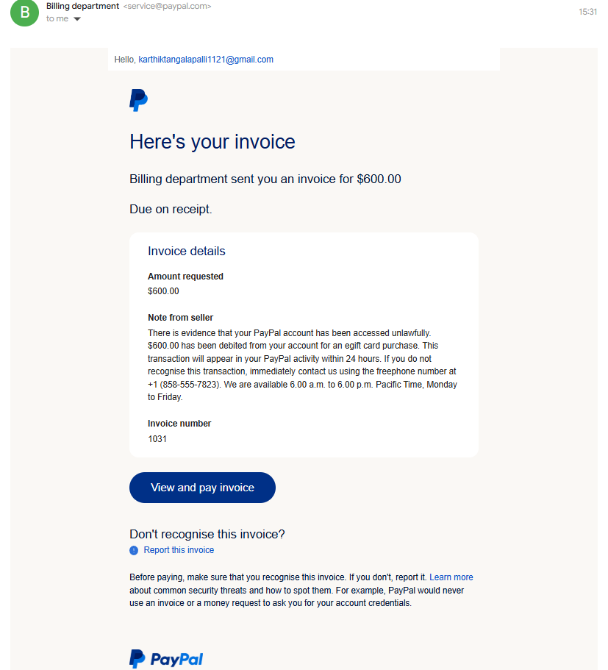
Classification | Phishing
Indicators | Creates panic using fake invoice/payment warning and suspicious payment action.
Risk Level | High
Recommendation | Verify sender email, avoid suspicious links, and enable MFA.

Awareness Guidelines
1. Verify sender email addresses.
2. Do not click unknown links.
3. Avoid suspicious attachments.
4. Enable MFA.
5. Verify urgent payment/account alerts.

Conclusion
The analysis identified phishing techniques including impersonation, urgency, and fake invoices. Users should carefully inspect emails before interacting.

