Helmet and Triple Ride Detection Using CNN and YOLO

L .Lakshmi Vagdevi
Department of ECE
Institute of Aeronautical Engineering
Hyderabad, India
22951A0478@iare.ac.in

G. Krishna Sri Mohan
Department of ECE
Institute of Aeronautical Engineering
Hyderabad, India
22951A0477@iare.ac.in

Tatineni Karthik Sai
Department of ECE
Institute of Aeronautical Engineering
Hyderabad, India
22951A0472@iare.ac.in

Ms. B.Veena
Department of ECE
Institute of Aeronautical Engineering
Hyderabad, India
b.veena@iare.ac.in

Abstract--Developing countries have always relied on motorcycles as their primary mode of transportation, but unfortunately, the number of motorcycle accidents has been on the rise in recent years. One of the leading causes of fatalities in these accidents is the lack of helmet usage by motorcyclists. To ensure that motorcyclists wear helmets, traditional methods include manual monitoring by traffic police at intersections or the use of CCTV footage to identify those not wearing a helmet. However, these methods require significant human effort and intervention This system proposes an automated approach to identify non-helmeted motorcyclists and retrieve their license plate information from CCTV footage. The system first differentiates moving objects as motorcycles or non-motorcycles. For classified motorcyclists, the system identifies whether they are wearing helmets or not. If the motorcyclist is not wearing a helmet, the system extracts the license plate number using an OCR algorithm. We used CNN and YOLO

Algorithm to identify the no helmet condition and triple ride condition. Automatic detection of safety helmet wearing is significant in ensuring safe production. However, the accuracy of safety helmet detection can be challenged by various factors, such as complex environments, poor lighting conditions and small-sized targets. This paper presents a novel and efficient deep learning framework named High-Resolution You Only Look Once (HR-YOLO) for safety helmet wearing detection. The proposed framework synthesizes safety helmet wearing information from the features of helmet objects and human pose. HR-YOLO can use features from two branches to make the bounding box of suppression predictions more accurate for small targets.
Index Terms-- safety helmet, Convolutional Neural Network, YOLO, Signal Processing

- INTRODUCTION
The aims for projects related to Helmet Detection and Number Plate Recognition typically involve developing computer vision systems to enhance safety, security, and compliance in various scenarios.

To leverage computer vision and machine learning techniques to improve safety, security, and operational efficiency in diverse settings, requiring a focus on accuracy, real-time performance, adaptability, and seamless integration with existing systems.
The scope of study for Helmet Detection and Number Plate Recognition involves various aspects related to computer vision, machine learning, and application development. The scope of study for Helmet Detection and Number Plate Recognition involves various aspects related to computer vision, machine learning, and application development. The scope of study for Helmet Detection and Number Plate Recognition involves various aspects related to computer vision, machine learning, and application development.
In many countries, wearing helmets while riding motorcycles is mandatory by law to ensure the safety of the riders. Currently, the responsibility of monitoring helmet usage falls on the police force. However, due to the limitations of human senses and insufficient police force, this method has proven to be inefficient. CCTV surveillance-based methods are also used in major cities, but they require human assistance and are not automated. As the number of motorcycles on the road increases and concern for human safety grows, research in the domain of road transport has also increased.
This paper proposes a system that automates the monitoring of motorcyclists by detecting those not wearing helmets and retrieving their license plate numbers in real time from CCTV camera videos at road junctions using machine learning. The problem of increasing road accidents in India has become a major concern, with a high number deaths caused by head injuries due to a significant portion of the population not wearing helmets. To address this issue, an automated system is needed to detect individuals not wearing helmets and identify the license plates of the motorcycles to penalize the offenders.
Caused by head injuries due to a significant portion of the population not wearing helmets. To address this issue, an automated system is needed to detect individuals not wearing helmets and identify the license plates of the motorcycles to penalize the offenders.
The use of machine learning in transportation systems has become increasingly popular in recent years. Automated systems that detect helmet usage and license plates on motor cycles are just one example of how technology can improve road safety. In addition to improving enforcement, such systems can also provide valuable data for policy makers to make informed decisions about road safety regulations. However, there are some challenges in implementing such systems.
For instance, the accuracy of license plate recognition algorithms can be affected by factors such as lighting conditions, weather, and the distance between the camera and the vehicle. In addition, the implementation of such systems requires significant investment in terms of infrastructure and manpower. Therefore, it is essential to carefully evaluate the feasibility of such systems and their potential impact on road safety. Despite these challenges, the use of machine learning and other advanced technologies has the potential to revolutionize road safety in developing countries.
By improving enforcement and providing valuable data for policymakers, such systems can help reduce the number of deaths and injuries caused by motorcycle accidents. With continued research and development, these systems may become an integral part of transportation systems around the world, makingroads safer for everyone.
Motorcycle Accidents have been rapidly growing throughout the years in many countries. The helmet is the main safety equipment of motorcyclists. However, many drivers do not use it. The main goal of helmet is to protect the drivers head in case of an accident.

II. LITERATURE
A. Image Descriptors and Classifiers
Motorcycle accidents have been rapidly growing throughout the years in many countries. Due to various social and economic factors, this type of vehicle is becoming increasingly popular. The helmet is the main safety equipment of motorcyclists, however many drivers do not use it. The main goal of helmet is to protect the drivers head in case of accident. In case of accident, if the motorcyclist does not use can be fatal. This paper aims to propose a system for detection of motorcyclist without helmet. For this, we have applied the circular Hough transform and the Histogram of Oriented Gradients descriptor to extract the image attributes.
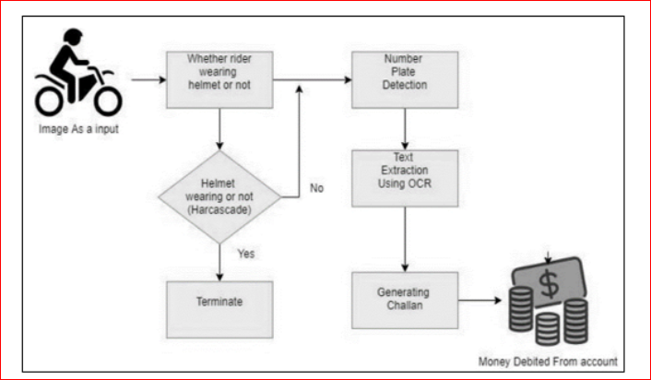
Fig 1. System Architecture

Then, the Multilayer Perceptron classifier was used and the obtained results were compared with others algorithms. Traffic images were captured by cameras from public roads and constitute a database of 255 images. Indeed, the algorithm step regarding the helmet detection accomplished an accuracy rate of 91.37%.

B. Image processing and machine learning
Safety helmet wearing detection is very essential in power substation. This paper proposed a innovative and practical safety helmet wearing detection method based on image processing and machine learning. At first, the ViBe background modelling algorithm is exploited to detect motion object under a view of fix surveillant camera in power substation. After obtaining the motion region of interest, the Histogram of Oriented Gradient (HOG) feature is extracted to describe inner human. And then, based on the result of HOG feature extraction, the Support Vector Machine (SVM) is trained to classify pedestrians. Finally, the safety helmet detection will be implemented by colour feature recognition.

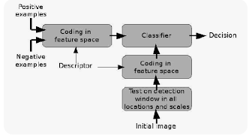
Fig 2. Classification of image

Compelling experimental results demonstrated the correctness and effectiveness of our proposed method. Over the past decades, increasing accidents in power substation has raised many attention for safety monitor.

In order to ensure the safe operation of power equipment, more and more intelligent surveillance systems had been developed based on computer vision or image processing. This measure can not only address the problem of labour monitor, but also highlight the unsafe operation to avoid unexpected accidents. Safety helmet wearing detection is a very common and crucial task for surveillance in power substation.

C.ImageNet Classification with Deep Convolutional Neural Networks
We trained a large, deep convolutional neural network to classify the 1.2 million high-resolution images in the ImageNet LSVRC-2010 contest into the 1000 different classes. On the test data, we achieved top-1 and top-5 error rates of 37.5% and 17.0% which is considerably better than the previous state-of-the-art. The neural network, which has 60 million parameters and 650,000 neurons, consists of five convolutional layers, some of which are followed by max-pooling layers, and three fully-connected layers with a final 1000-way softmax.
To make training faster, we used non-saturating neurons and a very efficient GPU implementation of the convolution operation. To reduce overfitting in the fully-connected layers we employed a recently-developed regularization method called “dropout” that proved to be very effective. We also entered a variant of this model in the ILSVRC-2012 competition and achieved a winning top-5 test error rate of 15.3%, compared to 26.2% achieved by the second-best entry

D. Densely Connected Convolutional Networks
Recent work has shown that convolutional networks can be substantially deeper, more accurate, and efficient to train if they contain shorter connections between layers close to the input and those close to the output. In this paper, we embrace this observation and introduce the Dense Convolutional Network (DenseNet), which connects each layer to every other layer in a feed-forward fashion. Whereas traditional convolutional networks with L layers have L connections-one between each layer and its subsequent layer-our network has L(L+1)/2 direct connections. For each layer, the feature-maps of all preceding layers are used as inputs, and its own feature-maps are used as inputs into all subsequent layers.
DenseNets have several compelling advantages: they alleviate the vanishing-gradient problem, strengthen feature propagation, encourage feature reuse, and substantially reduce the number of parameters. We evaluate our proposed architecture on four highly competitive object recognition benchmark tasks (CIFAR-10, CIFAR-100, SVHN, and ImageNet).

E. Challenges and Future Directions
We propose two novel model architectures for computing continuous vector representations of words from very large data sets. The quality of these representations is measured in a word similarity task, and the results are compared to the previously best performing techniques based on different types of neural networks.
We observe large improvements in accuracy at much lower computational cost, i.e. it takes less than a day to learn high quality word vectors from a 1.6 billion words data set. Furthermore, we show that these vectors provide state-of-the-art performance on our test set for measuring syntactic and semantic word similarities.
III.Methodology

- YOLOV5 Model

In this project we have used YoloV5 model to detect bike and helmet from images and then we tried various text reading techniques to read or recognize number plates but no algorithm or technique exists to read number plate accurately. So to read number we have utilized deep learning algorithm which will get trained on all available bikes and its number and then model will analyse bike in test images and then predict number plate.
To implement this project we have designed following modules
- Load Yolo Model: using this module we will load helmet and plate recognition model to application and then calculate model prediction accuracy on test images
- Upload Image: using this module we will upload test image to application
- Detect Motor Bike & Person: this module will apply YOLO model on input image to detect bike and person
- Detect Helmet: if bike and person detected in input image then application will detect helmet and if helmet not detected then plate detection model will predict recognise number plate.

2. System Overview
The proposed system consists of two main components: helmet detection and number plate recognition. It leverages the YOLOv5 algorithm, which is a state-of-the-art object detection framework known for its high accuracy and efficiency. By combining advanced computer vision techniques and machine learning algorithms, the system can effectively detect helmets and extract number plate information from video frames.
- Helmet Detection: The helmet detection component utilizes the YOLOv5 model, which has been fine-tuned using a diverse dataset of annotated images and videos. Through this process, the model has learned to identify and localize helmets in real-world scenarios. The YOLOv5 algorithm performs inference on video frames, predicting bounding boxes around detected helmets. Non-maximum suppression (NMS) is then applied to eliminate redundant detections and enhance the accuracy of the helmet detection process.

- Number Plate Recognition: Building upon the helmet detection results, the number plate recognition component extracts regions of interest (ROIs) corresponding to the detected number plates. Pre-processing techniques, including noise reduction, contrast adjustment, and thresholding, are applied to enhance the quality and readability of the number plate regions. Optical character recognition (OCR) algorithms are then employed to recognize and extract alphanumeric characters from the pre-processed number plate regions.

3. Processing of detection
- for detecting motorcyclists who are not wearing helmets from CCTV video

- Used for traffic management, security, and law enforcement

- Helmet detection helps promote road safety by ensuring that motorcyclists and scooter riders wear helmets, reducing the risk of head injuries in accidents.
Number plate recognition aids in monitoring traffic flow, identifying traffic violations, and managing congestion.
Load Yolo Model
Upload image
Detect motor bike and person
Detect helmet

Fig 3.Flow chart

4. UML Diagrams

Service Provider
Load the yolo model
Upload image
Detect the person with and without helmet
Detect person with person in image
If person without helmet then send email to him

Fig 4.USE CASE DIAGRAM

5. Sequence diagram
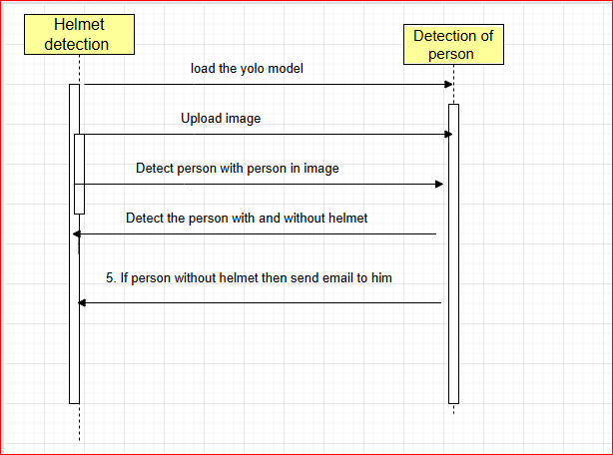

Fig 5.Sequence diagram

6. Class Diagram

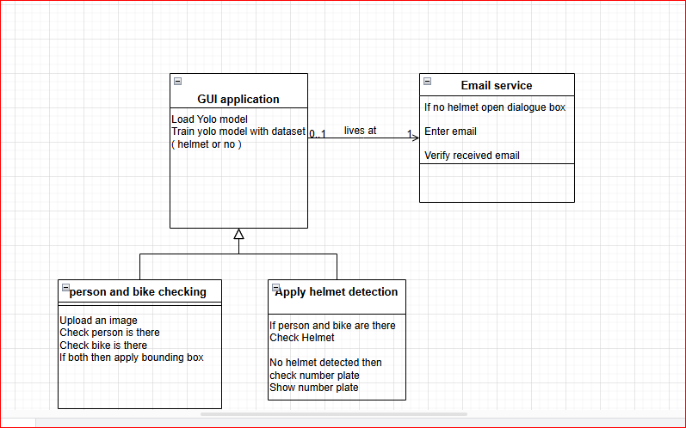

Fig 6. Class diagram

IV. Technologies Used

The proposed system for automatic helmet and triple ride detection employs state-of-the-art computer vision and deep learning technologies. The primary components of the system include a real-time object detection model, a classification model, and a post-processing logic unit for violation detection.
- YOLO (You Only Look Once) for Object Detection is a real-time object detection algorithm that performs both object localization and classification in a single neural network pass. The model divides the input image into a grid and predicts bounding boxes along with class probabilities for each cell. This architecture significantly enhances inference speed, making it suitable for real-time traffic surveillance applications.
In this system, YOLO is trained to detect the following classes:
- Person
- Motorcycle
- Helmet
The detection output provides the spatial coordinates and class of each object in the frame. Based on the spatial proximity between detected persons and motorcycles, the system determines the number of riders per motorcycle. Furthermore, by analyzing the spatial overlap between helmet and person bounding boxes, the presence or absence of helmets is inferred. YOLOv5 and YOLOv8 are preferred due to their balance of accuracy and speed, and their compatibility with transfer learning using pre-trained COCO weights.

- Convolutional Neural Networks (CNNs) are optionally employed for helmet classification tasks, especially in cases where helmet detection is ambiguous due to occlusion, small size, or complex backgrounds.
Detected head regions (cropped from the person bounding box) are input to a CNN model trained to classify images as either:
- Helmet
- No Helmet
CNNs extract hierarchical features from the input images using convolutional layers, pooling layers, and fully connected layers. This allows the model to learn discriminative features for distinguishing between helmeted and non-helmeted riders. Common frameworks used for CNN implementation include Tensor Flow/Keras and Torch.
- Real-Time Video Processing and Post-Processing Logic
OpenCV is employed for video stream handling and frame processing. Each video frame is passed to the detection model, and bounding boxes are drawn around detected objects. The post-processing module performs the following operations:
- Person–Motorcycle Association: Based on overlapping bounding boxes or proximity, persons are assigned to motorcycles.
- Triple Ride Detection: If more than two persons are associated with a single motorcycle, a triple riding violation is flagged.
- Helmet Detection: For each detected person, the presence of a nearby helmet bounding box is evaluated. In the absence of a detected helmet, or based on CNN classification results, a helmet violation is recorded.
V. RESULTS AND DUSCUSSIONS

To run project double click on ‘run.bat’ file to get below output

 Fig.7 ‘Load YOLO Model’

In above screen click on ‘Load YOLO Model’ button to load model and get below output


Fig.8 model is loaded
In above screen model is loaded and its prediction accuracy is 95% and now click on ‘Upload Image’ button to upload image

Fig 9 selecting and uploading ‘1.jpg’ image

In above screen selecting and uploading ‘1.jpg’ image and then click on ‘Open’ button to load image and then click on ‘Detect Motor Bike & Person’ button to get below output
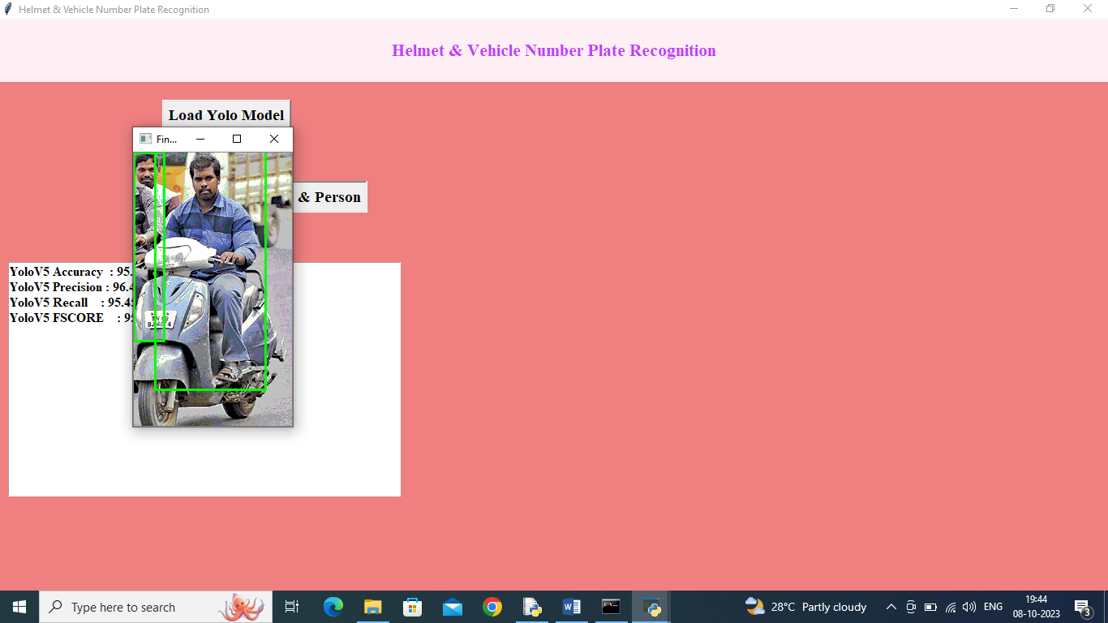
Fig.10 person and motor bike detected
In above screen person and motor bike detected and then close image and then click on ‘Detect Helmet’ button to get below output
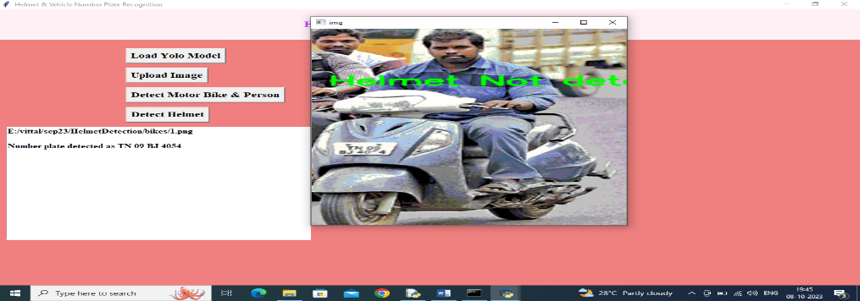
Fig.11 Helmet Not Detected
In above screen in green colour text we can see ‘Helmet Not Detected’ and then in text area we can see predicted number from the plate and now will test with other image
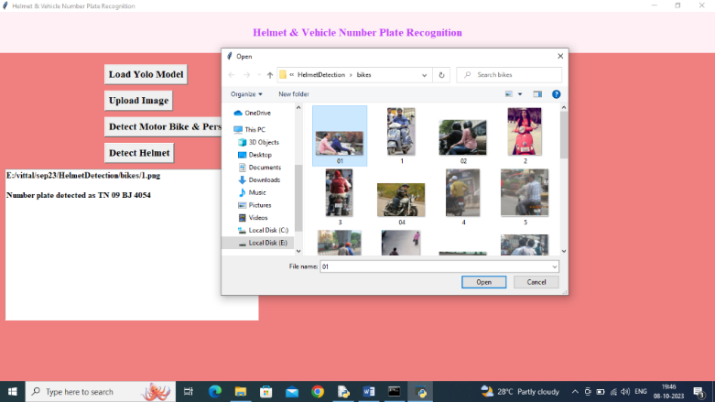
Fig.13 selecting and uploading ’01.jpg’ file
In above screen selecting and uploading ’01.jpg’ file and then click on ‘Open’ button and then click on ‘Detect Motor Bike & Person’ button to get below output
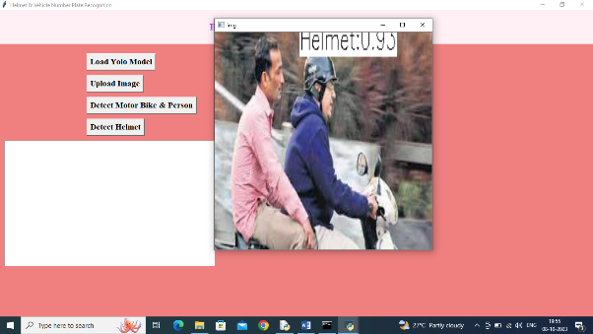
Fig.14 person and bike detected
In above screen person and bike detected and then click on ‘Detect Helmet’ button to get below output.

Fig.15 application detected Helmet
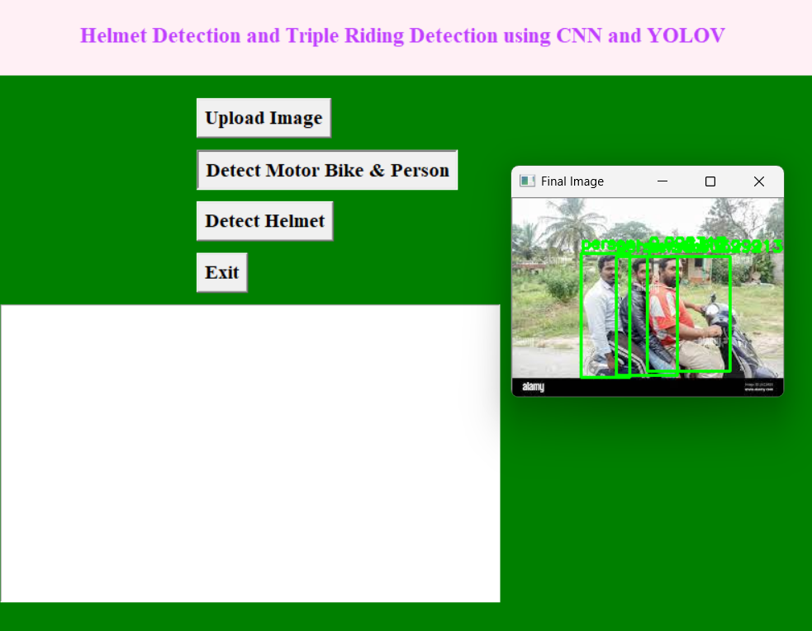
Fig.16 application detected triple riding
In above screen application detected Helmet so it will not recognize number. Similarly you can upload and test other images.
If you want to recognize other number plate then we need to train model with all new images and then you can test them
When helmet not detected then application will display dialog box to enter EMAIL ID and then email will be sent to given email id. Along with email I am writing all details inside ‘detected.txt’.
In above screen user has to enter email id and then press OK button to get below page



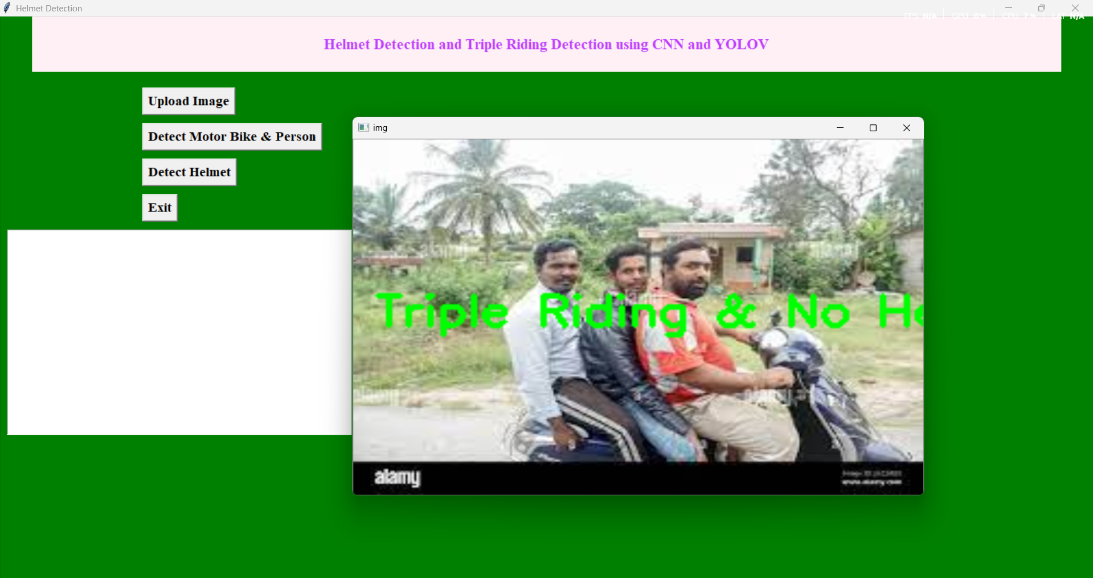
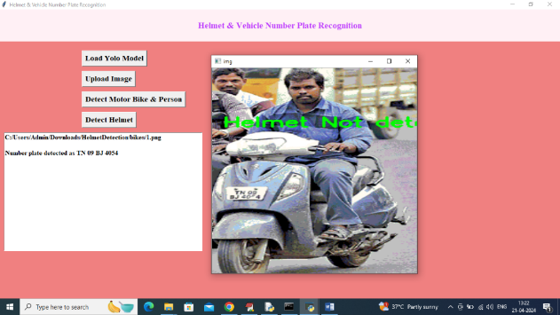
In above screen helmet not detected and triple riding detected so will get below email


In above screen got email along with number plate and similarly you can see details writing to detected.txt file

In above screen details written to file also, Similarly you can test will all image
VI. Conclusion

In summary, this project has proposed a framework for detecting motorcyclists who are not wearing helmets from CCTV video and retrieving their vehicle license number plates automatically. Using Convolutional Neural Networks (CNNs) and transfer learning, the system achieves high accuracy in identifying helmetless riders. However, the framework goes beyond just detecting these riders, as it also recognizes and stores the license plate numbers of their motorcycles. By storing the license plate numbers, the framework provides a means of identifying and penalizing riders who violate helmet laws. This comprehensive approach makes the system an effective tool for promoting road safety. The implementation of this framework can have a significant impact on road safety, especially since it can be integrated with existing CCTV networks. Furthermore, the use of transfer learning makes the system adaptable to different environments, making it a scalable solution that can be used in various locations. Overall, this project demonstrates the potential of using AI and machine learning to improve road safety. By providing a comprehensive solution for detecting helmetless riders and identifying their vehicles, this framework has the potential to reduce accidents and save lives

VII. Future Scope

6.1 Integration with License Plate Recognition
Future systems can incorporate Automatic License Plate Recognition (ALPR) to associate violations with vehicle registration details. This would enable automated issuance of fines or warning notices and integration with existing traffic enforcement databases for better legal compliance and accountability.

6.2 Enhanced Helmet Classification
While the current system classifies helmet usage in a binary manner (helmet/no helmet), future developments may involve:
- Helmet quality assessment (e.g., proper fastening, standard vs. non-standard helmets).
- Full-face vs. half-helmet classification, to comply with specific regulatory standards.
Advanced CNN architectures or attention-based models may improve the granularity and accuracy of helmet classification.

6.3 Improved Person-Motorcycle Association
In high-traffic scenarios or occluded views, associating multiple persons with a specific motorcycle can be challenging. Future work can explore:
- Pose estimation (e.g., Open Pose or Media Pipe) to identify riding posture.
- Trajectory tracking using multi-object tracking (MOT) algorithms for better temporal association of riders and vehicles.

6.4 Night and Low-Visibility Detection
YOLO-based models often struggle under poor lighting conditions. Incorporating:
- Infrared camera input
- Low-light image enhancement models
- Thermal imaging integration
...can significantly improve detection accuracy during night time or foggy conditions.

6.5 Cross-City and Multilingual Deployment
To make the system deployable at a national or international level, future systems can be designed to:
- Adapt to regional variations in traffic rules and helmet types.
- Support multi-language alerts and dashboards for local enforcement agencies.

6.6 Edge AI Optimization
For real-world deployment in urban surveillance networks, models need to be optimized for low-latency and low-power devices. Future work can focus on:
- Model compression techniques such as pruning and quantization.
- Deployment on microcontrollers with AI accelerators (e.g., Google Coral, NVIDIA Jetson).
- Federated learning for on-device training updates without sharing raw data.

6.7 Violation Prediction and Risk Analysis
With the accumulation of historical detection data, future systems could use predictive analytics and machine learning to:
- Identify accident-prone zones based on frequent violations.
- Forecast traffic risks based on helmet and ride behaviour patterns.
- Recommend targeted awareness campaigns in specific areas

VIII. References

[1] R. R. V. e. Silva, K. R. T. Aires and R. d. M. S. Veras, “Helmet Detection on Motorcyclists Using Image Descriptors and Classifiers,” 2014 27th SIBGRAPI Conference on Graphics, Patterns and Images, Rio de Janeiro, 2014, pp. 141- 148.
[2] Li, J., Liu, H., Wang, T., Jiang, M., Wang, S., Li, K., Zhao, X. (2017, February). Safety helmet wearing detection based on image processing and machine learning. In Advanced Computational Intelligence (ICACI), 2017 Ninth International Conference on (pp. 201-205). IEEE.
[3] K. Dahiya, D. Singh and C. K. Mohan “Automatic detection of bike-riders without helmet using surveillance videos in real-time,” 2016 International Joint Conference on Neural Networks (IJCNN), Vancouver, BC, 2016, pp. 3046- 3051
[4] C. Vishnu, D. Singh, C. K. Mohan and S. Babu, “Detection of motorcyclists without helmet in videos using convolutional neural network,” 2017 International Joint Conference on Neural Networks (IJCNN), Anchorage, AK, 2017, pp. 3036- 3041.
[5] Adrian Rosebrock, “Basic motion detection and tracking with Python and OpenCV”.https://www.pyimagesearch.com/2015/05/25/basicmotiondetectionandtracking-with-python-and-open.
[6] J. Deng, W. Dong, R. Socher, L. Li, K. Li, and L. Fei-Fei, \"ImageNet: A Large-Scale Hierarchical Image Database,\" in IEEE Conference on Computer Vision and Pattern Recognition, 2009.
[7] A. Krizhevsky, I. Sutskever, and G. Hinton, \"ImageNet Classification with Deep Convolutional Neural Networks,\" in Advances in Neural Information Processing Systems, 2012.
[8] Y. LeCun, Y. Bengio, and G. Hinton, \"Deep Learning,\" in Nature, 2015.
[9] G. Huang, Z. Liu, K. Q. Weinberger, and L. van der Maaten, \"Densely Connected Convolutional Networks,\" in IEEE Conference on Computer Vision and Pattern Recognition, 2017.
[10] T. Mikolov, K. Chen, G. Corrado, and J. Dean, \"Efficient Estimation of Word Representations in Vector Space,\" in Proceedings of the International Conference on Learning Representations, 2013
[11] A. Rajkomar, E. Oren, K. Chen, et al., \"Scalable and Accurate Deep Learning for Electronic Health Records,\" in npj Digital Medicine, 2018.
[12] Detection of helmets on motorcyclists. By Remuera R.V.e Silva, Kelson R.T. Aires, Rodrigo de M. S. Veras
[13] Helmet Detection using Machine Learning and Automatic License Plate Recognition. By Lokesh Allamki, Manjunath Panchakshari, Ashish Sateesha, K S Pratheek(BNMIT, Bangalore)
[14] Detecting motorcycle helmet use with deep learning. By Felix Wilhelm Sieberta, Hanhe Lin (Department of Psychology and Ergonomics, Technische Universit¨at Berlin, Marchstraße 12, 10587 Berlin Germany).
[15] A Hybrid Approach for Helmet Detection for Riders Safety using Image Processing, Machine Learning, Artificial Intelligence. By M.Swapna, Tahniyath Wajeeh, Shaziya Jabeen.
[16] C. Vishnu, Dinesh Singh, C. Krishna Mohan and Sobhan Babu Visual Intelligence and Learning Group (VIGIL), Department of Computer Science and Engineering Indian Institute of Technology Hyderabad, Kandi, Sangareddy-502285, India
[17] R. R. V. e. Silva, K. R. T. Aires and R. d. M. S. Veras, "Helmet Detection on Motorcyclists Using Image Descriptors and Classifiers," 2014 27th SIBGRAPI Conference on Graphics, Patterns and Images, Rio de Janeiro, 2014, pp. 141-148.
[18] P. Doungmala and K. Klubsuwan, "Helmet Wearing Detection in Thailand Using Haar Like Feature and Circle Hough Transform on Image Processing," 2016 IEEE International Conference on Computer and Information Technology (CIT), Nadi, 2016, pp. 611-614.
[19] Li, J., Liu, H., Wang, T., Jiang, M., Wang, S., Li, K., & Zhao, X. (2017, February). Safety helmet wearing detection based on image processing and machine learning. In Advanced Computational Intelligence (ICACI), 2017 Ninth International Conference on (pp. 201-205). IEEE.
[20] K. Dahiya, D. Singh and C. K. Mohan, "Automatic detection of bike-riders without helmet using surveillance videos in realtime," 2016 International Joint Conference on Neural Networks (IJCNN), Vancouver, BC, 2016, pp. 3046-3051.
[21] C. Vishnu, D. Singh, C. K. Mohan and S. Babu, "Detection of motorcyclists without helmet in videos using convolutional neural network," 2017 International Joint Conference on Neural Networks (IJCNN), Anchorage, AK, 2017, pp. 3036-3041.
[22] Mistry, K. A. Misraa, M. Agarwal, A. Vyas, V. M. Chudasama, and K. P. Upla, ‘An automatic detection of helmeted and nonhelmeted motorcyclist with license plate extraction using convolutional neural network’ In Proceedings of IEEE International Conference on Image Processing Theory, Tools and Applications (IPTA), pp. 1-6, 2017.
[23] 7. R. V. Silva, T. Aires, and V. Rodrigo, ‘Helmet detection on motorcyclists using image descriptors and classifiers,’ in Proceedings of Graphics, Patterns and Images (SIBGRAPI), pp. 141–148, 2014.
[24] 8. G. Ross, D. Jeff, D. Trevor, and M. Jitendra, ‘Rich feature hierarchies for accurate object detection and semantic segmentation,’ in Proceedings of IEEE Conference on Computer Vision and Pattern Recognition (CVPR), pp. 580– 587, 2014.

