**Outputs:-**

**Customer Details**

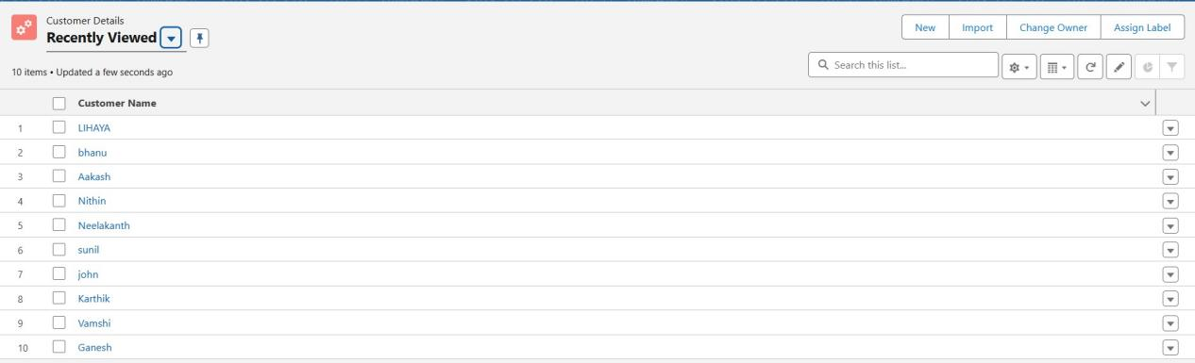

**Appointments**

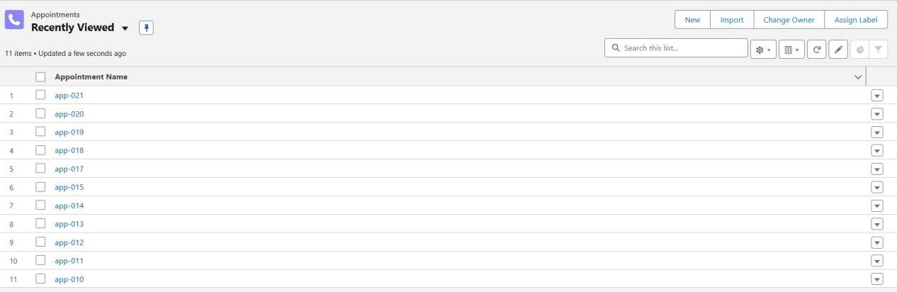

**Service Records**

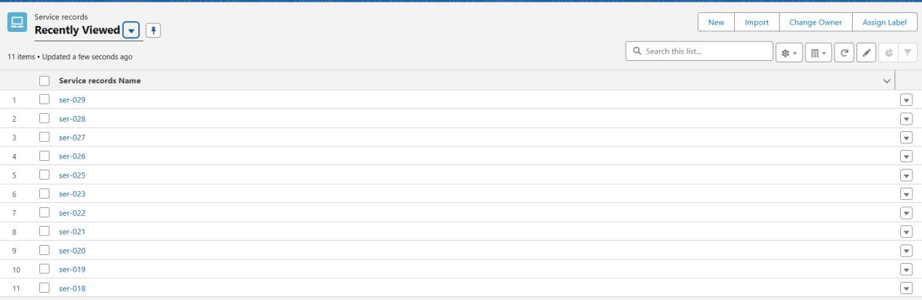

**Billingdetails and Feedback**

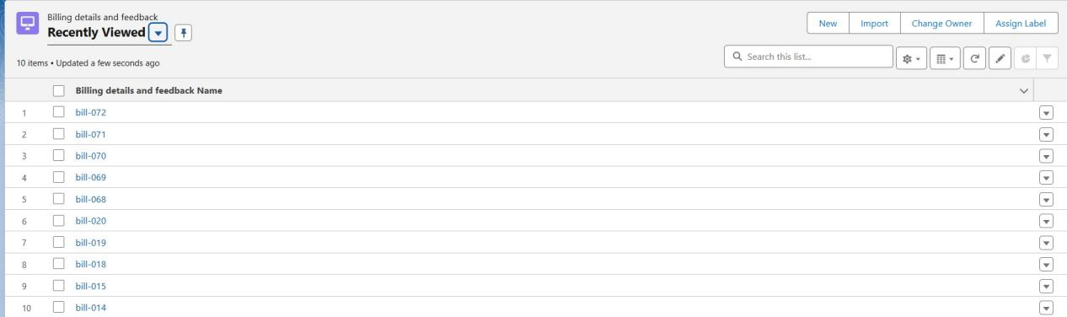

**Reports**

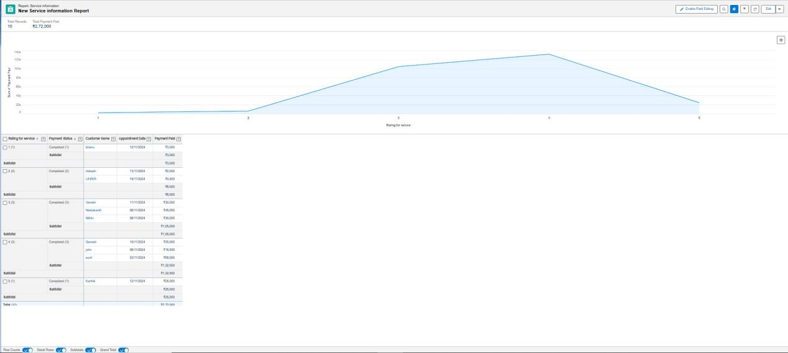

**Dashboard**