**SERVICE CATALOG USER GUIDE**

The intention of this document is to describe steps involved in using service catalog.

**(When the user type is Employee)**

**Login Page**

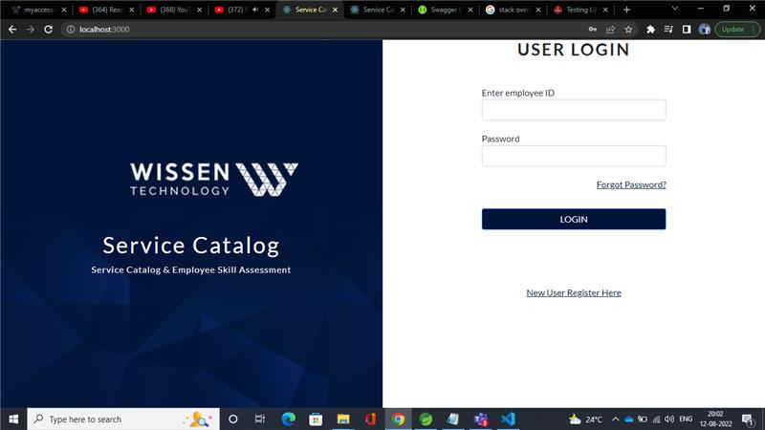

* If the username and password match it will be redirected to the Employee home page.
* If Username and password didn’t match page will redirect to the “no access page”.

After Login successfully!

**Signup Page**

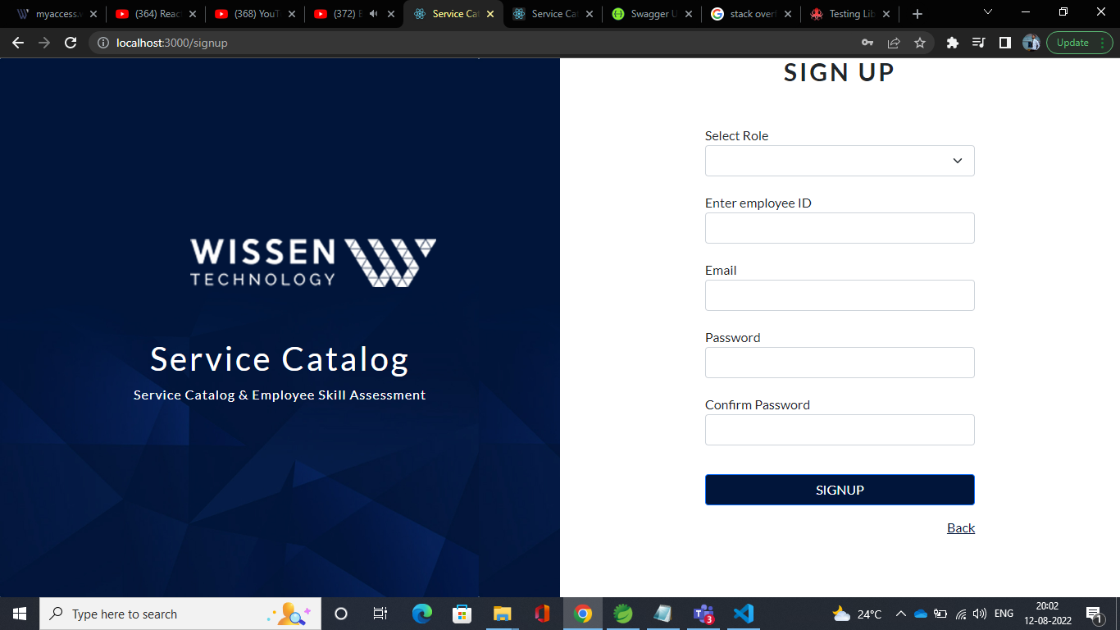

* The user will enter his/her respective details in the required fields of Signup form and then click on ***SIGNUP*** button.
* If the form is opened accidentally, the user can always go back to the previous page by clicking on the ***back*** button.

**OTP Page**

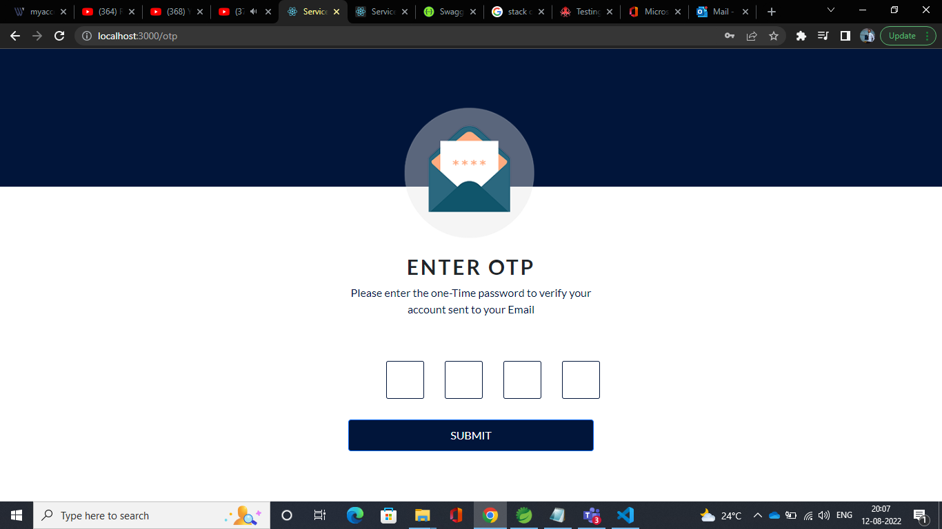

* After Sign up, the employee will receive a 4-digit OTP to employee’s respective Wissen email Id, which the employee will have to enter in OTP page to process further.
* After entering OTP, the employee has to click on the ***SUBMIT*** button to complete the sign-up process.
* If the employee didn’t get the OTP, employee can click on ***Resend OTP*** button to get a new OTP.

**Verify Employee Data Page**

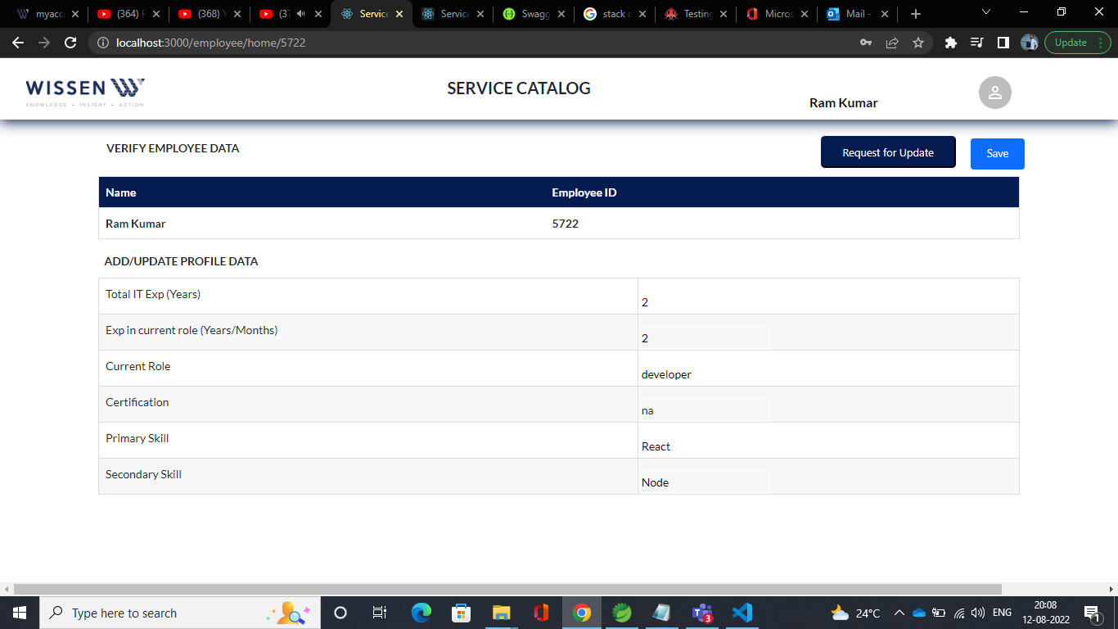

* After login, the employee can edit details except the name and email ID, and then click on ***Save*** to keep the changes.
* If employee wants to change his name or email ID, employee can always request for change from the HR by clicking on ***Request for update*** button.

**Assess Scores Page**

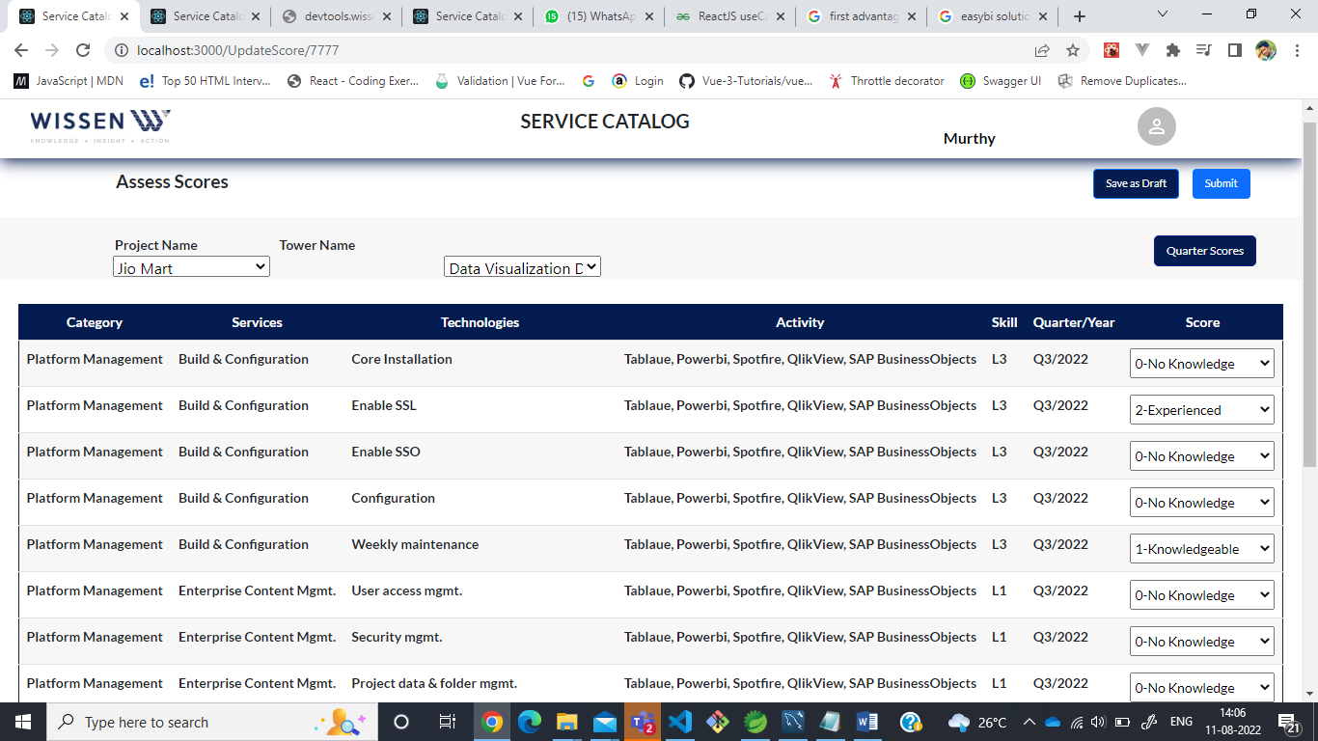

* After selecting a particular project, the employee will see a dropdown of respective towers of that particular project, then after selecting both project and towers, employee will see a list of activities where the employee can enter score and skill level
* The Scores are as follows: -

0 – No knowledge

1 – Knowledgeable

2 – Experienced

3 – Expertise

* After entering the score and skill level, the employee can either save it as a draft by clicking on ***Save as draft*** button or employee can directly submit it by clicking on ***Submit*** button.
* By saving it as a draft, the activity list, scores and skill level can only be seen by the employee. employee can also edit the scores when it is saved as draft and not submitted.
* By Submitting it, the activity list and scores can be seen by both employee and user’s respective manager, and once the scores are submitted Score and Skill level modifications are not allowed.
* By clicking on the Quarter Scores button, Quarter scores are displayed to employees when submitted scores are published by the admin.

**(When the user type is Admin)**

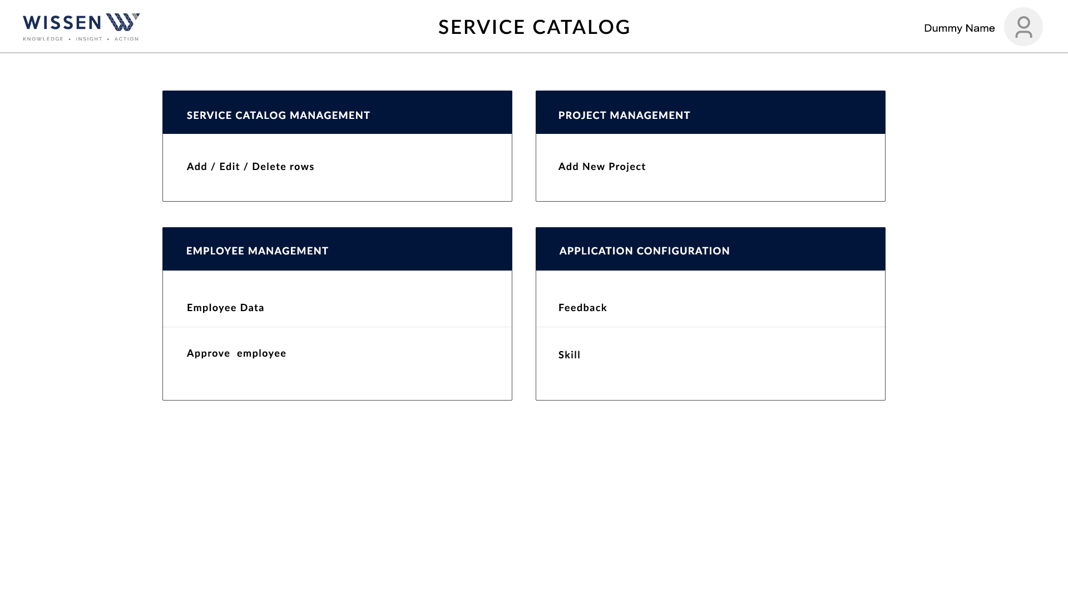

* In Admin Home screen, admin has 4 functionalities.

1. Service Catalog Management
2. Project Management
3. Employee Management
4. Application Configuration

**Service Catalog Management**

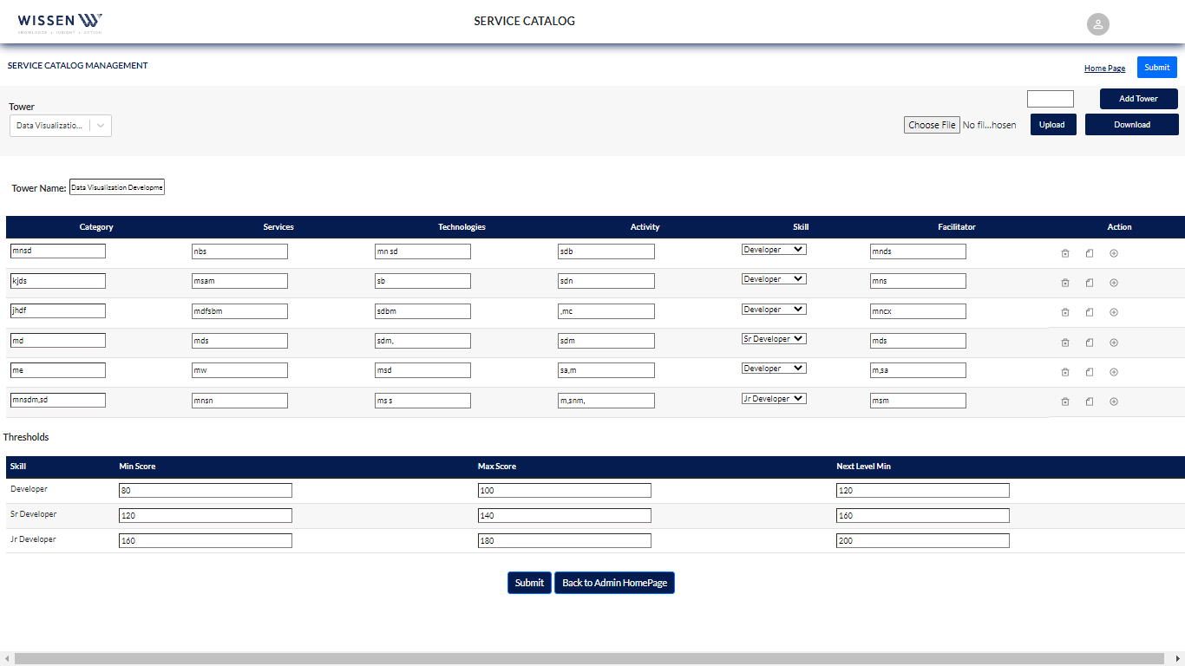

* When admin selects a particular tower from the tower dropdown, the respective list of that tower will be displayed. Here, Admin can add activity details.
* Admin can also perform three actions to a particular row which are displayed at the right most part of each row

1. Delete - It will delete the row
2. Clone – It will clone the content to the next row. If there is no next row, it will create a row and then copy the content into the new row.
3. Add- It will add the row.

* Admin can also set threshold for a particular tower and its respective skill.

The skills will be

* 1. L0
  2. L1
  3. L3
  4. Junior Developer
  5. Developer
  6. Senior Developer
* Admin can also add a tower by clicking on Add Tower button.
* Admin can go back to home page by clicking on home Page button.
* By clicking on the submit button, Admin can save all the changes.
* To upload data of multiple towers at once, Admin can choose and select an excel file and then click on Upload button.
* Download button can be used to download details of all towers.

**Employee Management**

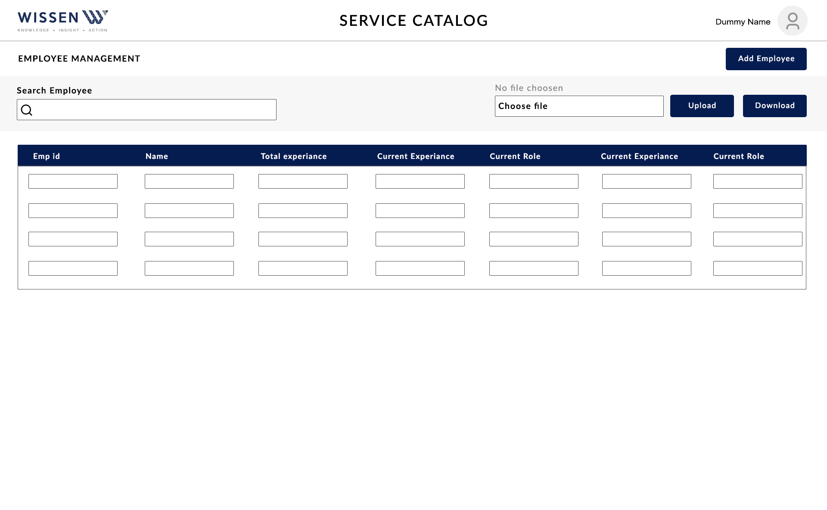

* The admin can add a new Employee by writing the employee details and then clicking on the add employee button.
* The admin also has an option of adding employees by uploading an excel file by choosing and then clicking on the upload button.
* **Download** button can be used to download details of all employees.

**Add Employee Details Pop-up**

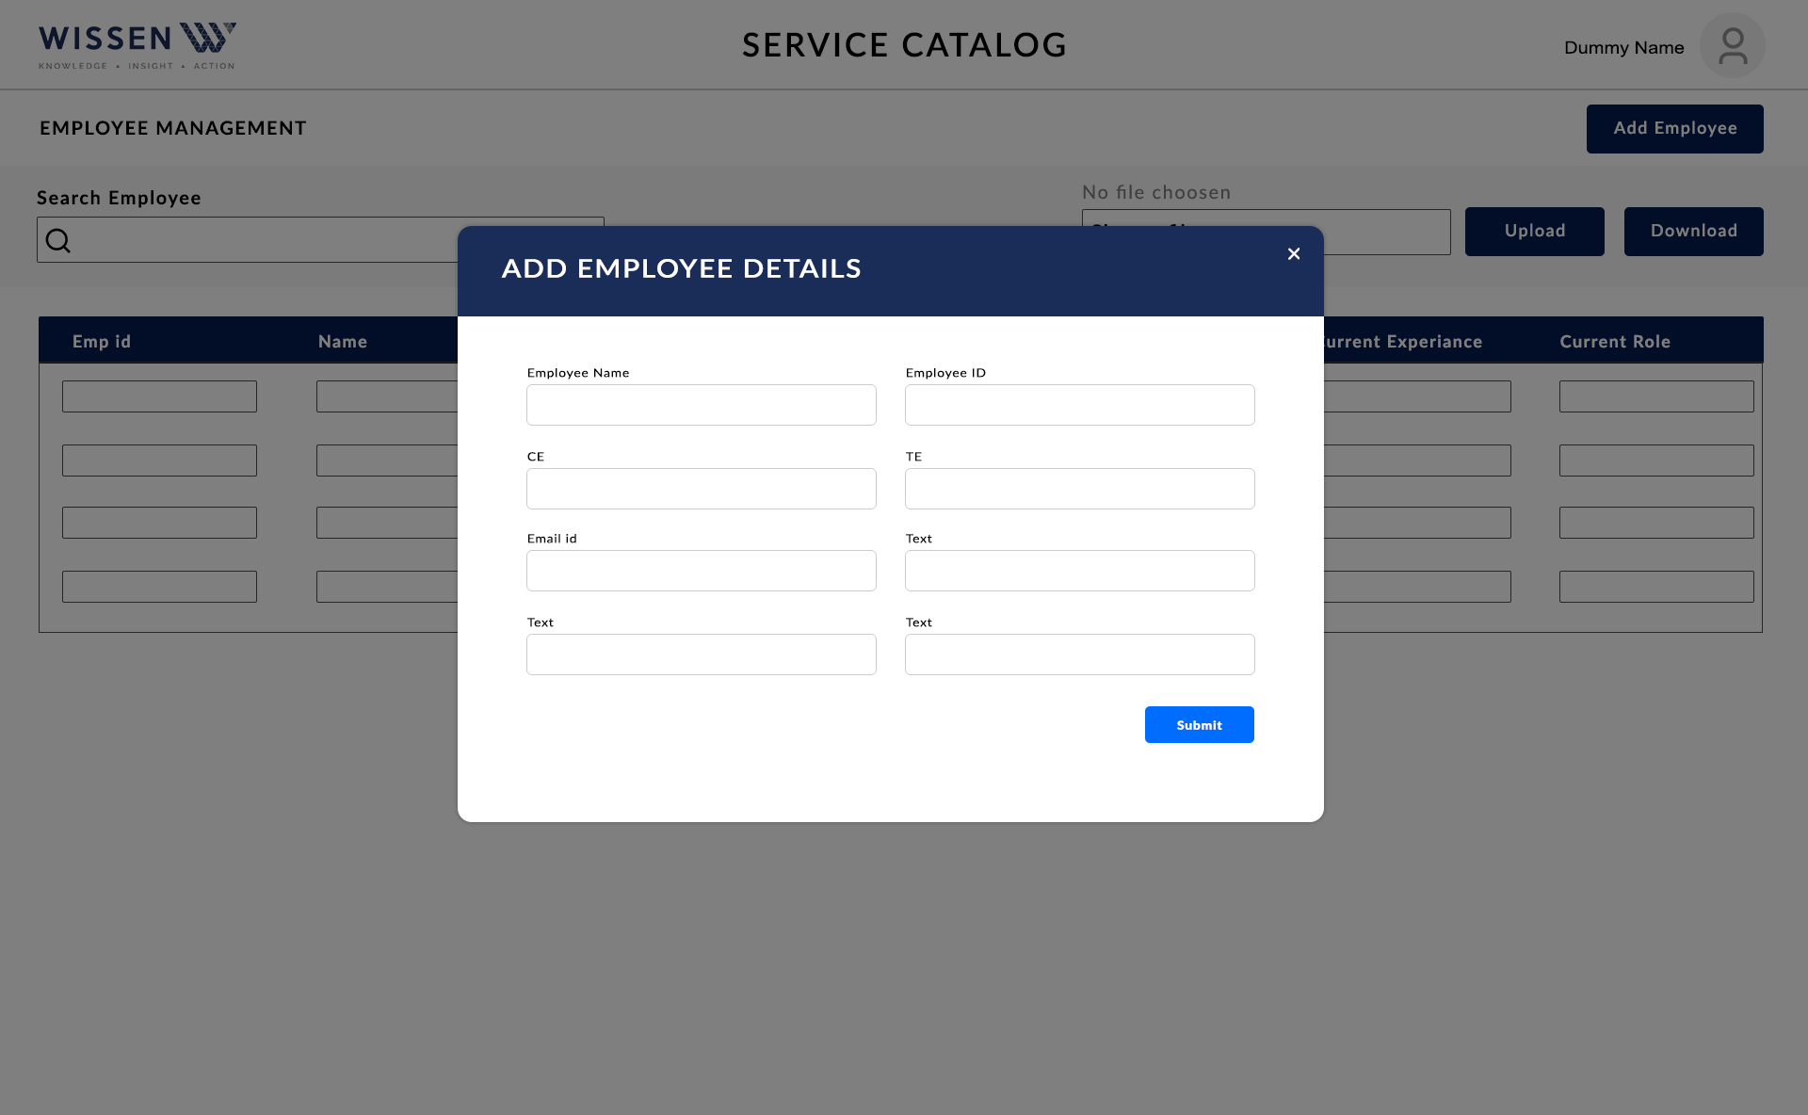

* After clicking on the Add Employee button, this dialogue box will pop up on the admin screen.
* After filling in all the necessary details into respective fields, the admin can click on submit button to add a new Employee.

**Project Management**

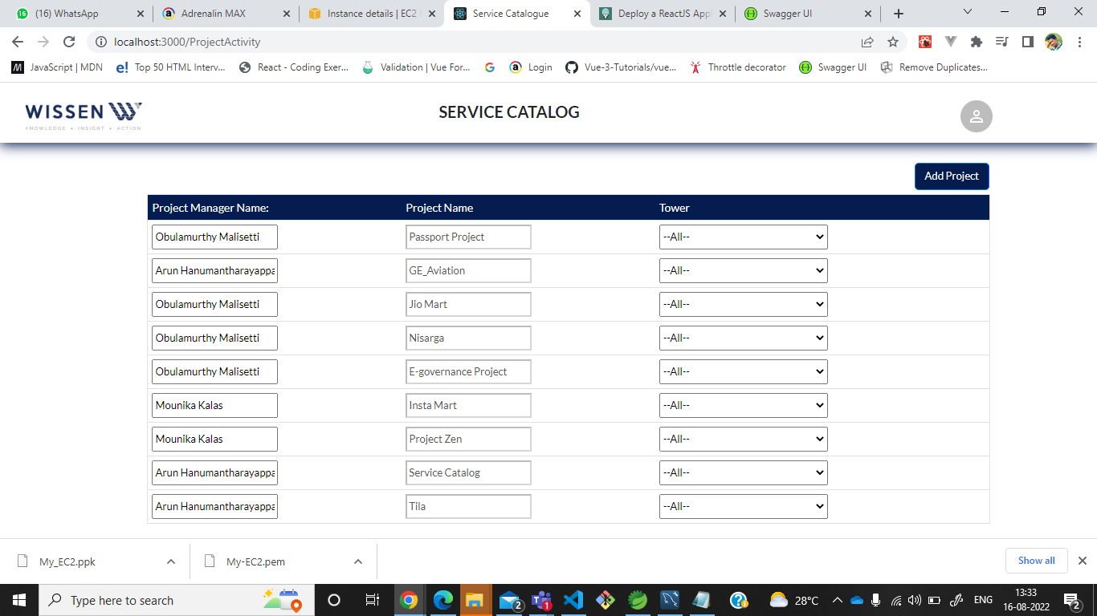

* In the Project Management screen, Admin can add project.
* To add a project, Admin needs to click on Add Project button and give necessary details and then click on the ***Submit*** button.
* The admin can also see a list of projects with their respective managers along with the towers present in it.

**Feedback and Skill Page**

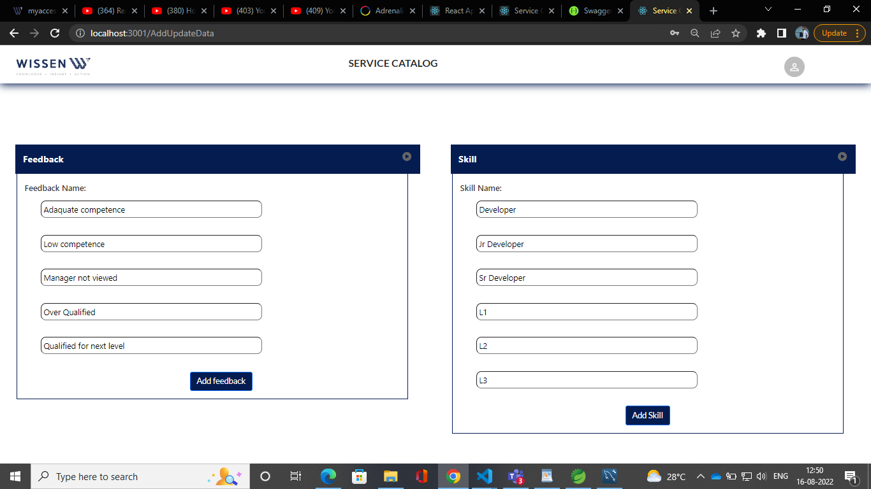

* Admin can add Feedback and skills of a particular Employee where Admin has to fill all the fields and then click on ***Add Feedback*** or ***Add Skill*** button.