Service Catalog Portal Deployment Guide

(v1.0.0)

Intention of this document to describe steps involved in deploying and using Service Catalog Portal v1.0.0.

# Files

|  |  |  |
| --- | --- | --- |
| Sl# | File Name | Description |
| 1 | service-catalogue-services-1.0.0.jar | Services API executable |
| 2 | service-catalogue-ui-1.0.0.zip | User Interface compressed zip file |
| 3 | nginx-1.21.6.zip | Nginx web server |
| 4 | service-catalog-portal_deployment_1.0.0.docx | This document with deployment details |
| 5 | Service_Catalog_User_Guide_1.0.0.docx | Application User Guide |

# Prerequisites

|  |  |  |
| --- | --- | --- |
| Sl# | Requirement | Description |
| 1 | JDK 1.8 or later | Java Development Kit 1.8 or later version installed |
| 2 | Nginx or Apache | Web server installed  (Optionally, can extract included nginx-1.21.6.zip) |
| 3 | Chrome or Edge | Web browsers with JavaScript enabled |

# Assumptions

|  |  |
| --- | --- |
| Sl# | Assumption |
| 1 | JDK & Web server installed in same server |
| 2 | ‘localhost’ is mapped to 127.0.0.1 |
| 3 | Ports 80 & 8080 are reserved for web server and API services respectively |

# Deployment

|  |  |  |
| --- | --- | --- |
| Sl# | Step | Comments |
| 1 | Copy service-catalogue-services-1.0.0.jar to a folder with minimum 2 GB mounted disk space and write permission for logged-in user ID | Based on log retention requirement, increase the disk space |
| 2 | Set JAVA_HOME to correct JDK (1.8 or later) and set PATH to respective JAVA_HOME/bin folder | In case of Unix environment, export the JAVA_HOME & PATH environment variables |
| 3 | Run below command in the folder.  java –jar service-catalogue-services-1.0.0.jar | In Unix environment, prefer to run as bellow:  nohup java –jar service-catalogue-services-1.0.0.jar 2>&1>> nohup.out &  tail -100f nohup.out |
| 4 | Extract the content of service-catalogue-ui-1.0.0.zip into default html folder of web server (Apache/Nginx) | Normally, for Nginx, default html folder will be *<Nginx installation folder>/html*; and for Apache it will be /var/www/html for Unix and <Apache installation folder>/htdocs for Windows |
| 5 | Setup reverse proxy for URL: ‘/api’. | For Nginx, open nginx.conf and add the below under server  # proxy the Service Catalog micro services api calls  #  location /api/ {  proxy_pass http://localhost:8080/;  } |
| 6 | Start webserver | Preferably, restart webserver if it was already running |

# Accessing web site

Step 1.

Access http://***<server-DNS/IP>***/



Step 2.

Login with credentials 1000/ADMIN

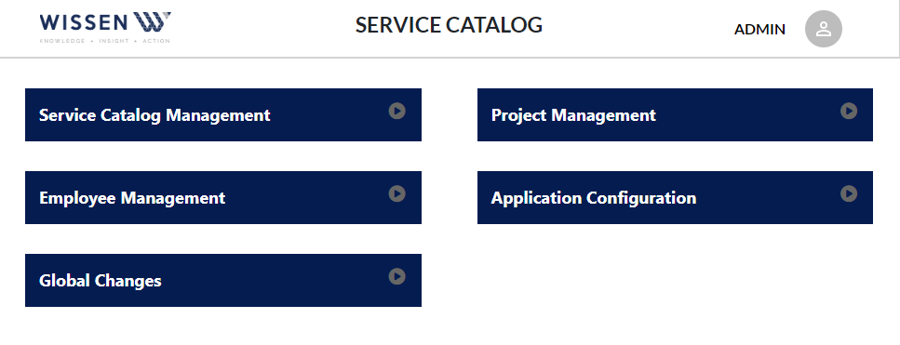

Step 3.

Refer to ‘Service_Catalog_User_Guide_1.0.0.docx’ for full functionalities details.

Complete the initial settings and basic data before uploading employees’ data.