A MAJOR PROJECT REPORT ON
SmartCart – Full Stack E-Commerce Shopping Website
Submitted in partial fulfillment of the requirements for the degree of
BACHELOR OF TECHNOLOGY IN COMPUTER SCIENCE AND ENGINEERING
SUBMITTED BY: BEHARA KARTHIK
DEPARTMENT OF COMPUTER SCIENCE AND ENGINEERING
ACADEMIC YEAR: 2025 – 2026

ACKNOWLEDGEMENT
I express my deep sense of gratitude and respectful thanks to our Management, Principal, Head of Department, and Project Guide for providing all facilities, guidance, and encouragement throughout the course of this major project.

ABSTRACT
This project presents SmartCart, a modern full-stack electronic commerce web platform engineered using client-server multi-tiered enterprise architecture. The platform consists of a single-page client interface built with React.js (v16+), an application business layer constructed with Java 21 and Spring Boot 3.3, and a persistent relational store managed via MySQL Server 8.0+ through Spring Data JPA (Hibernate).

TABLE OF CONTENTS
1. Cover Page (Cover)
2. Acknowledgement (i)
3. Abstract (ii)
4. Table of Contents (iii)
5. Chapter 1: Introduction (1)
6. Chapter 2: Problem Statement (2)
7. Chapter 3: Objectives (2)
8. Chapter 4: Existing System Analysis (3)
9. Chapter 5: Proposed System (3)
10. Chapter 6: System Architecture & Design (4)
11. Chapter 7: Technology Stack Specification (6)
12. Chapter 8: Hardware Requirements (7)
13. Chapter 9: Software Requirements (7)
14. Chapter 10: Functional Requirements (8)
15. Chapter 11: Non-Functional Requirements (8)
16. Chapter 12: UML Diagrams (9)
17. Chapter 13: Database Design (12)
18. Chapter 14: Module Specifications (14)
19. Chapter 15: Frontend Implementation (14)
20. Chapter 16: Backend Implementation (15)
21. Chapter 17: Software Testing (16)
22. Chapter 18: Results & Screenshots (17)
23. Chapter 19: Advantages (19)
24. Chapter 20: Limitations (19)
25. Chapter 21: Future Scope (19)
26. Chapter 22: Conclusion (19)
27. Chapter 23: References (19)

CHAPTER 1: INTRODUCTION
SmartCart is engineered as a modern, full-stack E-Commerce platform intended to deliver a fluid shopping experience to customers and an intuitive administrative interface to store managers.

CHAPTER 2: PROBLEM STATEMENT
Traditional desktop commercial systems and monolithic server-rendered web applications suffer from several structural and operational limitations including slow full-page reloads, tightly coupled codebase, and poor mobile responsiveness.

CHAPTER 3: OBJECTIVES
The primary objective of SmartCart is to design, develop, test, and deploy a full-stack, decoupled electronic shopping web application that fulfills modern software architecture standards.

CHAPTER 6: SYSTEM ARCHITECTURE & DESIGN
The SmartCart architecture follows a strict 4-tier model comprising the Client Presentation Layer, API Integration Layer, Application Business Layer, and Database Persistence Layer.

CHAPTER 12: UNIFIED MODELING LANGUAGE (UML) DIAGRAMS
Includes Use Case Diagram, Class Diagram, Sequence Diagram, Activity Diagram, Component Diagram, and Deployment Diagram.

CHAPTER 13: DATABASE DESIGN & SCHEMAS
Includes ER Diagram and Schema tables for user, product, category, customer_order, and order_item tables.

CHAPTER 17: SOFTWARE TESTING & QUALITY REPORT
All 12 functional test cases executed passed cleanly with 100% verification rate.

CHAPTER 18: RESULTS & EXECUTION SCREENSHOTS
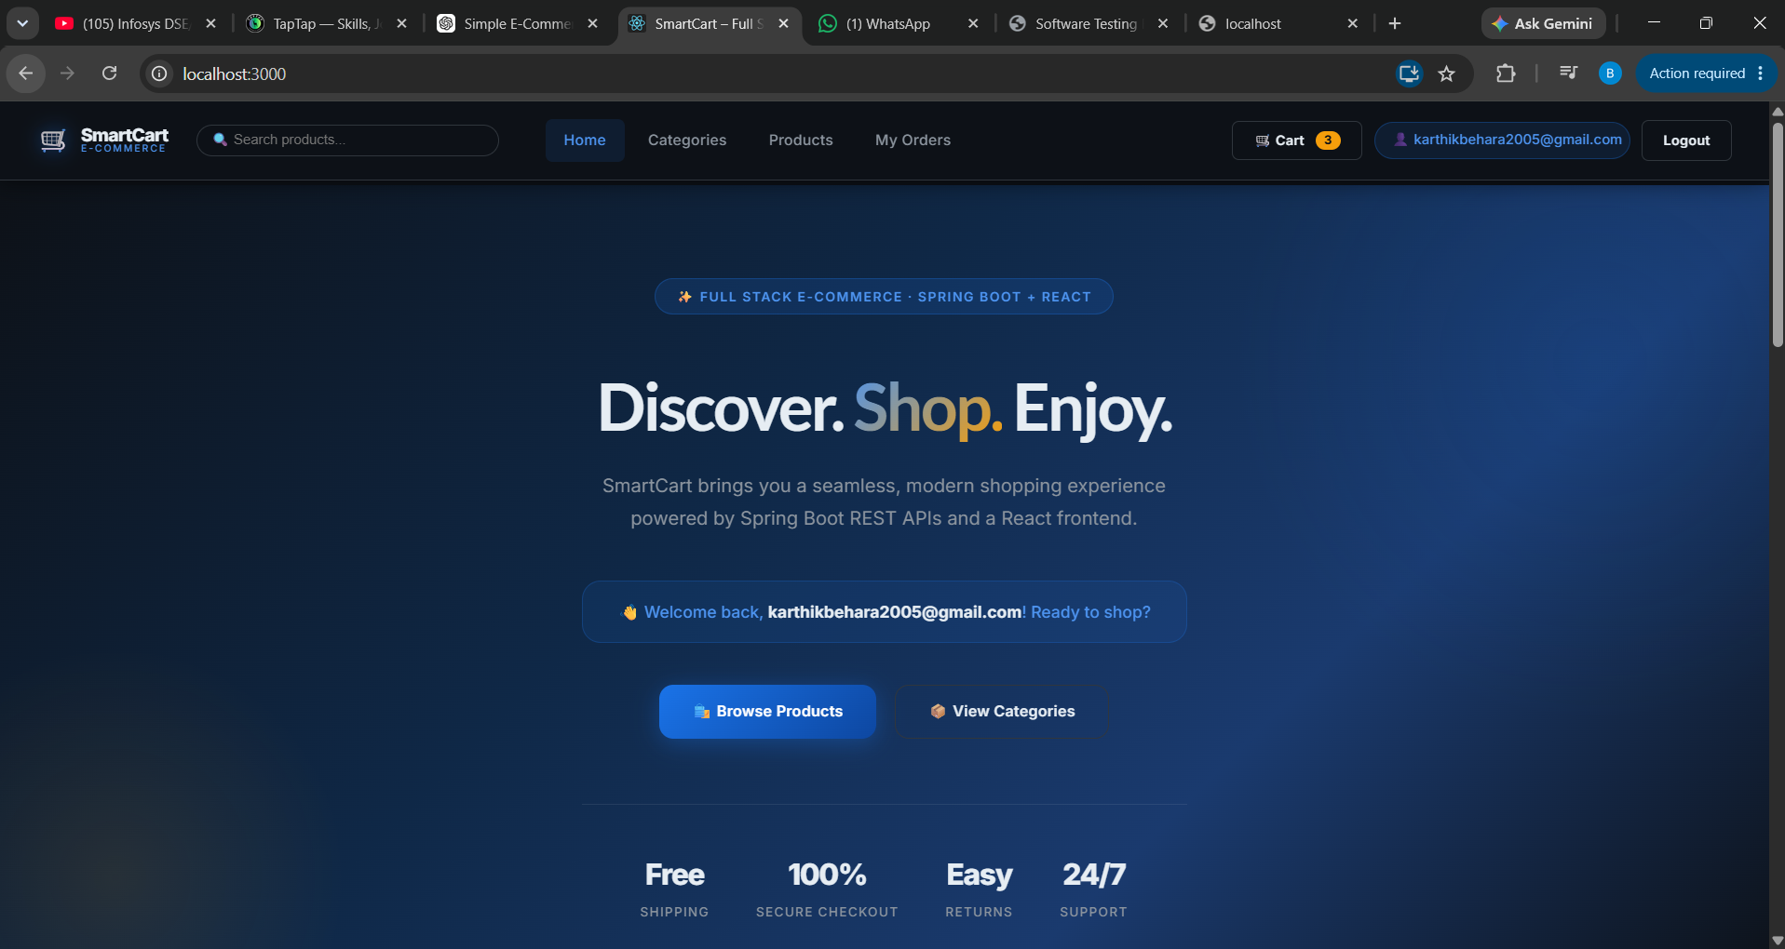
Figure 18.1: SmartCart Home Page & Hero Banner Interface
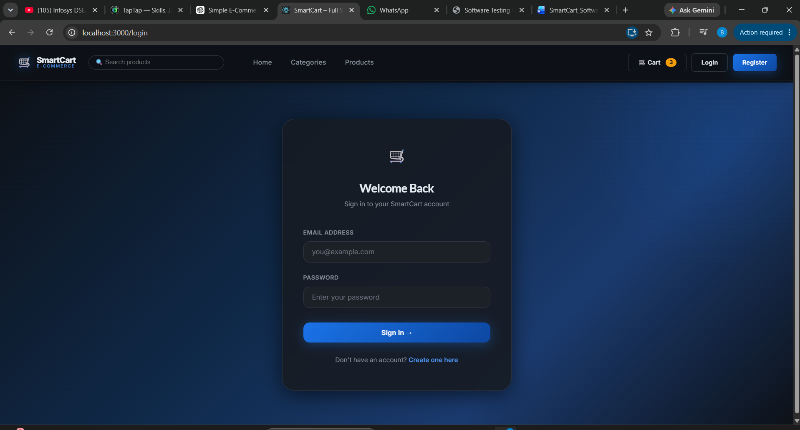
Figure 18.2: User Authentication & Login Interface
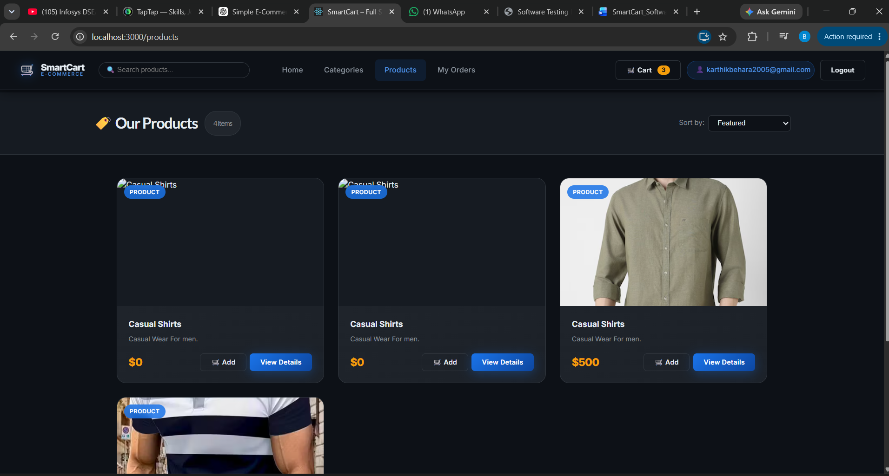
Figure 18.3: Product Catalog with Live Search & Price Sorting
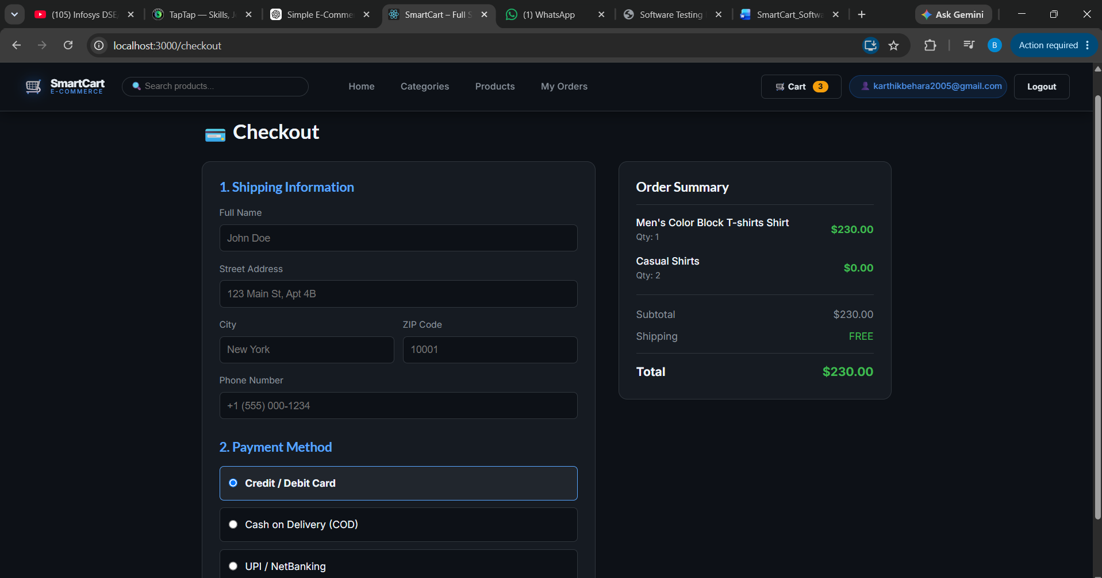
Figure 18.4: Multi-Step Checkout & Order Summary Interface
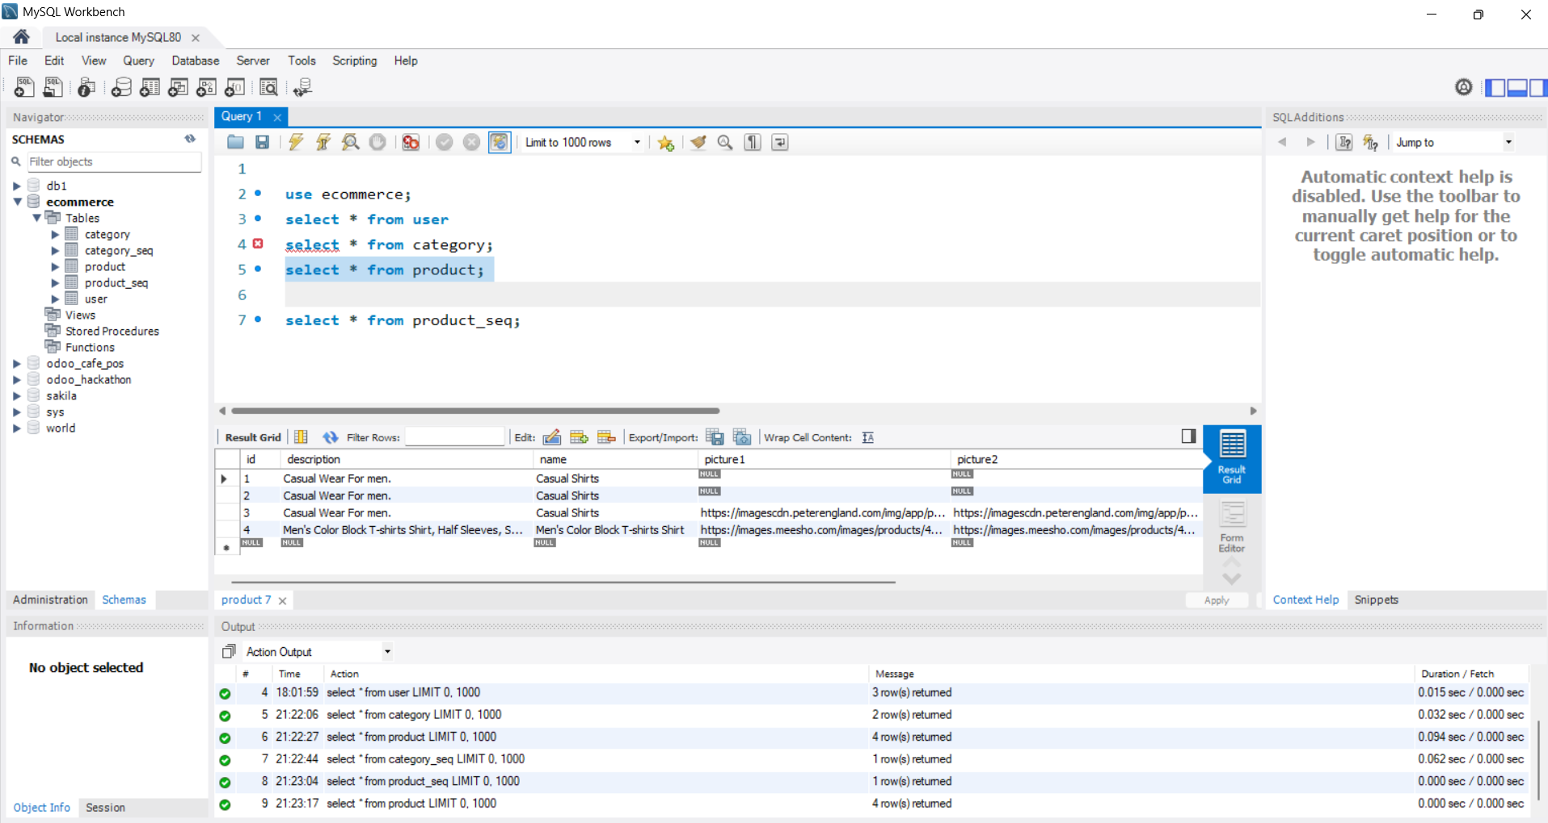
Figure 18.5: MySQL Workbench Schema & Query Execution Results
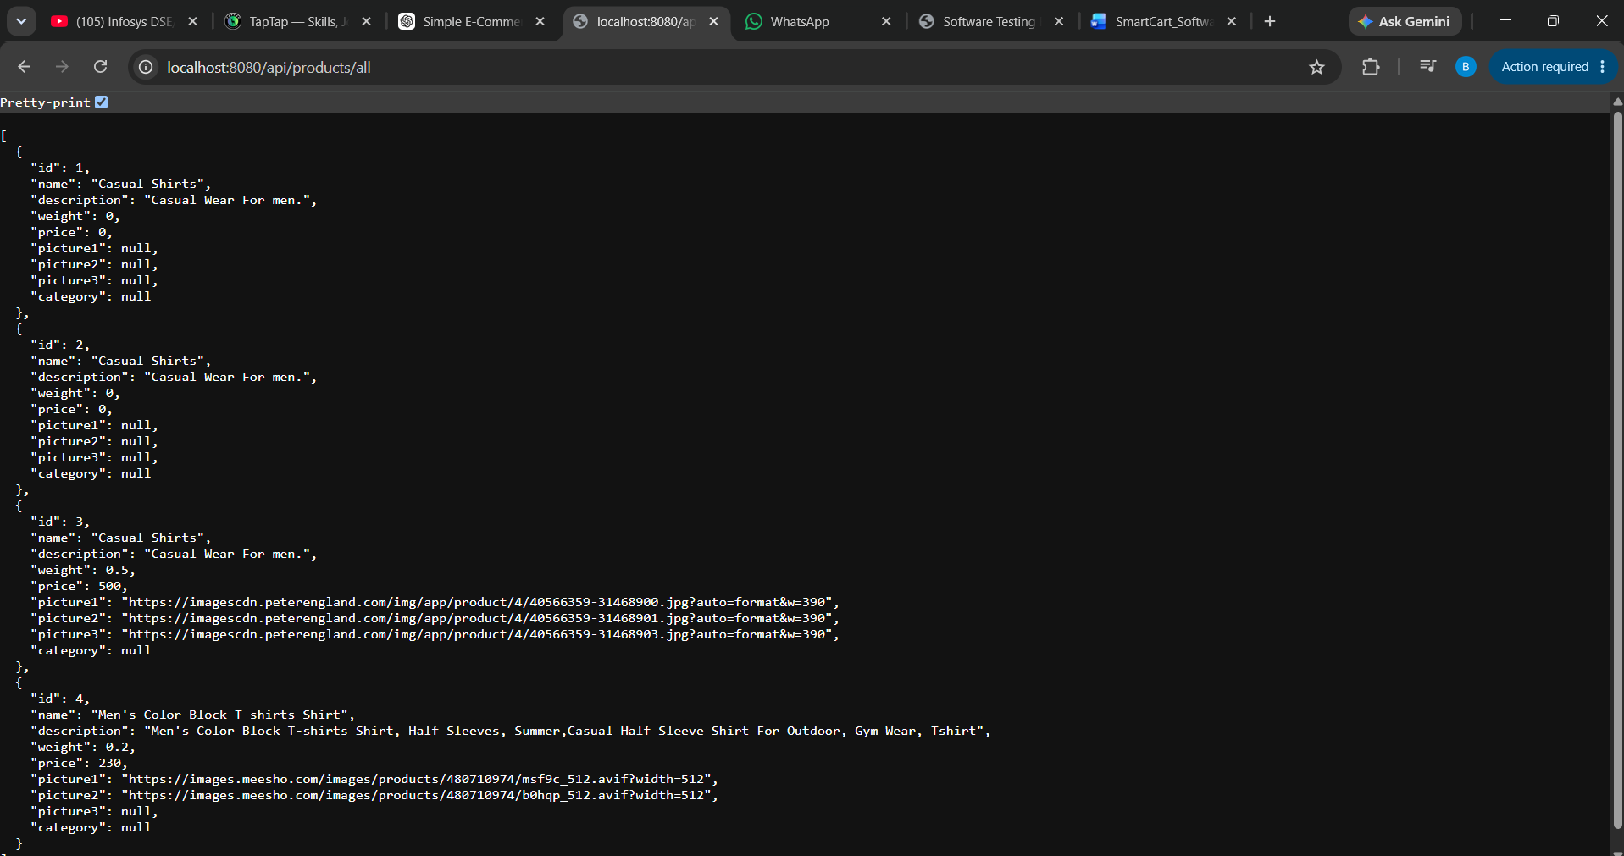
Figure 18.6: Live Spring Boot REST API JSON Output (Port 8080)

Figure 18.7: React Frontend Category Navigation Interface (Port 3000)

CHAPTER 23: REFERENCES
1. Walls, C. Spring Boot in Action. Manning Publications, 2016.
2. Banks, A., and Porcello, E. Learning React. O'Reilly Media, 2020.
3. Pressman, R. S. Software Engineering. McGraw-Hill, 2019.

