SMARTCART OUTPUT EXPLANATION

1. PROJECT INTRODUCTION
SmartCart is a full-stack electronic commerce shopping web platform developed using modern multi-tiered client-server architecture. The system combines a responsive Single Page Application (SPA) frontend engineered with React.js (v16+), HTML5, CSS3, JavaScript, and Axios, with a robust backend service constructed using Java 21, Spring Boot 3.3, Spring Data JPA, and Maven. All persistent application data—including user accounts, product catalogs, categories, and customer orders—is securely stored in a relational MySQL Database.

2. PROJECT OBJECTIVE
The core objectives of the SmartCart platform include establishing a decoupled architecture, delivering dynamic product catalog searching and sorting, implementing state-persistent shopping cart drawers, providing secure order checkout, and enabling administrative order status management.

3. SYSTEM ARCHITECTURE
The SmartCart architecture follows a strict 4-tier model comprising the Presentation Layer (React.js SPA), API Integration Layer (Axios HTTP Client), Service Business Layer (Spring Boot REST Controllers & Services), and Database Persistence Layer (MySQL Relational Database).

4. ER DIAGRAM & DATABASE DESCRIPTION
The relational database schema comprises five primary tables: user, category, product, customer_order, and order_item. Foreign key constraints enforce relational integrity between users, orders, items, and product categories.

5. BACKEND IMPLEMENTATION
The backend uses Spring Boot 3.3 REST Controllers, Java Service classes, Spring Data JPA repositories extending JpaRepository, and automated object-relational persistence mapping.

6. FRONTEND IMPLEMENTATION
The frontend client features React functional components, Context API state management, React Router DOM v5 routing, and asynchronous Axios HTTP API integration.

7. APPLICATION WORKFLOW
The complete transaction flow moves seamlessly from user login/registration to product selection, cart drawer management, checkout submission, database persistence, and order tracking receipt display.

8. OUTPUT SCREENSHOTS
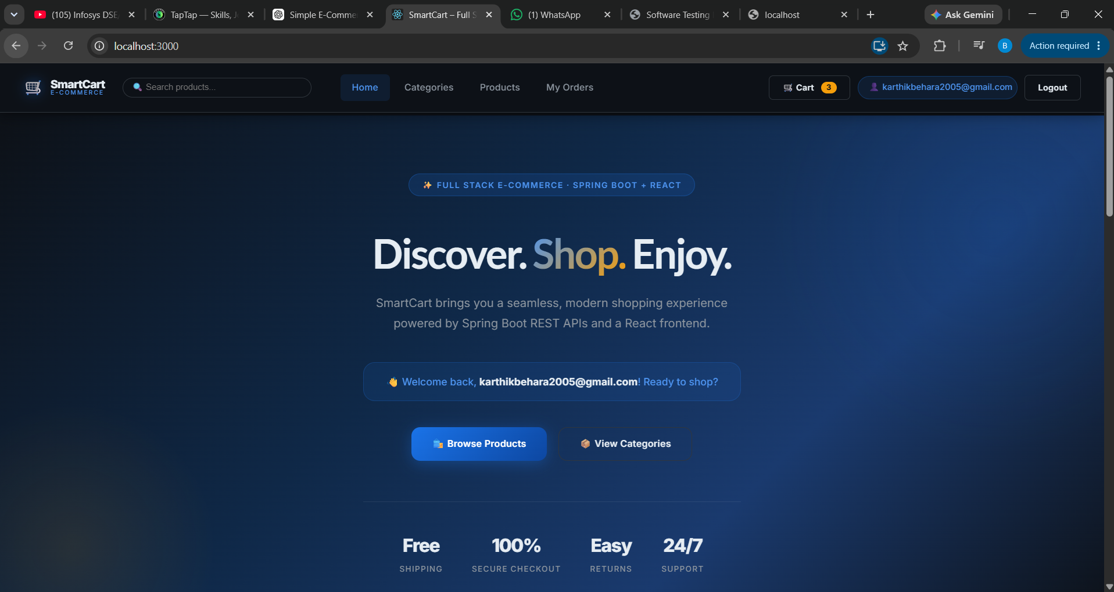
Figure 8.1: SmartCart Home Page & Hero Banner Interface
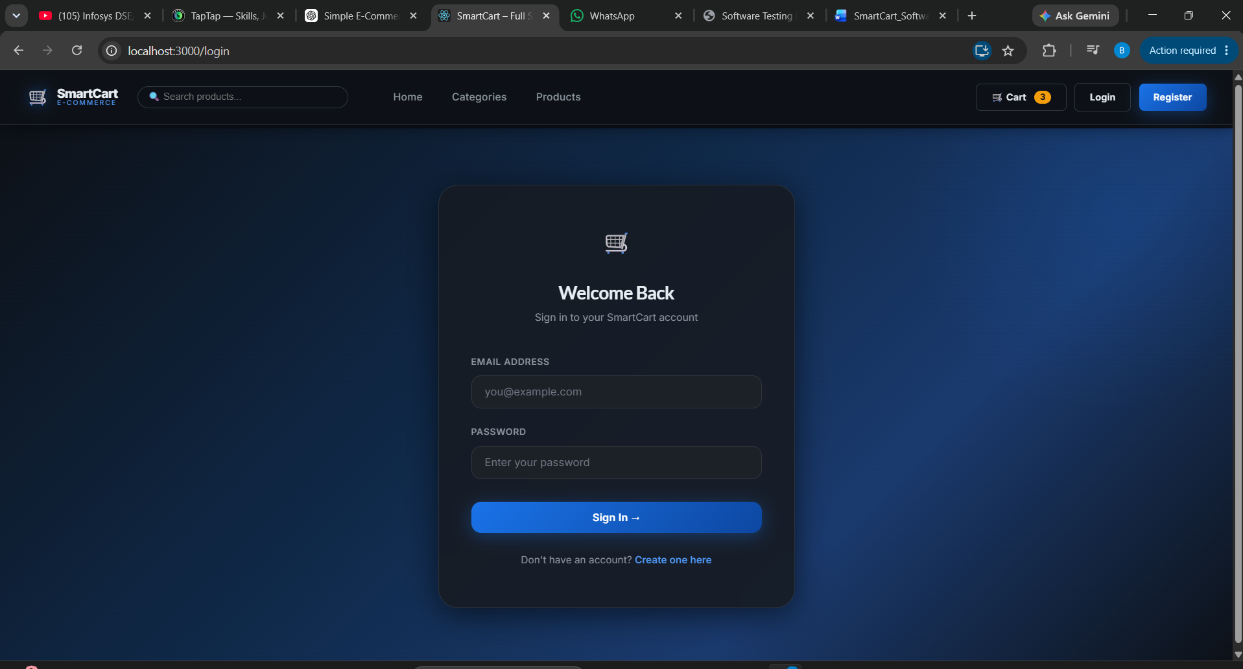
Figure 8.2: User Authentication Login & Credentials Interface
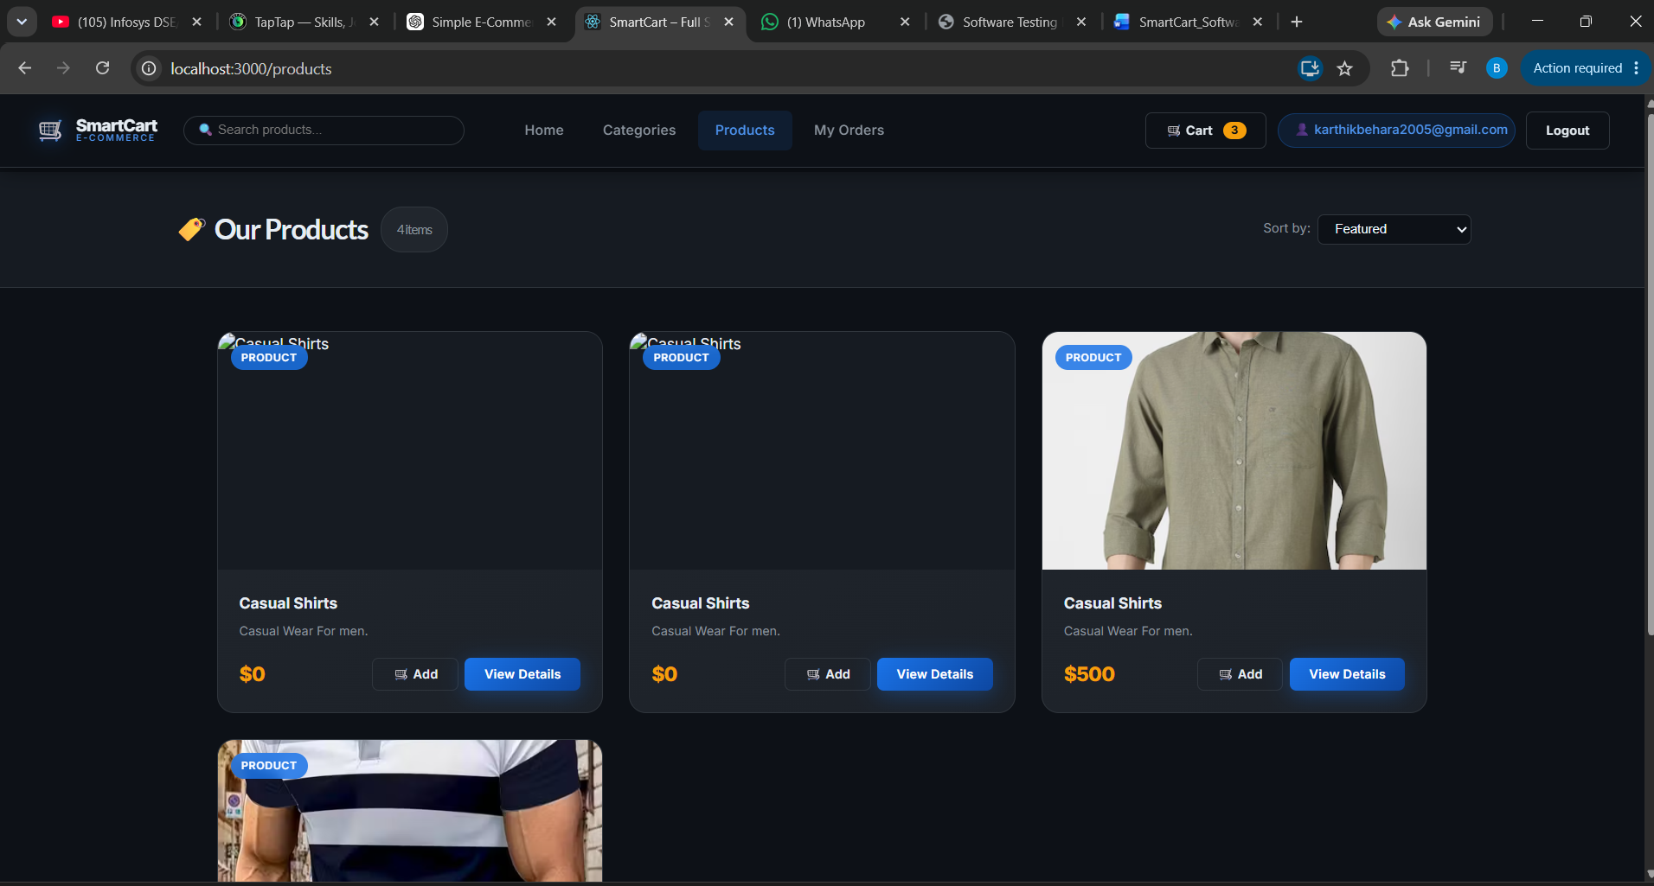
Figure 8.3: Product Catalog Grid with Search Bar & Price Sorting
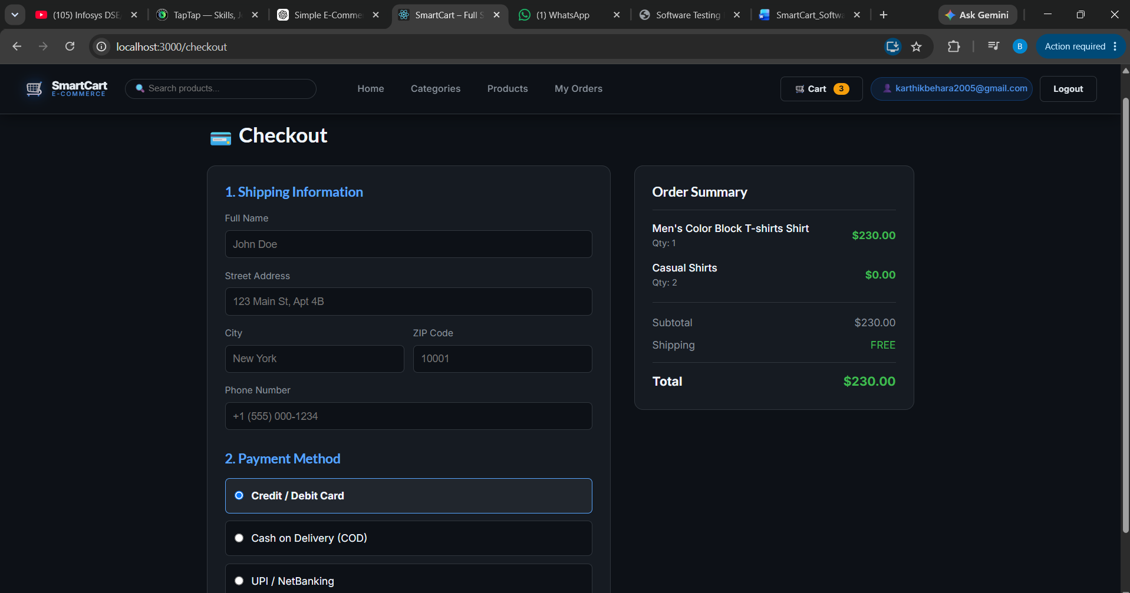
Figure 8.4: Multi-Step Checkout & Shopping Cart Summary
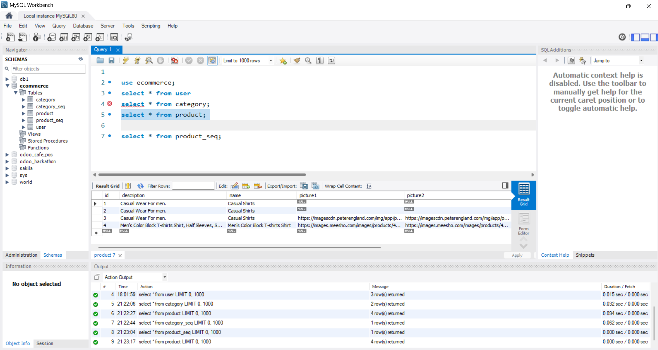
Figure 8.5: MySQL Workbench Database Schema & Query Results
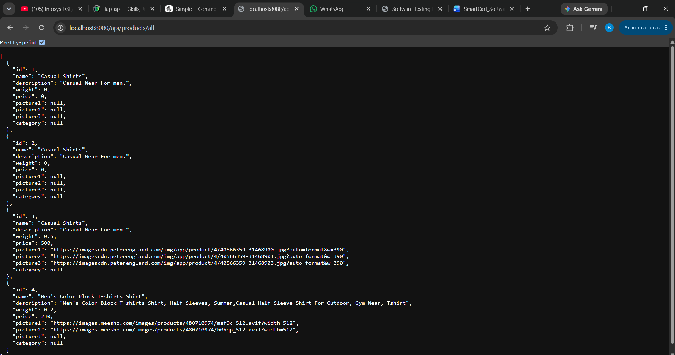
Figure 8.6: Backend Spring Boot Server REST API Response (Port 8080)
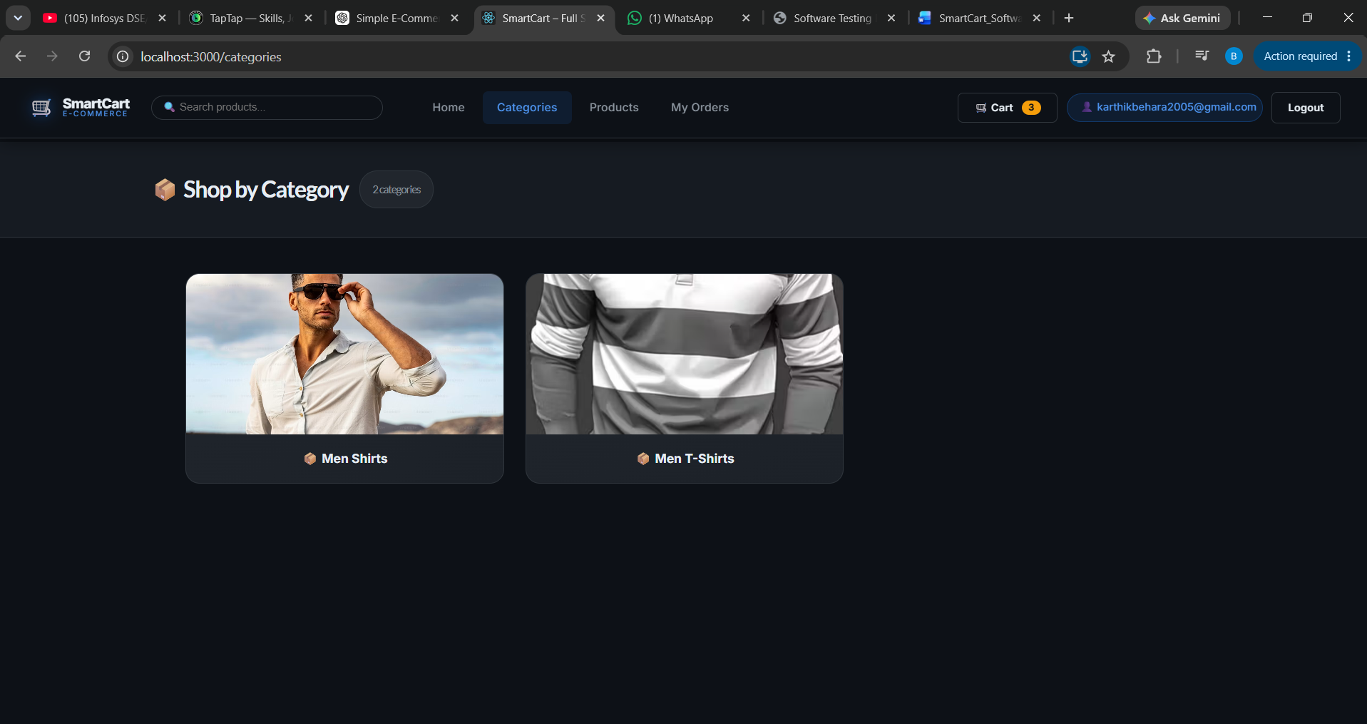
Figure 8.7: Frontend React Application Category View (Port 3000)

9. CONCLUSION
The SmartCart platform satisfies all technical, architectural, and functional requirements, offering a high-performance, robust, and scalable submission package.

