Git

* To solve merge conflict first commit the changes then pull.
* Creates local repository in each of every contributors system.
* Rebase : new Commit is created hole branch with history is moved to main branch.
* Merge : new commit is created history remains same.

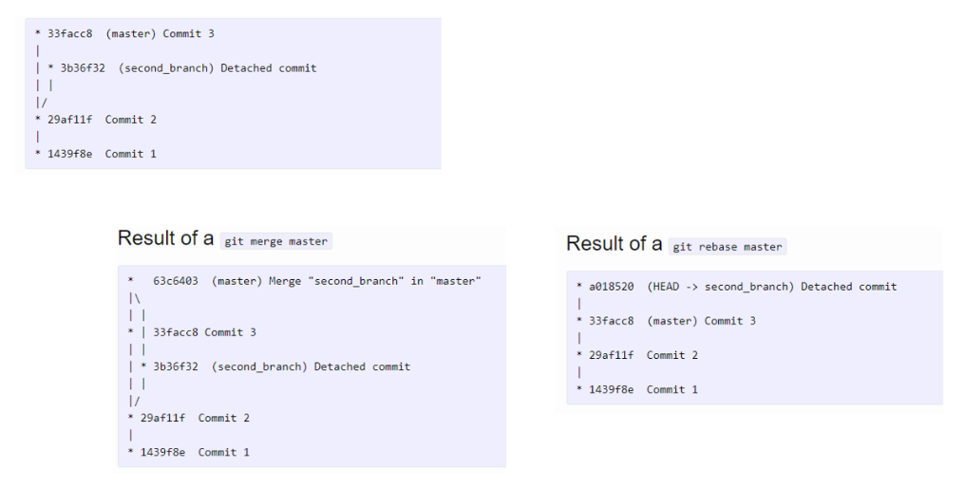

Advantages

* One of the biggest advantages of Git is its branching capabilities
* DisAdvantages
* The entire code base has to be cloned into local repository before making the changes or adding files to existing repositories.