Installation

1. adding repository to key stream

wget -q -O - https://pkg.jenkins.io/debian/jenkins-ci.org.key | sudo apt-key add -

2.echo deb https://pkg.jenkins.io/debian-stable binary/ | sudo tee /etc/apt/sources.list.d/jenkins.list

3. sudo apt-get update

4.sudo apt-get install jenkins

to install java if its not present(java 9 ,10 and 12 are not supported)

start jenkins

1.sudo systemctl start jenkins

2. sudo systemctl status jenkins(to check status)

Step 1: Select the following maven plugin in Mange jenkins-> Manage plugins -> Available -> select following plugins and install

* Maven Integration plugin
* Maven MetaData Plugin For Jenkins CI Server
* Maven Release plug-in plug-in

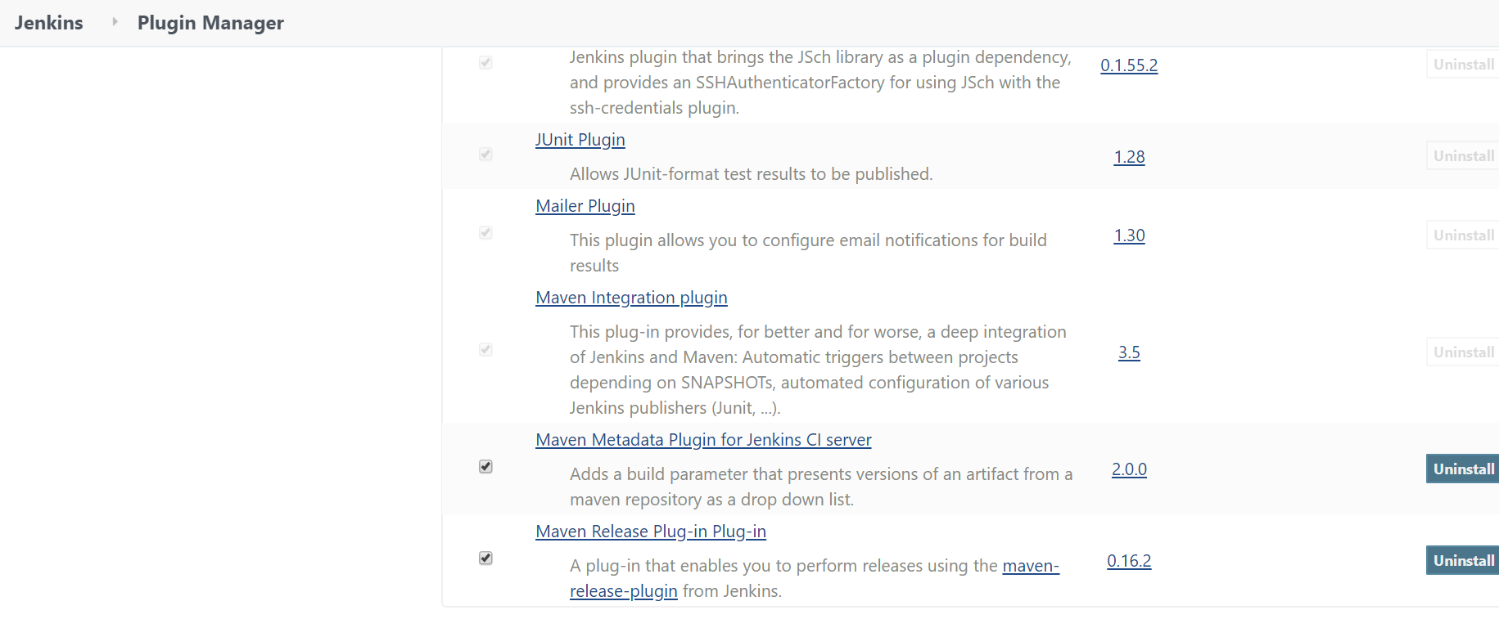

Step 2: Manage Jenkins -> Global Tool Configuration and do the following configuration as shown below.

