Assignment-2

Student Name: Kartik Velede

Student Id: 8672807

Course Instructor: Kevin Swayze

Assignment Posted Date: 11th June 2020

Assignment Submission Date: 19th June 2020

From: karthik.veledy@gmail.com  
To: byrisuraj@gmail.com   
Subject: Cloud based collaboration tool

Hello Suraj,

As we discussed earlier, I have gone through various cloud-based collaboration tools and found few of them which would help our company and contribute for our growth story. One Particular tool that has grabbed my attention and will be a great asset to our company is widely known as Team-Viewer.

My analysis for considering the above product is based on the following criteria mentioned below.

1. Cost
2. Functionality
3. Integration-Point.

Cost :

The cost of this product is relatively low when compared with other products of same functionality in the market. This makes team-viewer cost effective tool. There are wide range of options available to choose the product like single user, multi-user and for teams. Multi-user would be the best option for our company which would cost around $109.00/month where 50 users at a time can have access to a single system.

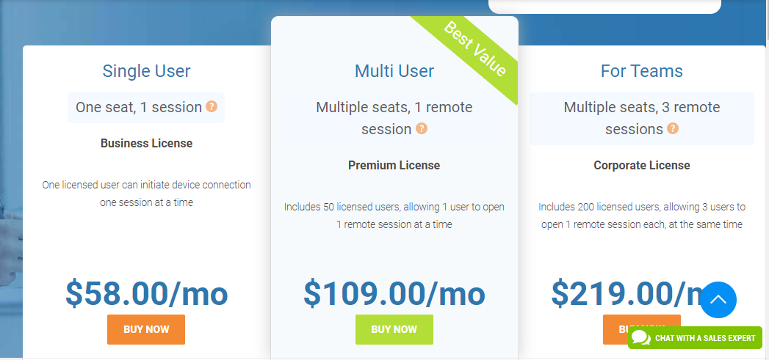

Functionality:

TeamViewer is a tool which allows users for connecting to multiple workstations. While there are other competitors in the market because of its flexibility, accessibility and user-friendly nature TeamViewer stands out as the top priority for small companies to choose.

Following are the functionalities in team-viewer

Remote control

Sharing data

Migrating data

Testing products

Updating Office systems

Web-conferences

Training sessions

Online Teamwork

Secure connection

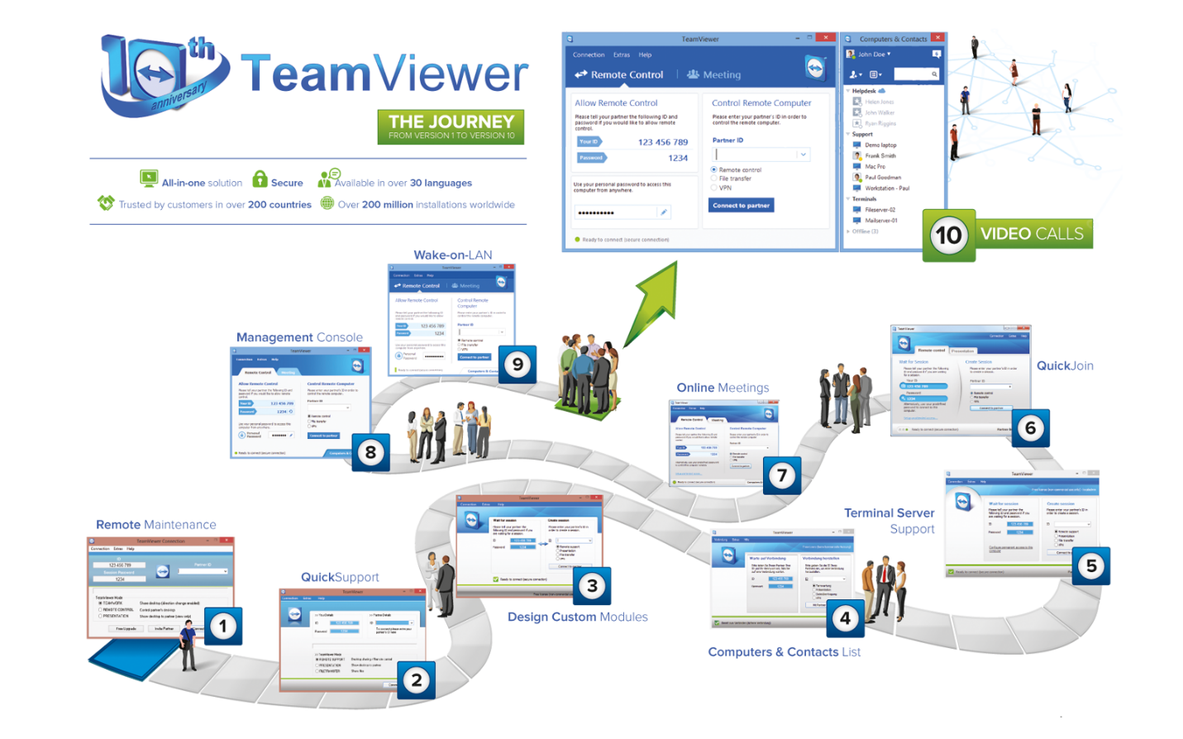

Integration-Point:

TeamViewer is a very simple tool to use and it does not overlap with any other products in the system. It is more safe and secure to use than any other products in the market. This tool can be integrated with any type of system configurations and will have no dependency issue it can be easily integrate with windows, ubuntu, Linux and Mac operating systems.

Considering all the above features I would strongly recommend TeamViewer to be implemented in our office work environment it would be game changer for our company. Please feel free to contact if you have any further queries regarding my research work.