Case Study 2: Workflows

Kartik Velede

8672807

Collaborative Productivity– INFO8870

Douglas Hardie

January-20-2019

January-22-2019

**Table of Contents**

**Introduction** 3

**Overtime Payroll Workflow Process** 3

**Announcement for Overtime Work Slot availability:** 3

**Applying for Overtime:** 3

**Manager approval:** 3

**Payroll team approval:** 4

**Payroll vendors:** 4

**Overtime Payroll Workflow** 4

**SharePoint Workflow Tool** 5

**Approval Workflow** 5

**Reasons to choose approval workflow** 5

**References** 6

# **Introduction**

VSN company can allows employees to work overtime during busy times in order to ensure that specific projects are completed on time. VSN company is committed to providing employees with appropriate compensation for overtime hours worked, in accordance with the law.

# **Overtime Payroll Workflow Process**

The following are the steps involved in to order to pay the employees of the organization for the Overtime work done.

## **Announcement for Overtime Work Slot availability:**

Managers will attempt to provide prior notification of at least 5 hours to the employee when they require an employee to work overtime hours.

## **Applying for Overtime:**

Employees who are interested to work for overtime should apply for it through organization overtime portal available by filling the basic details such as date, time and number of hours and submit the request to manager for the approval.

## **Manager approval:**

Manager gets an email notification for the request made by the employee to work for overtime.

Managers verify the information provided by the employee and takes the decision whether to approve or deny based on the slot availability.

The decision taken will be notified to the employee through an email

## **Payroll team approval:**

Payroll team will review whether the employee worked for overtime or not

If yes, they approve it and send the data to the payroll vendors in order to process the payment

If no, they ask the manager for the approval and proceed according to the response.

## **Payroll vendors:**

Payroll vendors are the ones who process the payment to all the employees based on the data they received from payroll team.

# **Overtime Payroll Workflow**

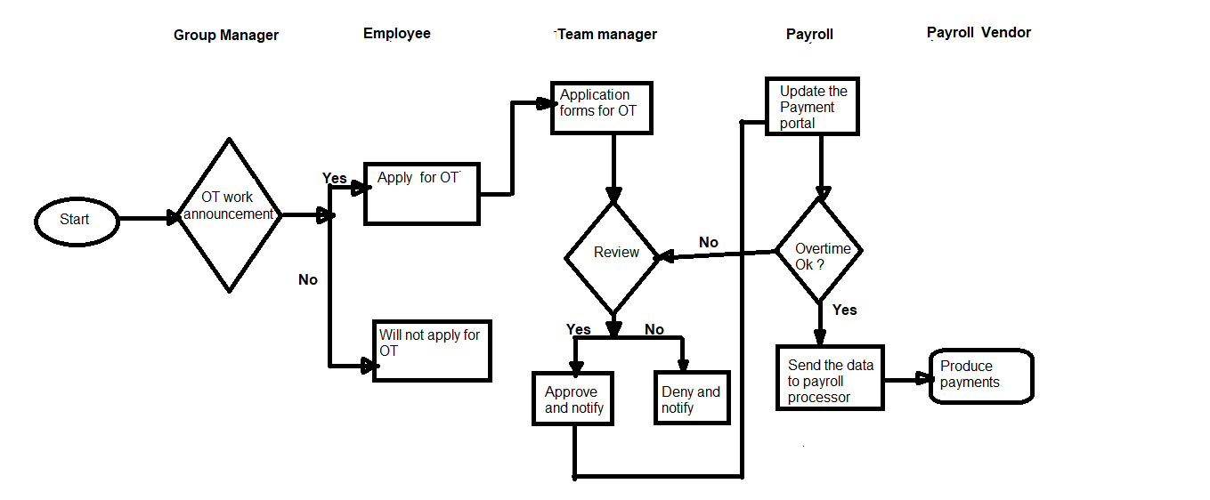

# **SharePoint Workflow Tool**

Workflows automate business process. They provide rules, conditions and actions for automatic behavior and tasks on lists and libraries that generally produce an outcome.

## **Approval Workflow**

The best suitable workflow tool for the above scenario is approval workflow.

In VSN company in order to pay the employees for the overtime work done ,it requires approval from various heads of the organization to verify their presence , so the Approval workflow lets you route documents and other items stored in SharePoint to one or more people for their approval.

VSN company automates and standardizes overtime payroll process by routing documents, requests, forms and tasks through configurable [approval workflows](https://www.cornerstoneondemand.com/link) to reduce errors, costs, and paperwork.

## **Reasons to choose approval workflow**

The following are some of the reasons to select approval workflow

**Automated approval routing**

The biggest advantage of automated approval workflow is easy to use. When you submit the request, it gets routed to automated approval software for approval after undergoing the steps that are built in workflow. This helps in getting rid of manual paperwork to be done which is time consuming process.

**Proxy and out-of-office delegation**

**The absence of approver due to health conditions, travel or vacation doesn’t delay the process that should be done. This proxy approver ant out-of-office delegation helps to manage the approval and keep moving the flow of request without approval presence and the approval workflow software helps to improve the process gaps.**

Proxy and out-of-office delegation highly benefit the payment processing since it should be done on time without any delays

**Less work for you**

  An Approval workflow saves you and your colleagues both time and trouble, and at the same time streamlines and standardizes your approval process.

# **References**

Smith,t. (2016). SharePoint 2016 User’s Guide: Learning Microsoft’s Business Collaboration Platform, Fifth Edition, 2016, Apress.

Microsoft. (n.d). All about approval workflow. Retrieved :<https://support.office.com/en-us/article/all-about-approval-workflows-078c5a89-821f-44a9-9530-40bb34f9f742>

Stanton Jandrell. (n.d). Key benefits of approval workflow automation. Retrieved from :<https://www.fraxion.biz/blog/key-benefits-of-approval-workflow-automation>