Assignment - 1

Kartik Velede

INFO8950 Capstone Project

Professor Srdjan Manojlovic

Date assignment posted: September 08,2020

Date assignment due: September 14, 2020

**Table of Contents**

**Project Summary 3**

**Executive Summary 4**

**Company Background 4**

**Identification of Needs & Opportunity 4**

**General Requirements 5**

**Project Plan 5**

**Scope of work 6**

**Proposed Solution 6**

**Benefits of the Proposal 7**

**Cost Requirements and budget 7**

**Risks 7**

**Conclusion 7**

**References 7**

# Project Summary

|  |  |
| --- | --- |
| PROJECT TITLE | Assignment -1 Capstone project |
| NAME OF ORGANIZATION | Conestoga College |
| PRIMARY CONTACT | Kartik Velede |
| PROJECT DESCRIPTION | Conestoga college was established in the year 1967. Conestoga academic institution is leading in polytechnic education in Ontario.  Conestoga college has approximately 23000 full-time students , 30,000 part-time students with 2000 employees in 200 different departments .  One of the major challenges the academic institution is facing an issue with data organization, file sharing and the outdated software to support the growing demand in the institution.  By analysing the above problems using existing advance technologies the appropriate solution is given. |
| PREPARED BY ORGANIZATION | VSN Slovs |
| KEY SPONSOR | Kartik Velede |
| PRODUCT OWNER | Siri Chandana |
| BUSINESS ANALYST | Akshay Varma |
| BUSINESS ANALYST | Hemomsu Subodh |

# Executive Summary

By analysing the problem that are being faced by the institution, VSN Solvs came up with solution called SharePoint that will put an end to all the problems in the organization. SharePoint is best tool in organizing the data and files according to departments which in turn helps in sharing of files easy, overcoming the dead data can be achieved , permission are given according to the roles so the option to do changes to files can be done with out any request to IT team and the changes made to files will be notified to every employee through notification bar.

# Company Background

Conestoga college was established in the year 1967. Conestoga academic institution is leading in polytechnic education in Ontario.

Conestoga college has approximately 23000 full-time students , 30,000 part-time students with 2000 employees in 200 different departments .

One of the major challenges the academic institution is facing an issue with data organization, file sharing and the outdated software to support the growing demand in the institution.

# Identification of Needs & Opportunity

The following are the needs and the opportunity of the client.

1. Sharing of file with different departments is made easy by using the SharePoint collaborative tools called project scheduling.
2. File hosting services in SharePoint such as OneDrive is very useful for institution to get the solution for many issues.
3. The security features in SharePoint protects the confidential data.

# General Requirements

The following are the some of the of the general business requirements

1. To automat the process to improve the business
2. Organizing the data in such way that it meets the business requirements.
3. To support the business growth permissions needs to be managed appropriately.
4. Improving the sharing of files between different departments and also the collaboration among them.

# Project Plan

Below are the followings steps that demonstrate the project plan.

1. Knowing the client needs
2. Analysing the problem from the project
3. Requirements Gathering
4. Validating the requirements
5. Developing the plan according to requirements
6. Executing the plan
7. Maintaining the developed project
8. Training the employees with the new environment developed

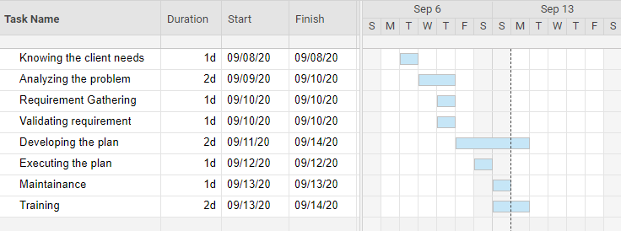

Figure 1: The above image shows the Gantt chart for Project Plan

# Scope of work

The main scope of this project is to overcome the issues in the project.

The following are in-scope of project

1. Enterprise content and document management
2. Collaborative software
3. File hosting services

The following are out of scope

1. Social network
2. Custom Web application

# Proposed Solution

One of the major challenges the academic institution is facing an issue with data organization, file sharing and the outdated software to support the growing demand in the institution. SharePoint is the best solution which meets the client needs.

# Benefits of the Proposal

1. Enterprise content and document management will help in data organization
2. File hosting service is one of the best features provided by SharePoint for sharing of file with different departments

# Cost Requirements and budget

SharePoint Online plan 2 costs $5 per user/month and the maintenance, security supports are everything provided by Microsoft. Hardware cost is $200 per user. Executing the plan costs $1000 and training the employees on new environment costs around $90.

# Risks

1. Awareness in the SharePoint Content
2. Permission being misconfigured
3. Network issue sin SharePoint
4. Giving access to secure data to all the employees.

# Conclusion

Overall, I would recommend SharePoint as the best solution to put an end to all the issues Client is facing.

# References

1. Cost of SharePoint

<https://www.microsoft.com/en-us/microsoft-365/sharepoint/compare-sharepoint-plans>

1. SharePoint Overview

<https://en.wikipedia.org/wiki/SharePoint>

1. Risks in SharePoint

<https://www.itprotoday.com/file-sharing-and-management/top-10-sharepoint-content-security-risks-and-what-do-about-them>