Assignment 8 - Analysis

Student Name: Kartik Velede

Student Number: 8672907

Course Code: INFO8950

Course Instructor: Srdjan Manojlovic

Assignment Due Date: December 8, 2020

**Table of Contents**

**Requriment Gathering Document analysis 3**

**BRD Baseline Document Analysis 4**

**Migration Project Analysis 5**

# Requriment Gathering Document analysis

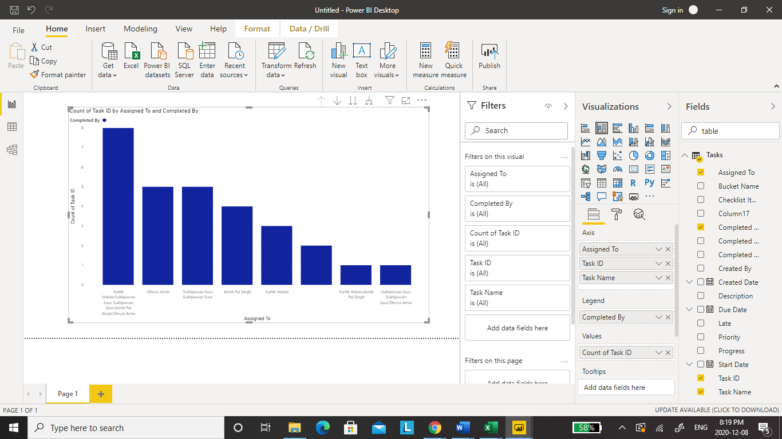

The above graph shows the Graphical represtnation of all the tasks that were assigned to a team member during documenting requirmnet gathering.

# BRD Baseline Document Analysis

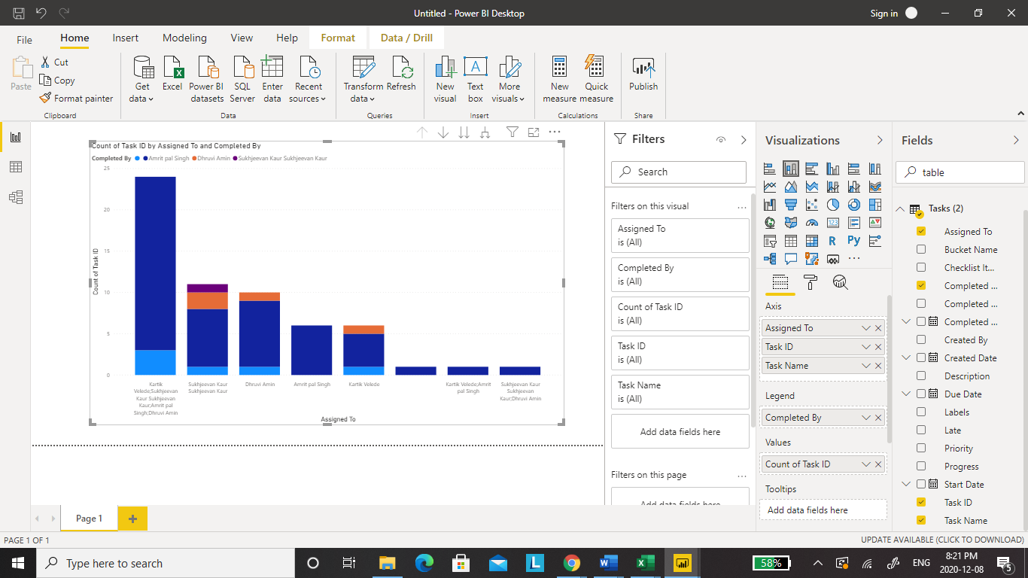

The above graph demonstartes the graphical respresentation of the work done by an individual in a team during BRD documnetation.

# Migration Project Analysis

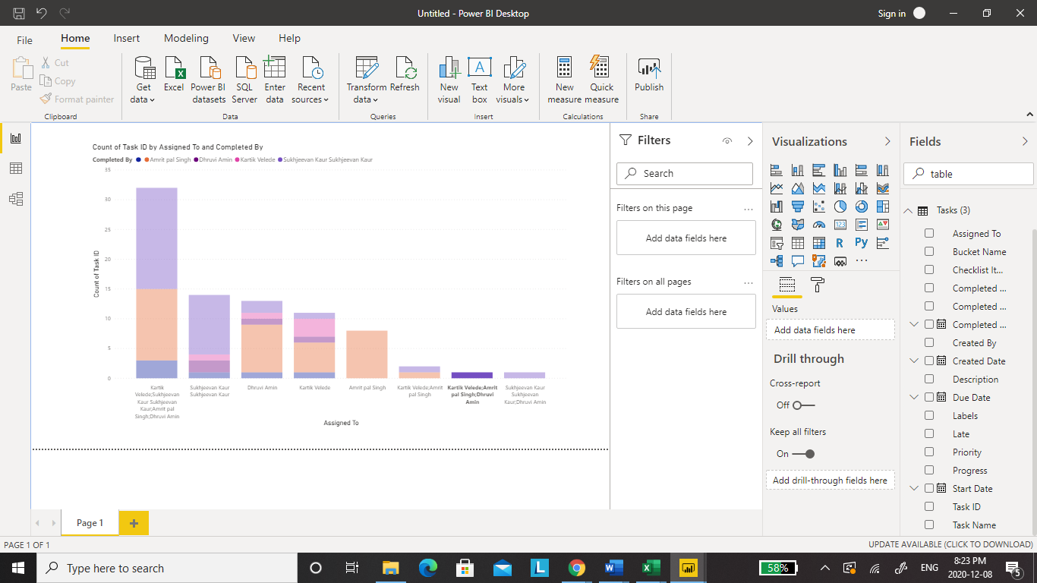

The above show all the works done by teammates during migration process from on-premise to Cloud.