WEEK-2
Name : V.Karthik
Roll Number : 2520030053

- CREATE TABLE NAME LOANS
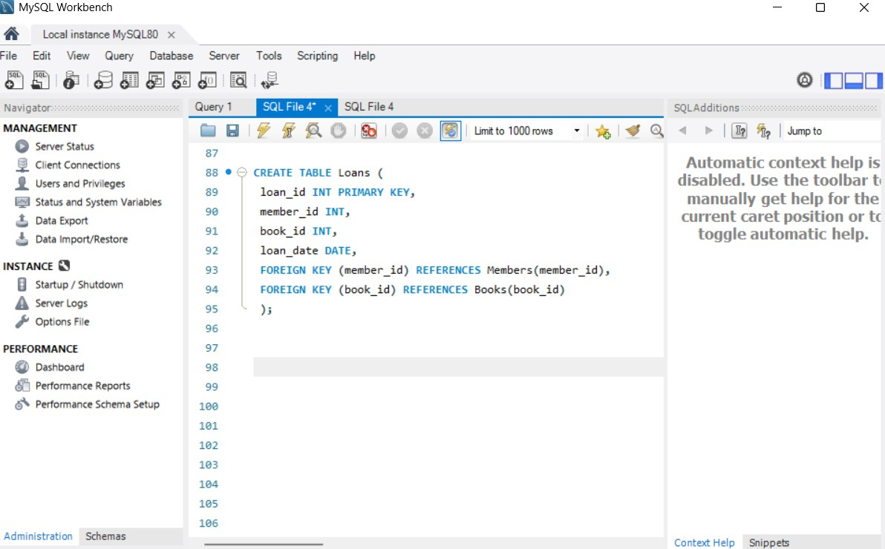

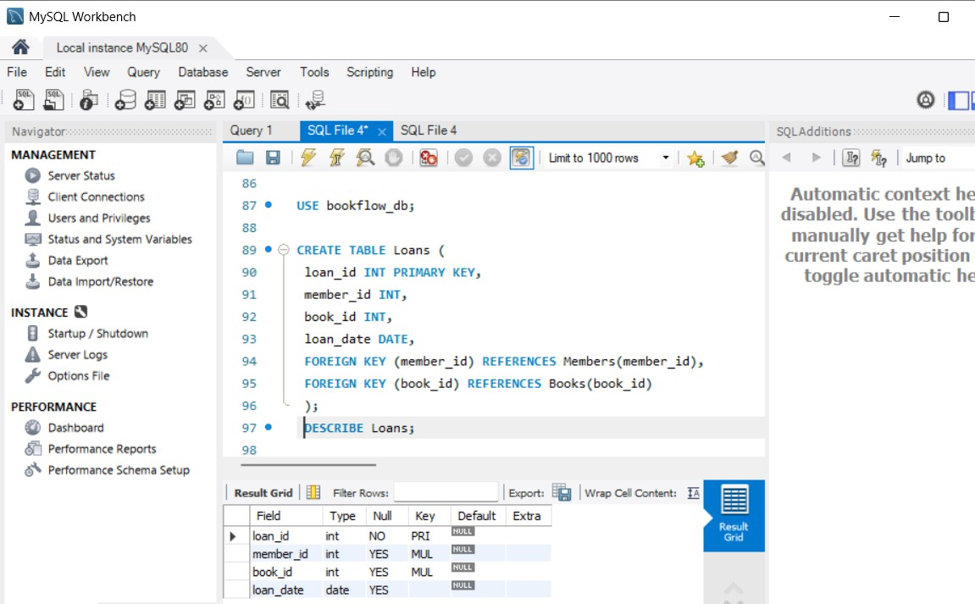

- JOIN QUERY COMBINED TWO TABLES

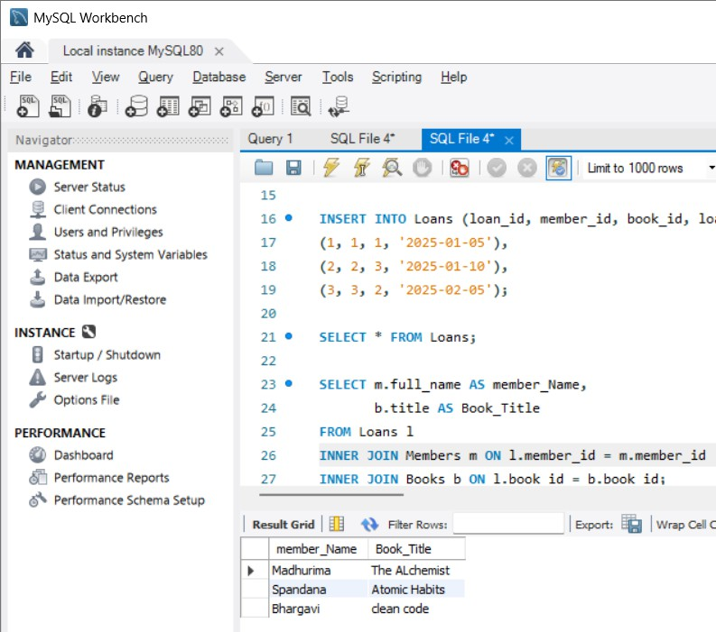

- TRANSACTION QUERIES

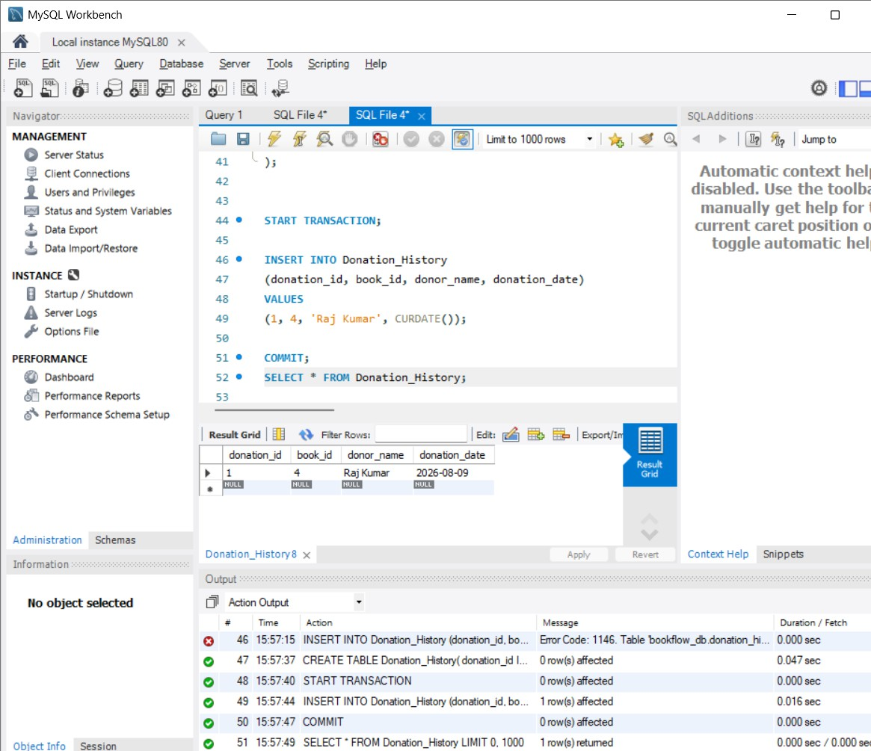

3. INDEX ON ISBN FROM FAST SEARCH

