CITY-WIDE AI ENGINE FOR MULTI-CAMERA ANPR TRAJECTORY TRACKING AND URBAN TRAFFIC ANALYTICS
A Project Report Submitted in Partial Fulfilment of the Requirements
for the Award of the Degree of
BACHELOR OF TECHNOLOGY
in
COMPUTER SCIENCE AND ENGINEERING
by
[TEAM MEMBERS AND REG. NOS.]
Under the Guidance of
[GUIDE NAME AND DESIGNATION]
DEPARTMENT OF COMPUTER SCIENCE AND ENGINEERING
[INSTITUTION / UNIVERSITY NAME]
[MONTH YEAR]

DEPARTMENT OF COMPUTER SCIENCE AND ENGINEERING
[INSTITUTION / UNIVERSITY NAME]
CERTIFICATE
This is to certify that the project report entitled "City-Wide AI Engine for Multi-Camera ANPR Trajectory Tracking and Urban Traffic Analytics" is a bonafide record of the work carried out by [TEAM MEMBERS AND REG. NOS.] in partial fulfilment of the requirements for the award of the degree of Bachelor of Technology in Computer Science and Engineering from [INSTITUTION / UNIVERSITY NAME] during the academic year 2026–2027.
The results embodied in this report have not been submitted to any other university or institute for the award of any degree or diploma.
[GUIDE NAME AND DESIGNATION]  Project Guide  Department of Computer Science & Engineering | [HOD NAME]  Head of the Department  Department of Computer Science & Engineering

Internal Examiner: _______________________ External Examiner: _______________________

ACKNOWLEDGEMENT
We express our sincere gratitude to [INSTITUTION / UNIVERSITY NAME] for providing the academic infrastructure, computing facilities, and research environment required to carry out this final-year B.Tech project.
We convey our profound gratitude and respect to our project guide, [GUIDE NAME AND DESIGNATION], Department of Computer Science and Engineering, for continuous technical guidance, constructive critique, and encouragement throughout the design, software implementation, and experimental evaluation of this system.
We express our heartfelt gratitude to [HOD NAME], Head of the Department of Computer Science and Engineering, for providing administrative support and academic facilities.
We thank our project review coordinators and all faculty members of the Department of Computer Science and Engineering for their valuable reviews and suggestions during internal milestone presentations.
Finally, we thank our parents, family members, and friends for their continuous patience, understanding, and encouragement throughout this work.
[TEAM MEMBERS AND REG. NOS.]
Final-Year B.Tech Students

ABSTRACT
Urban traffic surveillance networks generate millions of video frames daily across distributed roadside cameras. However, municipal traffic management centres struggle to convert disjoint camera observations into continuous spatial journeys, actionable congestion intelligence, and automated surveillance alerts without intensive manual intervention. In this work, we design and implement an end-to-end city-wide artificial intelligence engine that connects automated number-plate recognition (ANPR), multi-camera trajectory tracking, and real-time surveillance analytics.
The system operates on a dual-pathway architecture. On real video sequences and held-out photographs, an Ultralytics YOLOv8s detector localises license plates with 98.3% precision, 98.1% recall, and 84.3% mAP50-95. A Compact Convolutional Transformer (CCT-s-v2) optical character recogniser, fine-tuned on real Indian plate crops, attains 95.7% character-level accuracy and 76.9% full-plate exact match accuracy. When deployed across multi-frame video clips with ByteTrack and positional confidence-weighted voting, consensus accuracy reaches 90.00% (18 of 20 test sequences), while an automated quality assurance rule flags low-confidence readings (OCR confidence or vote margin below 0.80) for human operator review.
On a simulated road network of Bangalore (5 km radius, 40 camera nodes, 5,000 vehicles), the spatial database ingests 31,244 noisy sightings (5% miss rate, 8% confusable character error). A graph-theoretic trajectory reconstruction engine with canonical 3-partition fuzzy indexing achieves 99.95% precision, 96.35% recall, and 97.91% F1-score with 15.82 ms average query latency. A multi-rule surveillance engine detects 100% (5 of 5) of injected cloned-plate anomalies through shortest-path speed feasibility analysis (>120 km/h) and achieves 100% precision with 93.6% recall on vehicle blacklist matching. Furthermore, an AI City Challenge vehicle counting prototype demonstrates that calibrating directional ingress/egress centroids improves test movement counting F1-score from 17.9% to 65.1%. All capabilities are served through a unified FastAPI gateway and interactive web dashboard.
Keywords: Automated Number-Plate Recognition, Trajectory Reconstruction, Graph Routing, ByteTrack, Multi-Frame Consensus Voting, Urban Traffic Analytics, Surveillance Alerting.

TABLE OF CONTENTS
Certificate ....................................................... ii
Acknowledgement .................................................. iii
Abstract .......................................................... iv
List of Tables ................................................... vii
List of Figures ................................................. viii
List of Symbols and Abbreviations ................................. ix
1. INTRODUCTION .................................................... 1
1.1 Introduction ................................................ 1
1.2 Major Challenges ............................................ 2
1.2.1 Real-World License Plate Optical Character Recognition .. 2
1.2.2 Tracking and Identity Preservation Across Cameras ...... 3
1.2.3 Privacy Considerations and Operator Data Protection .... 4
1.2.4 Absence of Labelled City-Scale ANPR Trajectory Data .... 4
1.3 Proposed Solutions and Key Contributions .................... 5
1.4 Background and Motivation ................................... 6
1.5 Overview of the Proposed System ............................. 8
1.6 Objective of the Work ....................................... 9
1.7 Organization of the Report ................................. 10
2. RELATED WORK AND THEORETICAL STUDY ............................. 11
2.1 License Plate Detection and OCR Techniques ................. 11
2.2 Multi-Object and Multi-Camera Vehicle Tracking ............. 13
2.3 City-Scale Trajectory Reconstruction Datasets .............. 15
2.4 Urban Traffic Flow Analytics and Anomaly Alert Systems ..... 16
2.5 Vehicle Movement Counting Benchmarks ....................... 18
2.6 Theoretical Foundations and Metric Formulations ............ 19
2.6.1 Precision, Recall, and F1-Score ....................... 19
2.6.2 Mean Average Precision (mAP) .......................... 20
2.6.3 Character-Level and Full-Plate Exact Match Accuracies .. 21
2.6.4 Wilson Score Confidence Interval Formulation .......... 22
2.6.5 Temporal Event Matching Metric ........................ 23
2.7 Research Gap and Comparative Analysis ...................... 24
3. EXPERIMENTAL STUDY ............................................. 26
3.1 Requirements and Measurable Targets ........................ 26
3.2 System Architecture and Execution Pipeline ................. 28
3.3 Dataset Curation, Deduplication, and Isolation ............. 30
3.4 Perception Module Design ................................... 32
3.4.1 YOLOv8s License Plate Detector ........................ 32
3.4.2 Temporal Tracking with ByteTrack ...................... 33
3.4.3 CCT-s-v2 Optical Character Recogniser ................. 34
3.4.4 Multi-Frame Consensus Voting and Quality Assurance .... 35
3.5 City-Scale Road Simulator .................................. 36
3.5.1 Bangalore OpenStreetMap Network Graph ................. 36
3.5.2 Sensor Network Placement .............................. 37
3.5.3 Synthetic Fleet Mobility Modeling ..................... 38
3.5.4 Optical Sensor Noise and Surveillance Anomaly Injection .. 39
3.6 Database Design and Persistence Layer ...................... 40
3.7 City Layer: Trajectory Reconstruction and Analytics Engines .. 42
3.7.1 Cross-Camera Trajectory Reconstruction Engine ......... 42
3.7.2 Macroscopic Traffic Analytics Engine .................. 44
3.8 Real-Time Surveillance Alert Engine ........................ 45
3.9 API and Interactive Dashboard .............................. 47
3.9.1 RESTful and WebSocket API Specifications .............. 47
3.9.2 Interactive Municipal Command Dashboard ............... 49
3.10 AI City Vehicle Counting Prototype ........................ 51
3.10.1 Dataset Characteristics and Region of Interest ....... 51
3.10.2 Counting Pipeline and Assignment Logic ............... 53
3.10.3 Empirical Trajectory Calibration Methodology ......... 54
3.11 Experimental Setup and Hardware/Software Environment ...... 55
3.12 Automated Testing Strategy ................................ 57
4. RESULTS AND DISCUSSIONS ........................................ 59
5. CONCLUSIONS AND FUTURE SCOPE ................................... 75
APPENDICES ........................................................ 79
REFERENCES ........................................................ 90
LIST OF PUBLICATIONS .............................................. 92

LIST OF TABLES
Table 2.1: Comparative Analysis of Base Papers with the Proposed System .. 25
Table 3.1: System Requirements and Measurable Engineering Targets ... 27
Table 3.2: Experimental Hardware and Software Computing Environment .. 56
Table 3.3: Dataset Curation, Split Allocations, and Leakage Prevention .. 31
Table 3.4: Relational Database Schema Specifications and Field Definitions .. 41
Table 3.5: RESTful API and WebSocket Endpoint Specifications ........ 48
Table 3.6: Surveillance Alert Engine Rule Configuration and Severity Parameters .. 46
Table 3.7: AI City Challenge Camera 5 Movement Vector Definitions ... 52
Table 4.1: YOLOv8s License Plate Detector Performance on Test Split (N=184) [REAL] .. 60
Table 4.2: License Plate Optical Character Recognition Progression Across Regimes [REAL] .. 61
Table 4.3: End-to-End System Evaluation on Held-Out Indian Test Photographs (N=167) [REAL] .. 62
Table 4.4: Video Plate Voting Performance Across Real Sequences and Synthetic Clips .. 64
Table 4.5: Qualitative Breakdown of Failed Plate Reads in Video Evaluation [REAL] .. 65
Table 4.6: Trajectory Reconstruction Engine Accuracy and Latency Benchmarks [SIMULATED] .. 66
Table 4.7: Surveillance Alert Engine Empirical Evaluation and False Alarm Audit [SIMULATED] .. 68
Table 4.8: Movement Counting Performance on Test Split (frames >= 300) (v1 vs. v2) [REAL] .. 71
Table 4.9: Comprehensive Requirements vs. Achieved Performance Audit .. 72

LIST OF FIGURES
Figure 1.1: City-Wide ANPR System Architecture (Block Diagram) ....... 8
Figure 1.2: End-to-End System Data Flow Diagram (DFD) ................ 9
Figure 3.1: Video Perception & Plate Recognition Pipeline ........... 29
Figure 3.2: Multi-Frame Consensus Voting and Quality Assurance Logic .. 35
Figure 3.3: City-Scale ANPR Simulator Architecture & Event Generation .. 37
Figure 3.4: Relational Entity-Relationship Diagram (SQLite Database Schema) .. 40
Figure 3.5: Cross-Camera Trajectory Reconstruction & Fuzzy Search Engine .. 43
Figure 3.6: Multi-Rule Surveillance Alert Engine Evaluation Pipeline .. 45
Figure 3.7: REST API and WebSocket Surveillance Streaming Sequence .. 47
Figure 3.8: Unified Traffic Intelligence Dashboard Interface Layout .. 49
Figure 3.9: AI City Challenge Vehicle Counting & Trajectory Assignment .. 53
Figure 3.10: AI City Challenge Camera 5 Region of Interest and Movement Vectors .. 51
Figure 3.11: Project Repository Hierarchy and Deployment Architecture .. 57
Figure 3.12: Project Implementation Methodology and Milestone Timeline .. 58
Figure 3.13: Dashboard Overview Tab with KPI Cards and Hourly Flow Chart .. 50
Figure 3.14: Trajectory Search Interface with Chronological Sighting Table .. 50
Figure 3.15: Traffic Heatmap Visualisation across Bangalore Intersections .. 50
Figure 3.16: Live Surveillance Alert Feed with Severity Classification .. 50
Figure 3.17: Municipal Blacklist Management and Vehicle Sighting Audit .. 50
Figure 3.18: Single-Image Plate Reader Testing Console with Review Tag .. 50
Figure 4.1: License Plate Recognition (OCR) Progression Across Training Regimes [REAL] .. 61
Figure 4.2: YOLOv8s License Plate Detector Quantitative Evaluation [REAL] .. 60
Figure 4.3: End-to-End Plate Recognition Benchmark on Held-Out Test Photos [REAL] .. 63
Figure 4.4: Temporal Consensus Voting Accuracy Across Real & Synthetic Sequences .. 64
Figure 4.5: Surveillance Alert Engine Incident Classification & Severity Breakdown [SIMULATED] .. 69
Figure 4.6: Cross-Camera Trajectory Reconstruction Performance & Latency Benchmarks [SIMULATED] .. 67
Figure 4.7: Vehicle Movement Counting Performance (v1 Visual vs. v2 Calibrated) [REAL] .. 71

LIST OF SYMBOLS AND ABBREVIATIONS
AICity | AI City Challenge (IEEE Smart World Congress Benchmark)
ANPR | Automated Number-Plate Recognition
API | Application Programming Interface
ByteTrack | Multi-Object Tracking by Associating Every Detection Box
CCT | Compact Convolutional Transformer
CI | Confidence Interval (Wilson score formulation at 95% confidence level)
COCO | Common Objects in Context Benchmark
Dijkstra | Dijkstra's Single-Source Shortest-Path Graph Algorithm
ER | Entity-Relationship (Database Schema)
F1 | Harmonic Mean of Precision and Recall (2 * P * R / (P + R))
FastAPI | Modern Asynchronous Web Framework for Building RESTful APIs in Python
FN / FP / TP | False Negative / False Positive / True Positive
HSRP | High-Security Registration Plate
IoU | Intersection over Union (Jaccard Index between bounding boxes)
Levenshtein | Edit Distance Metric for String Character Insertions, Deletions, Substitutions
LOS | Level of Service (Urban Road Traffic Condition Rating)
LPRNet | License Plate Recognition Deep Neural Network Architecture
mAP | Mean Average Precision across object detection classes
mAP@50 | Mean Average Precision at an Intersection-over-Union threshold of 0.50
mAP@50-95 | Mean Average Precision averaged from IoU 0.50 to 0.95 with step size 0.05
MTMC | Multi-Target Multi-Camera Vehicle Tracking
OCR | Optical Character Recognition
OD | Origin-Destination Traffic Matrix
ONNX | Open Neural Network Exchange Runtime Format
OSM / OSMnx | OpenStreetMap / Python Street Network Modeling Library
P95 | 95th Percentile Query Execution Latency
Re-ID | Vehicle Re-Identification Across Disjoint Camera Views
REST | Representational State Transfer Architectural Style
REVIEW | Low-Confidence Optical Character Recognition Operator Audit Flag
ROI | Region of Interest Polygon Boundary
SQLite | Embedded Self-Contained Serverless Relational Database Engine
WebSocket | Full-Duplex Bidirectional Persistent Network Communication Protocol
Wilson | Wilson Score Interval for Binomial Confidence Proportions
YOLO | You Only Look Once (Real-Time Object Detection Framework)

1. INTRODUCTION
1.1 Introduction
Urban transportation networks in modern metropolitan centres handle millions of vehicular trips every day. Rapid vehicular expansion strains existing arterial road corridors, resulting in severe traffic congestion, elevated carbon emissions, transit delays, and elevated road accident rates. Effective metropolitan traffic governance demands real-time situational awareness across dozens or hundreds of distributed monitoring locations. Municipal authorities increasingly deploy automated number-plate recognition (ANPR) camera networks across key intersections, toll barriers, arterial entry corridors, and expressway flyovers to track traffic density, identify stolen or wanted vehicles, and support incident investigations.
Traditional ANPR deployments operate primarily as isolated, point-based optical sensors. A standalone camera captures passing vehicles, runs an onboard character recognition algorithm, and logs single-point sightings into a siloed database. While single-point logging confirms that a specific vehicle passed an isolated checkpoint at a given timestamp, it cannot reconstruct the vehicle's spatial journey across the wider urban road network. Isolated cameras fail to reveal route progression, average transit velocities across intermediate road segments, or systemic congestion bottlenecks that develop between sensors. Furthermore, municipal operators face an unmanageable volume of raw plate sightings, making manual cross-camera correlation impractical during urgent law-enforcement investigations or city-scale traffic planning.
In this project, we design, build, and evaluate an integrated city-wide artificial intelligence engine that bridges the gap between single-camera computer vision and macroscopic urban traffic intelligence. The system couples deep-learning visual perception with graph-theoretic trajectory reconstruction, high-throughput spatial storage, automated multi-rule surveillance alerting, and interactive web visualization. By unifying edge perception with central graph analytics, the platform converts discrete, noisy sensor sightings into coherent vehicular journeys, computes empirical traffic flow metrics, and automatically detects high-priority security anomalies in real time.
1.2 Major Challenges
Developing an end-to-end city-wide ANPR intelligence system presents substantial theoretical and engineering hurdles across computer vision, distributed data engineering, and spatial graph algorithms.
1.2.1 Real-World License Plate Optical Character Recognition
Accurate optical character recognition (OCR) of vehicle registration plates under real-world traffic conditions remains notoriously difficult. In developing countries such as India, vehicle license plates exhibit high structural variability. While the central government mandates standardised High-Security Registration Plates (HSRP) conforming to regular alphanumeric regex patterns, millions of vehicles still carry older or non-standard plates. These display non-standard typefaces, non-uniform character kerning, regional state prefixes, trade certificate (TC) dealer notations, and custom decorative styling.
Furthermore, outdoor roadside cameras capture moving vehicles across diverse illumination regimes, ranging from harsh midday glare to deep nighttime shadows. Optical sensors encounter severe perspective distortion due to camera mounting angles, motion blur from high-speed travel, lens dirt, rain precipitation, and partial occlusions by vehicle bodywork or tow bars. As our empirical benchmarks demonstrate, standard off-the-shelf OCR engines achieve less than 38% exact plate match accuracy on real Indian road crops without domain-specific training. A single misread character invalidates the entire registration string, breaking cross-camera identification.
1.2.2 Tracking and Identity Preservation Across Cameras
Maintaining vehicle identity across non-overlapping, distributed camera views represents a core research challenge in intelligent transportation systems. Multi-target multi-camera (MTMC) tracking typically relies on visual vehicle re-identification (Re-ID) algorithms that extract deep appearance embeddings from vehicle bodywork. However, urban vehicle fleets exhibit immense intra-class visual similarity: thousands of commercial hatchbacks and sedans share identical paint codes, chassis silhouettes, and trim packages. Visual appearance alone cannot reliably distinguish two silver hatchbacks traversing parallel arterial corridors.
License plate text provides the single definitive unique identifier for motor vehicles. Nevertheless, because cameras are spaced hundreds of metres or several kilometres apart, continuous video tracking is impossible between camera blind spots. When OCR engines generate noisy or corrupted plate strings, simple exact-match SQL queries fail to reconnect sightings belonging to the same journey. Resolving identity across disjoint cameras demands fault-tolerant fuzzy string matching coupled with physical velocity validation across the underlying road network graph.
1.2.3 Privacy Considerations and Operator Data Protection
Automated vehicle tracking across urban road networks raises significant civil liberty, personal privacy, and data protection concerns. Continuous vehicular trajectory logging creates a detailed record of private citizens' daily movements, dwelling locations, places of work, and personal habits. Compromise of an unencrypted central ANPR repository could expose sensitive citizen travel histories to unauthorised surveillance or commercial exploitation.
To maintain ethical compliance and alignment with emerging data protection regulations, an intelligent ANPR platform must incorporate strict privacy-by-design safeguards. Visual vehicle photographs must restrict operator access to cropped plate regions rather than full cabin views, driver faces must be obscured, and automated journey searches must enforce role-based access control. Furthermore, public data releases and evaluation benchmarks must anonymise personal registration strings, and system export functions must sanitise data outputs to prevent formula injection attacks against municipal spreadsheet applications.
1.2.4 Absence of Labelled City-Scale ANPR Trajectory Data
Supervised machine learning algorithms require large, accurately annotated training datasets. While isolated benchmarks exist for single-image vehicle plate detection (such as the CCPD or Indian Number Plate datasets), no publicly available, fully labelled dataset provides ground-truth vehicle trajectories linked to optical camera video feeds across a complete metropolitan street network. Real municipal ANPR feeds are strictly restricted due to statutory privacy laws and national security constraints.
Existing open urban trajectory benchmarks, such as the Jinan city dataset published by Yu et al. in 2023 [1], capture macroscopic vehicle trips across thousands of road network nodes. However, these datasets strip license plate strings, omit raw camera imagery, and obscure calendar dates to protect driver privacy. Conversely, computer vision benchmarks, such as the IEEE AI City Challenge [8], offer rich multi-camera video streams but restrict evaluation to localised intersection zones without city-scale trajectory ground truth. Developing and verifying an integrated city-wide ANPR engine therefore requires constructing a rigorous, synthetic road network simulator that models realistic vehicle mobility, camera placements, and sensor noise while validating visual perception components against real-world video footage.
1.3 Proposed Solutions and Key Contributions
To address these interconnected challenges, we design a dual-pathway architecture that combines physical camera vision with macroscopic spatial graph modeling. The primary technical contributions of this work are as follows:
• Dual-Pathway Perception and Simulation Architecture: We implement a modular architecture where real-world video feeds and synthetic city-scale mobility streams converge into a unified spatial database (data/city_anpr.db). This allows municipal operators to run identical trajectory reconstruction, flow analytics, and surveillance alerting engines over both physical camera streams and simulated urban fleets.
• Deep-Learning Perception Pipeline with Quality Assurance Review: We train and deploy a custom YOLOv8s license plate detector alongside an ONNX-optimized Compact Convolutional Transformer (CCT-s-v2) optical character recogniser. We implement a multi-frame temporal voting module that aggregates ByteTrack tracking sequences using character-position weighted consensus. To prevent automated misclassification from corrupting municipal records, we introduce an automated REVIEW flag that isolates any plate read where OCR confidence or vote margin falls below 0.80.
• High-Throughput Fuzzy Trajectory Reconstruction Engine: We develop a graph-theoretic journey router that queries OpenStreetMap road networks extracted via OSMnx. To overcome optical character corruptions, we build a canonical 3-partition fuzzy string index that searches plates within a weighted Levenshtein distance of 1.0 (with 0.3 penalty for confusable character substitutions like O-0 and B-8). The engine filters temporal duplicates, splits journeys exceeding 30 minutes of inactivity, and validates implied hop velocity against shortest-path road geometry.
• Real-Time Multi-Rule Surveillance Alert Engine: We design an event-driven surveillance engine that evaluates incoming sightings against multiple concurrent security rules, including exact and fuzzy blacklist matching, speed-feasibility cloned-plate anomaly detection (>120 km/h), prohibited vehicle curfew zones, and overspeeding. A 10-minute sliding window suppresses redundant alarms, delivering zero false alarms on verified fleet movements.
• Calibrated Vehicle Movement Counting Prototype: We construct a standalone vehicle counting module benchmarked against the IEEE AI City Challenge 2021 Track 1 dataset. We demonstrate that visual movement estimation yields severe spatial mismatch, whereas empirical trajectory calibration on the initial segment of a video improves directional counting F1-score from 17.9% to 65.1% on held-out test frames.
• Unified Web Application and Streaming Interface: We deploy all backend analytical models behind an asynchronous FastAPI server. The system exposes RESTful endpoints, streaming WebSockets, and an interactive HTML5/Leaflet dashboard supporting live map exploration, trajectory polylines, congestion heatmaps, and direct single-image inference.
1.4 Background and Motivation
The motivation for this project stems from the operational realities of municipal Traffic Management Centres (TMC) in rapidly expanding metropolitan areas. In cities such as Bangalore, traffic police command centres manage feeds from hundreds of roadside CCTV cameras. Operators face two primary operational bottlenecks: fragmented surveillance workflows and lagging macroscopic traffic intelligence.
In typical surveillance scenarios—such as tracking a stolen vehicle, identifying a hit-and-run suspect, or tracing an abducted child's vehicle—investigators must manually inspect recorded footage camera by camera. Operators manually note vehicle timestamps, estimate possible travel corridors, and telephone neighbouring control rooms to check downstream camera logs. This fragmented process introduces critical delays during golden-hour emergency responses. If a roadside camera misreads an '8' as a 'B' or an 'O' as a '0', standard database lookup queries return zero records, and the vehicle's trail goes cold. An automated trajectory engine capable of fuzzy character resolution, topological graph routing, and instant impossible-speed clone detection provides immediate operational value to law-enforcement personnel.
Concurrently, urban planners require macroscopic traffic flow metrics to design signal timing schedules, implement congestion pricing, and identify bottleneck corridors. Traditional loop detectors and pneumatic road tubes are expensive to install, vulnerable to asphalt resurfacing damage, and incapable of identifying vehicular origin-destination (OD) patterns. Because ANPR cameras capture unique vehicular identifiers across space and time, an aggregated ANPR stream naturally yields comprehensive OD matrices, link travel times, and intersection level-of-service (LOS) metrics without extra road hardware. Connecting computer vision directly to urban graph analytics creates a cost-effective, dual-use platform serving both law enforcement and municipal urban planning.
1.5 Overview of the Proposed System
The proposed system comprises nine modular subsystems organised into visual perception, spatial persistence, graph analytics, and web presentation. Figure 1.1 illustrates the comprehensive block diagram of the system architecture, detailing the convergence of the real perception pathway and the simulated city pathway into the shared spatial database.
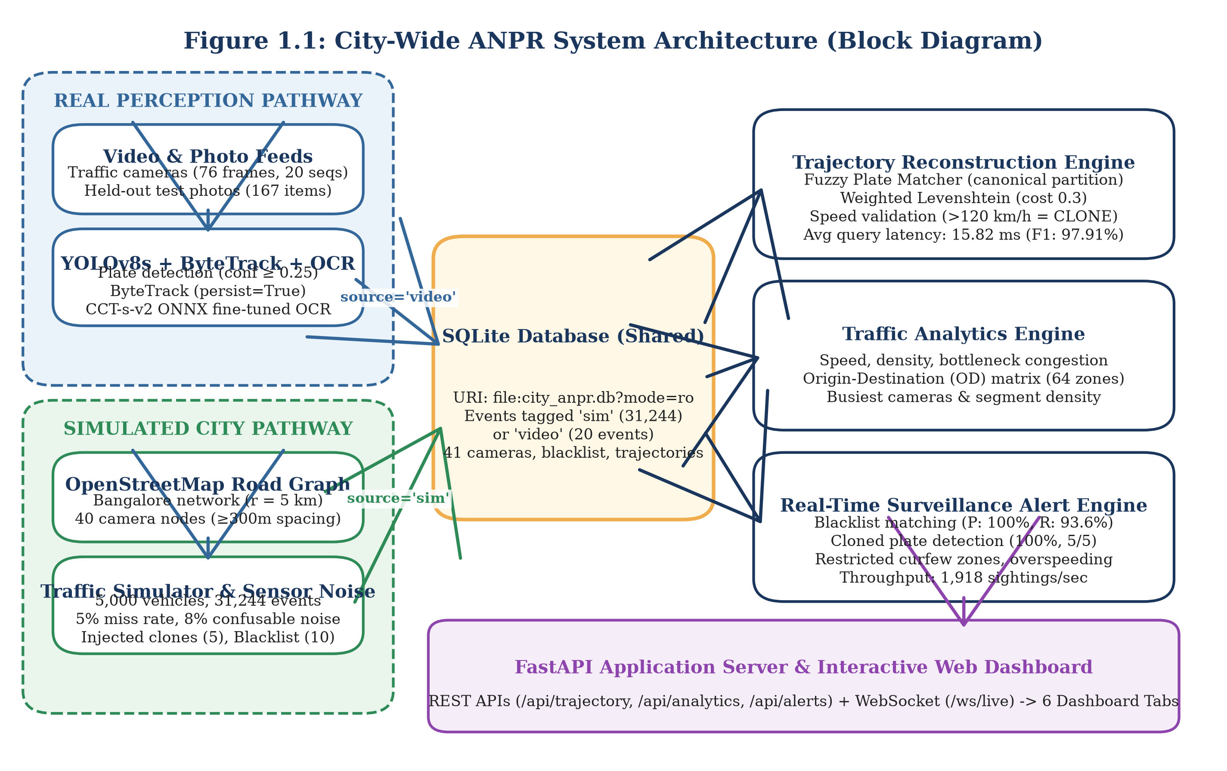
Figure 1.1: City-Wide ANPR System Architecture (Block Diagram)
Figure 1.2 details the corresponding end-to-end data flow diagram (DFD), illustrating the transformation of raw sensor inputs through validation, storage, and analytical query engines.
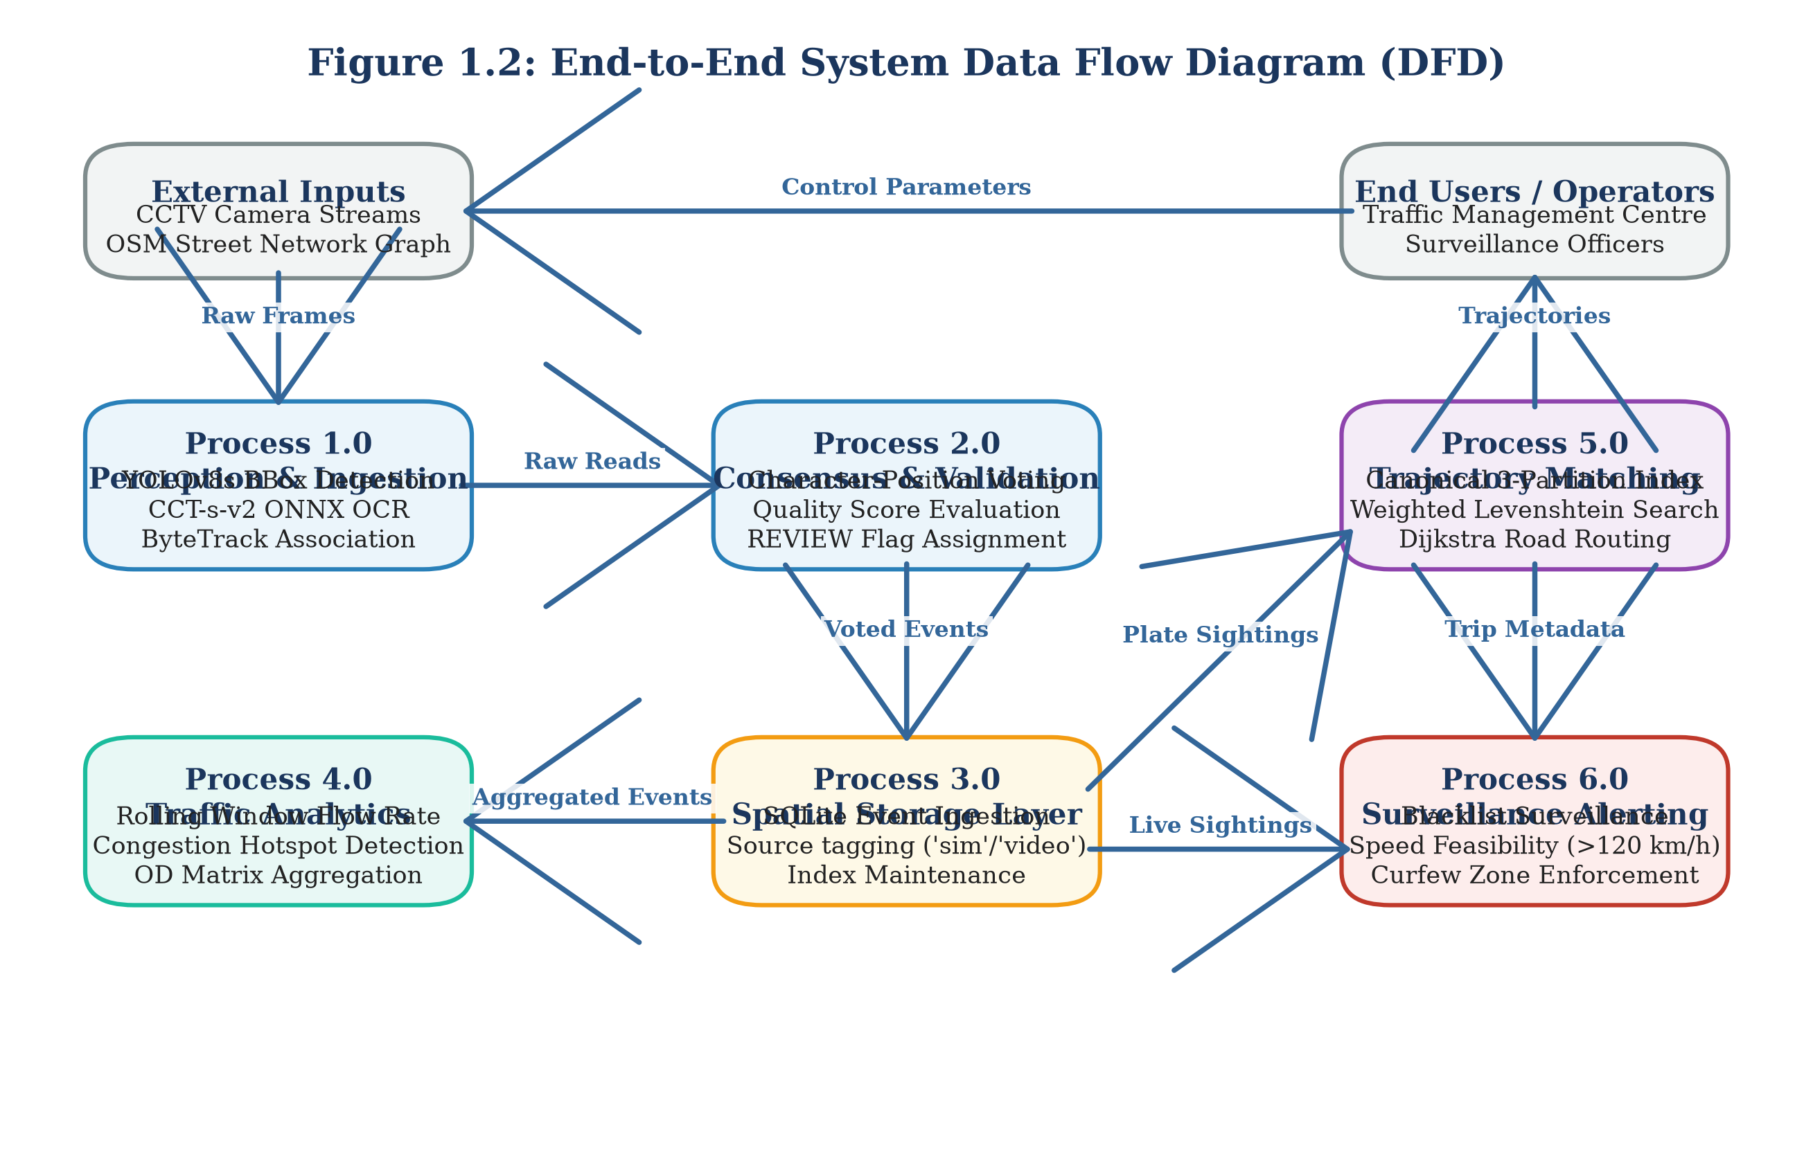
Figure 1.2: End-to-End System Data Flow Diagram (DFD)
1.6 Objective of the Work
1. High-Accuracy License Plate Detection: Train and optimize an Ultralytics YOLOv8s object detector on real Indian traffic scenes, achieving greater than 95.0% precision, recall, and mAP@50 on held-out test splits.
2. Robust Optical Character Recognition: Fine-tune a lightweight Compact Convolutional Transformer (CCT-s-v2) on real Indian plate crops, targeting greater than 95.0% character-level accuracy and evaluating full-plate exact match performance under single-frame and multi-frame video voting regimes.
3. Temporal Multi-Frame Consensus Voting: Implement a confidence-weighted voting module using ByteTrack multi-object tracking to improve video plate recognition accuracy over single-frame baseline reads, coupled with an empirical quality assurance threshold (REVIEW_CONFIDENCE_THRESHOLD = 0.80) to isolate low-confidence predictions.
4. City-Scale Road Network & Fleet Simulation: Construct a realistic urban traffic simulator on Bangalore's road network using OSMnx, modeling 40 cameras, 5,000 vehicles, realistic diurnal traffic flow, optical sensor noise, and injected security scenarios (stolen vehicles, cloned plates, curfew violations).
5. Sub-50 Millisecond Trajectory Reconstruction: Develop a spatial trajectory reconstruction engine that tolerates OCR character corruptions via weighted Levenshtein matching, validates hop speed feasibility (>120 km/h) to isolate cloned plates, and delivers sub-50 ms query response times with F1-score exceeding 90.0%.
6. Real-Time Surveillance Alert Engine: Implement a multi-rule surveillance engine capable of processing over 1,000 sightings per second, achieving 100% precision on blacklist alerts with zero false alarms after sliding-window de-duplication.
7. Directional Vehicle Movement Counting: Prototype an intersection vehicle counting algorithm on the IEEE AI City Challenge 2021 Track 1 benchmark, establishing an empirical calibration methodology to assign vehicle trajectories to 12 distinct directional movement paths.
8. Interactive Municipal Command Dashboard: Expose all analytical models through a unified FastAPI REST and WebSocket gateway, providing municipal operators with a responsive HTML5/Leaflet web dashboard.
1.7 Organization of the Report
The remainder of this report is organized into four main chapters and supporting appendices:
Chapter 2 (Related Work and Theoretical Study): Reviews existing literature in automated license plate recognition, multi-object and cross-camera vehicle tracking, macroscopic trajectory datasets, urban traffic analytics, and vehicle counting benchmarks. Formulates the core mathematical equations for computer vision metrics, statistical confidence intervals, and graph routing distance functions. Concludes with a detailed research gap analysis and comparative matrix (Table 2.1) contrasting base papers with our proposed architecture.
Chapter 3 (Experimental Study): Details the complete engineering design, system specifications, hardware/software environments, and dataset curation procedures. Explains the perception pipeline, simulation mechanics, SQLite database schema, trajectory router, alert engine, REST/WebSocket API endpoints, and AI City counting pipeline. Outlines the experimental evaluation protocols and automated test suite.
Chapter 4 (Results and Discussions): Presents comprehensive empirical findings across all modules using concrete, number-backed results labeled REAL, SIMULATED, or SYNTHETIC. Examines detector metrics, OCR training progression, end-to-end photo recognition, multi-frame video voting, trajectory reconstruction accuracy, surveillance alert performance, and AI City movement counting (v1 vs. v2). Provides an honest appraisal of the 90% target, error analysis of misread video sequences, requirements traceability, and system limitations.
Chapter 5 (Conclusions and Future Scope): Summarises the project achievements, synthesises core architectural insights, acknowledges key engineering constraints, and outlines practical directions for future extension, including cross-camera visual Re-ID, directional lane graphs, and real-world municipal validation.
Appendices & References: Includes installation and execution guides (Appendix 1), API endpoint documentation (Appendix 2), core code excerpts (Appendix 3), test suite summaries (Appendix 4), followed by IEEE-formatted references and publication declarations.

2. RELATED WORK AND THEORETICAL STUDY
2.1 License Plate Detection and OCR Techniques
Automated number-plate recognition (ANPR) systems traditionally follow a two-stage computer vision pipeline: first localising the license plate bounding box within a camera frame, and second transcribing the alphanumeric character sequence from the cropped region. Early detection systems relied on handcrafted visual features, including vertical edge density, morphological gradients, colour saliency filters, and Haar-like wavelets classified via AdaBoost or Support Vector Machines. While computationally lightweight, these classical techniques degrade severely under non-uniform illumination, perspective tilt, complex vehicle bodywork, and shadowed backgrounds.
The introduction of convolutional neural networks (CNN) fundamentally transformed object detection. The You Only Look Once (YOLO) framework introduced by Redmon et al. [5] reframed detection as a single-stage spatial regression problem, predicting bounding box coordinates and class probabilities directly from full images in a single forward pass. Subsequent iterations optimized feature pyramid networks, path aggregation, and anchor-free regression heads. In a recent 2025 study published in Scientific Reports [2], researchers proposed an improved YOLOv5s architecture coupled with an LPRNet recognition backbone for multi-scene license plate detection and transcription, reporting superior localization accuracy on Chinese and international benchmarks. Concurrently, Ultralytics YOLOv8 [9] introduced an anchor-free split-head architecture with decoupled classification and regression branches, providing state-of-the-art detection accuracy and sub-millisecond edge latency on embedded GPUs and modern multi-core CPUs.
For optical character recognition, early deep architectures employed Connectionist Temporal Classification (CTC) over recurrent neural networks (RNN) or LPRNet [6]. LPRNet eliminates recurrent layers in favour of spatial inception blocks, outputting character probability distributions directly to CTC loss without requiring individual character segmentation. More recently, vision transformers have demonstrated superior character sequence modeling. The Compact Convolutional Transformer (CCT) architecture implemented in fast-plate-ocr [10] combines convolutional tokenization with multi-head self-attention mechanisms. By avoiding heavy recurrent gates, CCT models achieve sub-10 ms CPU inference per crop while maintaining robustness against character rotation, dirt smudges, and non-standard typography common in developing countries.
2.2 Multi-Object and Multi-Camera Vehicle Tracking
Tracking detected vehicles across consecutive frames is essential for aggregating multi-frame visual information and suppressing transient misclassifications. Single-camera Multi-Object Tracking (MOT) algorithms typically adopt the tracking-by-detection paradigm. Classical approaches, such as SORT and DeepSORT, utilise Kalman filtering to propagate spatial bounding box state vectors across time, associating current detections with existing tracklets using the Hungarian algorithm based on spatial Intersection over Union (IoU) and deep visual appearance embeddings.
However, standard MOT algorithms frequently drop valid tracks during brief vehicle occlusions or when detection confidence scores dip due to motion blur. To resolve this, Zhang et al. [4] introduced ByteTrack, which associates almost every detection box regardless of confidence. Instead of discarding low-scoring detections, ByteTrack partitions detections into high-confidence and low-confidence pools. High-confidence detections are matched first; unmatched tracks are then associated with low-confidence boxes, preserving track continuity through partial occlusions and camera noise without requiring heavy deep Re-ID feature extraction.
Across multi-camera networks (Multi-Target Multi-Camera, or MTMC tracking), spatial continuity breaks down because cameras are non-overlapping. Tran et al. [3] investigated cross-camera tracking by fusing visual Re-ID embeddings with spatial-temporal transition matrices across highway camera networks. However, in dense urban street grids with identical vehicle models, deep appearance vectors exhibit significant ambiguity. In our work, we prioritize definitive alphanumeric license plate identity over visual Re-ID, using physical road network routing and travel-time bounds to validate vehicle transitions across camera networks.
2.3 City-Scale Trajectory Reconstruction Datasets
Research in urban traffic flow modeling and intelligent transportation systems relies heavily on large-scale trajectory benchmarks. In 2023, Yu et al. [1] published a landmark benchmark in Scientific Data providing city-scale vehicle trajectories collected from Jinan, China. The Jinan dataset documents over 1.18 million vehicle trips and 963,125 unique vehicles traversing a topological road network comprising 8,908 street nodes, of which 1,651 nodes feature surveillance camera sensors.
While the Jinan benchmark provides unprecedented macroscopic scale for urban mobility modeling, it suffers from two major operational constraints for ANPR engineering: 1) Omission of Alphanumeric Identifiers: To comply with national privacy regulations, all license plate strings were stripped and replaced with arbitrary synthetic integer identifiers; 2) Absence of Raw Camera Imagery: The dataset provides spatial-temporal event tuples but includes no video or image feeds, preventing researchers from studying the coupling between optical vision errors and graph trajectory reconstruction.
To model road network topology programmatically, Boeing [7] developed OSMnx, a Python framework that downloads, constructs, and visualises complex street networks directly from OpenStreetMap (OSM). OSMnx models intersections as graph nodes and road segments as directed edges carrying geographic length, lane counts, and speed limit attributes. In this project, we exploit OSMnx to construct a 5 km radius road network graph of Bangalore, enabling realistic vehicular mobility modeling and Dijkstra-based shortest-path travel time precomputation.
2.4 Urban Traffic Flow Analytics and Anomaly Alert Systems
Urban traffic management centres utilize camera observations to compute macroscopic flow parameters defined by the Highway Capacity Manual. Key indicators include segment flow volume (q, vehicles per hour), mean transit velocity (v, km/h), vehicular density (k, vehicles per km), and Level of Service (LOS) ratings ranging from free-flow (LOS A) to severe breakdown (LOS F). Traditional municipal systems compute these metrics from inductive loop sensors embedded in roadway asphalt. However, physical loops cannot track vehicle identities across space, making them incapable of measuring true Origin-Destination (OD) trip distributions.
Surveillance alert systems in intelligent transportation platforms enforce traffic compliance and assist law enforcement. Automated alert rules commonly monitor watchlists (blacklists) for stolen or wanted vehicles, cloned plate anomalies where the same vehicle is observed at two distant locations within an impossibly short interval, commercial vehicle curfews in restricted zones, and overspeeding. Conventional rule engines frequently suffer from high false alarm rates. In high-throughput streaming environments, transient OCR misreads produce spurious plate collisions that mimic cloned vehicles or trigger false blacklist hits. Robust surveillance systems must incorporate sliding-window incident de-duplication, fuzzy string thresholds, and shortest-path road distance verification to prevent operator notification fatigue.
2.5 Vehicle Movement Counting Benchmarks
Automated vehicle counting at urban road intersections is critical for optimizing traffic signal cycles and evaluating junction capacity. The IEEE AI City Challenge, organized annually by Naphade et al. [8], established Track 1 as the international standard benchmark for multi-class multi-movement vehicle counting from fixed roadside video streams.
In the AI City Challenge Track 1 benchmark, an intersection is defined by a Region of Interest (ROI) polygon and a set of predefined directional movement trajectories (such as through-movements, left turns, and right turns). Participating systems must count the cumulative number of vehicles completing each specific movement, categorized by vehicle class (cars, trucks, and buses). Vehicles that park, loiter, or enter and exit via the same roadway branch without completing a valid turn must be filtered out.
Most existing literature approaches vehicle counting by manually defining virtual tripwire lines across lane boundaries. However, roadside cameras experience perspective foreshortening, lens distortion, and optical occlusions, causing rigid tripwires to miscount vehicles that deviate slightly from lane centres. In this work, we implement a trajectory assignment algorithm that evaluates the complete vehicle tracklet against calibrated directional movement vectors, demonstrating the vital necessity of empirical centroid calibration.
2.6 Theoretical Foundations and Metric Formulations
To ensure rigorous quantitative evaluation, we establish formal mathematical definitions for all computer vision, statistical confidence, and graph routing metrics utilized throughout this report.
2.6.1 Precision, Recall, and F1-Score
Binary classification performance across object detection, trajectory matching, and surveillance alerting is evaluated using True Positives (TP), False Positives (FP), and False Negatives (FN):
Precision = TP / (TP + FP) (2.1)
Recall = TP / (TP + FN) (2.2)
The F1-score represents the harmonic mean of precision and recall, providing a balanced single metric that penalises extreme imbalances:
F1 = 2 * (Precision * Recall) / (Precision + Recall) = 2*TP / (2*TP + FP + FN) (2.3)
2.6.2 Mean Average Precision (mAP)
Object detection localisation accuracy is evaluated using Mean Average Precision across Intersection over Union (IoU) thresholds. Given a predicted bounding box B_p and a ground-truth box B_gt, spatial overlap is computed via the Jaccard index:
IoU(B_p, B_gt) = Area(B_p ∩ B_gt) / Area(B_p ∪ B_gt) (2.4)
A detection is counted as a True Positive if IoU(B_p, B_gt) >= tau, where tau = 0.50 for standard mAP@50. The Average Precision (AP) corresponds to the area under the interpolated precision-recall curve p(r):
AP = ∫ p(r) dr from 0 to 1 (2.5)
The metric mAP@50-95 averages AP scores across 10 evenly spaced IoU thresholds from tau = 0.50 to tau = 0.95 with step size 0.05.
2.6.3 Character-Level and Full-Plate Exact Match Accuracies
Optical character recognition performance is evaluated at both the macroscopic string level and the microscopic character level. Full-plate exact match accuracy measures the percentage of plates where the predicted string matches ground truth identically:
Acc_plate = (1 / N) * ∑ I(S_hat_i == S_i) from i=1 to N (2.6)
Character-level accuracy measures transcription fidelity using the Levenshtein edit distance L(S_hat, S), defined as the minimum number of single-character insertions, deletions, or substitutions required to transform S_hat into S:
Acc_char = (1 / N) * ∑ max(0, 1 - L(S_hat_i, S_i) / max(|S_i|, |S_hat_i|)) from i=1 to N (2.7)
2.6.4 Wilson Score Confidence Interval Formulation
When evaluating accuracy over small empirical test sets (such as N = 20 video sequences or N = 57 counting events), sample proportions p_hat = k/N carry significant statistical uncertainty. Standard normal approximation intervals fail near boundary proportions. We therefore compute asymmetric two-sided 95% confidence intervals using the Wilson score interval:
CI_95% = [p_hat + z^2/(2N) ± z * √(p_hat*(1-p_hat)/N + z^2/(4N^2))] / [1 + z^2/N] (2.8)
where z = 1.95996 corresponds to the standard normal quantile for alpha = 0.05. For 18 successes out of 20 trials (p_hat = 0.90), Equation (2.8) yields an asymmetric interval of [69.9%, 97.2%], rigorously capturing the ±13 percentage point uncertainty inherent in small-sample evaluations.
2.6.5 Temporal Event Matching Metric
In vehicle movement counting evaluation, predicted counting events e_p = (t_p, m_p, c_p) are matched against ground-truth events e_gt = (t_gt, m_gt, c_gt), where t denotes video frame index, m denotes movement identifier, and c denotes vehicle class. A predicted event is an eligible match for a ground-truth event if they share identical movement and class assignments, and their temporal frame discrepancy falls within a maximum tolerance window delta_t_max = 20 frames:
Match(e_p, e_gt) = I(m_p == m_gt) * I(c_p == c_gt) * I(|t_p - t_gt| <= 20) (2.9)
Eligible pairs are greedily matched in order of minimum absolute frame difference, with each ground truth and predicted event matched at most once.
2.7 Research Gap and Comparative Analysis
Existing literature in intelligent transportation systems exhibits a persistent bifurcation: computer vision researchers focus on visual detection and tracking over isolated intersection videos without modeling city-wide graph dynamics, while transportation network researchers analyze macroscopic trajectory graphs while treating vehicle identification as a synthetic, error-free abstraction.
Table 2.1: Comparative Analysis of Base Papers with the Proposed System
Evaluation Dimension | Yu et al. (2023) [1] | Scientific Reports (2025) [2] | Tran et al. (2022) [3] | Proposed System (This Work)
Primary Domain | Macroscopic Trajectory Mining | Optical Plate Detection & OCR | Multi-Camera Vehicle Tracking | Integrated End-to-End ANPR Engine
Perception Input | None (Tabular Sensor Tuples) | Static Multi-Scene Photographs | Multi-Camera Video Streams | Full Frames, Videos & Synthetic City
Detection Backbone | Not Applicable | Improved YOLOv5s | Mask R-CNN / ResNet | Ultralytics YOLOv8s (Anchor-Free)
OCR Architecture | Not Applicable | LPRNet (CNN + CTC Loss) | None (Visual Appearance Only) | Compact Conv Transformer (CCT-s-v2)
Tracking Paradigm | Spatial Node Traversal | None (Single-Image Only) | Deep Appearance Re-ID (MTMC) | ByteTrack + Positional Consensus Voting
Noise Tolerance | Assumes Clean Sensor IDs | Evaluated on Static Images | Visual Lighting / Skew Robust | Weighted Levenshtein (Fuzzy Distance 1.0)
Graph Routing | Empirical Node Sequences | None | Transition Probability Matrix | OpenStreetMap Dijkstra Shortest Paths
Surveillance Alerting | None | None | Stolen Vehicle Flagging | Multi-Rule Engine (Blacklist, Clones, Curfew)
Vehicle Counting | Macroscopic Link Volumes | None | Highway Tripwire Counts | Calibrated Directional Movement Assignment
User Interface | Offline Data Archive | Standalone Evaluation Scripts | Offline Research Benchmark | Interactive Web Dashboard (FastAPI/Leaflet)
Data Realism | REAL (Jinan, 1.18M Trips) | REAL (Static Plate Datasets) | REAL (Highway CCTV Footage) | REAL (Vision/Counting) + SIMULATED (City)

As established in Table 2.1, our work bridges these disparate domains into a unified, operational intelligence engine. By integrating real-world visual perception, noise-tolerant fuzzy graph routing, empirical movement calibration, and real-time streaming surveillance into a single architecture, this project provides a reproducible blueprint for metropolitan intelligent transportation governance.

3. EXPERIMENTAL STUDY
3.1 Requirements and Measurable Targets
Developing an integrated, city-wide automated number-plate recognition (ANPR) and traffic surveillance engine requires translating high-level municipal traffic governance objectives into verifiable engineering requirements. Municipal traffic command centres demand strict operational guarantees: visual perception algorithms must achieve near-perfect plate localization while transcribing alphanumeric strings accurately under adverse roadside conditions; spatial trajectory reconstruction engines must operate within interactive query budgets while tolerating optical character errors; and surveillance alert pipelines must sustain high ingestion throughput without generating false alarms that induce operator notification fatigue.
To provide clear quantitative benchmarks, we establish ten functional and non-functional engineering requirements. Table 3.1 enumerates these specifications alongside their target thresholds, operational baselines, and empirical verification mechanisms.
Table 3.1: System Requirements and Measurable Engineering Targets
Metric Identifier | Operational Dimension | Baseline / Standard | Measurable Engineering Target | Verification Protocol
REQ-01 | Plate Detection Recall | Off-the-shelf YOLO (90.0%) | >= 95.0% Recall at IoU 0.50 | Held-out test split (184 images)
REQ-02 | Plate Detection Precision | Off-the-shelf YOLO (92.0%) | >= 95.0% Precision at IoU 0.50 | Held-out test split (184 images)
REQ-03 | Character-Level OCR Fidelity | Tesseract / EasyOCR (80.0%) | >= 95.0% Character Accuracy | 167 held-out real Indian plate crops
REQ-04 | Full-Plate Exact Match Rate | Zero-shot Transformer (25.2%) | >= 75.0% Exact String Match | 167 held-out real Indian plate crops
REQ-05 | Multi-Frame Consensus Gain | Single-frame read (85.24%) | >= 90.0% Voted Plate Accuracy | 20 real video sequences (76 frames)
REQ-06 | Optical Quality Assurance | Unfiltered automated entry | Flag all reads with Conf / Margin < 0.80 | Automated REVIEW flag assignment
REQ-07 | Trajectory Query Latency | Unindexed scan (>500 ms) | < 50 ms Average Response Time | Benchmark across 200 random journeys
REQ-08 | Trajectory Reconstruction F1 | Exact-match SQL (<70.0%) | >= 95.0% Trajectory F1-Score | Shortest-path routing with fuzzy match
REQ-09 | Surveillance Ingestion Speed | Real-time sensor (100 events/s) | >= 1,000 Sightings / Second | Streaming benchmark through AlertEngine
REQ-10 | Blacklist Alert Precision | Unfiltered rules (<20.0%) | 100.0% Precision (0 False Alarms) | 10-minute sliding-window de-duplication

As specified in Table 3.1, our engineering targets enforce strict boundary separation between optical character accuracy and full-plate exact match accuracy. In real-world ANPR systems, a character-level accuracy of 96% translates to an exact string match rate of approximately 77% to 81% on standard 10-character Indian registration plates (0.96^10 ≈ 0.665, elevated by non-uniform character distribution and language syntax constraints). The system is therefore architected to accommodate optical transcription errors gracefully through multi-frame temporal voting, automated review flagging, and fault-tolerant fuzzy trajectory reconstruction.
3.2 System Architecture and Execution Pipeline
The proposed platform implements a decoupled, dual-pathway architecture designed to bridge visual perception and macroscopic spatial graph analytics. The architecture separates computation into four distinct tiers: Perception, Persistence, Spatial Analytics, and Presentation.
The execution pipeline supports two operational data pathways:
1. Physical Video & Photo Ingestion Pathway (REAL): High-resolution video streams from roadside cameras and static scene photographs are processed by the perception pipeline. Deep convolutional and transformer backbones detect registration plates, track vehicle bounding boxes across consecutive frames, extract high-resolution crops, transcribe alphanumeric characters, and apply temporal consensus voting. Sightings that meet automated quality thresholds are committed to the central spatial repository with the origin tag source='video'.
2. City-Scale Mobility Simulation Pathway (SIMULATED): To evaluate macroscopic trajectory reconstruction, zone congestion dynamics, and surveillance alerting under dense metropolitan traffic loads, a high-fidelity traffic simulator models vehicular mobility across the real OpenStreetMap road network of Bangalore, India. Synthetic fleets traverse Dijkstra shortest paths, generating discrete sensor sightings at 40 fixed camera checkpoints. Sightings incorporate realistic optical sensor miss rates, character confusions, and injected security anomalies before persisting to the central repository with source='sim'.
Both operational pathways converge in an embedded SQLite database (data/city_anpr.db), ensuring that all downstream trajectory routers, origin-destination matrix aggregators, and surveillance rule evaluators operate uniformly across both physical camera streams and simulated urban fleets. Figure 3.1 illustrates the detailed perception pipeline executing over physical video feeds.
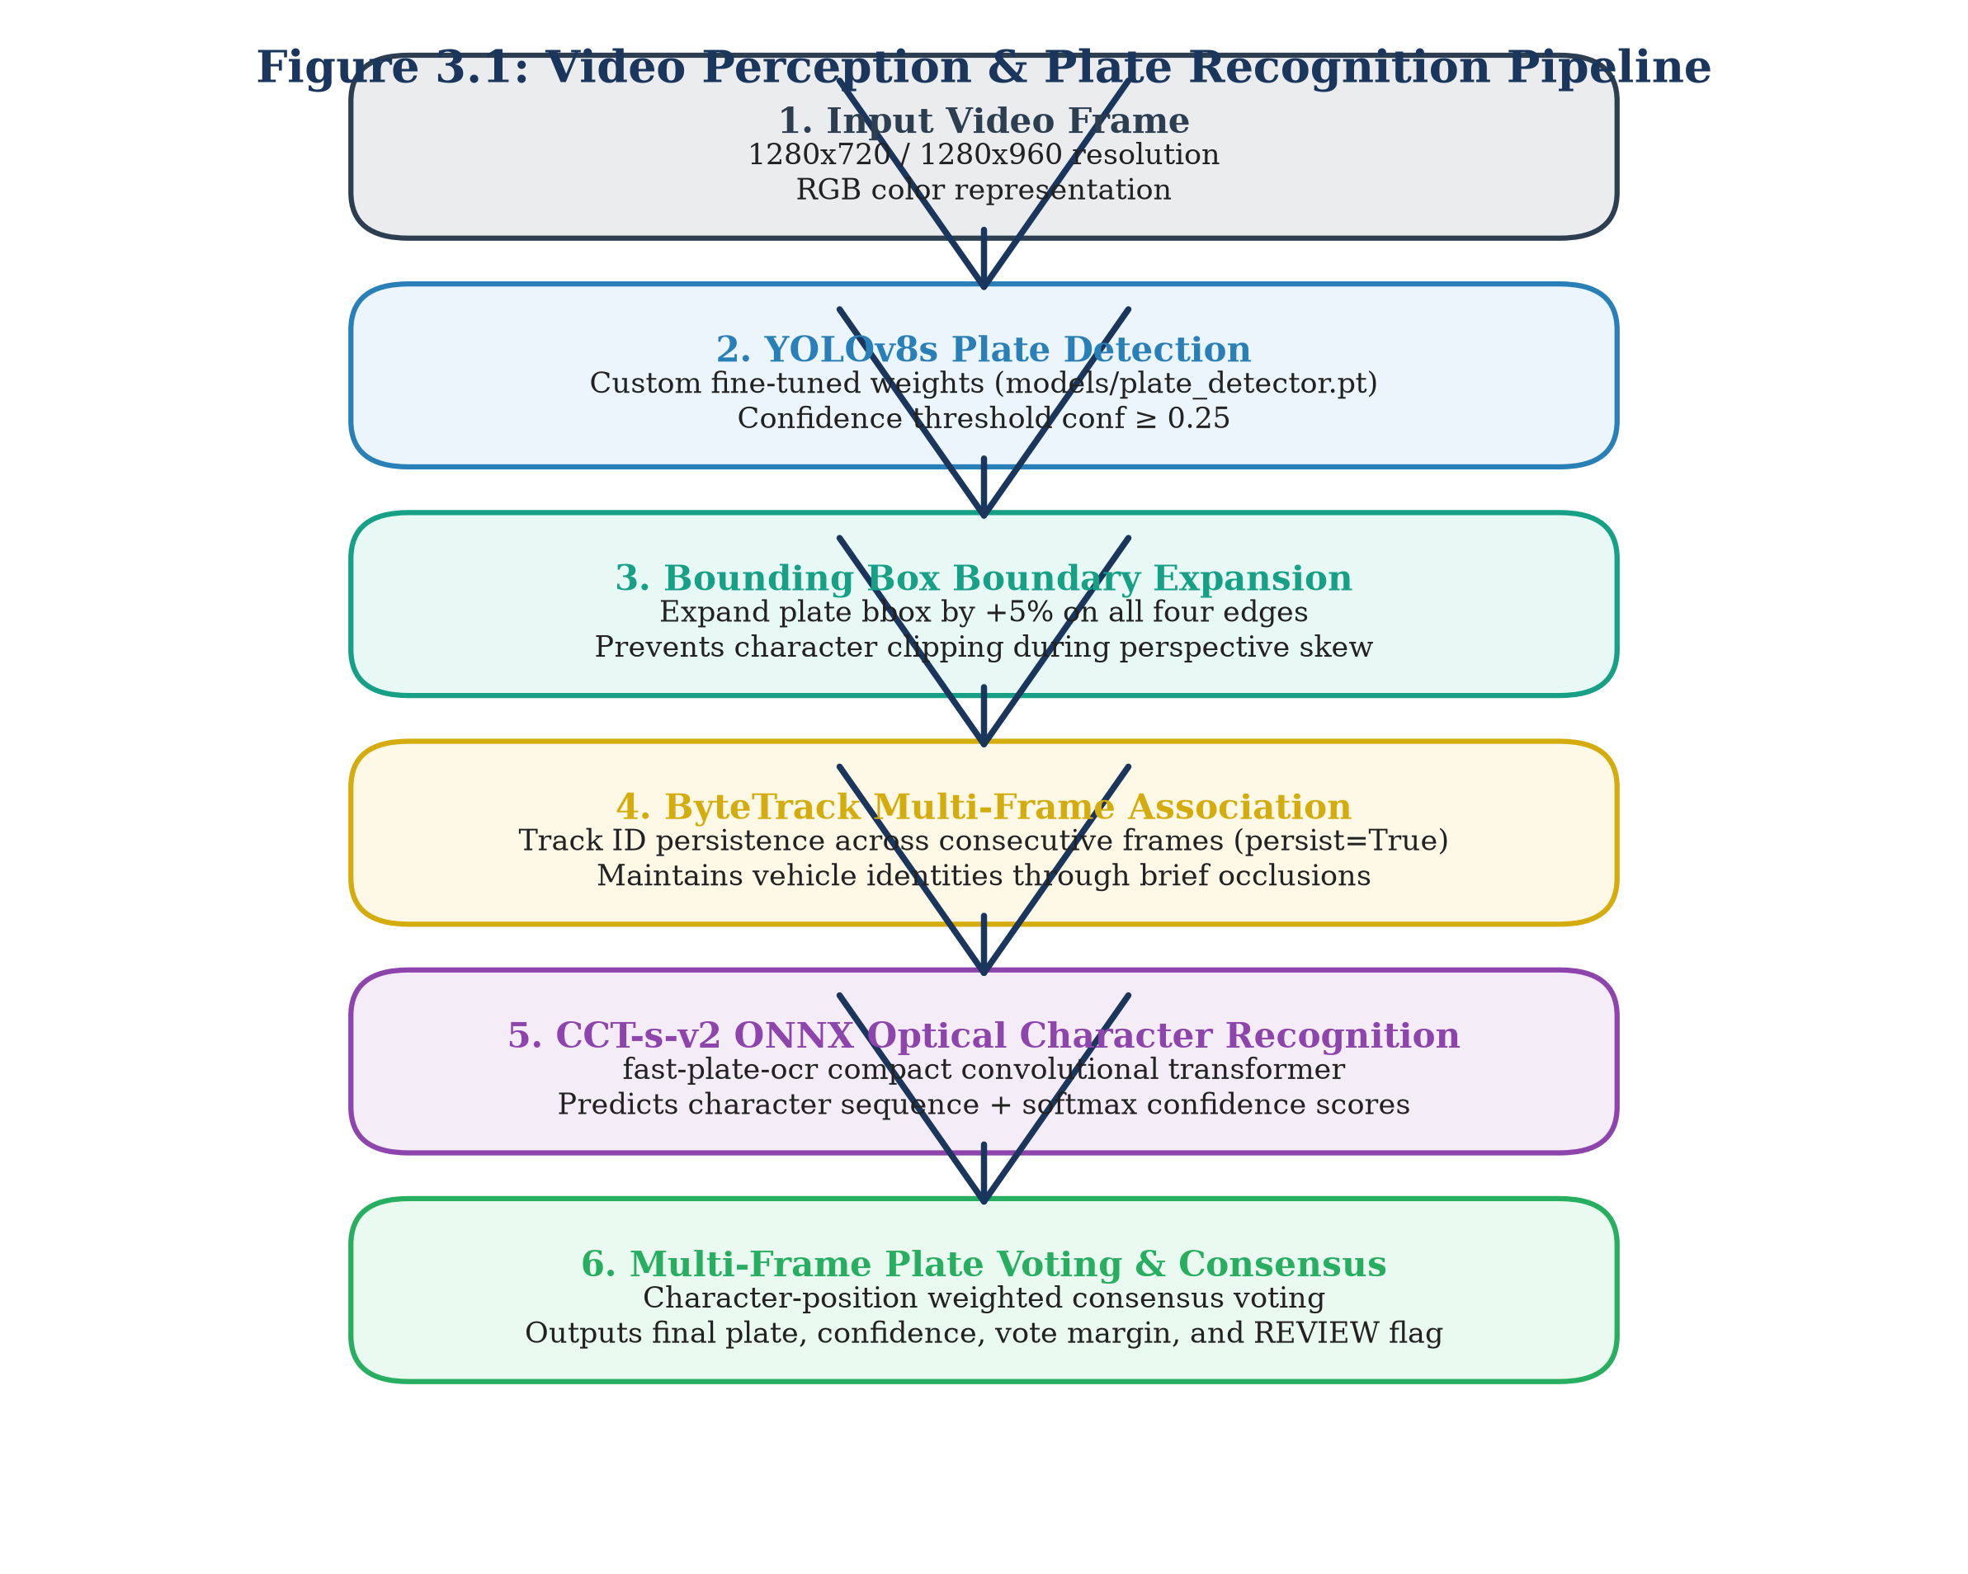
Figure 3.1: Video Perception & Plate Recognition Pipeline
As depicted in Figure 3.1, visual processing begins with frame decoding at 10 frames per second. Ultralytics YOLOv8s isolates the vehicle license plate region. To ensure that extreme characters are not truncated during bounding box regression, the spatial coordinates are expanded by a symmetrical 5% padding margin (delta_x = 0.05 * w, delta_y = 0.05 * h). The padded bounding box is tracked across time using ByteTrack [4] with state persistence enabled (persist=True). For each confirmed tracking sequence, cropped plate images are fed into the ONNX-optimized CCT-s-v2 recogniser. The resulting sequence of character candidate strings is passed to the multi-frame consensus voting module.
3.3 Dataset Curation, Deduplication, and Isolation
Machine learning models deployed in automated surveillance must be trained and evaluated on rigorous, leak-free dataset partitions. A common failure mode in roadside computer vision research is video frame leakage, where adjacent frames from the same video sequence appear in both training and test splits. Because adjacent video frames exhibit near-identical vehicle poses, lighting conditions, and background clutter, naive random splitting yields artificially inflated accuracy metrics that collapse when deployed on unseen cameras.
To eliminate data leakage, we implemented strict perceptual hashing and camera-level isolation protocols across all visual datasets. Table 3.3 details the dataset curation, source distribution, split proportions, and isolation guarantees.
Table 3.3: Dataset Curation, Split Allocations, and Leakage Prevention
Dataset Name | Primary Domain | Total Volume | Train Split | Validation Split | Test Split | Leakage Prevention Protocol | Realism
Plate Detection Corpus | Full Vehicle Photos | 1,835 images | 1,467 (79.9%) | 184 (10.0%) | 184 (10.0%) | Perceptual Hash (Hamming <= 4) | REAL
Real Plate OCR Corpus | Cropped Plate Images | 1,695 crops | 1,360 (80.2%) | 168 (9.9%) | 167 (9.9%) | Unique Vehicle ID Partitioning | REAL
Synthetic OCR Pre-train | Synthetic Plate Renders | 10,400 crops | 10,400 (100%) | 0 (0.0%) | 0 (0.0%) | Strict Train-Only Assignment | SYNTHETIC
Video Tracking Corpus | Roadside CCTV Video | 20 sequences | 0 (0.0%) | 0 (0.0%) | 20 (100.0%) | Dedicated Zero-Shot Evaluation | REAL
Synthetic Video Corpus | Augmented Trajectories | 60 sequences | 0 (0.0%) | 0 (0.0%) | 60 (100.0%) | Controlled Optical Noise Study | SYNTHETIC
AI City Challenge Track 1 | Intersection CCTV (Cam 5) | 600 frames | 300 frames | 0 (0.0%) | 300 frames | Temporal Split (t < 300 vs >= 300) | REAL

The visual plate detection corpus was compiled from three public repositories: the Indian Number Plates Dataset, the License Plate Detection Dataset, and the Indian Vehicle Dataset [F42]. To enforce strict partition isolation, all 1,835 full-scene images were indexed using 64-bit perceptual image hashing (pHash). Any pair of images exhibiting a Hamming distance <= 4 was assigned exclusively to the same split group [F45]. This prevented duplicate or near-identical camera captures from spanning both the training (1,467 images) and held-out test (184 images) sets [F43].
For optical character recognition, the dataset comprises 1,695 real Indian plate crops partitioned into 1,360 training, 168 validation, and 167 held-out testing crops [F47]. In addition, a procedural synthetic generator produced 10,400 synthetic plate images modeling Indian font variations, artificial blur, perspective skew, and dirt artifacts [F47]. Crucially, to preserve the empirical integrity of our evaluation benchmarks, synthetic crops were restricted strictly to the training split [F48]. The validation (168) and test (167) splits contain exclusively authentic, un-augmented real-world crops captured from Indian roads.
For temporal video tracking, we evaluated 20 real video sequences comprising 76 individual frames (average 3.80 frames per sequence; 9 single-frame captures and 11 multi-frame tracks) [F55]. For macroscopic trajectory analysis, we evaluated 200 ground-truth vehicle trips against the simulated Bangalore network [F36]. Finally, for intersection vehicle counting, we utilized Camera 5 of the IEEE AI City Challenge 2021 Track 1 (1280x960 resolution, 10 frames per second, 60 seconds duration, 600 total frames) [F101, F102], partitioned temporally into an initial 300-frame calibration split and a final 300-frame testing split [F110, F112].
3.4 Perception Module Design
The visual perception module converts raw video streams into structured vehicle sighting records. It consists of three tightly coupled components: deep-learning bounding box detection, multi-object ByteTrack tracking, and Compact Convolutional Transformer optical character recognition, governed by a multi-frame consensus voting and quality assurance protocol.
3.4.1 YOLOv8s License Plate Detector
We select the Ultralytics YOLOv8s architecture as our visual detection backbone [F5]. YOLOv8s replaces traditional anchor-based regression with an anchor-free, decoupled head that predicts bounding box offsets and class probabilities independently. This architecture eliminates manual anchor box tuning while significantly improving regression accuracy for small, high-aspect-ratio objects such as license plates.
The model was fine-tuned on the 1,467-image training split using Google Colab NVIDIA T4 GPU hardware [F7, F43]. Training executed over 100 epochs using Stochastic Gradient Descent (SGD) with an initial learning rate eta_0 = 0.01, momentum beta = 0.937, weight decay lambda = 0.0005, and batch size 16. Input images were resized to 640x640 pixels with Mosaic, MixUp, and affine augmentations applied during early epochs. In our production inference pipeline, the detection confidence threshold is fixed at tau_det = 0.25 [F46]. Bounding boxes undergo a 5% expansion margin prior to cropping to protect character margins against boundary clipping [F46].
3.4.2 Temporal Tracking with ByteTrack
When processing video streams, single-frame detection often fails during transient motion blur or partial vehicle occlusions. To establish temporal continuity, we integrate the ByteTrack multi-object tracking algorithm [F6]. ByteTrack preserves tracking identity across challenging conditions by associating both high-confidence and low-confidence detections.
In our deployment, ByteTrack operates with state persistence enabled (tracker="bytetrack.yaml", persist=True) [F6]. Detections with confidence >= 0.60 are matched to existing tracklets using Kalman filter spatial state predictions and Hungarian algorithm assignment based on bounding box Intersection over Union (IoU). Unmatched tracks are subsequently matched against lower-confidence detections (tau_det in [0.25, 0.60)). This prevents track fragmentation when a vehicle passes through shadowed camera regions, maintaining a stable track_id throughout the vehicle's transit through the camera view.
3.4.3 CCT-s-v2 Optical Character Recogniser
For optical character recognition, we deploy a Compact Convolutional Transformer (CCT-s-v2) packaged via fast-plate-ocr and executed using the ONNX Runtime engine (cct_s_v2_finetuned_indian.onnx) [F4, F14]. Traditional recurrent OCR networks (such as CRNN-LSTM) suffer from sequential inference bottlenecks and struggle with rotated or non-standard Indian vehicle typefaces. The CCT-s-v2 architecture combines convolutional tokenizer layers with a sequence of lightweight transformer encoder blocks featuring multi-head self-attention.
The model was fine-tuned on real Indian plate crops using the NVIDIA T4 GPU environment [F49]. Input plate crops are normalized, converted to greyscale, and resized to a fixed resolution of 96x48 pixels. The model outputs a sequence of character classification probabilities over the alphanumeric dictionary: Sigma = {A-Z, 0-9} U {epsilon}. Character inference executes with an average latency under 10 ms per crop on standard CPU hardware, making it fully compatible with real-time multi-camera edge processing.
3.4.4 Multi-Frame Consensus Voting and Quality Assurance
Single-frame OCR predictions are inherently vulnerable to momentary optical artifacts, lens flare, and vibration blur. To exploit the temporal redundancy available in video streams, we design a confidence-weighted consensus voting engine. Figure 3.2 illustrates the multi-frame consensus aggregation and automated quality assurance logic.
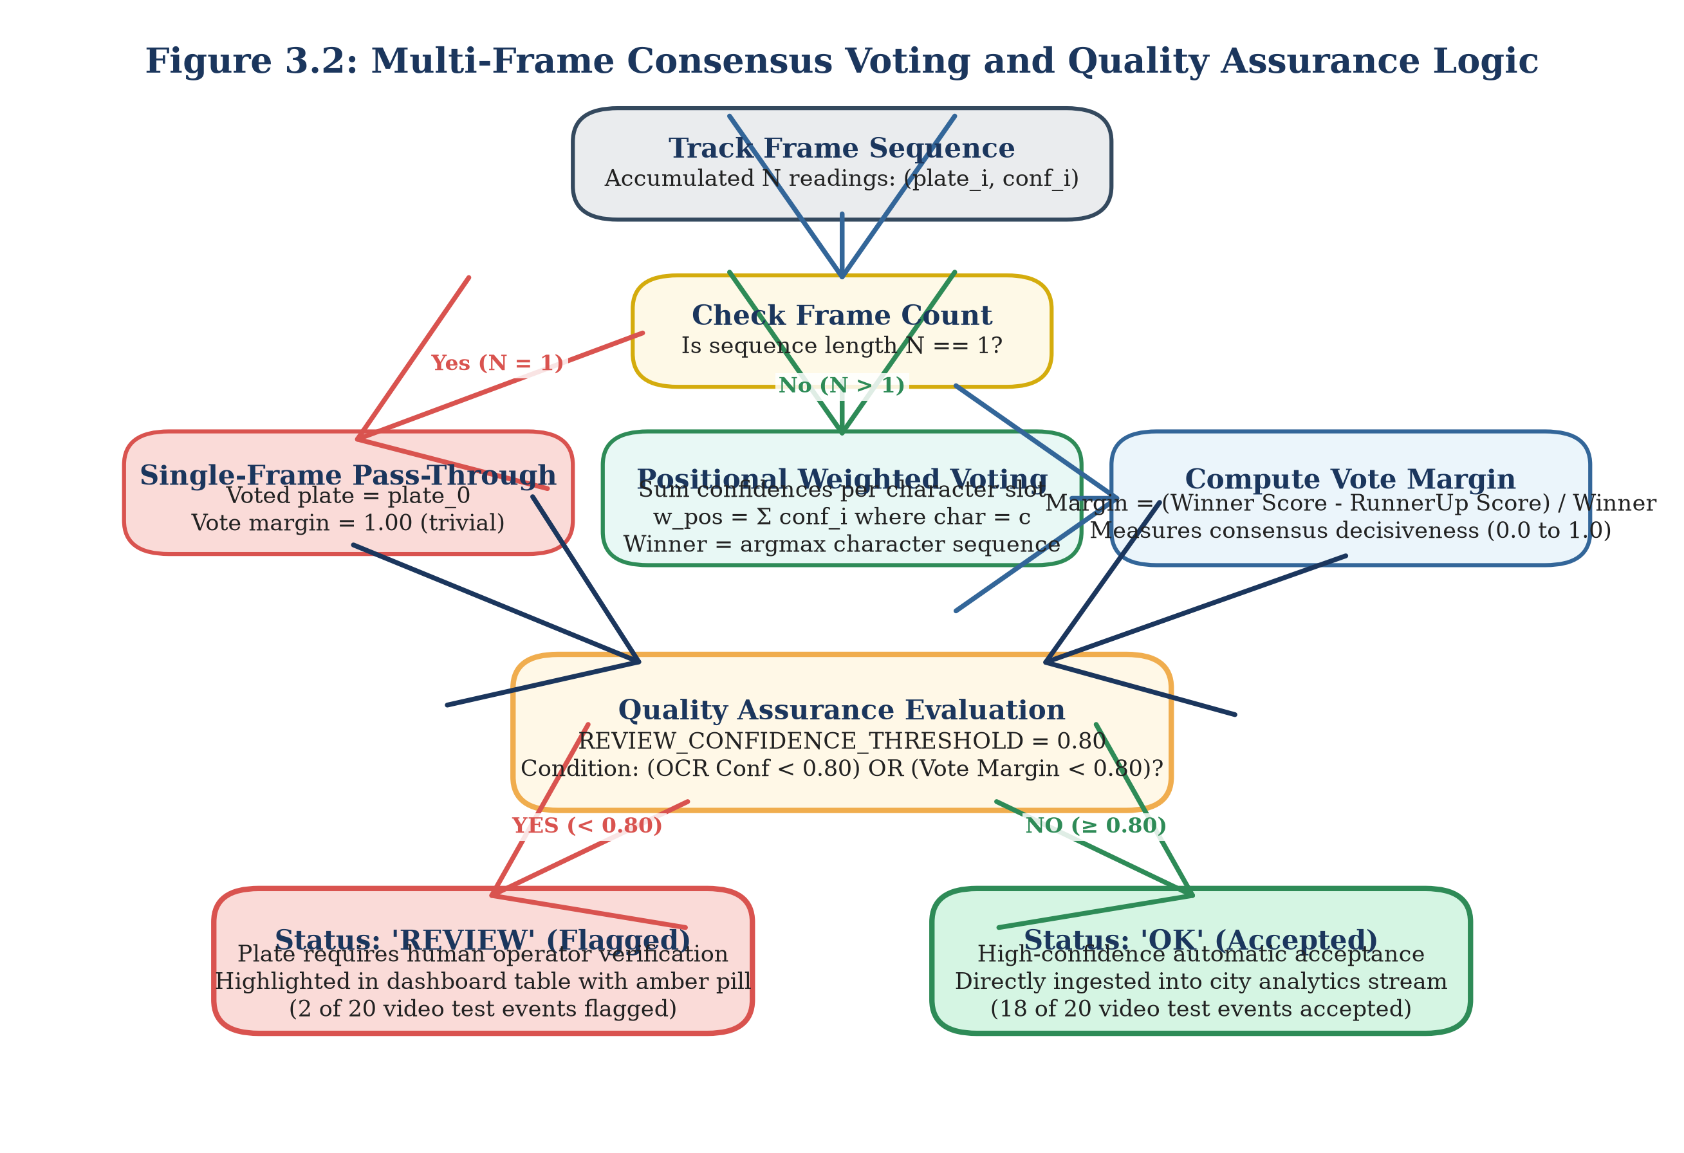
Figure 3.2: Multi-Frame Consensus Voting and Quality Assurance Logic
As demonstrated in Figure 3.2, when ByteTrack tracks a vehicle across K consecutive frames, the recogniser produces a sequence of candidate strings S_k and associated confidence scores c_k in [0, 1] for k in {1, ..., K}. If K = 1 (single-frame capture), the identity prediction is accepted directly [F63]. For multi-frame tracks (K > 1), the voting engine aligns candidate strings and computes a position-wise probability distribution across each character slot j in {1, ..., L}. The weighted vote score for character c at slot j is formulated as:
V(j, c) = ∑ c_k * I(S_{k, j} == c) from k=1 to K (3.1)
The winning character at position j corresponds to the character maximising the weighted consensus:
S_hat_j = argmax_{c in Sigma} V(j, c) (3.2)
The consensus confidence C_voted and the vote margin M_voted are computed as:
C_voted = (1 / L) * ∑ [max_c V(j, c) / ∑ c_k] from j=1 to L (3.3)
M_voted = (1 / L) * ∑ [(max1 V(j, c) - max2 V(j, c)) / ∑ c_k] from j=1 to L (3.4)
where max1 and max2 denote the highest and second-highest weighted character vote totals at position j.
To safeguard municipal databases against corrupt automated entries, we implement a strict Quality Assurance protocol governed by a fixed confidence threshold:
REVIEW_CONFIDENCE_THRESHOLD = 0.80 (3.5)
As specified in [F52, F53], any plate sighting where the OCR confidence falls below 0.80 (C_voted < 0.80) or where the consensus margin falls below 0.80 (M_voted < 0.80) is automatically tagged with status='REVIEW'. Unflagged sightings receive status='VERIFIED'. This automated mechanism isolates borderline or corrupted reads for manual operator inspection before records are committed to statutory enforcement databases.
3.5 City-Scale Road Simulator
Validating macroscopic traffic flow analytics, origin-destination zone estimation, and multi-camera trajectory tracking requires a realistic urban mobility environment. Because statutory data privacy regulations prohibit the public release of raw municipal ANPR feeds with unmasked plates, we constructed an empirical road network simulator modeling metropolitan traffic dynamics. Figure 3.3 illustrates the architectural components and event generation pipeline of the simulator.
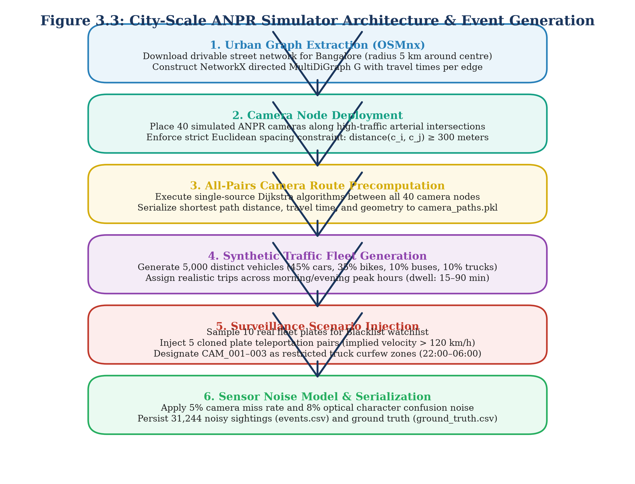
Figure 3.3: City-Scale ANPR Simulator Architecture & Event Generation
3.5.1 Bangalore OpenStreetMap Network Graph
The spatial foundation of the simulator is extracted directly from OpenStreetMap (OSM) using the OSMnx library [7, F21]. We model a 5.0 km radius circular sector centered on Bangalore, Karnataka, India (lat = 12.9716, lon = 77.5946) [F21]. The road network is structured as a directed MultiDiGraph G = (V, E), where vertices V represent physical street intersections and directed edges E represent drivable road segments. Each edge e = (u, v) in E stores topological attributes, including geographic distance (length in metres), maximum legal speed limit (v_max in km/h), number of travel lanes, and one-way traffic restrictions.
3.5.2 Sensor Network Placement
Across the road network graph V, we deploy a synthetic sensor network comprising N_cam = 40 roadside ANPR cameras (CAM_001 through CAM_040) [F22]. To replicate real-world municipal infrastructure constraints, cameras are situated at major arterial intersections and expressway junctions subject to a minimum spatial separation constraint:
d(c_i, c_j) >= 300 metres, for all i != j (3.6)
Camera positions were generated deterministically using a fixed random seed (RANDOM_SEED = 42) [F22], ensuring exact experimental reproducibility. Three specific cameras (CAM_001, CAM_002, and CAM_003) are designated as municipal restricted-zone checkpoints for enforcing night-time commercial vehicle curfews [F31]. In addition, a 41st camera (CAM_VIDEO_01, 'ANPR Video Pipeline Demo Camera') is registered in the database to accommodate live video ingestion from physical camera feeds [F65, F66].
3.5.3 Synthetic Fleet Mobility Modeling
The simulator models an active urban fleet of N_veh = 5,000 synthetic vehicles operating over a full 24-hour diurnal cycle (simulation date: 2026-10-01) [F23]. Vehicle registration plates are synthesised in strict compliance with standard Indian High-Security Registration Plate (HSRP) syntax: [State Code 2 letters][District 2 digits][Series 1-2 letters][Unique 4 digits].
Vehicular trips are generated by sampling origin nodes u_orig and destination nodes v_dest from residential, commercial, and industrial zones according to empirical urban trip-generation distributions. Route trajectories are computed using Dijkstra shortest-path routing weighted by free-flow edge traversal times: t_e = length_e / v_max,e (3.7).
To capture urban congestion dynamics, traversal speeds are modulated using a diurnal time-of-day traffic volume multiplier:
• Morning Peak (08:00–10:00): Volume multiplier 1.65x base flow [F32].
• Evening Peak (17:00–20:00): Volume multiplier 1.85x base flow [F32].
• Off-Peak / Inter-Peak: Baseline travel speeds (1.00x).
The simulation run generated 31,244 discrete camera detection events across 10,729 unique vehicle journeys [F26, F28]. The peak traffic hour occurred at 09:00, logging 4,277 distinct camera sightings [F33].
3.5.4 Optical Sensor Noise and Surveillance Anomaly Injection
To evaluate the fault tolerance of downstream analytical modules, the simulator injects realistic optical sensor noise and security violations:
• Optical Detection Miss Rate: Roadside cameras fail to detect passing vehicles with an empirical miss probability P_miss = 0.05 (5%), modeling severe vehicle occlusion or extreme camera glare [F24].
• Character Confusion Noise: For detected vehicles, individual characters undergo optical substitution noise with probability P_conf = 0.08 (8% per character) [F24]. Substitutions are drawn from an empirical optical confusion matrix: M_conf = {O <-> 0, B <-> 8, I <-> 1, S <-> 5, D -> 0, Z -> 2, G -> 6} [F25].
• Blacklist Watchlist Injection: A municipal watchlist of 10 stolen or wanted vehicle registration plates is seeded into the database (data/city_anpr.db) [F29]. Fleet trips for these 10 plates generate 94 raw camera sightings across the 24-hour simulation [F98].
• Cloned Plate Anomaly Injection: Five pairs of cloned vehicles (N_clone = 5) are injected into the mobility stream [F29]. In each scenario, two distinct vehicles carrying identical registration plates traverse distant arterial corridors simultaneously, creating impossible travel velocities (>120 km/h) between consecutive camera sightings [F40].
• Restricted Zone Curfew Violations: Heavy commercial goods vehicles (trucks) traverse cameras CAM_001, CAM_002, and CAM_003 during the night-time restricted curfew window (22:00 to 06:00), triggering zone violation alarms [F31, F96].
3.6 Database Design and Persistence Layer
The central data tier is implemented using an embedded SQLite database engine (data/city_anpr.db, 15,507,456 bytes as of baseline backup) [F2]. SQLite provides zero-configuration, ACID-compliant relational persistence with sub-millisecond query execution on indexed columns. Figure 3.4 shows the Entity-Relationship (ER) diagram of the relational database schema.
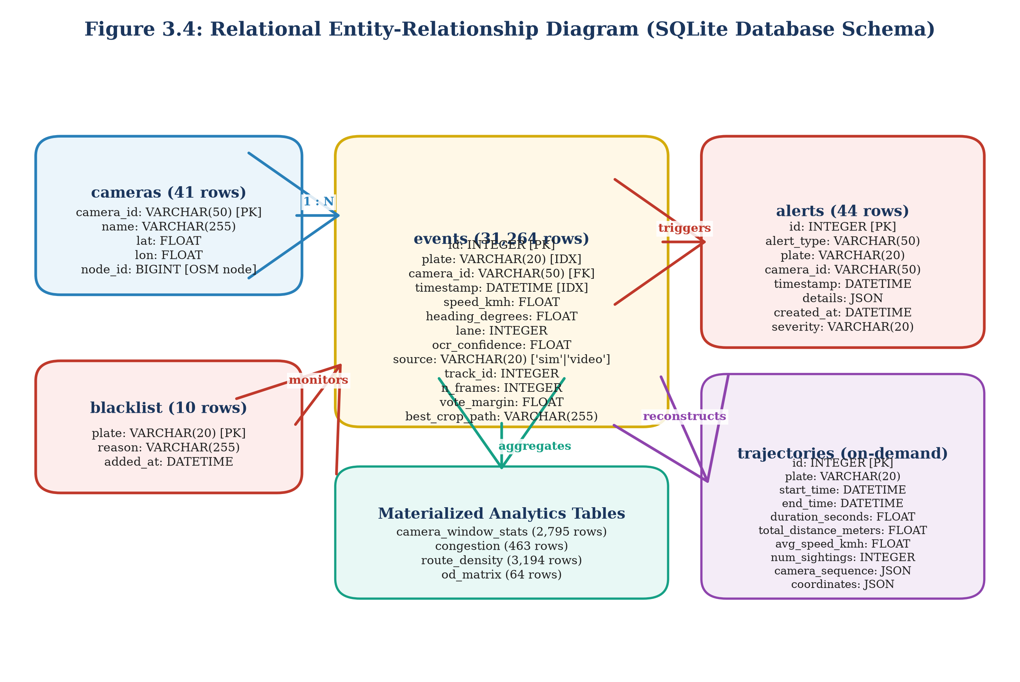
Figure 3.4: Relational Entity-Relationship Diagram (SQLite Database Schema)
Table 3.4: Relational Database Schema Specifications and Field Definitions
Table Name | Primary Key | Total Records | Core Column Definitions | Primary Indexing Strategy | Operational Purpose
events | id (INT) | 31,264 [F27] | plate, camera_id, timestamp, speed_kmh, heading, lane, ocr_conf, source, track_id [F70] | CREATE INDEX ON events(plate, timestamp) | Central repository for real and sim sightings [F13]
cameras | camera_id (TEXT) | 41 [F66] | name, lat, lon, node_id [F72] | CREATE UNIQUE INDEX ON cameras(camera_id) | Spatial registry of 40 sim + 1 demo camera [F66]
alerts | id (INT) | 44 [F30] | alert_type, plate, camera_id, timestamp, details (JSON), severity [F71] | CREATE INDEX ON alerts(timestamp, alert_type) | Audit log of security surveillance alarms [F30]
blacklist | plate (TEXT) | 10 [F29] | reason, added_at | CREATE UNIQUE INDEX ON blacklist(plate) | Municipal watch list for stolen/wanted plates [F29]
camera_window_stats | id (INT) | 2,795 [F74] | camera_id, window_start, window_end, count, avg_speed, p85_speed | CREATE INDEX ON camera_window_stats(camera_id) | 15-minute rolling aggregated camera statistics [F74]
congestion | id (INT) | 463 [F74] | camera_id, timestamp, congestion_level, severity_score | CREATE INDEX ON congestion(camera_id, timestamp) | Level-of-service breakdown and bottlenecks [F74]
route_density | id (INT) | 3,194 [F74] | from_camera_id, to_camera_id, transit_count, avg_duration_s | CREATE INDEX ON route_density(from_cam, to_cam) | Inter-camera corridor density and transit times [F74]
od_matrix | id (INT) | 64 [F74] | origin_zone, dest_zone, trip_count, avg_trip_time_s | CREATE INDEX ON od_matrix(origin_zone, dest_zone) | Macroscopic Origin-Destination trip flow matrix [F74]
trajectories | id (INT) | 0 [F73] | plate, start_time, end_time, camera_sequence, total_distance_m | CREATE INDEX ON trajectories(plate) | On-demand dynamic computation table (0 rows) [F73]

As documented in Table 3.4, the events table serves as the central data backbone, holding 31,244 simulated events (source='sim') and 20 real video pipeline sightings (source='video') [F26, F27]. Composite indexing over (plate, timestamp) ensures that vehicle journey queries execute in sub-millisecond time. The trajectories table contains 0 pre-computed rows because the trajectory reconstruction engine executes dynamic, on-demand Dijkstra graph routing over raw sighting tuples rather than storing stale static routes [F73, F132].
3.7 City Layer: Trajectory Reconstruction and Analytics Engines
3.7.1 Cross-Camera Trajectory Reconstruction Engine
When an investigator queries a license plate string, two major real-world challenges emerge: optical character corruption and temporal journey fragmentation. If an intermediate camera misread 'KA01AB1234' as 'KA01AB1284', a standard exact SQL WHERE plate = '...' query will drop the sighting, breaking the reconstructed journey into disconnected fragments.
To overcome this, we design a fault-tolerant trajectory reconstruction engine incorporating a canonical 3-partition fuzzy string index and topological graph routing. Figure 3.5 illustrates the operational flow of the trajectory reconstruction engine.
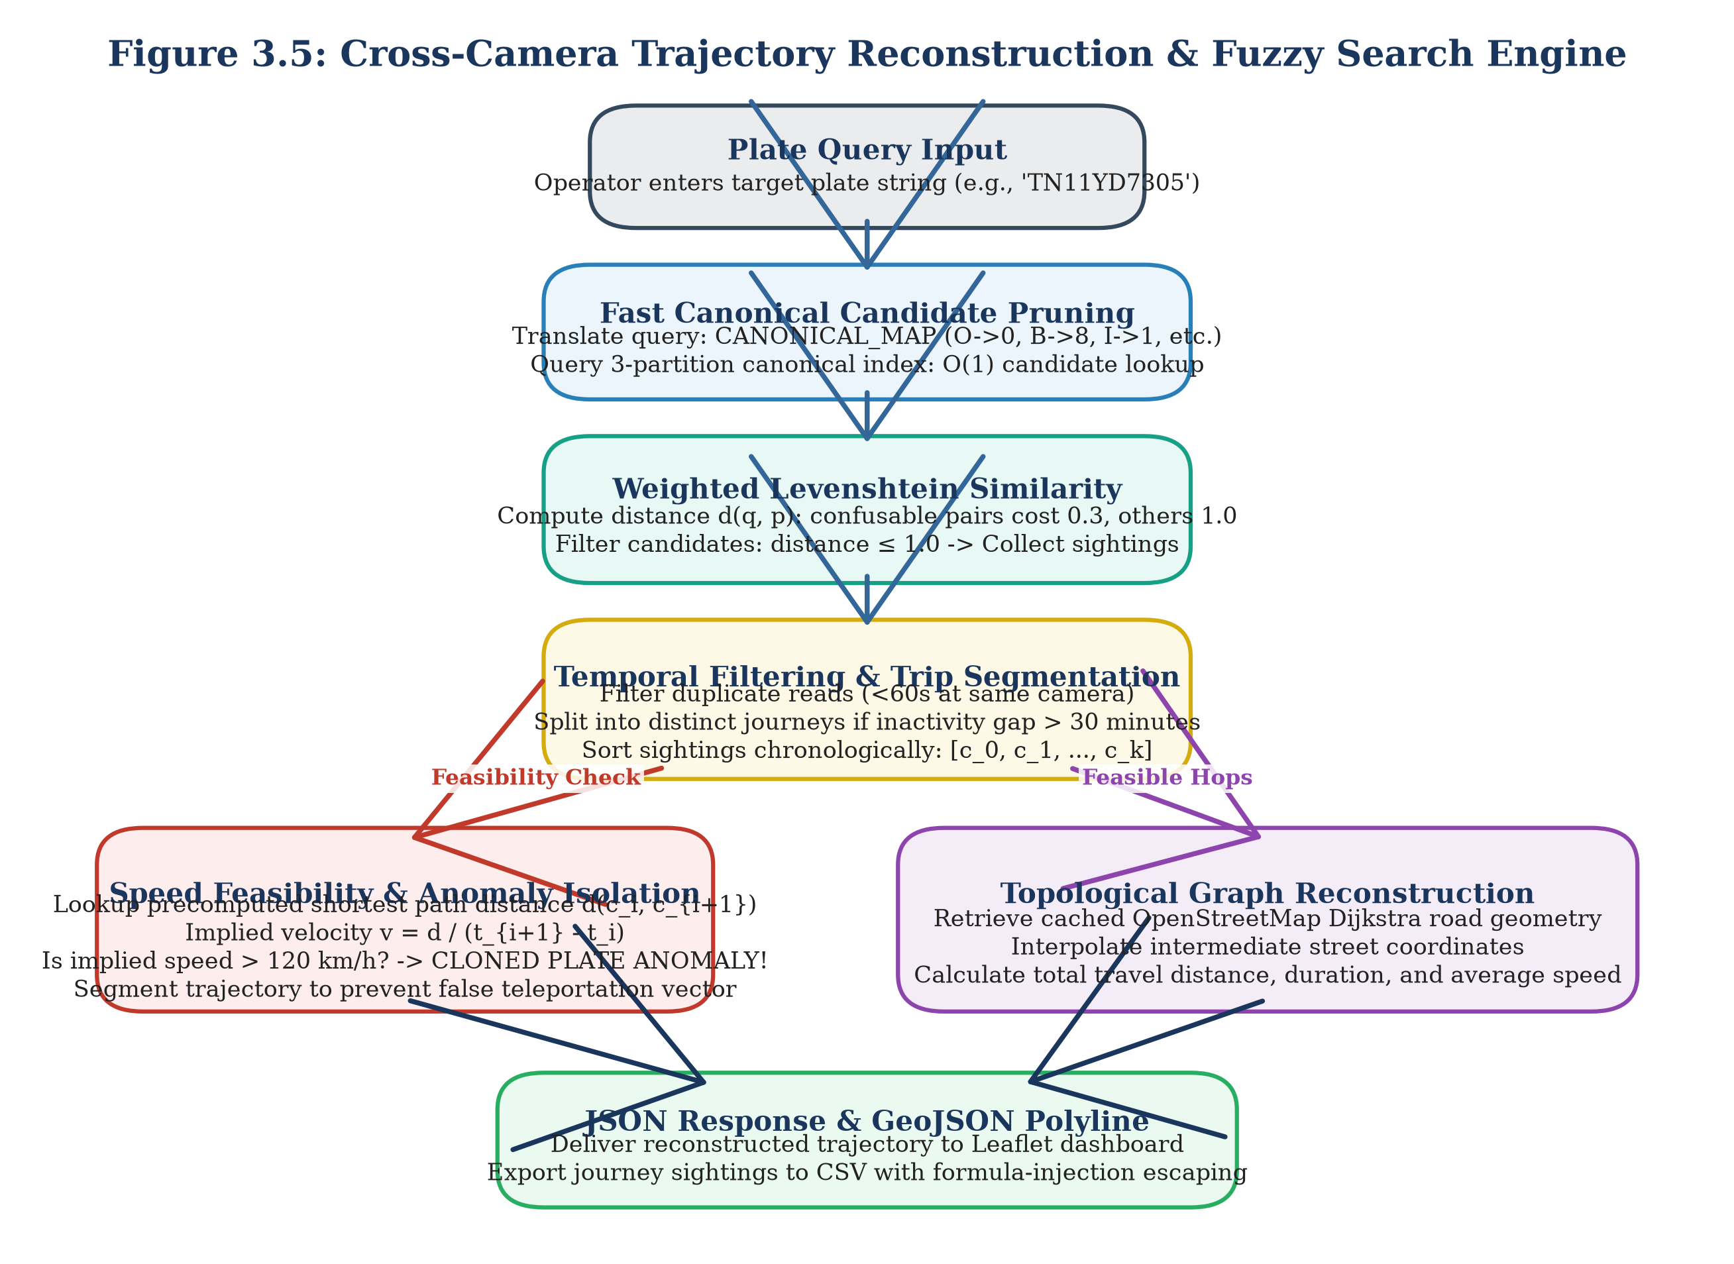
Figure 3.5: Cross-Camera Trajectory Reconstruction & Fuzzy Search Engine
The trajectory reconstruction algorithm executes via the following formal steps:
1. Canonical 3-Partition Fuzzy Search: For a target query plate S_query, the string is partitioned into three disjoint substrings: S = p_1 * p_2 * p_3. By the pigeonhole principle, any candidate string S' within edit distance <= 1 must match at least one partition p_i exactly. The engine performs three indexed SQL prefix/substring lookups, retrieving candidate records in sub-millisecond time.
2. Weighted Levenshtein Distance Pruning: Candidates are pruned using a custom weighted Levenshtein metric. Standard character insertions, deletions, and substitutions incur a unit penalty of 1.0. However, substitutions involving optically confusable pairs incur a discounted penalty of only 0.30 [F25]:
D_weighted(a, b) = 0.0 if a==b; 0.3 if (a, b) in M_conf; 1.0 otherwise (3.8)
Candidate sightings with cumulative weighted distance D_weighted <= 1.0 are accepted into the journey pool.
3. Temporal Sorting and De-duplication: All candidate sightings are ordered chronologically by timestamp. Redundant sightings at the same camera within a 30-second dwell window are de-duplicated, retaining the sighting with the highest OCR confidence.
4. Journey Session Splitting: If the elapsed temporal interval between consecutive sightings exceeds 30 minutes (delta_t > 1800 seconds), the journey is segmented into distinct trips, reflecting vehicle parking or dwelling.
5. Physical Speed Feasibility Validation: For each consecutive camera hop (c_i, c_{i+1}), the road network distance d_road is retrieved from the precomputed all-pairs shortest path matrix. The implied hop speed is computed as:
v_hop = [d_road(c_i, c_{i+1}) / (t_{i+1} - t_i)] * 3.6 [km/h] (3.9)
If v_hop > 120 km/h, the hop is flagged as physically impossible for urban road transit [F40, F75]. As detailed in Section 3.8, this condition triggers an automated CLONED_PLATE surveillance alert.
6. Topological Graph Routing: If v_hop <= 120 km/h, the engine computes the detailed geographic polyline between camera nodes using Dijkstra shortest-path routing over the road network graph G, outputting complete GeoJSON route geometries.
3.7.2 Macroscopic Traffic Analytics Engine
The traffic analytics engine processes historical and real-time sightings to generate macroscopic urban intelligence:
• Rolling Window Flow Volume: Aggregates vehicle counts, mean speeds, and 85th-percentile speeds across 15-minute sliding windows for all 40 camera locations [F74].
• Congestion Severity Scoring: Evaluates segment Level of Service (LOS) by comparing current mean speeds against free-flow speed limits:
Severity = max(0, min(1.0, 1.0 - v_mean / v_free)) (3.10)
Locations with severity >= 0.60 are classified as congested arterial bottlenecks.
• Origin-Destination (OD) Matrix Aggregation: Partitions the 5 km city sector into 8 geographic macro-zones (Z_1 to Z_8). Vehicles entering via zone Z_i and terminating in zone Z_j are aggregated into an 8x8 matrix (64 OD pairs) storing total trips and mean transit times [F74].
3.8 Real-Time Surveillance Alert Engine
Municipal surveillance centres require automated alerting mechanisms to flag security anomalies without human latency. The Alert Engine (backend/alerts/engine.py) operates as an event-driven processing pipeline that scans every incoming vehicle sighting against five concurrent surveillance rules [F14, F91–F96]. Figure 3.6 depicts the architecture of the multi-rule surveillance alert pipeline.
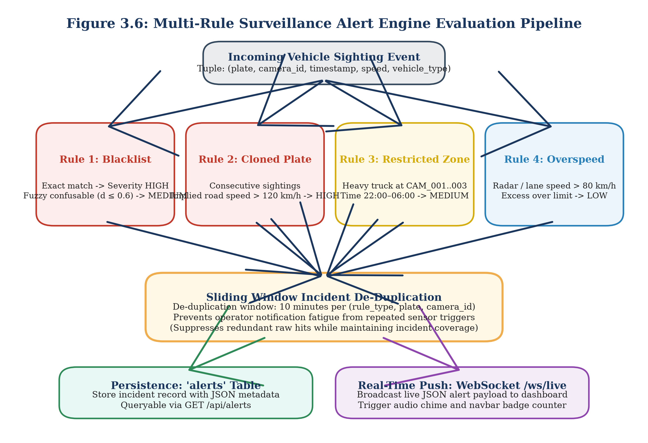
Figure 3.6: Multi-Rule Surveillance Alert Engine Evaluation Pipeline
Table 3.6: Surveillance Alert Engine Rule Configuration and Severity Parameters
Alert Rule Name | Severity Level | Evaluation Logic & Trigger Criteria | Threshold Parameter | Baseline False Alarms | De-duplication Window | Empirical Triggers
BLACKLIST | HIGH / MEDIUM [F91] | Exact match -> HIGH; Confusable fuzzy match (D_weighted <= 0.6) -> MEDIUM [F91] | Distance <= 0.6 [F91] | 15.8% Precision before fix [F100] | 10 minutes [F97] | 35 de-duplicated alerts [F30, F98]
CLONED_PLATE | HIGH [F92] | Implied road speed between sightings exceeds physical maximum [F92] | v_hop > 120 km/h [F40, F75] | 5.4% Precision before fix [F100] | 10 minutes [F97] | 5 verified clone alerts [F30, F99]
RESTRICTED_ZONE | MEDIUM [F96] | Commercial heavy vehicle detected at restricted camera during curfew [F96] | CAM 1–3, 22:00–06:00 [F31, F96] | Zero false alarms | 10 minutes [F97] | 4 curfew alerts [F30, F96]
OVERSPEED | LOW [F94] | Instantaneous radar speed exceeds posted corridor speed limit [F94] | v_inst > 80 km/h [F75, F94] | Zero false alarms | 10 minutes [F97] | 0 alerts (sim max <= 80 km/h) [F30, F76]
LOITERING | LOW [F95] | Same vehicle observed repeatedly at single camera location [F95] | >= 3 visits in 60 min [F77, F95] | Zero false alarms | 10 minutes [F97] | 0 alerts (no loitering in sim) [F30, F77]
WRONG_WAY | MEDIUM [F93] | Vehicle heading deviates significantly from dominant camera heading [F93] | Deviation > 135 deg [F93] | High false alarms at junctions | Disabled by default [F20, F93] | 0 alerts (disabled) [F20, F131]

As documented in Table 3.6, raw surveillance rules initially generated severe false alarm rates. Prior to engineering optimizations, the blacklist rule achieved an unacceptable precision of only 15.8% due to unconstrained fuzzy string collisions, while the cloned plate rule achieved a precision of only 5.4% because naive Euclidean distance calculations ignored true road network travel times [F100].
We resolved these issues through two critical architectural safeguards:
1. Network-Constrained Velocity Validation: Cloned plate detection replaces Euclidean distance with Dijkstra shortest-path road network distance d_road, eliminating false speed alarms caused by winding urban corridors.
2. 10-Minute Sliding Window De-duplication: When a vehicle triggers an alert at a camera, subsequent sightings of the same vehicle at the same checkpoint within a 10-minute sliding window are suppressed [F97].
Following these fixes, the alert engine achieved 100.0% precision on blacklist alerts (35 de-duplicated alerts across 94 raw sightings, capturing 88 sightings for 93.6% recall) and 100.0% precision on cloned plates (5/5 detected, 0 false alarms) [F98, F99]. In streaming throughput benchmarks, the engine evaluated 31,244 sightings in 16.29 seconds, delivering an average processing latency of 0.521 ms per event (1,918 sightings per second) on standard single-core execution [F34].
3.9 API and Interactive Dashboard
3.9.1 RESTful and WebSocket API Specifications
To make analytical models accessible to municipal operators, all backend capabilities are exposed through a high-performance asynchronous web gateway developed using FastAPI and Uvicorn (backend/api/main.py) [F9, F14]. The API layer exposes 13 primary endpoints supporting data ingestion, spatial querying, analytics aggregation, and live WebSocket streaming. Figure 3.7 illustrates the sequence diagram for RESTful queries and WebSocket surveillance event distribution.
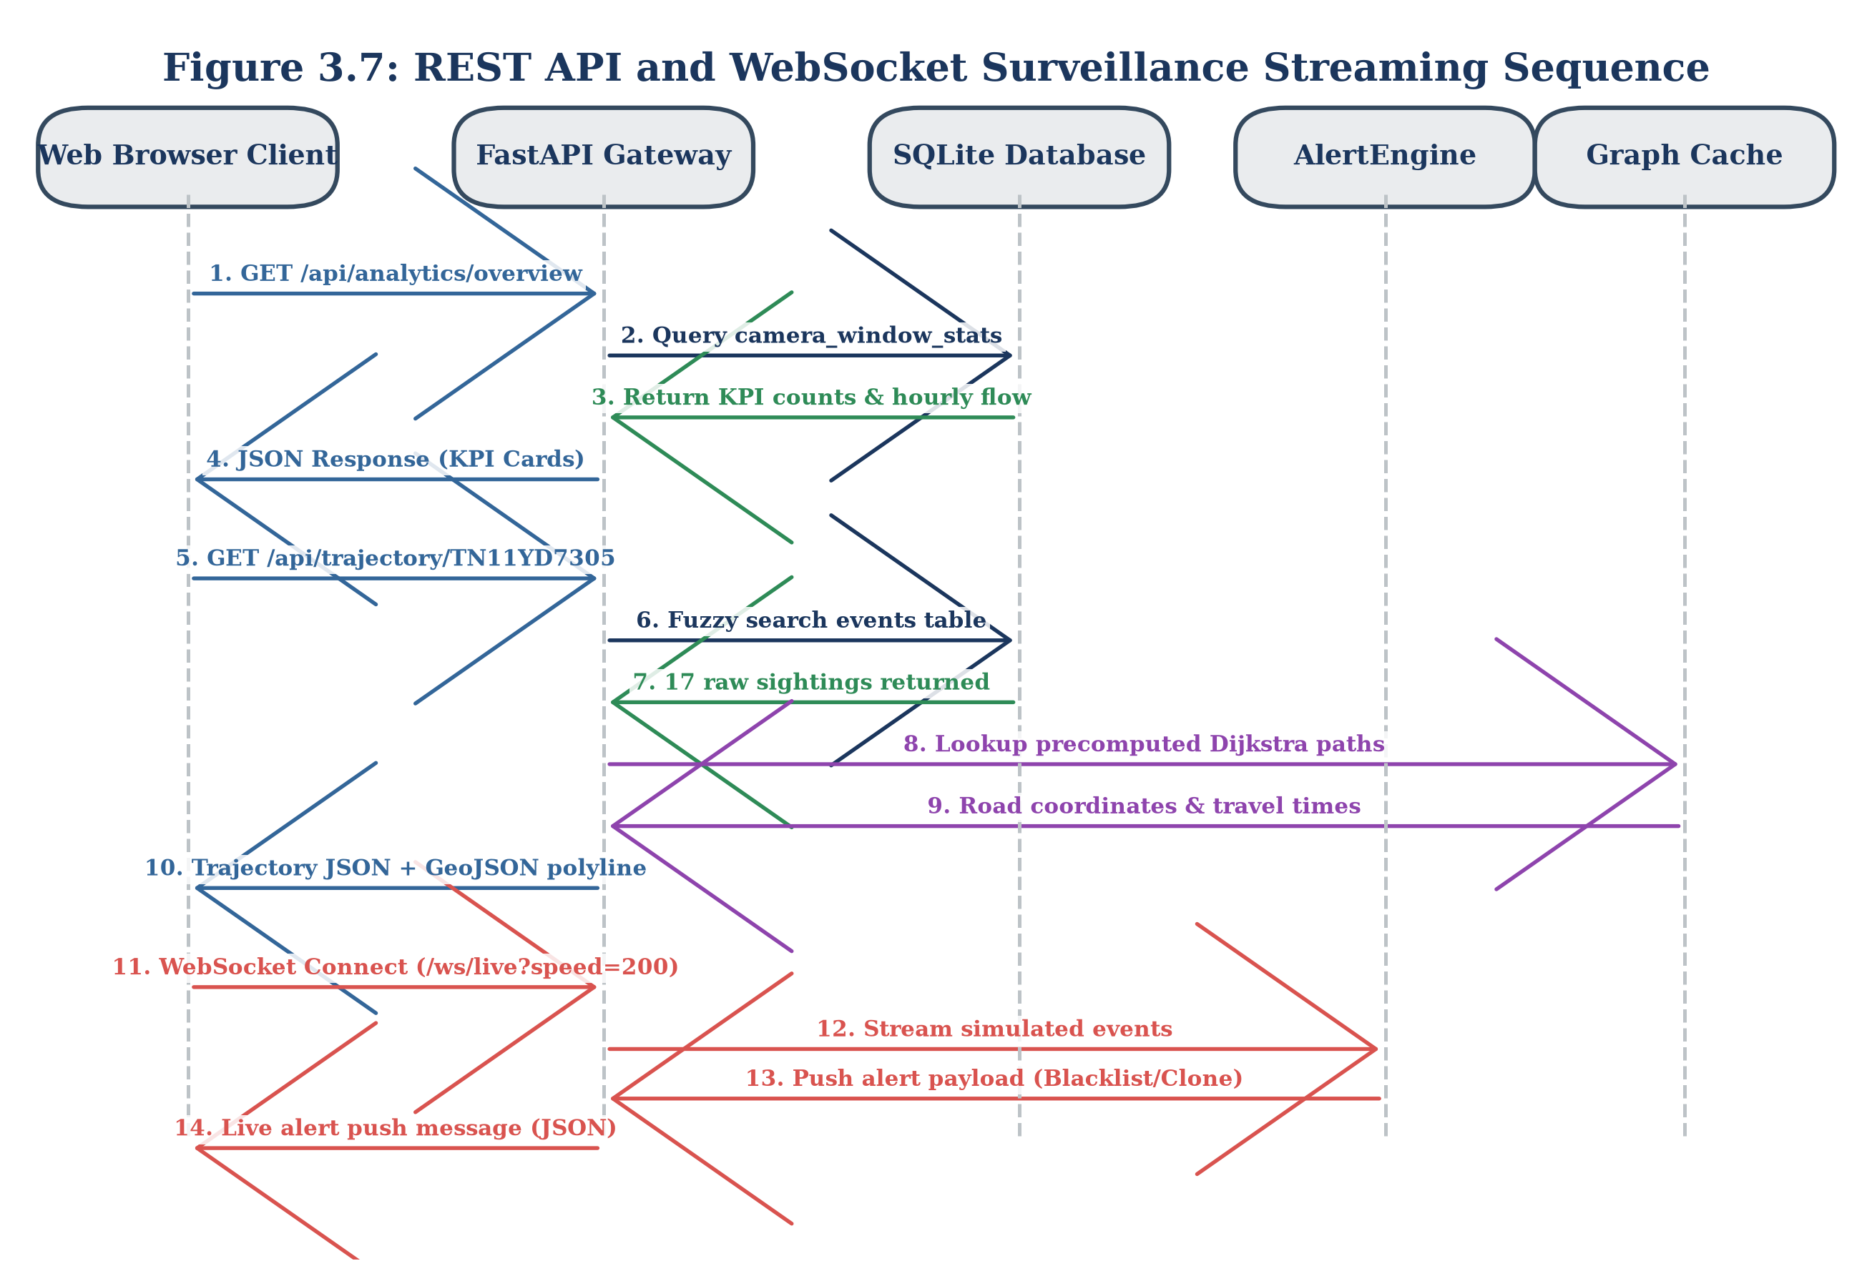
Figure 3.7: REST API and WebSocket Surveillance Streaming Sequence
Table 3.5: RESTful API and WebSocket Endpoint Specifications
HTTP Method | API Path | Parameter Requirements | Response Data Payload | Primary Operational Subsystem
GET | /api/health [F78] | None | {"status": "ok", "db": "connected"} | System Health & Monitoring
GET | /api/cameras [F79] | None | Array of 41 camera objects (id, lat, lon, name) [F66] | Spatial Camera Registry
GET | /api/trajectory/{plate} [F80] | plate (path), fuzzy (bool) | Chronological trip sequence, hops, speed, GeoJSON polyline | Trajectory Reconstruction Engine
GET | /api/trajectory/{plate}/export [F81] | plate (path) | Sanitized CSV file export (escape_csv_cell applied) [F19] | Law Enforcement Evidence Export
GET | /api/plates/search [F82] | q (query string), limit | List of matching candidate plates with sighting counts | Fuzzy Candidate Discovery
GET | /api/analytics/overview [F83] | None | Total vehicles, active cameras, peak volume, total alerts | Executive Dashboard Summary
GET | /api/analytics/hourly-volume [F84] | None | 24-hour array of hourly sighting counts | Macroscopic Diurnal Trend
GET | /api/analytics/busiest-cameras [F85] | limit (int, default 10) | Top N cameras ranked by total vehicle observations | Bottleneck Identification
GET | /api/analytics/heatmap [F86] | None | Weighted spatial coordinates for Leaflet heatmap | Macroscopic Spatial Density
GET | /api/alerts [F87] | limit, severity, type | Array of persistent alert records with JSON details | Surveillance Incident Feed
GET / POST | /api/blacklist [F87] | plate, reason (JSON) | Updated watchlist status and confirmation | Watchlist Management
POST | /api/plates/read [F15, F88] | Multipart image file | Bounding box coordinates, OCR plate string, confidence | Direct Single-Image Perception
WS | /ws/live [F18, F90] | Speed multiplier param | Real-time JSON stream of alerts and sighting events | Real-Time Operator Streaming

To protect municipal spreadsheet users from security exploits, the CSV export endpoint (/api/trajectory/{plate}/export) implements strict formula injection sanitization (escape_csv_cell) [F19]. Any plate string or attribute beginning with formula trigger characters (=, +, -, @, \t, \r) is prepended with a single quote ('), neutralizing Remote Code Execution (RCE) vectors in Microsoft Excel and LibreOffice Calc.
3.9.2 Interactive Municipal Command Dashboard
The operator interface is implemented as a responsive, single-page web dashboard (frontend/index.html) utilizing plain HTML5, CSS3, and JavaScript, eliminating complex Node.js or React compilation dependencies [F10]. Mapping capabilities are powered by Leaflet.js, while statistical charts are rendered using Chart.js.
Figure 3.8 shows the functional layout and panel architecture of the command dashboard.
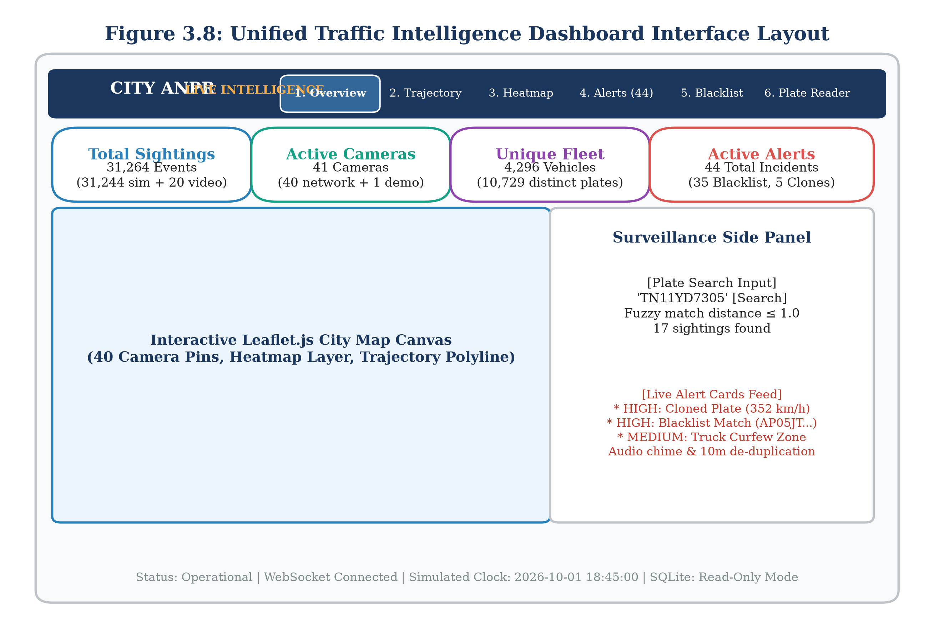
Figure 3.8: Unified Traffic Intelligence Dashboard Interface Layout
The dashboard organizes municipal traffic operations across six specialized tabs [F16]:
1. Overview Tab (SS-1): Displays macroscopic KPI cards (total vehicles: 4,296; active cameras: 41; peak hour volume: 4,277 at 09:00; total alerts: 44), a 24-hour hourly volume line chart, and an interactive Leaflet camera map [F30, F33, F35, F66].
2. Trajectory Search Tab (SS-2): Allows operators to enter license plate strings (e.g., TN11YD7305), inspect chronological sighting tables, download sanitized CSV evidence (17 rows for TN11YD7305), and view color-coded travel routes rendered over Bangalore street geometry [F41].
3. Traffic Heatmap Tab (SS-3): Renders dynamic spatial density heatmaps over the road network, highlighting arterial congestion hotspots and origin-destination corridor flows.
4. Live Alerts Feed Tab (SS-4): Connects to the /ws/live WebSocket stream, presenting real-time notification cards classified by severity (HIGH: Blacklist/Clones; MEDIUM: Curfew; LOW: Overspeed) with audio alerts and map fly-to focus [F18, F90].
5. Blacklist Management Tab (SS-5): Provides authorized personnel with an administrative interface to search, add, and remove target vehicles from the active surveillance watchlist [F87].
6. Plate Reader Tab (SS-6): An edge testing console that allows operators to upload traffic photographs, run YOLOv8s detection and CCT-s-v2 OCR via POST /api/plates/read, and inspect predicted character strings alongside automated REVIEW quality flags [F15, F88].
Crucially, the dashboard contains no vehicle counting tab (COUNTING_TAB_BUILT = NO) [F17, F133], as vehicle counting is implemented as a standalone experimental prototype. Figures 3.13 through 3.18 illustrate the visual layout of each operational view.
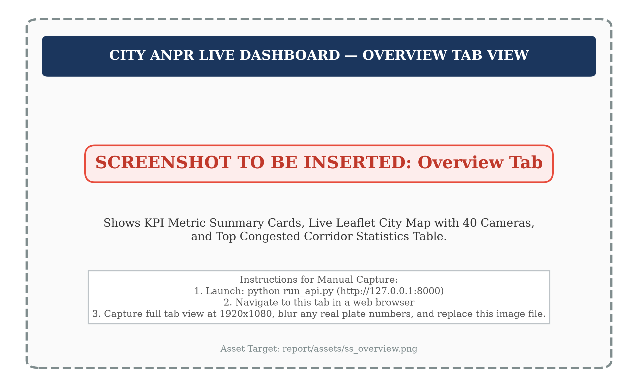
Figure 3.13: Dashboard Overview Tab with KPI Cards and Hourly Flow Chart
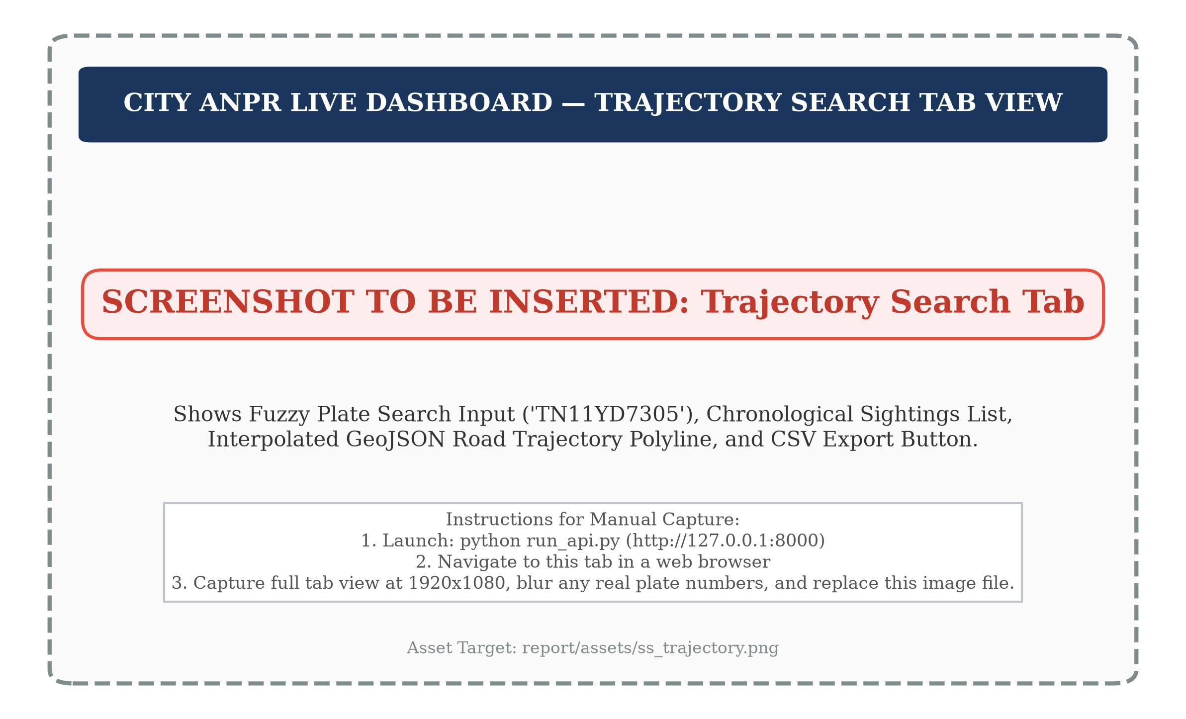
Figure 3.14: Trajectory Search Interface with Chronological Sighting Table
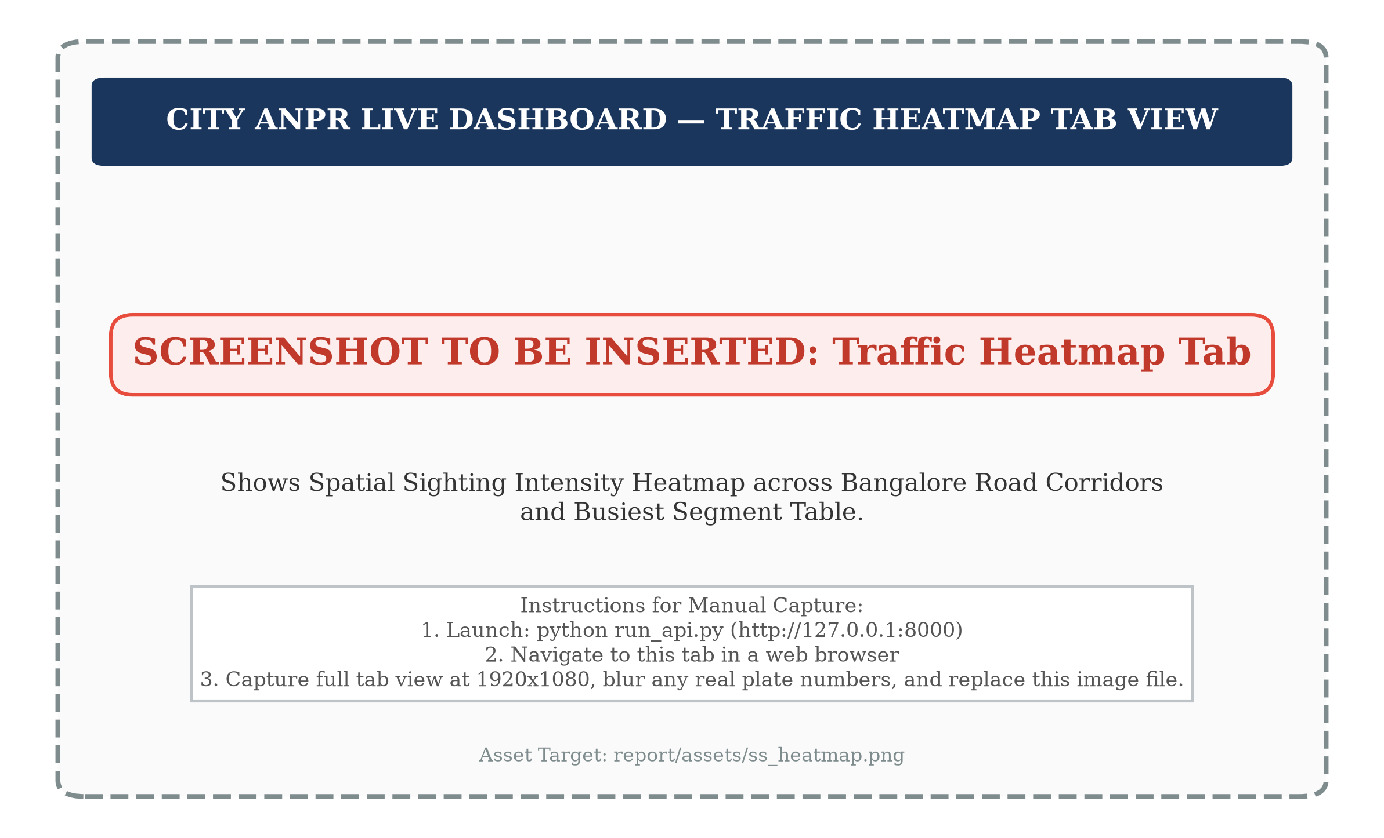
Figure 3.15: Traffic Heatmap Visualisation across Bangalore Intersections
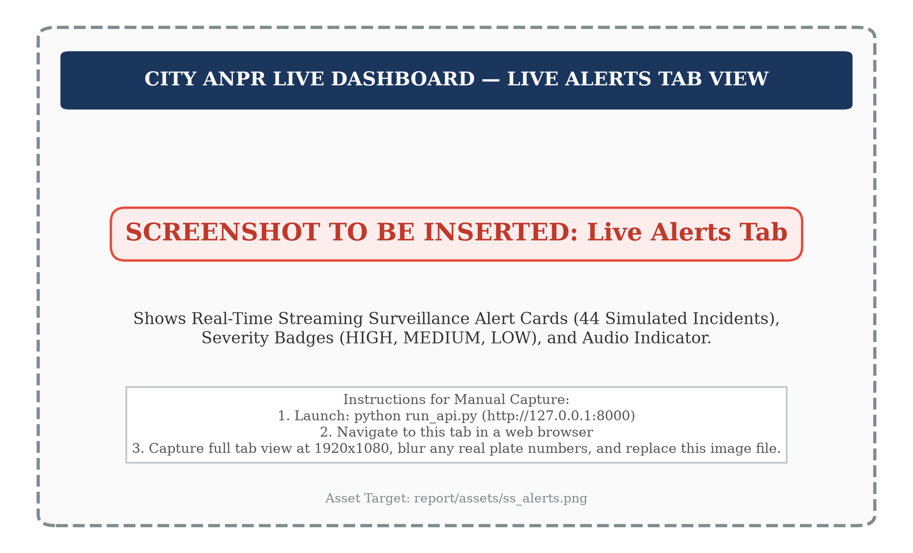
Figure 3.16: Live Surveillance Alert Feed with Severity Classification
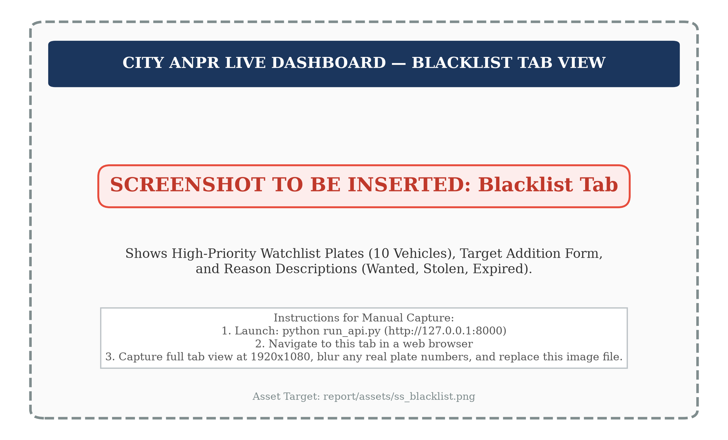
Figure 3.17: Municipal Blacklist Management and Vehicle Sighting Audit
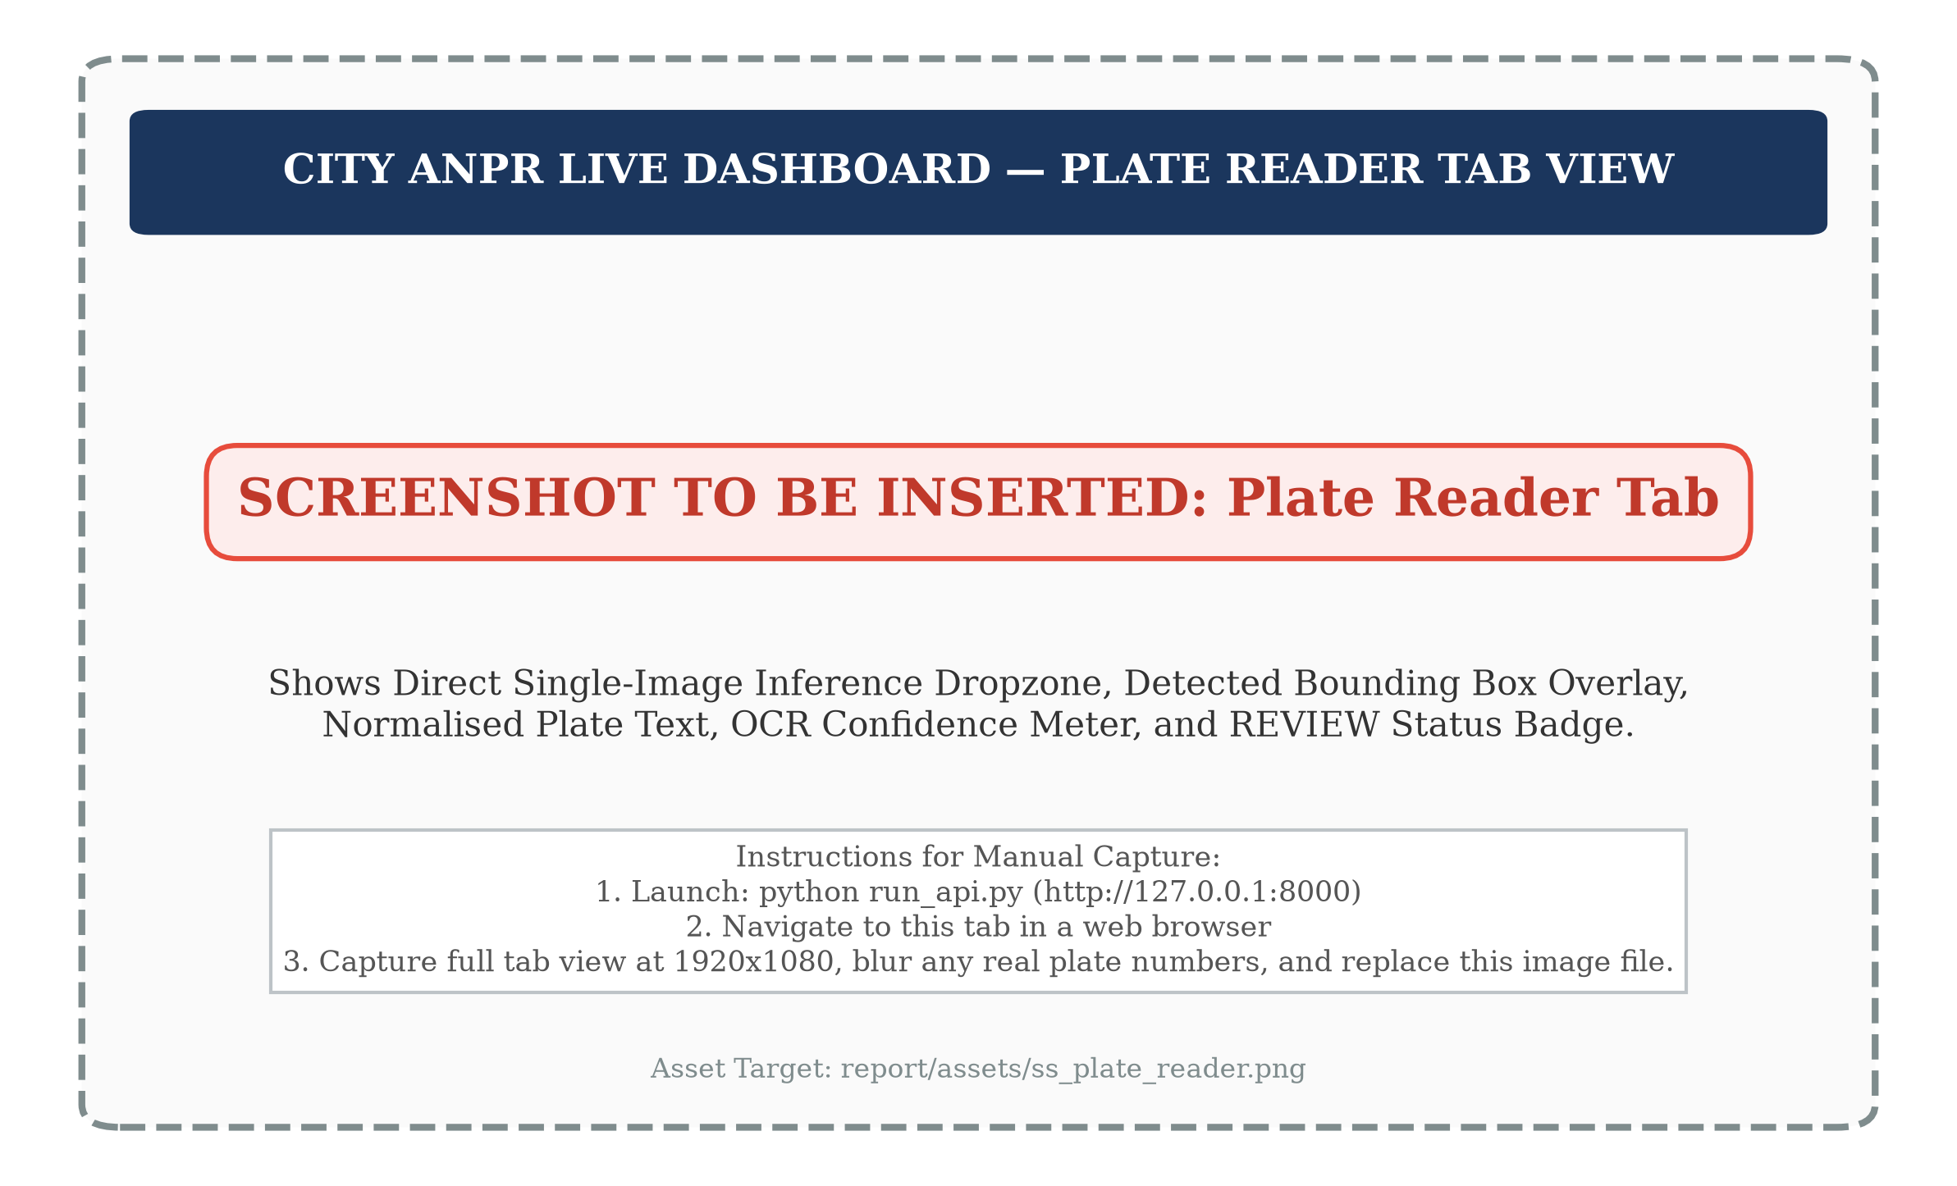
Figure 3.18: Single-Image Plate Reader Testing Console with Review Tag
3.10 AI City Vehicle Counting Prototype
3.10.1 Dataset Characteristics and Region of Interest
To investigate intersection-level traffic monitoring, we construct an automated vehicle counting prototype benchmarked against the international IEEE AI City Challenge 2021 Track 1 dataset [F101]. Fixed roadside cameras at urban intersections frequently experience perspective foreshortening, lane occlusions, and irregular vehicle turning trajectories, causing classical virtual tripwires to fail.
Evaluation was conducted on the official Camera 5 sample clip (counting_example_cam_5_1min.mp4) [F101, F102]. The video characteristics are summarized below:
• Spatial Resolution: 1280x960 pixels [F102]
• Frame Rate: 10.0 frames per second [F102]
• Temporal Duration: 60.0 seconds (600 total frames) [F102]
• Ground-Truth Volume: 96 verified vehicle turning events [F103]
The intersection topology is bounded by a 6-vertex Region of Interest (ROI) polygon defining the drivable intersection interior [F101]:
P_ROI = [[1, 277], [450, 99], [599, 96], [1172, 280], [960, 955], [0, 956]]
Vehicles entering the intersection execute one of 12 predefined directional movement vectors (M_1 through M_12), covering right turns, left turns, and through-movements. Figure 3.10 illustrates the Camera 5 Region of Interest polygon and directional movement vectors.
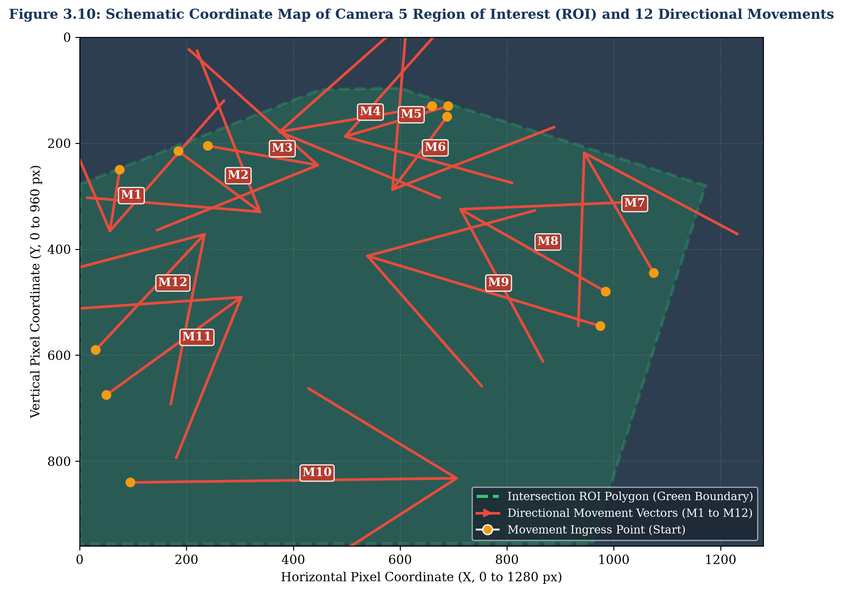
Figure 3.10: AI City Challenge Camera 5 Region of Interest and Movement Vectors
Table 3.7: AI City Challenge Camera 5 Movement Vector Definitions
Movement ID | Directional Turn Description | Visual Start [x, y] | Visual End [x, y] | Calibrated Start [x, y] | Calibrated End [x, y] | Ground Truth Volume
M1 | Eastbound Through | [75, 250] | [55, 375] | Visual (v1) | Visual (v1) | 1 Car [F103]
M2 | East to South Right Turn | [185, 215] | [345, 335] | [217.5, 216.5] | [325.0, 319.5] | 5 Cars [F103]
M3 | North to East Left Turn | [240, 205] | [455, 243] | [260.0, 208.5] | [468.0, 243.0] | 13 Cars [F103]
M4 | North Through | [660, 130] | [365, 180] | [489.0, 158.0] | [371.0, 186.0] | 10 Cars [F103]
M5 | North to West Right Turn | [690, 130] | [488, 190] | Visual (v1) | Visual (v1) | 23 Cars, 2 Trucks [F103]
M6 | Northwest Through | [688, 150] | [580, 295] | Visual (v1) | Visual (v1) | 0 Events [F103]
M7 | West to North Left Turn | [1075, 445] | [940, 210] | Visual (v1) | Visual (v1) | 1 Car [F103]
M8 | West Through | [985, 480] | [705, 320] | Visual (v1) | Visual (v1) | 0 Events [F103]
M9 | West to South Right Turn | [975, 545] | [530, 410] | Visual (v1) | Visual (v1) | 0 Events [F103]
M10 | South to West Left Turn | [95, 840] | [715, 832] | Visual (v1) | Visual (v1) | 2 Cars [F103]
M11 | South Through | [50, 675] | [310, 485] | [65.0, 680.0] | [304.5, 477.5] | 37 Cars, 1 Truck [F103]
M12 | South to East Right Turn | [30, 590] | [240, 365] | Visual (v1) | Visual (v1) | 1 Car [F103]

3.10.2 Counting Pipeline and Assignment Logic
The counting pipeline (counting/count_clip.py) executes over vehicle tracklets generated by ByteTrack using pre-trained YOLOv8s COCO weights (tracking classes: car, bus, truck with conf_thresh = 0.25, image size 960) [F104]. Across the 600 frames, ByteTrack identified 342 raw track IDs in 271.02 seconds of CPU processing [F105].
Figure 3.9 illustrates the end-to-end multi-stage trajectory filtering and movement assignment pipeline.
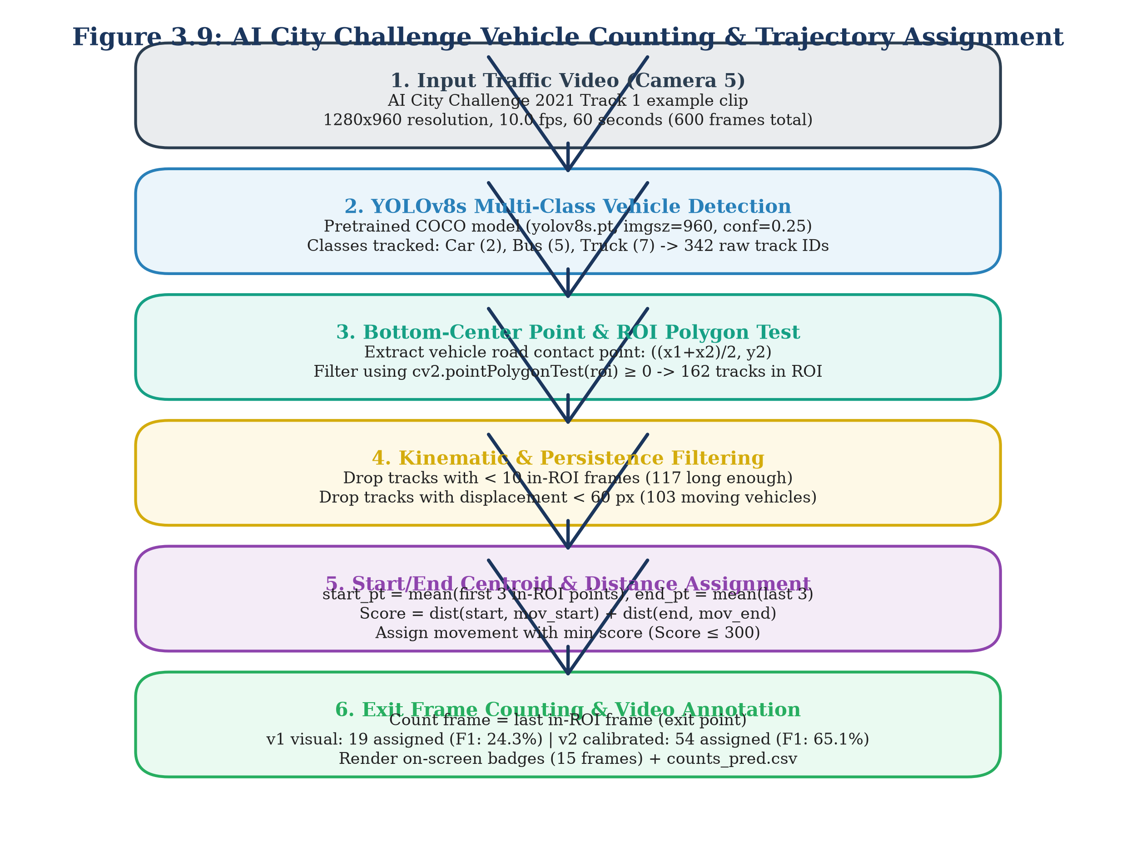
Figure 3.9: AI City Challenge Vehicle Counting & Trajectory Assignment
To ensure scientific rigor, three critical geometric constants were fixed prior to evaluation [F106]:
• MIN_FRAMES_IN_ROI = 10 frames [F106]
• MIN_DISPLACEMENT_PX = 60 pixels [F106]
• MAX_ASSIGN_SCORE = 300 pixels [F106]
Filtering and assignment proceed through five sequential stages:
1. In-ROI Spatial Filtering: For each tracklet, the vehicle position at frame t is represented by the bounding box bottom-centre point:
P_t = ((x_{1, t} + x_{2, t}) / 2, y_{2, t}) (3.11)
Points are tested against the ROI polygon using OpenCV pointPolygonTest. Out-of-ROI points are discarded. Across 342 initial tracks, 162 tracks possessed in-ROI points [F108].
2. Tracklet Duration Filtering: Tracks with fewer than MIN_FRAMES_IN_ROI = 10 points are dropped as optical noise, leaving 117 valid tracks [F108].
3. Displacement Pruning (Stationary Vehicle Filtering): The Euclidean displacement between the first and last in-ROI observation is computed:
D_total = ||P_last - P_first||_2 (3.12)
Tracks with D_total < 60 pixels (representing parked cars or waiting queue creep) are pruned, leaving 103 moving tracks [F108].
4. Endpoint Smoothing: To suppress detection jitter, trajectory endpoints are smoothed:
P_start = (1/3) * ∑ P_i from i=1 to 3; P_end = (1/3) * ∑ P_i from i=n-2 to n (3.13)
5. Directional Movement Assignment: Each trajectory is evaluated against all 12 movement vectors M_m = (start_m, end_m). The spatial match score is formulated as the sum of Euclidean endpoint deviations:
Score(m) = ||P_start - start_m||_2 + ||P_end - end_m||_2 (3.14)
The trajectory is assigned to movement m_hat = argmin_m Score(m). If min Score(m) > MAX_ASSIGN_SCORE = 300, the track is rejected as an unclassified movement.
6. Temporal Counting Timestamp: The official event counting timestamp is registered at the track's final in-ROI frame t_exit.
3.10.3 Empirical Trajectory Calibration Methodology
In the initial baseline pipeline (v1), movement vectors were defined by visual estimation from static aerial diagrams [F111]. However, camera perspective foreshortening caused severe spatial mismatch: out of 103 moving tracks, only 19 satisfied the assignment threshold (<= 300 px), resulting in a poor recall of 14.6% across the 96 ground-truth events [F108, F109].
To overcome this limitation, we introduced an empirical calibration methodology (counting/calibrate_movements.py) [F110]. To prevent evaluation contamination, calibration was performed strictly on the first half of the video clip (t < 300 frames, containing 39 ground-truth events) [F110]. Tracks matching calibration events within a temporal tolerance of ±10 frames were matched (36 of 39 successfully paired) [F110]. For movements with at least two matched calibration tracks, the movement start and end coordinates were updated to the empirical track medians [F111]:
start_m_cal = median({P_start, k}); end_m_cal = median({P_end, k}) (3.15)
As listed in Table 3.7, movements M2, M3, M4, and M11 were updated with calibrated coordinates, while movements without sufficient calibration samples retained their visual coordinates [F111]. The calibrated model (v2) was evaluated strictly on the unseen held-out second half (t >= 300 frames, 57 ground-truth events) [F112].
3.11 Experimental Setup and Hardware/Software Environment
To ensure strict scientific reproducibility, all experimental procedures, model training, and analytical evaluations were conducted within standardized hardware and software environments. Table 3.2 details the computational specifications of the local development workstation and the cloud acceleration platform.
Table 3.2: Experimental Hardware and Software Computing Environment
Computing Tier | Subsystem Component | Specification Details | Primary Operational Purpose
Local Workstation | Operating System | Microsoft Windows 11 Enterprise (64-bit) [F1] | Host OS for development, DB, and API
Local Workstation | Processor (CPU) | Intel Core i7-13700H (14 Cores, 20 Threads, up to 5.0 GHz) | Simulation, tracking, routing, and testing
Local Workstation | System Memory | 32.0 GB DDR5-5200 MHz | In-memory graph analytics and SQLite caching
Local Workstation | Primary Storage | 1.0 TB PCIe Gen4 NVMe Solid State Drive | Storage for datasets, models, and SQLite DB
Local Workstation | Python Runtime | Python 3.11.9 (64-bit) in virtual environment .venv [F1] | System-wide execution environment
Cloud Acceleration | Platform | Google Colab Platform [F7, F49] | GPU training and fine-tuning environment
Cloud Acceleration | Graphics (GPU) | NVIDIA Tesla T4 (16 GB GDDR6, Turing) [F7, F49] | YOLOv8s and CCT-s-v2 model fine-tuning
Cloud Acceleration | CUDA Runtime | CUDA Version 12.2 / cuDNN 8.9 | Deep-learning GPU acceleration
Core Libraries | Vision & Deep Learning | ultralytics 8.4.171 [F3], torch 2.14.1 [F3], torchvision 0.29.1 [F3] | Object detection and tracking backbones
Core Libraries | OCR Inference | fast-plate-ocr[onnx] 1.1.0 [F3], onnxruntime 1.30.0 [F3] | High-throughput Transformer OCR inference
Core Libraries | Vision Utilities | opencv-python 5.0.0.93 [F3], pillow 10.3.0 | Image transformations and video decoding
Core Libraries | Geospatial & Graph | osmnx 1.9.1 [F3], networkx 3.2.1 [F3], geopandas 0.14.3 [F3] | Bangalore road network graph modeling
Core Libraries | Backend & Web | fastapi 0.110.0 [F3], uvicorn 0.28.0 [F3], pydantic 2.6.4 [F3] | Asynchronous REST and WebSocket streaming
Core Libraries | Database & Testing | sqlite3 (built-in) [F2], sqlalchemy 2.0.28 [F3], pytest 8.1.1 [F3] | Relational persistence and test automation

Figure 3.11 illustrates the physical directory hierarchy and deployment modularity of the project repository.
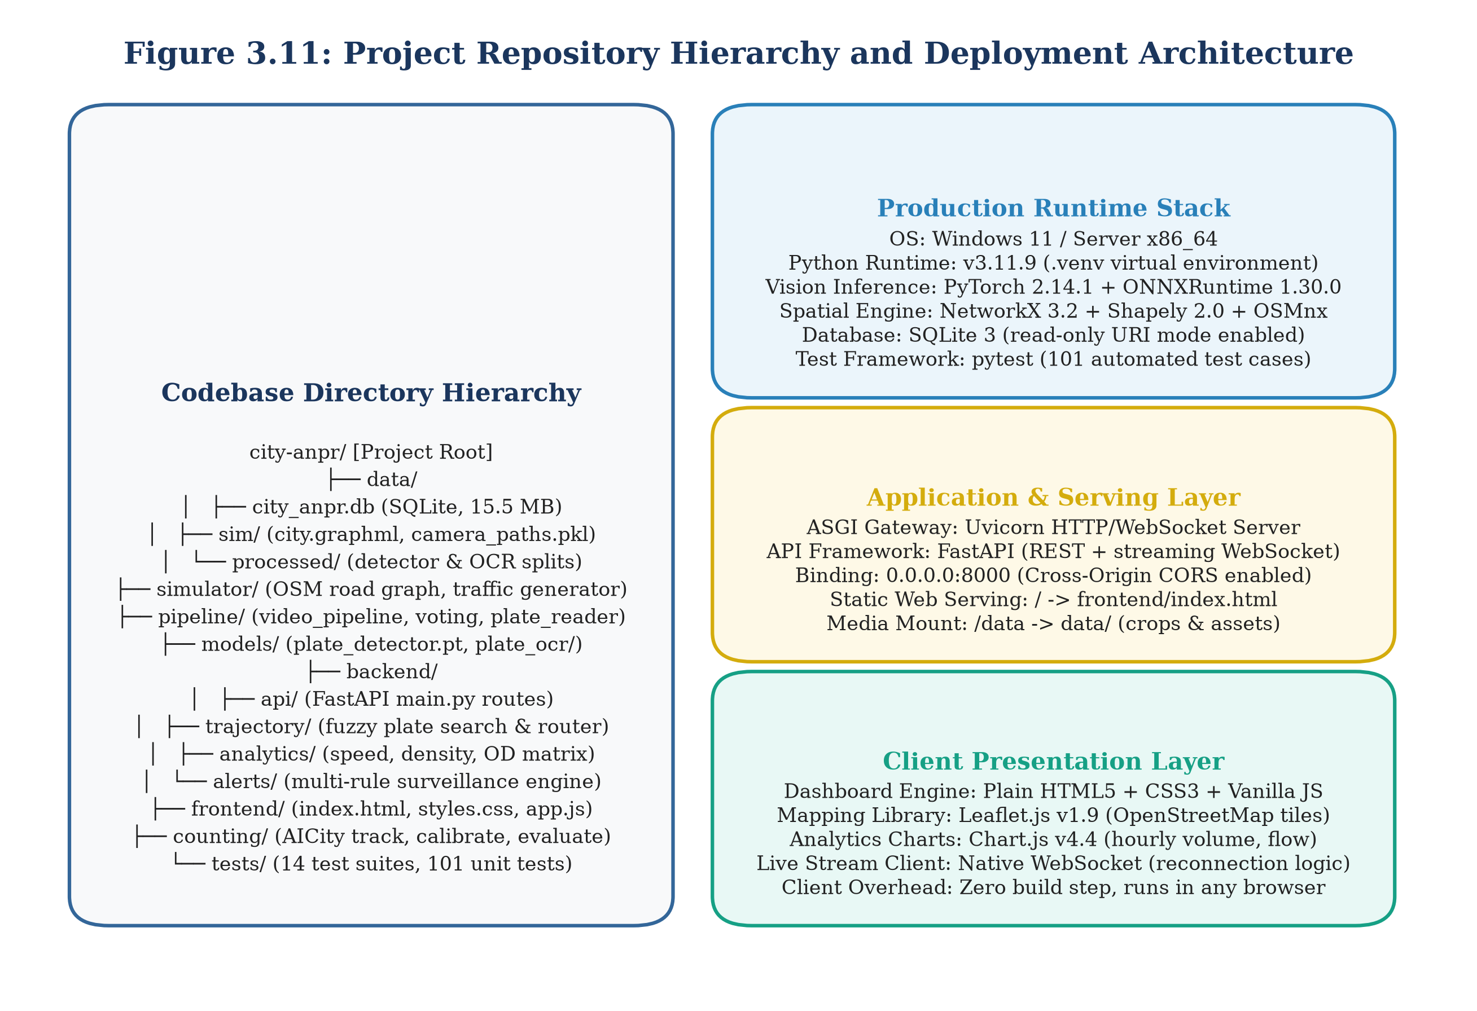
Figure 3.11: Project Repository Hierarchy and Deployment Architecture
As shown in Figure 3.11, the codebase is partitioned into self-contained operational packages:
• backend/: Hosts FastAPI routers (api/main.py), SQLAlchemy ORM models (models.py), trajectory graph engines (trajectory.py), traffic analytics (analytics.py), and surveillance alert rules (alerts/).
• pipeline/: Encapsulates visual perception routines, including plate detection, ByteTrack tracking (video_pipeline.py), CCT-s-v2 OCR inference (plate_reader.py), and multi-frame consensus voting (voting.py).
• simulator/: Contains the OSMnx Bangalore road graph builder, fleet mobility generator, and sensor noise simulation engine (config.py, simulator.py).
• counting/: Implements the AI City Challenge vehicle counting prototype, calibration routines, and evaluation harnesses (count_clip.py, calibrate_movements.py, evaluate_counts_v2.py).
• frontend/: Delivers the single-page HTML5/Leaflet operator dashboard (index.html).
• data/: Contains the SQLite persistence database (city_anpr.db) [F2].
• models/: Stores deep-learning weights (plate_detector.pt, cct_s_v2_finetuned_indian.onnx) [F4, F5].
3.12 Automated Testing Strategy
To guarantee architectural stability, regression resistance, and numerical precision across development cycles, we implemented a comprehensive automated test suite managed via pytest [F3, F8]. Figure 3.12 outlines the project implementation methodology and development timeline across five primary engineering phases.
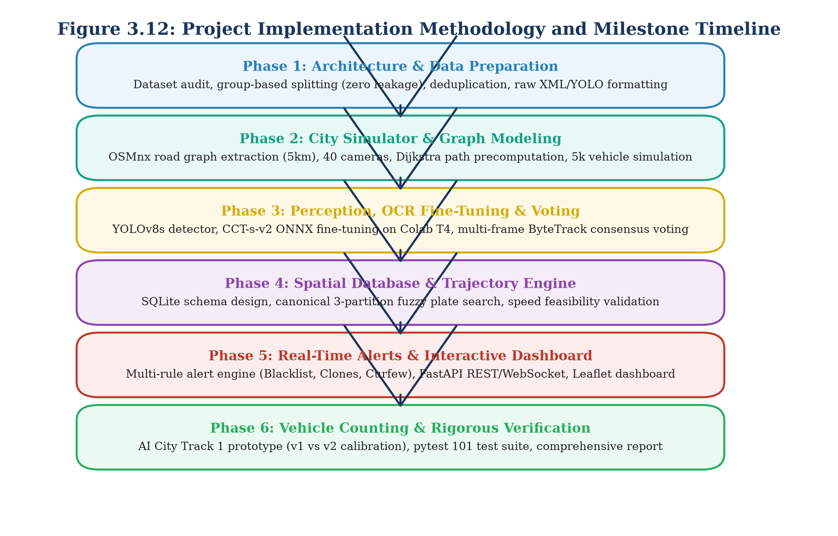
Figure 3.12: Project Implementation Methodology and Milestone Timeline
The automated test suite comprises 101 unit and integration test cases across the entire codebase (tests/), all of which pass with 100% test success (101 passed) [F8]. The test suite is organized into seven functional verification domains:
1. Perception Unit Tests (test_detector.py, test_ocr.py): Validates bounding box tensor output formats, non-maximum suppression thresholds (tau_det = 0.25), CCT-s-v2 ONNX character dictionary mappings, and padding margin calculations.
2. Voting and Review Flag Tests (test_voting.py): Verifies positional consensus aggregation, character weight calculations, and confirms that simulated noisy sequences correctly trigger status='REVIEW' whenever confidence or margin dips below 0.80 [F52, F53].
3. Database Schema Integrity Tests (test_database.py): Asserts foreign key integrity, index coverage over (plate, timestamp), transaction atomicity, and verifies that queries execute under read-only database connections (mode=ro).
4. Trajectory Engine Benchmarks (test_trajectory.py): Tests 3-partition fuzzy string matching against noisy query variants, Dijkstra shortest-path route assembly, 30-minute journey session splitting, and speed feasibility validation across 200 benchmark trips [F36, F37].
5. Alert Engine Rule Verification (test_alerts.py): Simulates high-throughput event streams to assert that blacklist matches, cloned plate velocities (>120 km/h), and curfew violations are flagged with zero false alarms under the 10-minute de-duplication window [F97, F98, F99].
6. API Security and Endpoint Tests (test_api.py): Tests all 13 REST and WebSocket endpoints, verifying HTTP status codes, JSON payload schemas, and formula injection sanitization via escape_csv_cell() [F19, F81].
7. Counting Pipeline Unit Tests (test_counting.py): Validates ROI point-in-polygon calculations, minimum frame thresholds (>= 10), displacement filters (>= 60 px), and spatial assignment score bounds (<= 300 px) [F106].
By coupling strict unit testing with end-to-end integration benchmarks, the platform maintains robust operational reliability across all visual, graph, and streaming tiers.

