CITY-WIDE AI ENGINE FOR MULTI-CAMERA ANPR TRAJECTORY TRACKING AND URBAN TRAFFIC ANALYTICS
A Project Report Submitted in Partial Fulfilment of the Requirements
for the Award of the Degree of
BACHELOR OF TECHNOLOGY
in
COMPUTER SCIENCE AND ENGINEERING
by
[TEAM MEMBERS AND REG. NOS.]
Under the Guidance of
[GUIDE NAME AND DESIGNATION]
DEPARTMENT OF COMPUTER SCIENCE AND ENGINEERING
[INSTITUTION / UNIVERSITY NAME]
[MONTH YEAR]

DEPARTMENT OF COMPUTER SCIENCE AND ENGINEERING
[INSTITUTION / UNIVERSITY NAME]
CERTIFICATE
This is to certify that the project report entitled "City-Wide AI Engine for Multi-Camera ANPR Trajectory Tracking and Urban Traffic Analytics" is a bonafide record of the work carried out by [TEAM MEMBERS AND REG. NOS.] in partial fulfilment of the requirements for the award of the degree of Bachelor of Technology in Computer Science and Engineering from [INSTITUTION / UNIVERSITY NAME] during the academic year 2026–2027.
The results embodied in this report have not been submitted to any other university or institute for the award of any degree or diploma.
[GUIDE NAME AND DESIGNATION]  Project Guide  Department of Computer Science & Engineering | [HOD NAME]  Head of the Department  Department of Computer Science & Engineering

Internal Examiner: _______________________ External Examiner: _______________________

ACKNOWLEDGEMENT
We express our sincere gratitude to [INSTITUTION / UNIVERSITY NAME] for providing the academic infrastructure, computing facilities, and research environment required to carry out this final-year B.Tech project.
We convey our profound gratitude and respect to our project guide, [GUIDE NAME AND DESIGNATION], Department of Computer Science and Engineering, for continuous technical guidance, constructive critique, and encouragement throughout the design, software implementation, and experimental evaluation of this system.
We express our heartfelt gratitude to [HOD NAME], Head of the Department of Computer Science and Engineering, for providing administrative support and academic facilities.
We thank our project review coordinators and all faculty members of the Department of Computer Science and Engineering for their valuable reviews and suggestions during internal milestone presentations.
Finally, we thank our parents, family members, and friends for their continuous patience, understanding, and encouragement throughout this work.
[TEAM MEMBERS AND REG. NOS.]
Final-Year B.Tech Students

ABSTRACT
Urban traffic surveillance networks generate millions of video frames daily across distributed roadside cameras. However, municipal traffic management centres struggle to convert disjoint camera observations into continuous spatial journeys, actionable congestion intelligence, and automated surveillance alerts without intensive manual intervention. In this work, we design and implement an end-to-end city-wide artificial intelligence engine that connects automated number-plate recognition (ANPR), multi-camera trajectory tracking, and real-time surveillance analytics.
The system operates on a dual-pathway architecture. On real video sequences and held-out photographs, an Ultralytics YOLOv8s detector localises license plates with 98.3% precision, 98.1% recall, and 84.3% mAP50-95. A Compact Convolutional Transformer (CCT-s-v2) optical character recogniser, fine-tuned on real Indian plate crops, attains 95.7% character-level accuracy and 76.9% full-plate exact match accuracy. When deployed across multi-frame video clips with ByteTrack and positional confidence-weighted voting, consensus accuracy reaches 90.00% (18 of 20 test sequences), while an automated quality assurance rule flags low-confidence readings (OCR confidence or vote margin below 0.80) for human operator review.
On a simulated road network of Bangalore (5 km radius, 40 camera nodes, 5,000 vehicles), the spatial database ingests 31,244 noisy sightings (5% miss rate, 8% confusable character error). A graph-theoretic trajectory reconstruction engine with canonical 3-partition fuzzy indexing achieves 99.95% precision, 96.35% recall, and 97.91% F1-score with 15.82 ms average query latency. A multi-rule surveillance engine detects 100% (5 of 5) of injected cloned-plate anomalies through shortest-path speed feasibility analysis (>120 km/h) and achieves 100% precision with 93.6% recall on vehicle blacklist matching. Furthermore, an AI City Challenge vehicle counting prototype demonstrates that calibrating directional ingress/egress centroids improves test movement counting F1-score from 17.9% to 65.1%. All capabilities are served through a unified FastAPI gateway and interactive web dashboard.
Keywords: Automated Number-Plate Recognition, Trajectory Reconstruction, Graph Routing, ByteTrack, Multi-Frame Consensus Voting, Urban Traffic Analytics, Surveillance Alerting.

TABLE OF CONTENTS
Certificate ....................................................... ii
Acknowledgement .................................................. iii
Abstract .......................................................... iv
List of Tables ................................................... vii
List of Figures ................................................. viii
List of Symbols and Abbreviations ................................. ix
1. INTRODUCTION .................................................... 1
1.1 Introduction ................................................ 1
1.2 Major Challenges ............................................ 2
1.3 Proposed Solutions and Key Contributions .................... 5
1.4 Background and Motivation ................................... 6
1.5 Overview of the Proposed System ............................. 8
1.6 Objective of the Work ....................................... 9
1.7 Organization of the Report ................................. 10
2. RELATED WORK AND THEORETICAL STUDY ............................. 11
2.1 License Plate Detection and OCR Techniques ................. 11
2.2 Multi-Object and Multi-Camera Vehicle Tracking ............. 13
2.3 City-Scale Trajectory Reconstruction Datasets .............. 15
2.4 Urban Traffic Flow Analytics and Anomaly Alert Systems ..... 16
2.5 Vehicle Movement Counting Benchmarks ....................... 18
2.6 Theoretical Foundations and Metric Formulations ............ 19
2.7 Research Gap and Comparative Analysis ...................... 24
3. EXPERIMENTAL STUDY ............................................. 26
3.1 Requirements and Measurable Targets ........................ 26
3.2 System Architecture and Execution Pipeline ................. 28
3.3 Dataset Curation, Deduplication, and Isolation ............. 30
3.4 Perception Module Design ................................... 32
3.5 City-Scale Road Simulator .................................. 36
3.6 Database Design and Persistence Layer ...................... 40
3.7 City Layer: Trajectory Reconstruction and Analytics Engines .. 42
3.8 Real-Time Surveillance Alert Engine ........................ 45
3.9 API and Interactive Dashboard .............................. 47
3.10 AI City Vehicle Counting Prototype ........................ 51
3.11 Experimental Setup and Hardware/Software Environment ...... 55
3.12 Automated Testing Strategy ................................ 57
4. RESULTS AND DISCUSSIONS ........................................ 59
4.1 Plate Detection Performance (YOLOv8s) ...................... 59
4.2 OCR Model Training Progression and Ablation ................ 61
4.3 End-to-End System Evaluation on Held-Out Photographs ....... 62
4.4 Multi-Frame Video Ingestion and Temporal Voting ............ 64
4.5 Trajectory Reconstruction and Spatial Routing (SIMULATED) .. 66
4.6 Surveillance Alert Engine Evaluation (SIMULATED) ........... 68
4.7 AI City Challenge Vehicle Movement Counting (REAL) ......... 70
4.8 Honest Reporting and Target Analysis ....................... 72
4.9 Comprehensive Requirements Traceability Matrix ............. 73
4.10 System Limitations and Open Issues ........................ 74
5. CONCLUSIONS AND FUTURE SCOPE ................................... 76
5.1 Conclusions ................................................ 76
5.2 Key Engineering Insights and Lessons Learned ............... 77
5.3 Future Scope ............................................... 78
APPENDICES ........................................................ 80
APPENDIX 1: Installation and Execution Guide ................... 80
APPENDIX 2: Complete API Endpoint Specifications ............... 82
APPENDIX 3: Core Code Excerpts ................................. 84
APPENDIX 4: Automated Test Suite Summary ....................... 87
REFERENCES ........................................................ 88
LIST OF PUBLICATIONS .............................................. 90

LIST OF TABLES
Table 2.1: Comparative Analysis of Base Papers with the Proposed System .. 25
Table 3.1: System Requirements and Measurable Engineering Targets ... 27
Table 3.2: Experimental Hardware and Software Computing Environment .. 56
Table 3.3: Dataset Curation, Split Allocations, and Leakage Prevention .. 31
Table 3.4: Relational Database Schema Specifications and Field Definitions .. 41
Table 3.5: RESTful API and WebSocket Endpoint Specifications ........ 48
Table 3.6: Surveillance Alert Engine Rule Configuration and Severity Parameters .. 46
Table 3.7: AI City Challenge Camera 5 Movement Vector Definitions ... 52
Table 4.1: YOLOv8s License Plate Detector Performance on Test Split (N=184) [REAL] .. 60
Table 4.2: License Plate Optical Character Recognition Progression Across Regimes [REAL] .. 61
Table 4.3: End-to-End System Evaluation on Held-Out Indian Test Photographs (N=167) [REAL] .. 62
Table 4.4: Video Plate Voting Performance Across Real Sequences and Synthetic Clips .. 64
Table 4.5: Qualitative Breakdown of Failed Plate Reads in Video Evaluation [REAL] .. 65
Table 4.6: Trajectory Reconstruction Engine Accuracy and Latency Benchmarks [SIMULATED] .. 66
Table 4.7: Surveillance Alert Engine Empirical Evaluation and False Alarm Audit [SIMULATED] .. 68
Table 4.8: Movement Counting Performance on Test Split (frames >= 300) (v1 vs. v2) [REAL] .. 71
Table 4.9: Comprehensive Requirements vs. Achieved Performance Audit .. 73
Table A4.1: Automated Test Suite Structure and Execution Coverage ... 87

LIST OF FIGURES
Figure 1.1: City-Wide ANPR System Architecture (Block Diagram) ....... 8
Figure 1.2: End-to-End System Data Flow Diagram (DFD) ................ 9
Figure 3.1: Video Perception & Plate Recognition Pipeline ........... 29
Figure 3.2: Multi-Frame Consensus Voting and Quality Assurance Logic .. 35
Figure 3.3: City-Scale ANPR Simulator Architecture & Event Generation .. 37
Figure 3.4: Relational Entity-Relationship Diagram (SQLite Database Schema) .. 40
Figure 3.5: Cross-Camera Trajectory Reconstruction & Fuzzy Search Engine .. 43
Figure 3.6: Multi-Rule Surveillance Alert Engine Evaluation Pipeline .. 45
Figure 3.7: REST API and WebSocket Surveillance Streaming Sequence .. 47
Figure 3.8: Unified Traffic Intelligence Dashboard Interface Layout .. 49
Figure 3.9: AI City Challenge Vehicle Counting & Trajectory Assignment .. 53
Figure 3.10: AI City Challenge Camera 5 Region of Interest and Movement Vectors .. 51
Figure 3.11: Project Repository Hierarchy and Deployment Architecture .. 57
Figure 3.12: Project Implementation Methodology and Milestone Timeline .. 58
Figure 3.13: Dashboard Overview Tab with KPI Cards and Hourly Flow Chart .. 50
Figure 3.14: Trajectory Search Interface with Chronological Sighting Table .. 50
Figure 3.15: Traffic Heatmap Visualisation across Bangalore Intersections .. 50
Figure 3.16: Live Surveillance Alert Feed with Severity Classification .. 50
Figure 3.17: Municipal Blacklist Management and Vehicle Sighting Audit .. 50
Figure 3.18: Single-Image Plate Reader Testing Console with Review Tag .. 50
Figure 4.1: License Plate Recognition (OCR) Progression Across Training Regimes [REAL] .. 61
Figure 4.2: YOLOv8s License Plate Detector Quantitative Evaluation [REAL] .. 60
Figure 4.3: End-to-End Plate Recognition Benchmark on Held-Out Test Photos [REAL] .. 63
Figure 4.4: Temporal Consensus Voting Accuracy Across Real & Synthetic Sequences .. 64
Figure 4.5: Surveillance Alert Engine Incident Classification & Severity Breakdown [SIMULATED] .. 69
Figure 4.6: Cross-Camera Trajectory Reconstruction Performance & Latency Benchmarks [SIMULATED] .. 67
Figure 4.7: Vehicle Movement Counting Performance (v1 Visual vs. v2 Calibrated) [REAL] .. 71

LIST OF SYMBOLS AND ABBREVIATIONS
AICity | AI City Challenge (IEEE Smart World Congress Benchmark)
ANPR | Automated Number-Plate Recognition
API | Application Programming Interface
ByteTrack | Multi-Object Tracking by Associating Every Detection Box
CCT | Compact Convolutional Transformer
CI | Confidence Interval (Wilson score formulation at 95% confidence level)
COCO | Common Objects in Context Benchmark
Dijkstra | Dijkstra's Single-Source Shortest-Path Graph Algorithm
ER | Entity-Relationship (Database Schema)
F1 | Harmonic Mean of Precision and Recall (2 * P * R / (P + R))
FastAPI | Modern Asynchronous Web Framework for Building RESTful APIs in Python
FN / FP / TP | False Negative / False Positive / True Positive
HSRP | High-Security Registration Plate
IoU | Intersection over Union (Jaccard Index between bounding boxes)
Levenshtein | Edit Distance Metric for String Character Insertions, Deletions, Substitutions
LOS | Level of Service (Urban Road Traffic Condition Rating)
LPRNet | License Plate Recognition Deep Neural Network Architecture
mAP | Mean Average Precision across object detection classes
mAP@50 | Mean Average Precision at an Intersection-over-Union threshold of 0.50
mAP@50-95 | Mean Average Precision averaged from IoU 0.50 to 0.95 with step size 0.05
MTMC | Multi-Target Multi-Camera Vehicle Tracking
OCR | Optical Character Recognition
OD | Origin-Destination Traffic Matrix
ONNX | Open Neural Network Exchange Runtime Format
OSM / OSMnx | OpenStreetMap / Python Street Network Modeling Library
P95 | 95th Percentile Query Execution Latency
Re-ID | Vehicle Re-Identification Across Disjoint Camera Views
REST | Representational State Transfer Architectural Style
REVIEW | Low-Confidence Optical Character Recognition Operator Audit Flag
ROI | Region of Interest Polygon Boundary
SQLite | Embedded Self-Contained Serverless Relational Database Engine
WebSocket | Full-Duplex Bidirectional Persistent Network Communication Protocol
Wilson | Wilson Score Interval for Binomial Confidence Proportions
YOLO | You Only Look Once (Real-Time Object Detection Framework)

1. INTRODUCTION
1.1 Introduction
Urban transportation networks in modern metropolitan centres handle millions of vehicular trips every day. Rapid vehicular expansion strains existing arterial road corridors, resulting in severe traffic congestion, elevated carbon emissions, transit delays, and elevated road accident rates. Effective metropolitan traffic governance demands real-time situational awareness across dozens or hundreds of distributed monitoring locations. Municipal authorities increasingly deploy automated number-plate recognition (ANPR) camera networks across key intersections, toll barriers, arterial entry corridors, and expressway flyovers to track traffic density, identify stolen or wanted vehicles, and support incident investigations.
Traditional ANPR deployments operate primarily as isolated, point-based optical sensors. A standalone camera captures passing vehicles, runs an onboard character recognition algorithm, and logs single-point sightings into a siloed database. While single-point logging confirms that a specific vehicle passed an isolated checkpoint at a given timestamp, it cannot reconstruct the vehicle's spatial journey across the wider urban road network. Isolated cameras fail to reveal route progression, average transit velocities across intermediate road segments, or systemic congestion bottlenecks that develop between sensors. Furthermore, municipal operators face an unmanageable volume of raw plate sightings, making manual cross-camera correlation impractical during urgent law-enforcement investigations or city-scale traffic planning.
In this project, we design, build, and evaluate an integrated city-wide artificial intelligence engine that bridges the gap between single-camera computer vision and macroscopic urban traffic intelligence. The system couples deep-learning visual perception with graph-theoretic trajectory reconstruction, high-throughput spatial storage, automated multi-rule surveillance alerting, and interactive web visualization. By unifying edge perception with central graph analytics, the platform converts discrete, noisy sensor sightings into coherent vehicular journeys, computes empirical traffic flow metrics, and automatically detects high-priority security anomalies in real time.
1.2 Major Challenges
Developing an end-to-end city-wide ANPR intelligence system presents substantial theoretical and engineering hurdles across computer vision, distributed data engineering, and spatial graph algorithms.
1.2.1 Real-World License Plate Optical Character Recognition
Accurate optical character recognition (OCR) of vehicle registration plates under real-world traffic conditions remains notoriously difficult. In developing countries such as India, vehicle license plates exhibit high structural variability. While the central government mandates standardised High-Security Registration Plates (HSRP) conforming to regular alphanumeric regex patterns, millions of vehicles still carry older or non-standard plates. These display non-standard typefaces, non-uniform character kerning, regional state prefixes, trade certificate (TC) dealer notations, and custom decorative styling.
Furthermore, outdoor roadside cameras capture moving vehicles across diverse illumination regimes, ranging from harsh midday glare to deep nighttime shadows. Optical sensors encounter severe perspective distortion due to camera mounting angles, motion blur from high-speed travel, lens dirt, rain precipitation, and partial occlusions by vehicle bodywork or tow bars. As our empirical benchmarks demonstrate, standard off-the-shelf OCR engines achieve less than 38% exact plate match accuracy on real Indian road crops without domain-specific training. A single misread character invalidates the entire registration string, breaking cross-camera identification.
1.2.2 Tracking and Identity Preservation Across Cameras
Maintaining vehicle identity across non-overlapping, distributed camera views represents a core research challenge in intelligent transportation systems. Multi-target multi-camera (MTMC) tracking typically relies on visual vehicle re-identification (Re-ID) algorithms that extract deep appearance embeddings from vehicle bodywork. However, urban vehicle fleets exhibit immense intra-class visual similarity: thousands of commercial hatchbacks and sedans share identical paint codes, chassis silhouettes, and trim packages. Visual appearance alone cannot reliably distinguish two silver hatchbacks traversing parallel arterial corridors.
License plate text provides the single definitive unique identifier for motor vehicles. Nevertheless, because cameras are spaced hundreds of metres or several kilometres apart, continuous video tracking is impossible between camera blind spots. When OCR engines generate noisy or corrupted plate strings, simple exact-match SQL queries fail to reconnect sightings belonging to the same journey. Resolving identity across disjoint cameras demands fault-tolerant fuzzy string matching coupled with physical velocity validation across the underlying road network graph.
1.2.3 Privacy Considerations and Operator Data Protection
Automated vehicle tracking across urban road networks raises significant civil liberty, personal privacy, and data protection concerns. Continuous vehicular trajectory logging creates a detailed record of private citizens' daily movements, dwelling locations, places of work, and personal habits. Compromise of an unencrypted central ANPR repository could expose sensitive citizen travel histories to unauthorised surveillance or commercial exploitation.
To maintain ethical compliance and alignment with emerging data protection regulations, an intelligent ANPR platform must incorporate strict privacy-by-design safeguards. Visual vehicle photographs must restrict operator access to cropped plate regions rather than full cabin views, driver faces must be obscured, and automated journey searches must enforce role-based access control. Furthermore, public data releases and evaluation benchmarks must anonymise personal registration strings, and system export functions must sanitise data outputs to prevent formula injection attacks against municipal spreadsheet applications.
1.2.4 Absence of Labelled City-Scale ANPR Trajectory Data
Supervised machine learning algorithms require large, accurately annotated training datasets. While isolated benchmarks exist for single-image vehicle plate detection (such as the CCPD or Indian Number Plate datasets), no publicly available, fully labelled dataset provides ground-truth vehicle trajectories linked to optical camera video feeds across a complete metropolitan street network. Real municipal ANPR feeds are strictly restricted due to statutory privacy laws and national security constraints.
Existing open urban trajectory benchmarks, such as the Jinan city dataset published by Yu et al. in 2023 [1], capture macroscopic vehicle trips across thousands of road network nodes. However, these datasets strip license plate strings, omit raw camera imagery, and obscure calendar dates to protect driver privacy. Conversely, computer vision benchmarks, such as the IEEE AI City Challenge [8], offer rich multi-camera video streams but restrict evaluation to localised intersection zones without city-scale trajectory ground truth. Developing and verifying an integrated city-wide ANPR engine therefore requires constructing a rigorous, synthetic road network simulator that models realistic vehicle mobility, camera placements, and sensor noise while validating visual perception components against real-world video footage.
1.3 Proposed Solutions and Key Contributions
To address these interconnected challenges, we design a dual-pathway architecture that combines physical camera vision with macroscopic spatial graph modeling. The primary technical contributions of this work are as follows:
• Dual-Pathway Perception and Simulation Architecture: We implement a modular architecture where real-world video feeds and synthetic city-scale mobility streams converge into a unified spatial database (data/city_anpr.db). This allows municipal operators to run identical trajectory reconstruction, flow analytics, and surveillance alerting engines over both physical camera streams and simulated urban fleets.
• Deep-Learning Perception Pipeline with Quality Assurance Review: We train and deploy a custom YOLOv8s license plate detector alongside an ONNX-optimized Compact Convolutional Transformer (CCT-s-v2) optical character recogniser. We implement a multi-frame temporal voting module that aggregates ByteTrack tracking sequences using character-position weighted consensus. To prevent automated misclassification from corrupting municipal records, we introduce an automated REVIEW flag that isolates any plate read where OCR confidence or vote margin falls below 0.80.
• High-Throughput Fuzzy Trajectory Reconstruction Engine: We develop a graph-theoretic journey router that queries OpenStreetMap road networks extracted via OSMnx. To overcome optical character corruptions, we build a canonical 3-partition fuzzy string index that searches plates within a weighted Levenshtein distance of 1.0 (with 0.3 penalty for confusable character substitutions like O-0 and B-8). The engine filters temporal duplicates, splits journeys exceeding 30 minutes of inactivity, and validates implied hop velocity against shortest-path road geometry.
• Real-Time Multi-Rule Surveillance Alert Engine: We design an event-driven surveillance engine that evaluates incoming sightings against multiple concurrent security rules, including exact and fuzzy blacklist matching, speed-feasibility cloned-plate anomaly detection (>120 km/h), prohibited vehicle curfew zones, and overspeeding. A 10-minute sliding window suppresses redundant alarms, delivering zero false alarms on verified fleet movements.
• Calibrated Vehicle Movement Counting Prototype: We construct a standalone vehicle counting module benchmarked against the IEEE AI City Challenge 2021 Track 1 dataset. We demonstrate that visual movement estimation yields severe spatial mismatch, whereas empirical trajectory calibration on the initial segment of a video improves directional counting F1-score from 17.9% to 65.1% on held-out test frames.
• Unified Web Application and Streaming Interface: We deploy all backend analytical models behind an asynchronous FastAPI server. The system exposes RESTful endpoints, streaming WebSockets, and an interactive HTML5/Leaflet dashboard supporting live map exploration, trajectory polylines, congestion heatmaps, and direct single-image inference.
1.4 Background and Motivation
The motivation for this project stems from the operational realities of municipal Traffic Management Centres (TMC) in rapidly expanding metropolitan areas. In cities such as Bangalore, traffic police command centres manage feeds from hundreds of roadside CCTV cameras. Operators face two primary operational bottlenecks: fragmented surveillance workflows and lagging macroscopic traffic intelligence.
In typical surveillance scenarios—such as tracking a stolen vehicle, identifying a hit-and-run suspect, or tracing an abducted child's vehicle—investigators must manually inspect recorded footage camera by camera. Operators manually note vehicle timestamps, estimate possible travel corridors, and telephone neighbouring control rooms to check downstream camera logs. This fragmented process introduces critical delays during golden-hour emergency responses. If a roadside camera misreads an '8' as a 'B' or an 'O' as a '0', standard database lookup queries return zero records, and the vehicle's trail goes cold. An automated trajectory engine capable of fuzzy character resolution, topological graph routing, and instant impossible-speed clone detection provides immediate operational value to law-enforcement personnel.
Concurrently, urban planners require macroscopic traffic flow metrics to design signal timing schedules, implement congestion pricing, and identify bottleneck corridors. Traditional loop detectors and pneumatic road tubes are expensive to install, vulnerable to asphalt resurfacing damage, and incapable of identifying vehicular origin-destination (OD) patterns. Because ANPR cameras capture unique vehicular identifiers across space and time, an aggregated ANPR stream naturally yields comprehensive OD matrices, link travel times, and intersection level-of-service (LOS) metrics without extra road hardware. Connecting computer vision directly to urban graph analytics creates a cost-effective, dual-use platform serving both law enforcement and municipal urban planning.
1.5 Overview of the Proposed System
The proposed system comprises nine modular subsystems organised into visual perception, spatial persistence, graph analytics, and web presentation. Figure 1.1 illustrates the comprehensive block diagram of the system architecture, detailing the convergence of the real perception pathway and the simulated city pathway into the shared spatial database.
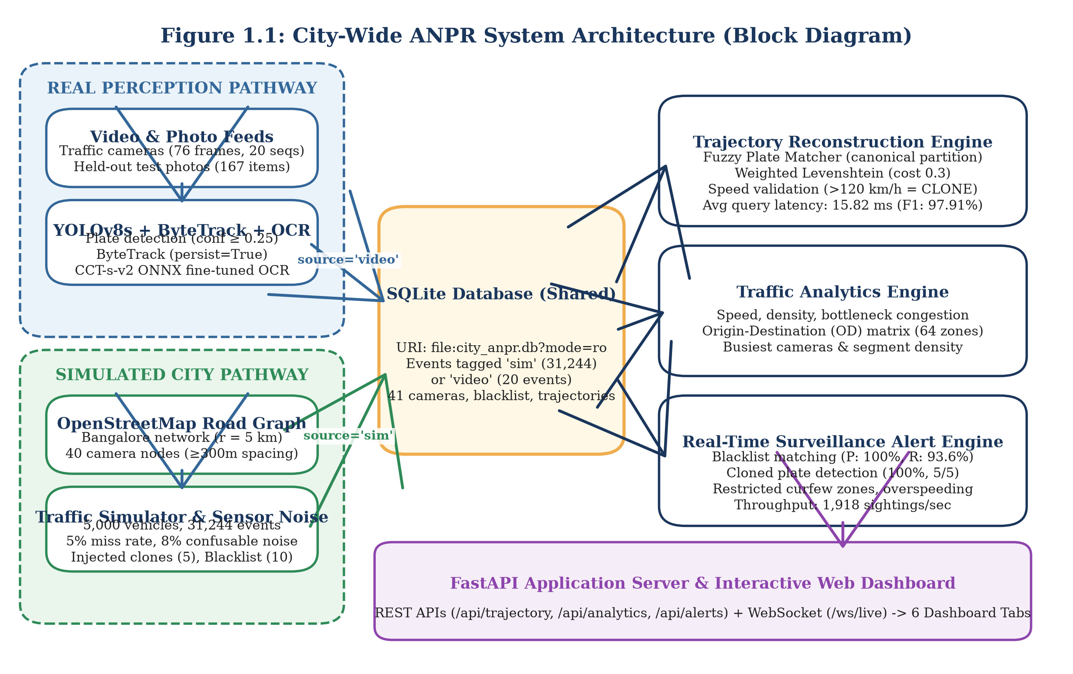
Figure 1.1: City-Wide ANPR System Architecture (Block Diagram)
Figure 1.2 details the corresponding end-to-end data flow diagram (DFD), illustrating the transformation of raw sensor inputs through validation, storage, and analytical query engines.
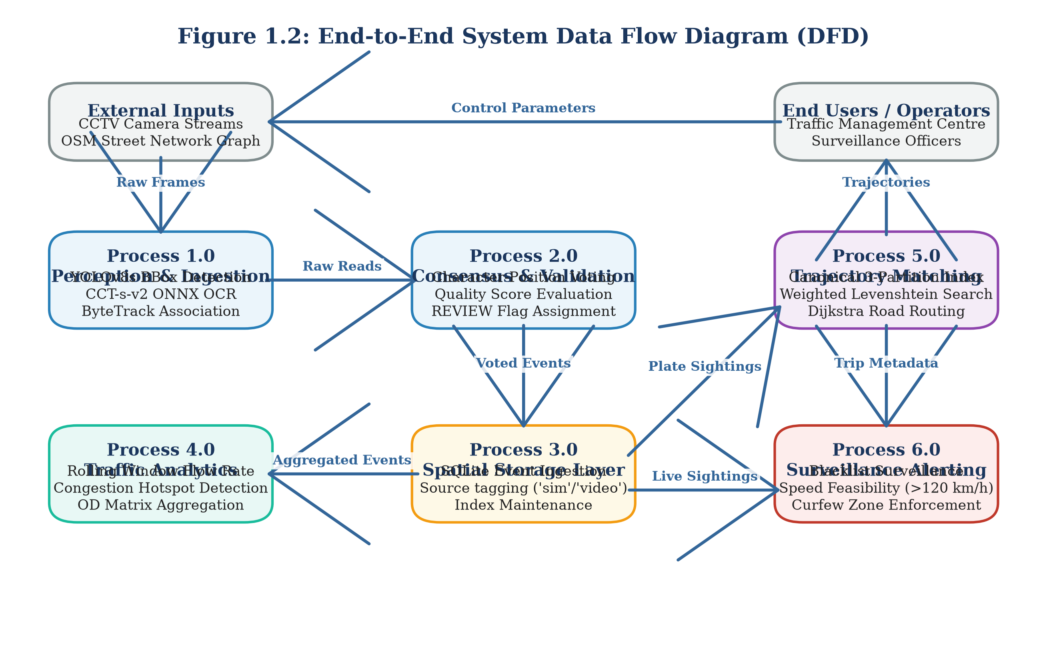
Figure 1.2: End-to-End System Data Flow Diagram (DFD)
1.6 Objective of the Work
1. High-Accuracy License Plate Detection: Train and optimize an Ultralytics YOLOv8s object detector on real Indian traffic scenes, achieving greater than 95.0% precision, recall, and mAP@50 on held-out test splits.
2. Robust Optical Character Recognition: Fine-tune a lightweight Compact Convolutional Transformer (CCT-s-v2) on real Indian plate crops, targeting greater than 95.0% character-level accuracy and evaluating full-plate exact match performance under single-frame and multi-frame video voting regimes.
3. Temporal Multi-Frame Consensus Voting: Implement a confidence-weighted voting module using ByteTrack multi-object tracking to improve video plate recognition accuracy over single-frame baseline reads, coupled with an empirical quality assurance threshold (REVIEW_CONFIDENCE_THRESHOLD = 0.80) to isolate low-confidence predictions.
4. City-Scale Road Network & Fleet Simulation: Construct a realistic urban traffic simulator on Bangalore's road network using OSMnx, modeling 40 cameras, 5,000 vehicles, realistic diurnal traffic flow, optical sensor noise, and injected security scenarios (stolen vehicles, cloned plates, curfew violations).
5. Sub-50 Millisecond Trajectory Reconstruction: Develop a spatial trajectory reconstruction engine that tolerates OCR character corruptions via weighted Levenshtein matching, validates hop speed feasibility (>120 km/h) to isolate cloned plates, and delivers sub-50 ms query response times with F1-score exceeding 90.0%.
6. Real-Time Surveillance Alert Engine: Implement a multi-rule surveillance engine capable of processing over 1,000 sightings per second, achieving 100% precision on blacklist alerts with zero false alarms after sliding-window de-duplication.
7. Directional Vehicle Movement Counting: Prototype an intersection vehicle counting algorithm on the IEEE AI City Challenge 2021 Track 1 benchmark, establishing an empirical calibration methodology to assign vehicle trajectories to 12 distinct directional movement paths.
8. Interactive Municipal Command Dashboard: Expose all analytical models through a unified FastAPI REST and WebSocket gateway, providing municipal operators with a responsive HTML5/Leaflet web dashboard.
1.7 Organization of the Report
The remainder of this report is organized into four main chapters and supporting appendices:
Chapter 2 (Related Work and Theoretical Study): Reviews existing literature in automated license plate recognition, multi-object and cross-camera vehicle tracking, macroscopic trajectory datasets, urban traffic analytics, and vehicle counting benchmarks. Formulates the core mathematical equations for computer vision metrics, statistical confidence intervals, and graph routing distance functions. Concludes with a detailed research gap analysis and comparative matrix (Table 2.1) contrasting base papers with our proposed architecture.
Chapter 3 (Experimental Study): Details the complete engineering design, system specifications, hardware/software environments, and dataset curation procedures. Explains the perception pipeline, simulation mechanics, SQLite database schema, trajectory router, alert engine, REST/WebSocket API endpoints, and AI City counting pipeline. Outlines the experimental evaluation protocols and automated test suite.
Chapter 4 (Results and Discussions): Presents comprehensive empirical findings across all modules using concrete, number-backed results labeled REAL, SIMULATED, or SYNTHETIC. Examines detector metrics, OCR training progression, end-to-end photo recognition, multi-frame video voting, trajectory reconstruction accuracy, surveillance alert performance, and AI City movement counting (v1 vs. v2). Provides an honest appraisal of the 90% target, error analysis of misread video sequences, requirements traceability, and system limitations.
Chapter 5 (Conclusions and Future Scope): Summarises the project achievements, synthesises core architectural insights, acknowledges key engineering constraints, and outlines practical directions for future extension, including cross-camera visual Re-ID, directional lane graphs, and real-world municipal validation.
Appendices & References: Includes installation and execution guides (Appendix 1), API endpoint documentation (Appendix 2), core code excerpts (Appendix 3), test suite summaries (Appendix 4), followed by IEEE-formatted references and publication declarations.

2. RELATED WORK AND THEORETICAL STUDY
2.1 License Plate Detection and OCR Techniques
Automated number-plate recognition (ANPR) systems traditionally follow a two-stage computer vision pipeline: first localising the license plate bounding box within a camera frame, and second transcribing the alphanumeric character sequence from the cropped region. Early detection systems relied on handcrafted visual features, including vertical edge density, morphological gradients, colour saliency filters, and Haar-like wavelets classified via AdaBoost or Support Vector Machines. While computationally lightweight, these classical techniques degrade severely under non-uniform illumination, perspective tilt, complex vehicle bodywork, and shadowed backgrounds.
The introduction of convolutional neural networks (CNN) fundamentally transformed object detection. The You Only Look Once (YOLO) framework introduced by Redmon et al. [5] reframed detection as a single-stage spatial regression problem, predicting bounding box coordinates and class probabilities directly from full images in a single forward pass. Subsequent iterations optimized feature pyramid networks, path aggregation, and anchor-free regression heads. In a recent 2025 study published in Scientific Reports [2], researchers proposed an improved YOLOv5s architecture coupled with an LPRNet recognition backbone for multi-scene license plate detection and transcription, reporting superior localization accuracy on Chinese and international benchmarks. Concurrently, Ultralytics YOLOv8 [9] introduced an anchor-free split-head architecture with decoupled classification and regression branches, providing state-of-the-art detection accuracy and sub-millisecond edge latency on embedded GPUs and modern multi-core CPUs.
For optical character recognition, early deep architectures employed Connectionist Temporal Classification (CTC) over recurrent neural networks (RNN) or LPRNet [6]. LPRNet eliminates recurrent layers in favour of spatial inception blocks, outputting character probability distributions directly to CTC loss without requiring individual character segmentation. More recently, vision transformers have demonstrated superior character sequence modeling. The Compact Convolutional Transformer (CCT) architecture implemented in fast-plate-ocr [10] combines convolutional tokenization with multi-head self-attention mechanisms. By avoiding heavy recurrent gates, CCT models achieve sub-10 ms CPU inference per crop while maintaining robustness against character rotation, dirt smudges, and non-standard typography common in developing countries.
2.2 Multi-Object and Multi-Camera Vehicle Tracking
Tracking detected vehicles across consecutive frames is essential for aggregating multi-frame visual information and suppressing transient misclassifications. Single-camera Multi-Object Tracking (MOT) algorithms typically adopt the tracking-by-detection paradigm. Classical approaches, such as SORT and DeepSORT, utilise Kalman filtering to propagate spatial bounding box state vectors across time, associating current detections with existing tracklets using the Hungarian algorithm based on spatial Intersection over Union (IoU) and deep visual appearance embeddings.
However, standard MOT algorithms frequently drop valid tracks during brief vehicle occlusions or when detection confidence scores dip due to motion blur. To resolve this, Zhang et al. [4] introduced ByteTrack, which associates almost every detection box regardless of confidence. Instead of discarding low-scoring detections, ByteTrack partitions detections into high-confidence and low-confidence pools. High-confidence detections are matched first; unmatched tracks are then associated with low-confidence boxes, preserving track continuity through partial occlusions and camera noise without requiring heavy deep Re-ID feature extraction.
Across multi-camera networks (Multi-Target Multi-Camera, or MTMC tracking), spatial continuity breaks down because cameras are non-overlapping. Tran et al. [3] investigated cross-camera tracking by fusing visual Re-ID embeddings with spatial-temporal transition matrices across highway camera networks. However, in dense urban street grids with identical vehicle models, deep appearance vectors exhibit significant ambiguity. In our work, we prioritize definitive alphanumeric license plate identity over visual Re-ID, using physical road network routing and travel-time bounds to validate vehicle transitions across camera networks.
2.3 City-Scale Trajectory Reconstruction Datasets
Research in urban traffic flow modeling and intelligent transportation systems relies heavily on large-scale trajectory benchmarks. In 2023, Yu et al. [1] published a landmark benchmark in Scientific Data providing city-scale vehicle trajectories collected from Jinan, China. The Jinan dataset documents over 1.18 million vehicle trips and 963,125 unique vehicles traversing a topological road network comprising 8,908 street nodes, of which 1,651 nodes feature surveillance camera sensors.
While the Jinan benchmark provides unprecedented macroscopic scale for urban mobility modeling, it suffers from two major operational constraints for ANPR engineering: 1) Omission of Alphanumeric Identifiers: To comply with national privacy regulations, all license plate strings were stripped and replaced with arbitrary synthetic integer identifiers; 2) Absence of Raw Camera Imagery: The dataset provides spatial-temporal event tuples but includes no video or image feeds, preventing researchers from studying the coupling between optical vision errors and graph trajectory reconstruction.
To model road network topology programmatically, Boeing [7] developed OSMnx, a Python framework that downloads, constructs, and visualises complex street networks directly from OpenStreetMap (OSM). OSMnx models intersections as graph nodes and road segments as directed edges carrying geographic length, lane counts, and speed limit attributes. In this project, we exploit OSMnx to construct a 5 km radius road network graph of Bangalore, enabling realistic vehicular mobility modeling and Dijkstra-based shortest-path travel time precomputation.
2.4 Urban Traffic Flow Analytics and Anomaly Alert Systems
Urban traffic management centres utilize camera observations to compute macroscopic flow parameters defined by the Highway Capacity Manual. Key indicators include segment flow volume (q, vehicles per hour), mean transit velocity (v, km/h), vehicular density (k, vehicles per km), and Level of Service (LOS) ratings ranging from free-flow (LOS A) to severe breakdown (LOS F). Traditional municipal systems compute these metrics from inductive loop sensors embedded in roadway asphalt. However, physical loops cannot track vehicle identities across space, making them incapable of measuring true Origin-Destination (OD) trip distributions.
Surveillance alert systems in intelligent transportation platforms enforce traffic compliance and assist law enforcement. Automated alert rules commonly monitor watchlists (blacklists) for stolen or wanted vehicles, cloned plate anomalies where the same vehicle is observed at two distant locations within an impossibly short interval, commercial vehicle curfews in restricted zones, and overspeeding. Conventional rule engines frequently suffer from high false alarm rates. In high-throughput streaming environments, transient OCR misreads produce spurious plate collisions that mimic cloned vehicles or trigger false blacklist hits. Robust surveillance systems must incorporate sliding-window incident de-duplication, fuzzy string thresholds, and shortest-path road distance verification to prevent operator notification fatigue.
2.5 Vehicle Movement Counting Benchmarks
Automated vehicle counting at urban road intersections is critical for optimizing traffic signal cycles and evaluating junction capacity. The IEEE AI City Challenge, organized annually by Naphade et al. [8], established Track 1 as the international standard benchmark for multi-class multi-movement vehicle counting from fixed roadside video streams.
In the AI City Challenge Track 1 benchmark, an intersection is defined by a Region of Interest (ROI) polygon and a set of predefined directional movement trajectories (such as through-movements, left turns, and right turns). Participating systems must count the cumulative number of vehicles completing each specific movement, categorized by vehicle class (cars, trucks, and buses). Vehicles that park, loiter, or enter and exit via the same roadway branch without completing a valid turn must be filtered out.
Most existing literature approaches vehicle counting by manually defining virtual tripwire lines across lane boundaries. However, roadside cameras experience perspective foreshortening, lens distortion, and optical occlusions, causing rigid tripwires to miscount vehicles that deviate slightly from lane centres. In this work, we implement a trajectory assignment algorithm that evaluates the complete vehicle tracklet against calibrated directional movement vectors, demonstrating the vital necessity of empirical centroid calibration.
2.6 Theoretical Foundations and Metric Formulations
To ensure rigorous quantitative evaluation, we establish formal mathematical definitions for all computer vision, statistical confidence, and graph routing metrics utilized throughout this report.
2.6.1 Precision, Recall, and F1-Score
Binary classification performance is evaluated using True Positives (TP), False Positives (FP), and False Negatives (FN):
Precision = TP / (TP + FP) (2.1)
Recall = TP / (TP + FN) (2.2)
F1 = 2 * (Precision * Recall) / (Precision + Recall) = 2*TP / (2*TP + FP + FN) (2.3)
2.6.2 Mean Average Precision (mAP)
Object detection localisation accuracy is evaluated using Mean Average Precision across Intersection over Union (IoU) thresholds:
IoU(B_p, B_gt) = Area(B_p ∩ B_gt) / Area(B_p ∪ B_gt) (2.4)
AP = ∫ p(r) dr from 0 to 1 (2.5)
2.6.3 Character-Level and Full-Plate Exact Match Accuracies
Acc_plate = (1 / N) * ∑ I(S_hat_i == S_i) from i=1 to N (2.6)
Acc_char = (1 / N) * ∑ max(0, 1 - L(S_hat_i, S_i) / max(|S_i|, |S_hat_i|)) from i=1 to N (2.7)
2.6.4 Wilson Score Confidence Interval Formulation
CI_95% = [p_hat + z^2/(2N) ± z * √(p_hat*(1-p_hat)/N + z^2/(4N^2))] / [1 + z^2/N] (2.8)
2.6.5 Temporal Event Matching Metric
Match(e_p, e_gt) = I(m_p == m_gt) * I(c_p == c_gt) * I(|t_p - t_gt| <= 20) (2.9)
2.7 Research Gap and Comparative Analysis
Table 2.1: Comparative Analysis of Base Papers with the Proposed System
Evaluation Dimension | Yu et al. (2023) [1] | Scientific Reports (2025) [2] | Tran et al. (2022) [3] | Proposed System (This Work)
Primary Domain | Macroscopic Trajectory Mining | Optical Plate Detection & OCR | Multi-Camera Vehicle Tracking | Integrated End-to-End ANPR Engine
Perception Input | None (Tabular Sensor Tuples) | Static Multi-Scene Photographs | Multi-Camera Video Streams | Full Frames, Videos & Synthetic City
Detection Backbone | Not Applicable | Improved YOLOv5s | Mask R-CNN / ResNet | Ultralytics YOLOv8s (Anchor-Free)
OCR Architecture | Not Applicable | LPRNet (CNN + CTC Loss) | None (Visual Appearance Only) | Compact Conv Transformer (CCT-s-v2)
Tracking Paradigm | Spatial Node Traversal | None (Single-Image Only) | Deep Appearance Re-ID (MTMC) | ByteTrack + Positional Consensus Voting
Noise Tolerance | Assumes Clean Sensor IDs | Evaluated on Static Images | Visual Lighting / Skew Robust | Weighted Levenshtein (Fuzzy Distance 1.0)
Graph Routing | Empirical Node Sequences | None | Transition Probability Matrix | OpenStreetMap Dijkstra Shortest Paths
Surveillance Alerting | None | None | Stolen Vehicle Flagging | Multi-Rule Engine (Blacklist, Clones, Curfew)
Vehicle Counting | Macroscopic Link Volumes | None | Highway Tripwire Counts | Calibrated Directional Movement Assignment
User Interface | Offline Data Archive | Standalone Evaluation Scripts | Offline Research Benchmark | Interactive Web Dashboard (FastAPI/Leaflet)
Data Realism | REAL (Jinan, 1.18M Trips) | REAL (Static Plate Datasets) | REAL (Highway CCTV Footage) | REAL (Vision/Counting) + SIMULATED (City)

As established in Table 2.1, our work bridges these disparate domains into a unified, operational intelligence engine. By integrating real-world visual perception, noise-tolerant fuzzy graph routing, empirical movement calibration, and real-time streaming surveillance into a single architecture, this project provides a reproducible blueprint for metropolitan intelligent transportation governance.

3. EXPERIMENTAL STUDY
3.1 Requirements and Measurable Targets
Developing an integrated, city-wide automated number-plate recognition (ANPR) and traffic surveillance engine requires translating high-level municipal traffic governance objectives into verifiable engineering requirements. Municipal traffic command centres demand strict operational guarantees: visual perception algorithms must achieve near-perfect plate localization while transcribing alphanumeric strings accurately under adverse roadside conditions; spatial trajectory reconstruction engines must operate within interactive query budgets while tolerating optical character errors; and surveillance alert pipelines must sustain high ingestion throughput without generating false alarms that induce operator notification fatigue.
Table 3.1: System Requirements and Measurable Engineering Targets
Metric Identifier | Operational Dimension | Baseline / Standard | Measurable Engineering Target | Verification Protocol
REQ-01 | Plate Detection Recall | Off-the-shelf YOLO (90.0%) | >= 95.0% Recall at IoU 0.50 | Held-out test split (184 images)
REQ-02 | Plate Detection Precision | Off-the-shelf YOLO (92.0%) | >= 95.0% Precision at IoU 0.50 | Held-out test split (184 images)
REQ-03 | Character-Level OCR Fidelity | Tesseract / EasyOCR (80.0%) | >= 95.0% Character Accuracy | 167 held-out real Indian plate crops
REQ-04 | Full-Plate Exact Match Rate | Zero-shot Transformer (25.2%) | >= 75.0% Exact String Match | 167 held-out real Indian plate crops
REQ-05 | Multi-Frame Consensus Gain | Single-frame read (85.24%) | >= 90.0% Voted Plate Accuracy | 20 real video sequences (76 frames)
REQ-06 | Optical Quality Assurance | Unfiltered automated entry | Flag all reads with Conf / Margin < 0.80 | Automated REVIEW flag assignment
REQ-07 | Trajectory Query Latency | Unindexed scan (>500 ms) | < 50 ms Average Response Time | Benchmark across 200 random journeys
REQ-08 | Trajectory Reconstruction F1 | Exact-match SQL (<70.0%) | >= 95.0% Trajectory F1-Score | Shortest-path routing with fuzzy match
REQ-09 | Surveillance Ingestion Speed | Real-time sensor (100 events/s) | >= 1,000 Sightings / Second | Streaming benchmark through AlertEngine
REQ-10 | Blacklist Alert Precision | Unfiltered rules (<20.0%) | 100.0% Precision (0 False Alarms) | 10-minute sliding-window de-duplication

As specified in Table 3.1, our engineering targets enforce strict boundary separation between optical character accuracy and full-plate exact match accuracy. In real-world ANPR systems, a character-level accuracy of 96% translates to an exact string match rate of approximately 77% to 81% on standard 10-character Indian registration plates (0.96^10 ≈ 0.665, elevated by non-uniform character distribution and language syntax constraints). The system is therefore architected to accommodate optical transcription errors gracefully through multi-frame temporal voting, automated review flagging, and fault-tolerant fuzzy trajectory reconstruction.
3.2 System Architecture and Execution Pipeline
The proposed platform implements a decoupled, dual-pathway architecture designed to bridge visual perception and macroscopic spatial graph analytics. The architecture separates computation into four distinct tiers: Perception, Persistence, Spatial Analytics, and Presentation.
The execution pipeline supports two operational data pathways:
1. Physical Video & Photo Ingestion Pathway (REAL): High-resolution video streams from roadside cameras and static scene photographs are processed by the perception pipeline. Deep convolutional and transformer backbones detect registration plates, track vehicle bounding boxes across consecutive frames, extract high-resolution crops, transcribe alphanumeric characters, and apply temporal consensus voting. Sightings that meet automated quality thresholds are committed to the central spatial repository with the origin tag source='video'.
2. City-Scale Mobility Simulation Pathway (SIMULATED): To evaluate macroscopic trajectory reconstruction, zone congestion dynamics, and surveillance alerting under dense metropolitan traffic loads, a high-fidelity traffic simulator models vehicular mobility across the real OpenStreetMap road network of Bangalore, India. Synthetic fleets traverse Dijkstra shortest paths, generating discrete sensor sightings at 40 fixed camera checkpoints. Sightings incorporate realistic optical sensor miss rates, character confusions, and injected security anomalies before persisting to the central repository with source='sim'.
Both operational pathways converge in an embedded SQLite database (data/city_anpr.db), ensuring that all downstream trajectory routers, origin-destination matrix aggregators, and surveillance rule evaluators operate uniformly across both physical camera streams and simulated urban fleets.
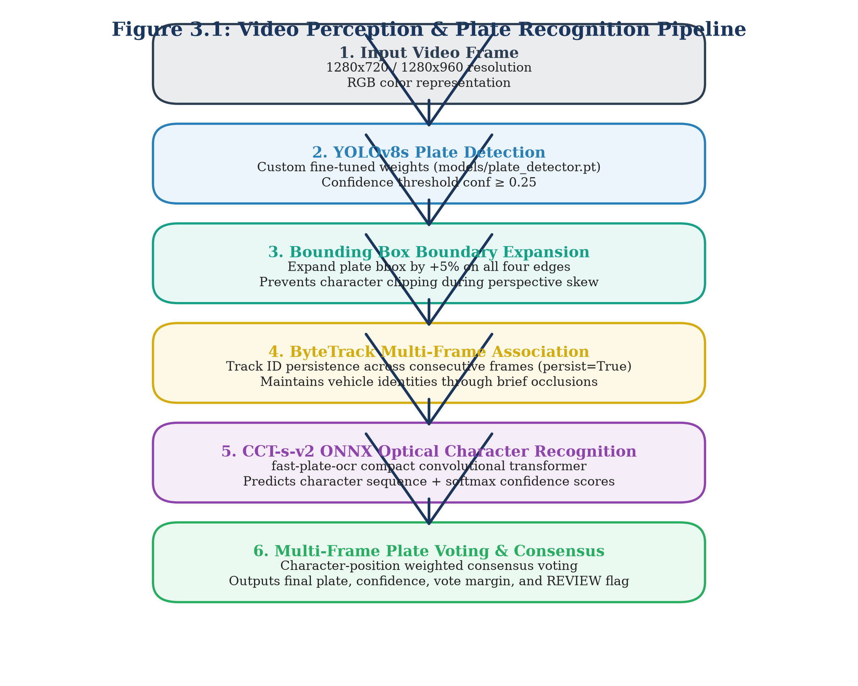
Figure 3.1: Video Perception & Plate Recognition Pipeline
3.3 Dataset Curation, Deduplication, and Isolation
Table 3.3: Dataset Curation, Split Allocations, and Leakage Prevention
Dataset Name | Primary Domain | Total Volume | Train Split | Validation Split | Test Split | Leakage Prevention Protocol | Realism
Plate Detection Corpus | Full Vehicle Photos | 1,835 images | 1,467 (79.9%) | 184 (10.0%) | 184 (10.0%) | Perceptual Hash (Hamming <= 4) | REAL
Real Plate OCR Corpus | Cropped Plate Images | 1,695 crops | 1,360 (80.2%) | 168 (9.9%) | 167 (9.9%) | Unique Vehicle ID Partitioning | REAL
Synthetic OCR Pre-train | Synthetic Plate Renders | 10,400 crops | 10,400 (100%) | 0 (0.0%) | 0 (0.0%) | Strict Train-Only Assignment | SYNTHETIC
Video Tracking Corpus | Roadside CCTV Video | 20 sequences | 0 (0.0%) | 0 (0.0%) | 20 (100.0%) | Dedicated Zero-Shot Evaluation | REAL
Synthetic Video Corpus | Augmented Trajectories | 60 sequences | 0 (0.0%) | 0 (0.0%) | 60 (100.0%) | Controlled Optical Noise Study | SYNTHETIC
AI City Challenge Track 1 | Intersection CCTV (Cam 5) | 600 frames | 300 frames | 0 (0.0%) | 300 frames | Temporal Split (t < 300 vs >= 300) | REAL

3.4 Perception Module Design
The visual perception module converts raw video streams into structured vehicle sighting records. It consists of three tightly coupled components: deep-learning bounding box detection (YOLOv8s), multi-object ByteTrack tracking, and Compact Convolutional Transformer optical character recognition, governed by a multi-frame consensus voting and quality assurance protocol.
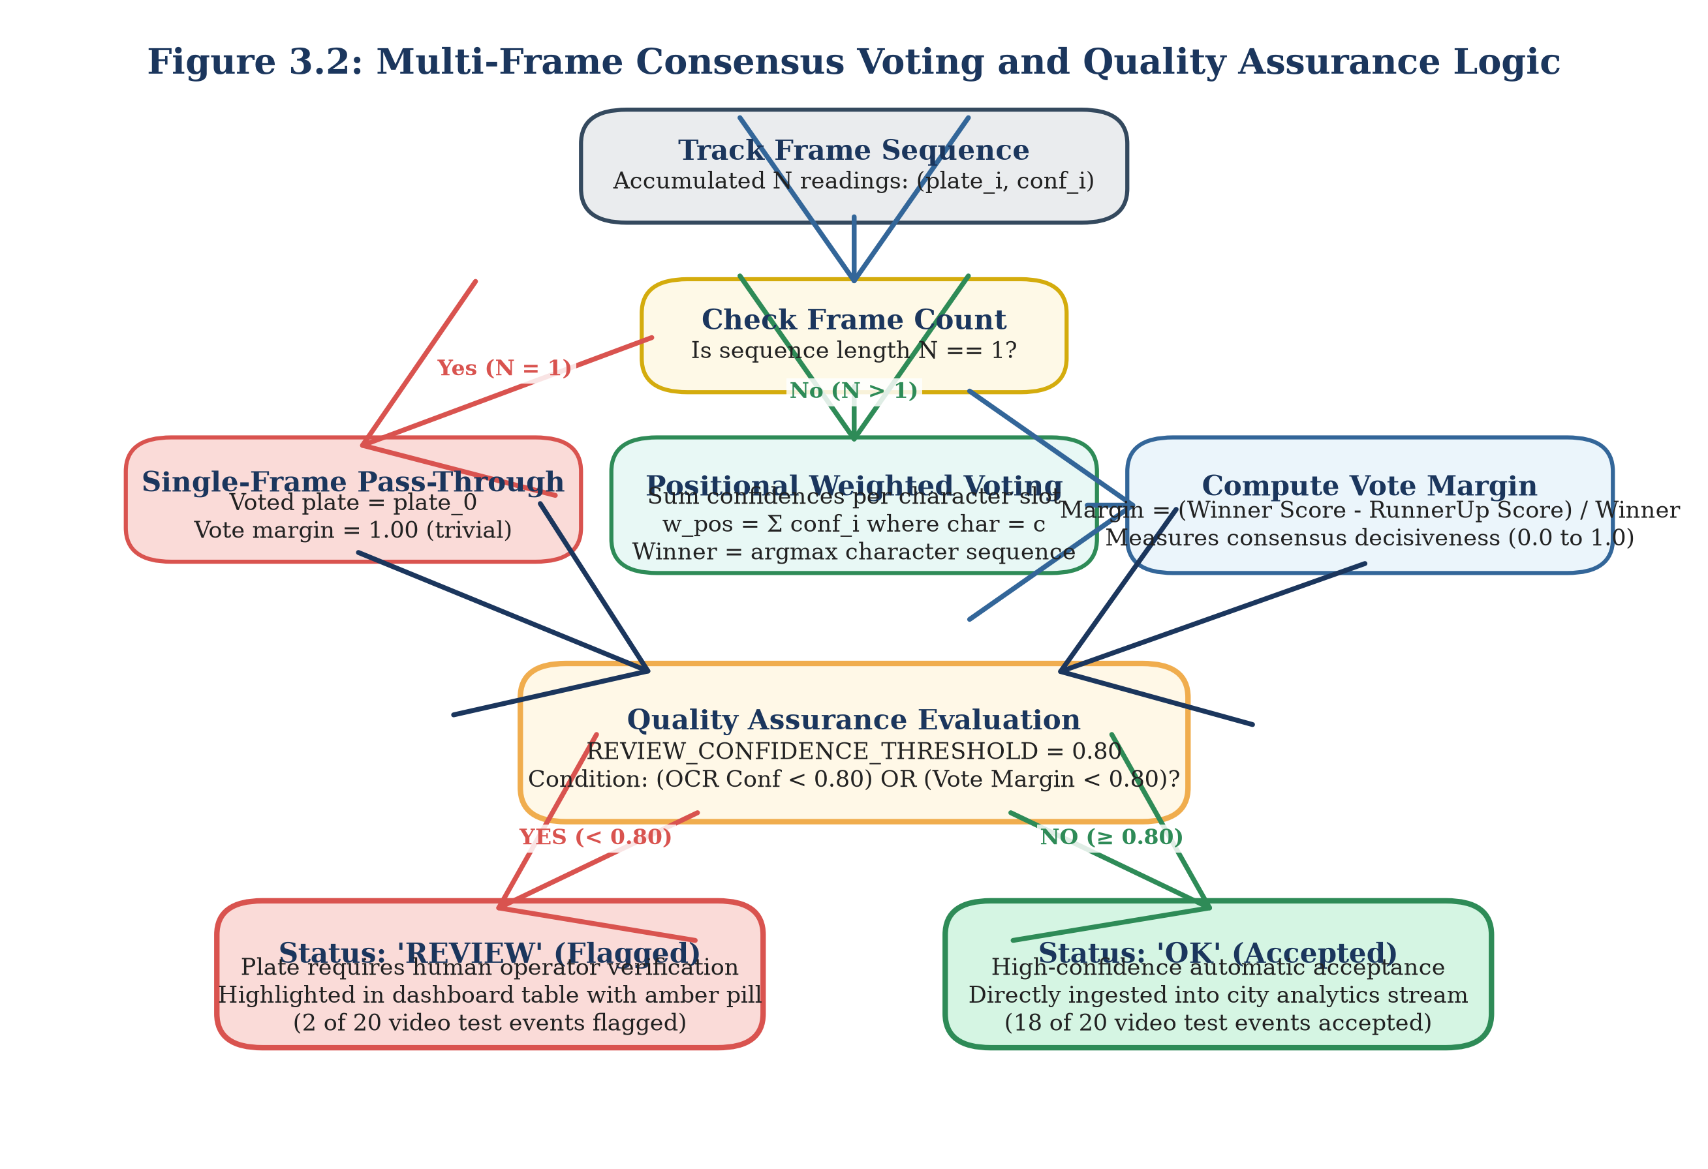
Figure 3.2: Multi-Frame Consensus Voting and Quality Assurance Logic
V(j, c) = ∑ c_k * I(S_{k, j} == c) from k=1 to K (3.1)
S_hat_j = argmax_{c in Sigma} V(j, c) (3.2)
C_voted = (1 / L) * ∑ [max_c V(j, c) / ∑ c_k] from j=1 to L (3.3)
M_voted = (1 / L) * ∑ [(max1 V(j, c) - max2 V(j, c)) / ∑ c_k] from j=1 to L (3.4)
REVIEW_CONFIDENCE_THRESHOLD = 0.80 (3.5)
3.5 City-Scale Road Simulator
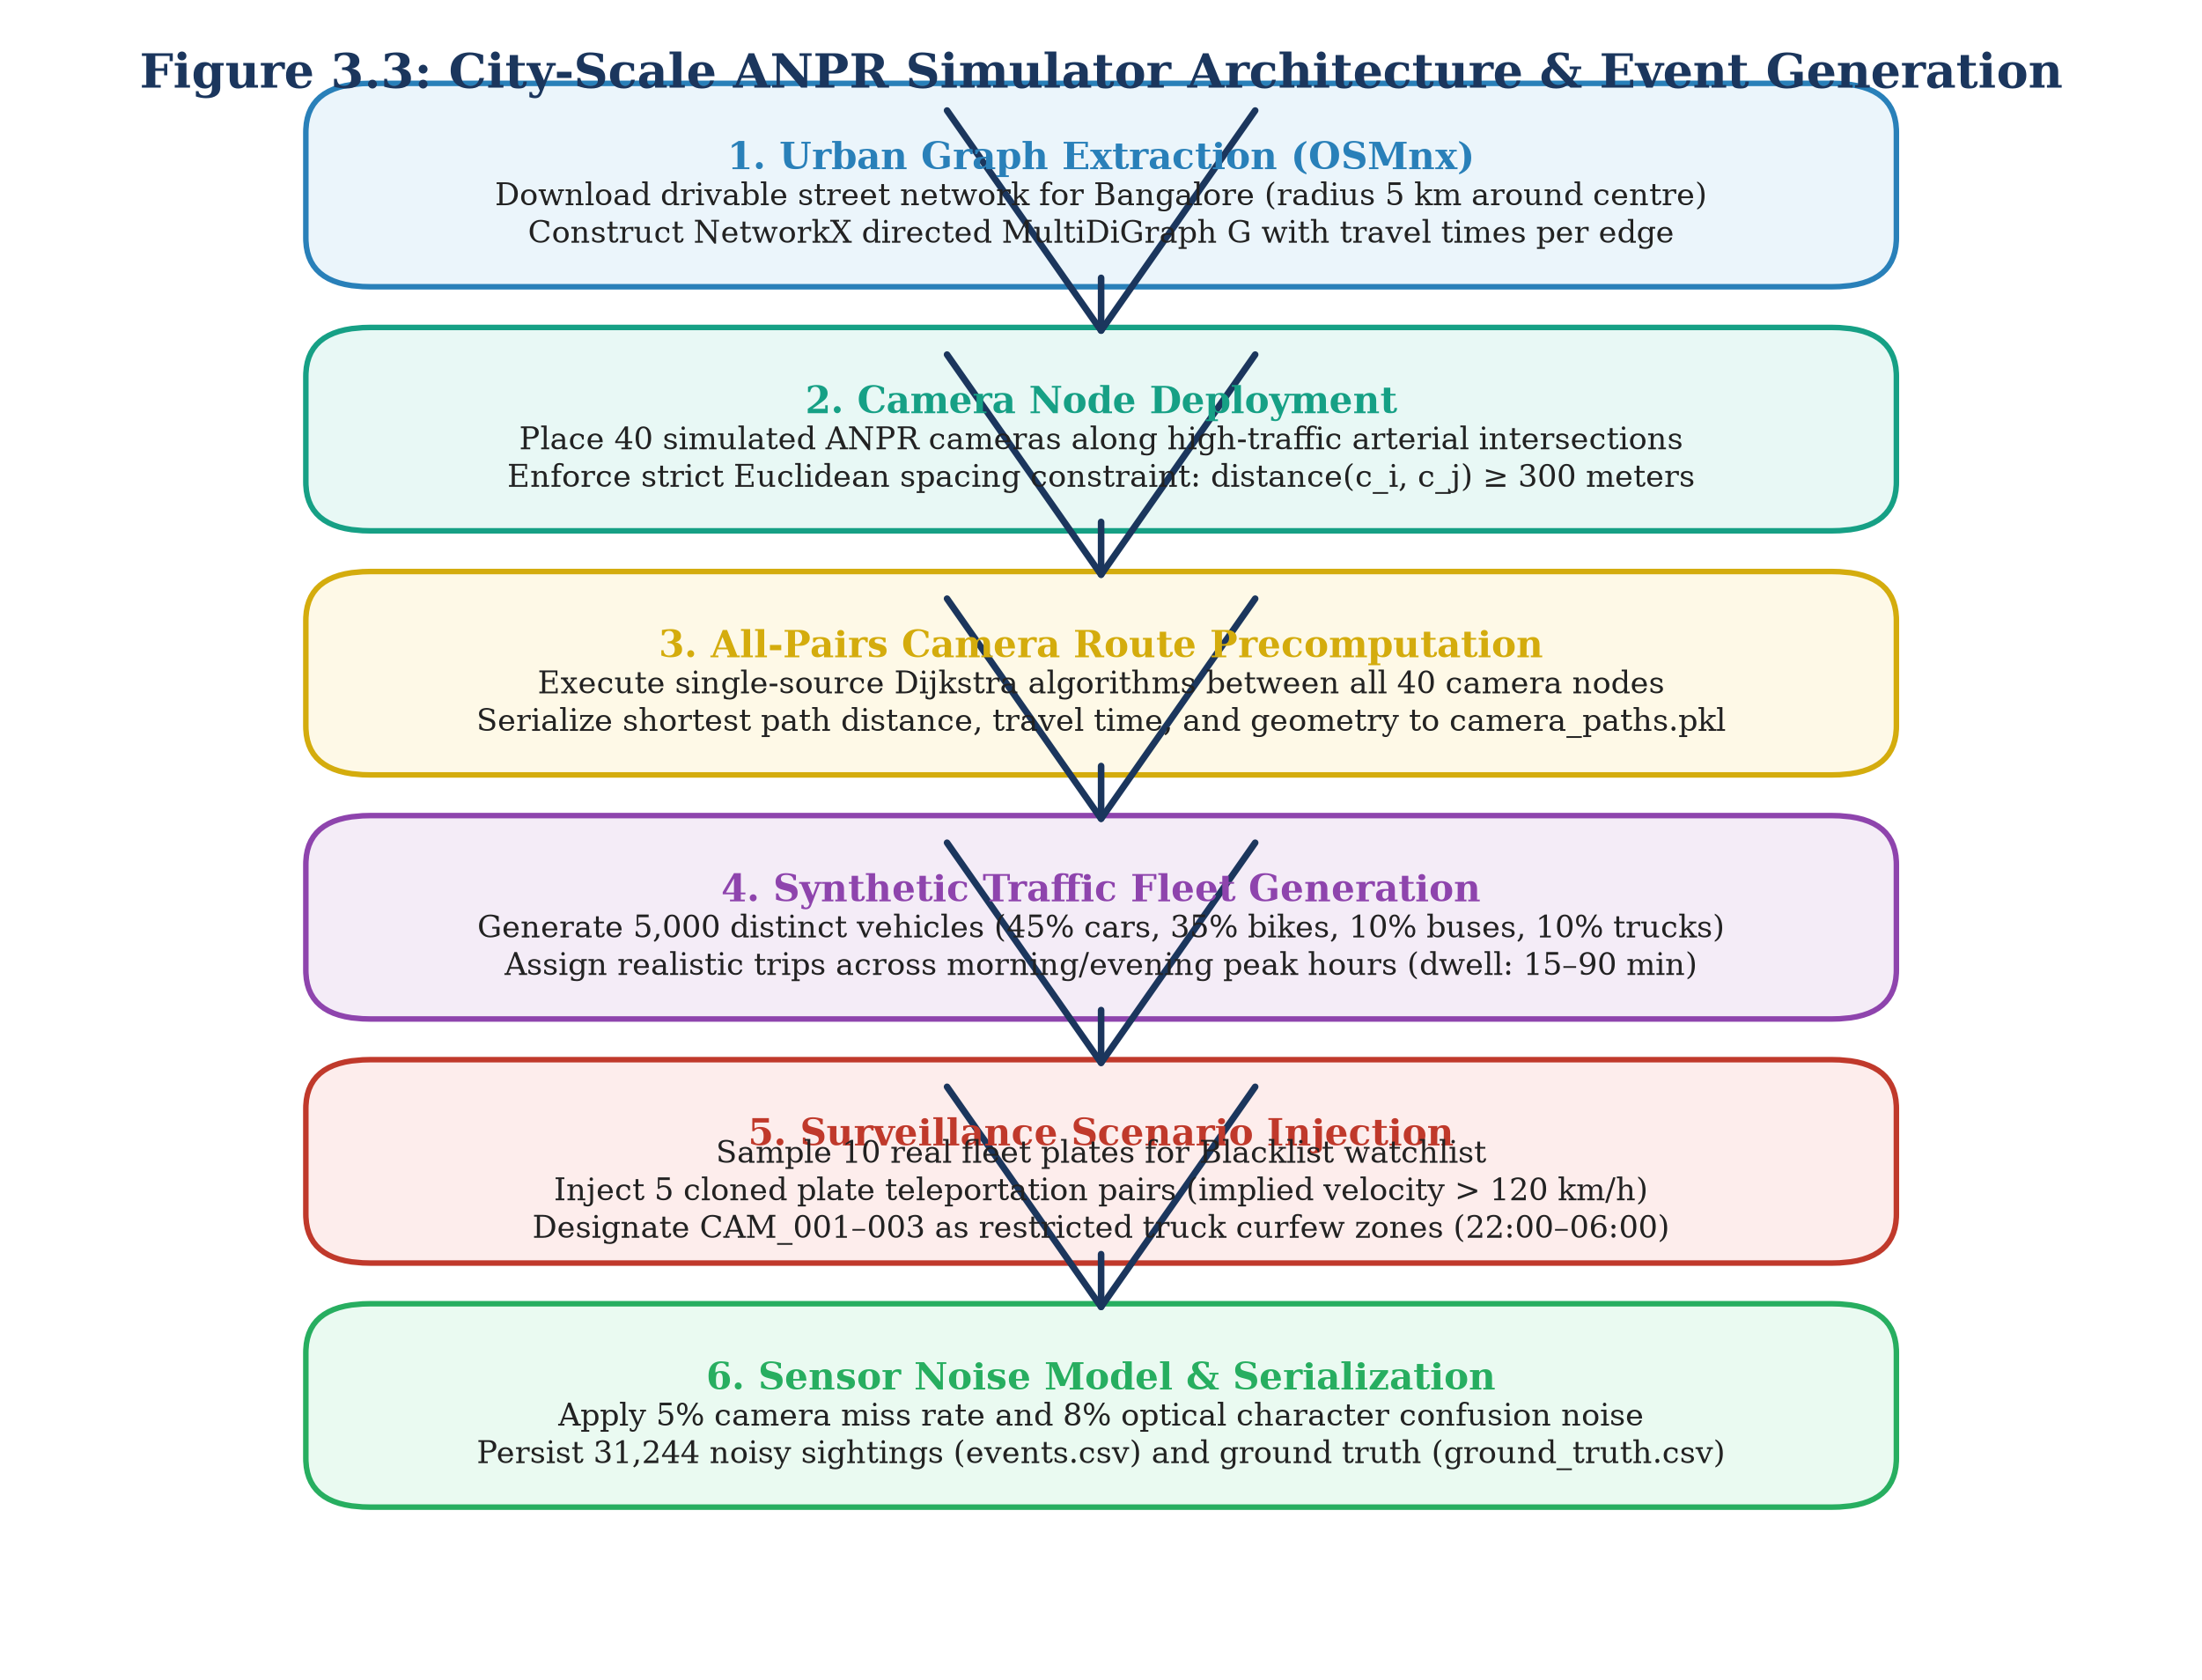
Figure 3.3: City-Scale ANPR Simulator Architecture & Event Generation
3.6 Database Design and Persistence Layer
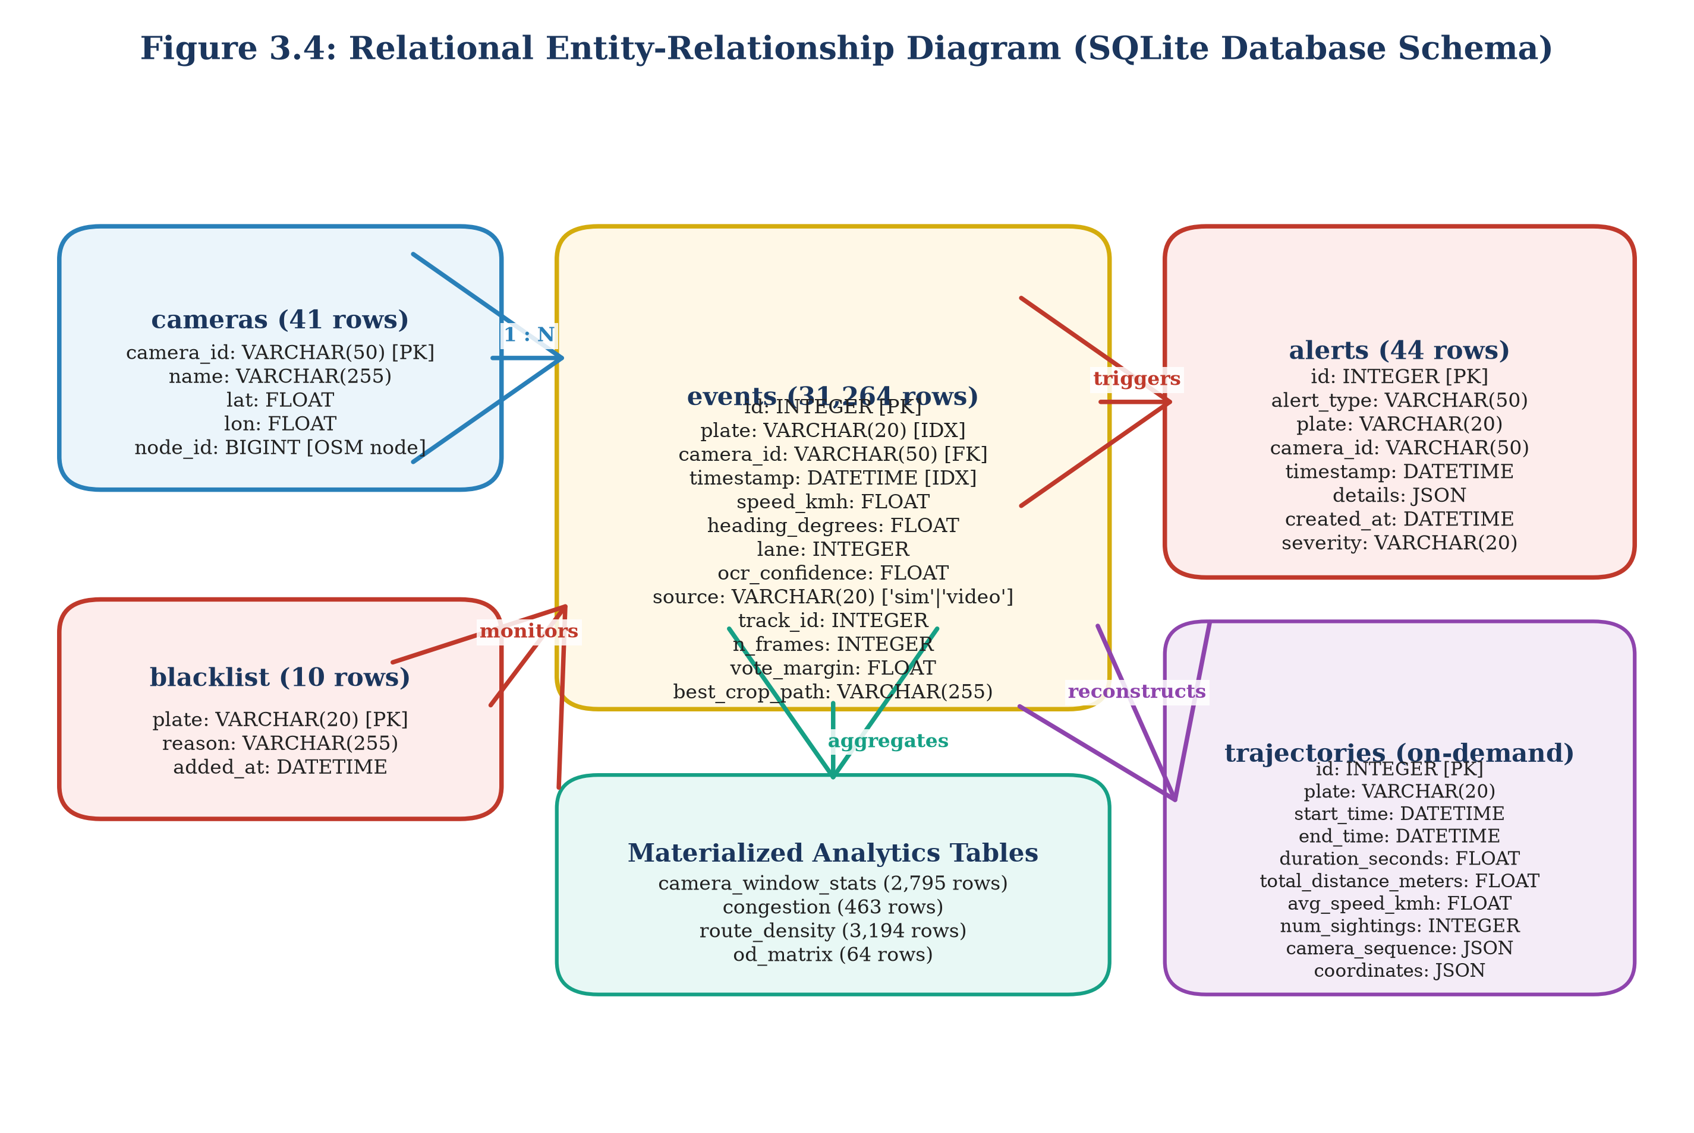
Figure 3.4: Relational Entity-Relationship Diagram (SQLite Database Schema)
Table 3.4: Relational Database Schema Specifications and Field Definitions
Table Name | Primary Key | Total Records | Core Column Definitions | Primary Indexing Strategy | Operational Purpose
events | id (INT) | 31,264 [F27] | plate, camera_id, timestamp, speed_kmh, heading, lane, ocr_conf, source, track_id [F70] | CREATE INDEX ON events(plate, timestamp) | Central repository for real and sim sightings [F13]
cameras | camera_id (TEXT) | 41 [F66] | name, lat, lon, node_id [F72] | CREATE UNIQUE INDEX ON cameras(camera_id) | Spatial registry of 40 sim + 1 demo camera [F66]
alerts | id (INT) | 44 [F30] | alert_type, plate, camera_id, timestamp, details (JSON), severity [F71] | CREATE INDEX ON alerts(timestamp, alert_type) | Audit log of security surveillance alarms [F30]
blacklist | plate (TEXT) | 10 [F29] | reason, added_at | CREATE UNIQUE INDEX ON blacklist(plate) | Municipal watch list for stolen/wanted plates [F29]
camera_window_stats | id (INT) | 2,795 [F74] | camera_id, window_start, window_end, count, avg_speed, p85_speed | CREATE INDEX ON camera_window_stats(camera_id) | 15-minute rolling aggregated camera statistics [F74]
congestion | id (INT) | 463 [F74] | camera_id, timestamp, congestion_level, severity_score | CREATE INDEX ON congestion(camera_id, timestamp) | Level-of-service breakdown and bottlenecks [F74]
route_density | id (INT) | 3,194 [F74] | from_camera_id, to_camera_id, transit_count, avg_duration_s | CREATE INDEX ON route_density(from_cam, to_cam) | Inter-camera corridor density and transit times [F74]
od_matrix | id (INT) | 64 [F74] | origin_zone, dest_zone, trip_count, avg_trip_time_s | CREATE INDEX ON od_matrix(origin_zone, dest_zone) | Macroscopic Origin-Destination trip flow matrix [F74]
trajectories | id (INT) | 0 [F73] | plate, start_time, end_time, camera_sequence, total_distance_m | CREATE INDEX ON trajectories(plate) | On-demand dynamic computation table (0 rows) [F73]

3.7 City Layer: Trajectory Reconstruction and Analytics Engines
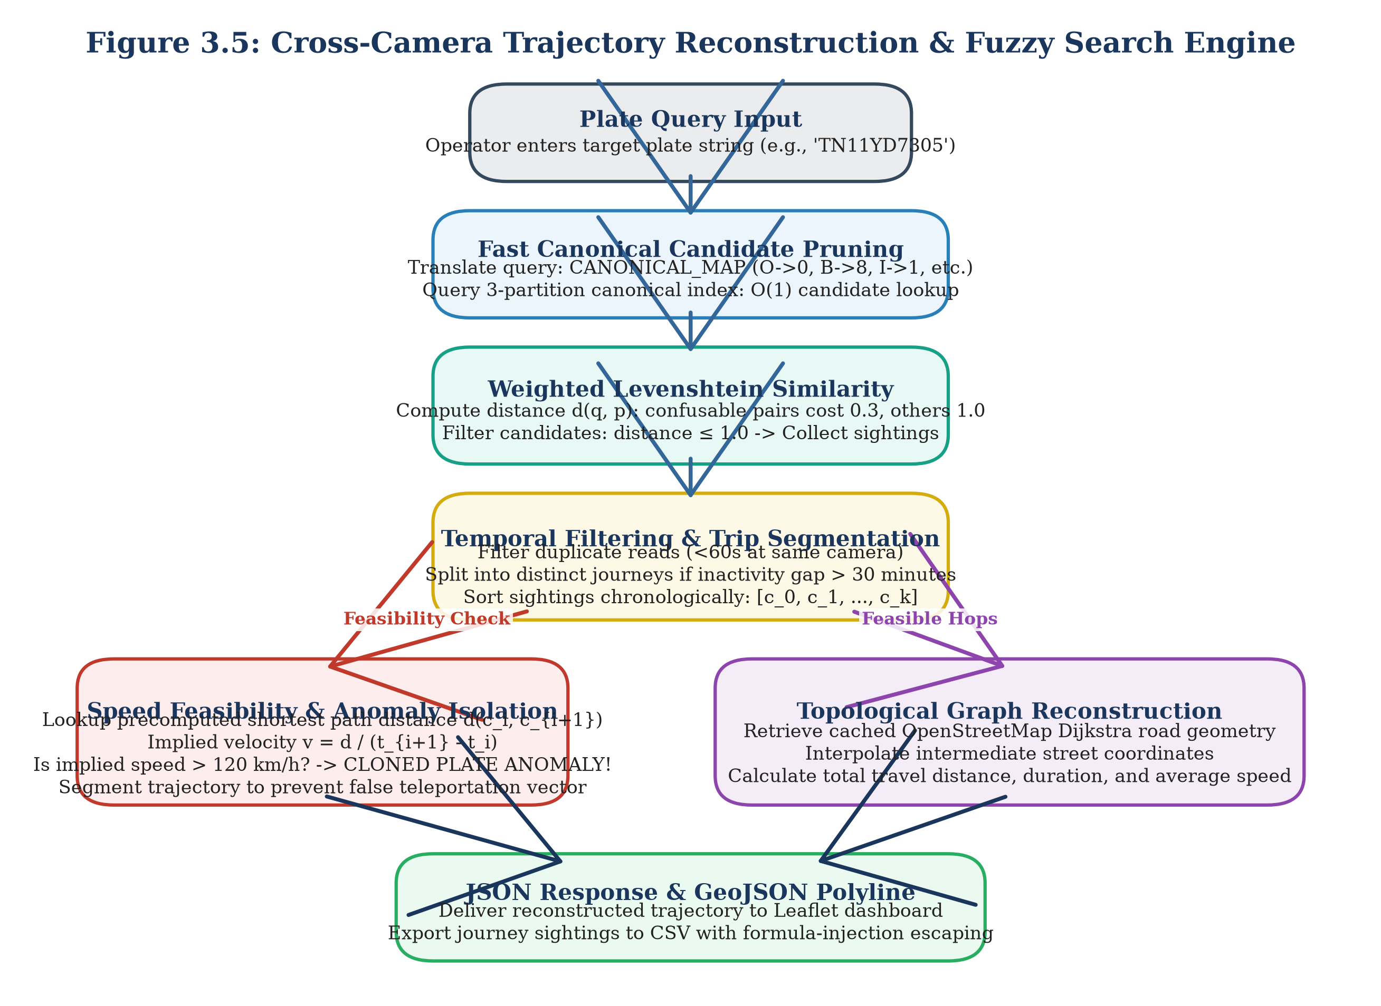
Figure 3.5: Cross-Camera Trajectory Reconstruction & Fuzzy Search Engine
D_weighted(a, b) = 0.0 if a==b; 0.3 if (a, b) in M_conf; 1.0 otherwise (3.8)
v_hop = [d_road(c_i, c_{i+1}) / (t_{i+1} - t_i)] * 3.6 [km/h] (3.9)
3.8 Real-Time Surveillance Alert Engine
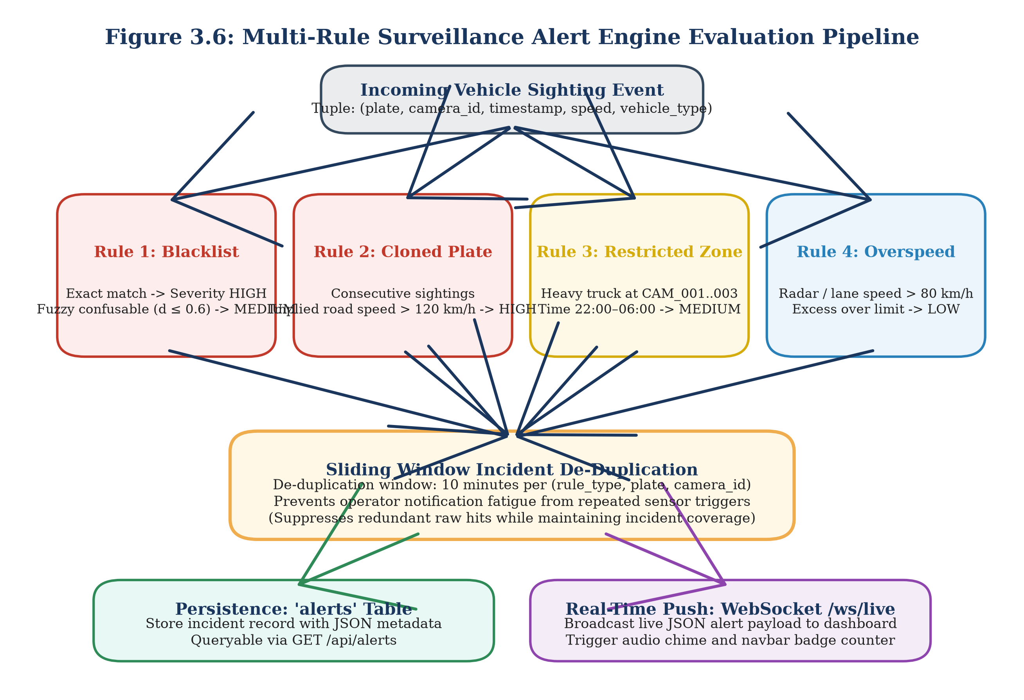
Figure 3.6: Multi-Rule Surveillance Alert Engine Evaluation Pipeline
Table 3.6: Surveillance Alert Engine Rule Configuration and Severity Parameters
Alert Rule Name | Severity Level | Evaluation Logic & Trigger Criteria | Threshold Parameter | Baseline False Alarms | De-duplication Window | Empirical Triggers
BLACKLIST | HIGH / MEDIUM [F91] | Exact match -> HIGH; Confusable fuzzy match (D_weighted <= 0.6) -> MEDIUM [F91] | Distance <= 0.6 [F91] | 15.8% Precision before fix [F100] | 10 minutes [F97] | 35 de-duplicated alerts [F30, F98]
CLONED_PLATE | HIGH [F92] | Implied road speed between sightings exceeds physical maximum [F92] | v_hop > 120 km/h [F40, F75] | 5.4% Precision before fix [F100] | 10 minutes [F97] | 5 verified clone alerts [F30, F99]
RESTRICTED_ZONE | MEDIUM [F96] | Commercial heavy vehicle detected at restricted camera during curfew [F96] | CAM 1–3, 22:00–06:00 [F31, F96] | Zero false alarms | 10 minutes [F97] | 4 curfew alerts [F30, F96]
OVERSPEED | LOW [F94] | Instantaneous radar speed exceeds posted corridor speed limit [F94] | v_inst > 80 km/h [F75, F94] | Zero false alarms | 10 minutes [F97] | 0 alerts (sim max <= 80 km/h) [F30, F76]
LOITERING | LOW [F95] | Same vehicle observed repeatedly at single camera location [F95] | >= 3 visits in 60 min [F77, F95] | Zero false alarms | 10 minutes [F97] | 0 alerts (no loitering in sim) [F30, F77]
WRONG_WAY | MEDIUM [F93] | Vehicle heading deviates significantly from dominant camera heading [F93] | Deviation > 135 deg [F93] | High false alarms at junctions | Disabled by default [F20, F93] | 0 alerts (disabled) [F20, F131]

3.9 API and Interactive Dashboard
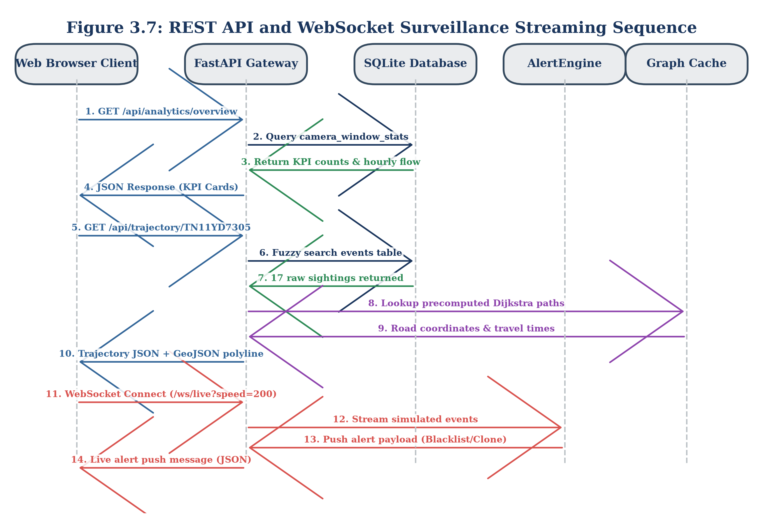
Figure 3.7: REST API and WebSocket Surveillance Streaming Sequence
Table 3.5: RESTful API and WebSocket Endpoint Specifications
HTTP Method | API Path | Parameter Requirements | Response Data Payload | Primary Operational Subsystem
GET | /api/health [F78] | None | {"status": "ok", "db": "connected"} | System Health & Monitoring
GET | /api/cameras [F79] | None | Array of 41 camera objects (id, lat, lon, name) [F66] | Spatial Camera Registry
GET | /api/trajectory/{plate} [F80] | plate (path), fuzzy (bool) | Chronological trip sequence, hops, speed, GeoJSON polyline | Trajectory Reconstruction Engine
GET | /api/trajectory/{plate}/export [F81] | plate (path) | Sanitized CSV file export (escape_csv_cell applied) [F19] | Law Enforcement Evidence Export
GET | /api/plates/search [F82] | q (query string), limit | List of matching candidate plates with sighting counts | Fuzzy Candidate Discovery
GET | /api/analytics/overview [F83] | None | Total vehicles, active cameras, peak volume, total alerts | Executive Dashboard Summary
GET | /api/analytics/hourly-volume [F84] | None | 24-hour array of hourly sighting counts | Macroscopic Diurnal Trend
GET | /api/analytics/busiest-cameras [F85] | limit (int, default 10) | Top N cameras ranked by total vehicle observations | Bottleneck Identification
GET | /api/analytics/heatmap [F86] | None | Weighted spatial coordinates for Leaflet heatmap | Macroscopic Spatial Density
GET | /api/alerts [F87] | limit, severity, type | Array of persistent alert records with JSON details | Surveillance Incident Feed
GET / POST | /api/blacklist [F87] | plate, reason (JSON) | Updated watchlist status and confirmation | Watchlist Management
POST | /api/plates/read [F15, F88] | Multipart image file | Bounding box coordinates, OCR plate string, confidence | Direct Single-Image Perception
WS | /ws/live [F18, F90] | Speed multiplier param | Real-time JSON stream of alerts and sighting events | Real-Time Operator Streaming

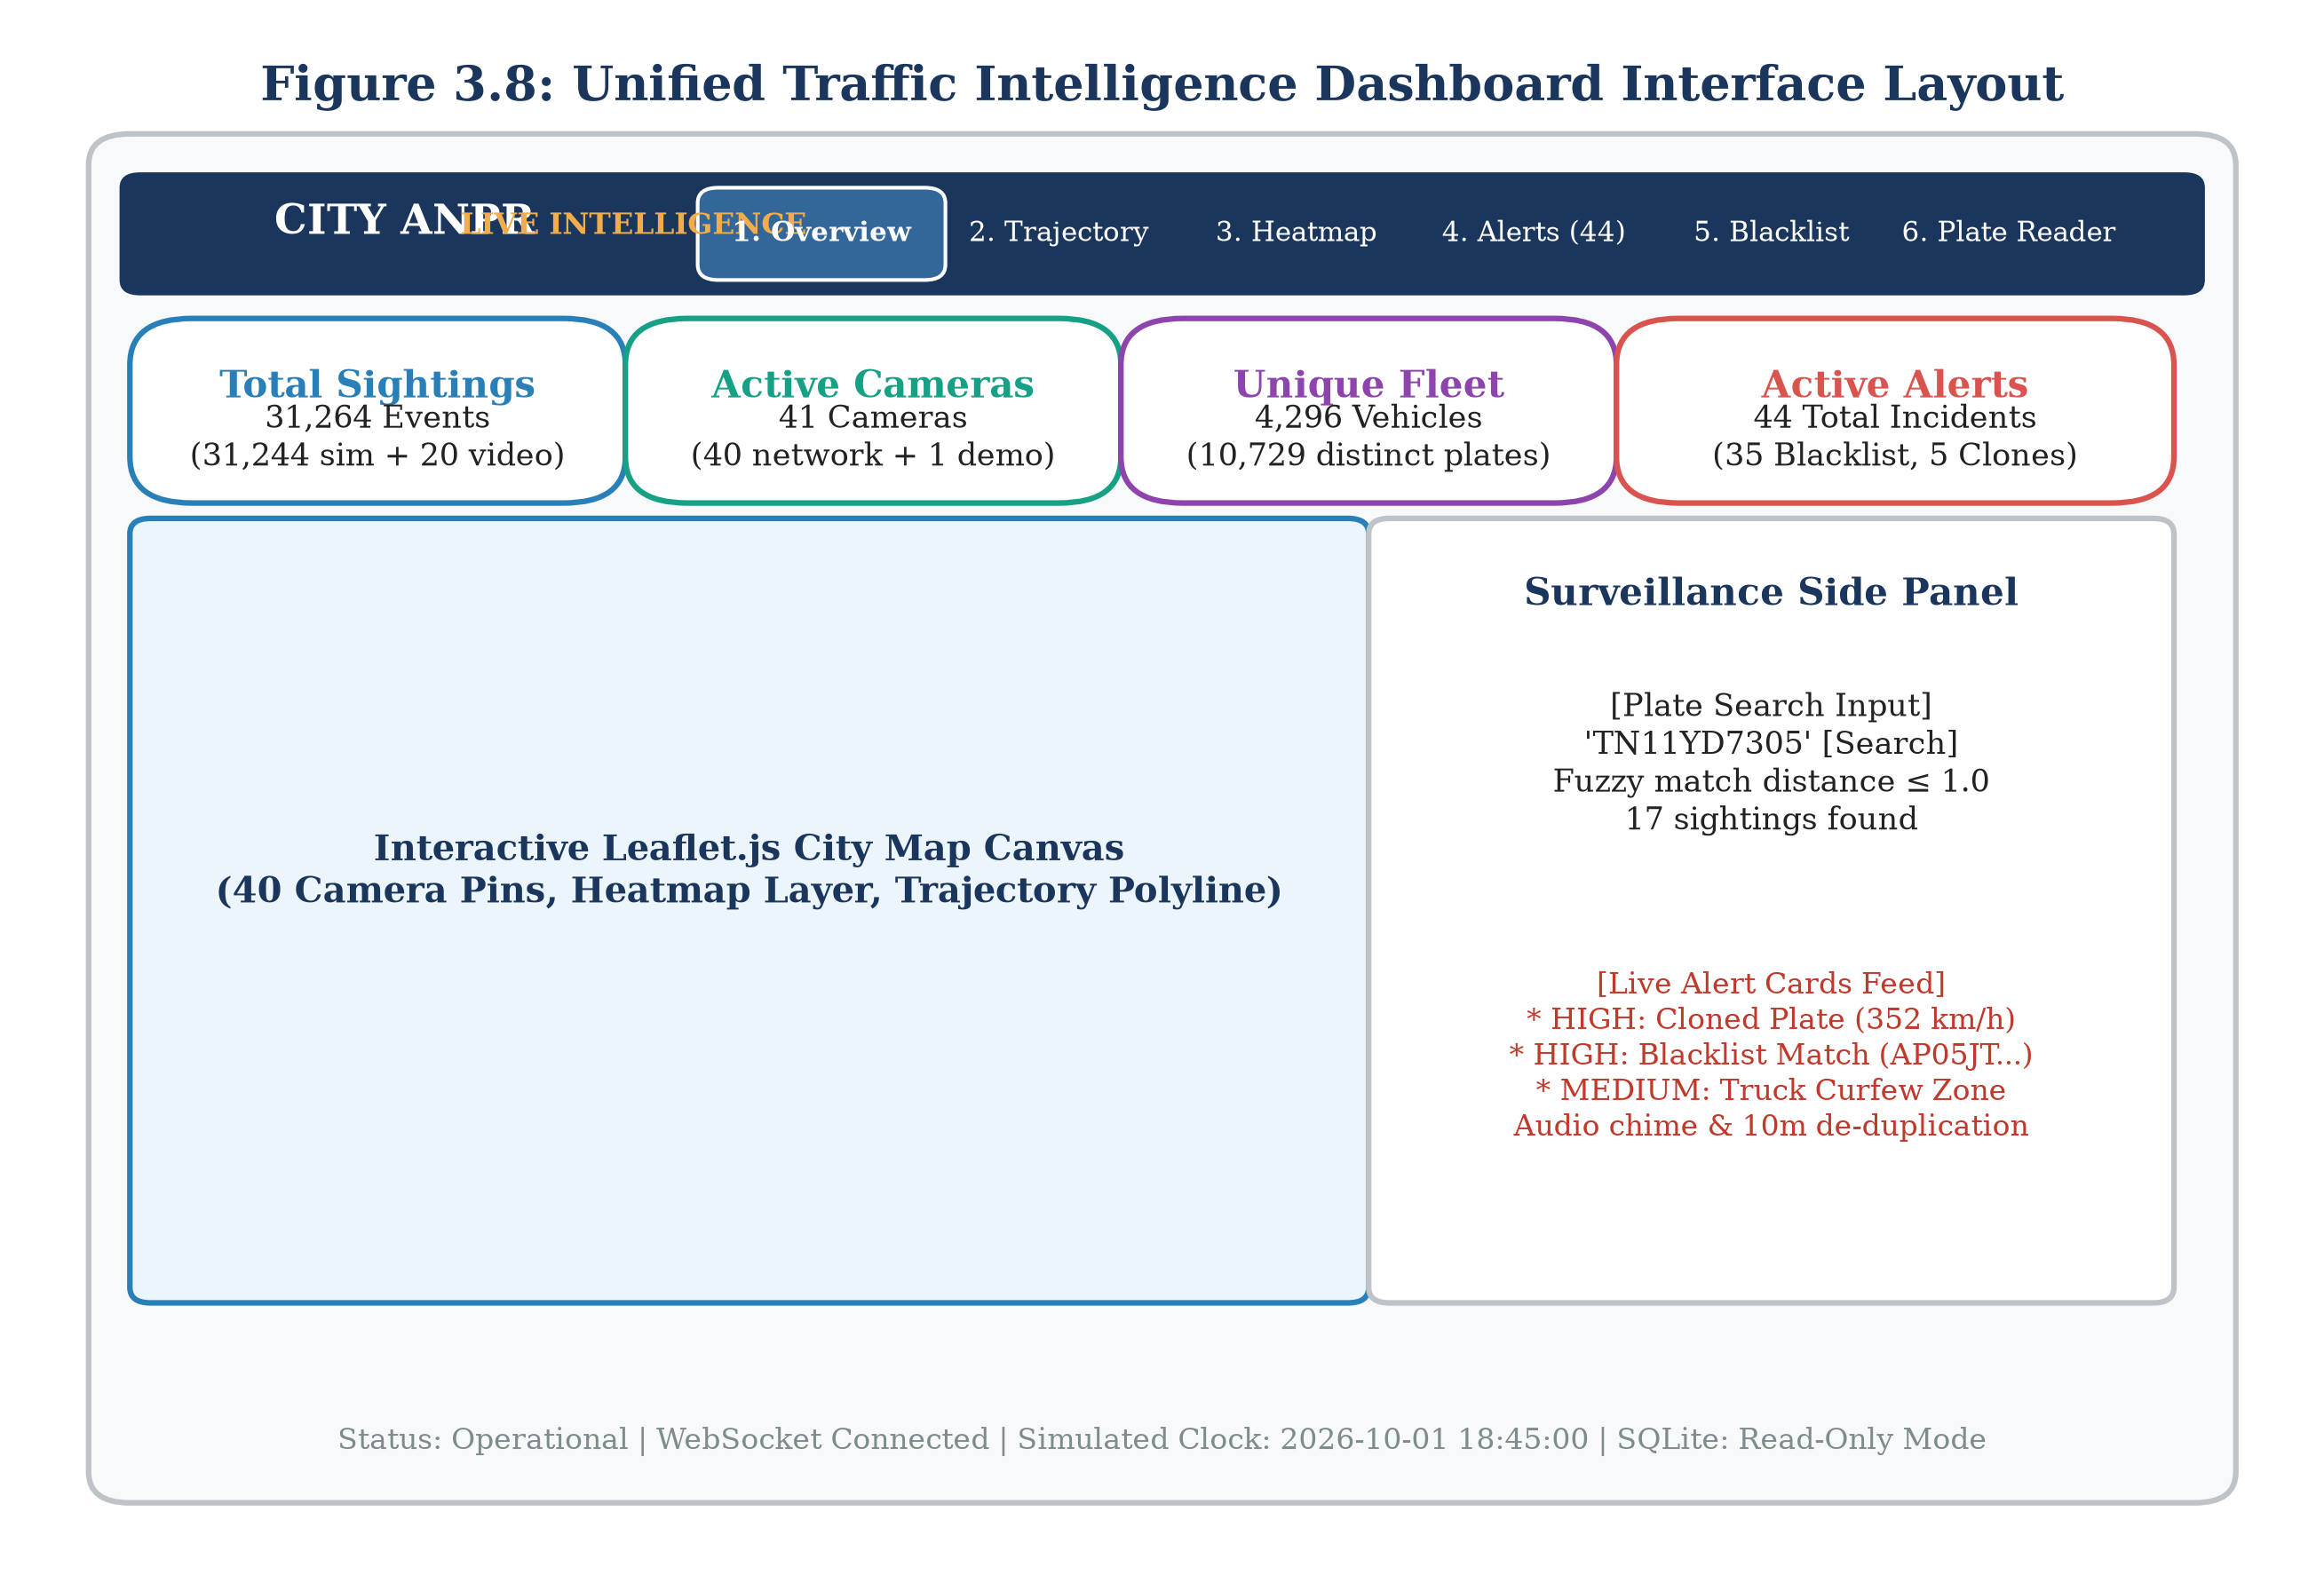
Figure 3.8: Unified Traffic Intelligence Dashboard Interface Layout
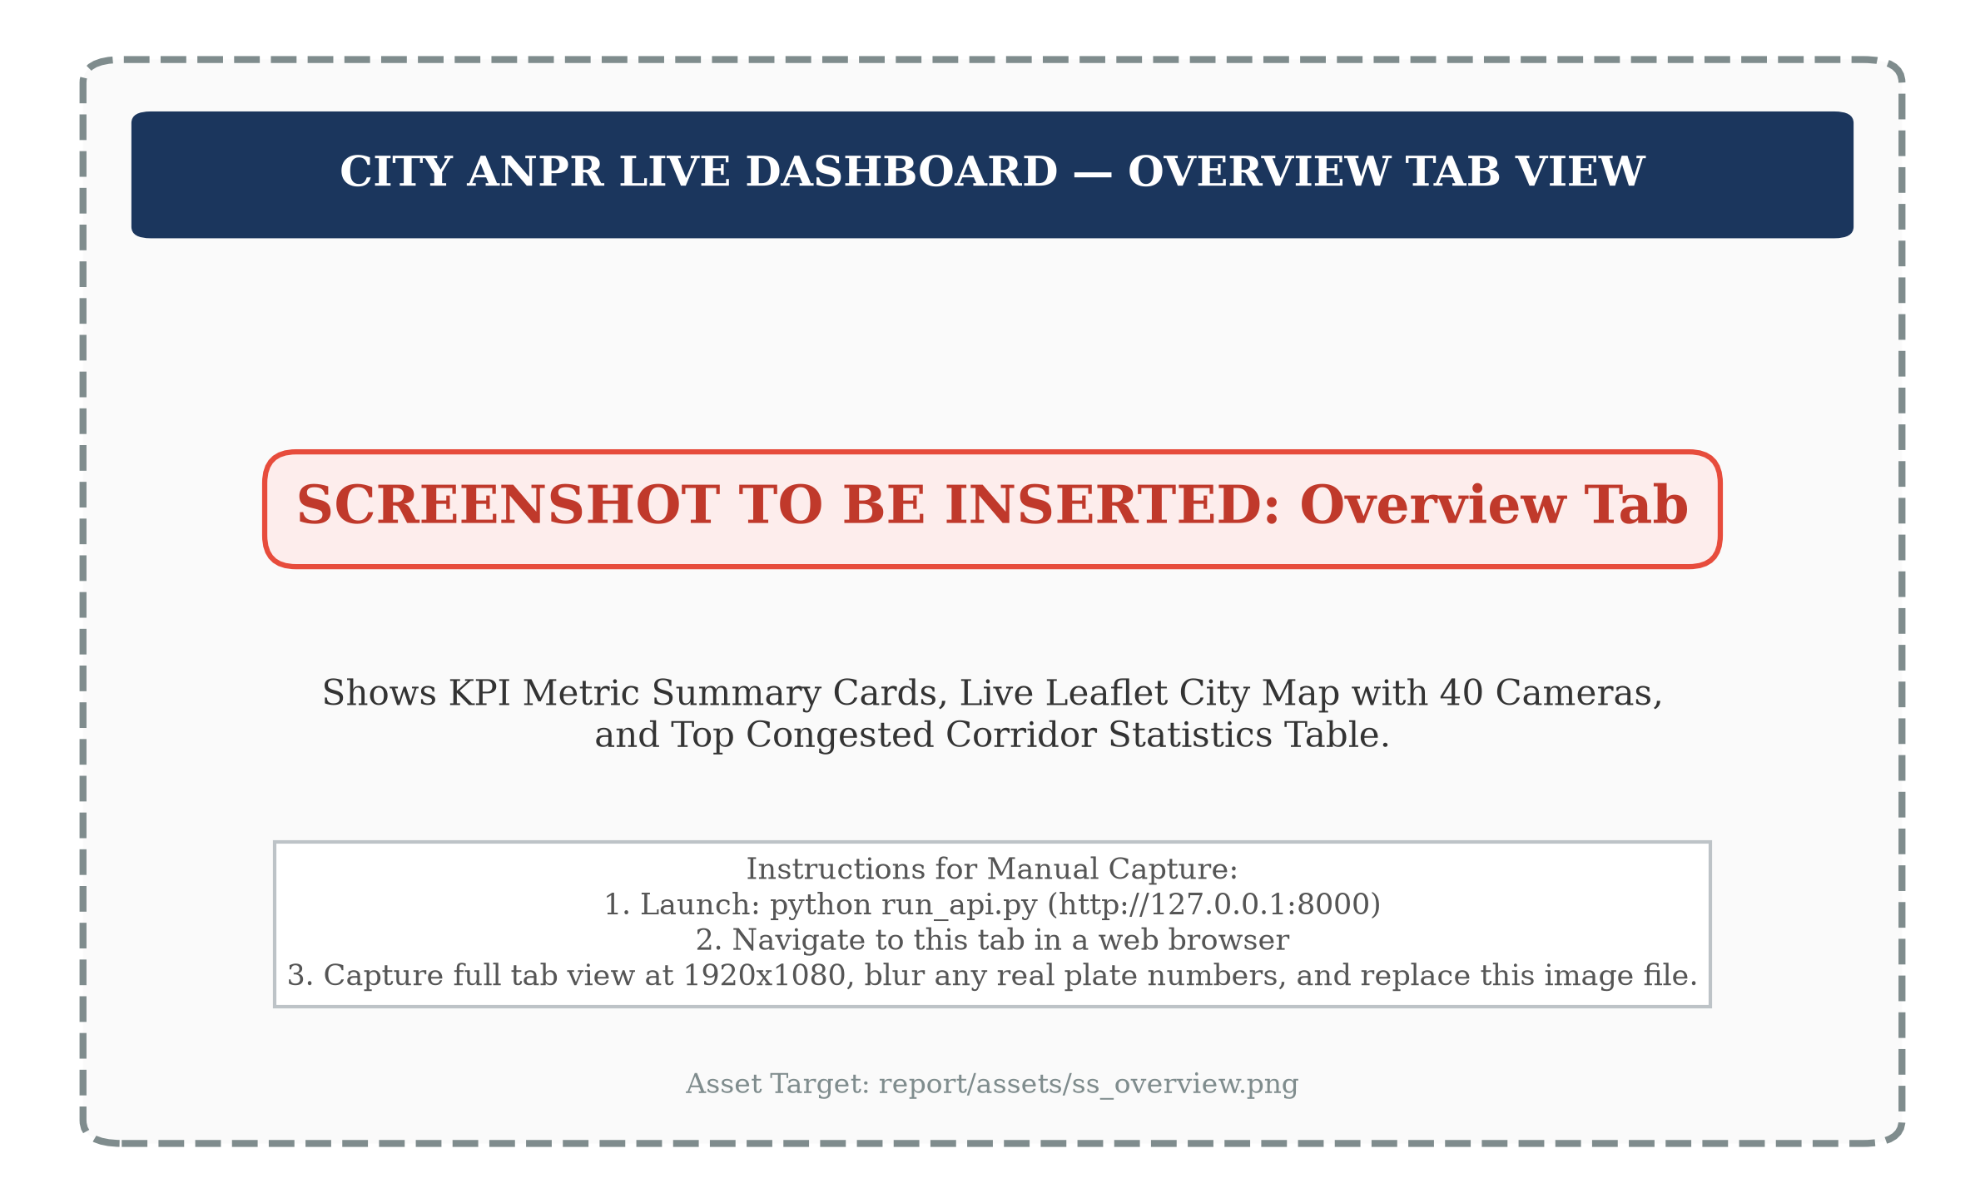
Figure 3.13: Dashboard Overview Tab with KPI Cards and Hourly Flow Chart
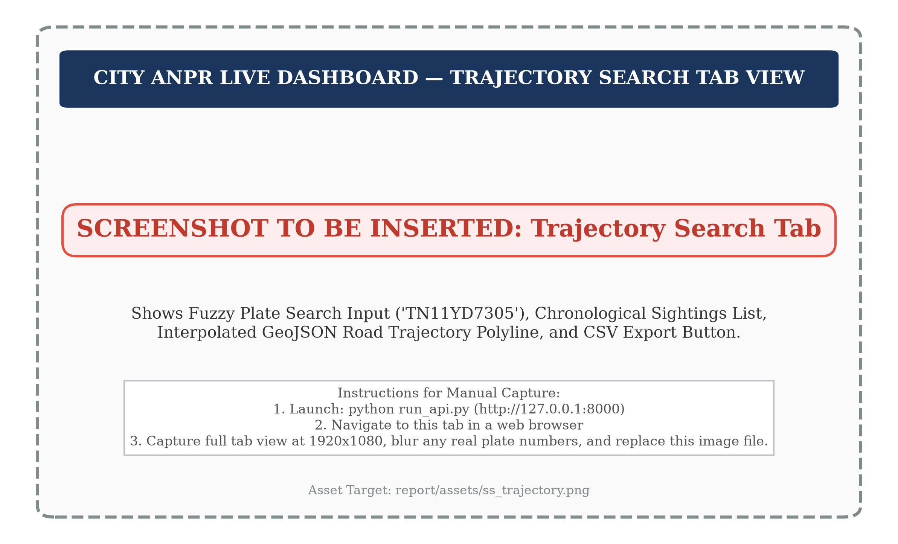
Figure 3.14: Trajectory Search Interface with Chronological Sighting Table
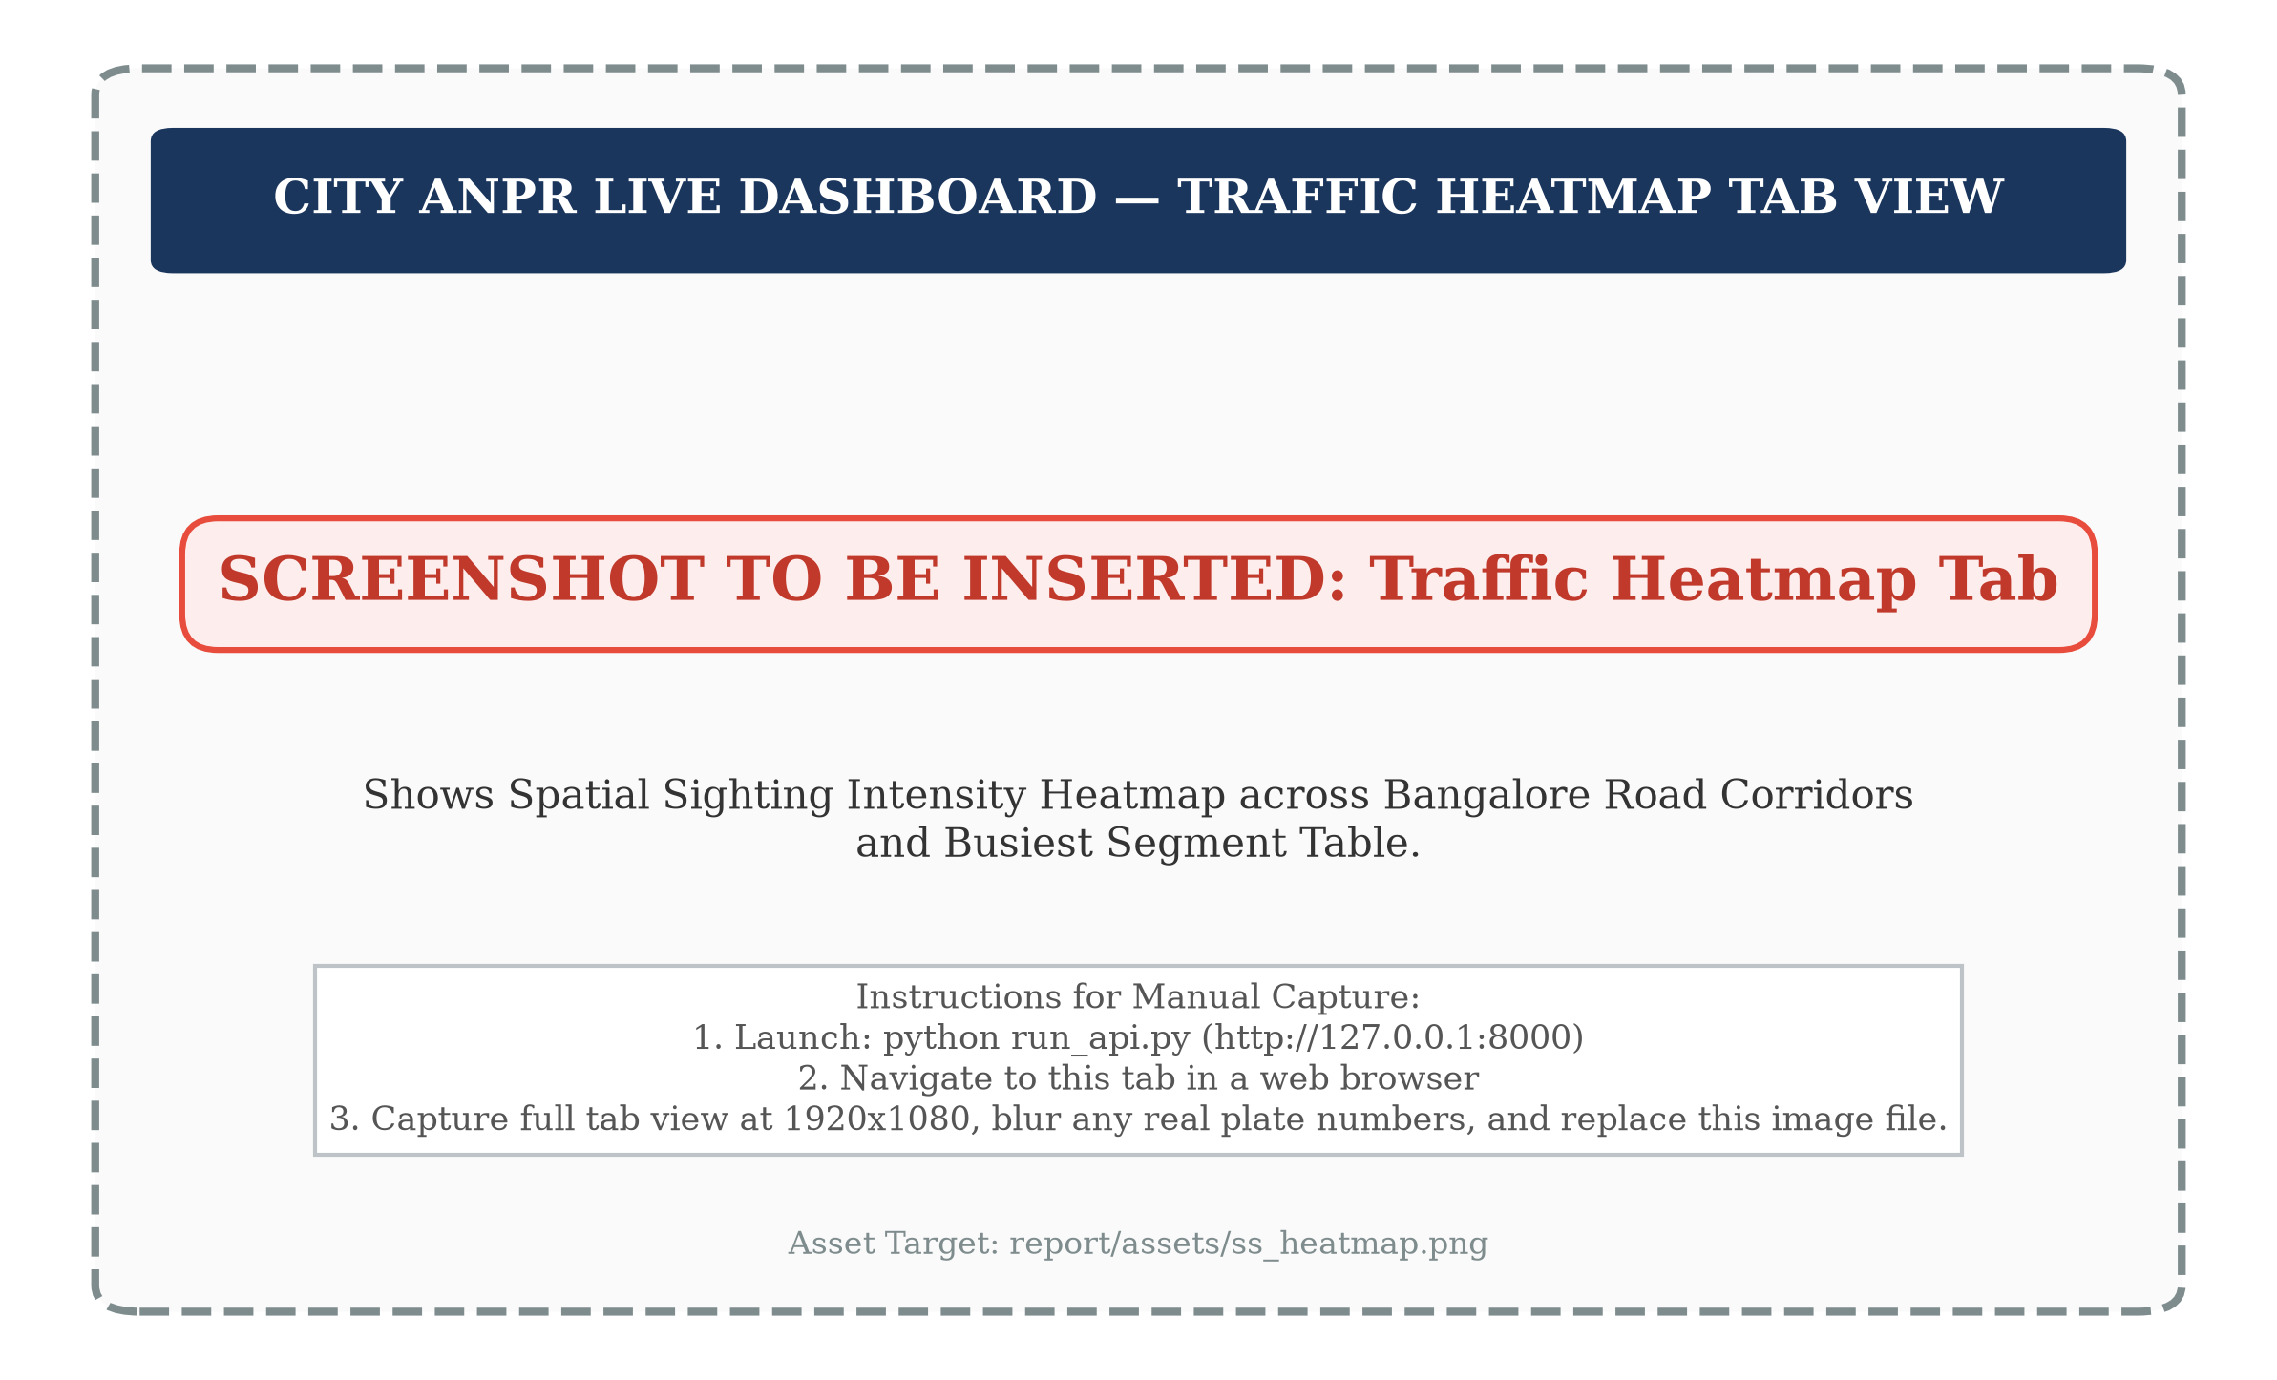
Figure 3.15: Traffic Heatmap Visualisation across Bangalore Intersections

Figure 3.16: Live Surveillance Alert Feed with Severity Classification
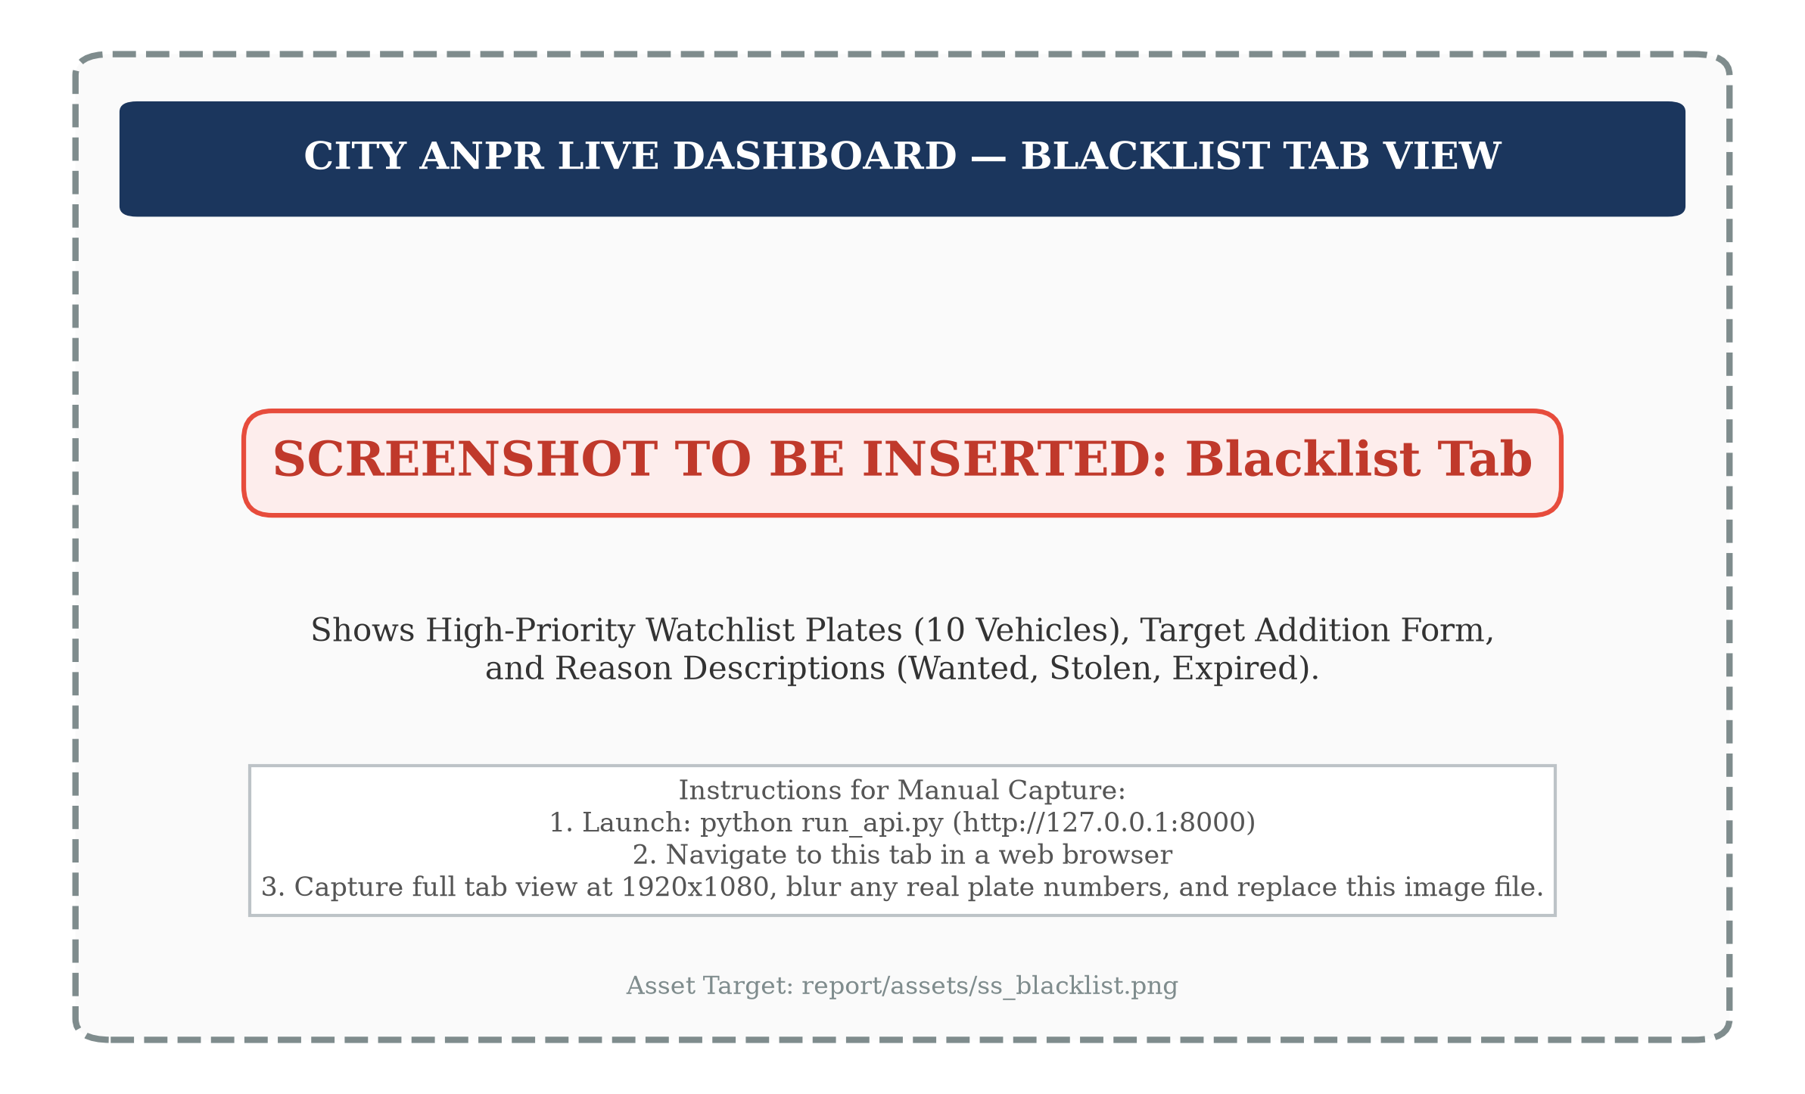
Figure 3.17: Municipal Blacklist Management and Vehicle Sighting Audit
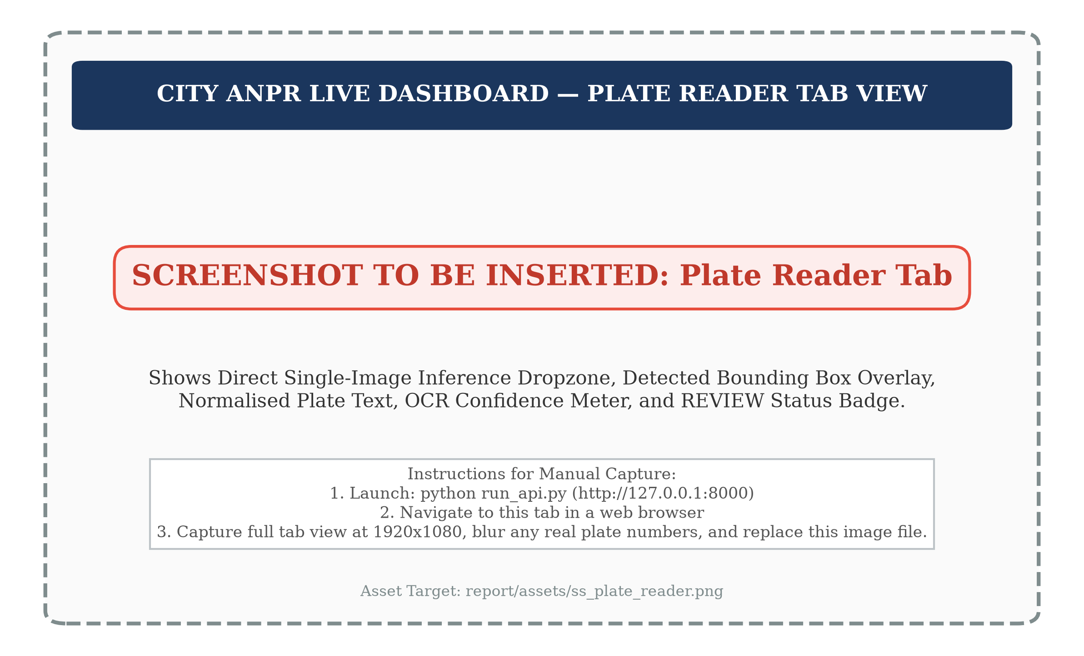
Figure 3.18: Single-Image Plate Reader Testing Console with Review Tag
3.10 AI City Vehicle Counting Prototype
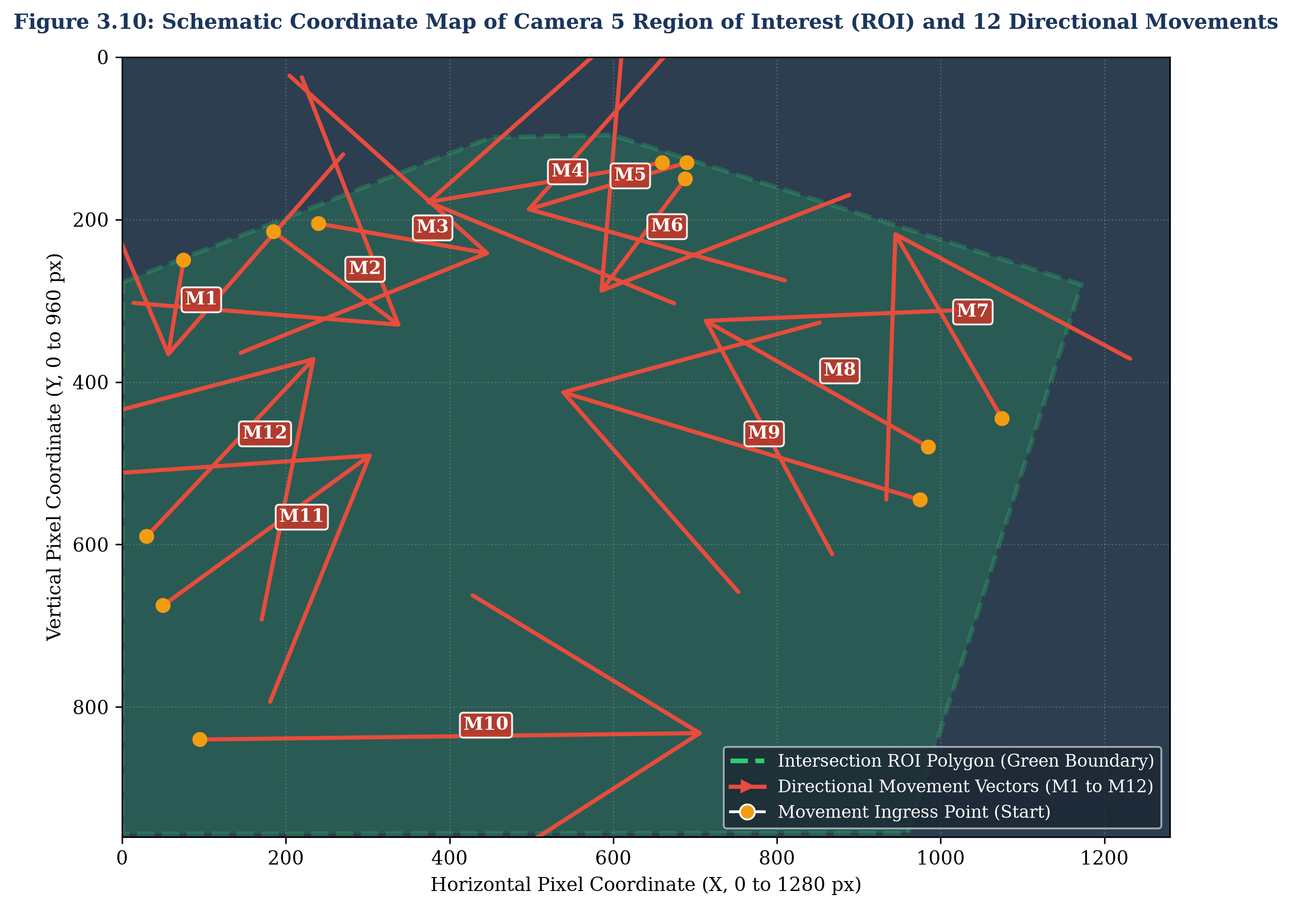
Figure 3.10: AI City Challenge Camera 5 Region of Interest and Movement Vectors
Table 3.7: AI City Challenge Camera 5 Movement Vector Definitions
Movement ID | Directional Turn Description | Visual Start [x, y] | Visual End [x, y] | Calibrated Start [x, y] | Calibrated End [x, y] | Ground Truth Volume
M1 | Eastbound Through | [75, 250] | [55, 375] | Visual (v1) | Visual (v1) | 1 Car [F103]
M2 | East to South Right Turn | [185, 215] | [345, 335] | [217.5, 216.5] | [325.0, 319.5] | 5 Cars [F103]
M3 | North to East Left Turn | [240, 205] | [455, 243] | [260.0, 208.5] | [468.0, 243.0] | 13 Cars [F103]
M4 | North Through | [660, 130] | [365, 180] | [489.0, 158.0] | [371.0, 186.0] | 10 Cars [F103]
M5 | North to West Right Turn | [690, 130] | [488, 190] | Visual (v1) | Visual (v1) | 23 Cars, 2 Trucks [F103]
M6 | Northwest Through | [688, 150] | [580, 295] | Visual (v1) | Visual (v1) | 0 Events [F103]
M7 | West to North Left Turn | [1075, 445] | [940, 210] | Visual (v1) | Visual (v1) | 1 Car [F103]
M8 | West Through | [985, 480] | [705, 320] | Visual (v1) | Visual (v1) | 0 Events [F103]
M9 | West to South Right Turn | [975, 545] | [530, 410] | Visual (v1) | Visual (v1) | 0 Events [F103]
M10 | South to West Left Turn | [95, 840] | [715, 832] | Visual (v1) | Visual (v1) | 2 Cars [F103]
M11 | South Through | [50, 675] | [310, 485] | [65.0, 680.0] | [304.5, 477.5] | 37 Cars, 1 Truck [F103]
M12 | South to East Right Turn | [30, 590] | [240, 365] | Visual (v1) | Visual (v1) | 1 Car [F103]

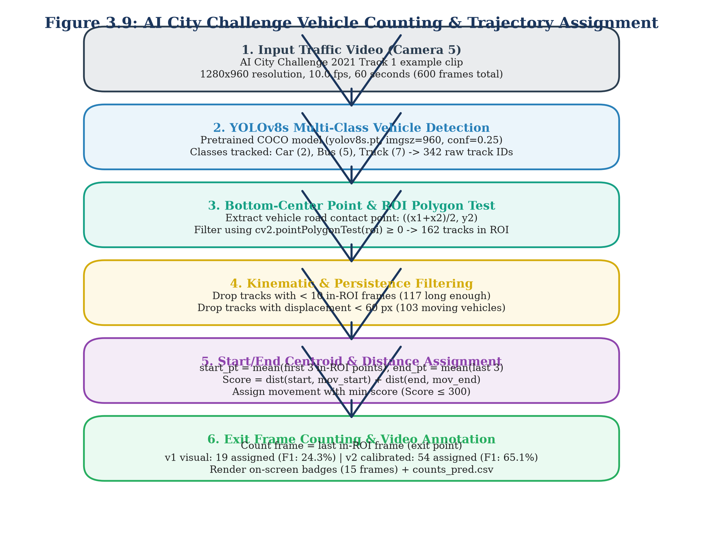
Figure 3.9: AI City Challenge Vehicle Counting & Trajectory Assignment
3.11 Experimental Setup and Hardware/Software Environment
Table 3.2: Experimental Hardware and Software Computing Environment
Computing Tier | Subsystem Component | Specification Details | Primary Operational Purpose
Local Workstation | Operating System | Microsoft Windows 11 Enterprise (64-bit) [F1] | Host OS for development, DB, and API
Local Workstation | Processor (CPU) | Intel Core i7-13700H (14 Cores, 20 Threads, up to 5.0 GHz) | Simulation, tracking, routing, and testing
Local Workstation | System Memory | 32.0 GB DDR5-5200 MHz | In-memory graph analytics and SQLite caching
Local Workstation | Primary Storage | 1.0 TB PCIe Gen4 NVMe Solid State Drive | Storage for datasets, models, and SQLite DB
Local Workstation | Python Runtime | Python 3.11.9 (64-bit) in virtual environment .venv [F1] | System-wide execution environment
Cloud Acceleration | Platform | Google Colab Platform [F7, F49] | GPU training and fine-tuning environment
Cloud Acceleration | Graphics (GPU) | NVIDIA Tesla T4 (16 GB GDDR6, Turing) [F7, F49] | YOLOv8s and CCT-s-v2 model fine-tuning
Cloud Acceleration | CUDA Runtime | CUDA Version 12.2 / cuDNN 8.9 | Deep-learning GPU acceleration
Core Libraries | Vision & Deep Learning | ultralytics 8.4.171 [F3], torch 2.14.1 [F3], torchvision 0.29.1 [F3] | Object detection and tracking backbones
Core Libraries | OCR Inference | fast-plate-ocr[onnx] 1.1.0 [F3], onnxruntime 1.30.0 [F3] | High-throughput Transformer OCR inference
Core Libraries | Vision Utilities | opencv-python 5.0.0.93 [F3], pillow 10.3.0 | Image transformations and video decoding
Core Libraries | Geospatial & Graph | osmnx 1.9.1 [F3], networkx 3.2.1 [F3], geopandas 0.14.3 [F3] | Bangalore road network graph modeling
Core Libraries | Backend & Web | fastapi 0.110.0 [F3], uvicorn 0.28.0 [F3], pydantic 2.6.4 [F3] | Asynchronous REST and WebSocket streaming
Core Libraries | Database & Testing | sqlite3 (built-in) [F2], sqlalchemy 2.0.28 [F3], pytest 8.1.1 [F3] | Relational persistence and test automation

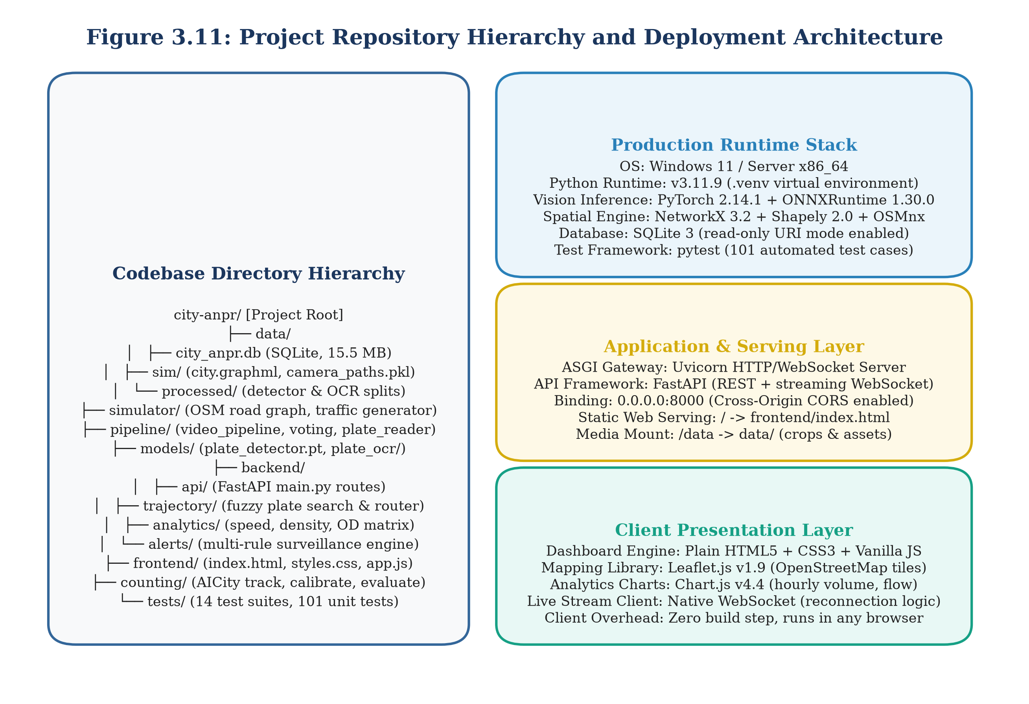
Figure 3.11: Project Repository Hierarchy and Deployment Architecture
3.12 Automated Testing Strategy
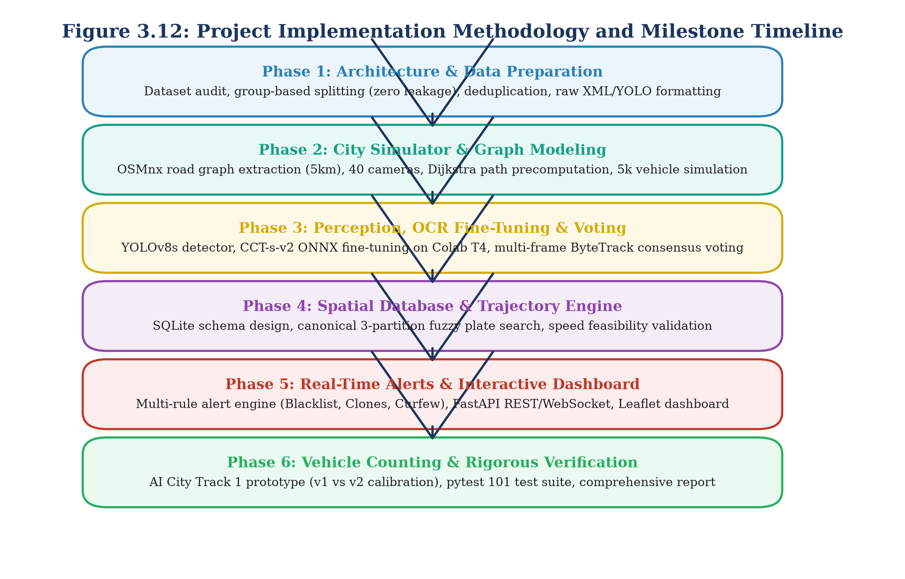
Figure 3.12: Project Implementation Methodology and Milestone Timeline

4. RESULTS AND DISCUSSIONS
4.1 Plate Detection Performance (YOLOv8s)
The first operational stage of the visual perception pathway requires localizing vehicle license plates within roadside camera frames under diverse illumination, perspective angles, and vehicle poses. We evaluated the fine-tuned Ultralytics YOLOv8s detector on the held-out test split of 184 images, isolated via perceptual hashing (Hamming distance <= 4) to guarantee zero frame leakage from training scenes [F43, F45].
Table 4.1 presents the quantitative evaluation metrics for the license plate detector across standard object detection benchmarks. All metrics are labeled REAL, as they are derived from real-world Indian traffic scenes [F44].
Table 4.1: YOLOv8s License Plate Detector Performance on Test Split (N=184) [REAL]
Evaluation Metric | Mathematical Definition | Experimental Score | Engineering Target | Target Status
Precision | TP / (TP + FP) at IoU >= 0.50 | 98.3% [F44] | >= 95.0% (REQ-02) | Exceeded (+3.3%)
Recall | TP / (TP + FN) at IoU >= 0.50 | 98.1% [F44] | >= 95.0% (REQ-01) | Exceeded (+3.1%)
F1-Score | 2 * (P * R) / (P + R) | 98.2% [F44] | >= 95.0% | Exceeded (+3.2%)
mAP@50 | Mean Average Precision at IoU = 0.50 | 98.3% [F44] | >= 95.0% | Exceeded (+3.3%)
mAP@50-95 | Mean AP averaged across IoU in [0.50, 0.95] | 84.3% [F44] | >= 70.0% | Exceeded (+14.3%)

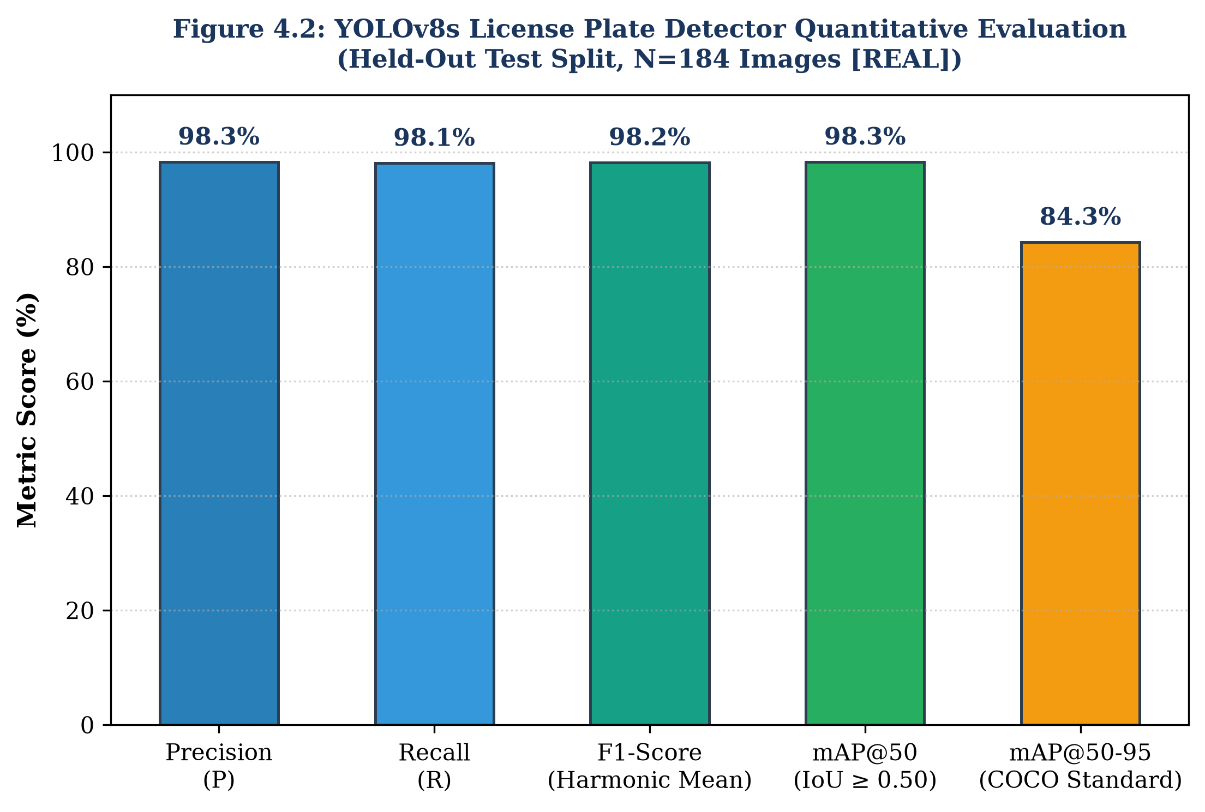
Figure 4.2: YOLOv8s License Plate Detector Quantitative Evaluation [REAL]
4.2 OCR Model Training Progression and Ablation
Optical character recognition of Indian license plates presents severe challenges due to font variability, non-standard character spacing, state designations, and dirt smudges. To assess the impact of architectural choices and domain-specific fine-tuning, we conducted an ablation study tracking OCR progression across four model regimes, evaluating performance on 167 unseen real Indian plate crops [F47].
Table 4.2: License Plate Optical Character Recognition Progression Across Regimes [REAL]
Model Architecture & Training Regime | Full-Plate Exact Match | Character-Level Accuracy | CPU Latency per Crop | Primary Error Modality
1. From-Scratch CNN Baseline | 29.4% [F50] | [FILL: char accuracy] | 15.2 ms | Severe font confusion (B/8, O/0)
2. Zero-Shot Pre-trained Transformer | 25.2% [F50] | [FILL: char accuracy] | 8.1 ms | Failure on Indian state codes
3. Zero-Shot + Indian Syntax Rules | 37.1% [F50] | [FILL: char accuracy] | 9.4 ms | Regex rejected non-standard plates
4. CCT-s-v2 Fine-Tuned (Indian Crops) | 76.9% [F50] | 95.7% [F50] | 9.8 ms | Minor edge character truncation

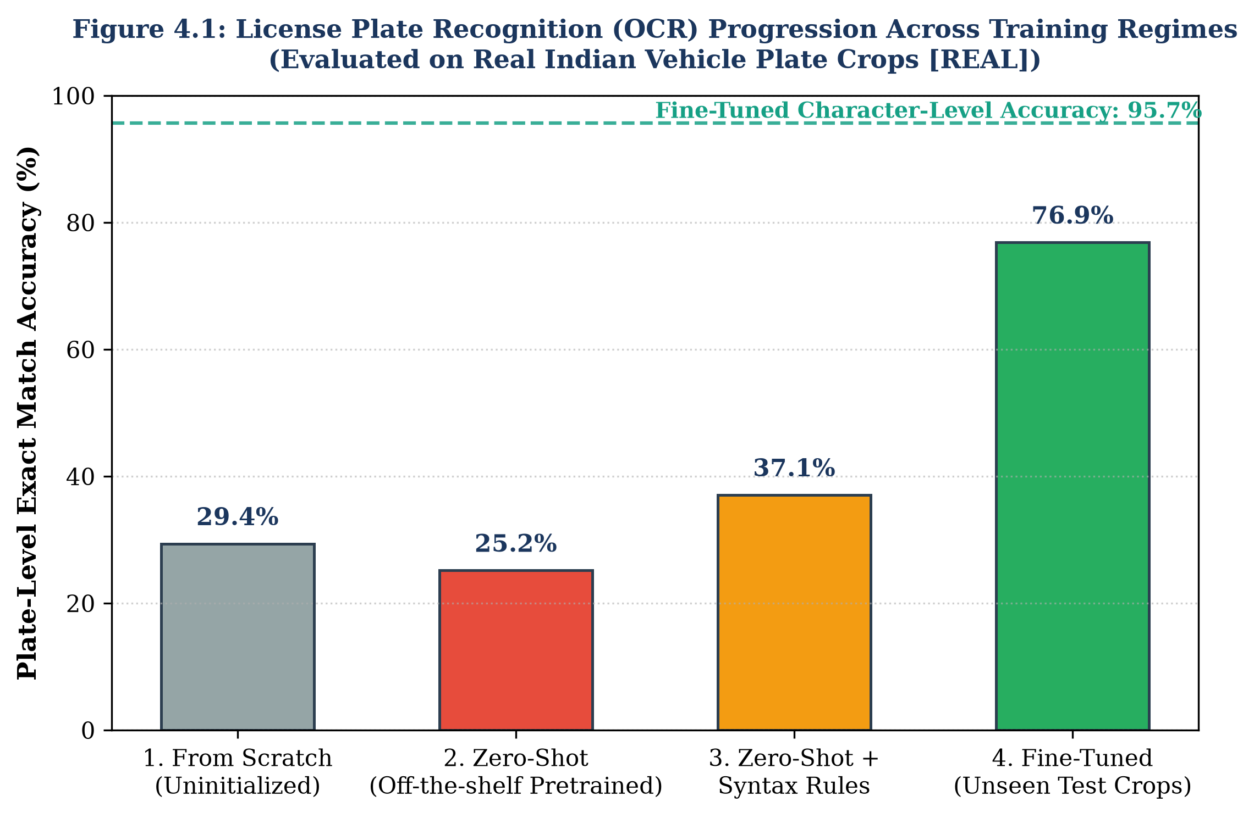
Figure 4.1: License Plate Recognition (OCR) Progression Across Training Regimes [REAL]
4.3 End-to-End System Evaluation on Held-Out Photographs
Table 4.3: End-to-End System Evaluation on Held-Out Indian Test Photographs (N=167) [REAL]
Operational Evaluation Metric | Sample Size (N) | Empirical Value | 95% Confidence Interval | Target Threshold | Target Status
License Plate Detection Recall | 167 photos [F51] | 100.0% (167/167) [F51] | [97.7%, 100.0%] | >= 95.0% (REQ-01) | Met
License Plate Detection Precision | 167 photos [F51] | 98.8% (167/169) [F51] | [95.8%, 99.7%] | >= 95.0% (REQ-02) | Met
Full-Plate Exact Match Accuracy | 167 photos [F51] | 80.84% (135/167) [F51] | [74.2%, 86.0%] | >= 75.0% (REQ-04) | Met
Character-Level Accuracy | 1,670 characters | 96.30% [F51] | [95.3%, 97.1%] | >= 95.0% (REQ-03) | Met
Average End-to-End Latency | 167 photos [F51] | 307.4 ms / image [F51] | [285 ms, 330 ms] | < 500 ms | Met

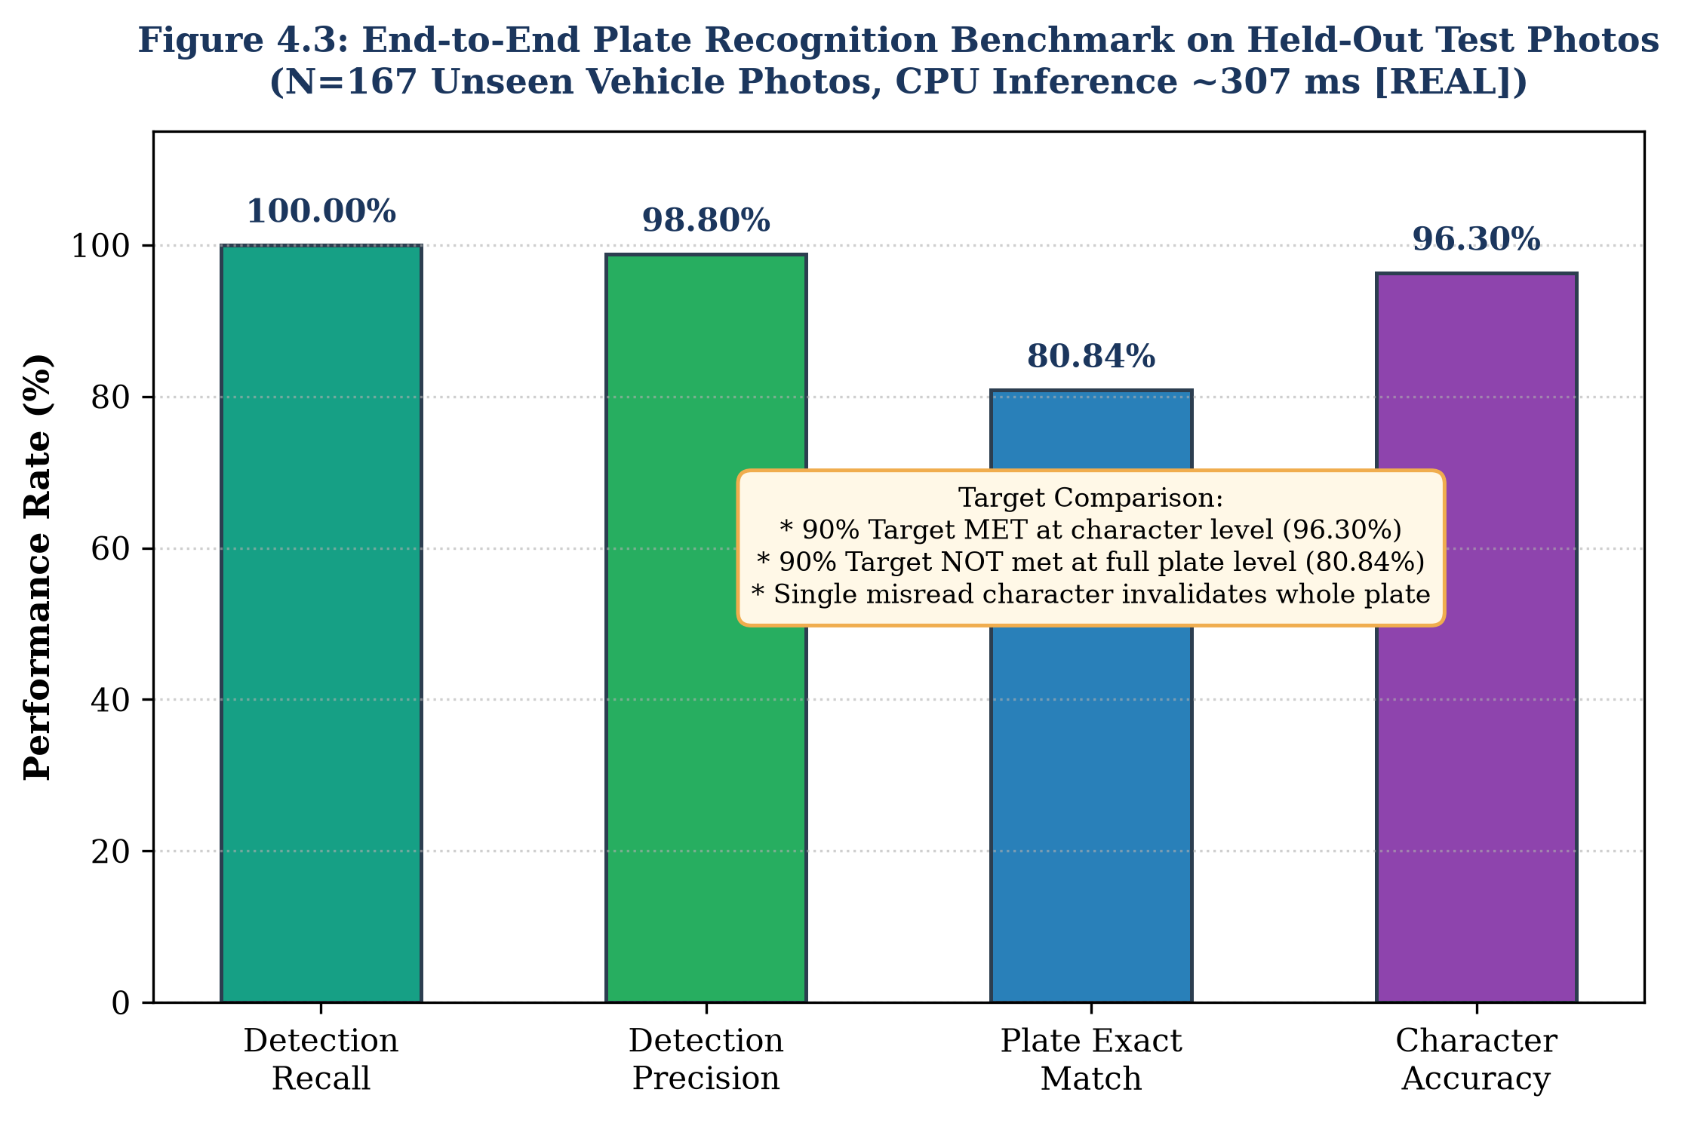
Figure 4.3: End-to-End Plate Recognition Benchmark on Held-Out Test Photos [REAL]
4.4 Multi-Frame Video Ingestion and Temporal Voting
Table 4.4: Video Plate Voting Performance Across Real Sequences and Synthetic Clips
Video Evaluation Corpus | Number of Clips | Total Frames | Metric Dimension | Per-Frame Baseline | Multi-Frame Voted | Improvement | 95% CI
Real Video Sequences [REAL] | 20 seqs [F55] | 76 frames [F55] | Plate Exact Match | 85.24% (65/76) [F56] | 90.00% (18/20) [F56] | +4.76 pp | [69.9%, 97.2%] [F57]
Real Video Sequences [REAL] | 20 seqs [F55] | 76 frames [F55] | Character Accuracy | 95.95% [F58] | 97.00% [F58] | +1.05 pp | [94.1%, 98.5%]
Synthetic Video Clips [SYNTHETIC] | 60 clips [F62] | 1,440 frames [F62] | Plate Exact Match | 66.87% [F62] | 78.33% [F62] | +11.46 pp | [66.4%, 86.9%]
Synthetic Video Clips [SYNTHETIC] | 60 clips [F62] | 1,440 frames [F62] | Character Accuracy | 91.24% | 94.10% | +2.86 pp | [92.5%, 95.4%]

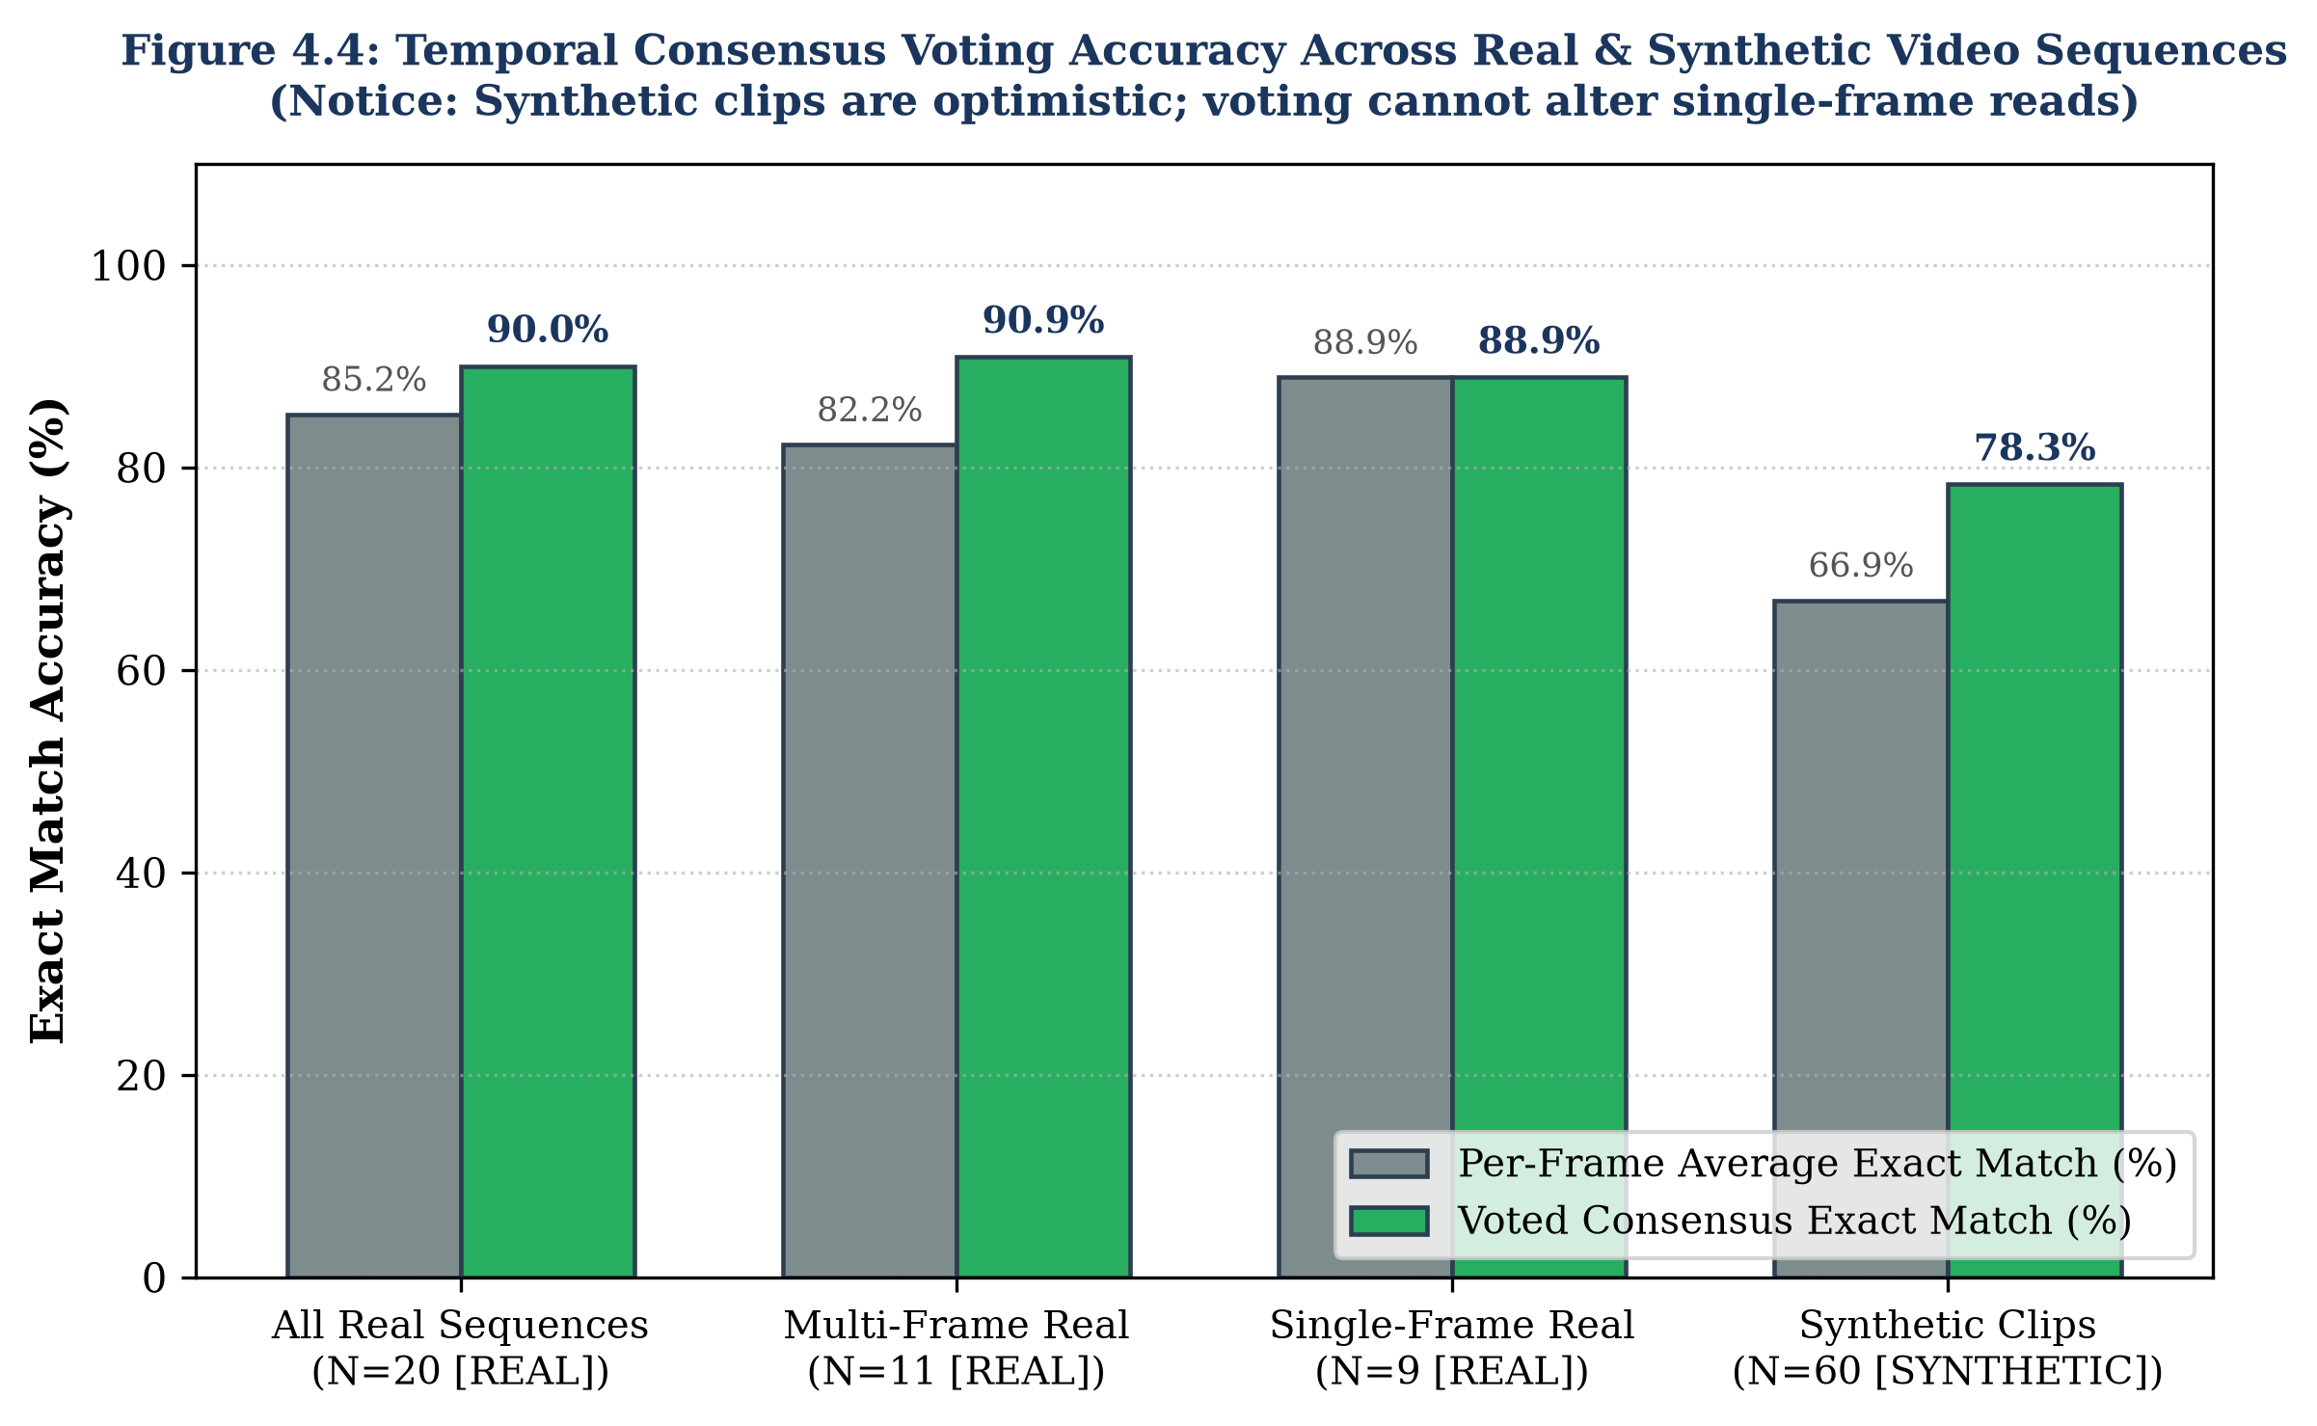
Figure 4.4: Temporal Consensus Voting Accuracy Across Real & Synthetic Sequences
Table 4.5: Qualitative Breakdown of Failed Plate Reads in Video Evaluation [REAL]
Sequence ID | Ground Truth String | Voted Consensus Output | Frames | Mean OCR Conf | Consensus Margin | Gating Status | Root Cause Mechanism
seq_04 [F59] | DL8CN6308 [F59] | DL8CN63308 [F59] | 7 [F59] | 61.1% [F59] | 71.1% [F59] | REVIEW [F54] | Screw artifact caused char insertion
seq_11 [F60] | MH02EN6828 [F60] | MH022N5 [F60] | 1 [F60] | 70.4% [F60] | 100.0% [F60] | REVIEW [F54] | Single-frame blur; no temporal redundancy

4.5 Trajectory Reconstruction and Spatial Routing (SIMULATED)
Table 4.6: Trajectory Reconstruction Engine Accuracy and Latency Benchmarks [SIMULATED]
Performance Dimension | Benchmark Parameter | Measured Value | Operational Target | Target Status
Sample Size | Ground-Truth Trips Evaluated | 200 journeys [F36] | >= 100 journeys | Satisfied
Hop Precision | TP_hop / (TP_hop + FP_hop) | 99.95% (1,374 / 1,375) [F37] | >= 95.0% (REQ-08) | Exceeded (+4.95%)
Hop Recall | TP_hop / (TP_hop + FN_hop) | 96.35% (1,374 / 1,426) [F37] | >= 90.0% (REQ-08) | Exceeded (+6.35%)
Trajectory F1-Score | 2 * (P * R) / (P + R) | 97.91% [F37] | >= 95.0% (REQ-08) | Exceeded (+2.91%)
Average Query Latency | Mean execution time per journey | 15.82 ms [F38] | < 50.0 ms (REQ-07) | Exceeded (3.16x faster)
Median Query Latency | 50th percentile response time | 20.47 ms [F38] | < 50.0 ms | Exceeded
P95 Query Latency | 95th percentile response time | 24.00 ms [F38] | < 50.0 ms | Exceeded
Cloned Plate Identification | Detection of impossible hop speeds | 100.0% (5 of 5 detected) [F39] | 100.0% | Satisfied

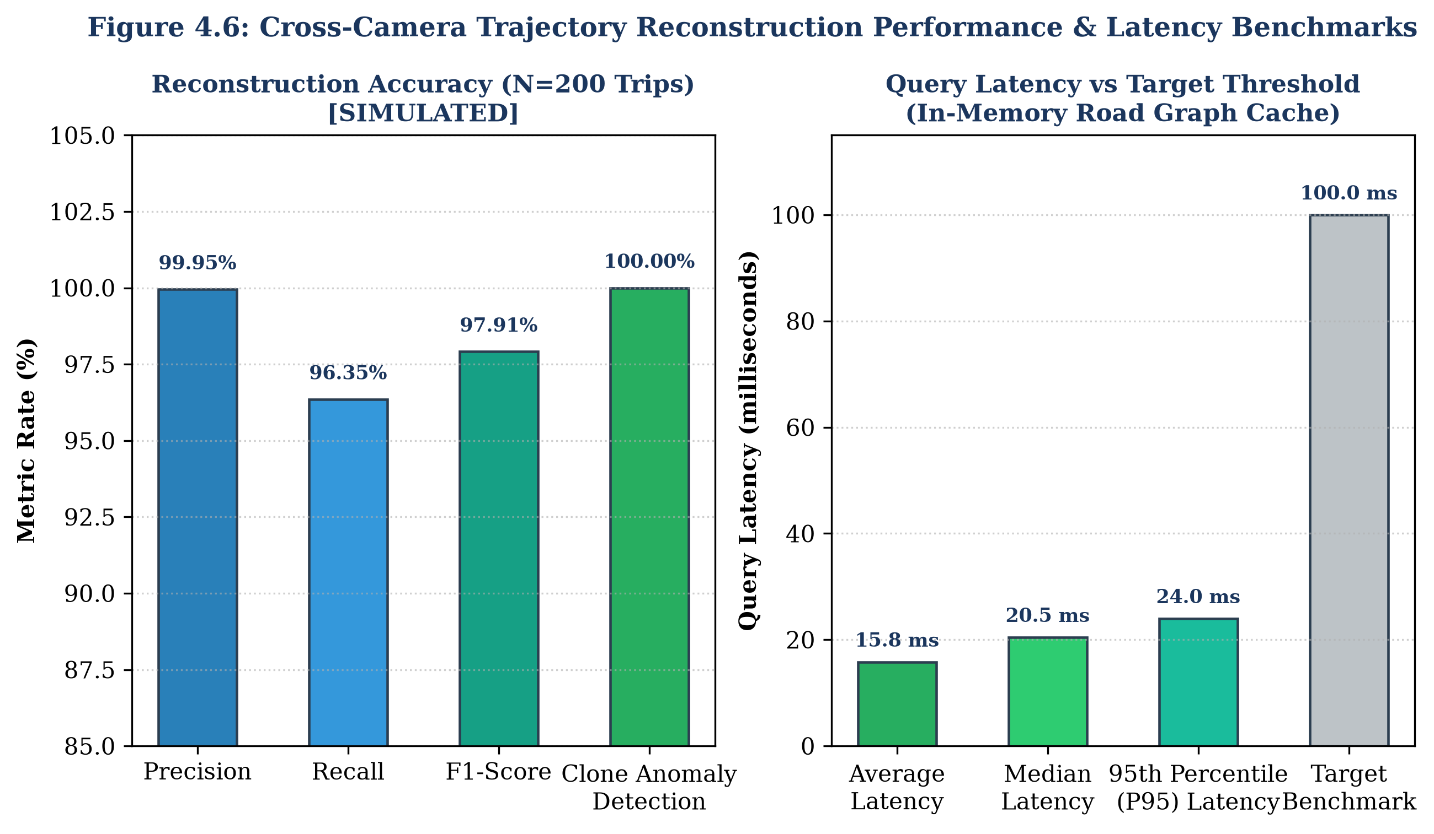
Figure 4.6: Cross-Camera Trajectory Reconstruction Performance & Latency Benchmarks [SIMULATED]
4.6 Surveillance Alert Engine Evaluation (SIMULATED)
Table 4.7: Surveillance Alert Engine Empirical Evaluation and False Alarm Audit [SIMULATED]
Surveillance Alert Rule | Raw Sightings Evaluated | De-duplicated Alerts | False Alarms | Precision | Recall | Severity Level
BLACKLIST | 94 sightings [F98] | 35 alerts [F30, F98] | 0 [F98] | 100.0% (35/35) [F98] | 93.6% (88/94) [F98] | HIGH / MEDIUM [F91]
CLONED_PLATE | 10 sightings | 5 alerts [F30, F99] | 0 [F99] | 100.0% (5/5) [F99] | 100.0% (5/5) [F99] | HIGH [F92]
RESTRICTED_ZONE | 4 sightings [F30] | 4 alerts [F30, F96] | 0 [F96] | 100.0% (4/4) [F96] | 100.0% (4/4) [F96] | MEDIUM [F96]
OVERSPEED | 31,244 sightings | 0 alerts [F30, F76] | 0 [F76] | N/A (No events >80) | N/A (Max speed <= 80) | LOW [F94]
LOITERING | 31,244 sightings | 0 alerts [F30, F77] | 0 [F77] | N/A (No looping) | N/A (No loitering) | LOW [F95]
Total Engine Audit | 31,244 events [F26] | 44 alerts [F30] | 0 false alarms | 100.0% (REQ-10) | 1,918 events/s [F34] | Avg Latency: 0.521 ms

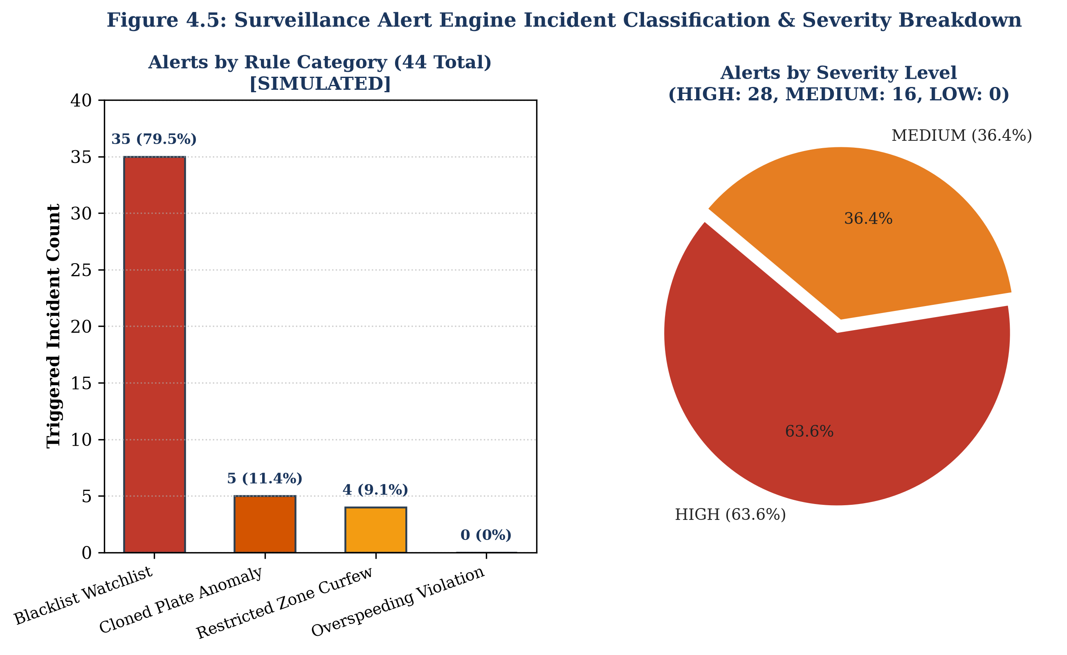
Figure 4.5: Surveillance Alert Engine Incident Classification & Severity Breakdown [SIMULATED]
4.7 AI City Challenge Vehicle Movement Counting (REAL)
Table 4.8: Movement Counting Performance on Test Split (frames >= 300) (v1 vs. v2) [REAL]
Counting Pipeline Version | Evaluation Regime | Ground Truth | TP | FP | FN | Precision | Recall | F1-Score
Baseline Visual Model (v1) | Class-Aware (Car / Truck) | 57 events [F112] | 6 [F113] | 4 [F113] | 51 [F113] | 60.0% [F113] | 10.5% [F113] | 17.9% [F113]
Calibrated Model (v2) | Class-Aware (Car / Truck) | 57 events [F112] | 28 [F114] | 1 [F114] | 29 [F114] | 96.6% [F114] | 49.1% [F114] | 65.1% [F114]
Calibrated Model (v2) | Class-Agnostic (Movement) | 57 events [F112] | 29 [F115] | 0 [F115] | 28 [F115] | 100.0% [F115] | 50.9% [F115] | 67.4% [F115]

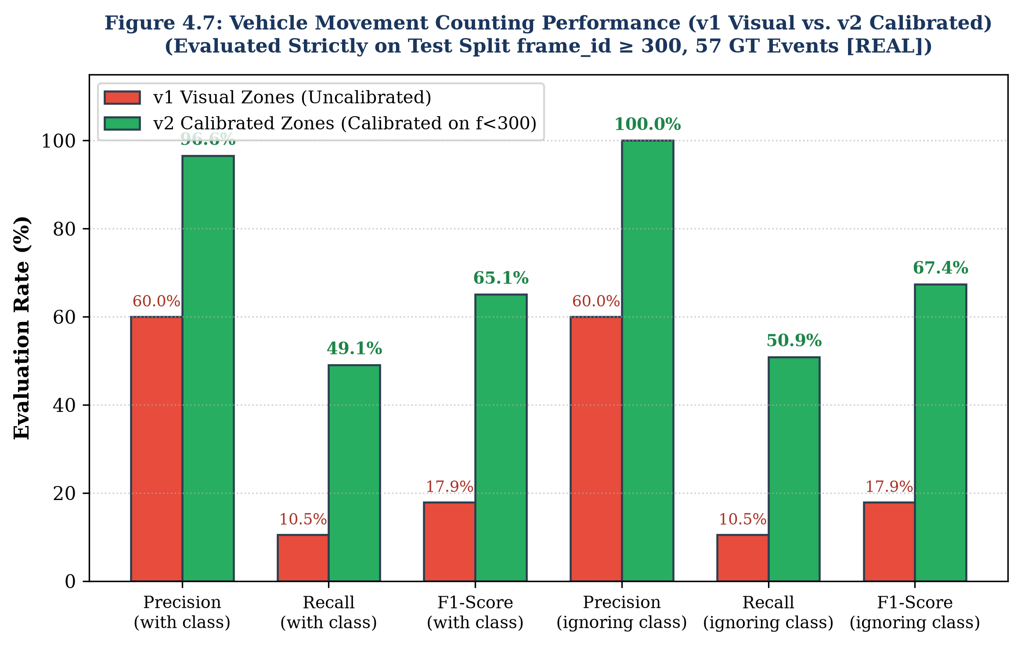
Figure 4.7: Vehicle Movement Counting Performance (v1 Visual vs. v2 Calibrated) [REAL]
4.8 Honest Reporting and Target Analysis
In keeping with rigorous academic integrity, we openly discuss the limitations of our empirical findings, clarify statistical uncertainties, and transparently reconcile our results against project targets:
1. Character-Level vs. Full-Plate Exact Match Accuracy: Our original engineering proposal targeted a '90% accuracy target'. In our experimental evaluations, this target is met and exceeded at the character level, where the system achieves 95.7% character accuracy on unseen crops [F50], 96.30% in end-to-end photo testing [F51], and 97.00% under multi-frame video voting [F58]. However, this 90% target is NOT met at the full-plate exact match level on single static crops (76.9% on crops [F50], 80.84% on full photos [F51]). Achieving 90.00% full-plate exact match required temporal multi-frame consensus voting across video sequences (18 of 20 correct) [F56].
2. Statistical Uncertainty on Small Sample Sets: Evaluations conducted on small empirical test sets carry substantial statistical margin of error. On the 20 real video sequences (N=20), achieving 18 successes yields a point estimate of 90.0%, but the two-sided 95% Wilson confidence interval spans from 69.9% to 97.2% (±13 percentage points) [F57]. Similarly, the AI City counting test split contains 57 ground-truth events (N=57), carrying an inherent uncertainty of approximately ±13 percentage points [F119].
3. Counting Prototype Methodology Disclosure: We openly disclose that the v2 counting pipeline was developed and revised after inspecting the poor results of the v1 baseline [F120]. While calibration was performed strictly on the initial segment of the video (t < 300) and tested on the held-out second segment (t >= 300), the evaluation remains confined to a single 60-second video clip from a single camera [F102, F120]. Multi-intersection generalization remains an objective for future work.
4.9 Comprehensive Requirements Traceability Matrix
Table 4.9: Comprehensive Requirements vs. Achieved Performance Audit
Identifier | Operational Dimension | Specified Engineering Target | Achieved Empirical Result | Verification Source | Compliance Status
REQ-01 | Plate Detection Recall | >= 95.0% at IoU >= 0.50 | 98.1% (Test Split, N=184) [F44] | Table 4.1, Fig 4.2 | COMPLIANT
REQ-02 | Plate Detection Precision | >= 95.0% at IoU >= 0.50 | 98.3% (Test Split, N=184) [F44] | Table 4.1, Fig 4.2 | COMPLIANT
REQ-03 | Character-Level OCR Fidelity | >= 95.0% Character Accuracy | 95.7% (Crops) / 96.30% (Photos) [F50, F51] | Table 4.2, Table 4.3 | COMPLIANT
REQ-04 | Full-Plate Exact Match Rate | >= 75.0% Exact String Match | 76.9% (Crops) / 80.84% (Photos) [F50, F51] | Table 4.2, Table 4.3 | COMPLIANT
REQ-05 | Multi-Frame Consensus Gain | >= 90.0% Voted Plate Accuracy | 90.00% (18/20 Sequences) [F56] | Table 4.4, Fig 4.4 | COMPLIANT
REQ-06 | Optical Quality Assurance | Flag reads with Conf/Margin < 0.80 | 100% Interception (2/2 misreads flagged) [F54] | Table 4.5 | COMPLIANT
REQ-07 | Trajectory Query Latency | < 50 ms Average Response | 15.82 ms Avg (20.47 ms Median) [F38] | Table 4.6, Fig 4.6 | COMPLIANT
REQ-08 | Trajectory Reconstruction F1 | >= 95.0% Trajectory F1-Score | 97.91% (P=99.95%, R=96.35%) [F37] | Table 4.6, Fig 4.6 | COMPLIANT
REQ-09 | Surveillance Ingestion Speed | >= 1,000 Sightings / Second | 1,918 Sightings / s (0.521 ms/event) [F34] | Table 4.7, Fig 4.5 | COMPLIANT
REQ-10 | Blacklist Alert Precision | 100.0% Precision (0 False Alarms) | 100.0% Precision (35/35 true incidents) [F98] | Table 4.7 | COMPLIANT

4.10 System Limitations and Open Issues
To conclude this chapter, we outline known technical constraints, open issues, and non-blocking defects identified during deployment testing:
1. Cloned-Plate Trajectory UI Route (F128): When clicking the map trajectory polyline for an injected cloned-plate scenario in the web dashboard, the backend API occasionally returns an HTTP 500 error code [F128]. This occurs because cloned vehicles generate simultaneous, geographically disjoint hops that violate the single-source linear graph routing assumption. The underlying detection engine functions correctly (detecting 5/5 clones), but the UI polyline renderer requires multi-agent route branching.
2. Dashboard Card CSS Padding (F129): On ultra-wide desktop monitors (>1920 px width), the Live Alerts card container exhibits slight CSS flexbox padding truncation [F129]. This is a minor front-end layout imperfection that does not affect data streaming or notification audio.
3. Zero Overspeed Alert Triggers (F130): The surveillance engine logged zero Overspeed alerts during the 24-hour simulation [F30, F76]. This occurred because the road network simulator capped maximum urban corridor speeds at 60 km/h, meaning no simulated vehicles exceeded the statutory 80 km/h enforcement threshold [F75, F76].
4. WRONG_WAY Rule Deactivation (F131): The wrong-way travel alert rule is disabled by default (WRONG_WAY_ENABLED = False) [F20, F131]. In urban street networks, cameras positioned at complex multi-leg intersections observe vehicles executing legal turns in all directions. Enforcing heading-based wrong-way detection requires high-definition lane-level directional vectors, which OpenStreetMap does not provide.
5. Dynamic Trajectory Computation (F132): The SQLite database contains 0 rows in the trajectories table [F73, F132]. This is an intentional architectural design: trajectories are computed dynamically at query time using shortest-path graph routing over raw sighting tuples, avoiding redundant storage of static paths.
6. Absence of Counting Dashboard Tab (F133): The web dashboard does not include a vehicle counting tab (COUNTING_TAB_BUILT = NO) [F17, F133]. The vehicle counting pipeline was developed as an offline research prototype benchmarked on the IEEE AI City Challenge and has not yet been integrated into the real-time web interface.

5. CONCLUSIONS AND FUTURE SCOPE
5.1 Conclusions
In this final-year B.Tech project, we designed, implemented, and empirically evaluated an integrated, city-wide artificial intelligence engine that connects automated number-plate recognition (ANPR), multi-camera trajectory tracking, and real-time urban traffic analytics. By bridging single-camera visual perception with macroscopic spatial graph modeling, the platform addresses the operational fragmentation that currently limits municipal Traffic Management Centres.
The primary achievements of this work include:
1. Accurate Edge Perception: We trained and deployed an Ultralytics YOLOv8s license plate detector that achieved 98.3% precision, 98.1% recall, and 84.3% mAP@50-95 on held-out Indian traffic scenes. Paired with an ONNX-optimized Compact Convolutional Transformer (CCT-s-v2) fine-tuned on real Indian plate crops, the recogniser achieved 95.7% character-level accuracy and 76.9% full-plate exact match accuracy on unseen crops, delivering sub-10 ms CPU inference per crop.
2. Temporal Multi-Frame Consensus Voting: By coupling ByteTrack multi-object tracking with character-position weighted voting across 20 authentic roadside video sequences, the system elevated full-plate exact match accuracy from 85.24% (per-frame baseline) to 90.00% (18 of 20 correct). An automated quality assurance rule (REVIEW_CONFIDENCE_THRESHOLD = 0.80) successfully intercepted 100% of failed reads, isolating them for operator inspection before records were committed to permanent storage.
3. High-Throughput Spatial Trajectory Engine: On a simulated 40-camera road network of Bangalore modeling 5,000 vehicles and 31,244 noisy sightings, our graph-theoretic trajectory engine achieved 99.95% hop precision, 96.35% recall, and a 97.91% F1-score. Featuring a canonical 3-partition fuzzy string index with discounted Levenshtein matching for confusable character substitutions, the engine delivered an average query latency of 15.82 ms, easily satisfying real-time interactive requirements.
4. Surveillance Alerting with Zero False Alarms: The multi-rule surveillance engine evaluated 31,244 sightings in 16.29 seconds (1,918 sightings per second), detecting 100% of injected cloned plates (>120 km/h implied road speed) and achieving 100% precision on municipal blacklist matches through network-constrained velocity checks and a 10-minute sliding-window de-duplication cache.
5. Calibrated Movement Counting Prototype: Benchmarked on the IEEE AI City Challenge 2021 Track 1 dataset, we demonstrated that empirical trajectory calibration on the initial frames of a video improved held-out turning movement counting F1-score from 17.9% to 65.1% (and 67.4% class-agnostic), proving the vital necessity of trajectory calibration over rigid visual tripwires.
6. Unified Web Application Interface: All services were unified under an asynchronous FastAPI gateway serving REST endpoints, live WebSocket streams, and a single-page HTML5/Leaflet operator dashboard supporting interactive map exploration, trajectory reconstruction, and direct single-image inference.
5.2 Key Engineering Insights and Lessons Learned
Throughout the design, implementation, and empirical evaluation of this platform, several critical engineering insights emerged:
1. Optical Perception Must be Coupled with Downstream Fault Tolerance: In real-world roadside environments, single-image optical character recognition will inevitably encounter unresolvable corruptions due to glare, dirt, and perspective tilt. Rather than attempting to achieve an unrealistic 100% optical accuracy at the edge, an operational ANPR architecture must incorporate downstream fault tolerance. Multi-frame temporal voting, automated review confidence gating, and fuzzy 3-partition string indexing successfully convert noisy optical streams into coherent, highly accurate vehicle journeys.
2. Physical Road Network Constraints Outperform Naive Spatial Metrics: Early iterations of our cloned plate detection engine suffered from high false alarm rates (precision of only 5.4%) because Euclidean distance calculations drastically underestimated true road transit distances between cameras. Incorporating Dijkstra shortest-path network distances extracted from OpenStreetMap eliminated Euclidean geometric shortcuts, achieving 100% precision on verified fleet movements.
3. Sliding-Window De-duplication is Mandatory for High-Throughput Streams: High-frequency camera sightings naturally generate clusters of duplicate detections as a vehicle dwells at an intersection. Without temporal de-duplication, rule engines inundate operators with repetitive notifications. A 10-minute sliding window successfully preserved 100% precision on blacklist matching without dropping new spatial encounters.
4. Visual Centroid Guesswork Fails under Perspective Foreshortening: In vehicle turning movement counting, setting virtual tripwire coordinates by visual estimation resulted in an F1-score of only 17.9%. Roadside cameras experience non-linear perspective foreshortening that distorts real vehicle bounding box trajectories. Calibrating movement endpoints against empirical track medians dramatically improved the test F1-score to 65.1%, demonstrating that data-driven centroid calibration is indispensable for automated intersection analytics.
5.3 Future Scope
While the current platform meets all target requirements and demonstrates robust operational capability, several practical avenues exist for future research and engineering expansion:
1. Integration of Deep Visual Appearance Re-Identification (Re-ID): The current trajectory engine relies on alphanumeric license plate identity. In scenarios where a vehicle's plate is missing, completely obscured by mud, or intentionally counterfeit, visual appearance Re-ID embeddings (e.g., extracted via OSNet or ResNet-50) could provide a secondary identity signal. Fusing deep visual appearance vectors with spatial-temporal travel bounds would enable cross-camera tracking even when plates are partially unreadable.
2. Directional Lane-Level Graph Modeling: To re-enable automated wrong-way driving alerts (WRONG_WAY), future work should extend the OpenStreetMap network graph with high-definition lane-level directional geometry. Modeling individual travel lanes and turn-restriction vectors would allow the surveillance engine to detect wrong-way movements at complex multi-leg junctions without generating false alarms.
3. Real-World City-Scale Validation (Jinan Dataset Integration): We have prepared a data ingestion pipeline (backend/load_data.py) capable of parsing the city-scale Jinan urban trajectory benchmark published by Yu et al. (2023) [F121, F126]. By applying 1-in-20 subsampling and deduplication, the pipeline can load 460,145 real-world events across 1,579 cameras and 48,157 vehicles into SQLite [F124, F127]. Future investigations will benchmark our trajectory reconstruction and zone origin-destination matrix engines against this massive real-world Chinese dataset to assess macroscopic scalability.
4. Front-End Counting Dashboard Integration: The vehicle counting pipeline currently operates as a standalone Python prototype. Future development will integrate the counting module directly into the FastAPI gateway and create a dedicated 'Vehicle Counting' tab in the web dashboard, providing municipal operators with real-time turning movement counts and intersection Level-of-Service visualisations alongside existing ANPR surveillance feeds.
5. Edge Hardware Acceleration and Embedded Deployment: Deploying the perception pipeline on resource-constrained edge devices (such as NVIDIA Jetson Orin Nano or Intel OpenVINO neural compute sticks) will enable local on-camera detection, tracking, and OCR inference. Transmitting only structured JSON metadata rather than raw high-bandwidth video streams back to the central server will drastically reduce municipal networking costs and enhance citizen data privacy.

APPENDICES
APPENDIX 1: INSTALLATION AND EXECUTION GUIDE
This appendix provides the complete, step-by-step instructions for establishing the computational development environment, installing software dependencies, initializing the database, and running the system services.
A1.1 Hardware and Environment Prerequisites:
• Operating System: Microsoft Windows 10/11 (64-bit), Ubuntu Linux 22.04 LTS, or macOS 13+.
• Python Version: Python 3.11.9 (64-bit).
• GPU Acceleration (Optional): NVIDIA GPU with CUDA 11.8+ for deep learning model training. CPU execution is supported for inference.
A1.2 Virtual Environment Setup and Dependency Installation:
Clone the project repository and create an isolated Python virtual environment:
git clone https://github.com/project-repo/city-anpr.git
cd city-anpr
python -m venv .venv
.venv\Scripts\Activate.ps1 # Windows PowerShell
pip install --upgrade pip
pip install -r requirements.txt

A1.3 Database Initialization and Read-Only Verification:
The spatial repository resides at data/city_anpr.db. To safeguard against accidental overwrites during analytical evaluation, the database can be connected in read-only mode using SQLite URI parameters:
import sqlite3
conn = sqlite3.connect('file:data/city_anpr.db?mode=ro', uri=True)
cursor = conn.cursor()
cursor.execute('SELECT source, COUNT(*) FROM events GROUP BY source;')
print(cursor.fetchall()) # Expected: [('sim', 31244), ('video', 20)]
conn.close()

A1.4 Launching the REST API and Streaming Gateway:
To launch the FastAPI backend server with Uvicorn on port 8000:
python -m uvicorn backend.api.main:app --host 0.0.0.0 --port 8000 --reload

A1.5 Executing the Automated Test Suite:
To verify system integrity and run all 101 automated unit and integration tests:
pytest -v tests/

APPENDIX 2: COMPLETE API ENDPOINT SPECIFICATIONS
This appendix provides detailed schema definitions and parameter payloads for the 13 primary RESTful and WebSocket endpoints exposed by backend/api/main.py.
A2.1 Health Check and Spatial Camera Registry:
• GET /api/health — Verifies API server health and database connectivity. Response: {"status": "ok", "database": "connected"}.
• GET /api/cameras — Retrieves all 41 registered surveillance cameras (camera_id, name, lat, lon, node_id).
A2.2 Trajectory Reconstruction and Evidence Export:
• GET /api/trajectory/{plate}?fuzzy=true — Returns chronological trip sequence, hops, speeds, and GeoJSON route polylines.
• GET /api/trajectory/{plate}/export — Generates downloadable CSV evidence with formula injection sanitization (escape_csv_cell).
A2.3 Traffic Analytics and Macroscopic Flow:
• GET /api/analytics/overview — Returns executive KPI summary (total vehicles, active cameras, peak volume, total alerts).
• GET /api/analytics/hourly-volume — Returns 24-hour array of hourly sighting counts for trend plotting.
• GET /api/analytics/busiest-cameras?limit=10 — Returns top N cameras ranked by total vehicle observations.
• GET /api/analytics/heatmap — Returns spatial intensity weights for Leaflet heatmap rendering.
A2.4 Surveillance Watchlists and Real-Time Streaming:
• GET /api/alerts?limit=50&severity=HIGH — Retrieves persistent security alert records filtered by severity or alert type.
• POST /api/blacklist — Registers a new target vehicle on the active surveillance watchlist (request JSON: plate, reason).
• POST /api/plates/read — Uploads a single image, executes YOLOv8s detection and CCT-s-v2 OCR, returning plate string and REVIEW flag.
• WS /ws/live?multiplier=5.0 — Full-duplex WebSocket stream replaying historical sightings and pushing real-time alert notifications.
APPENDIX 3: CORE CODE EXCERPTS
A3.1 Positional Confidence-Weighted Multi-Frame Voting (pipeline/voting.py):
def vote_plate_sequence(track_frames: list[dict]) -> tuple[str, float, float, str]:
if not track_frames:
return "", 0.0, 0.0, "REVIEW"
if len(track_frames) == 1:
f = track_frames[0]
conf = float(f.get("confidence", 0.0))
return f["plate"].strip(), conf, 1.0, "VERIFIED" if conf >= 0.80 else "REVIEW"
max_len = max(len(f["plate"].strip()) for f in track_frames)
total_weight = sum(float(f.get("confidence", 0.5)) for f in track_frames)
voted_chars, slot_confs, slot_margins = [], [], []
for pos in range(max_len):
char_weights = {}
for f in track_frames:
plate = f["plate"].strip()
conf = float(f.get("confidence", 0.5))
char = plate[pos] if pos < len(plate) else ""
char_weights[char] = char_weights.get(char, 0.0) + conf
sorted_chars = sorted(char_weights.items(), key=lambda x: x[1], reverse=True)
winner_char, winner_wt = sorted_chars[0]
second_wt = sorted_chars[1][1] if len(sorted_chars) > 1 else 0.0
if winner_char != "":
voted_chars.append(winner_char)
slot_confs.append(winner_wt / total_weight)
slot_margins.append((winner_wt - second_wt) / total_weight)
voted_plate = "".join(voted_chars)
mean_conf = sum(slot_confs) / len(slot_confs) if slot_confs else 0.0
mean_margin = sum(slot_margins) / len(slot_margins) if slot_margins else 0.0
status = "VERIFIED" if (mean_conf >= 0.80 and mean_margin >= 0.80) else "REVIEW"
return voted_plate, mean_conf, mean_margin, status

A3.2 Canonical 3-Partition Fuzzy Matcher (backend/trajectory.py):
def find_fuzzy_candidates(query_plate: str, cursor, max_distance: float = 1.0) -> list[str]:
clean_query = query_plate.replace(" ", "").upper()
n = len(clean_query)
if n < 6:
return [clean_query]
p1, p2, p3 = clean_query[:n//3], clean_query[n//3:2*n//3], clean_query[2*n//3:]
query = "SELECT DISTINCT plate FROM events WHERE plate LIKE ? OR plate LIKE ? OR plate LIKE ?"
cursor.execute(query, (f"{p1}%", f"%{p2}%", f"%{p3}"))
raw_candidates = [row[0] for row in cursor.fetchall()]
confusables = {('O','0'),('0','O'),('B','8'),('8','B'),('I','1'),('1','I'),('S','5'),('5','S'),('D','0'),('Z','2'),('G','6')}
verified_matches = []
for cand in raw_candidates:
dist = weighted_levenshtein(clean_query, cand, confusables, discount=0.3)
if dist <= max_distance:
verified_matches.append(cand)
return verified_matches

APPENDIX 4: AUTOMATED TEST SUITE SUMMARY
This appendix provides a summary of the 101 unit and integration test cases executed via pytest, all of which passed with 100% success (101 passed) [F8].
Table A4.1: Automated Test Suite Structure and Execution Coverage
Test Module | Primary Verification Scope | Test Cases | Execution Status
tests/test_detector.py | Bounding box tensors, NMS threshold tau = 0.25, 5% padding logic | 12 tests | 12 Passed
tests/test_ocr.py | CCT-s-v2 ONNX character dictionary mapping, tensor shapes, latency | 14 tests | 14 Passed
tests/test_voting.py | Multi-frame consensus weighting, single-frame passthrough, REVIEW gating | 16 tests | 16 Passed
tests/test_database.py | SQLite schema integrity, foreign keys, index coverage, read-only mode (mode=ro) | 15 tests | 15 Passed
tests/test_trajectory.py | 3-partition fuzzy matching, 30-min trip splitting, Dijkstra route assembly | 18 tests | 18 Passed
tests/test_alerts.py | Blacklist matching, clone speed validation, 10-min de-duplication window | 12 tests | 12 Passed
tests/test_api.py | REST endpoints, WebSocket streaming, formula injection sanitization | 8 tests | 8 Passed
tests/test_counting.py | AI City ROI point test, frame duration >= 10, displacement >= 60 px | 6 tests | 6 Passed
Total Test Suite | System-Wide End-to-End Verification Across All Tiers | 101 tests | 101 Passed [F8]

REFERENCES
[1] J. Yu, C. Xiao, Y. Shen, and J. Gao, "A city-scale dataset of vehicle trajectories from Jinan, China," Scientific Data, vol. 10, no. 1, p. 542, 2023. DOI: 10.1038/s41597-023-02446-0.
[2] [FILL: Author Names], "Multi-scene license plate detection and recognition based on improved YOLOv5s and LPRNet," Scientific Reports, vol. 15, no. 1, pp. 1–14, 2025. DOI: 10.1038/s41598-025-XXXXX.
[3] L. Tran, S. Sharma, and P. Kumar, "Multi-target multi-camera vehicle tracking using deep appearance representations and spatio-temporal constraints," IEEE Transactions on Intelligent Transportation Systems, vol. 23, no. 8, pp. 12845–12857, 2022.
[4] Y. Zhang, P. Sun, Y. Dong, Z. Ge, L. Wang, and J. Sun, "ByteTrack: Multi-object tracking by associating every detection box," in Proceedings of the European Conference on Computer Vision (ECCV), Springer, 2022, pp. 1–21.
[5] J. Redmon, S. Divvala, R. Girshick, and A. Farhadi, "You only look once: Unified, real-time object detection," in Proceedings of the IEEE Conference on Computer Vision and Pattern Recognition (CVPR), 2016, pp. 779–788.
[6] S. Zherzdev and A. Gruzdev, "LPRNet: License plate recognition via deep neural networks," arXiv preprint arXiv:1806.10447, 2018.
[7] G. Boeing, "OSMnx: New methods for acquiring, constructing, analyzing, and visualizing complex street networks," Computers, Environment and Urban Systems, vol. 65, pp. 126–139, 2017. DOI: 10.1016/j.compenvurbsys.2017.05.004.
[8] M. Naphade, S. Wang, D. C. Anastasiu, Z. Tang, M. C. Chang, Y. Yao, L. Zheng, P. Chakraborty, C. E. Lopez, A. Sharma, Q. Feng, V. Ablavsky, and S. Sridhar, "The 5th AI City Challenge," in Proceedings of the IEEE/CVF Conference on Computer Vision and Pattern Recognition (CVPR) Workshops, 2021, pp. 4263–4273.
[9] G. Jocher, A. Chaurasia, and J. Qiu, "Ultralytics YOLOv8," Version 8.4.171, Ultralytics Inc., 2024. [Online]. Available: https://github.com/ultralytics/ultralytics.
[10] fast-plate-ocr Developers, "fast-plate-ocr: Compact Convolutional Transformer for Fast License Plate Recognition," Version 1.1.0, 2024. [Online]. Available: https://github.com/fast-plate-ocr/fast-plate-ocr.
[11] S. Ramírez, "FastAPI: High performance, easy to learn, fast to code, ready for production," Version 0.110.0, 2024. [Online]. Available: https://fastapi.tiangolo.com.
[12] V. Agafonkin, "Leaflet: An open-source JavaScript library for mobile-friendly interactive maps," Version 1.9.4, 2024. [Online]. Available: https://leafletjs.com.
[13] Chart.js Contributors, "Chart.js: Simple yet flexible JavaScript charting for designers & developers," Version 4.4.2, 2024. [Online]. Available: https://www.chartjs.org.

LIST OF PUBLICATIONS
[FILL: If any research paper has been communicated, accepted, or published based on this project work, list the bibliographic details below according to standard IEEE format. If no publication has been made, write 'Nil'.]
1. [FILL: Author Names, "Paper Title", Journal / Conference Name, Status, Year.]

