INTERNAL TECHNICAL THESIS
Beyond the Coding Agent
An Enterprise Engineering Intelligence Platform for the Post-Commodity Coding Agent
A reference architecture and research thesis for principal engineers, architects, and engineering leadership

Distinguished Engineering · Enterprise Architecture
September 2026
Classification: Internal — Engineering Leadership

Executive Thesis
The agent is rented. The intelligence around it is owned.
Claude Code, GitHub Copilot, Cursor, and the IDE-native agents that will follow them are improving on a curve steep enough that any enterprise strategy resting on “we built a better coding agent” has a shelf life measured in a small number of product cycles. That is true even for capable internal teams: reasoning quality, planning, tool-use, and terminal-level autonomy are precisely the dimensions frontier labs are optimizing hardest, with more capital and more training data than any single enterprise can bring to bear on the same problem.
This thesis starts from that premise rather than arguing against it. It does not propose a competing agent. It asks a narrower and, we will argue, more durable question: once the agent itself is excellent and effectively interchangeable across vendors, what is left for an enterprise to build that a generic agent cannot buy, copy, or absorb into its next release?
The answer developed across this paper is an Enterprise Engineering Intelligence Platform — a control plane that sits above and around the coding agent and supplies four things no model vendor can supply on an enterprise's behalf:
- Context Intelligence — what this organization's code, architecture, data, and operations actually look like, assembled per task rather than dumped wholesale;
- Engineering Knowledge — this organization's accumulated patterns, playbooks, and failure lessons, codified into a form an agent can consume;
- Workflow Intelligence — how engineering work actually happens here, including which steps are deterministic and which require judgment; and
- Assurance — verifiable evidence that generated work meets this organization's standards, not merely a plausible-looking diff.
None of this is portable to a competitor. All of it compounds the longer it accumulates. And critically, none of it depends on which coding agent is plugged in underneath — which is the point. The architecture in this paper is designed so that Claude Code, Copilot, Cursor, or their 2028 successors are interchangeable execution engines sitting on top of the same durable intelligence layer.
Central claim: the long-term competitive advantage in enterprise AI-assisted engineering will not come from a better agent, a better prompt, or better model routing. It will come from an organization-specific intelligence layer that gets more valuable every quarter, independent of which model sits underneath it.

The paper is deliberately skeptical of its own premise throughout. Section 18 is devoted entirely to where this architecture could be wrong, and readers in a hurry should not skip it — a platform team that only reads the parts of this document that flatter the platform will build the wrong thing.

Why Coding Agents Change the Enterprise Architecture Problem
Three waves of tooling have asked enterprises to invest in different places, and it is worth being explicit about which wave we are now in, because the previous wave's investments do not automatically transfer.
- Wave 1 — IDE plus human. The human held all context and made all decisions; tooling provided navigation and static analysis. Enterprise investment went into IDE plugins, linters, and internal developer portals.
- Wave 2 — Agent-assisted (current). The agent reasons and drafts; the human directs and reviews. Enterprise investment has largely gone into prompt libraries, ad hoc RAG over documentation, and per-team custom tooling — much of which is now redundant with what frontier agents ship natively.
- Wave 3 — Agent-autonomous (approaching). The agent plans, executes, and self-corrects across multi-step tasks with limited supervision. In this wave, the scarce resource is no longer “can the agent code” — it is “can the agent be trusted with this organization's standards without a human re-deriving them on every task.”
The practical consequence for architecture investment is this: capability that lives inside the model's own reasoning loop is being commoditized on a roughly annual cycle, while capability that lives in an organization's accumulated, proprietary decisions is not being commoditized at all — it cannot be, because it does not exist anywhere outside the organization that produced it. Investment should move up the stack, away from re-implementing what frontier labs already do well, and toward the layer only the enterprise itself can build.
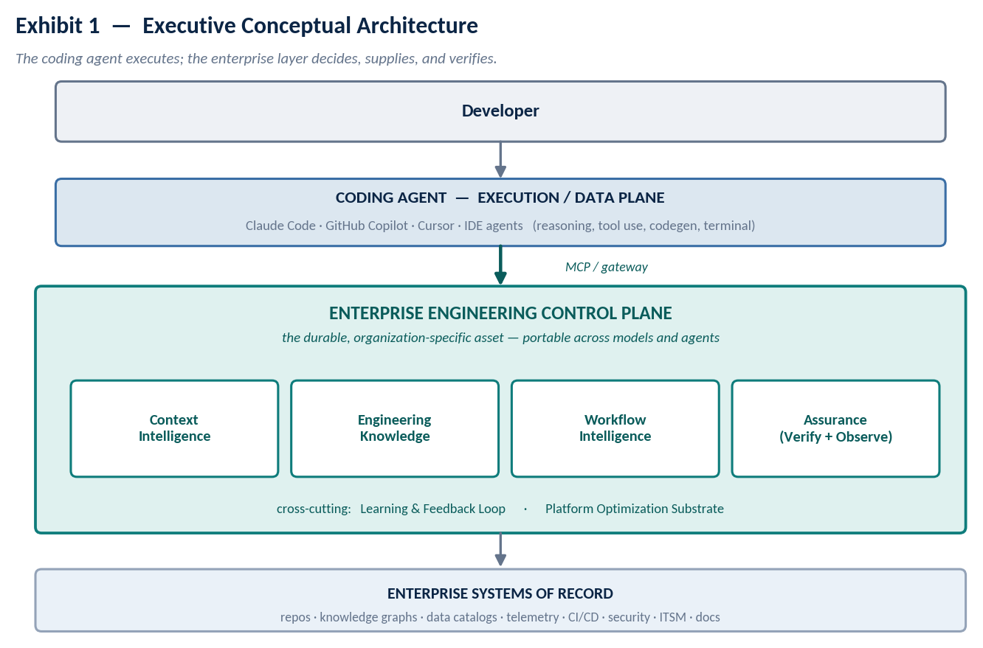
Exhibit 1 — the coding agent is the execution substrate; the durable asset is the control plane above it.

What Coding Agents Already Solve — Do Not Rebuild This
The single most common failure mode in enterprise AI-engineering platform efforts is re-implementing, badly and slowly, something the underlying coding agent already does well. Before specifying a single enterprise capability, it is worth being blunt about what is already commodity-grade in Claude Code, GitHub Copilot, Cursor, and comparable tools today, and what will very likely be commodity-grade in the next one to two release cycles regardless of what any single enterprise does.
Capability | Should the enterprise build it?
Natural-language intent understanding | No — table stakes in every frontier agent
Multi-step reasoning and planning | No — the core competitive axis for model vendors
Code generation and refactoring | No — do not re-implement code synthesis
File navigation and local editing | No — solved at the harness level
Terminal / shell execution | No — solved at the harness level
Generic tool selection within a turn | No — model-native, improving fast
A custom intent router for “which internal tool applies” | Rarely — prefer MCP capability contracts over a bespoke router
This organization's architecture standards | Yes — no vendor has access to them
This organization's incident history and lessons | Yes — proprietary, non-transferable
Policy enforcement and approval boundaries | Yes — requires organizational authority
Evidence that generated work meets internal standards | Yes — no vendor can attest to your standards

A useful gut check for any proposed platform component: would a frontier lab plausibly ship this as a built-in agent capability within eighteen months? If yes, the component is a bet against the model vendors' own roadmaps and should be justified explicitly as such — not assumed away. If no, because the capability requires this organization's own data, decisions, or authority, it belongs in the platform.

Architectural Principles
The brief for this thesis proposed ten candidate principles. Several overlapped, one was redundant with the central thesis, and several needed sharper qualification to avoid being trivially true. What follows is the refined set actually used to make design decisions in the rest of this document.
# | Principle | Why it is stated this way
1 | Context is assembled, not stored. | A context database is necessary but not sufficient. The valuable artifact is the task-specific bundle produced at request time, not the corpus it was drawn from.
2 | Enterprise truth outranks model memory — within its domain of authority. | A security policy outranks the model's guess about security. A six-month-old ADR does not outrank a live incident. Authority must be scoped, not treated as a single global trust level.
3 | Retrieve context sufficient for the task, not the maximum available. | Both under-retrieval and over-retrieval are failure modes; the second is easy to miss because it fails silently as noise rather than loudly as an error.
4 | Authority must be explicit and inspectable, not implicit in retrieval order. | If a developer cannot ask “why did the agent trust this source,” the ranking model is a black box wearing a policy costume.
5 | Live operational truth is fetched, not copied. | Logs, traces, and incident state should be queried live wherever latency allows; copying them into a knowledge store creates a second, staler source of truth.
6 | Deterministic systems govern deterministic requirements. | Security gates, compliance checks, and approval boundaries belong in policy engines and pipelines, not in a prompt asking the model to please remember the rule.
7 | Agents propose; platforms enforce work earns trust through evidence, not assertion. | A generated change is a claim until it is paired with the action taken, the check run, and the result — see Section 10.
8 | Models are replaceable; organizational intelligence must outlive any single model or vendor. | This is the thesis restated as a design constraint: nothing in the platform should assume a specific model, and everything durable should survive a model migration untouched.

Two candidate principles from the original brief were folded into Principle 8 rather than kept separate — “enterprise knowledge should improve independently of model evolution” is not a distinct idea from “models are replaceable,” it is the same idea applied to the learning loop specifically, and is addressed directly in Section 11.

The Capability Framework — Revising the Seven Pillars
The originating brief for this platform proposed seven capability pillars: Context Intelligence, Engineering Knowledge Intelligence, Organizational Workflow Intelligence, Continuous Verification, Learning and Feedback Intelligence, AI Engineering Observability, and Platform Optimization and Shared Intelligence. Taken as seven parallel, equally-weighted boxes, this model has a specific failure mode: it invites seven teams to build seven independent stores, each with its own retrieval path, and none of them naturally close the loop back into the others. Three revisions fix this.

Revision 1 — Verification and Observability are one domain, not two.
Verification without a trace is unauditable — a pass/fail result nobody can inspect after the fact. Observability without a gate is unactionable — a trace nobody blocks a merge on. Neither is useful alone; they are two disciplines inside one Assurance domain, evidence generation and evidence-based gating, and building them as separate pillars with separate owners produces exactly the seven-silo problem this revision is meant to avoid.

Revision 2 — Learning and Feedback is a loop, not a pillar.
Learning has no independent output of its own; every learning signal it produces is a write into Context, Knowledge, or Workflow. Modeled as a fifth parallel box, it tends to accumulate its own duplicate store of “lessons learned” that the other domains never actually consume. Modeled as a cross-cutting loop — the reclassification adopted here — it has exactly one job: classify signals from Assurance and route the ones that pass governance back into the domains that own them (Section 11).

Revision 3 — Platform Optimization is substrate, not a capability domain.
Shared indices, semantic caching, and cost controls are necessary and genuinely difficult engineering — but they are a non-functional requirement that every other domain needs, not a capability any of them differentiates on. Elevating it to a peer pillar puts an operating-model concern on the same footing as “does the agent understand our architecture,” which misprices it for both technical design and executive sponsorship conversations. It is addressed as a substrate layer in Section 12.

Original pillar | New placement | Rationale
Context Intelligence | Capability domain (kept) | Dynamic, task-scoped retrieval — Section 7
Engineering Knowledge Intelligence | Capability domain (kept) | Curated, versioned, durable — distinct governance profile from Context
Organizational Workflow Intelligence | Capability domain (kept) | Deterministic process + agent-driven judgment — Section 9
Continuous Verification | Merged into Assurance | Unprovable without a trace — Section 10
AI Engineering Observability | Merged into Assurance | Unactionable without a gate — Section 10
Learning and Feedback Intelligence | Cross-cutting loop | Has no output except writes into the other domains — Section 11
Platform Optimization and Shared Intelligence | Substrate layer | Non-functional requirement beneath every domain — Section 12

The result is four capability domains, one connecting loop, and one substrate layer — six named things instead of seven, and, more importantly, a model where every arrow has somewhere to go (Exhibit 1).

Reference Architecture
Exhibit 2 expands the conceptual view into the full layered architecture used for implementation planning. Four things are worth calling out explicitly because they are easy to omit from a first draft and expensive to retrofit.
- A single trust boundary. Everything the control plane touches — the four capability domains and the platform substrate — sits inside one enterprise trust boundary. The coding agent and the MCP layer sit outside it and are treated as untrusted callers that authenticate in.
- Identity and authorization at the gateway, not scattered through the domains. Every call from the agent into the control plane is authenticated and authorized once, at the MCP/gateway boundary, so individual capability services do not each reimplement access control.
- Provenance and audit as a first-class strip, not a side effect of logging. Every retrieval, decision, and verification event is recorded in a form that can answer “why did the agent do that” months later, not just “what did the agent do.”
- The substrate is shared, not duplicated per domain. Code graphs, knowledge graphs, vector indices, and telemetry are built once and consumed by all four capability domains — this is what Section 12 formalizes.
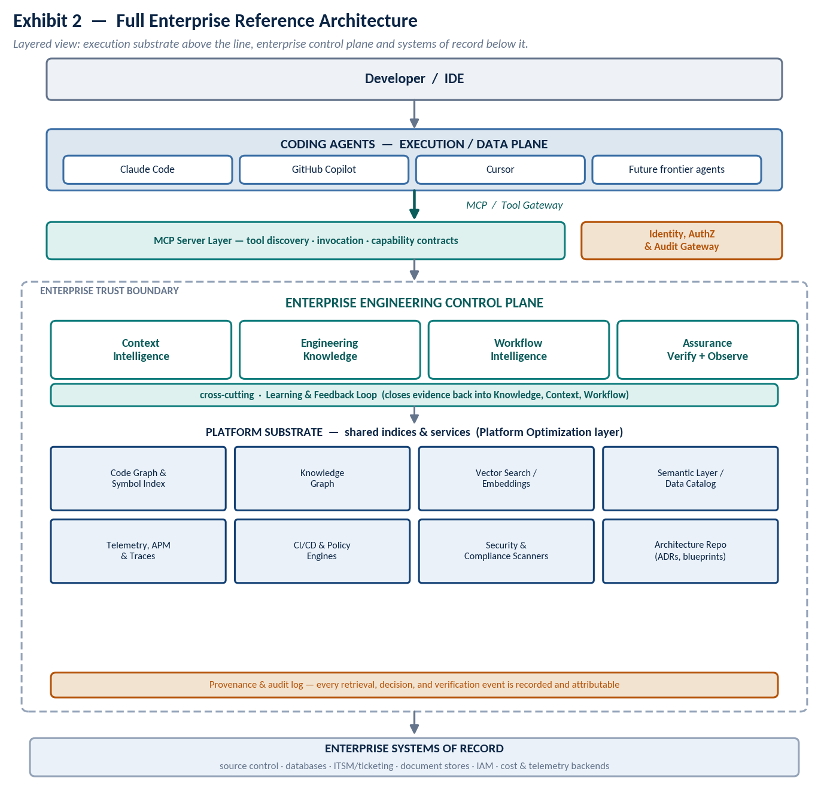
Exhibit 2 — full enterprise reference architecture, with trust boundary, identity/audit gateway, and shared substrate.

Context Intelligence — Deep Dive
Context Intelligence is deliberately not reduced to “RAG.” Vector search is one retrieval mechanism among several — graph traversal, structured API calls, and deterministic policy lookups are just as central — and different context domains warrant fundamentally different storage technology. The governing question is not “what do we index” but four narrower questions: what context should the agent receive, when, from where, and how much.

7.1 Eight context domains, one orchestrator
Enterprise context spans at least eight distinct domains — code, architecture, data, runtime, security and compliance, business and domain knowledge, engineering process, and developer/team context — and each domain tends to already have a storage technology suited to it: a code graph and symbol index for code, a document/policy store for architecture decisions, a semantic layer over a data catalog for data intelligence, a metrics and trace backend for runtime intelligence, and so on. Forcing all eight into a single vector database or a single graph is the most common and most expensive mistake in enterprise RAG programs. The correct architecture is federated: keep each domain in its native store, and put a single orchestrator in front of all of them.
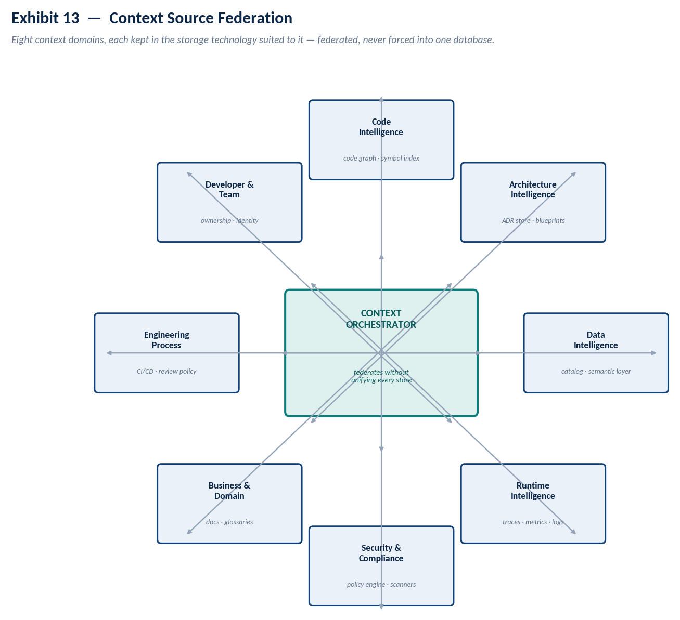
Exhibit 13 — eight federated context domains, each in its native store, coordinated by one orchestrator.

7.2 Context Engine architecture
Exhibit 3 lays out the pipeline a request actually travels: from federated sources, through ingestion, extraction, and entity resolution, into knowledge stores, and out through retrieval, ranking, policy, assembly, and compression before delivery to the agent. The Context Orchestrator does not sit at one stage of this pipeline — it governs the middle four stages directly (retrieval, ranking, policy, assembly/compression) and is accountable for eight decisions on every request: what is required, which sources are authoritative, how much is appropriate, what must be refreshed versus cached, how conflicts resolve, how sensitive data is filtered, how the result is compressed, and how provenance survives the whole trip.
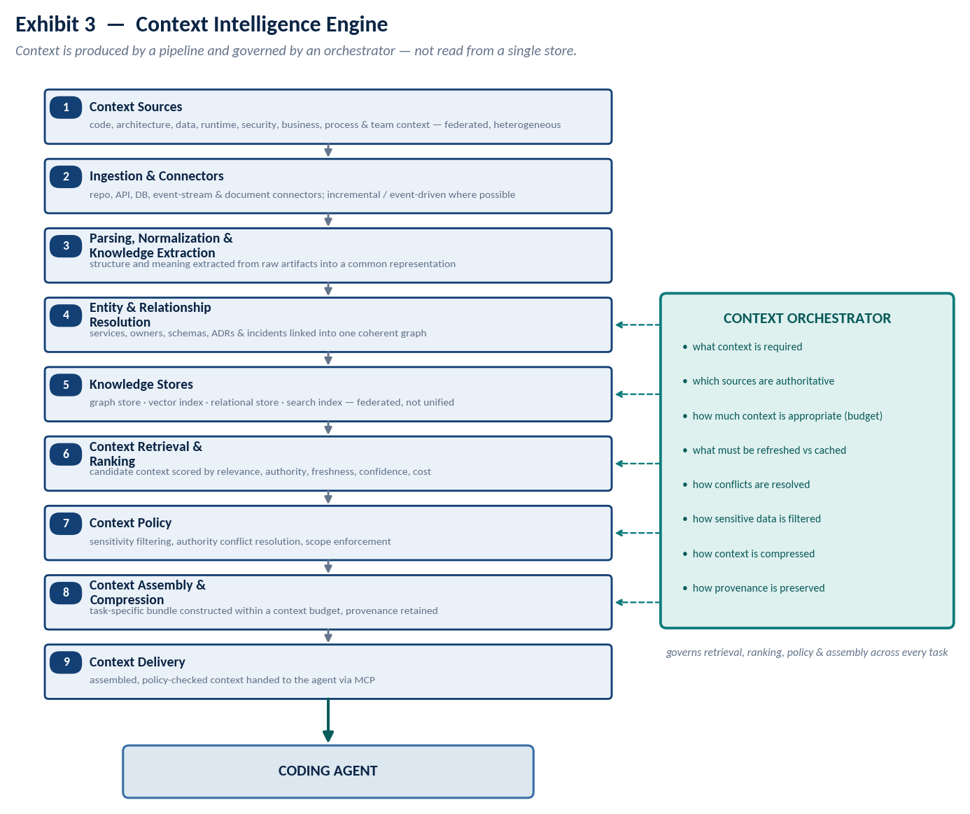
Exhibit 3 — the Context Intelligence Engine pipeline and the orchestrator's governing responsibilities.

7.3 Context is assembled, not stored
The same federated sources must produce materially different bundles depending on the task. A production-defect fix needs code, traces, logs, recent deploys, and incident history; a new microservice needs the reference architecture, the approved stack, and security standards; a modernization task needs the code graph, the dependency graph, and the target-state architecture. A static context dump sized for any one of these over-serves it and under-serves the other two — this is the practical argument for assembly-per-task over a single enterprise context database, independent of any storage-technology consideration.
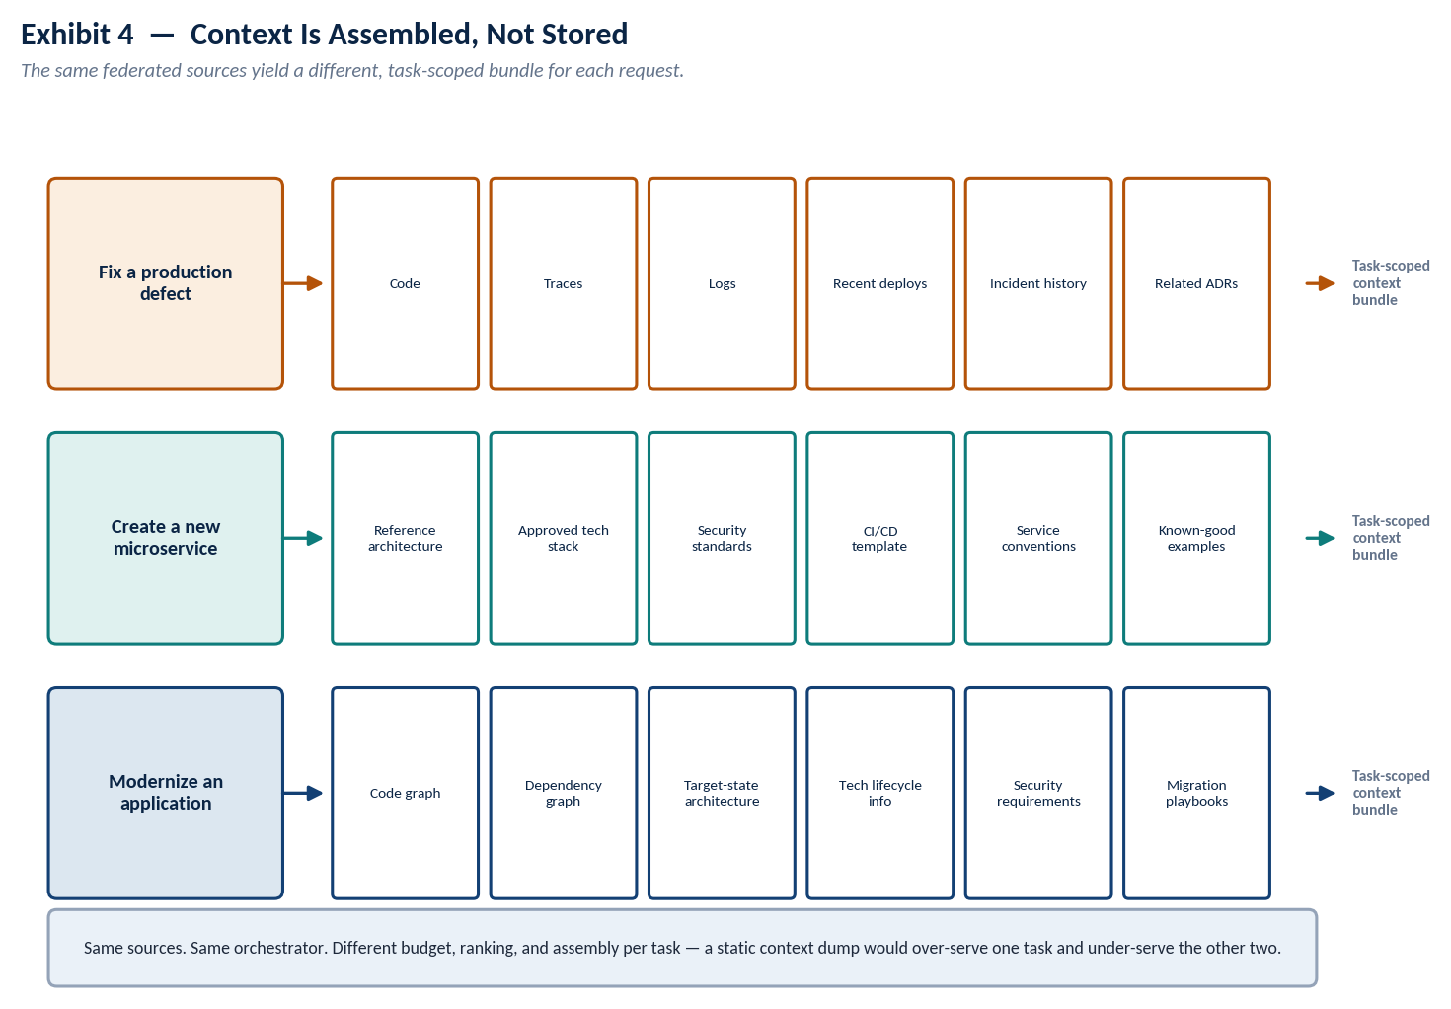
Exhibit 4 — three tasks, the same sources, three different assembled bundles.

7.4 A context value model
The originating brief proposed a multiplicative ranking formula — relevance × authority × freshness × task importance × confidence, divided by cost. The freshness term does not survive contact with real source heterogeneity: a security policy's useful half-life is measured in months, a production trace's in minutes, and a single global freshness multiplier either over-penalizes stable, high-authority sources or under-penalizes stale operational ones. The refinement used in this architecture treats freshness as a per-source-type decay rather than a flat multiplier, and treats cost as a soft rather than hard divisor so that a single very-high-value source is not automatically crowded out by ten mediocre cheap ones:
Context Value = ( Relevance × Authority × Confidence × Task Weight × e^{−Δt/τ} ) / ( 1 + λ·Cost )
where τ (the freshness half-life) is a property of the source type, not a platform-wide constant — set per domain in Exhibit 14 — and λ is tuned so cost discourages, rather than forbids, retrieving an expensive but high-value source.

7.5 Authority and freshness as a governing model
Plotting context types on authority against freshness requirement — rather than listing them — makes the caching and retrieval policy nearly self-evident. Stable, high-authority sources (security policy, ADRs, approved technology lists) should be cached aggressively with a long TTL. High-authority sources that change fast (dependency vulnerabilities, live incidents, production telemetry) must be fetched live and never cached at all. Low-authority, fast-changing context — a developer's current branch, for instance — is legitimate and often necessary, but it is session-scoped and should never be promoted into the durable knowledge store without going through the governance gate in Section 11.
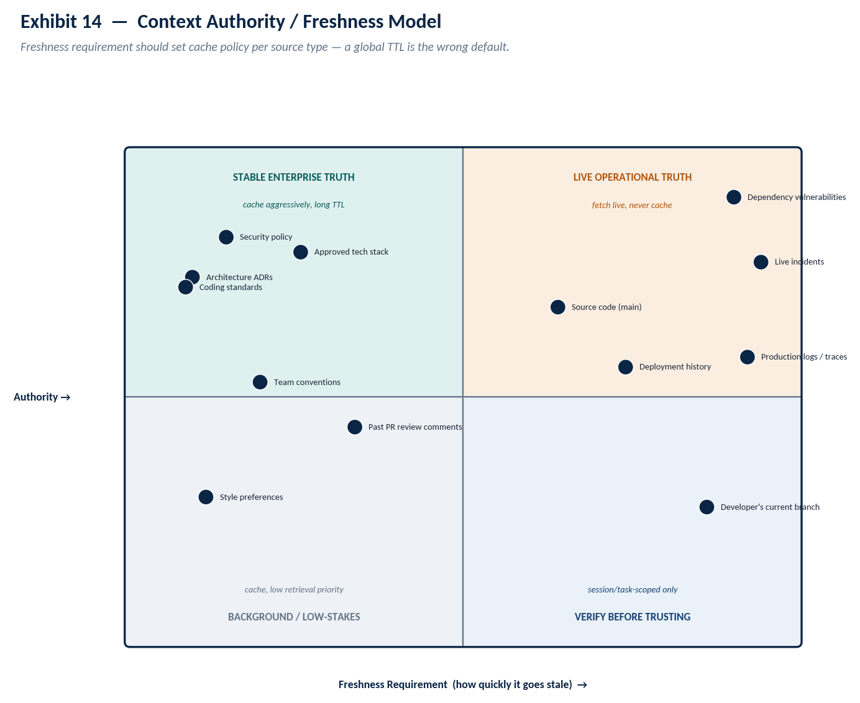
Exhibit 14 — plotting context types by authority and freshness requirement sets cache policy directly.

Engineering Knowledge Intelligence
Every organization has engineers who know, without consulting a document, which caching pattern survived last year's incident and which one caused it. That knowledge currently lives in senior engineers' heads, in code review comments, in postmortems nobody re-reads, and in pull requests that got quietly copied as a template three teams over. Engineering Knowledge Intelligence is the discipline of converting that tacit, distributed expertise into a codified, versioned, machine-retrievable form — distinct from Context Intelligence in one important respect: context is retrieved dynamically per task, while knowledge is curated once, deliberately, and reused many times.

Documentation is not executable knowledge
A wiki page describing “how we do caching” is written for a human to read, interpret, and apply with judgment. An engineering playbook consumable by this platform is scoped to a specific situation, versioned, tied to the evidence that justified it, and structured so the context orchestrator can retrieve and apply it directly — the difference between prose a person re-reads and a pattern a system re-uses. Converting the former into the latter is most of the actual engineering effort in this pillar; it is not a data-ingestion problem, it is an editorial and governance problem.
Five artifact types are worth distinguishing explicitly, because they get retrieved differently and reviewed by different people:
- Engineering playbooks — step-by-step guidance for a recurring situation (“add caching to a Java service”), owned by the domain team that wrote it.
- Architecture and implementation patterns — approved shapes for a class of problem, owned by the architecture function.
- Migration recipes — validated sequences for moving from a known legacy state to a known target state.
- Failure patterns and anti-patterns — what not to do, sourced directly from postmortems and rollback history — often the highest-value and most under-invested artifact type.
- Reusable agent skills — packaged, tool-callable capabilities the agent can invoke directly rather than reason its way to from first principles each time.
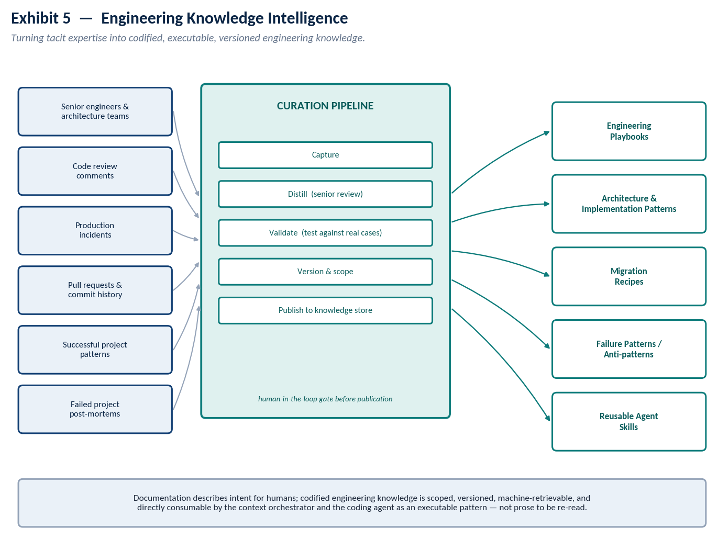
Exhibit 5 — converting tacit expertise into codified, versioned engineering knowledge, gated by human review.
The human-in-the-loop gate before publication is not a formality. A pattern that reaches the knowledge store is one the agent will apply with organizational authority behind it, repeatedly, without further review — the bar for entry should be higher than the bar for a merged pull request, not lower.

Organizational Workflow Intelligence
A coding agent that understands your architecture and has your playbooks available can still get the sequence of a task wrong — running a security assessment after the migration plan is already written, or skipping the approval gate a compliance team requires before code touching payment infrastructure ships. Workflow Intelligence teaches the platform how work actually happens inside this organization: not just what good output looks like, but what order it has to happen in and who or what has to sign off along the way.

Representation: graphs with typed nodes, not free-text runbooks
Of the representation options considered — workflow graphs, policy engines, deterministic pipelines, state machines, event-driven orchestration — the practical answer for most organizations is a graph or state machine where every node is typed as either deterministic or agent-driven, because that typing is the decision that actually matters operationally, more than the choice of graph engine itself.
- Deterministic nodes (dependency analysis, security scanning, architecture conformance checks, deployment gates) run the same way every time, are owned by a pipeline or policy engine, and are not subject to the agent's judgment.
- Agent-driven nodes (architecture discovery, target-state comparison, drafting the migration plan, generating code and tests) genuinely require reasoning over an ambiguous or novel situation, and are where the coding agent adds the most value.
- Human/governance gates are a third, explicit node type — not a special case of either of the above — because conflating “requires a human” with “requires determinism” is how approval steps silently disappear during platform refactors.
Exhibit 6 walks a concrete example — “modernize this service” — through nine steps and two governance gates, color-coded by node type. The specific sequence is illustrative; the typing discipline is the transferable part.
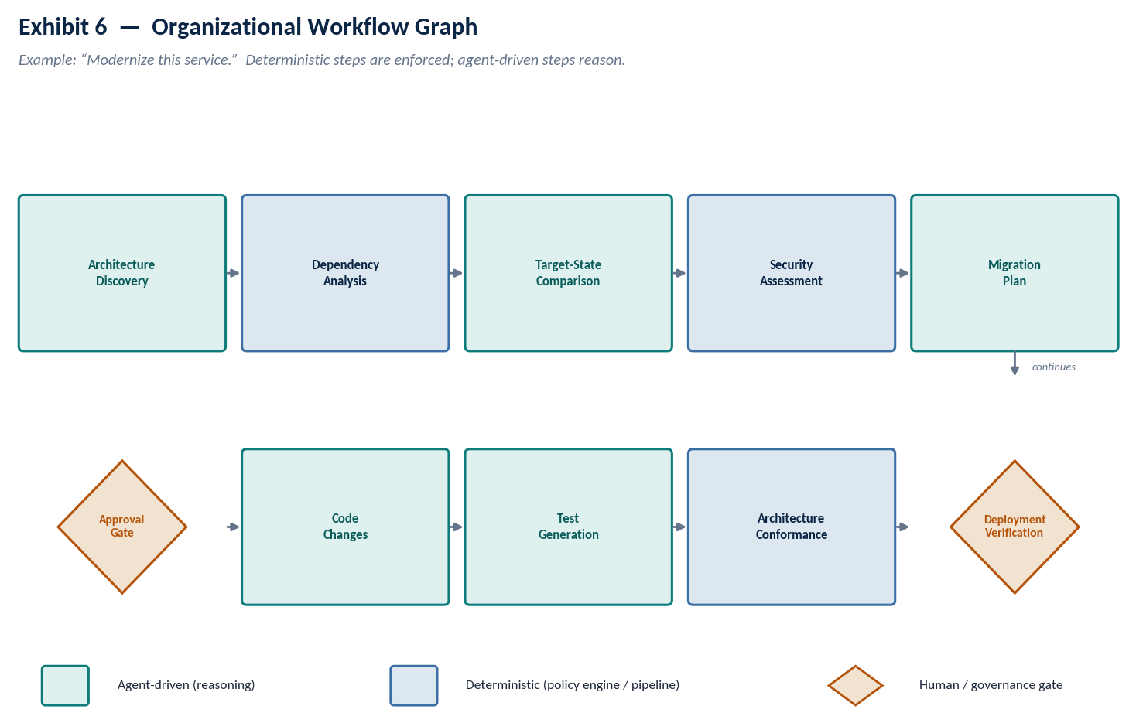
Exhibit 6 — the modernization workflow as a typed graph: deterministic, agent-driven, and human-gate nodes.
Two failure modes are common enough to call out directly. First, over-typing everything as deterministic produces a workflow so rigid that any task not anticipated at design time has no path through it — the platform becomes a form to fill out rather than an intelligence layer. Second, under-typing everything as agent-driven reintroduces exactly the inconsistency this pillar exists to remove, because “the agent used good judgment” is not an audit trail. The typed-graph discipline exists specifically to force that decision to be made once, explicitly, per workflow step, rather than implicitly, per task, by whichever engineer is running it that day.

Assurance: Continuous Verification and Observability
As argued in Section 5, verification and observability are two disciplines inside one domain rather than two pillars: verification produces evidence, observability makes that evidence — and the reasoning that led to it — inspectable after the fact. Neither is optional at scale. A platform that verifies without recording why it verified that way cannot be audited; a platform that records everything without gating on any of it is expensive logging, not assurance.

10.1 Continuous verification, not end-of-pipeline review
The operating principle is that AI-generated work continuously produces evidence as it is produced, not that it is reviewed once after the fact. Exhibit 7 shows this as a loop: generation is followed immediately by compilation and unit testing, security and dependency scanning, and architecture and policy conformance checking, each producing a structured evidence record before the change reaches a gate decision. A failing gate routes back to generation with the specific evidence attached, rather than a generic “request changes.”
Every step in the loop writes to the same evidence schema — claim, action, evidence, result, confidence — which is what makes the loop auditable rather than merely automated. “The agent said the tests pass” is a claim; “the agent ran `pytest`, captured 14/14 passing, and recorded a confidence of 0.98 based on coverage of the changed lines” is evidence. The platform should never accept the former as a substitute for the latter, regardless of how confident the agent's own narration sounds.
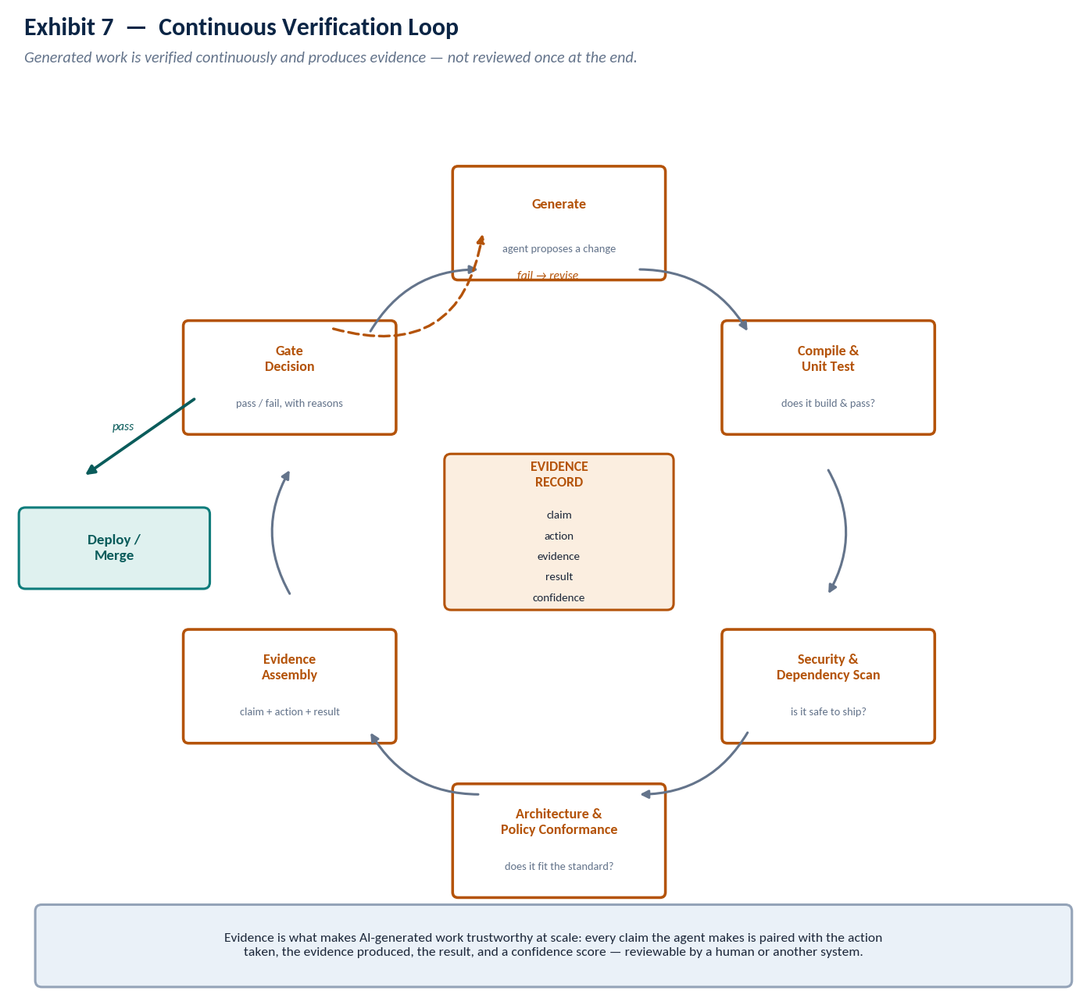
Exhibit 7 — the continuous verification loop and the evidence record every step writes to.

10.2 Observability: why, not just what
Traditional observability answers “what did the software do.” AI engineering observability has to answer a harder question — why did the agent decide this, on what context, under which enterprise policy, and what did it consider and reject — because the artifact under observation is a reasoning process, not a deterministic execution path. Seven trace types cover this: agent, context, tool, policy, verification, cost, and model traces, unified into one queryable timeline per task rather than seven disconnected logs a human has to correlate by hand.
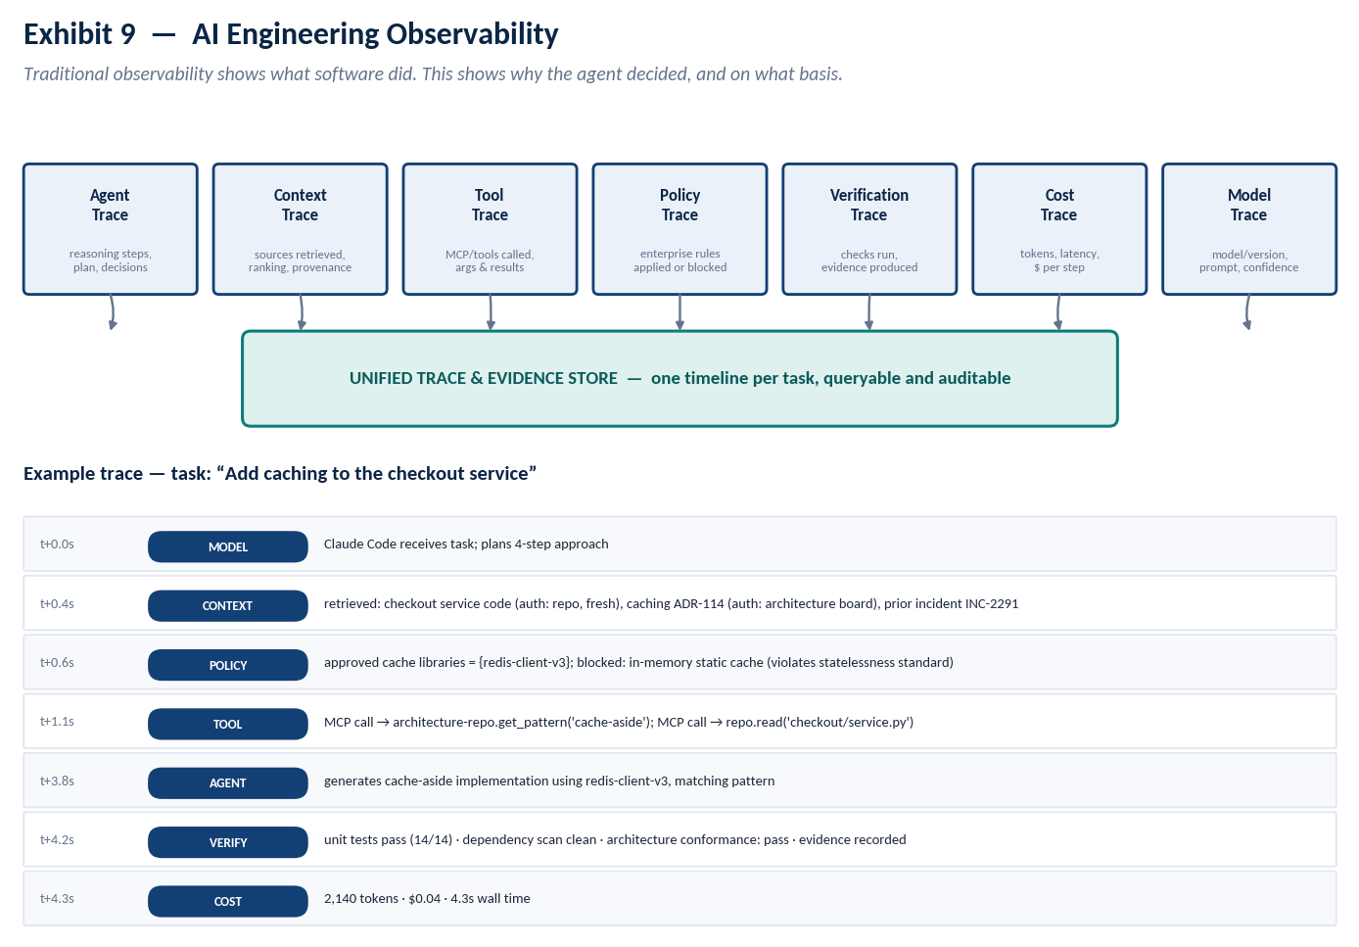
Exhibit 9 — the seven trace types and an example unified trace for a real task.
The example trace in Exhibit 9 is deliberately mundane — adding caching to a checkout service — because the value of this design shows up precisely in the unremarkable cases: a reviewer can see, in under a minute, which architecture pattern the agent matched against, which library was blocked and why, and what evidence backs the claim that the change is safe to merge. That review used to require re-deriving the agent's reasoning from the diff alone.
Evidence is what makes AI-generated work trustworthy at organizational scale. It is also what makes an incident review tractable six months later, when nobody remembers why a particular change was approved — the trace answers the question the memory of the room cannot.

Learning and Feedback: A Loop, Not a Store
Operational outcomes — PR acceptance and rejection, review comments, production incidents and rollbacks, test failures, security findings, developer corrections, architecture review outcomes, and performance regressions — are a rich signal about what the platform is getting right and wrong. The temptation is to let the system act on that signal automatically and continuously. The discipline this section argues for is the opposite: every signal passes through an explicit governance gate before it changes anything, and the gate asks four questions — is the signal statistically reliable rather than anecdotal, does it conflict with an existing enterprise standard, who must approve a change of this kind, and what is the smallest scope it should apply to.
Five learning types are worth distinguishing, because they are governed differently and four of them are squarely this platform's job while the fifth deliberately is not:
- Organizational learning — playbooks and patterns get updated (feeds Section 8).
- Context learning — authority and freshness scores get tuned (feeds Section 7.4).
- Workflow learning — process steps and gates get tuned (feeds Section 9).
- Retrieval learning — ranking weights get tuned (feeds the context orchestrator directly).
- Model learning — fine-tuning or otherwise adjusting the underlying model itself. This is explicitly out of the platform's scope and left to the model vendor relationship and a separate, explicit MLOps process. A platform that quietly retrains or reweights the model based on one team's feedback is making an organization-wide bet on a private signal, which is precisely the kind of ungoverned change Principle 6 (Section 4) exists to prevent.
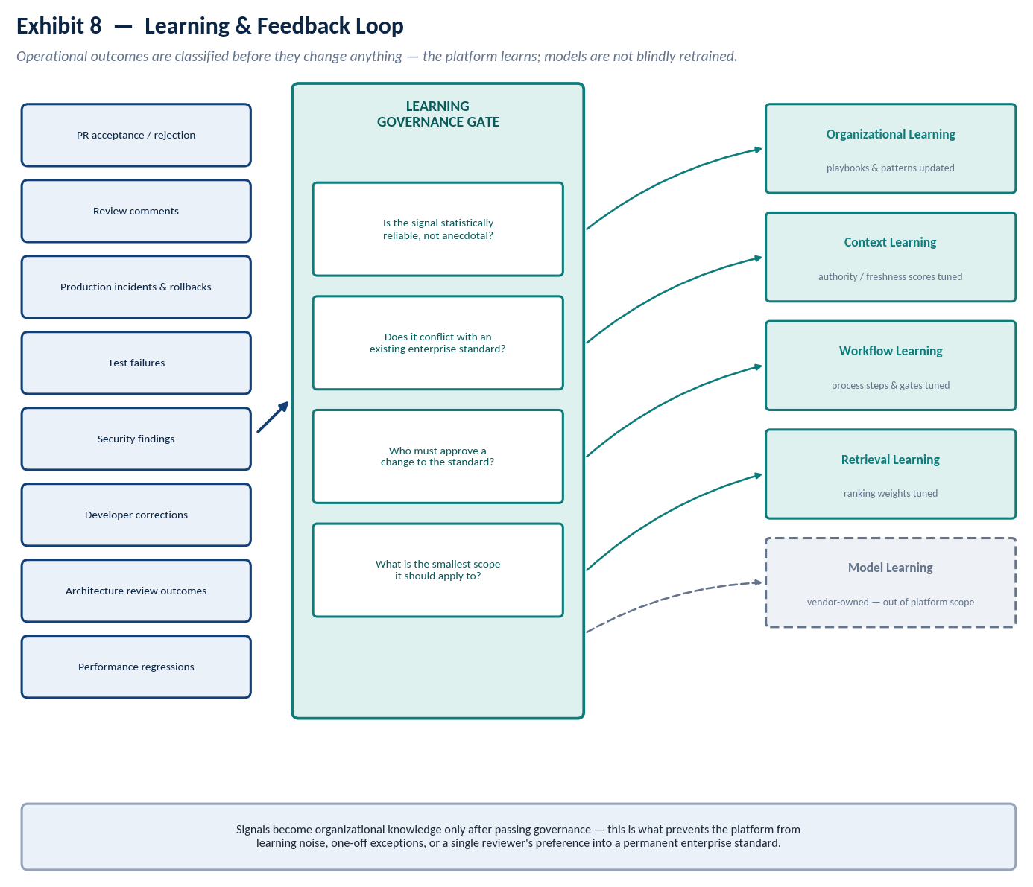
Exhibit 8 — feedback signals pass through governance before becoming organizational knowledge; model learning stays out of platform scope.
This is also the answer to “how does the platform improve without a model provider's cooperation”: it does not need one. Every one of the four in-scope learning types improves the intelligence layer this paper is actually about, and every one of them survives a model migration untouched — which is the point of Principle 8.

Platform Optimization — The Efficiency Substrate
Left unmanaged, every developer's agent session independently re-indexes the same repositories, re-embeds the same documents, and re-derives the same dependency graph — a cost that scales linearly with headcount for work that should scale roughly with the rate of change in the underlying systems. The fix is a shared substrate: code graphs, knowledge graphs, vector indices, and telemetry built once, incrementally updated on the underlying source's actual cadence, and consumed by every one of the four capability domains, not rebuilt per domain or per developer.
Not every piece of intelligence should live at the same scope, and getting this wrong in either direction is expensive — too global and a team's local conventions get silently overridden by an org-wide default; too narrow and every team pays to rediscover what three other teams already knew:
Scope | Example intelligence | Typical refresh cadence
Global (platform-wide) | Retrieval/ranking algorithms, generic code-graph parsers | With platform releases
Organization-wide | Architecture standards, security policy, approved libraries | Governed review cycle (Section 11)
Business-unit specific | Domain terminology, BU-specific compliance rules | Governed review cycle, BU-owned
Team-specific | Team conventions, ownership boundaries | As the team updates them
Repository-specific | Symbol index, dependency graph for that repo | Event-driven, on commit
Developer-specific | Current task context, formatting preferences | Session-to-session
Session-specific | In-flight conversation state, pending verification results | Ephemeral

This scoping table is also the practical answer to “what should be cached versus recomputed”: anything above team scope should be treated as durable and cached aggressively (subject to the freshness model in Section 7.5); anything at developer or session scope should be treated as disposable and never promoted into a shared store without passing through the same governance gate as any other learning signal.

The Role of MCP
The Model Context Protocol solves a real and previously unsolved problem — a standard way for an agent to discover tools, understand their capability contracts, and invoke them, without every enterprise and every agent vendor inventing a bespoke integration. It deserves to be treated seriously in this architecture. It also deserves to be scoped correctly, because the most common misreading of MCP inside enterprises is treating it as the platform rather than the transport the platform's capability services are exposed through.
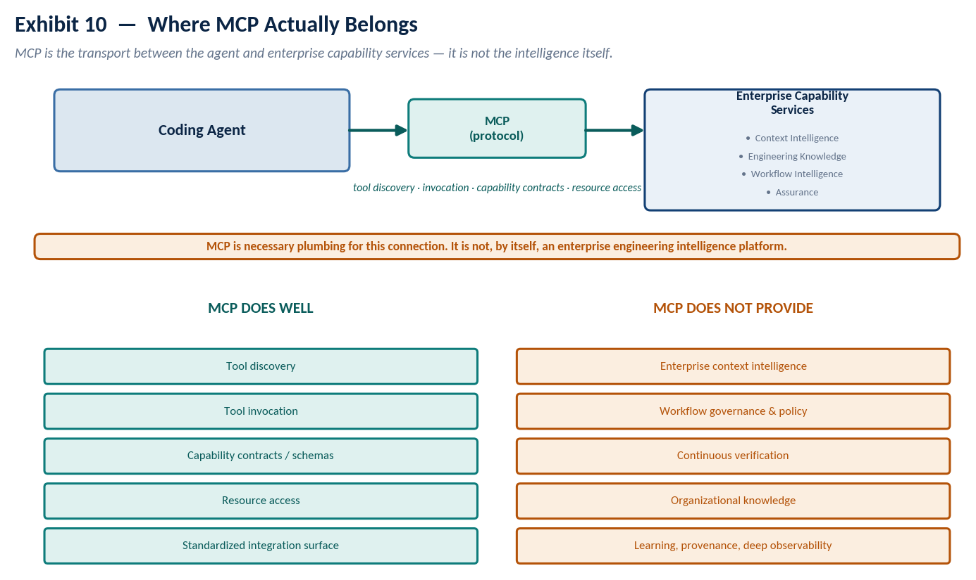
Exhibit 10 — MCP is the protocol between the agent and the enterprise capability services, not the intelligence layer itself.
Put directly: an organization can stand up a fleet of MCP servers exposing every internal API it has, and still possess none of the four capability domains described in this paper. Tool discovery is not context ranking. Resource access is not workflow governance. A capability contract is not an evidence record. MCP is necessary plumbing for the connection between the agent and the control plane — it is not, by itself, an argument that the control plane exists.

Not “Harness on Harness”: Data Plane and Control Plane
A fair objection to this entire paper is architectural: Claude Code and GitHub Copilot already behave like agent harnesses, managing their own reasoning, tool use, and file/terminal access. Why would an enterprise need a second harness wrapped around the first one? The objection is worth taking seriously, and the honest answer is that “harness” is the wrong word for what this paper proposes, not that the objection is mistaken about harnesses.
A harness governs a single reasoning-and-tool loop end to end. The enterprise layer described in this paper does not run a second, competing loop around the agent's own loop — it supplies inputs the agent's existing loop consumes (context, applicable policy) and checks the outputs that loop produces (verification, evidence). That is a different relationship than harness-inside-harness, and infrastructure architecture already has a well-understood term for it: a control plane does not re-execute a data plane's work, it schedules, configures, and observes it — the same relationship a Kubernetes control plane has to the pods it never directly runs code inside of.
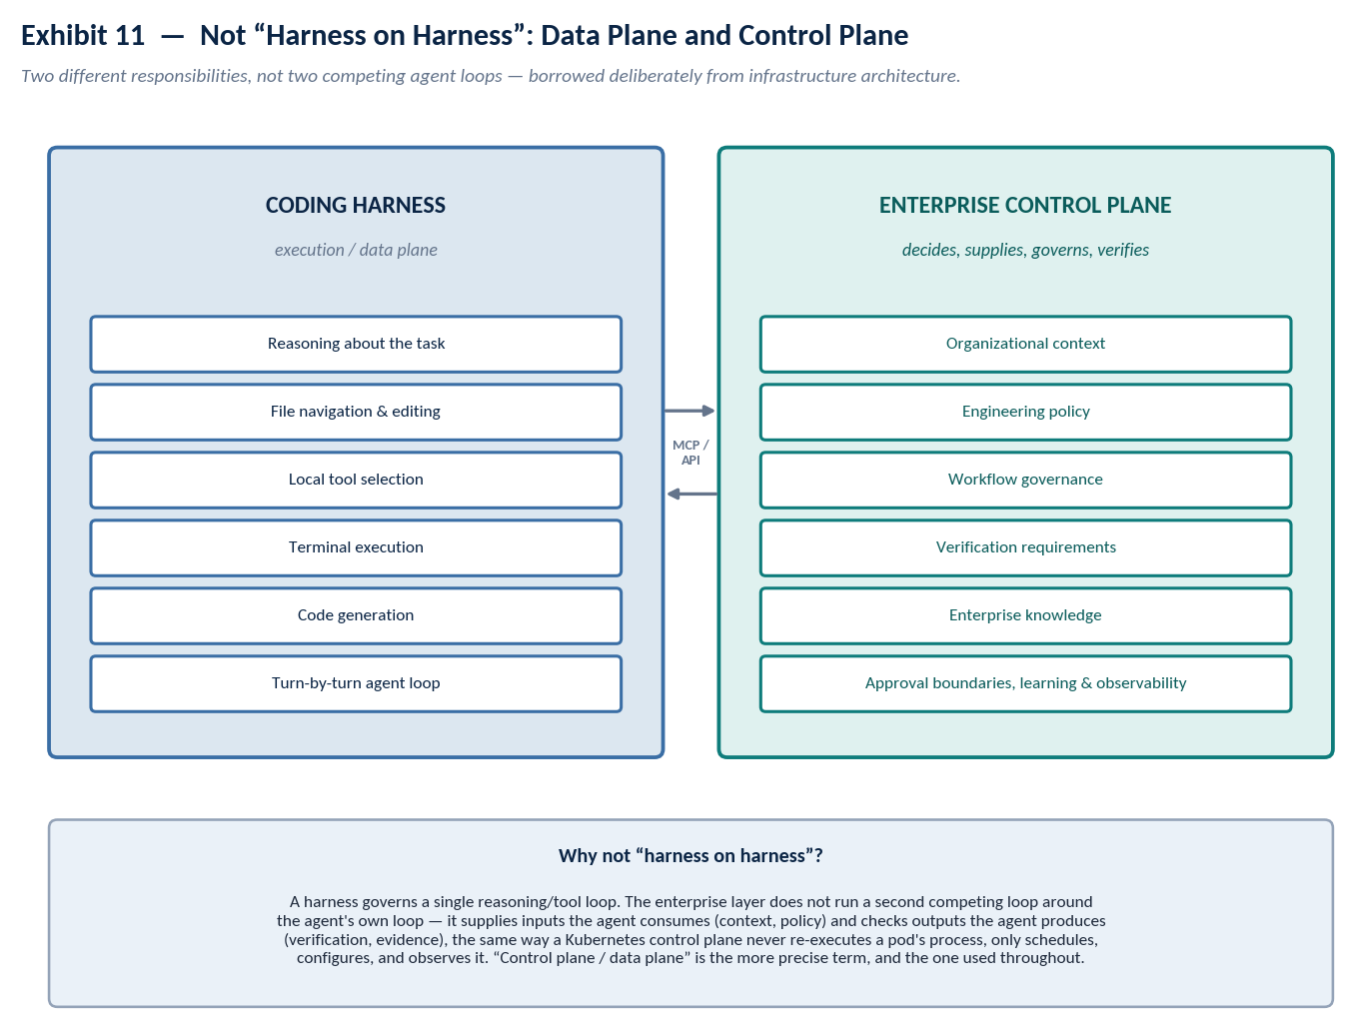
Exhibit 11 — the coding harness (data plane) and the enterprise engineering control plane, connected via MCP/API, not nested.
This is not merely a terminology preference. “Harness on harness” implies competing authority over the same reasoning loop, which is a genuinely bad architecture — two systems both trying to decide what the agent does next is a recipe for deadlock or silent override. “Control plane and data plane” implies exactly the division of responsibility this paper actually argues for: the agent decides how to accomplish a task; the platform decides what the agent is allowed to know, what it is allowed to do, and whether the result is good enough to ship. “Control plane / data plane” is the term used throughout the rest of this document.

End-to-End Example
A developer asks the coding agent to “modernize this legacy service to the company's current cloud-native architecture.” It is worth being concrete about what changes and what does not.

Generic agent, no control plane
A capable coding agent alone will read the repository, infer a reasonable target architecture from general knowledge of cloud-native patterns, and produce a plausible modernization. It has no way to know this organization's actual target-state architecture, which of several plausible approaches was already tried and rolled back eighteen months ago, which libraries are on the approved list, or which team's sign-off the change requires before it can ship. The output can be well-engineered and still wrong for this organization, in ways that only surface in review — or worse, in production.

Platform-enhanced
With the control plane in place, the same request triggers task-scoped context retrieval against the organization's own code graph, dependency graph, ADRs, and target-state architecture; a workflow lookup that sequences dependency analysis and a security assessment before the migration plan is drafted, with an approval gate before code changes ship; generation against a validated migration-recipe pattern rather than general knowledge; and a verification pass that produces evidence — test results, a security scan, and an architecture-conformance check — before the change is presented back to the developer. Exhibit 12 traces this as a twelve-step sequence across five participants.
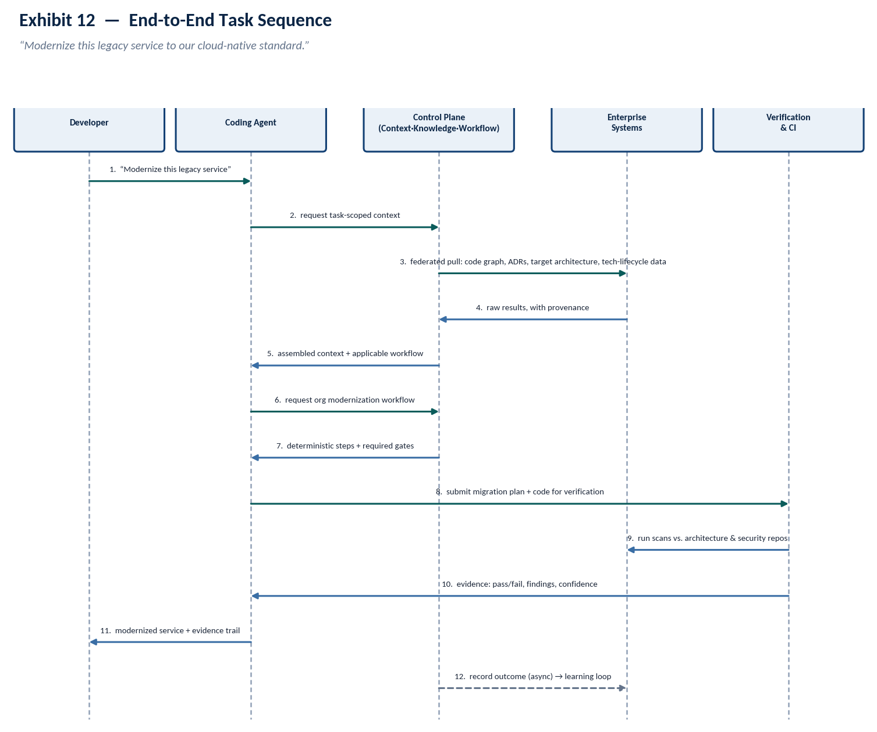
Exhibit 12 — the same request, traced end to end through context, workflow, and verification.
Dimension | Generic agent alone | Platform-enhanced
Architecture fit | Plausible, generic cloud-native pattern | Matches this org's actual target-state architecture
Awareness of prior attempts | None | Retrieves and avoids a previously rolled-back approach
Security posture | Best-effort from general knowledge | Checked against this org's approved libraries and policy
Evidence at handoff | A diff and the agent's own narration | Test results, scan output, conformance check, confidence score
Approval routing | Manual, developer-initiated | Workflow-enforced gate before merge

Comparative Analysis
Positioning this architecture against adjacent, better-known approaches is more useful than describing it in isolation. The rating scale is intentionally coarse — H (strong/native), P (partial or requires significant extension), N (not addressed) — because false precision on a comparison like this is itself misleading.
Approach | Context richness | Org knowledge | Workflow gov. | Verification | Learning | Model indep.
Traditional RAG | P | P | N | N | N | H
Enterprise search | P | P | N | N | N | H
GraphRAG | H | P | N | N | N | H
Knowledge graphs (standalone) | H | P | N | N | N | H
MCP-only architecture | N | N | N | N | N | H
Generic agent frameworks | P | N | P | N | N | H
Coding copilots, out of the box | P | N | N | P | N | N
Custom internal AI dev platforms | H | H | H | P | P | P
Prompt engineering platforms | N | N | N | N | N | H
Internal developer platforms (IDP) | P | P | H | P | N | H
Semantic layers | P | N | N | N | N | H
This paper's proposal | H | H | H | H | H | H

H = strong/native · P = partial, requires significant extension · N = not addressed by the approach as typically deployed. Ratings are directional, not a procurement scorecard — a specific vendor implementation of “generic agent framework” may score better on workflow governance than shown here if it has been heavily customized, at which point it has effectively become a custom internal platform.

Two rows deserve a specific comment. Custom internal AI developer platforms are the closest existing analog to what this paper proposes, and the honest reading of that row is that most of them arrive at partial workflow governance, partial verification, and partial model independence not because the architecture is wrong but because they were built incrementally, capability by capability, without the pillar-level framework in Section 5 — which is a large part of the motivation for writing that framework down explicitly. Coding copilots, out of the box, score N on model independence for the structural reason that they are the model — a fully agent-native platform cannot be independent of its own substrate, which is exactly why an enterprise's differentiated intelligence has to live one layer up.

What Becomes Commodity?
Any architecture proposal that does not name what it expects to lose value should be read skeptically. The following list is a genuine forecast, not a hedge, and it should be revisited at least annually.
Commoditizing over the next 2–5 years | Durable and organization-specific
Basic code generation and refactoring | This org's architecture decisions and the reasoning behind them
Basic single-corpus RAG | This org's incident history and what it actually taught
Generic agent loops and tool routing | A pattern library validated against this org's own failures
Generic prompt engineering | This org's workflow, sequencing, and approval structure
Basic multi-step planning | Cross-repo, cross-team dependency and ownership graphs
Basic MCP tool integration | A verified evidence trail tied to this org's compliance obligations
Single-repo understanding (symbol index, local call graph) | A ranking/authority model tuned on this org's actual source reliability, learned over years
Boilerplate test generation | Judgment about which of several valid architectures fits this org's constraints

A more skeptical reading is warranted for the left column even than presented above: cross-repo dependency graphing, for instance, is already trending toward a built-in agent capability in several 2026-era tools, and belongs closer to the boundary than the middle of the commoditizing list. The durable claim in this paper is deliberately not tied to any specific capability staying proprietary indefinitely — retrieval mechanics, ranking algorithms, and even workflow representations will likely commoditize on a similar timeline to everything else in the left column. What does not commoditize, because it cannot exist anywhere except inside this specific organization, is the accumulated data and the decisions made about it: which architecture was chosen and why, which pattern survived contact with production and which did not, which team owns what, and what evidence was required before the last five hundred changes of a given type were allowed to ship. That is the asset. The mechanisms in this paper are simply how it gets built, used, and kept current — the mechanisms themselves are expected to evolve, and should.

Where This Architecture Could Be Wrong
A thesis that only survives friendly questions has not been tested. This section takes the hardest objections seriously, including the one that undermines the paper's own recommendation.

“Isn't this too complex?”
Yes, if built as a single big-bang program before any of it has proven value. The phased roadmap in Section 21 exists specifically to prevent that: each phase has to justify its own cost against its own measured outcomes before the next one is funded, and a program that cannot show Phase 1 value should not be trusted to build Phase 4.

“Won't future agents just absorb most of this?”
Partially, and unevenly. The mechanics of Context Intelligence — retrieval, ranking, repository understanding — are the most exposed to this risk; frontier agents already ship increasingly sophisticated built-in memory and codebase understanding, and that trend should be assumed to continue. Engineering Knowledge, Workflow Intelligence, and Assurance are much less exposed, for a structural reason rather than a technical one: they require this organization's proprietary data and this organization's authority to enforce policy, and no model vendor is going to be granted either on an enterprise's behalf. The honest framing is that Context Intelligence is the pillar most likely to need renegotiating with the vendor roadmap over time, not the one to build the biggest custom investment against.

“Which capabilities should stay outside the model, permanently?”
Policy enforcement, approval boundaries, and anything that requires access to systems the model vendor is not — and should not be — trusted with. This is a governance boundary, not a capability gap; it does not shrink as models improve.

“Where does this architecture become a bottleneck?”
The Context Orchestrator and the verification gate are the two synchronous choke points in every request path. Both need an explicit latency budget and a defined degradation behavior — serve the best-available context under budget pressure rather than block the developer, and fail a gate closed only for the specific check categories where that is the correct default (security), not universally.

“How do we stop organizational knowledge from going stale?”
Versioned knowledge with a mandatory review cadence keyed to the source's own freshness half-life (τ, Section 7.4), and automatic authority decay for entries that go unreviewed past their cadence — a stale pattern should lose ranking priority before anyone notices it is wrong, not after.

“How do we stop context overload?”
The context budget in the orchestrator is a hard constraint, not a soft target, and compression is measured against information loss, not merely token count reduction — a compressed bundle that drops the one caveat that mattered is a failure even if it hits its token target.

“How do we stop policy from destroying developer productivity?”
Every deterministic gate publishes a false-positive rate as a first-class, visible metric. A gate that blocks more than it correctly catches gets demoted to advisory automatically, on a defined schedule — not silently bypassed by developers routing around it, which is the failure mode that actually erodes governance in practice.

“Can we actually measure whether any of this helps?”
That is the subject of Section 19 in full, and it is deliberately not treated as a footnote — a platform that cannot demonstrate its own value with the same evidentiary rigor it demands of the agent's output has no standing to demand that rigor in the first place.

The objection that actually weakens the paper's own recommendation
If a model vendor ships a durable, defensible enterprise-memory product that plugs directly into an organization's systems at a cost below what building this internally would take, the build case in this paper weakens substantially, and the right response is not to defend the architecture but to buy the substrate and build only the last-mile proprietary policy and knowledge layer on top of it. This should be re-evaluated explicitly at every roadmap phase gate in Section 21 — treating it as settled at the outset of the program is the single biggest way this thesis could age badly.

Measurement and Evaluation Framework
Metrics split into leading indicators, which move weekly and should drive iteration, and lagging indicators, which move quarterly and should drive funding decisions. A platform team that reports only leading indicators to its own leadership is marking its own homework.
Metric | What it captures
Time-to-first-correct-change | How long from task assignment to a change that passes verification on the first attempt
Developer acceptance rate | Share of agent-proposed changes a developer keeps without material rewrite
PR rework rate | Share of merged changes requiring a meaningful follow-up fix
Defect escape rate | Defects reaching production per change, before vs. after platform adoption (lagging)
Context retrieval precision | Share of retrieved context actually used or referenced in the final change (leading)
Context retrieval latency | Time from request to assembled, policy-checked context (leading)
Architecture compliance rate | Share of changes passing conformance checks without exception (leading)
Security finding reduction | Change in findings per release, before vs. after (lagging)
Agent task completion rate | Share of tasks completed without human takeover
Human intervention rate | Frequency and type of manual override of an agent decision
Token consumption per task | Cost efficiency of the context assembly, tracked against Section 7.4's cost term
Tool-call / MCP-call efficiency | Calls per completed task, a proxy for orchestration overhead
Mean time to repair (MTTR) | For incidents involving AI-generated code, before vs. after (lagging)
Developer trust (survey) | Whether developers report relying on the platform's output without independent re-verification

Developer trust deserves a specific caution: rising trust alongside a flat or worsening defect-escape rate is not a success story, it is a leading indicator of a future incident, and should be treated by platform leadership as more urgent than a trust score that is merely low.

Maturity Model
The original six-level model in the brief survives largely intact; the refinements here are naming precision and tying each level to the capability framework in Section 5 rather than to a generic description, so that “what level are we at” has a checkable answer instead of a subjective one.
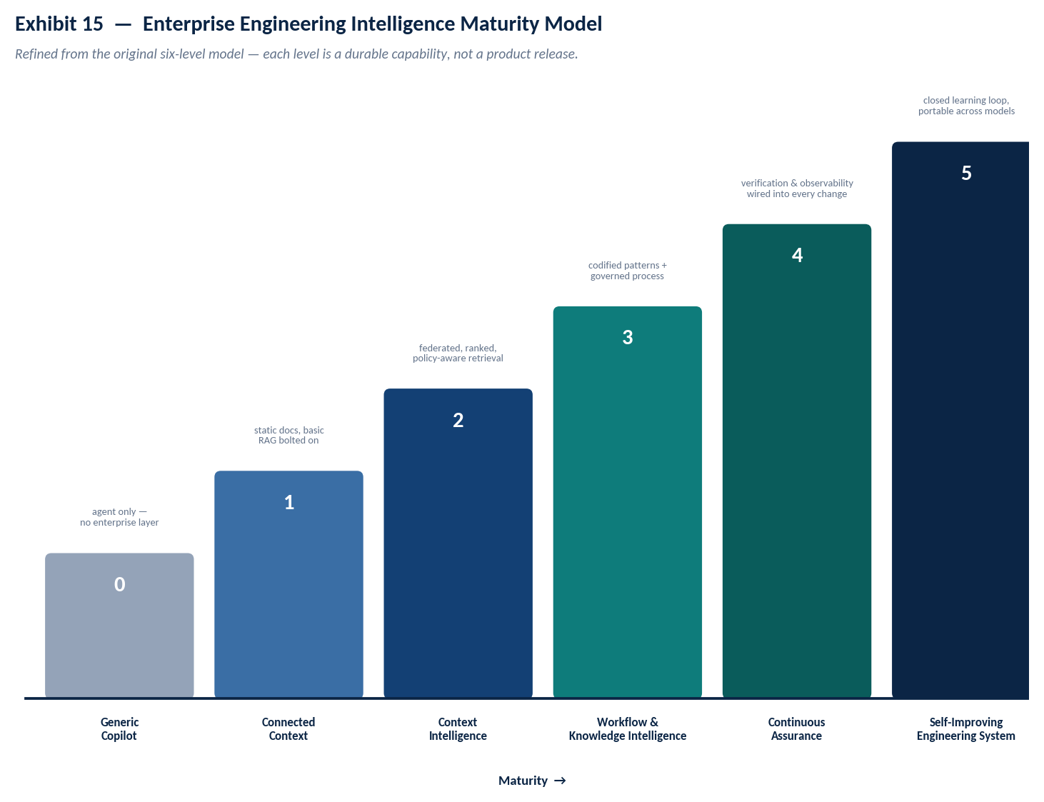
Exhibit 15 — six maturity levels, each a durable capability rather than a product milestone.
Level | Exit criterion to advance
0 — Generic Copilot | N/A — baseline
1 — Connected Context | Sources connected with provenance; no ranking or policy yet
2 — Context Intelligence | Retrieval precision and latency meet target (Section 19); policy filtering live
3 — Workflow & Knowledge Intelligence | At least one high-value workflow fully typed (Section 9) and one knowledge domain codified (Section 8)
4 — Continuous Assurance | Evidence model live on all changes in at least one critical service; gate false-positive rate tracked
5 — Self-Improving Engineering System | Learning loop operating with governance gate; four in-scope learning types demonstrably updating stores

Implementation Roadmap
The roadmap is state-based rather than date-based: a phase advances when its exit evidence exists, not on a calendar, and a phase is not started before the one before it is actually load-bearing in production use. This is a deliberate departure from a fixed-quarter roadmap, because the single most common cause of enterprise AI-platform failure observed across the industry is advancing to “learning and observability” while “context intelligence” is still returning low-precision results nobody trusts.
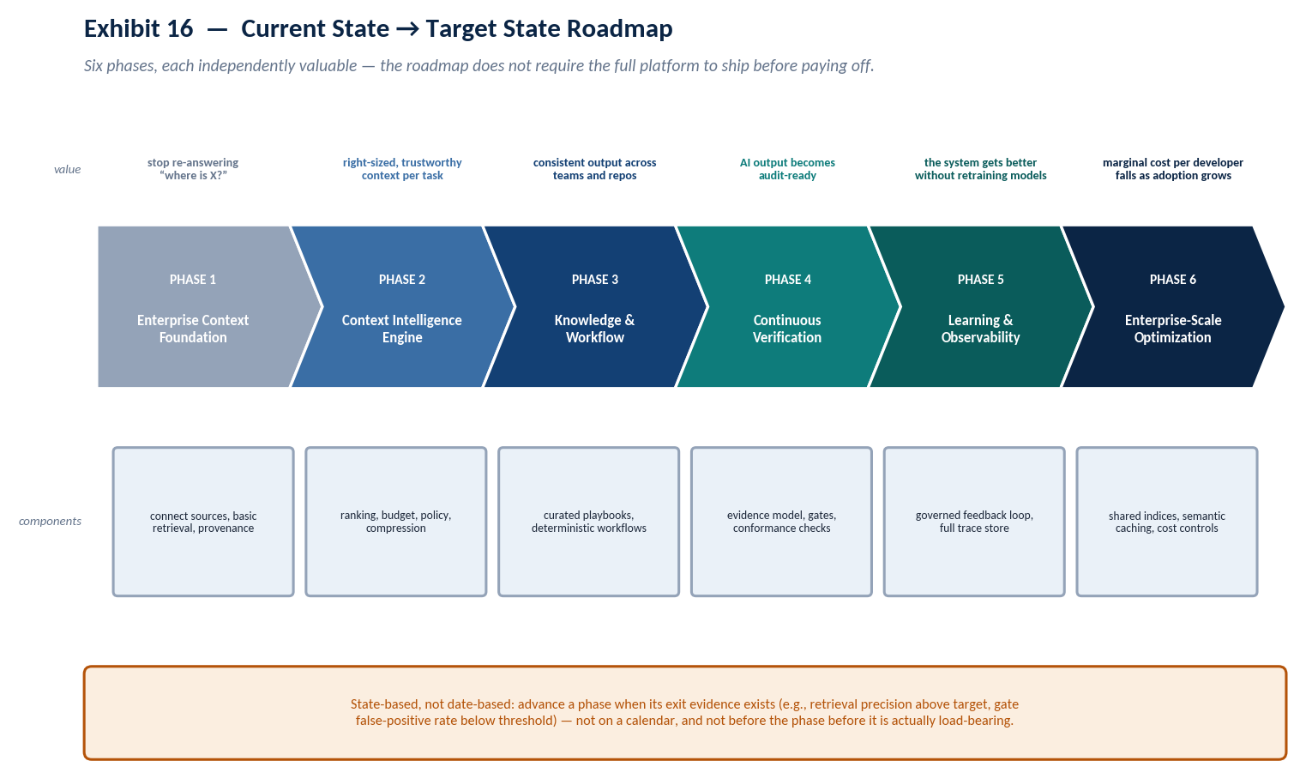
Exhibit 16 — six phases, each independently valuable, gated on evidence rather than the calendar.
Phase | Primary risk | Mitigation
1 — Context foundation | Connecting everything, ranking nothing — a firehose, not intelligence | Ship retrieval with explicit authority tagging from day one, even if coarse
2 — Context Intelligence Engine | Over-engineering the orchestrator before real usage data exists | Start with the simplest ranking model that satisfies Section 7.4; tune from measured precision, not intuition
3 — Knowledge & Workflow | Codifying knowledge nobody asked for, or typing workflows too rigidly | Start from the highest-friction real workflow, not the most impressive one
4 — Continuous Verification | Gates with high false-positive rates get silently bypassed | Publish false-positive rate per gate from week one (Section 18)
5 — Learning & Observability | Learning loop applies noisy signal at organizational scope | Governance gate is mandatory before this phase starts, not added after an incident
6 — Enterprise-scale optimization | Optimizing cost before the platform has proven value worth optimizing | Sequence last, deliberately — this phase pays for itself only once adoption is real

Strategic Conclusion
Every claim in this paper collapses to one operating decision: when the coding agent underneath the platform is replaced — and it will be, more than once — does the organization lose anything that mattered? If the answer is yes, the platform was built around the model rather than around the organization, and the investment amortizes over one model generation instead of many. If the answer is no, because the context, the codified knowledge, the workflow logic, and the evidence trail all live in a control plane the agent merely calls into, the investment compounds instead of depreciating.
That is the actual test to apply to every future build-versus-buy decision this platform will face, more useful in practice than any individual principle in Section 4: not “can the agent do this today,” which is a fast-moving and largely unwinnable question to compete on, but “will we still own something valuable here after the agent underneath us has changed twice.”
The agent is rented. The intelligence around it is owned. Build the second thing.

