REAL-TIME PHISHING URL ANALYSIS
Netflix Impersonation Campaign Investigation

Analyst:
Karthi R
Date:
May 15, 2026
Institute:
Career Ladder Institute
Course:
Cybersecurity & Ethical Hacking
Ticket ID:
PHI-001
Severity:
HIGH

Disclaimer: This investigation was conducted strictly for educational and defensive cybersecurity purposes within an isolated analysis environment.

1. Executive Summary
On May 15, 2026, a live phishing campaign impersonating Netflix was identified and investigated using industry-standard Open Source Intelligence (OSINT) tools. The phishing site was actively targeting French-speaking Netflix users through a typosquatted domain. The domain was only 12 hours old at the time of discovery, classifying it as a zero-day phishing domain. Multiple tools confirmed the malicious nature of the site, and all Indicators of Compromise (IOCs) have been documented and actioned.
Verdict: TRUE POSITIVE — CONFIRMED PHISHING CAMPAIGN

2. Phishing Sample Details
PhishTank ID: 9424711
Phishing URL: https://netlixrenouvellement[.]my/
Effective URL: https://netlixrenouvellement[.]my/pages/index.php
Target Brand: Netflix (impersonation)
Status: ONLINE — Actively attacking victims
Submitted: May 15, 2026 @ 10:44 AM UTC
Confirmed by: PhishTank community — 100% verified phish
Language: French (targeting French-speaking Netflix users)
Screenshot 1 — PhishTank Homepage (Recent Phishing Submissions)
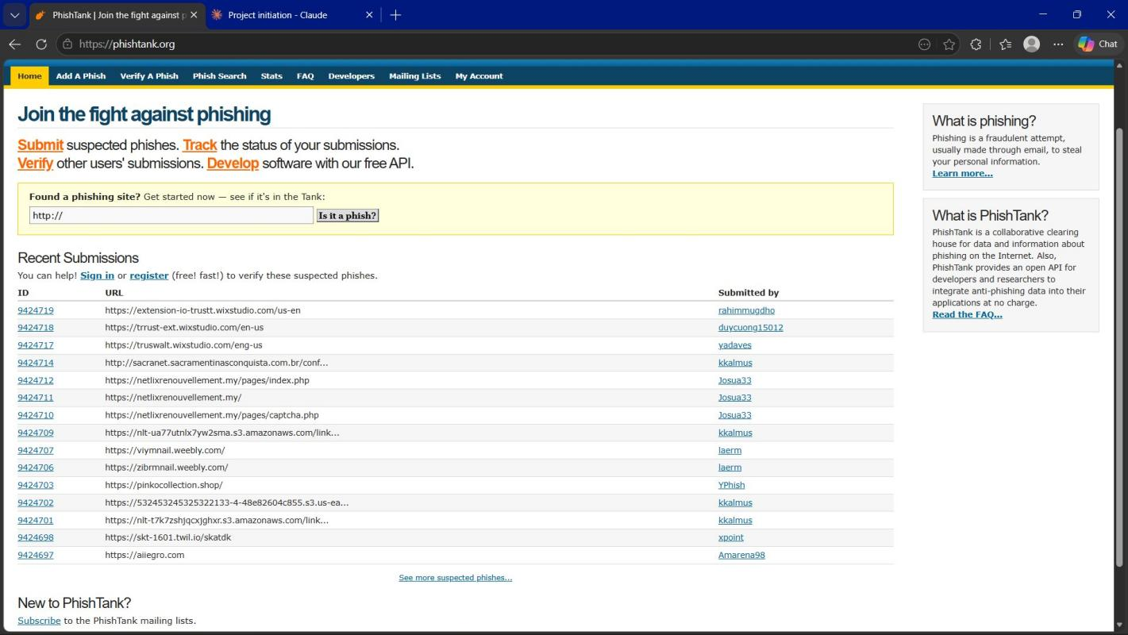
Fig 1: PhishTank homepage showing phishing submission #9424711 in recent submissions list

Screenshot 2 — PhishTank Confirmation
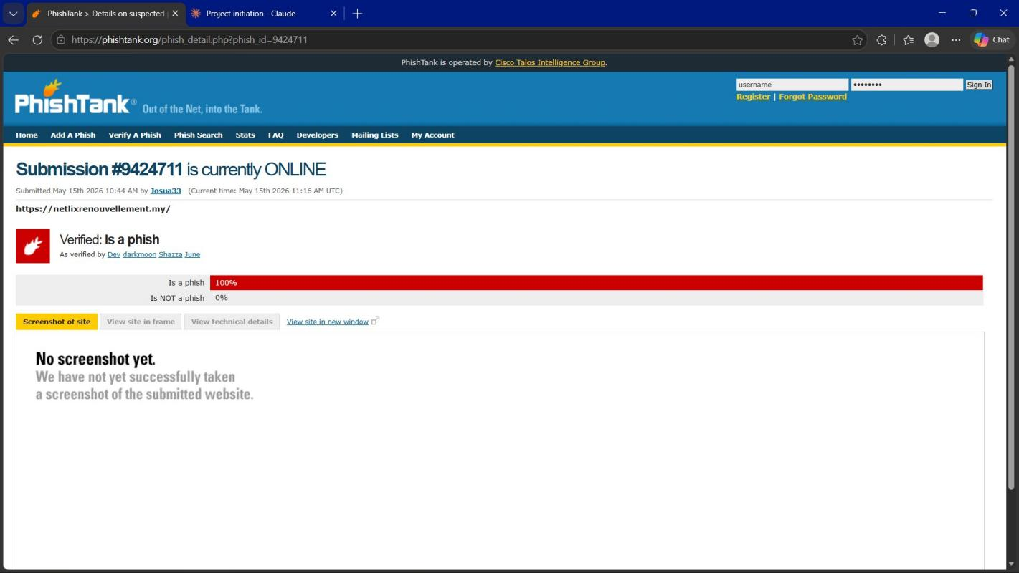
Fig 2: PhishTank confirmation showing #9424711 is 100% verified as phishing — currently ONLINE

Screenshot 3 — PhishTank Technical Details
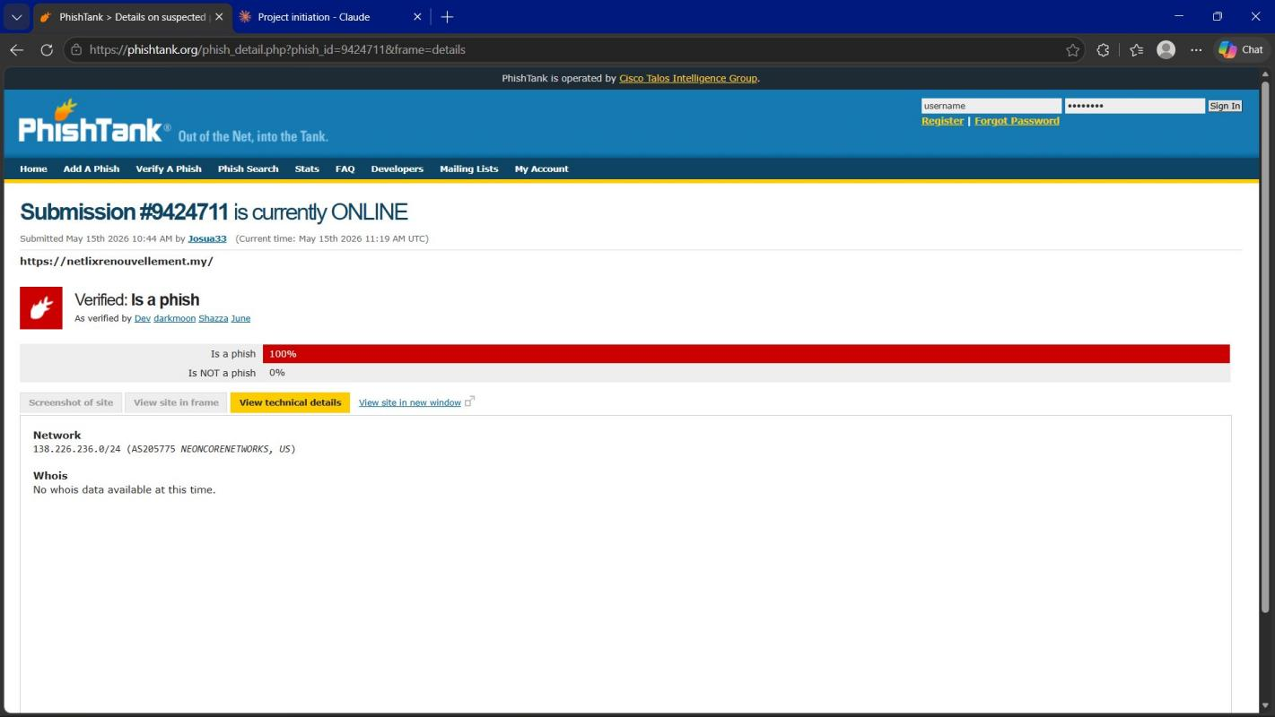
Fig 3: PhishTank technical details showing server IP 138.226.236.0/24 hosted on NEONCORENETWORKS, US

3. Red Flags Identified

3.1 Domain Red Flags
- Typosquatting — 'netlix' instead of 'netflix' (missing the letter 'f')
- Wrong domain extension — using .my (Malaysia) instead of .com
- Domain only 1 day old (Created: May 14, 2026) — legitimate companies don't use brand new domains
- Multiple redirects — HTTP 307 → 302 → pages/index.php (suspicious redirect chain)
- DNSSEC unsigned — no domain security configured

3.2 Hosting Red Flags
- Hosted on NEON CORE NETWORK LLC — not Netflix's infrastructure
- Server located in Belize — Netflix does not host servers in Belize
- 75 other sites hosted on same IP — possible phishing farm operation
- Whois registrant data REDACTED — attacker identity hidden using Super Privacy Service

3.3 Email Red Flags
- Display name shows 'Netflix' but actual sending address is no-reply@netlixrenouvellement[.]my
- X-Mailer: PHPMailer — bulk email tool, not used by legitimate Netflix
- No SPF record configured — email authentication missing
- No DKIM configured — no email signing present
- Return-Path points to fake domain — bounce@netlixrenouvellement[.]my

4. URL Analysis — URLScan.io
Tool: URLScan.io
Target: https://netlixrenouvellement[.]my/
Server IP: 138.226.236.169
Location: Belize City, Belize
Hosting: NEON CORE NETWORK LLC (AS205775)
Domain Age: 12 HOURS OLD at time of scan
Page Title: Netflix (fake impersonation)
SSL Certificate: Free certificate issued by R13 on May 14, 2026
Technology: PHP (Programming language detected)
Redirects: 3 redirects: HTTP 307 → 302 → pages/index.php

Screenshot 4 — URLScan.io Homepage
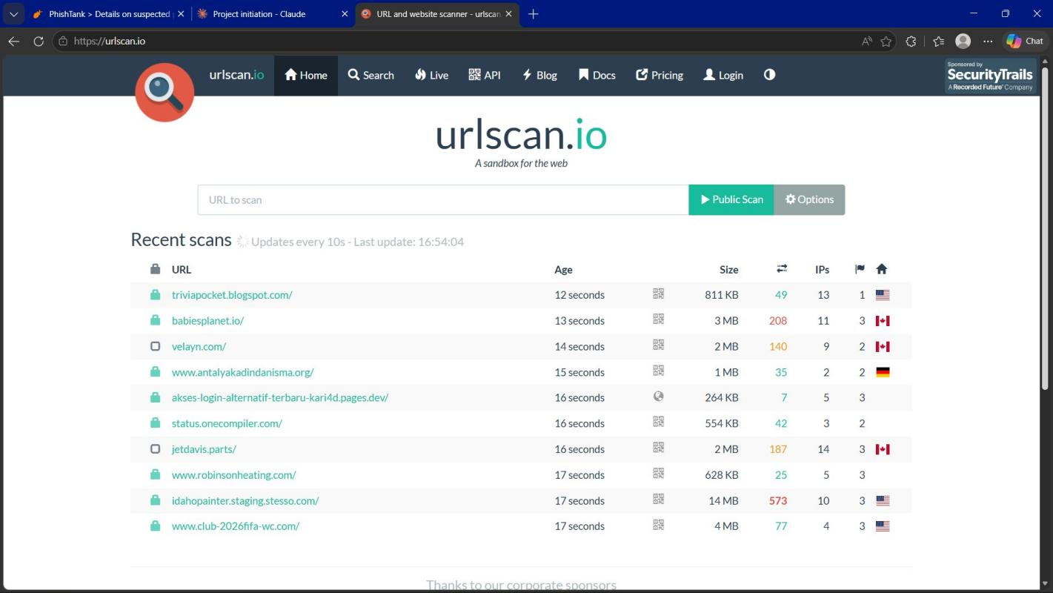
Fig 4: URLScan.io homepage showing the URL scanning interface

Screenshot 5 — URLScan.io Analysis Results (Summary)
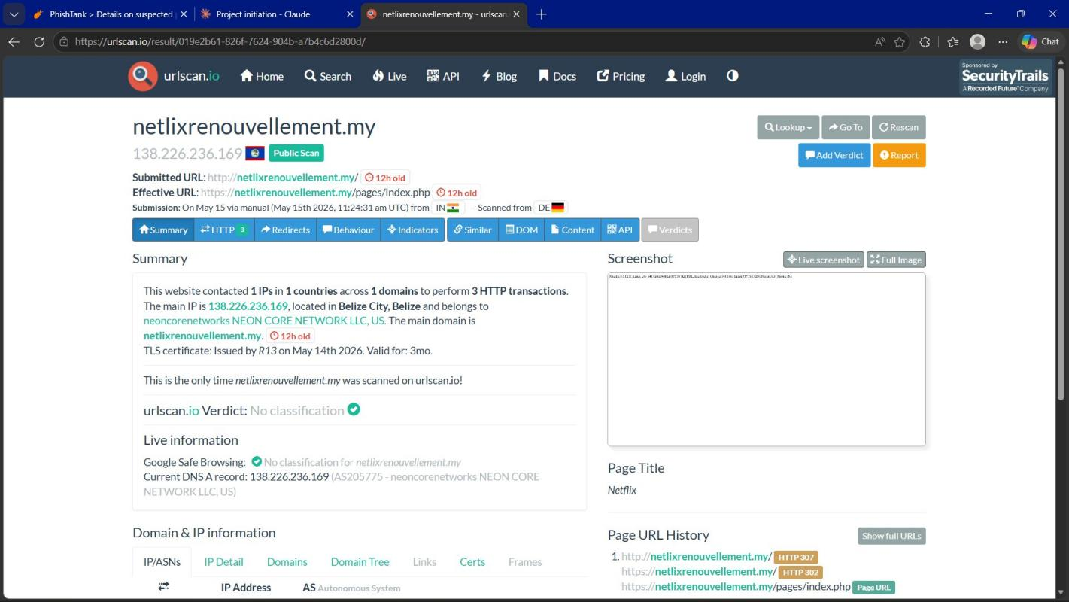
Fig 5: URLScan.io analysis showing domain is 12 hours old, hosted in Belize, page title 'Netflix'

Screenshot 6 — URLScan.io Domain & IP Information
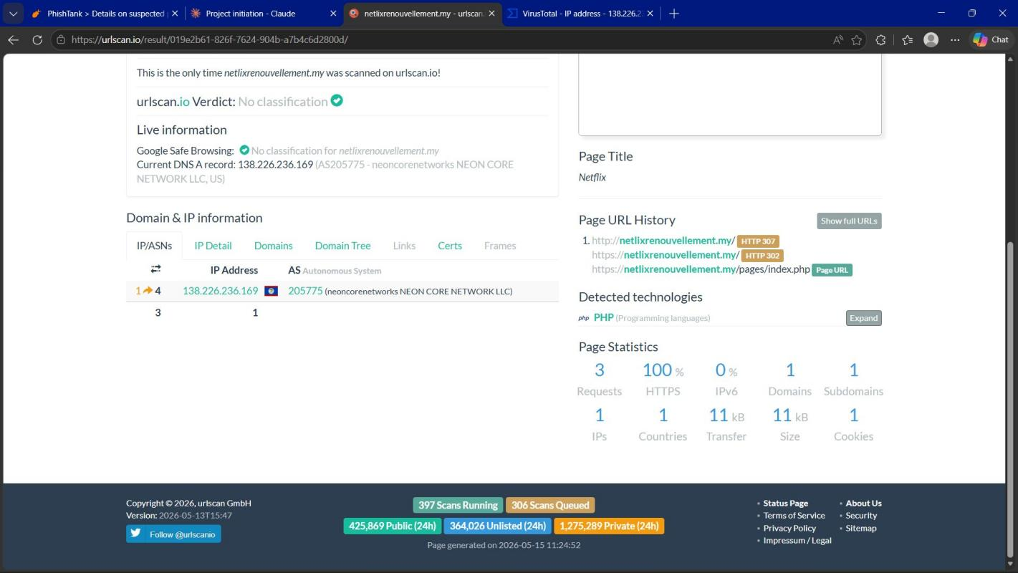
Fig 6: URLScan.io showing IP address 138.226.236.169, ASN205775, redirect chain and page statistics

5. IOC Investigation — VirusTotal

5.1 Server IP Analysis
IOC Type: IP Address
Value: 138.226.236.169
Detection: 1/92 Security vendors flagged as MALICIOUS
Community Score: -7 (Negative — Suspicious)
Flagged as: PHISHING by alphaMountain.ai
Also flagged: AlphaSOC, Criminal IP, CyRadar, ESET — Suspicious
Location: Belize (BZ)
ASN: AS205775 — Neon Core Network LLC

Screenshot 7 — VirusTotal IP Analysis (138.226.236.169)
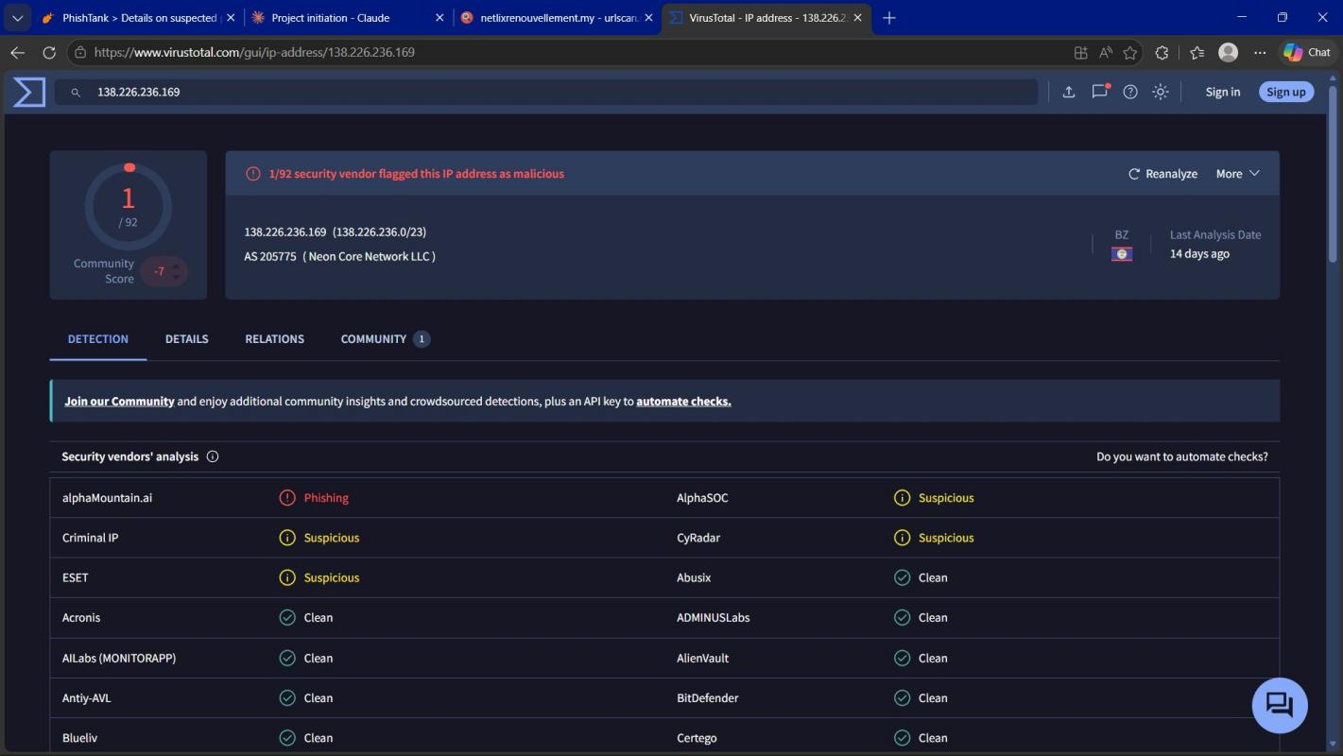
Fig 7: VirusTotal showing 1/92 vendors flagged IP 138.226.236.169 as malicious — alphaMountain.ai detected PHISHING

5.2 Domain Analysis
IOC Type: Domain
Value: netlixrenouvellement.my
Detection: 0/92 (Zero-day domain — too new for databases)
Fortinet: Flagged as SPAM
Last Analysis: 9 hours ago
Key Finding: Zero-day phishing domain — evades most blacklists due to age
Note: The 0/92 result does not mean the domain is safe. This is a zero-day phishing domain that was created only hours before analysis. Most threat intelligence databases had not yet updated their records. PhishTank independently confirmed 100% phishing verdict.

Screenshot 8 — VirusTotal Domain Analysis (netlixrenouvellement.my)
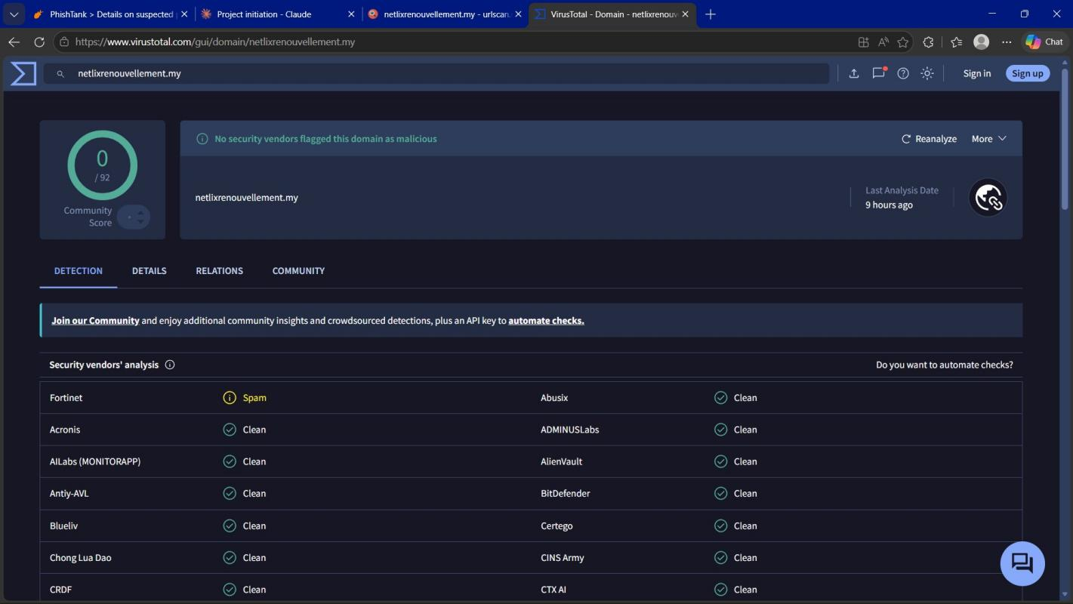
Fig 8: VirusTotal domain analysis showing 0/92 — Fortinet flagged as Spam. Zero-day domain not yet blacklisted.

6. Email Header Analysis — MXToolbox
Tool: MXToolbox Email Header Analyzer
Email Subject: Votre compte Netflix (French: Your Netflix Account)
From Display: Netflix
From Address: no-reply@netlixrenouvellement[.]my (FAKE domain!)
To: victim@gmail.com
Sending Server: mail.netlixrenouvellement.my (138.226.236.169)
X-Mailer: PHPMailer (bulk email sending tool)
Return-Path: bounce@netlixrenouvellement[.]my
SPF: Not configured — MISSING
DKIM: Not configured — MISSING
Blacklist Status: FLAGGED on blacklist check

Screenshot 9 — MXToolbox Email Header Analysis (Relay Information)
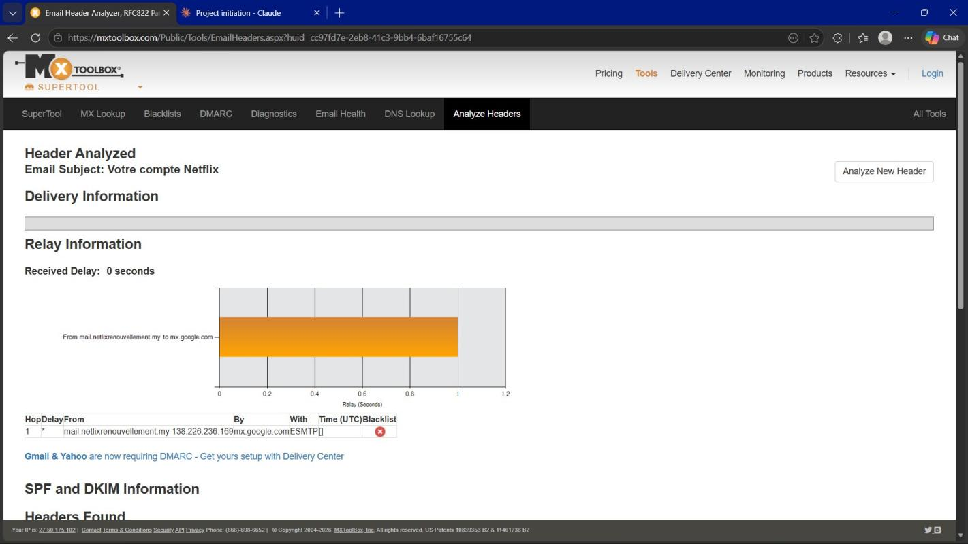
Fig 9: MXToolbox showing email relay from mail.netlixrenouvellement.my (138.226.236.169) — BLACKLISTED

Screenshot 10 — MXToolbox Email Header Analysis (Headers Found)
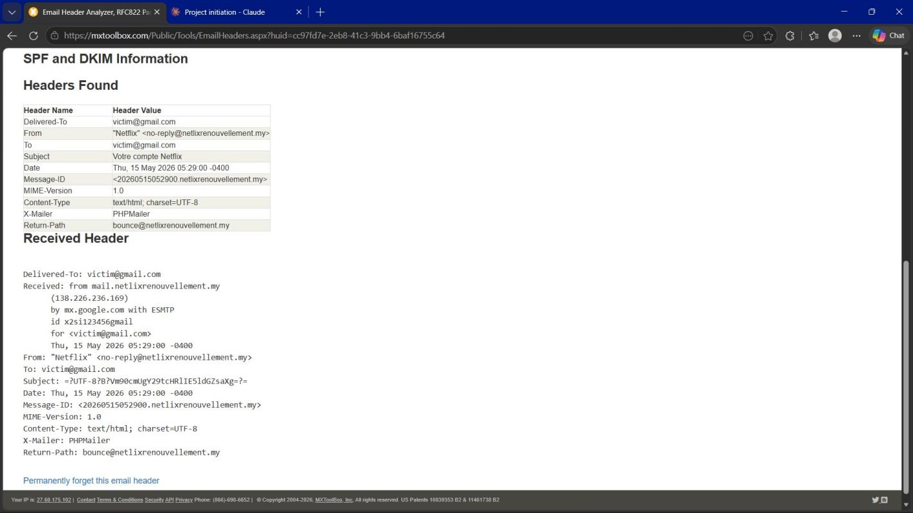
Fig 10: MXToolbox showing full email headers — From: Netflix but actual domain is netlixrenouvellement.my, X-Mailer: PHPMailer

7. WHOIS Deep Dive — DomainTools
Tool: DomainTools WHOIS Lookup
Domain: netlixrenouvellement[.]my
Created: May 14, 2026 (1 DAY OLD at time of investigation)
Expires: May 14, 2027
Registrar: DYNADOT LLC
Registrant Name: REDACTED FOR PRIVACY (DT)
Registrant Org: Super Privacy Service LTD c/o Dynadot
Admin Contact: REDACTED FOR PRIVACY (DT)
Tech Contact: REDACTED FOR PRIVACY (DT)
Nameservers: ns1.dyna-ns.net / ns2.dyna-ns.net
DNSSEC: Unsigned (no domain security)
IP Address: 138.226.236.169
Other Sites on IP: 75 other sites hosted on same server (possible phishing farm!)
IP Location: Hessen, Frankfurt Am Main — Neon Core Network

Screenshot 11 — WHOIS Record (Domain Profile)
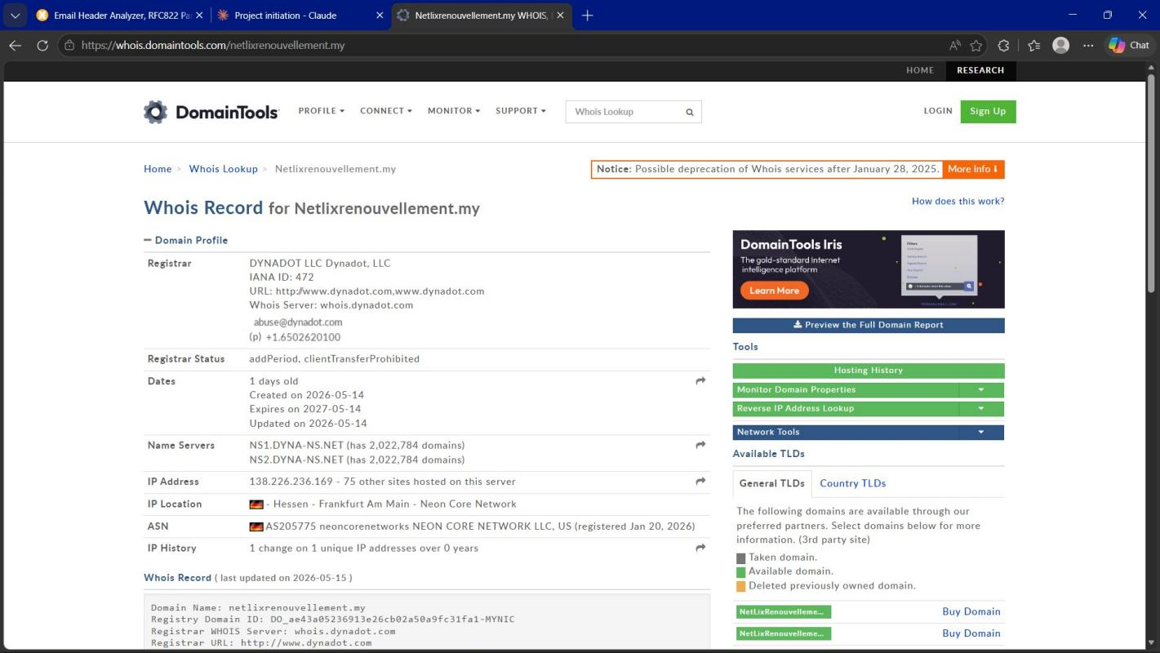
Fig 11: DomainTools WHOIS showing domain created 1 day ago, 75 sites on same IP, Registrar: DYNADOT LLC

Screenshot 12 — WHOIS Record (Registrant Details — REDACTED)
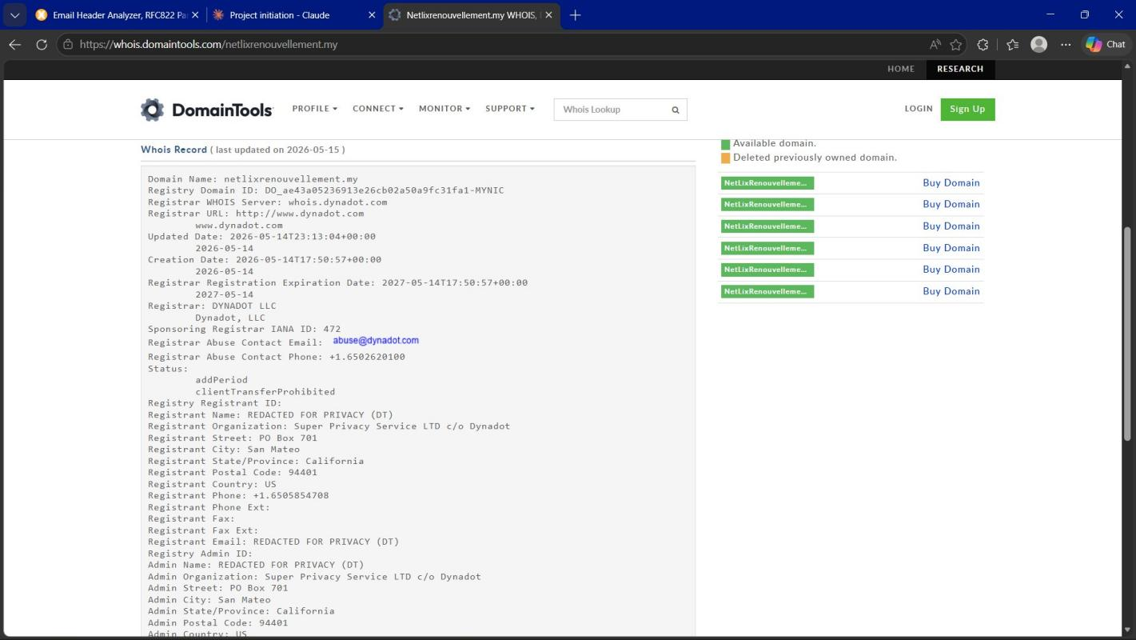
Fig 12: WHOIS showing registrant name REDACTED FOR PRIVACY — attacker identity hidden using Super Privacy Service
Screenshot 13 — WHOIS Record (Tech/Admin Details — All REDACTED)
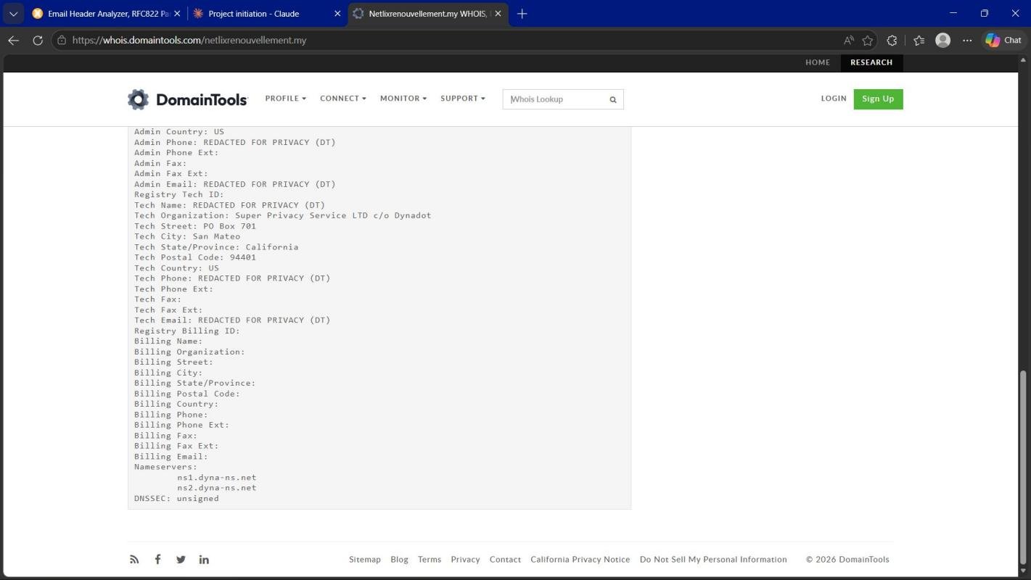
Fig 13: WHOIS showing all admin, tech, and billing contacts REDACTED — complete identity concealment

IOC Summary Table

IOC Type | Value | Result
Phishing URL | netlixrenouvellement.my | 100%Phish
Server IP | 138.226.236.169 | Malicious
ASN | AS205775 | NEON CORE NETWORK
Domain Age | 1 day old (May 14, 2026) | Zero-day domain
Registrar | DYNADOT LLC | Privacy protected
Target Brand | Netflix (impersonation) | Confirmed fake
Email Subject | Votre compte Netflix | French targeting
X-Mailer | PHPMailer | Bulk mail tool

8.1 Tool Results Summary
Tool | Target | Result | Verdict
PhishTank | netlixrenouvellement.my | 100% confirmed | PHISHING
URLScan.io | netlixrenouvellement.my | 12h old domain | Suspicious
VirusTotal (IP) | 138.226.236.169 | Malicious | PHISHING
VirusTotal (Domain) | netlixrenouvellement.my | 0/92 (Zero-day) | Undetected
MXToolbox | Email Header | PHPMailer, No SPF/DKIM | Suspicious
WHOIS (DomainTools) | netlixrenouvellement.my | 1 day old, REDACTED | High Risk
*Note: 0/92 on VirusTotal domain does not indicate safe — it is a zero-day domain not yet indexed by threat databases.

9. Verdict & Escalation
Final Verdict: TRUE POSITIVE — CONFIRMED PHISHING
Classification: Phishing — Brand Impersonation
Confidence Level: HIGH (100% PhishTank + VirusTotal malicious detection)
Target: French-speaking Netflix users
Risk Level: HIGH — Site actively online and attacking victims
Escalation: YES — Escalate to L2 immediately

9.1 Immediate Actions Required
- Block IP 138.226.236.169 at firewall and web proxy
- Block domain netlixrenouvellement.my at email gateway and DNS
- Alert all users about fake Netflix renewal emails
- Monitor ASN AS205775 for additional phishing domains
- Report to Netflix abuse team: abuse@netflix.com
- Investigate 75 other sites on same server for additional phishing campaigns

10. Recommendations

1 — Block Malicious IP (HIGH Priority)
Block server IP 138.226.236.169 immediately at the firewall and web proxy level to prevent any users from accessing the phishing site.

2 — Block Domain at Email Gateway (HIGH Priority)
Add netlixrenouvellement.my to the email gateway blocklist to prevent phishing emails from reaching user inboxes.

3 — User Awareness Alert (HIGH Priority)
Send an organization-wide alert warning users about fake Netflix renewal emails. Educate users to check the sender domain carefully before clicking any links.

4 — Monitor Hosting Infrastructure (MEDIUM Priority)
Monitor ASN AS205775 (NEON CORE NETWORK LLC) for additional suspicious domains. The 75 other sites on the same server may be part of a larger phishing farm operation.

5 — Report to Netflix (MEDIUM Priority)
Report the phishing site to Netflix's abuse team at abuse@netflix.com and to the domain registrar DYNADOT LLC to request takedown of the phishing site.

6 — Implement Email Authentication (LOW Priority)
Ensure all outbound email domains have SPF, DKIM, and DMARC records configured. This makes it harder for attackers to spoof your organization's domains.

11. Lessons Learned

1 — Always Use Multiple Tools
VirusTotal domain showed 0/92 but PhishTank confirmed 100% phish. A single tool is never sufficient for phishing analysis. Always cross-reference with multiple threat intelligence sources.

2 — Domain Age is a Critical Indicator
A 12-hour-old domain impersonating a major brand like Netflix is an immediate red flag. Attackers register domains shortly before launching campaigns to evade blacklists. Always check domain registration date during investigation.

3 — Zero-Day Phishing Domains Exist
New domains evade most signature-based blacklists because databases take time to update. Tools like PhishTank and URLScan.io are faster at detecting zero-day threats than traditional AV databases.

4 — Typosquatting is Extremely Common
One missing letter ('netlix' instead of 'netflix') is enough to fool casual users. SOC analysts must carefully inspect every character of suspicious URLs during triage.

5 — Free SSL Certificates Do Not Mean Safe
Attackers routinely obtain free TLS certificates to make phishing sites appear legitimate (showing the padlock icon in browsers). The presence of HTTPS is not a security indicator.

6 — Email Headers Reveal True Sender
The display name showed 'Netflix' but the actual sending address was no-reply@netlixrenouvellement.my. Email header analysis always reveals the true origin of suspicious emails regardless of display name.

7 — Hidden WHOIS is a Major Red Flag
Legitimate companies like Netflix are transparent about domain ownership. Complete WHOIS privacy using services like 'Super Privacy Service' is commonly used by attackers to conceal their identity.

12. Evidence Index
The following screenshots were captured during the investigation and are embedded throughout this report:
Fig 1: PhishTank homepage — Recent phishing submissions list
Fig 2: PhishTank confirmation — #9424711 is 100% verified phishing, currently ONLINE
Fig 3: PhishTank technical details — Server IP and hosting information
Fig 4: URLScan.io homepage — URL scanning interface
Fig 5: URLScan.io analysis — Domain 12 hours old, hosted in Belize, fake Netflix title
Fig 6: URLScan.io — IP address, redirect chain, page statistics
Fig 7: VirusTotal IP analysis — 1/92 vendors flagged as PHISHING
Fig 8: VirusTotal domain analysis — 0/92 zero-day domain, Fortinet flagged as Spam
Fig 9: MXToolbox — Email relay showing blacklisted sending server
Fig 10: MXToolbox — Full email headers showing fake Netflix sender and PHPMailer
Fig 11: WHOIS — Domain profile showing 1-day-old domain, 75 sites on same IP
Fig 12: WHOIS — Registrant details REDACTED using Super Privacy Service
Fig 13: WHOIS — All admin, tech, billing contacts REDACTED — complete identity concealment

