soc l1 threat detection and incident response
SMB Brute Force Attack Detection & Response — Wazuh SIEM
INC-001
Lab Environment
Wazuh Manager: 192.168.56.101 | Windows 10 Target: 192.168.56.105 | Kali Attacker: 192.168.56.104
May 14–15, 2026

Phase 0 — Pre-Shift Setup
Before beginning the shift, the lab environment was verified in Wazuh's Endpoints module. Three agents were confirmed active: a Kali Linux attacker machine and two Windows endpoints (Win-10 and Win-11) monitored by the Wazuh manager.
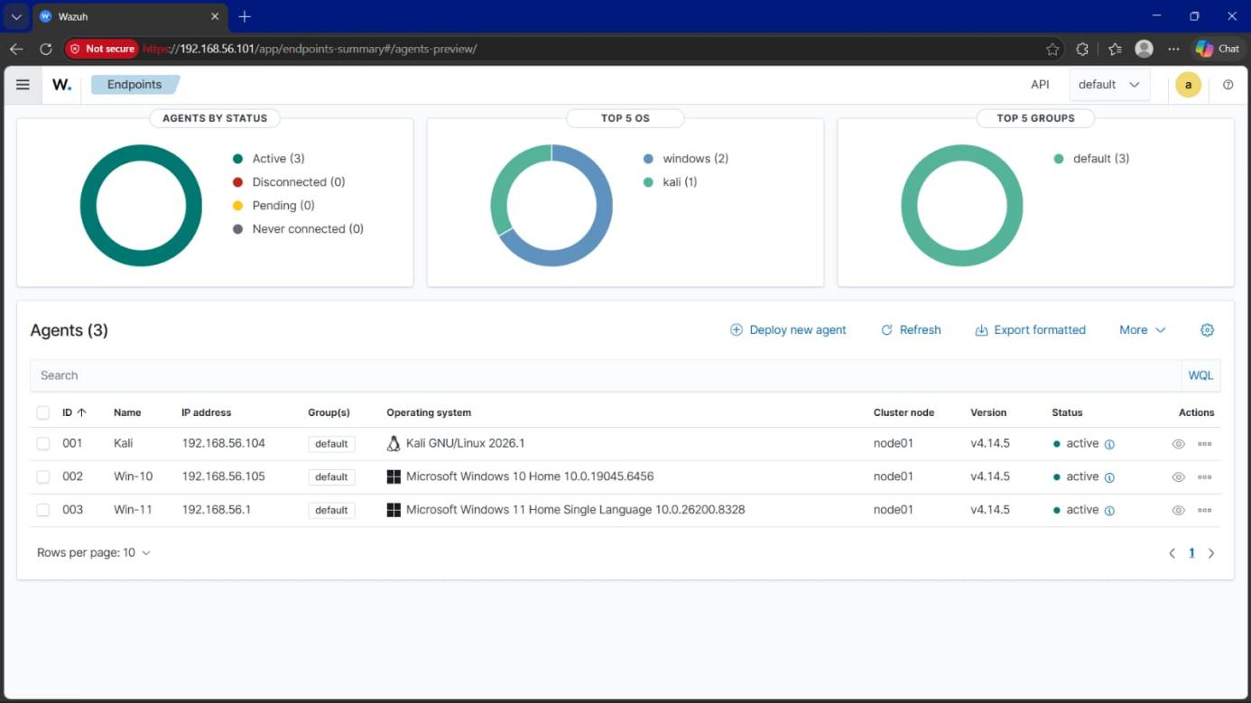
Figure 1 — Wazuh Endpoints Summary: 3 active agents (Kali, Win-10, Win-11), all reporting to node01.
Wazuh Manager | 192.168.56.101
Agent 001 — Kali | 192.168.56.104 (Kali GNU/Linux 2026.1)
Agent 002 — Win-10 | 192.168.56.105 (Windows 10 Home 10.0.19045.6456)
Agent 003 — Win-11 | 192.168.56.1 (Windows 11 Home Single Language)
Agent Status | All 3 agents Active — 0 Disconnected, 0 Pending

Phase 1 — Attacks Simulated
Four attack techniques were executed against the Windows 10 target to generate realistic detection scenarios for the SOC exercise.

Attack 1 — Reconnaissance (Nmap)
Tool | Nmap -sV -Pn
Source IP | 192.168.56.104 (Kali)
Target IP | 192.168.56.105 (Windows 10)
Ports Found | 135, 139, 445
Services | RPC, NetBIOS, SMB
OS Detected | Windows
Lesson Learned: Nmap scans do not trigger Wazuh alerts by default. Detecting port scans in a production SOC requires a network IDS such as Snort or Suricata integrated alongside the SIEM.

Attack 2 — SMB Brute Force (Metasploit)
Tool | Metasploit smb_login
Source IP | 192.168.56.104 (Kali)
Target IP | 192.168.56.105 (Windows 10)
Target Account | administrator
Total Attempts | ~10
Result | Account lockout triggered
Detection | Windows account lockout policy active
Detection Rules Fired:
Rule ID | Description | Level
60122 | Logon Failure — Unknown user or bad password | 5
60204 | Multiple Windows Logon Failures | 10
60115 | User account locked out (multiple login errors) | 9
VERDICT: TRUE POSITIVE — ESCALATE: YES (HIGH PRIORITY)

Attack 3 — Web Vulnerability Scan (Nikto)
Tool | Nikto
Target | http://192.168.56.105
Findings | XST vulnerability (HTTP TRACE active); directory indexing exposed (/img/, /icons/); outdated Apache/PHP/OpenSSL; 5 missing security headers; Apache default files exposed
Detection Rules Fired:
Rule ID | Description | Level
60104 | Windows audit failure event | 5
61107 | Microsoft Defender Core Service terminated unexpectedly | 5
60602 | Windows application error event | 9
Note: No rule directly identified the web scan itself. Lesson: a network IDS (Suricata/Snort) is needed for reliable web scan detection.

Attack 4 — Suspicious File Drop
File | totally_normal.exe
Location | C:\Windows\System32\
FIM Detection | Rule 554 — File added to the system (Level 5)
FIM Detection | Rule 550 — Integrity checksum changed (Level 7)
VERDICT: TRUE POSITIVE — FIM successfully monitoring System32

Phase 2 — Alert Monitoring
With attacks executed, the Threat Hunting module was used to monitor alert volume in near real time. Alert counts climbed rapidly as the brute-force and scanning activity generated repeated Windows security events.
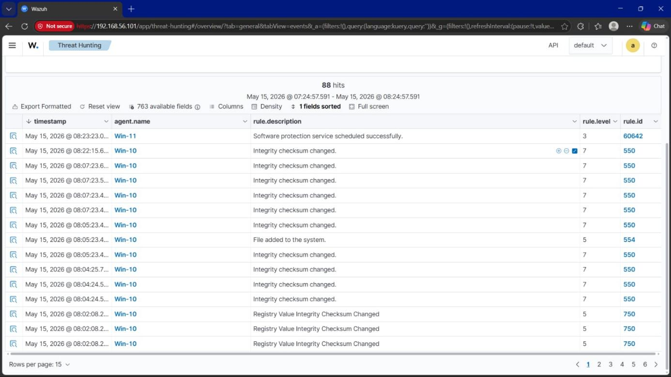
Figure 2 — Threat Hunting overview: 88 hits in a 1-hour window, dominated by FIM "Integrity checksum changed" (Rule 550, Level 7) and registry integrity alerts.
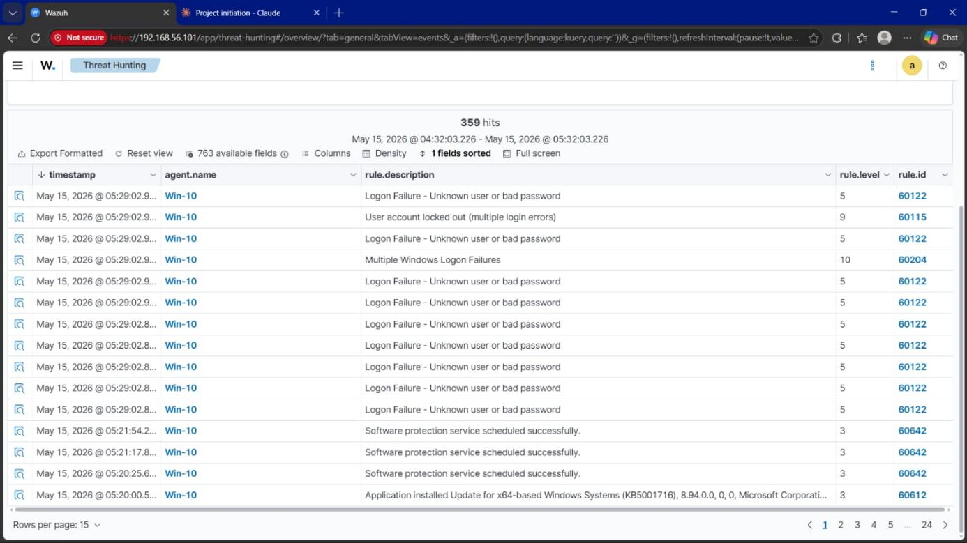
Figure 3 — Threat Hunting overview: 359 hits in a 1-hour window, including Rule 60204 "Multiple Windows Logon Failures" (Level 10) and Rule 60115 "User account locked out" (Level 9).
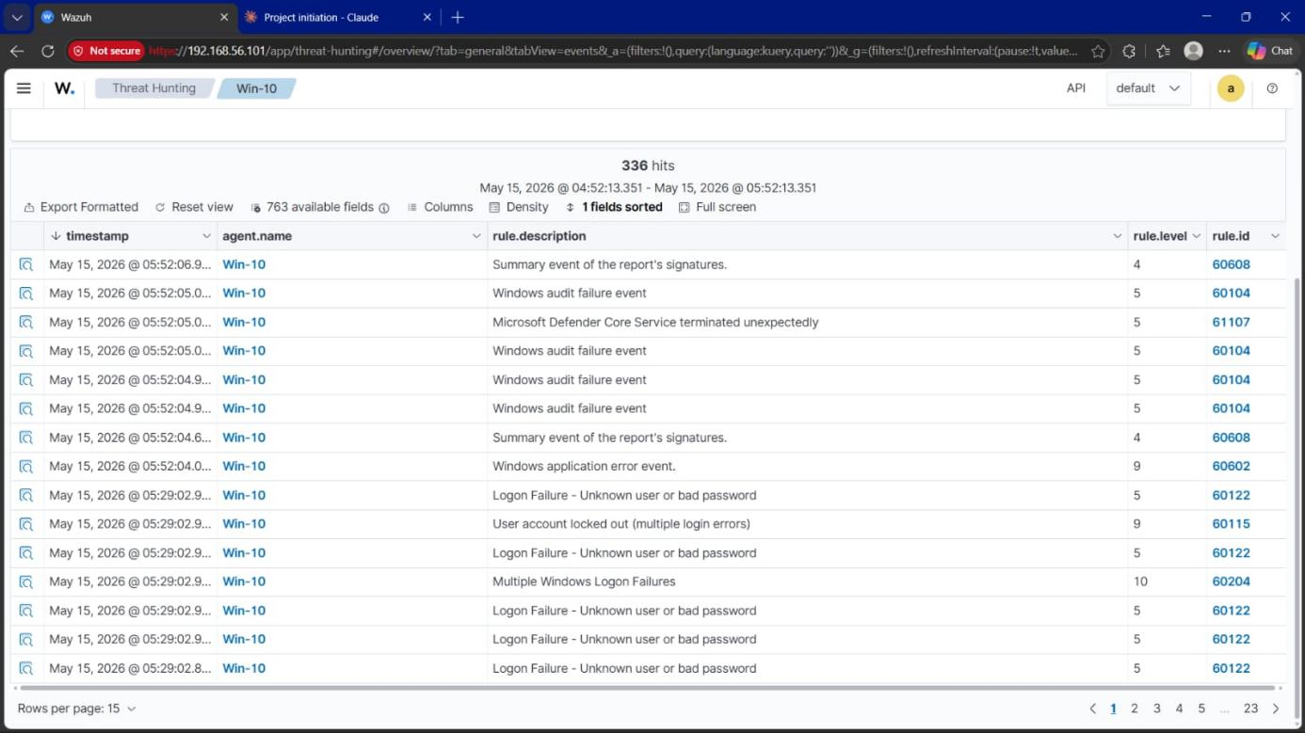
Figure 4 — Alerts filtered to agent Win-10: 336 hits, showing the brute-force logon failure sequence alongside routine audit and application events.
Total alert volume across the shift reached approximately 123 pages of events — a high volume typical of an actively monitored endpoint.
Key High-Severity Alerts Identified:
Rule ID | Description | Level
60204 | Multiple Login Failures | 10
60115 | Account Locked Out | 9
550 | Integrity Checksum Changed | 7
554 | File Added to System | 5
23505 | CVE-2022-30168 | 10
SOC Lesson: high alert volume requires filtering. Strategy adopted — filter to Level 7 and above to prioritize triage effort.

Phase 3 — Alert Triage Table

Alert 1 — Nmap Reconnaissance
Source IP | 192.168.56.104 (Kali)
Target IP | 192.168.56.105 (Windows 10)
Verdict | TRUE POSITIVE
Reason | Port scanning is not normal behavior
Priority | Medium

Alert 2 — SMB Brute Force
Source IP | 192.168.56.104 (Kali)
Target IP | 192.168.56.105 (Windows 10)
Rule(s) | 60204, 60115, 60122
Verdict | TRUE POSITIVE
Reason | 200+ failed logins; account lockout triggered
Priority | HIGH — Escalate immediately

Alert 3 — Nikto Web Scan
Source IP | 192.168.56.104 (Kali)
Target IP | 192.168.56.105 (Windows 10)
Verdict | TRUE POSITIVE
Reason | Automated web vulnerability scanner detected
Priority | Medium

Alert 4 — File Added to System32
Source IP | C:\Windows\System32\totally_normal.exe
Target IP | Windows 10 (192.168.56.105)
Rule(s) | 554, 550
Verdict | TRUE POSITIVE
Reason | Executable dropped in sensitive directory
Priority | HIGH — Escalate immediately

Phase 4 — Log Analysis
The core brute-force event was drilled into via Wazuh's Document Details view, which exposes the full raw Windows Security event (Event ID 4625) alongside the Wazuh rule metadata that classified it.
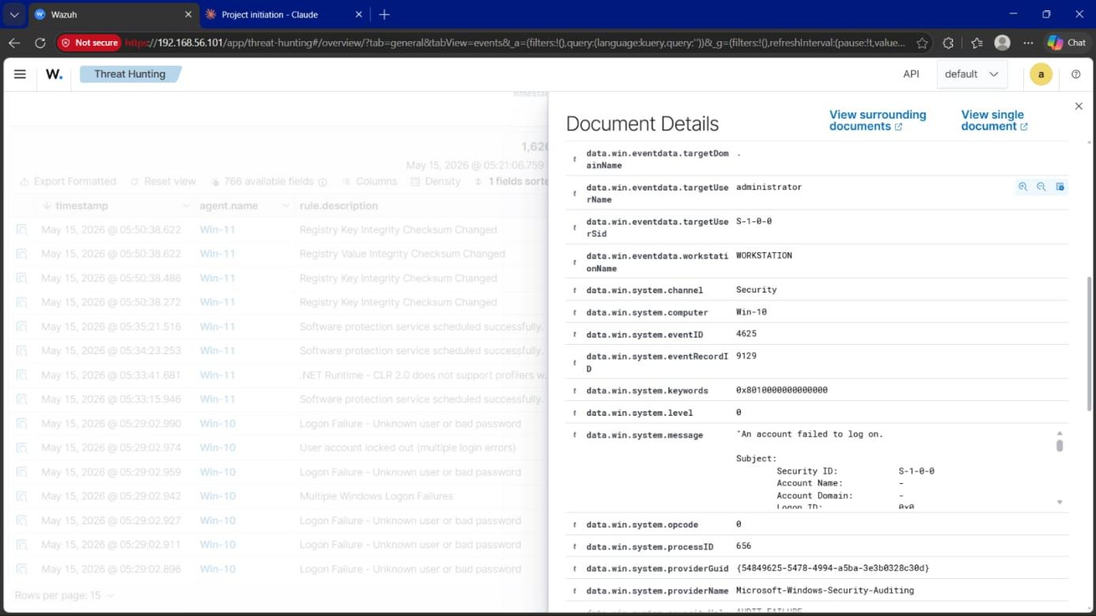
Figure 5 — Raw Event ID 4625 fields: target account "administrator", target domain, workstation name "WORKSTATION", and the full Windows message "An account failed to log on."
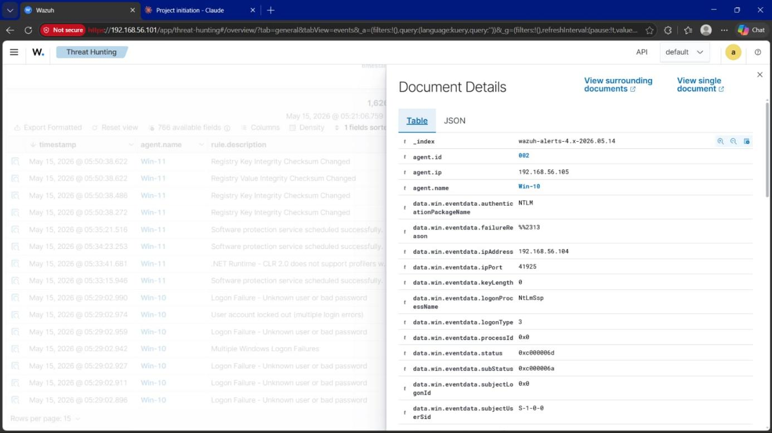
Figure 6 — Authentication detail: NTLM package, source IP 192.168.56.104, port 41925, logon type 3 (network), status 0xc000006d / sub-status 0xc000006a (bad username or password).
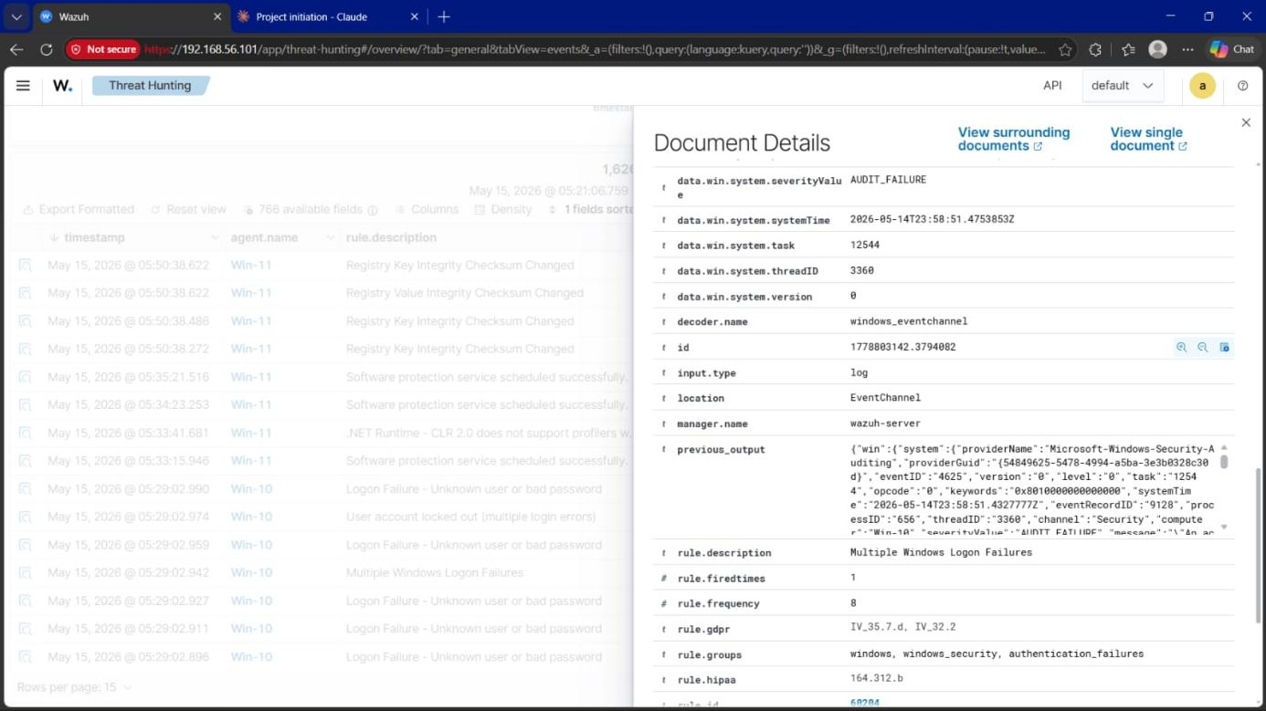
Figure 7 — Wazuh classification metadata: rule.description "Multiple Windows Logon Failures", rule.id 60204, rule.level 10, decoder "windows_eventchannel".
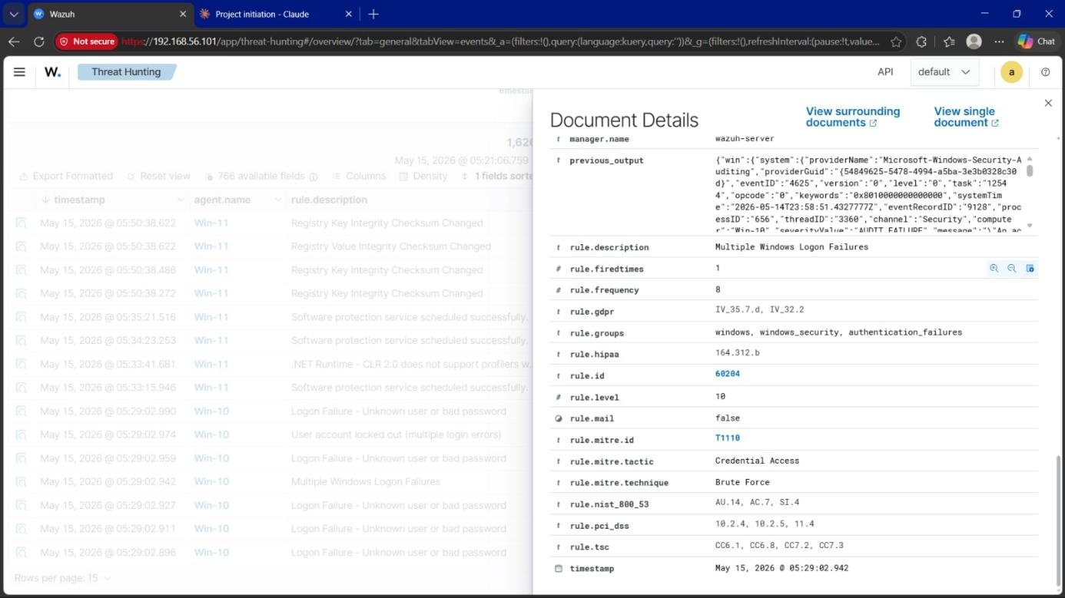
Figure 8 — Full rule metadata for the matched alert: MITRE ID T1110 (Brute Force), tactic Credential Access, plus GDPR, HIPAA, NIST 800-53, PCI DSS and TSC compliance mappings.
Log Analysis Summary:
Event ID | 4625
Source IP | 192.168.56.104
Target Account | administrator
Logon Type | 3 (network/remote)
Auth Method | NTLM
Result | AUDIT_FAILURE
Rule Fired Count | 9 times (within timeframe)
MITRE Technique | T1110 — Brute Force
Verdict | Automated brute force confirmed

Phase 5 — IOC Investigation

IOC 1 — Attacker IP
Type | IP Address
Value | 192.168.56.104
Tool | VirusTotal
Result | 0/92 Clean
Reason | Private/local IP range
Action | Monitor

IOC 2 — Target Port
Type | Port / Service
Value | Port 445 (SMB)
Found In | Nmap scan + brute-force logs
Risk | SMB is a high-value target for attackers
Action | Restrict SMB access; add firewall rule

IOC 3 — Suspicious File
Type | File
Value | totally_normal.exe
Location | C:\Windows\System32\
Detected By | Wazuh FIM — Rule 554
Risk | Executable in sensitive directory
Action | Delete file; escalate to L2

IOC 4 — Attacker Techniques
MITRE Tactic | Credential Access
MITRE ID | T1110 — Brute Force
Tool Used | Metasploit smb_login
Auth Method | NTLM
Event ID | 4625 (Failed Logon)

Phase 6 — Attack Timeline
Date: May 14–15, 2026 | Attacker IP: 192.168.56.104 (Kali) | Target IP: 192.168.56.105 (Windows 10)
[08:41] RECONNAISSANCE
Tool: Nmap -sV -Pn
Source → Target: 192.168.56.104 → 192.168.56.105
Ports Found: 135, 139, 445 (RPC, NetBIOS, SMB)
Wazuh: No direct alert (detection gap)
[09:41] BRUTE FORCE ATTACK
Tool: Metasploit smb_login | Protocol: SMB (Port 445)
Target Account: administrator | Attempts: ~10
Result: Account lockout triggered
Wazuh: Rules 60122, 60204, 60115 fired
[20:14] WEB VULNERABILITY SCAN
Tool: Nikto | Target: http://192.168.56.105:80
Findings: Outdated Apache/PHP/OpenSSL; XST vulnerability; directory indexing exposed
Wazuh: Rules 60104, 61107 fired
[08:05] SUSPICIOUS FILE DROPPED
File: totally_normal.exe | Location: C:\Windows\System32\
Detected by: Wazuh FIM
Wazuh: Rules 554, 550 fired

Phase 7 — Escalation Decisions

Alert 1 — Nmap Reconnaissance
Escalate: NO Priority: Low
Reason:
- Single scan, no follow-up exploitation detected
Action:
- Monitor, document, keep open

Alert 2 — SMB Brute Force
Escalate: YES ⚠ Priority: HIGH
Reason:
- Automated attack against Administrator account
- Account lockout triggered
- MITRE T1531 detected
Action:
- Escalate to L2 immediately
- Block 192.168.56.104 at firewall
- Review account lockout policy

Alert 3 — Nikto Web Scan
Escalate: YES Priority: Medium
Reason:
- Outdated software detected
- XST vulnerability found
- Directory indexing exposed
Action:
- Escalate to L2
- Patch Apache, PHP, OpenSSL
- Disable HTTP TRACE method

Alert 4 — Suspicious File in System32
Escalate: YES ⚠ Priority: HIGH
Reason:
- Executable dropped in sensitive Windows directory
- Possible malware installation
Action:
- Escalate to L2 immediately
- Delete file
- Full endpoint scan required

Rule Reference — Multiple Windows Logon Failures (Rule 60204)
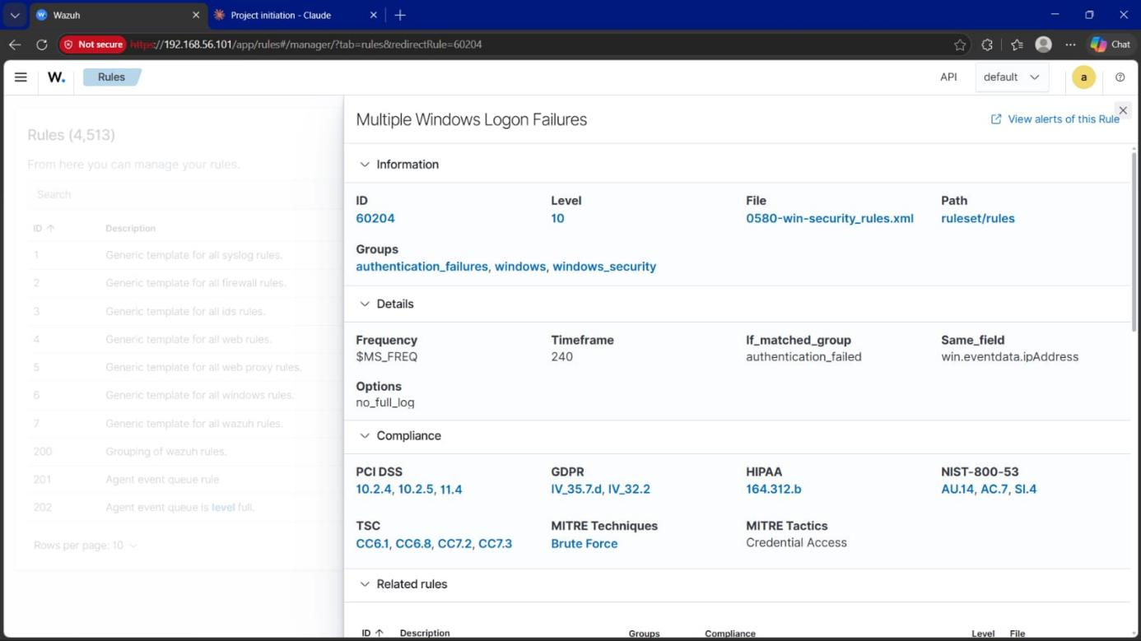
Figure 9 — Wazuh Rules Manager detail for Rule 60204: Level 10, groups authentication_failures/windows/windows_security, MITRE technique Brute Force / tactic Credential Access, with PCI DSS, GDPR, HIPAA, NIST 800-53 and TSC compliance mappings.

Phase 8 — Incident Ticket
Ticket ID | INC-001
Date / Time | May 15, 2026 — 05:29 AM
Analyst | SOC Analyst (L1)
Severity | HIGH
Status | Escalated to L2

Alert Summary
Wazuh detected an automated SMB brute-force attack against Windows 10 (192.168.56.105) originating from Kali Linux (192.168.56.104). The Administrator account was locked out after 10 failed attempts.

What Happened
The Metasploit smb_login module attempted to guess the Administrator password over SMB (Port 445). The Windows account lockout policy triggered after 10 failed attempts. No successful login was recorded.

IOCs Identified
Attacker IP | 192.168.56.104
Target IP | 192.168.56.105
Target Account | Administrator
Target Port | 445 (SMB)
Total Attempts | ~10
Event ID | 4625
MITRE ID | T1531

Actions Taken by L1
- Alert confirmed as TRUE POSITIVE
- Attacker IP investigated via VirusTotal
- Attack timeline documented
- No successful login confirmed in logs
- Suspicious file found in System32

Escalation
Escalating to L2 — brute-force activity against the Administrator account requires a firewall rule review and deeper forensic analysis.

Recommended Actions
- Block 192.168.56.104 at the firewall
- Review account lockout policy
- Restrict SMB access to trusted IPs
- Scan endpoint for malware
- Remove totally_normal.exe from System32

Phase 9 — Lessons Learned
L1 Detection Gaps Are Real
Nmap port scanning was not detected by Wazuh by default. In a real SOC, additional tools such as Suricata or Snort are needed alongside a SIEM for full coverage.
L2 Account Lockout Saves Lives
The Windows account lockout policy stopped the brute-force attack automatically after 10 attempts — a simple but powerful control every organization should enable.
L3 FIM Is Powerful
Wazuh File Integrity Monitoring detected file changes in System32 in real time, which is critical for catching malware drops and unauthorized file modifications.
L4 Logs Tell the Full Story
Raw log analysis of Event ID 4625 revealed the exact attacker IP, target account, authentication method, and timestamp. Logs remain the most reliable source of forensic evidence.
L5 Triage Before Investigation
With roughly 123 pages of alerts generated, investigating everything is impossible. Filtering by severity level and prioritizing High/Critical alerts first is essential.
L6 Tools Have Limitations
Hydra failed against modern SMB due to NTLMv2 and SMB signing requirements. Purpose-built tools like Metasploit succeed where generic tools fail.
L7 Documentation Is Everything
Every action taken during this incident was documented with timestamps, IOCs, rule IDs, and screenshots. If it isn't documented, it didn't happen.

