**KAKINADA INSTITUTE OF ENGEERING AND TECHNOLOGY**

**TEEM:7   
KARTHISWAR ULAPALLI   
216Q1A4653   
16/02/2025**

**﻿﻿ git & github**

**git: Git a free, open-source version control system (VCS) that helps track and manage code changes. It's the most widely used version control system in the world.**

**github : GitHub is a website that helps developers store, manage, and collaborate on software projects. It's a social network for programmers that encourages collaboration and sharing of code.**

**Why should we use these?    
 Git is the version control system GitHub uses. Git is open source and free to use for small and large projects. It is the system that keeps track of every change you make in GitHub. GitHub, meanwhile, is where people can share and collaborate on the files they have created.**

**How to install git.**

* **Install git from any browser.**
* **Setup the git in Windows.**
* **then start the git.**

**Configuring user information used across all local repositories.**

**git config --global user.name “[firstname lastname]”**

**git config --global user.email “[valid-email]”**

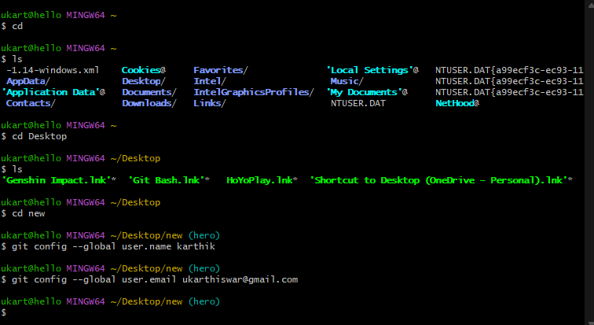

**That means we tell git our name and email address. Please use "FirstName LastName" and name@domain.org email address. This is needed because every Git commit uses this information. The information is added to the commits you start creating.**

**git init**

**initialize an existing directory as a Git repository.**

**git add .**

**The git add command adds a change in the working directory to the staging area.**

**git commit -m “[descriptive message]”**

**The git commit command is used to commit staged changes with a descriptive message.**

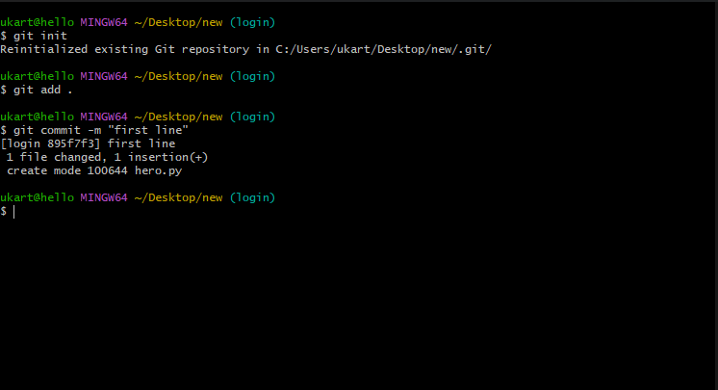

**git remote add origin <repo_URL>**

**The `git remote add origin` command is used to add a remote repository to your local Git repository. This allows you to push and pull changes between your local and remote repositories. The term "origin" is an alias that refers to the remote repository URL.**

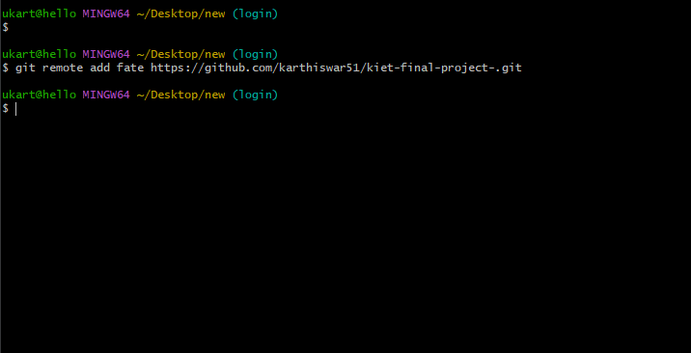

**git branch**

**List your branches. A * will appear next to the currently active branch.**

**git branch [branch-name]**

**Create a new branch at the current commit.**

**git checkout**

**Switch to another branch and check it out into your working directory.**

