Star Buddy

1) Overview:

Star Buddy is a home based observatory which is an encyclopedia of stars. It can locate a star and describe it for a user.

2) Target audience:

For Students of Astronomy: amateur astronomers can benefit from it

3) Prototype developed:

2.1) Hardware requirements
Arduino-2 Servo motors

2.2) Software requirements
Stellarium: The open source tool which gives an image representation of our sky.

2.3) Description of working
The user has to launch Stellarium on the desktop, which renders a complete image representation of the sky with the gamut of stars and all other celestial bodies, based on the user's geographical location. The user while navigating through the image may select (by clicking) a celestial body, the coordinates of which are captured by Stellarium, then the coordinates are sanitized and passed to Arduino-2 Servo motors which rotate a laser torch and point it in the direction of the celestial body, indicating the direction in which the celestial body can be found. Following which the prototype may connect to wikipedia or other web resources to fetch the user a description of the celestial body.

Proposed idea to explore the sky:

The user can wear a wearable device on the wrist comprising of gyroscope, accelerometer and camera. The user may then raise the hand to point to a celestial body. The gyroscope and accelerometer are used to capture the direction and the trajectory in which the user is pointing and camera is used to capture the celestial space/body in that direction and trajectory. A software program may capture the 3 parameters, direction, trajectory and use the image to retrieve information about the celestial body/space for the user from the web.

Details:

Azimuth coordinate system

The Altitude/Azimuth coordinate system can be used to describe a direction of view (the azimuth angle) and a height in the sky (the altitude angle). The azimuth angle is measured clockwise round from due North.
The Altitude/Azimuth coordinate system is attractive in that it is intuitive - most people are familiar with azimuth angles from bearings in the context of navigation, and the altitude angle is something most people can visualise pretty easily.
However, the altitude/azimuth coordinate system is not suitable for describing the general position of stars and other objects in the sky - the altitude and azimuth values for an object in the sky change with time and the location of the observer.
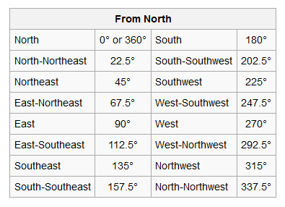

Cartographical azimuth

Calculating azimuth
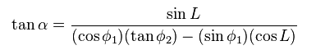

Bomford says Cunningham's formula is exact for any distance
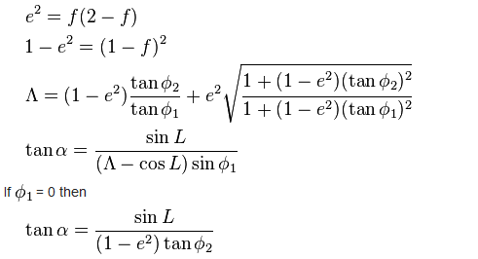

Coordinate system conversions

As the spherical coordinate system is only one of many three-dimensional coordinate systems, there exist equations for converting coordinates between the spherical coordinate system and others.
Cartesian coordinates
The spherical coordinates of a point in the ISO convention (radius r, inclination θ, azimuth φ) can be obtained from its Cartesian coordinates (x, y, z) by the formulae
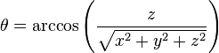
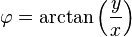
The inverse tangent denoted in φ = arctan(y/x) must be suitably defined, taking into account the correct quadrant of (x,y). See the article on atan2.
Alternatively, the conversion can be considered as two sequential rectangular to polar conversions: the first in the Cartesian x–y plane from (x,y) to (R,φ), where R is the projection of r onto the x–y plane, and the second in the Cartesian z–R plane from (z,R) to (r,θ). The correct quadrants for φ and θ are implied by the correctness of the planar rectangular to polar conversions.
These formulae assume that the two systems have the same origin, that the spherical reference plane is the Cartesian x–y plane, that θ is inclination from the z direction, and that the azimuth angles are measured from the Cartesian x axis (so that the y axis has φ = +90°). If θ measures elevation from the reference plane instead of inclination from the zenith the arccos above becomes an arcsin, and the cos θ and sin θ below become switched.
Conversely, the Cartesian coordinates may be retrieved from the spherical coordinates (radius r, inclination θ, azimuth φ), where r ∈ [0, ∞), θ ∈ [0, π], φ ∈ [0, 2π), by:
Cylindrical coordinates
Main article: Cylindrical coordinate system
Cylindrical coordinates (radius ρ, azimuth φ, elevation z) may be converted into spherical coordinates (radius r, inclination θ, azimuth φ), by the formulas
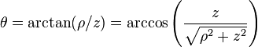
Conversely, the spherical coordinates may be converted into cylindrical coordinates by the formulae
These formulae assume that the two systems have the same origin and same reference plane, measure the azimuth angle φ in the same sense from the same axis, and that the spherical angle θ is inclination from the cylindrical z axis.
Star buddy has three servo motors for positioning star in the sky with respect to the input given by the Stellarium software. Two motors are used to position laser pointer in X axis and one is for Y axis. Basically servo can move up to 180o so that we mounted two servo together in parallel to make movement 360o and base servo will move if the degree is greater than 180o to achieve the full rotation.

Servo Motor

A servo motor is a device that translates a PWM signal into a rotational angle.
A servo is composed of a motor, gears, and control circuitry. The input pulse signal
is typically between 1ms and 2ms, rotating the shaft between -90 and 90 degrees.
Feedback internal to the servo keeps the shaft at the proper angle as long as power is supplied and the PWM signal is still being sent. Servos are typically high torque

Advantages

Low cost drive:
A DC brush drive can be made very economically since only a single bridge circuit is required.
Advantages of Servo motors0

No power used at standstill:
With no static loads on the motor, no current is required to hold position.

High peak torque available:
In intermittent duty applications, particularly when positioning mainly-inertial loads, the motor can be overdriven beyond its continuous rating.

Flat speed-torque curve:
Gives optimum performance with easily generated linear acceleration ramps.

Wide variety of types available:
Brush motors are produced in many styles including very low inertia types for high dynamic applications.

High speed attainable:
Brush servos are typically good for speeds up to 5000 rpm.

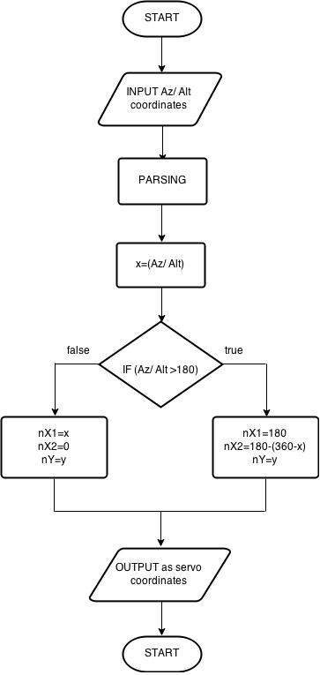

Arduino

Arduino is an open source computer hardware and software company, project and user community that designs and manufactures kits for building digital devices and interactive objects that can sense and control the physical world. Here we used Arduino Uno microcontroller. The Arduino Uno is a microcontroller board based on the ATmega328 . It has 14 digital input/output pins (of which 6 can be used as PWM outputs), 6 analog inputs, a 16 MHz ceramic resonator, a USB connection, a power jack, an ICSP header, and a reset button.
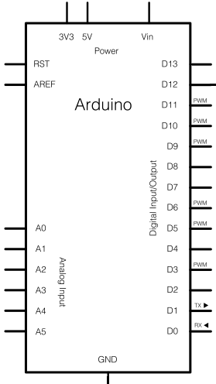

Laser pointer

These are the simplest pointers, as laser diodes are available in these wavelengths. The pointer is nothing more than a battery-powered laser diode.

Bread board

A breadboard (or protoboard) is a construction base for prototyping of electronics. This makes it easy to use for creating temporary prototypes and experimenting with circuit design. Solderless breadboards are also extremely popular with students and in technological education.
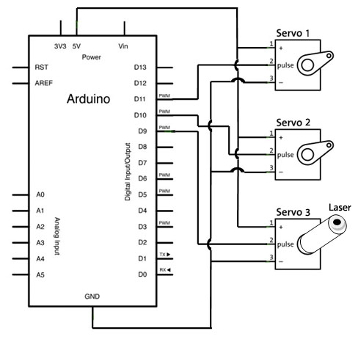

Connection Diagram of Star Buddy

