# GIT HUB Steps

Git Hub is mainly used on software development project. More than one who uses the same repository and used it in version control.

1. Login into your git account.

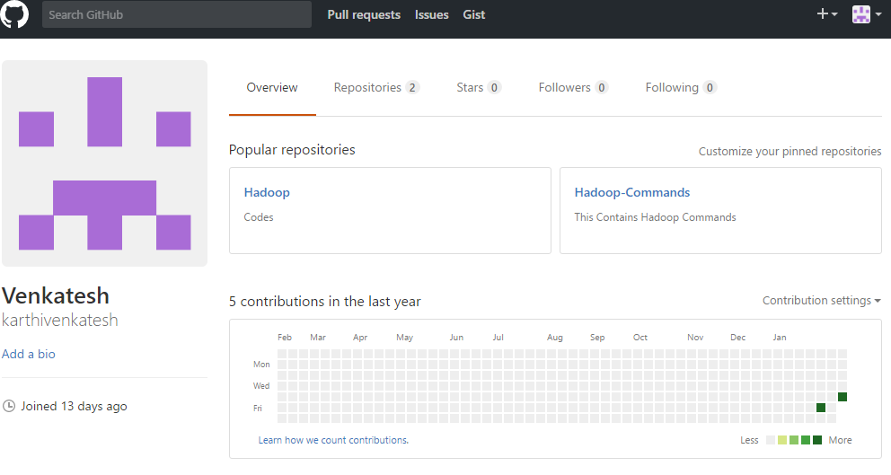Link: <https://github.com>

1. Repository Creation.
   1. Repository is just like a project or folder structure.
   2. Click New button to create new repository.

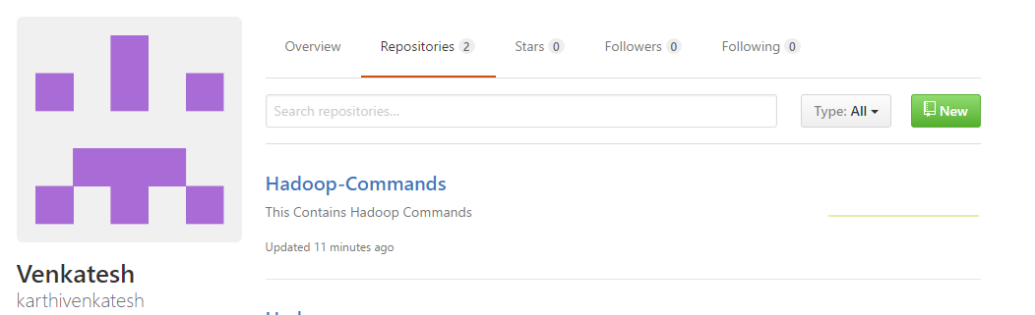

* 1. Name it as yours in “**Repository name”** box.
  2. Make a description of what you stored in this repository.
  3. Select Private or public.
  4. Tick the check box of read me file.
  5. If you want add licence or ignore it.
  6. Click create repository

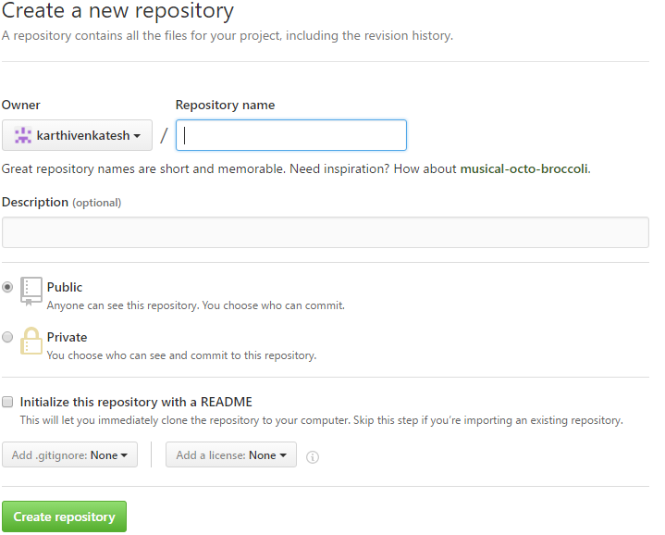

# Git Commands

1. We need to configure git account for git repository.
   1. git config --global user.name “Your name”
      1. git config --global user.name "karthivenkatesh"
   2. git config --global user.email [youremail@domain.com](mailto:youremail@domain.com)
      1. git config --global user.email anuvenkatesheee@gmail.com
   3. git clone (url)
      1. git clone <https://github.com/karthivenkatesh/Git-.git>

once cloned with url in your master folder, you will see a folder name as git name will created.

* 1. git add (file names)
     1. git add GitHubSteps.docx
  2. git status
     1. It shows the new files in your repository folder

git status

On branch master

Your branch is up-to-date with 'origin/master'.

Changes to be committed:

(use "git reset HEAD <file>..." to unstage)

new file: GitHubSteps.docx

* 1. git commit -m "(committed message)

git commit -m "Git creation commands" GitHubSteps.docx

[master 3c17e86] Git creation commands

1 file changed, 0 insertions (+), 0 deletions (-)

create mode 100644 GitHubSteps.docx

* 1. git push -u origin master

git push -u origin master

Counting objects: 3, done.

Delta compression using up to 4 threads.

Compressing objects: 100% (3/3), done.

Writing objects: 100% (3/3), 118.11 KiB | 0 bytes/s, done.

Total 3 (delta 0), reused 0 (delta 0)

Branch master set up to track remote branch master from origin.

To https://github.com/karthivenkatesh/Git-.git

3624662..3c17e86 master -> master

* 1. git remote add origin master (url)

* 1. IF you did any changes in your file you have follow from like below.
     1. git status

changed file shows in red colour

git status

On branch master

Your branch is up-to-date with 'origin/master'.

Changes not staged for commit:

(use "git add <file>..." to update what will be committed)

(use "git checkout -- <file>..." to discard changes in working directory)

modified: GitHubSteps.docx

* + 1. git commit -m “message” File name

git commit -m "New chages in file" GitHubSteps.docx

[master c20aeda] New chages in file

1 file changed, 0 insertions(+), 0 deletions(-)

* + 1. git push -u origin master

git push -u origin master

Counting objects: 3, done.

Delta compression using up to 4 threads.

Compressing objects: 100% (3/3), done.

Writing objects: 100% (3/3), 16.62 KiB | 0 bytes/s, done.

Total 3 (delta 1), reused 0 (delta 0)

remote: Resolving deltas: 100% (1/1), completed with 1 local objects.

Branch master set up to track remote branch master from origin.

To https://github.com/karthivenkatesh/Git-.git

3c17e86..c20aeda master -> master