Multi-tier Distribution Network Design Document
Subject: Multi-tier Distribution Network
Audience: Primary: Solution Architects, Partners; Secondary: Customer executives and planners, o9 sales
Prerequisite knowledge: None

Learning Goals:
- What are multi-tier distribution networks?
- Which industries are they important for?
- What is the value leakage if a multi-tier distribution network has incorrect inventory?
- What data does o9 maintain on distribution lanes (also called routes to market or BODlanes)?
- What are the plans that o9 generates regarding multi-tier distribution networks?

Video 1: Introduction to Multi-tier Distribution Network

What Is Multi-Tier Distribution Network?
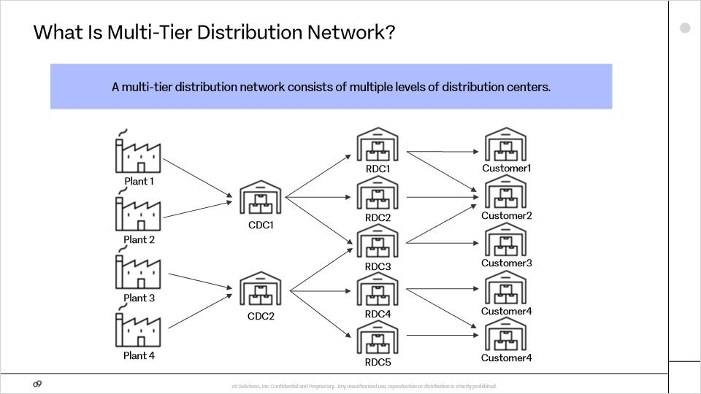
A Multi-tier distribution network consists of multiple levels of distribution centers.
Plants typically have limited storage space, so they immediately ship finished goods to a central distribution center. The central distribution centers then distribute finished goods to regional distribution centers. The regional distribution centers are located close to customer distribution centers, enabling faster order fulfillment times. This model is also referred to as a hub and spoke model.

What are the industries that use multi-tier distribution networks?
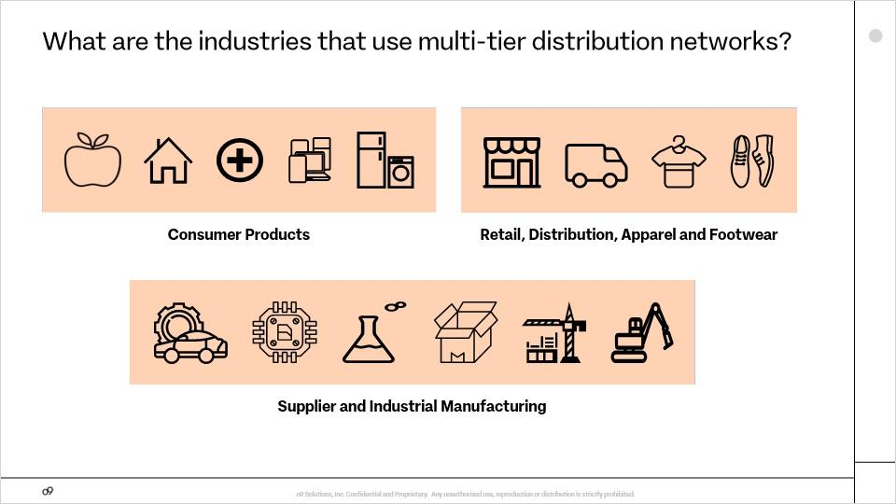
Nearly all industries use multi-tier distribution networks, including consumer products, Retail, Distribution, Apparel and Footwear, and Supplier and Industrial Manufacturing.

What planning decisions does it influence?
In a multi tier distribution network, the planning decisions include:
- Managing Safety stock targets to maintain appropriate inventory levels.
- Managing shelf life obsolescence risks and opportunities.
- Making strategic move decisions to balance inventory across the distribution network.
- And optimizing transportation, storage, inbound and outbound capacity requirements

What is the value leakage if a multi-tier distribution network has incorrect inventory?
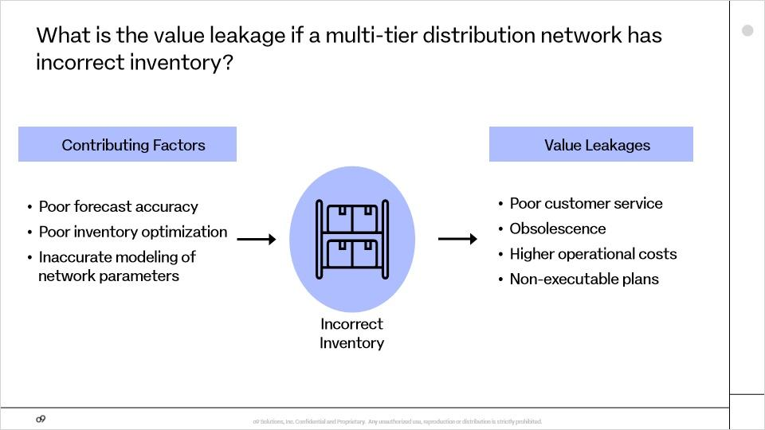
A key goal of multi-tier distribution networks is to ensure correct inventory at each distribution center, so that demand can be met. What are the factors that can lead to incorrect inventory and the value leakages that can result?
Factors that can lead to incorrect inventory include poor forecast accuracy, poor inventory optimization, and inaccuracies in modeling network parameters, such as lot size constraints, transportation modes, operational calendars, and capacity constraints of distribution centers. The resulting value leakages can include poor customer service, obsolescence, higher operational costs, and plans that cannot be executed.

Video 2: Overview of o9 Solutions for Multi-tier Distribution Network

What Solution Building Blocks Do Multi-Tier Distribution Networks Influence?
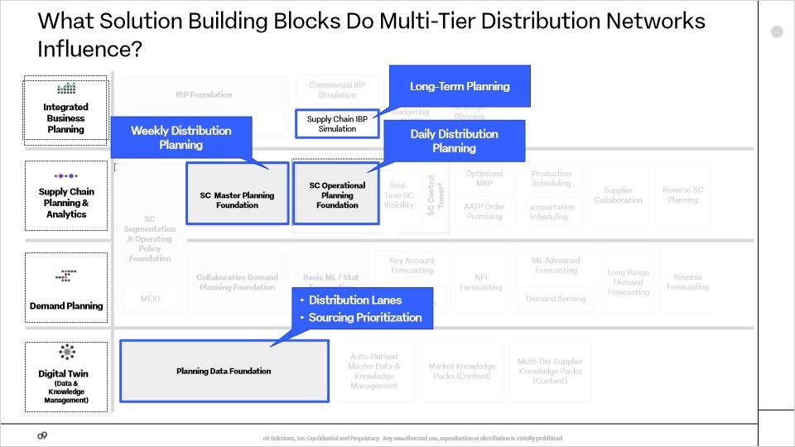
Multi-tier distribution networks influence the various levels of supply chain planning. Long-term planning of distribution center locations and capacity occurs in the Supply Chain IBP Simulation building block. Weekly distribution planning occurs in the master planning building block. Daily distribution planning occurs in the operational planning building block. In addition, the planning data foundation building block stores data about the distribution network, including distribution lanes and sourcing prioritization.

What data does o9 maintain on each distribution lane?
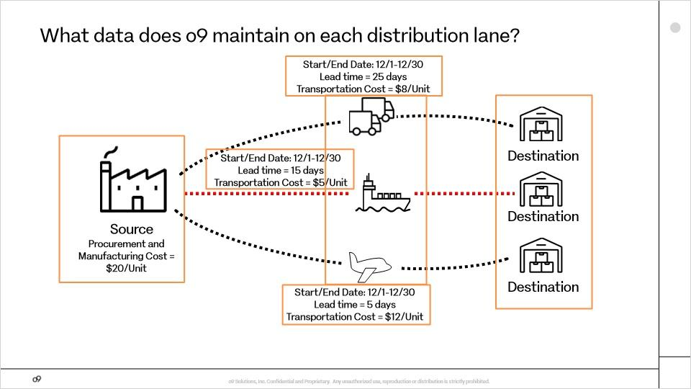
o9 maintains detailed data on all distribution lanes within the network, including source, destination, transportation mode, start and end dates, lead time, and transportation cost. Distribution lanes are also called routes to market or BOD lanes, which stands for bill of distribution lanes.

How does o9 assign priorities to distribution lanes?
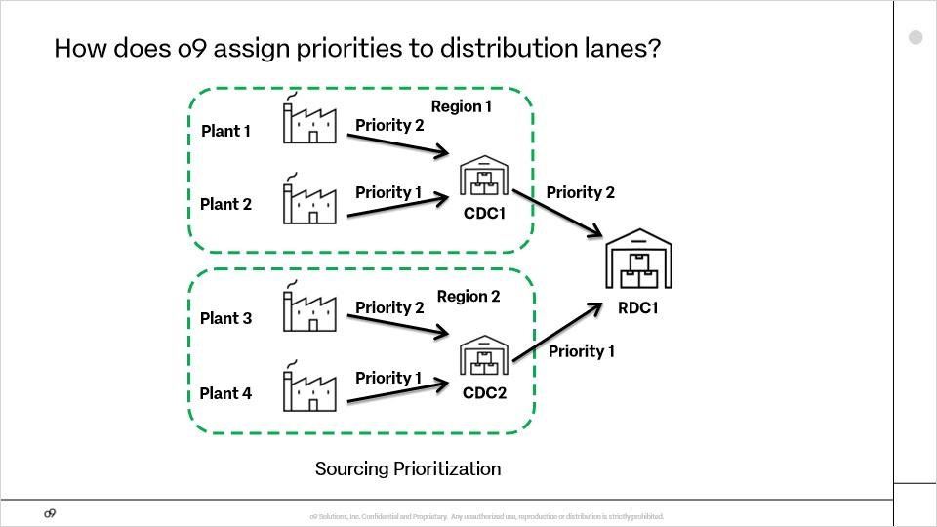
o9 assigns a priority to each distribution lane based on manufacturing and transportation costs. Other parameters such as future demand volume and inventory holding costs can be considered in more complex situations.
o9 maintains this sourcing prioritization data and provides it as input to o9’s supply chain solver.

What are the plans that o9 generates?
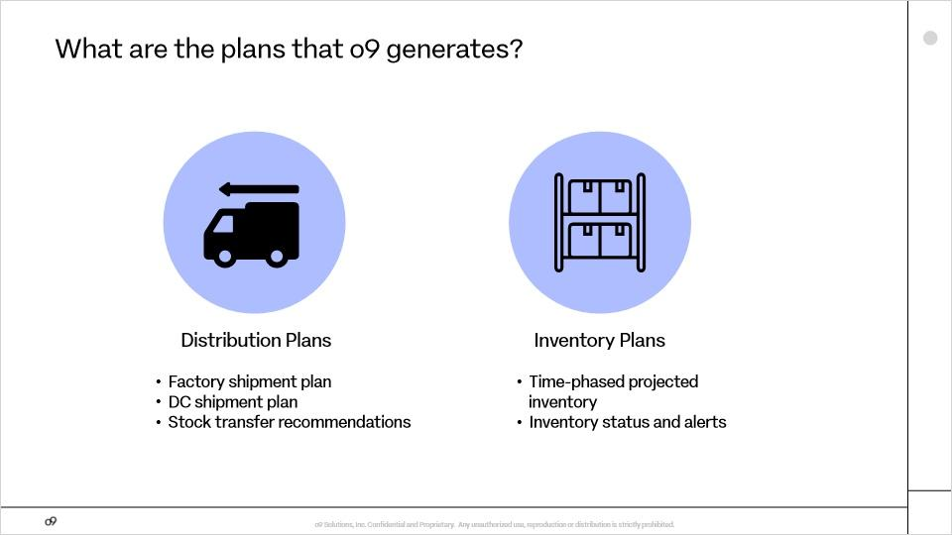
o9 generates distribution plans, including shipment plans from factories and distribution centers and stock transfer recommendations. Additionally, o9 creates inventory plans that provide time-phased projected inventory and inventory status updates and alerts that highlight low or excess stock.

Video 3: Distribution Lanes

What is a Distribution Lane?
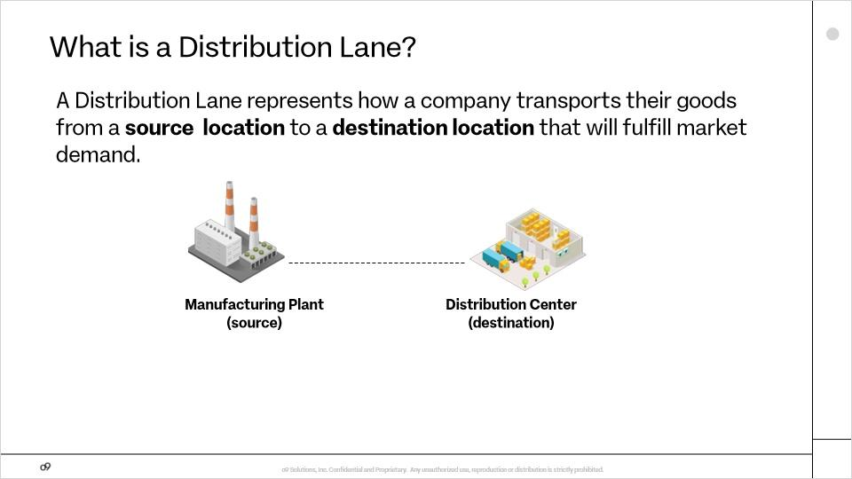
A Distribution Lane, sometimes also referred to as a BOD lane and route to market, represents how a company transports their goods from a source location to a destination location in order to fulfill market demand. Often a source is a manufacturing plant and a destination is a distribution center that fulfills customer orders.

RTM (Slide Layer)
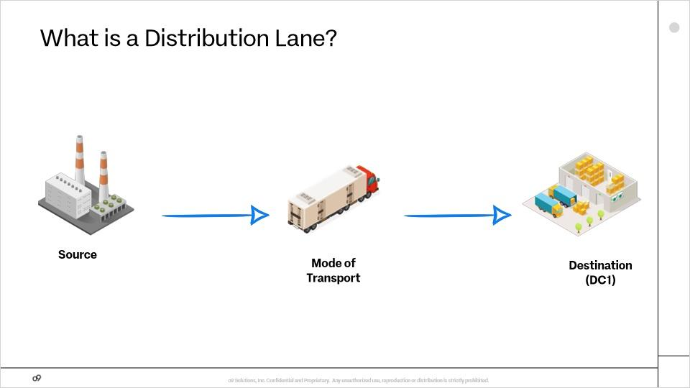
Each distribution lane is composed of three parts: a source (where the finished good is coming from), a destination (where the finished good is moving to), and a mode of transport (how the finished good is being transported). For example, the distribution lane in this diagram could be defined as source at plant, mode of transport by truck, and destination at DC1.

Complex RTM (Slide Layer)
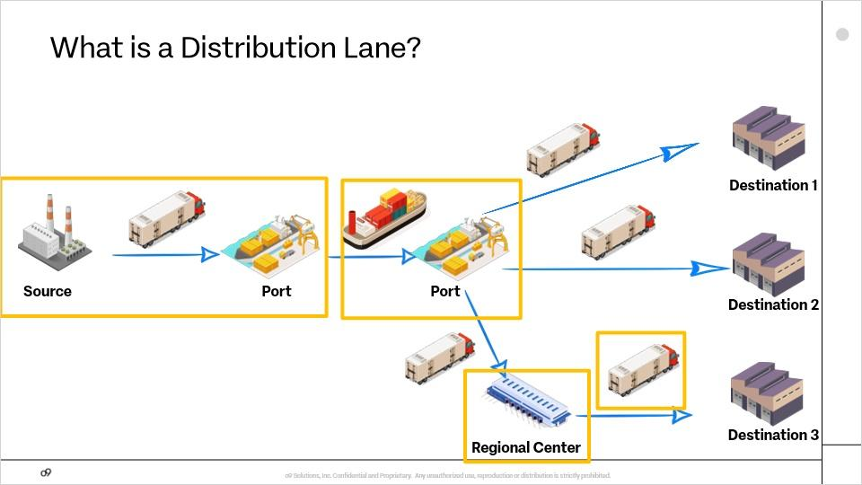
Distribution lanes tend to be complex and consist of many different lanes and modes of transport. In this example, you can see that the goods are moved from the source to the port via truck. The goods are then sent by ship to a receiving port. From the port, the goods are then transported by truck to the destination.

Refrigerated Truck (Slide Layer)
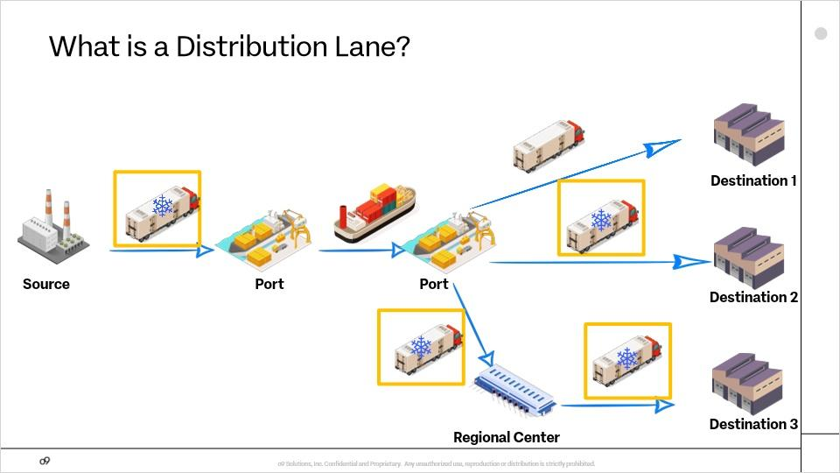
There is further complexity in various distribution lanes when item attributes are considered. For example, take into account refrigerated goods. These types of goods would require specialized transportation options such as refrigerated containers and trucks to transport the goods from the source to the destination. This could impact available modes of transportation, lead times, and transportation costs.

Key Characteristics of Distribution Lanes
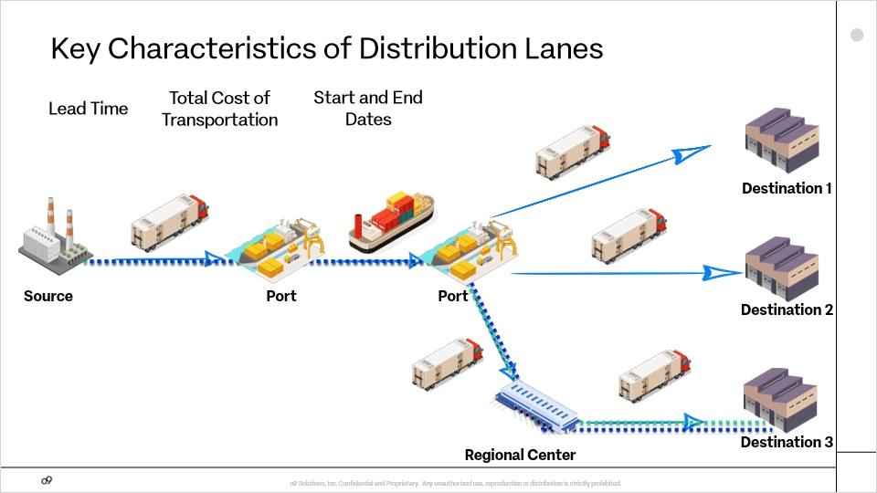
Notes:
Key Characteristics of Distribution Lanes. Values for lead time, total cost of transportation, and start and end dates are associated with each lane. Lead time is the total time taken to move goods from the source to the destination, while total cost of transportation represents the cost of carrying a full load of goods from the source to the destination on the given mode of transport. Finally, the start date is the date the lane is open to ship on and the end date would be the date you could no longer ship on that lane.

Characteristics of Distribution Lane Example
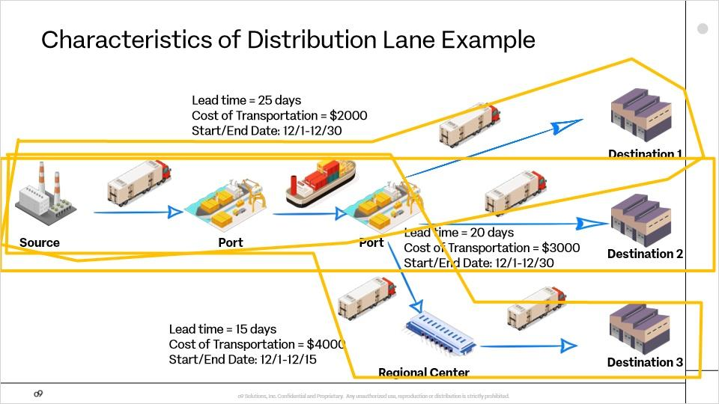
Here is an example of the key characteristics of routes. In route A, there is a lead time of 25 days, a cost of transportatipon of 2000 dollars and a start and end date of the route from December first to December thirtieeth. Route B, has a lead time of 20 days, a cost of transportation of 3000 dollars with a start and end date the same as Route A.
Route C, has a 15 day lead time, a 4000 dollar cost of transportation and a start and end date of December first to December 15th. As you can see, lead time, cost of transportation and start and end date vary based upon the route and modes of transportation.

Why Maintain Distribution Lanes in o9?
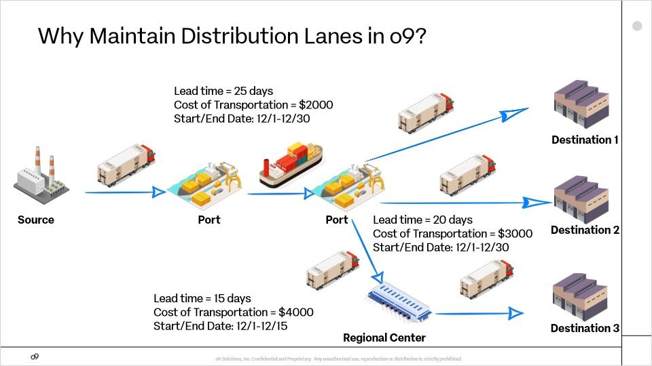
Notes:
So why do you maintain route to market in o9. The answer is really quite simple. When you maintain route to market in the o9 system, you get a full view of the network. This full network view allows the system to generate an optimized supply chain plan.

How Does the User Maintain RTM in o9? Step 1
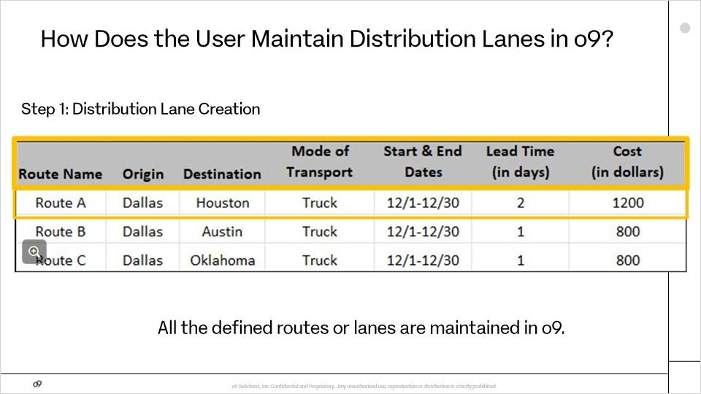
Now that we learned about lanes and the key terms associated with distribution lanes, let's look how the user maintains distribution lanes in o9.
The first step is to create a lane.
Users create routes or lanes for all unique combinations of origin, destination, transportation mode, start and end dates, lead time, and transportation cost.
For example: “Route A” is created for the transportation of items from Dallas to Houston via truck. The lane is available December first to December thirteenth and it takes 2 days to deliver the products through the lane with cost of $1200.
Note that at this time item attributes are NOT included. All the defined routes or lanes are maintained in o9.
All the defined routes are maintained in o9.

How Does the User Maintain RTM in o9? Step 2
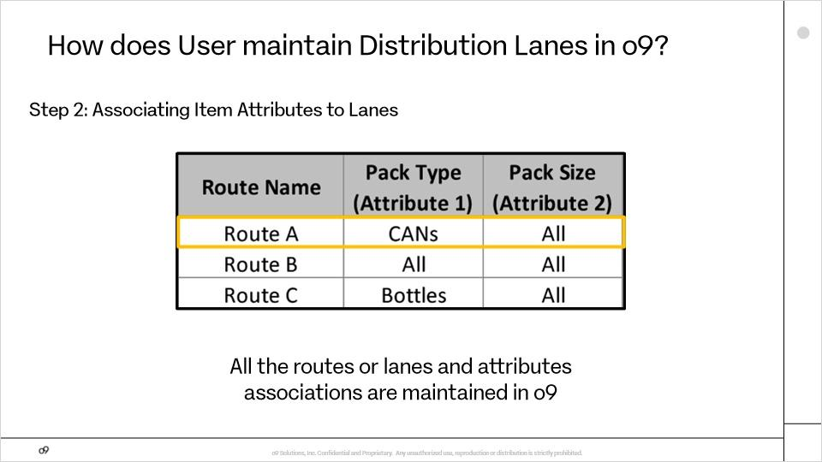
In step 2, the user now associates item attributes to each of the lanes.
For example: “Route A can be applicable to all items that have pack type of “CANs” with any pack size attribute.
In this step, we create rules to associated item attributes with routes or lanes. It is important to remember that different attributes have different rules associated with them.
All the routes or lanes and attributes associations are maintained in o9.

How does o9 convert user-maintained lanes to item-level distribution lanes?
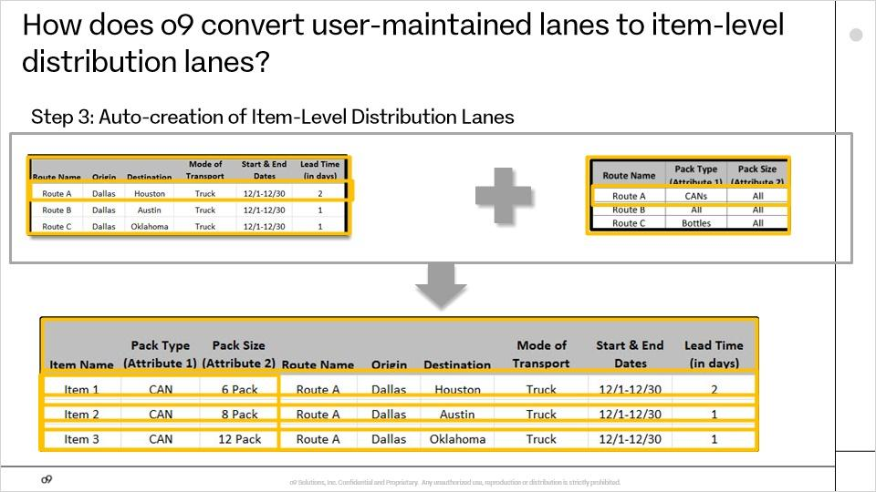
In step 3, the o9 platform auto-creates the item level distribution lanes.
The o9 plug-in uses the routes established in step 1 and the item associations to routes in step 2 to convert the route to market to item level distribution lanes.
The o9 plug-in explodes this information into the item level by using the item attributes associated with the routes.
For example, Route A from Dallas to Houston with transportation mode of Truck ships the products in 2 days for $1200. Assume that item 1, item 2 and item 3 all belong to the Pack Type of cans and Pack size of 6 pack, 8 pack and 12 pack.
The o9 plug-in combines the Route A information with item attributes association table to create item level distribution lanes for item 1, item 2 and item 3.

How does o9 compute item-lane level distribution cost?
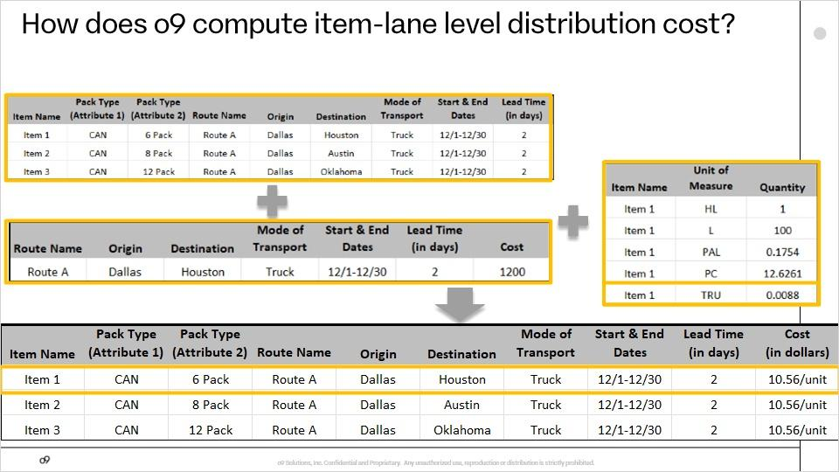
Finally, the system will use the unit of measure table to convert the item-level distribution lanes into item-level distribution lane costs. In this example, in Step 3 the system determined the total transportation cost is $1200 for moving item 1 by truck on route eh. The system multiplies the total cost by the coefficient 0.0088 in the unit of measure table to generate the cost per unit for truck transportation at 10 dollars and 56 cents.

Video 4: Sourcing Prioritization

What Is Sourcing Prioritization?
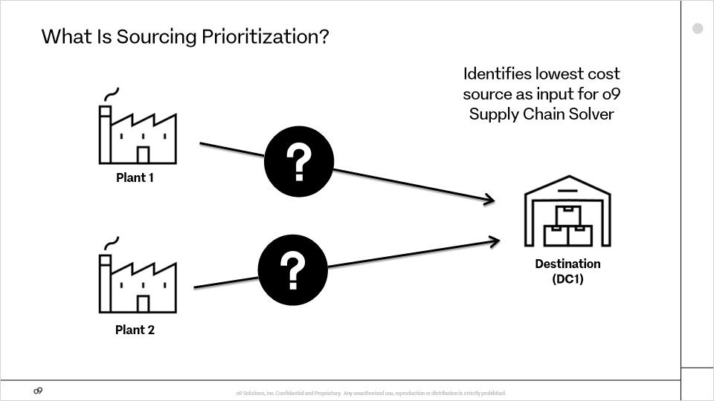
Let's assume there is a product demand at a Distribution Center (DC1) and the same product can be sourced from either Plant 1 or Plant 2. The question is where to source the product from. Is plant 1 a better option than plant 2 or vice versa? This is where sourcing prioritization comes in. Sourcing prioritization identifies the lowest cost source as input for the o9 supply chain solver.

Purpose of Sourcing Prioritization
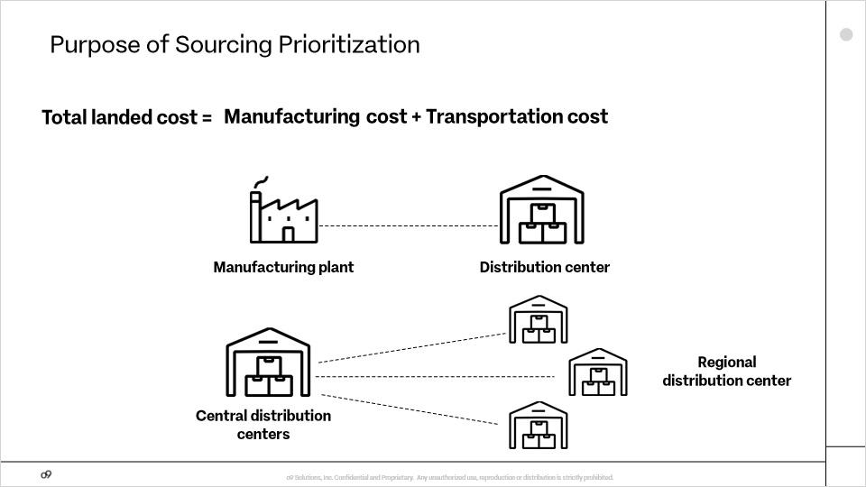
The objective of sourcing prioritization is to ensure that the routes with the lowest total landed cost, which equals manufacturing cost plus transportation cost, are prioritized when moving goods from plants to distribution centers or from central distribution centers to regional distribution centers.

Check Input/Output (Slide Layer)
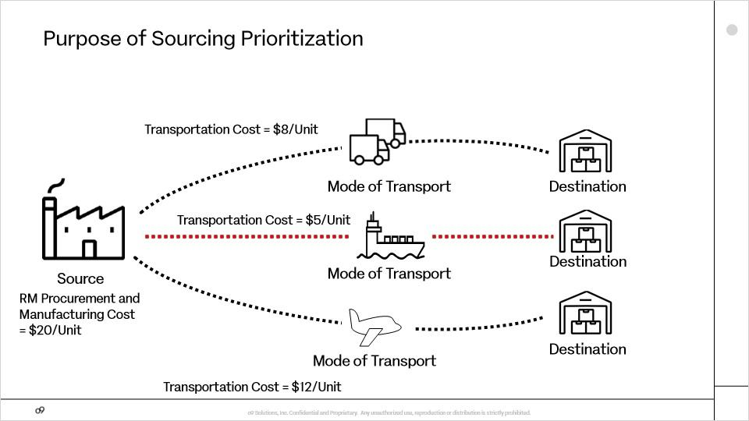
Sourcing prioritization uses the route to market and manufacturing costs maintained within o9 to assign priority to routes that minimize distribution costs.

Source Prioritization in Single-Tier Distribution Network
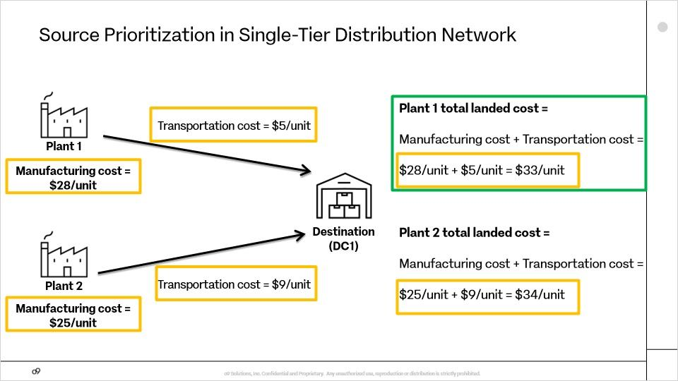
In this example, at first glance a planner might prefer sourcing from Plant 2, since the manufacturing cost is lower - only $25 per unit, compared to $28 per unit at Plant 1. However, when the transportation cost is taken into account, $5 per unit from Plant 1 and $9 per unit from Plant 2, the picture changes. Now the planner can compare the total landed costs: $33 per unit for sourcing from Plant 1, compared to $34 for sourcing from Plant 2. It is clear that the best choice is to source from Plant 1. If Plant 1 is unavailable, the system will recommend sourcing product from Plant 2.

Multi-Tier Distribution Network
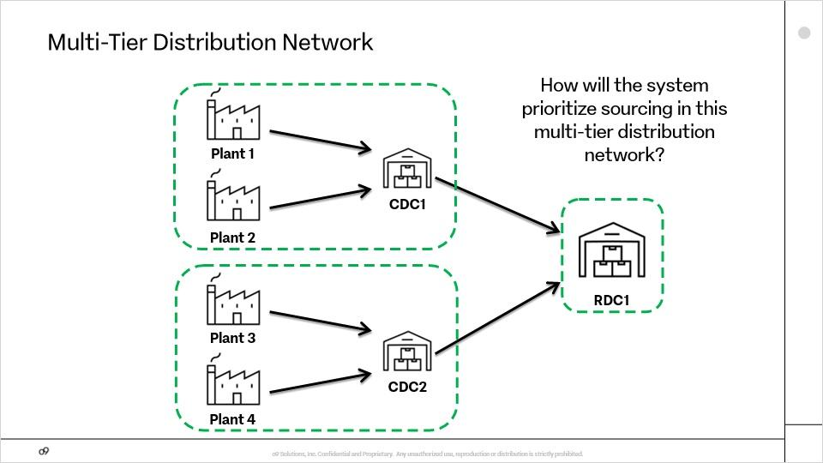
The situation is more complicated in a multi-tier distribution network. We will explore this example, where Plant 1 and Plant 2 are available to source product to central distribution center 1. Plant 3 and Plant 4 are available to source product to central distribution center 2. CDC 1 and CDC 2 are both available to source product to regional distribution center 1. How will the system prioritize sourcing?

Sourcing Prioritization in Multi-Tier Distribution Network - Step 1
The o9 platform deals with the complexity of sourcing prioritization in a multi-tier distribution network by computing priority sequentially, from upstream to downstream, at each node in the supply chain. In this example, because there are two sets of routes (plant to CDC, and CDC to RDC), sourcing prioritization is accomplished in two steps. In Step 1, the system assigns priorities to all of the plant-to-CDC routes within their respective regions. In Region 1, total landed cost for Plant 2 is cheaper than for Plant 1, at $65 per unit versus $80 per unit. So Plant 2 to CDC1 is the highest priority in Region 1. In Region 2, total landed cost for Plant 4 is cheaper than for Plant 3, at $55 per unit versus $70 per unit. So Plant 4 to CDC2 is the highest priority in Region 2.

Sourcing Prioritization in Multi-Tier Distribution Network - Step 2
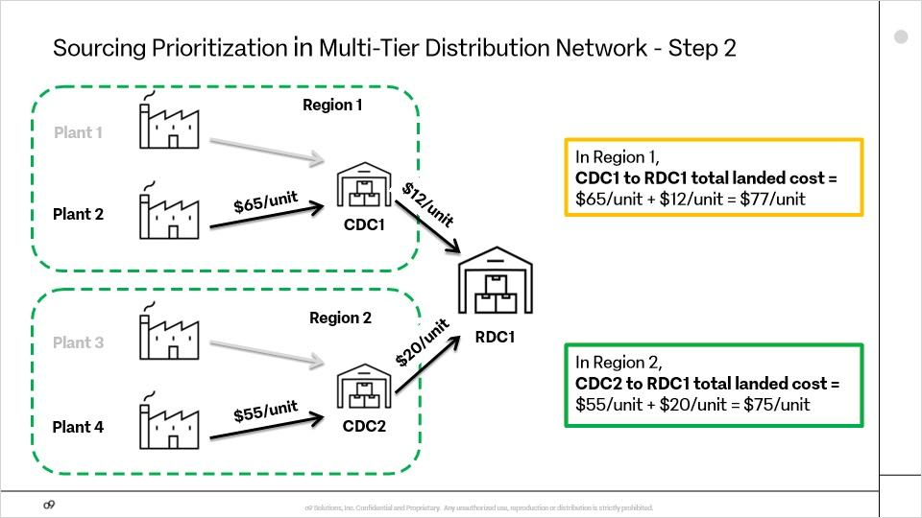
In Step 2, the system computes priorities for the routes from CDCs to RDC1, using the lowest total landed cost found for each region’s plant-to-CDC path to begin. In Region 1, the transportation cost from CDC1 to RDC1 is added to the total landed cost of the priority Plant2 to CDC1 route, yielding a total landed cost for the CDC1 to RDC1 pathway of $77 per unit. Similarly, in Region 2, the transportation cost from CDC2 to RDC1 is added to the total landed cost of the priority Plant4 to CDC2 route, yielding a total landed cost for the CDC2 to RDC1 pathway of $75 per unit. The total landed cost for CDC2 is cheaper, so sourcing from CDC2 is prioritized over sourcing from CDC1.

Sourcing Prioritization With Multi Tier Distribution Network - Solution
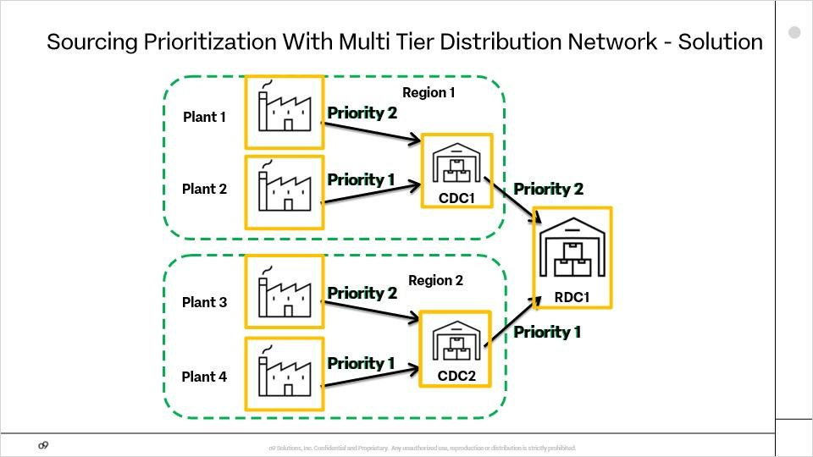
The output of the sourcing prioritization process is a assigning a priority to each lane in the distribution network, as shown here. Let’s take a look at what happens when there is demand at RDC1. CDC2 has been assigned a higher priority than CDC1, so the request goes from RDC1 to CDC2. If CDC2 has safety stock available, it will use it to satisfy the request. Otherwise, the request goes to Plant 4, because it has a higher priority than Plant 3. If Plant 4 cannot fulfill the demand, the request goes to Plant 3. If Plant 3 cannot fulfill the demand, CDC2 notifies RDC1 that it cannot fulfill the demand. The request goes to CDC1, as the priority 2 pathway. If CDC1 does not have safety stock, the request goes to Plant 2. If Plant 2 can’t fulfill the demand, the request goes to Plant 1. As you have seen, the demand is propagated node by node, from downstream to upstream.

Video 5: o9's Solutions for Multi-tier Distribution Network

What are the inputs and outputs of o9’s supply chain solver?
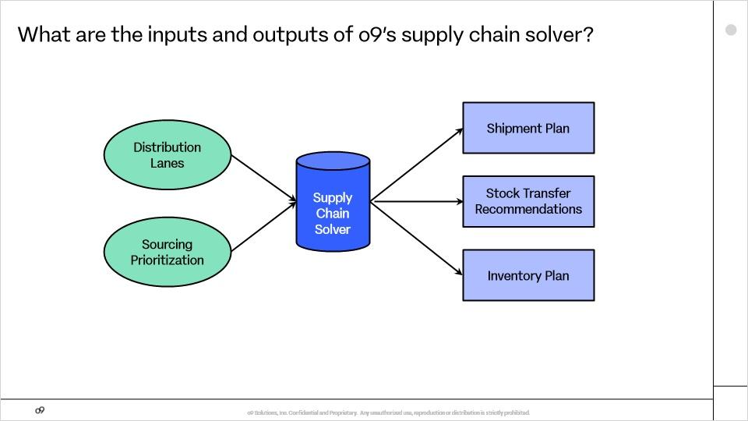
One input is data on distribution lanes, which are also called routes to market or BOD lanes, which stands for bill of distribution lanes. Another input is sourcing prioritization, which is the priority assigned to each distribution lane for each item. Based on these inputs, the solver generates shipment plans, stock transfer recommendations, and inventory plans.

How can you view distribution lane and sourcing prioritization data?
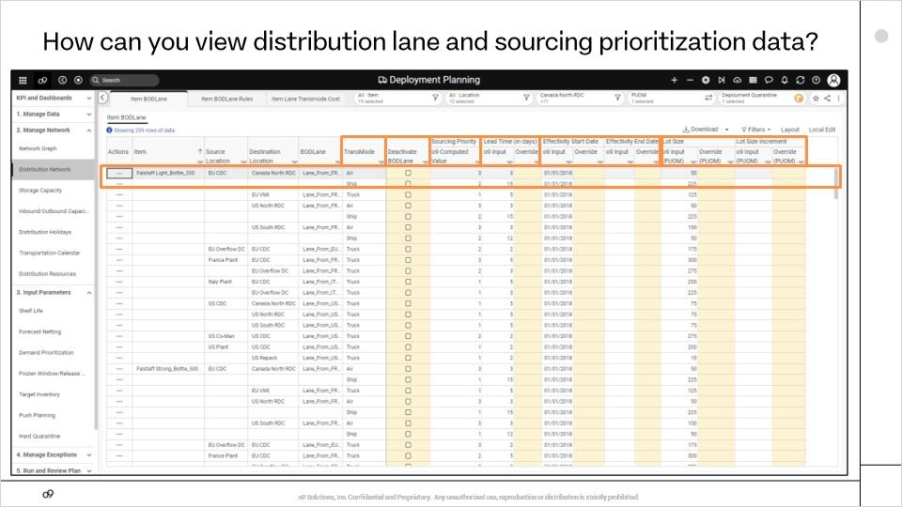
We will start with how you can view distribution lane and sourcing prioritization data, which are the inputs to the supply chain solver. There are many screens in o9 where you can view information on the distribution lanes that are used to move items through the distribution network, but let’s look at one example.
This screen shows transportation modes, lead times for delivery from source to destination, lane effectivity start and end dates, and lot sizes. For example, Falstaff Light Bottle 330 can be transported from the Europe CDC to the Canada North RDC by air or by ship. o9 provides planners with the flexibility to activate or deactivate these lanes according to their requirements. Additionally, o9 calculates sourcing priorities for all feasible lanes associated with each item.

How can you view transportation costs for each lane?
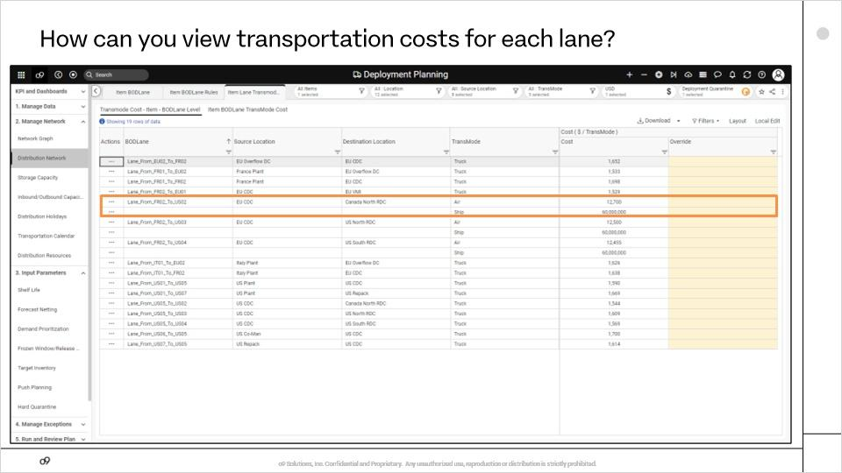
Planners can also view the transportation costs in o9 and override them as needed. For example, here you can see the cost for air and ship transportation from Europe CDC to Canada North RDC.

How do you review shipment plans?
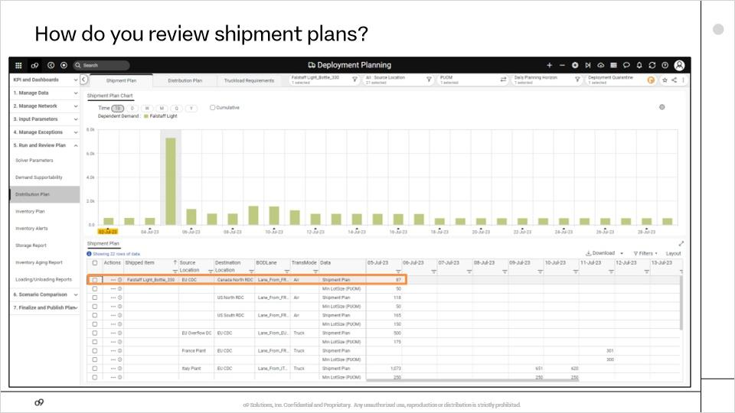
Now, we will look at the outputs of the supply chain solver, beginning with shipment plans.
Shipment plans detail the movement of finished goods between factories, CDCs, and RDCs. For example, you can see that 87 palettes of Falstaff Light Bottle 330 will be transported by air from Europe CDC to Canada North RDC on July 5th.

How do you approve stock transfer recommendations?
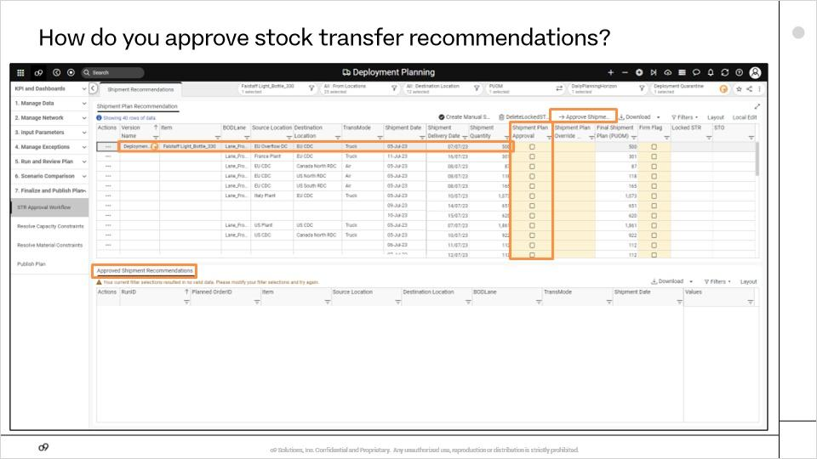
o9 also provides stock transfer recommendations for the movement of stock from one distribution center to another. For example, o9 is recommending the shipment of 500 Falstaff Light Bottle 330 from Europe Overflow DC to Europe CDC by truck leaving July 5 and arriving July 7.
Once reviewed, planners can approve the shipment plan by selecting the check box in the Shipment approval column and then clicking on the "Approve Shipment Plan" action button.
In the "Approved Shipment Recommendations" report, you can see the approved items.

How do you review inventory plans?
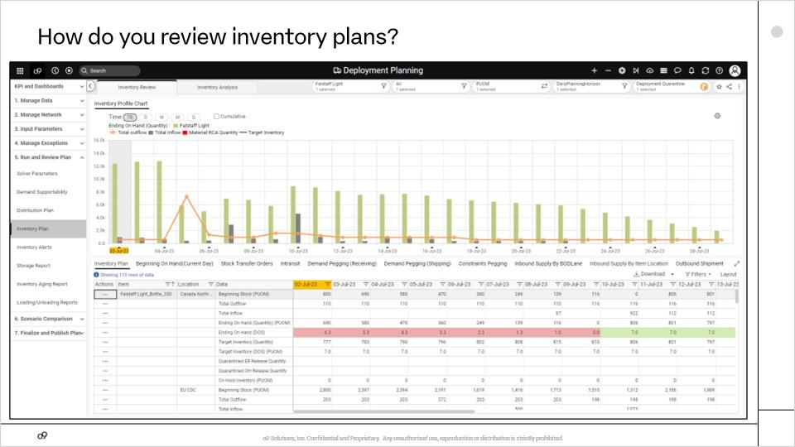
The final output of the supply chain solver that we will discuss is the inventory plan.
The inventory plan allows planners to compare the target inventory and actual inventory across all factories, central distribution centers, and regional distribution centers. Planners can then address the potential stockouts or excess inventory across the distribution network.

