Software

**Project Title**: Smart Solution for Railways **Team ID**: PNT2022TMID42986

**Procedure**

* Install the Python IDLE.

Click <https://www.youtube.com/watch?v=4Rx_JRkwAjY> for the reference video of python installation.

* Install the required python libraries:

Install Watson IoT Python SDK, Cloudant DB, pyzbar, OpenCV to integrate Cloud services, capture the data from the camera, and process the data stored in QR code using the python code.

Install the above libraries using the commands listed below one after the other in the command prompt.

* **pip install wiotp-sdk**
* **pip install ibmcloudant**
* **pip install opencv-python**
* **pip install pyzbar**

Step 1: Type python.org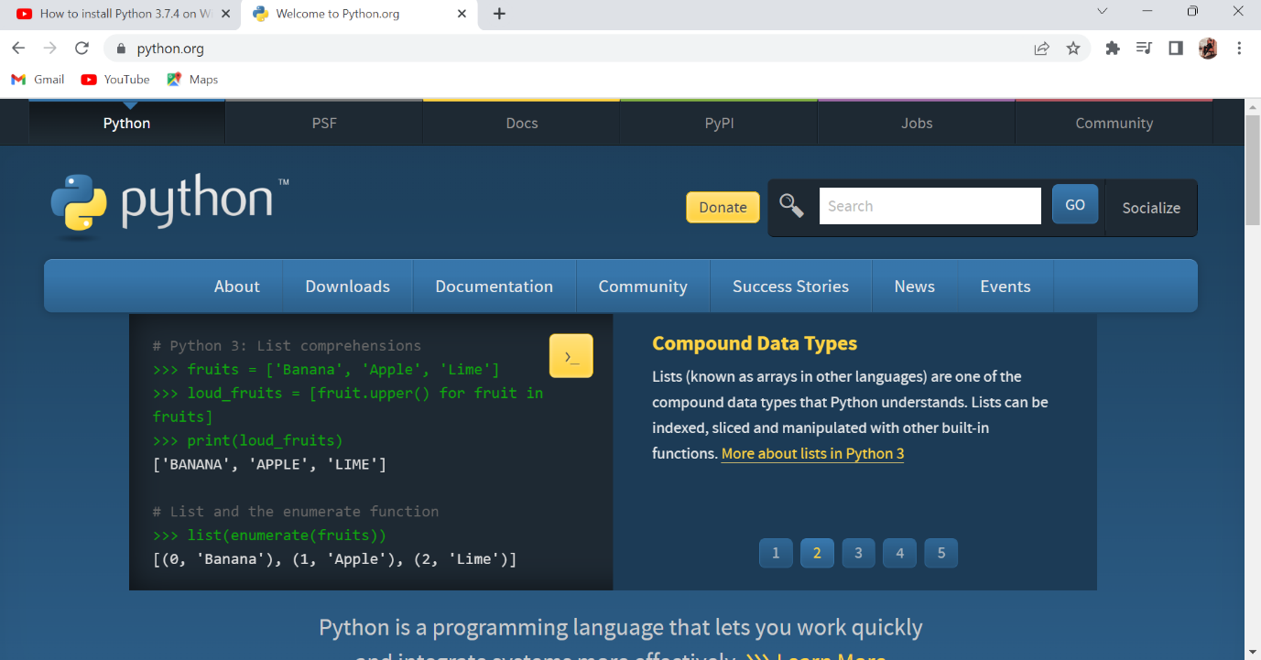

Step 2: Scroll down to DOWNLOAD and click python 3.11.0

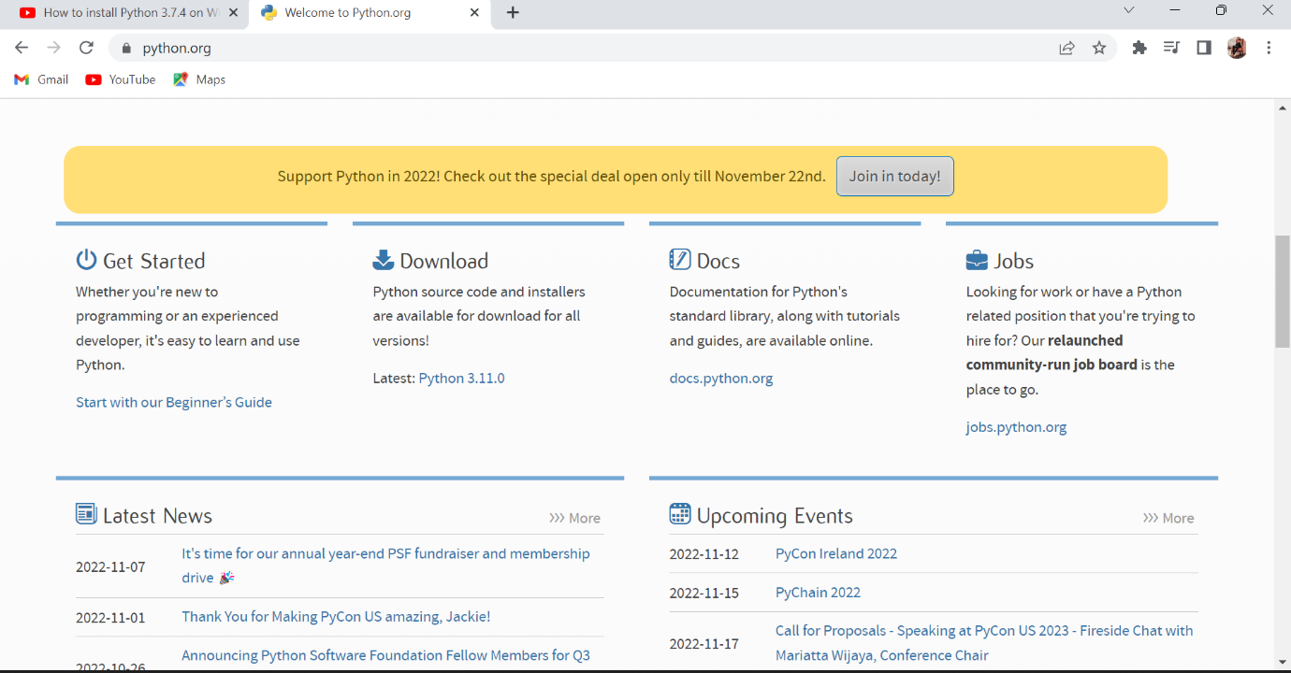

Step 3: Then scroll down to Files and click Windows installer(64-bit) as shown below.



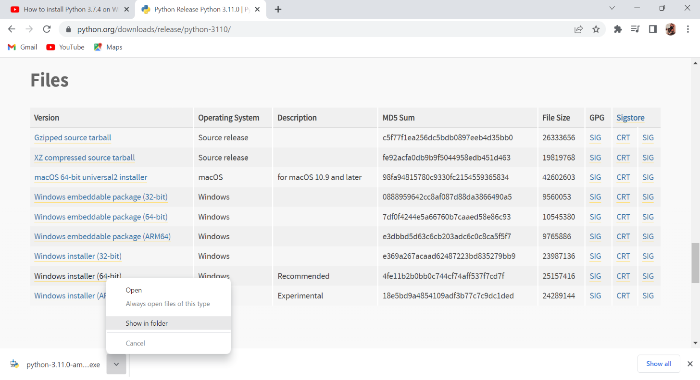



Step 4: Open the Download in file then to install Click python 3.11.0 , Then click Add python.exe to PATH And then click Install now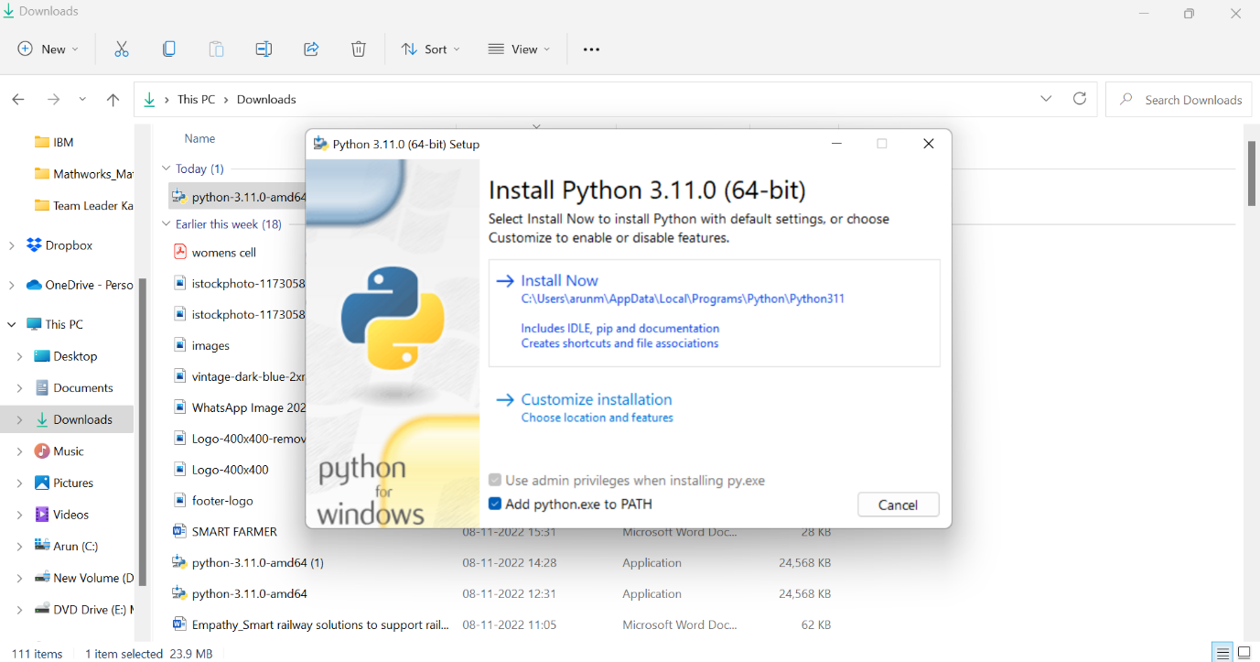

Step 6: After clicking Install now the setup will progress.

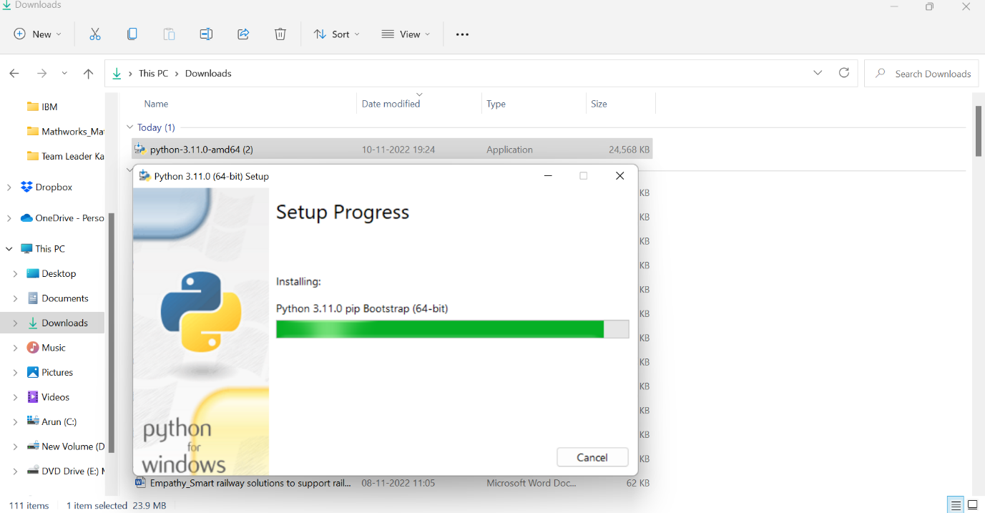

Step 7: After then it will add the windows on recent.

