Pizzeria Bello Website Project
A responsive restaurant website concept
Project overview
Pizzeria Bello is a warm, modern website concept for a neighborhood pizza restaurant. It introduces the restaurant, highlights its menu, and helps visitors find its location and opening hours. The layout is designed to work on both desktop and mobile screens.
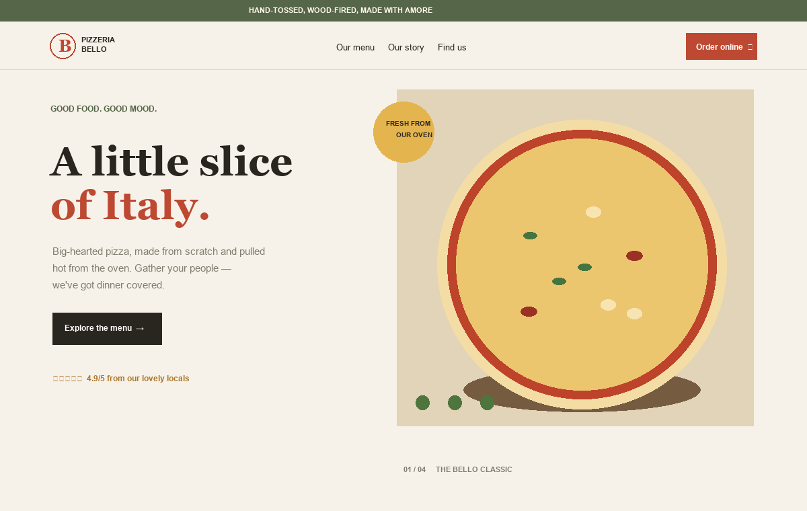
Website preview: homepage and hero section
The homepage uses a simple call to action, restaurant branding, and a large food visual to introduce the concept at a glance.

Menu and site features
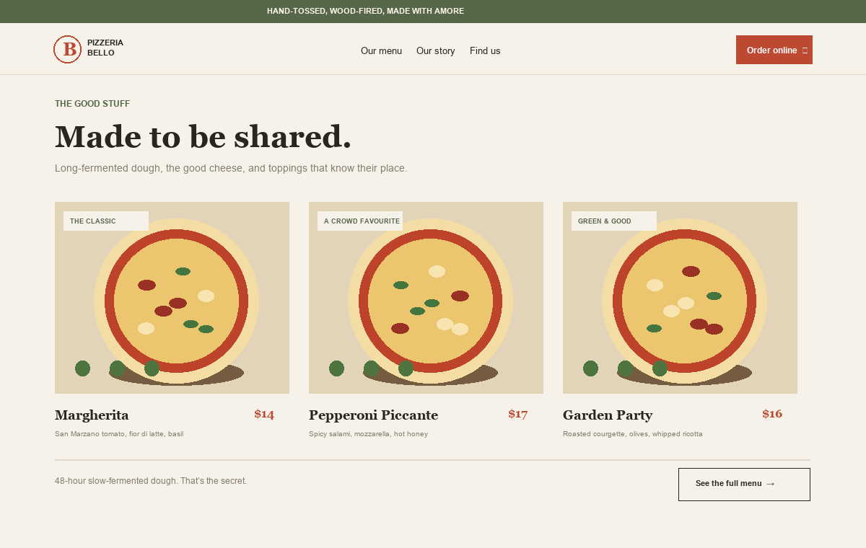
Website preview: featured pizza menu
Menu cards Three featured pizzas with descriptions and sample prices.
Restaurant story A short introduction to the restaurant and its food.
Visit details Sample address, opening hours, directions, and tap-to-call phone link.
Responsive navigation A compact navigation menu for smaller screens.
Visual style Cream backgrounds, tomato-red accents, green details, and editorial typography.
Customization note Restaurant contact details, location, prices, and menu items are sample content and can be replaced for the final presentation.

