KARTIK GULERIA 23DIT015

**Charotar University of Science and Technology**

IT267 – JAVA PROGRAMMING

Practical 1:

**Aim**: In a peaceful town, a budding programmer named Sam was tasked by her mentor, Ms. Java, to declare an integer variable named age, assign it the value of 25, and display it in a sentence. Sam quickly took to her computer and, with focus, wrote a program that would show "25 is the age of Sam." On the screen. Pleased with her work, Sam proudly presented her solution to Ms. Java, who commended her for her precise and clear coding skills.

CODE :

|  |
| --- |
| import java.util.Scanner;    class pra1  { public static void main(String arg[]) {  Scanner sc = new Scanner(System.in);  System.out.println("Enter Your Name : - "); String name=sc.nextLine();  System.out.println("Your Name Is : "+name);    }  } |

OUTPUT :

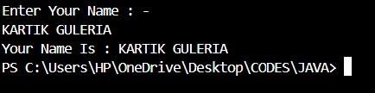

Conclusion:-

This Java program shows how to create a class called p1 and a main method, which is where the program starts running. In the main method, it sets the age to

KARTIK GULERIA 23DIT015

18 and prints "AGE:-18". This example helps understand how to declare a variable and print messages in Java