KARTIK GULERIA 23DIT015

**Charotar University of Science and Technology**

IT267 – JAVA PROGRAMMING Practical 11:

**Aim**: You're a budding Java programmer working on a currency conversion application. Your initial task is to convert Pounds to Rupees. To practice different input methods, you decide to implement two approaches: command line arguments and user input using the Scanner class.

CODE :

|  |
| --- |
| import java.util.Scanner; public class prac_12 { public static void main(String[] args)  {  System.out.println("Enter pound -  "); Scanner sc=new  Scanner(System.in); float p  =sc.nextFloat(); float r=p*100;  System.out.println("The converted rupees is "+r);  System.out.println("KARTIK GULERIA - 23DIT015");  } } |

OUTPUT :

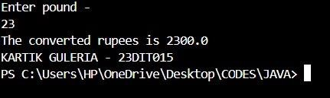

Conclusion:-

This Java program converts an amount from pounds to rupees. It prompts the user to enter an amount in pounds, then uses the pound method to convert it to rupees by multiplying the pounds amount by 100.