**Charotar University of Science and Technology**

IT267 – JAVA PROGRAMMING Practical 12:

**Aim**: Create a class called Employee that includes three pieces of information as instance variables—a first name (type String), a last name (type String), and a monthly salary (double). Your class should have a constructor that initializes the three instance variables. Provide a set and a get method for each instance variable. If the monthly salary is not positive, set it to 0.0. Write a test application named EmployeeTest that demonstrates class Employee’s capabilities. Create two Employee objects and display each object’s yearly salary. Then give each Employee a 10% raise and display each Employee’s yearly salary again.

CODE :

|  |
| --- |
| import java.util.Scanner;  class  Employee  { public String fn ; public String ln; public double sal;  Employee() { fn="0"; ln="0"; sal=0;  }  Scanner sc= new Scanner(System.in); void  set_Firstname()  {  System.out.print("Enter first name - "); fn = sc.nextLine(); } void set_Lastname()  {  System.out.print("Enter last name - "); ln = sc.nextLine(); } void set_Salary()  {  System.out.print("Enter your monthly salary :  "); sal = sc.nextDouble(); if(sal<0)  {  sal=0;  } }  void get_firstname()  {  System.out.println("The first name is " + fn); } |
| void get_lastname()  {  System.out.println("The last name is " + ln);  } void get_bsalary() {  System.out.println("Before raise , the monthly salary is "+ sal);  } void get_asalary()  {  sal = sal +(sal*0.1);  System.out.println("After raise , the monthly salary is "+sal); } }      public class prac_13 { public static void main(String[] args)  {  Employee emp1 = new Employee(); Employee emp2 = new Employee(); emp1.set_Firstname(); emp1.set_Lastname(); emp1.set_Salary(); System.out.println(); emp2.set_Firstname(); emp2.set_Lastname(); emp2.set_Salary(); System.out.println(); emp1.get_firstname(); emp1.get_lastname(); emp1.get_bsalary(); emp1.get_asalary(); System.out.println(); emp2.get_firstname(); emp2.get_lastname();  emp2.get_bsalary(); emp2.get_asalary();  System.out.println("KARTIK GULERIA - 23DIT015");  }  } |

OUTPUT :

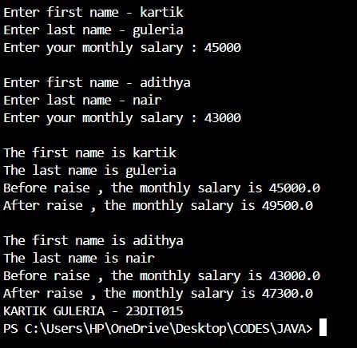

Conclusion:-

This Java program defines an employee class to manage employee details, including first name, last name, and salary. It includes methods to set and get these details, with additional functionality to calculate and display yearly salary and a 10% salary increase. The p13 class creates two employee objects, prompts the user to enter details for each, and displays the results, including the yearly salary and the increased salary after applying a 10% rise.