**Charotar University of Science and Technology**

IT267 – JAVA PROGRAMMING Practical 13:

**Aim**: Create a class called Date that includes three pieces of information as instance variables—a month (type int), a day (type int) and a year (type int). Your class should have a constructor that initializes the three instance variables and assumes that the values provided are correct. Provide a set and a get method for each instance variable. Provide a method displayDate that displays the month, day and year separated by forward slashes (/). Write a test application named DateTest that demonstrates class Date’s capabilities.

CODE :

|  |
| --- |
| import java.util.Scanner;    class date  { public int day; public int month; public int year; Scanner sc = new Scanner(System.in); date() { day=0; month=0; year=0;  } void set_day()  {  System.out.print("Enter Day : "); day = sc.nextInt(); } void set_month()  {  System.out.print("Enter Month : "); month = sc.nextInt();  } void set_year()  {  System.out.print("Enter Year : "); year = sc.nextInt(); } void displayDate()  {  System.out.println("Date : "+day+"/"+month+"/"+year); }    } public class prac_14 { public static void main(String[] args)  { date d = new date(); |
| d.set_day();  d.set_month(); |

d.set_year();

d.displayDate();

System.out.println("KARTIK GULERIA - 23DIT015"); } }

OUTPUT :

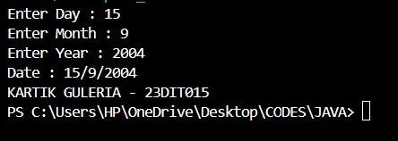

Conclusion:-

This Java program manages and displays a date using the date class. The p14 class creates an instance of date, prompts the user to input the day, month, and year, and then displays this information. The date class includes methods to set and get the date components and to display the complete date in the format "day/month/year."