KARTIK GULERIA 23DIT015

**Charotar University of Science and Technology**

IT267 – JAVA PROGRAMMING Practical 14:

**Aim**: Write a program to print the area of a rectangle by creating a class named 'Area' taking the values of its length and breadth as parameters of its constructor and having a method named 'returnArea' which returns the area of the rectangle.

Length and breadth of rectangle are entered through keyboard.

CODE :

|  |
| --- |
| import java.util.Scanner;  class Area { int l; int b;  Area(int len, int bre)  { l=len; b=bre;  } void find_area() {  int area = l*b;  System.out.println("The area of rectangle is "+area); }  } public class prac_15  { public static void main(String[] args) {  Scanner sc = new Scanner(System.in); int l,b;  System.out.println("Enter the length of rectangle : "); l = sc.nextInt();  System.out.println("Enter the breadth of rectangle : "); b = sc.nextInt(); Area a=new Area(l,b); a.find_area();  System.out.println("KARTIK GULERIA - 23DIT015");  }  } |

KARTIK GULERIA 23DIT015

OUTPUT :

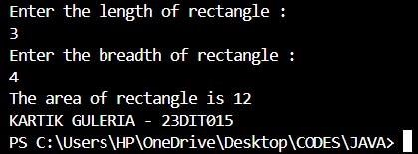

Conclusion:-

This Java program calculates the area of a rectangle. The p15 class takes user input for the rectangle's length and breadth, creates an area object with these dimensions, and computes the area. The area class stores the computed area and provides a method to return it. The program then prints the area of the rectangle.