KARTIK GULERIA 23DIT015

**Charotar University of Science and Technology**

IT267 – JAVA PROGRAMMING Practical 15:

**Aim**: Imagine you're building a scientific calculator application. One crucial feature is handling complex numbers. You decide to create a Complex class to represent complex numbers and perform operations on them. (sum, difference and product) CODE :

|  |
| --- |
| import java.util.*; public class p16 { public static void main(String[] args) { complax o; o = new complax(); o.sum(); o.diff();  o.mul();  System.out.println("KARTIK GULERIA - 23DIT015"); } }  class complax {  Scanner sc = new Scanner(System.in); int re1, im1, re2, im2;  complax() {  System.out.println("Enter the real and imaginary part of the first complex number:"); re1 = sc.nextInt(); im1 = sc.nextInt(); System.out.println("Enter the real and imaginary part of the second complex number:"); re2 = sc.nextInt(); im2 = sc.nextInt();  }  void sum() {  System.out.println("Sum of complex number is: " + (re1 + re2) + "+" +  (im1 + im2) + "i");  }  void diff() {  System.out.println("Difference of complex number is: " + (re1 - re2) +  "+" + (im1 - im2) + "i");  }  void mul() {  System.out.println("Product of complex number is "+((re1*re2)-  (im1*im2))+"+"+((re1*im2)+(re2*im1))+"i"); }    } |

KARTIK GULERIA 23DIT015

OUTPUT :

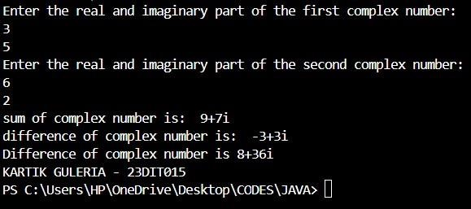

Conclusion:-

This Java program performs operations on complex numbers. It prompts the user to input the real and imaginary parts of two complex numbers, then calculates and displays their sum, difference, and product. The complax class handles these operations, using methods to compute and print the results.