**Charotar University of Science and Technology**

IT267 – JAVA PROGRAMMING Practical 17:

Aim:

Create a class named 'Member' having the following members: Data members

1 - Name

2 - Age

3 - Phone number

4 - Address

5 – Salary

It also has a method named 'printSalary' which prints the salary of the members. Two classes 'Employee' and 'Manager' inherits the 'Member' class. The 'Employee' and 'Manager' classes have data members 'specialization' and 'department' respectively. Now, assign name, age, phone number, address and salary to an employee and a manager by making an object of both of these classes and print the same.

CODE :

import java.util.Scanner;

public class prac_17 {

    public static void main(String[] args)

    {

       employee emp = new employee();

       manager m = new manager();

       emp.details();

       m.details();

       emp.printedetails();

       m.printmdetails();

       System.out.println("KARTIK GULERIA - 23DIT015");

    }

}

class member

{

    Scanner sc = new Scanner(System.in);

    Scanner sc1 = new Scanner(System.in);

    Scanner sc2 = new Scanner(System.in);

    String name;

    int age;

    String number;

    String address;

    int salary;

    void details()

    {

      System.out.print("Enter name : ");

      name = sc.nextLine();

      System.out.print("Enter age : ");

      age = sc.nextInt();

      System.out.print("Enter phone number : ");

      number = sc1.nextLine();

      System.out.print("Enter address : ");

      address = sc2.nextLine();

      System.out.print("Enter salary : ");

      salary = sc.nextInt();

    }

    void printedetails()

    {

        System.out.println("For Employee : ");

        System.out.println("Name : "+ name +" Age : "+age+" Phone no. : "+number+" Address : "+address+" Salary : "+salary);

    }

    void printmdetails()

    {

        System.out.println("For Employee : ");

        System.out.println("Name : "+ name +" Age : "+age+" Phone no. : "+number+" Address : "+address+" Salary : "+salary);

    }

    void printsalary()

    {

      System.out.println("Salary is " + salary);

    }

}

class employee extends member

{

   String specialization;

}

class manager extends member

{

   String department;

}

OUTPUT :

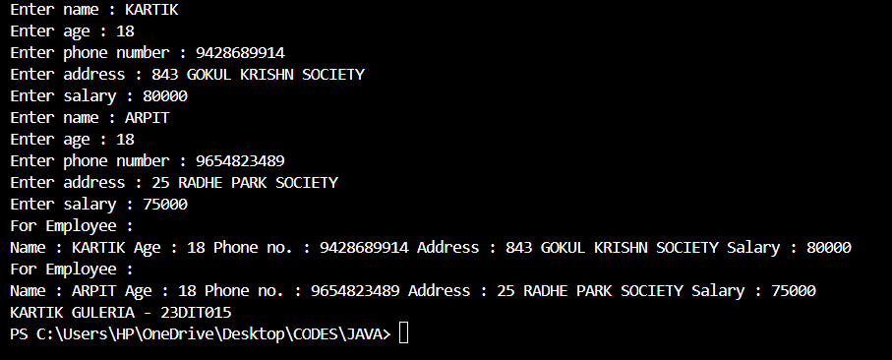

P a g e 2 | 2