KARTIK GULERIA 23DIT015

**Charotar University of Science and Technology**

IT267 – JAVA PROGRAMMING

Practical 3:

**Aim**: A typical mobile number in India is “+91-AA-BBB-CCCCC”. Where the first two digits (AA)indicate a mobile system operator, the next three (BBB) denote the mobile switching code (MSC) while the remaining five digits (CCCCC) are unique to the subscriber. Write an application that takes a mobile number as an input from a user in above mentioned format and display code for mobile system operator, mobile switching code and last 5 digits which are unique to subscriber. Ex. For an input +91-94-999-65789, output should be: Mobile system operator code is 94 MSC is 999 Unique code is 65789

CODE :

|  |
| --- |
| import  java.util.Scanner;    class pra3  {  public static void main(String[] args) {  System.out.print("Enter You mobile number of this formate  (+919624105887): - ");  Scanner sc = new Scanner(System.in); long mobile_number = sc.nextLong(10); System.out.println(mobile_number); long x=100000000,y,k,b; y=mobile_number/x; k=mobile_number/100000;  //System.out.println("Syetem MSc is : -  "+k); b=mobile_number%100000; k=k-  (y*1000);  System.out.println("Syetem opreter code is : - "+y);  System.out.println("Syetem MSc is : - "+k);  System.out.println("Syetem Unique code is : - "+b);  System.out.println("KARTIK GULERIA - 23DIT015"); }  } |

OUTPUT :

KARTIK GULERIA 23DIT015

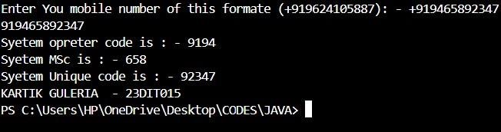

Conclusion:-

This Java program, defined in the class p3, processes a mobile phone number entered by the user. It splits the mobile number into three parts: the mobile system operator (first two digits), the MSC (Mobile Switching Center) number (next three digits), and the unique subscriber number (last five digits). The program then prints these parts separately. This example demonstrates basic string manipulation and user input handling in Java.