**Charotar University of Science and Technology**

IT267 – JAVA PROGRAMMING

Practical 4:

**Aim**: An electric appliance shop assigns code 1 to motor,2 to fan,3 to tube and 4 for wires. All other items have code 5 or more. While selling the goods, a sales tax of 8% to motor,12% to fan,5% to tube light,7.5% to wires and 3% for all other items is charged. A list containing the product code and price in two different arrays. Write a java program using switch statement to prepare the bill.

CODE :

|  |
| --- |
| import java.util.Scanner;    class pra4  { public static void main(String[] args) {  float motor_prize;  Scanner sc = new  Scanner(System.in); int u; do{  System.out.println("\n\n\t\tMAIN M");  System.out.println("\t\t0.MOTOR");  System.out.println("\t\t1.FAN");  System.out.println("\t\t2.LIGHT");  System.out.println("\t\t3.wires");  System.out.print("\t\t4.Exit \n Enter Any One : - "); u = sc.nextInt(); String[] a={"motor","fan","Light","wires"}; int[] b={1000,500,600,800}; int[] c={8,5,6,18};  System.out.println("YOUR choice IS "+u);  switch(u)  { case 1: |
| {    System.out.println("You Enter :- "+a[u]); motor_prize=b[u]+((c[u]*b[u])/100);  System.out.println("Motor Prize is: -"+motor_prize);  break;  } case 2:  {  System.out.println("You Enter :- "+a[u]); motor_prize=b[u]+((c[u]*b[u])/100);  System.out.print(a[u]);  System.out.println(" Prize is: -"+motor_prize); break;  } case 3:  {  System.out.println("You Enter :- "+a[u]); motor_prize=b[u]+((c[u]*b[u])/100);  System.out.print(a[u]);  System.out.println(" Prize is: -"+motor_prize); break;  } case 4:  {  System.out.println("You Enter :- "+a[u]); motor_prize=b[u]+((c[u]*b[u])/100);  System.out.print(a[u]);  System.out.print(" Prize is: -"+ motor_prize); break;  } case 5:  {  System.out.println("thank you");  } default:  {  System.out.println("This is Wrong.....");  }  }  }while(u!=5);  System.out.print("KARTIK GULERIA - 23DIT015");  }  } |

OUTPUT :

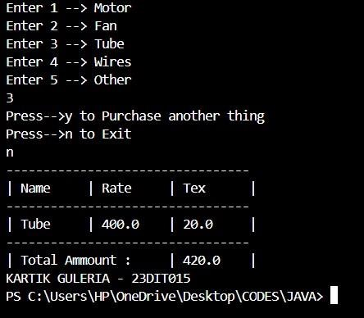

Conclusion:-

This Java program allows users to buy items like motors, fans, tubes, and wires, calculating the total cost including tax. Users choose an item, specify the quantity, and the program calculates the price, adding it to the total bill. It continues to prompt the user until they decide to stop shopping. At the end, it displays the final bill with the breakdown of each item and the total amount spent. This program demonstrates basic loops, conditionals, and arithmetic operations in Java.