**Charotar University of Science and Technology**

IT267 – JAVA PROGRAMMING

Practical 5:

**Aim**: Create a Java program that simulates a guessing game, where the computer picks a random number between 1 and 100 and the user has to guess it. We can use the Scanner class to 1 get user input and a loop to allow multiple guesses.

* Prompt the user to guess the number and keep track of the number of attempts they make.
* Use if-else statements to give feedback like too low or too high compared to the number.
* Use a loop to allow the user to guess again until they guess the correct number

CODE :

|  |
| --- |
| import java.util.*;  // import java.io.*; // import java.util.Random; import java.util.Scanner; // import java.util.random.*; public class pr_5  { public static void main(String[] args) { Random r = new Random(); int x = r.nextInt(100); int i=0;  Scanner sc = new Scanner(System.in); while(i!=5){  System.out.println("Guess the any Number between 1 to 100"); // System.out.print("Enter your Number : "); int n = sc.nextInt(); if(n>=(x+10)){  System.out.println("too High");  }  else if(n==x){  System.out.println("You Win");  } else  {  System.out.println("too Low");  } i++;  }  System.out.println( "Answer is : " + x);  System.out.println("KARTIK GULERIA -23DIT015");  }  } |

OUTPUT :

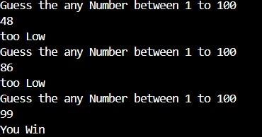

Conclusion:-

This Java program is a number guessing game where the user has five attempts to guess a randomly generated number between 0 and 99. After each guess, the program provides feedback on whether the guess is correct, very far (more than 20 away), or very close (less than 20 away) to the random number.