KARTIK GULERIA 23DIT015

# Charotar University of Science and Technology

IT267 – JAVA PROGRAMMING Practical 7:

**Aim**: Imagine you're working with an array of integers, and your task is to count how many times the number 9 appears in the array. How would you write a Java program that efficiently determines this count, regardless of the array's size or the position of the numbers?

CODE :

|  |
| --- |
| import java.util.Scanner;    public class pra_7 {  public static void main(String[] args) {  Scanner sc = new Scanner(System.in);  System.out.print("Enter How Many Element You Want in Array :  "); int n = sc.nextInt(); int arr[] = new int[n]; |
| int count = 0;  for (int i = 0; i < n; i++) {  System.out.print("Enter Element " + (i + 1) + " : "); arr[i] = sc.nextInt();  } for (int i = 0; i  < n; i++) { if (arr[i] == 9)  { count++;  }  }  System.out.println("9 is in this Array : " + count + " times");  System.out.println("KARTIK GULERIA - 23DIT015");  } } |

KARTIK GULERIA 23DIT015

OUTPUT :

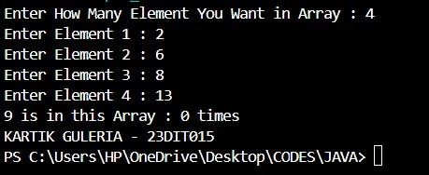4

Conclusion:-

This Java program counts the number of times the number 9 appears in a predefined array. Here's a breakdown of the steps: 1. The program initializes an array with several integers.

1. It sets the number to count (k) as 9.
2. It iterates through the array, checking each element to see if it matches 9.
3. It keeps a count of how many times 9 appears.
4. After finishing the loop, it prints out the total count of occurrences of 9 in the array.

This example demonstrates basic array traversal and counting in Java.