 | CHAROTAR UNIVERSITY OF SCIENCE & TECHNOLOGY  DEVANG PATEL INSTITUTE OF ADVANCE TECHNOLOGY AND RESEARCH | 

WEEK-1 REPORT

Project ID: | Student ID: 23DIT015
From Date: 17/12/2025 | To Date: 23/12/2026
Semester: 6th | SGP ID:

Rough Gantt Chart (Project Timeline: 17/12/2025 → 05/04/2026)

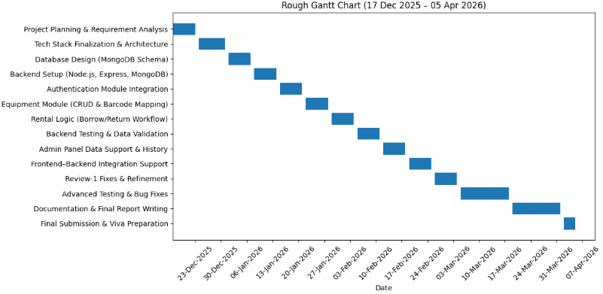

Studied and understood the problem statement related to manual sports equipment management in educational institutions.
Analyzed existing issues such as lack of real-time availability, manual tracking, delayed returns, and poor accountability.
Participated in initial project planning discussions with team members.
Identified functional requirements such as equipment borrowing, return, penalty calculation, and admin management.
Analyzed system requirements from a database and backend perspective.
Identified core data entities required for the system: User, Equipment, and Rental.
Contributed to high-level system architecture discussion, focusing on how backend and database will support application workflows.
- Plans for next week:
- Finalize technology stack decisions.
- Design high-level database architecture using MongoDB.
- Define relationships between core entities.
- Assist in preparing architecture-related inputs for Review-1.

References:

MongoDB Data Modeling
https://www.mongodb.com/docs/manual/core/data-model-design/
Mongoose Documentation
https://mongoosejs.com/docs/

Kartik Guleria (23DIT015) -

Signature of Student Signature of Mentor

