Java Lab File
Kartik Verma
CSE-3
Lab 4:-
Program 12: Write a java program to implement run time polymorphism using method overriding.
Code:-
class Animal {
void sound() {
System.out.println("Animal makes a sound");
}
}
class Dog extends Animal {
void sound() {
System.out.println("Dog barks");
}
}
class Cat extends Animal {
void sound() {
System.out.println("Cat meows");
}
}
public class Kartik{
public static void main(String args[]){
// Method Over-riding
Animal animal1 = new Animal();
Animal animal2 = new Dog(); // constructor of "DOG" class will be called
Animal animal3 = new Cat(); // constructor of "Cat" class will be called
// but the object is of Animal class---
animal1.sound(); // Output: Animal makes a sound
animal2.sound(); // Output: Dog barks
animal3.sound(); // Output: Cat meows
}
}
Output
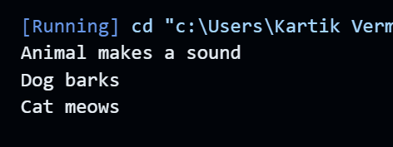

Java Lab File
Kartik Verma
CSE-3
Lab 4:-
Program 11: Write a java program to implement compile time polymorphism using method overloading.
Code:-
class PolymorphismExample {
// Method to add two integers
static int add(int a, int b) {
return a + b;
}
// Method to add three integers
static int add(int a, int b, int c) {
return a + b + c;
}
// Method to concatenate two strings
static String add(String a, String b) {
return a + b;
}
}
public class Kartik{
public static void main(String args[]){
PolymorphismExample p1=new PolymorphismExample();
int sum1 = p1.add(5, 10); // Invokes the first add method
int sum2 = p1.add(5, 10, 15); // Invokes the second add method
String result = p1.add("Hello, ", "world!"); // Invokes the third add method
System.out.println("Sum of two integers: " + sum1);
System.out.println("Sum of three integers: " + sum2);
System.out.println("Concatenated string: " + result);
}
}

Output
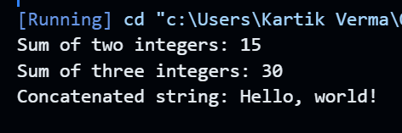

Java Lab File
Kartik Verma
CSE-3
Lab 4:-
Program 10: Write a java program to implement Inhertiance: Single, Multilevel, and Hierarchical.
Code:-
class Vehicle {
void move() {
System.out.println("Vehicle is moving...");
}
}
class Car extends Vehicle {
void accelerate() {
System.out.println("Car is accelerating...");
}
}
// Multilevel Inheritance
class Airplane extends Vehicle {
void fly() {
System.out.println("Airplane is flying...");
}
}
class Jet extends Airplane {
void supersonic() {
System.out.println("Jet is flying at supersonic speed...");
}
}
// Hierarchical Inheritance
class Bicycle extends Vehicle {
void pedal() {
System.out.println("Bicycle is being pedaled...");
}
}
class Motorcycle extends Vehicle {
void revEngine() {
System.out.println("Motorcycle is revving its engine...");
}
}
public class Kartik{
public static void main(String args[]){
// Single level Inheritance
Car car = new Car();
car.move(); // Output: Vehicle is moving...
car.accelerate(); // Output: Car is accelerating...
// Multilevel Inheritance
Jet jet = new Jet();
jet.move(); // Output: Vehicle is moving...
jet.fly(); // Output: Airplane is flying...
jet.supersonic(); // Output: Jet is flying at supersonic speed...
// Hierarchical Inheritance
Bicycle bicycle = new Bicycle();
bicycle.move(); // Output: Vehicle is moving...
bicycle.pedal(); // Output: Bicycle is being pedaled...
Motorcycle motorcycle = new Motorcycle();
motorcycle.move(); // Output: Vehicle is moving...
motorcycle.revEngine();
}
}

Output
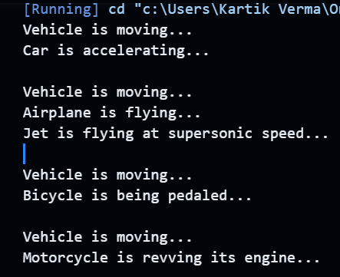

Java Lab File
Kartik Verma
CSE-3
Lab 4:-
Program 9: Write and implement java program to instance methods and static methods.
Code:-
public class MathOperations {
// Instance method to calculate the square of a number
double square(double num) {
return num * num;
}
// Static method to calculate the factorial of a number
static int factorial(int n) {
if (n == 0)
return 1;
else
return n * factorial(n - 1);
}
public static void main(String[] args) {
MathOperations mathObj = new MathOperations();

// Calling instance method
double result1 = mathObj.square(5.5);
System.out.println("Square of 5.5 is: " + result1); // Output: Square of 5.5 is: 30.25

// Calling static method
int result2 = factorial(5);
System.out.println("Factorial of 5 is: " + result2); // Output: Factorial of 5 is: 120
}
}
Output

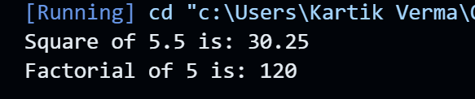

Java Lab File
Kartik Verma
CSE-3
Lab 3:-
Program 8: Write and implement java program to in-built methods and user-defined methods.
Code:-
import java.util.Arrays;
public class MethodExample {

// User-defined method to find the maximum value in an array
public static int findMax(int[] arr) {
int max = Integer.MIN_VALUE;
for (int num : arr) {
if (num > max) {
max = num;
}
}
return max;
}

public static void main(String[] args) {
// Using in-built methods
int[] numbers = {5, 2, 9, 1, 7};
Arrays.sort(numbers); // Using in-built sort method
System.out.println("Sorted numbers: " + Arrays.toString(numbers));

// Using the user-defined method
int maximum = findMax(numbers);
System.out.println("Maximum number: " + maximum);
}
}
Output

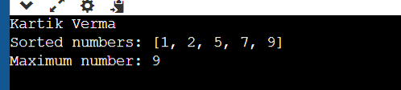

Java Lab File
Kartik Verma
CSE-3
Lab 3:-
Program 7: Write and implement java program to create class and object initialization by the 3 methods i.e. using class reference variable, using methods, using constructors.
Code:-

class Person {
private String name;
private int age;
// Constructor method to initialize name and age
public Person(String name, int age) {
this.name = name;
this.age = age;
}
// Method to set name
public void setName(String name) {
this.name = name;
}
// Method to set age
public void setAge(int age) {
this.age = age;
}
// Method to display information
public void displayInfo() {
System.out.println("Name: " + name);
System.out.println("Age: " + age);
}
}

public class Main {
public static void main(String[] args) {
// Using class reference variable
Person person1 = new Person("Alice", 30);
person1.displayInfo();

// Using methods
Person person2 = new Person("", 0); // Create object with default values
person2.setName("Bob");
person2.setAge(25);
person2.displayInfo();

// Using constructor
Person person3 = new Person("Charlie", 35);
person3.displayInfo();
}
}

Output

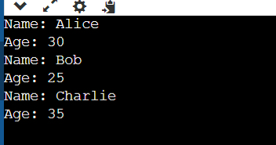

Java Lab File
Kartik Verma
CSE-3
Lab 2:-
Program 2: Fibonacci series in java.
Code:-
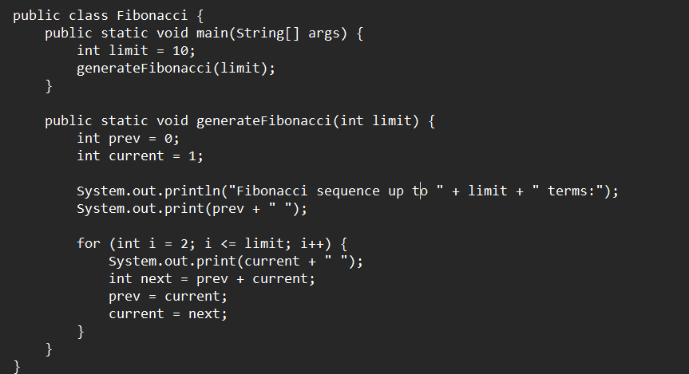

Output

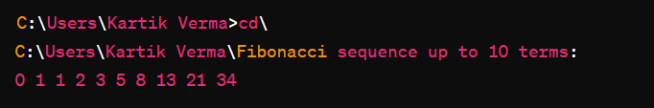

Java Lab File
Kartik Verma
CSE-3
Lab 2:-
Program 3: Prime number program in java.
Code:-
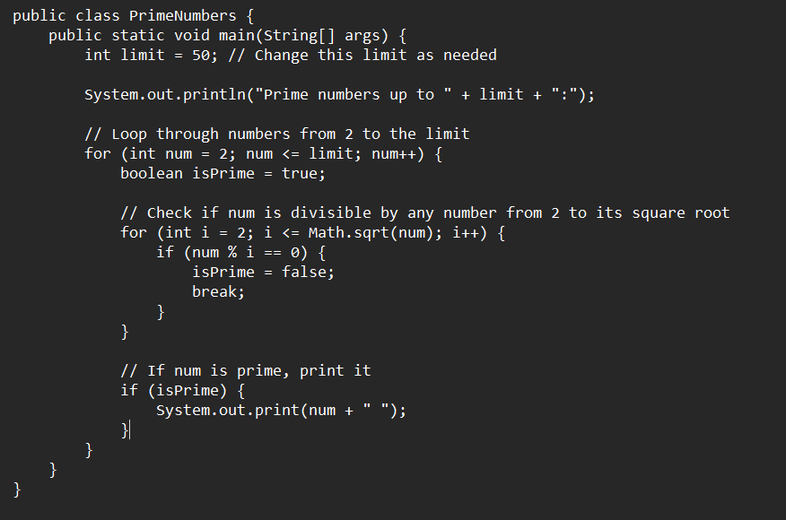

Output
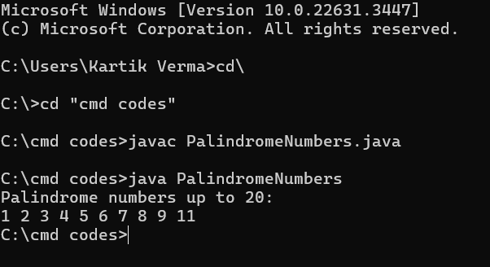

Java Lab File
Kartik Verma
CSE-3
Lab 2:-
Program 4: Palindrome program in java.
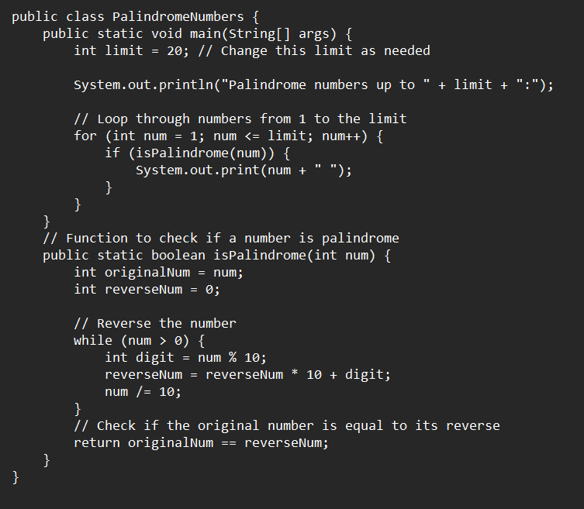
Code:-

Output

Java Lab File
Kartik Verma
CSE-3
Lab 2:-
Program 5: Factorial program in java.
Code:-
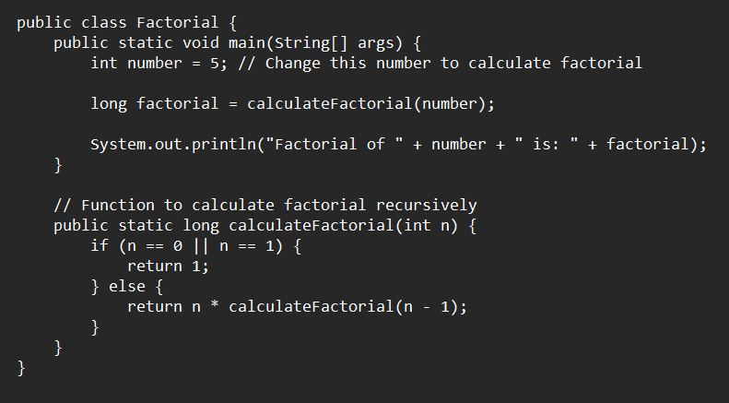

Output
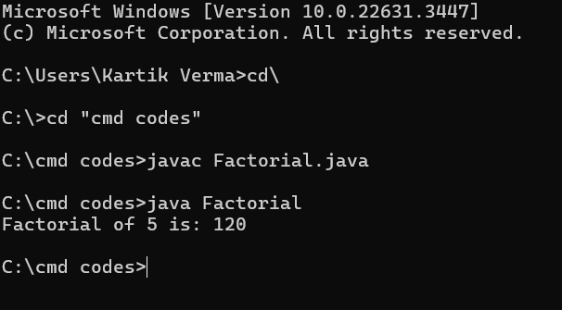

Java Lab File
Kartik Verma
CSE-3
Lab 2:-
Program 6: Factorial program in java.
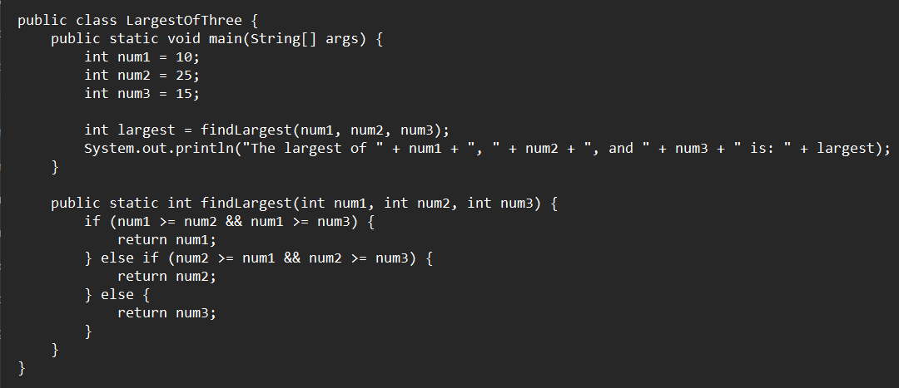
Code:-

Output

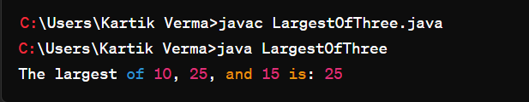

Java Lab File
Kartik Verma
CSE-3
Lab 1:-
Program 1: Write Simple Java Program to print “Hello World!” string using Eclipse Platform. Explain working of each and every line of program. Give Brief introduction of Eclipse Platform.
Code:-
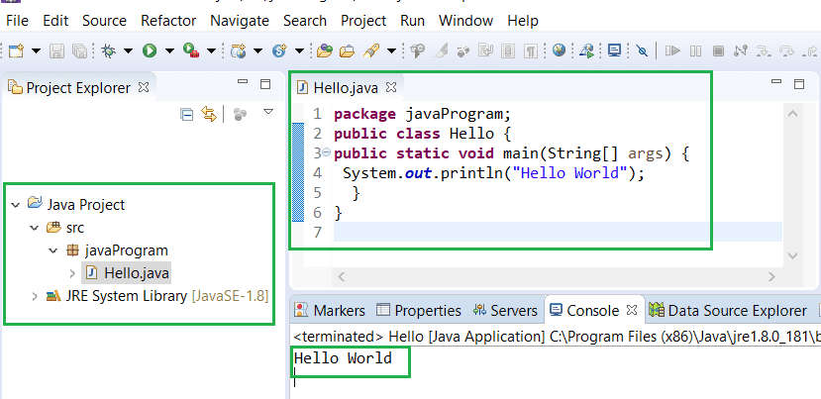

Explanation of each & every line of code:-
- public class HelloWorld : This line declares a class named HelloWorld. In Java, every program must have at least one class, and the class name must match the filename (without the .java extension). The public keyword indicates that the class is accessible from other classes.
- public static void main(String[] args) : This line declares the main method, which is the entry point of the Java program. This method is where the program starts executing. It takes an array of strings args as input, which allows the program to accept command-line arguments. The public and static keywords are access modifiers that allow the method to be called from outside the class without creating an instance of the class. The void keyword indicates that the method does not return any value.
- System.out.println("Hello World!"); : This line prints the string "Hello World!" to the console. The System.out is an object of type PrintStream that represents the standard output stream. The println method is used to print the specified string followed by a newline character to the console.

Eclipse Platform:
- Integrated Development Environment (IDE) for Java.
- Offers features like code editing, debugging, and project management.
- Supports other languages via plugins.
- Highly customizable and extensible.
- Popular among Java developers for its robust tools and user-friendly interface.


