CROSSTAB EXPORTS
Row and Column Percentages in Exports
Short product brief and prototype walkthrough
Prototype: https://survey-re.vercel.app/reports

Problem statement
BI crosstab cells can show a count, row percentage, and column percentage together. The UI identifies row percentages with an orange R% prefix and column percentages with a blue C% prefix, but the current XLSX export writes both as unlabeled black values. The prototype should preserve these prefixes and colors in the workbook without changing calculations or report structure.

How to reach the prototype
Step 1 Open the official Survey-RE prototype link above.
Step 2 Open the report named “Variable cross tab” at Reports → Variable cross tab.
Step 3 Open Report settings → Analytics and enable Count, Row percentage, and Column percentage.
Step 4 Select Apply and verify each visible body cell uses Count, orange R%, and blue C% in that order.
Step 5 Select the Excel download icon, wait for Progress to reach 100%, then select the completed XLSX filename.
Export cell order: Count, R% row percentage, C% column percentage. Prefixes are retained even when color is unavailable.
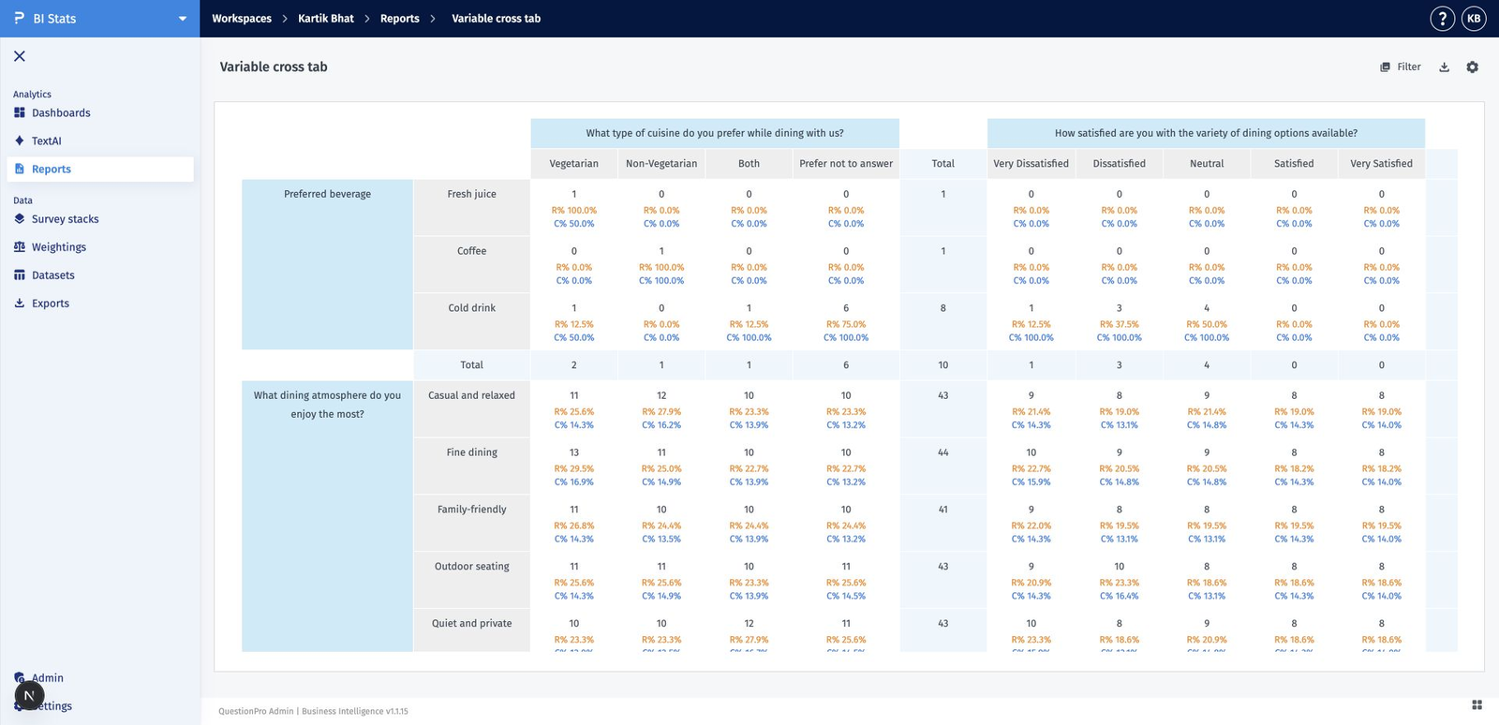
Figure 1. Prototype crosstab canvas with Count, orange R%, and blue C% values.

Acceptance criteria
AC-01 — Export order and consistency When Count, Row percentage, and Column percentage are enabled, every exported body cell writes them in Count → R% → C% order using the report’s displayed precision.
AC-02 — Row percentage identity Every exported row-percentage value begins with R% and uses orange #F68505, matching the UI. The prefix remains present even if an application does not render rich-text color.
AC-03 — Column percentage identity Every exported column-percentage value begins with C% and uses blue #267CE1, matching the UI. The prefix remains present even if an application does not render rich-text color.
AC-04 — Independent display settings The export includes only enabled measures. Count, Row percentage, and Column percentage remain independent; disabling one must not add, remove, or relabel either of the others.
AC-05 — Non-color identification R% and C% are part of the exported cell text, not a decorative legend. The prefixes preserve meaning for accessibility and in viewers that suppress rich-text colors.
AC-06 — Calculation integrity Exported counts and percentages exactly match the UI after filters, weighting, base rules, calculation-mode changes, and selected question rows. The export performs no independent recalculation.
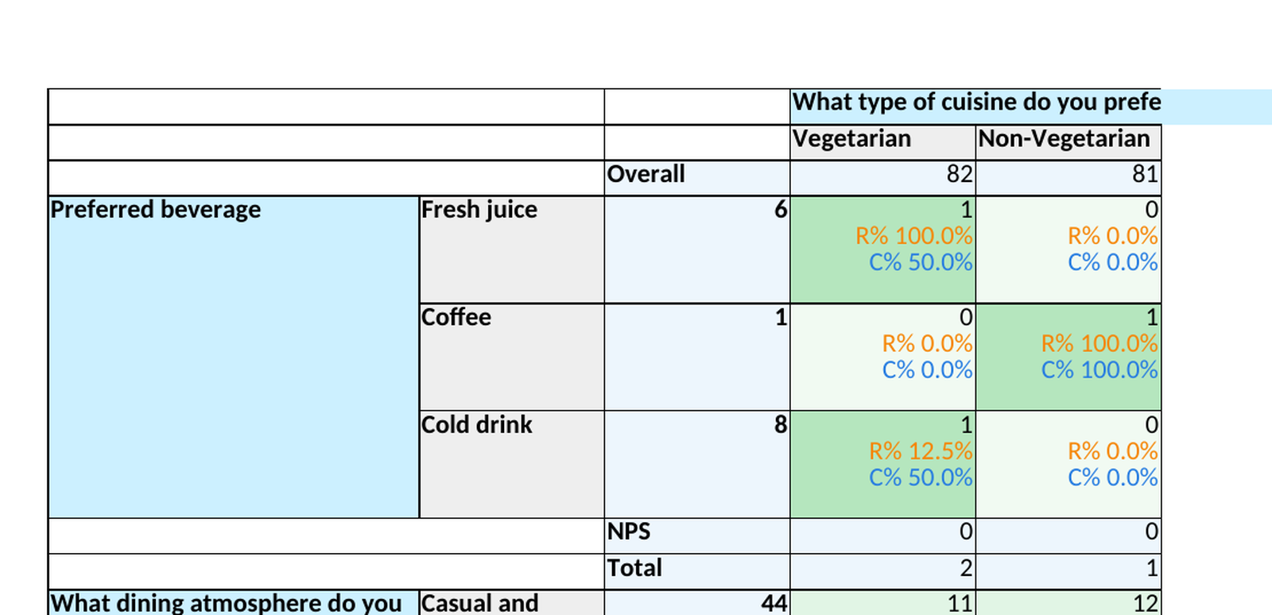
Figure 2. Prototype XLSX output preserves black Count, orange R%, and blue C% rich-text runs.

Acceptance criteria (continued)
AC-07 — Question and row coverage The same export treatment applies across single-select and multi-select questions, multiple row groups, column blocks, totals, overall cells, NPS metrics, and zero or unavailable values.
AC-08 — Workbook structure and formatting Merged headers, cell fills, heatmaps, borders, wrapping, labels, totals, NPS rows, and decimal precision remain unchanged. Rich-text styling must not alter values, sheet geometry, or formulas.
AC-09 — Export workflow and compatibility The XLSX export remains queued through Progress, exposes a completed 100% download item, and opens with prefixes and colors intact in Excel and compatible spreadsheet viewers.
AC-10 — Report routing and scope Standard prototype reports use the canonical crosstab dataset and export behavior. Laptop Conjoint retains its existing specialized report rendering and is not replaced by the canonical report.

Export reference
The workbook cell is authored as rich text rather than three visually identical lines. Count remains neutral, R% uses orange #F68505, and C% uses blue #267CE1. Prefixes remain part of the cell text so meaning survives when color is unavailable.
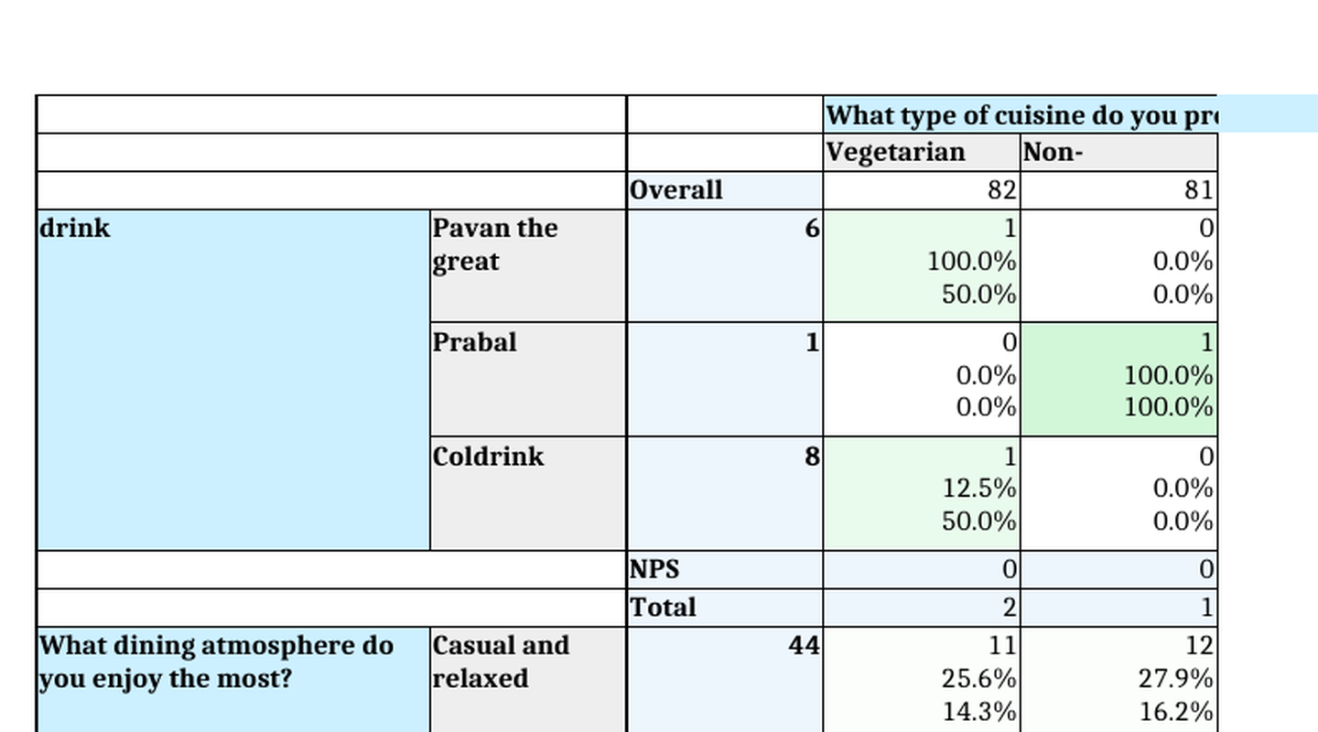
Figure 3. Current production XLSX output shows two unlabeled black percentage lines that the prototype corrects.

Prototype link
https://survey-re.vercel.app/reports

