CROSSTAB REPORTING
Total Row and Column Percentages
Short product brief and prototype walkthrough
Prototype: https://survey-re.vercel.app/reports

Problem statement
Crosstab users can show counts and percentages inside the body of the table, but marginal Total rows and Total columns currently provide counts only. Users must export data or calculate the percentage contribution manually. The report should optionally show marginal percentages independently from the total counts, using the same filtered and weighted valid base as the rest of the crosstab.

How to reach the prototype
Step 1 Open the official Survey-RE prototype link above.
Step 2 Open the report named “Variable cross tab” at Reports → Variable cross tab.
Step 3 Select the Report settings gear in the upper-right corner, then select Analytics.
Step 4 Under Display data, find Total row percentage and Total column percentage immediately after Column total.
Step 5 Enable either or both switches, select Apply, and review the Total cells in the table.
Display data order: Count, Row percentage, Column percentage, Row overall, Column overall, Row total, Column total, Total row percentage, Total column percentage, Heatmap rows, Heatmap columns.
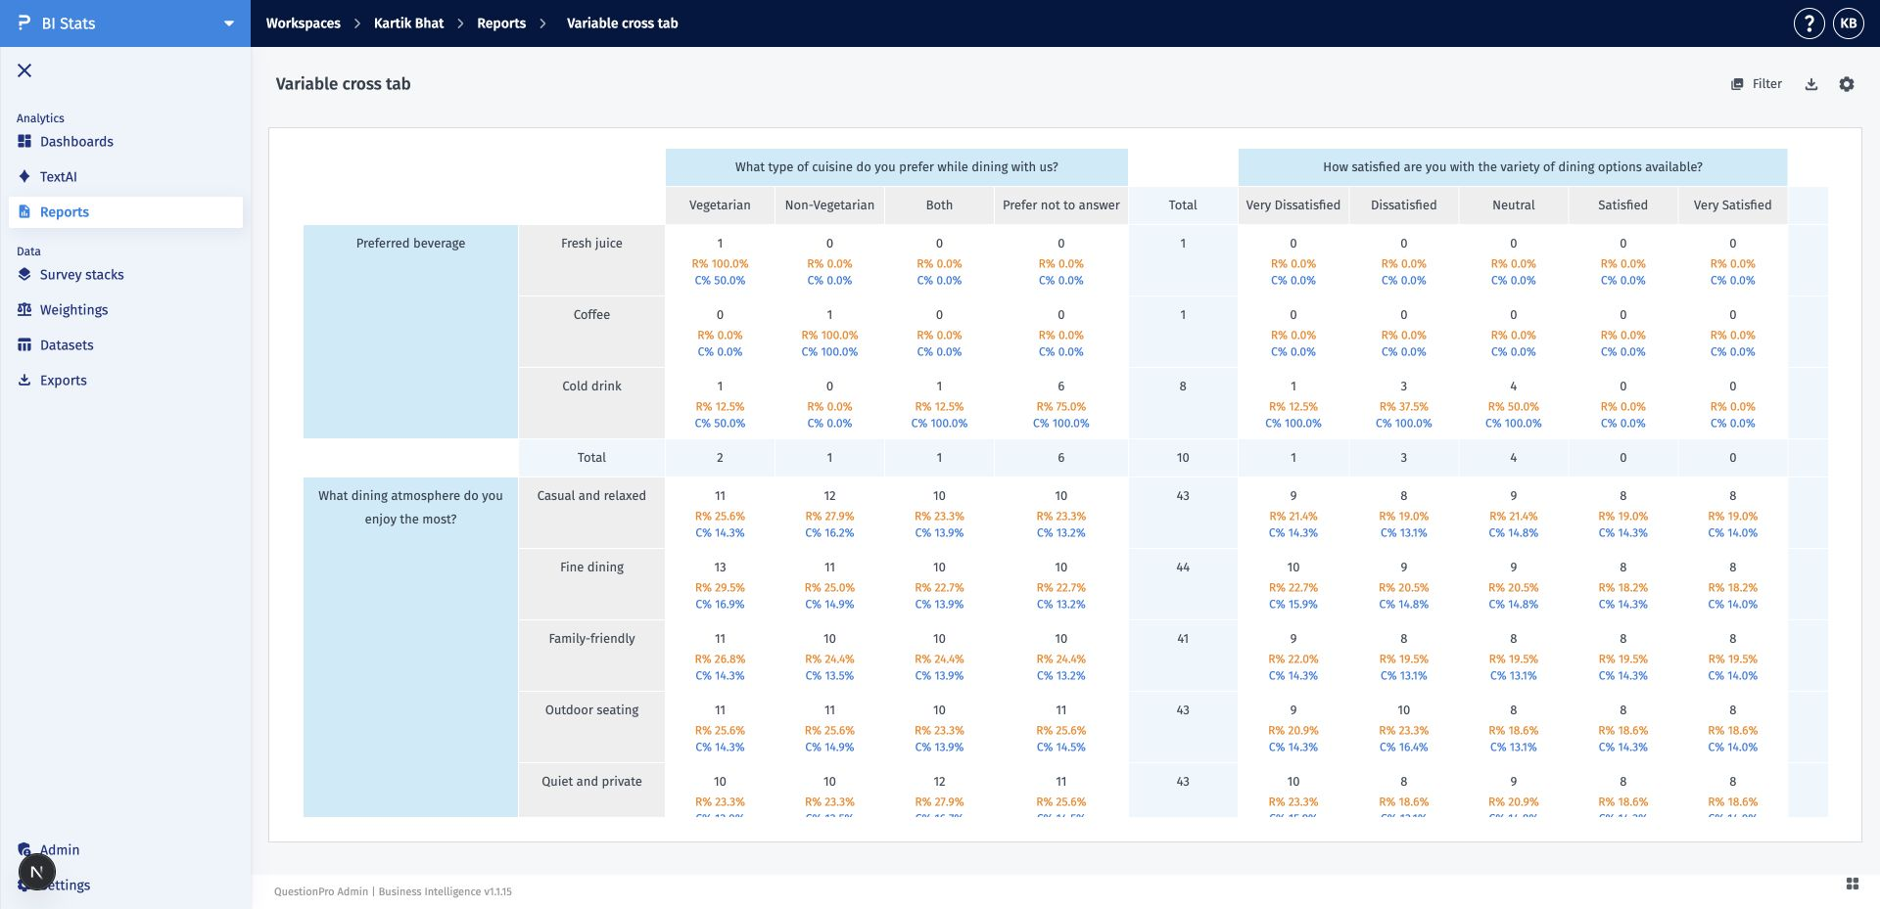
Figure 1. Crosstab report canvas with counts and interior row/column percentages.

Acceptance criteria
AC-01 — Placement and consistency Both controls appear inline within Display data in the documented order and use the same switch styling, spacing, typography, and behavior as surrounding options. There is no separate heading, badge, helper copy, or preview.
AC-02 — Total row percentage When Total row percentage is enabled, each answer row’s right-side Total-column cell shows R%. Row total independently controls whether the marginal count appears above it. R% remains visible when Row total is disabled.
AC-03 — Total column percentage When Total column percentage is enabled, each answer column’s bottom Total-row cell shows C%. Column total independently controls whether the marginal count appears above it. C% remains visible when Column total is disabled.
AC-04 — Independent controls All four controls operate independently. Enabling or disabling a percentage option must not change either total-count option, and disabling a total-count option must not remove its corresponding percentage.
AC-05 — Grand-total intersection When both marginal planes are visible, their intersection shows one neutral Base 100.0% label. The valid-base count appears only when both total-count options are enabled.
AC-06 — Calculation integrity Counts and percentages recalculate together after filters, weighting, base rules, or calculation-mode changes. Multi-select marginal percentages may exceed 100% and must not be normalized.
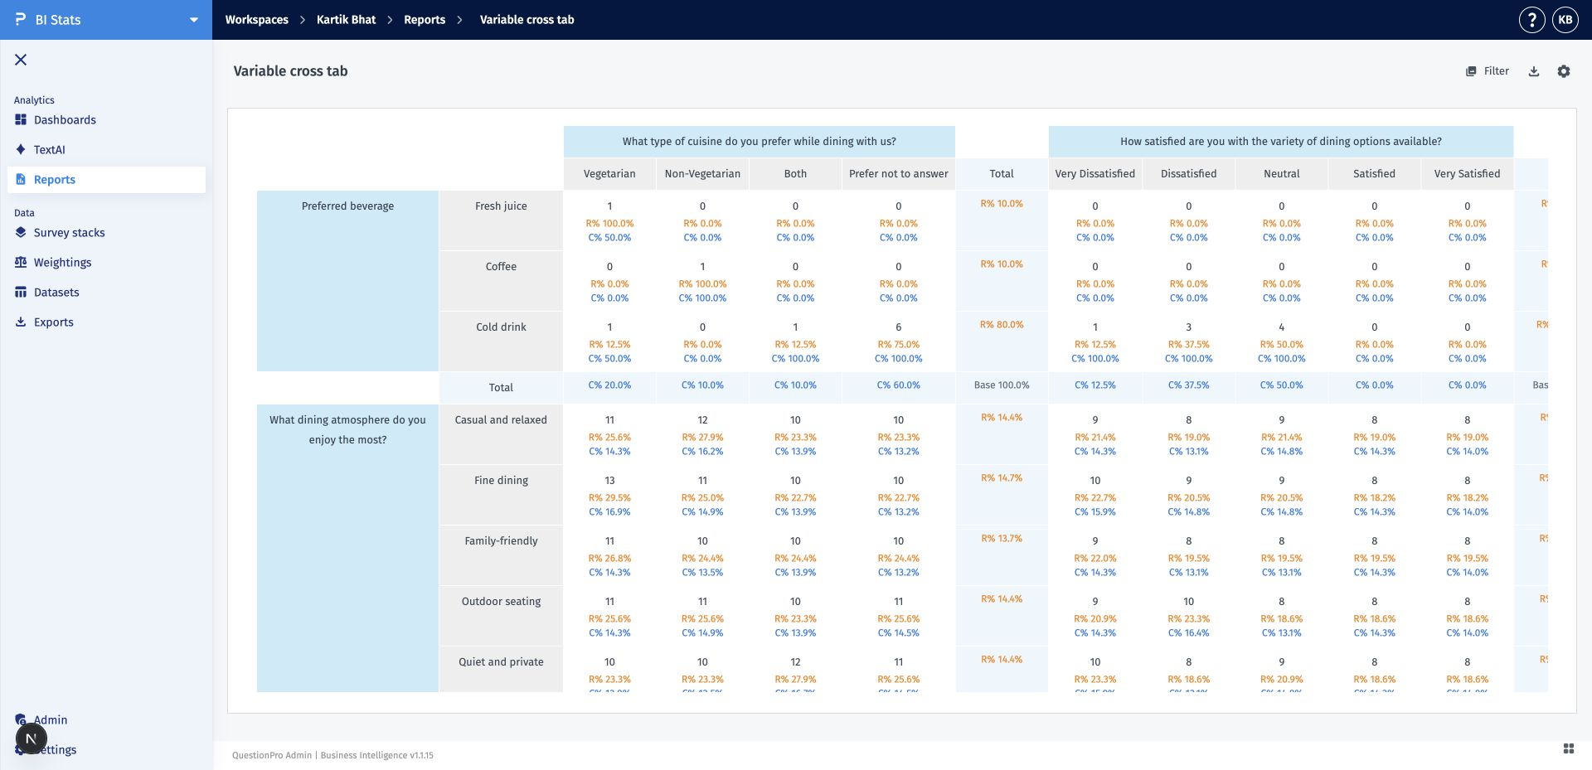
Figure 2. R% and C% remain visible with Row total and Column total disabled; the intersection shows Base 100.0%.

Acceptance criteria (continued)
AC-07 — Zero base and precision A zero or unavailable denominator displays an em dash rather than 0%, NaN, or infinity. Percentages follow the report’s configured decimal precision and locale rules.
AC-08 — Draft, persistence, and compatibility Changes remain draft until Apply. Saved values survive reload, duplicate, and shared-view rendering; reports created before the feature default both fields to false.
AC-09 — Export and accessibility parity Tabular exports preserve the same counts, labels, precision, and base semantics. Switches support keyboard operation and expose accessible names and checked state; R%, C%, and Base prefixes prevent color-only meaning.
AC-10 — Freeze-pane behavior The complete column-header group remains fixed while the table scrolls vertically. Row-label columns scroll horizontally with the table, matching the current BI crosstab behavior.

Interaction reference
The table owns both scrollbars. When users scroll vertically, body rows move beneath the opaque header. Horizontal scrolling moves the entire table, including the row-question and answer-label columns.
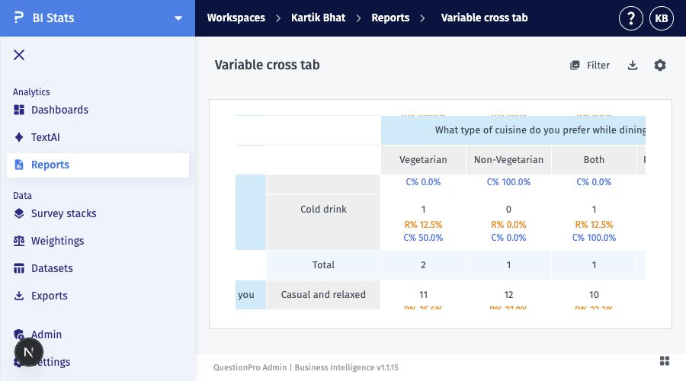
Figure 3. The multi-row column header remains visible during combined horizontal and vertical scrolling.

Prototype link
https://survey-re.vercel.app/reports

