TEXTAI DASHBOARD SETTINGS
Emerging Theme Preference Parity
Short product brief and prototype walkthrough
Prototype: https://survey-re.vercel.app/text-ai

Problem statement
Theme Configuration already lets users control whether emerging themes and sub-themes are auto-approved and shown on a TextAI dashboard. Dashboard Settings did not expose the same preference, forcing users to leave the dashboard to change it. The dashboard Preferences tab should provide the same toggle, persist the same per-dashboard value, and update both screens immediately.

How to reach the prototype
Step 1 Open the official Survey-RE prototype link above.
Step 2 Open any completed TextAI dashboard from the TextAI list.
Step 3 Select the Dashboard settings gear, then open Preferences.
Step 4 Find Auto approve emerging themes below Show themes with no responses.
Step 5 Change the toggle, then open Theme Configuration settings to verify the same state.
Preference scope: Per dashboard. Both settings surfaces use the same stored preference and change event.
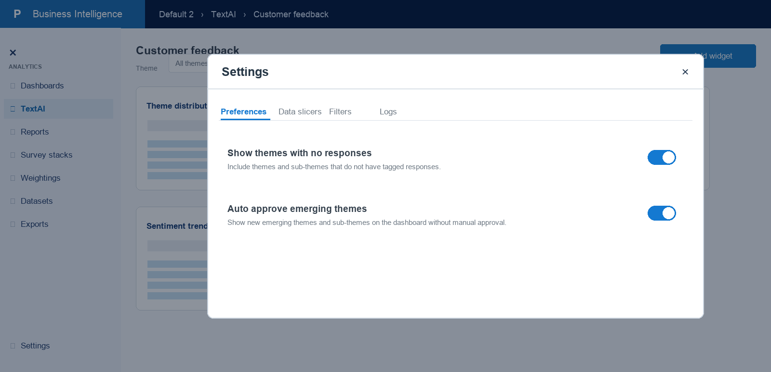
Figure 1. Dashboard Settings > Preferences includes the emerging-theme auto-approval toggle.

Acceptance criteria
AC-01 — Placement and consistency Dashboard Settings > Preferences shows Auto approve emerging themes directly below Show themes with no responses, using the same label, helper text, switch styling, spacing, and accessible name as Theme Configuration.
AC-02 — Shared source of truth Both settings surfaces read and write the same per-dashboard theme preference. The dashboard modal must not maintain a separate copy, key, default, or save path.
AC-03 — Dashboard-to-configuration sync Changing the switch in Dashboard Settings immediately updates Theme Configuration settings for the same dashboard without requiring a page reload.
AC-04 — Configuration-to-dashboard sync Changing the switch in Theme Configuration immediately updates Dashboard Settings and the open dashboard through the existing preference-change event.
AC-05 — Enabled behavior When enabled, new emerging themes and sub-themes are auto-approved and are eligible to appear in supported dashboard widgets without manual approval.
AC-06 — Disabled behavior When disabled, manually approved emerging names are cleared and unapproved emerging themes and sub-themes are hidden from the dashboard until approved through the existing flow.
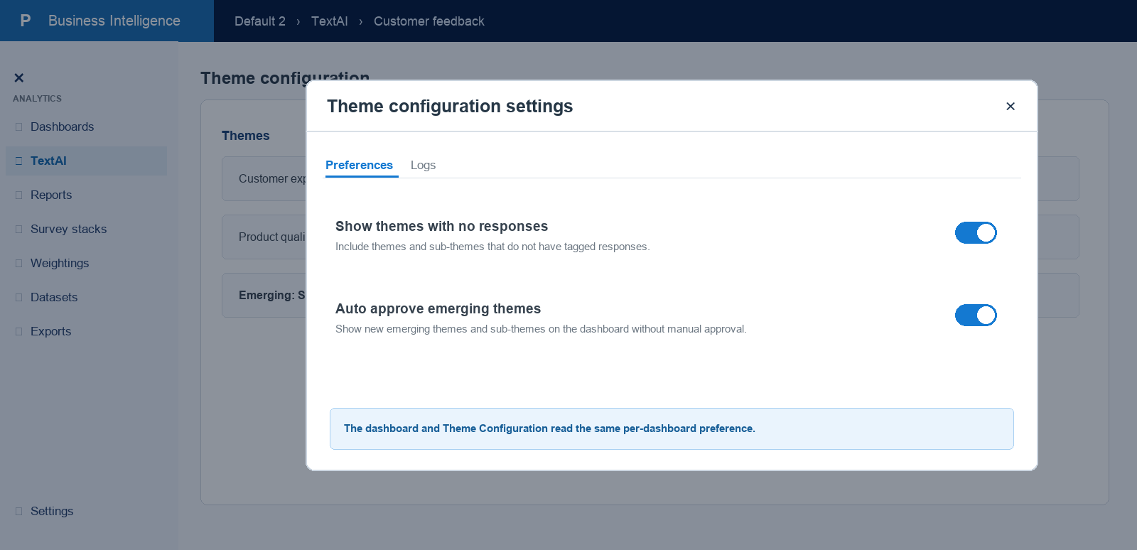
Figure 2. Theme Configuration exposes the same control and reads the same per-dashboard state.

Acceptance criteria (continued)
AC-07 — Dashboard rendering Theme and sub-theme widgets re-evaluate visibility from the updated preference so the dashboard reflects the change immediately and consistently.
AC-08 — Persistence and isolation The selected value survives modal close, navigation, and reload for that dashboard. Changing one dashboard must not change another dashboard’s preference.
AC-09 — Defaults and compatibility Dashboards without a saved preference continue to use the existing default of enabled. Existing saved preferences and manually approved-name data remain readable.
AC-10 — Accessibility and regression safety The switch supports keyboard operation, exposes a meaningful checked state and accessible name, and does not alter the behavior of Show themes with no responses or other dashboard settings tabs.

Interaction reference
Turning the control off in either settings surface publishes the shared preference, clears manually approved emerging names, and causes subscribed dashboard widgets and the other settings surface to refresh from the same value.
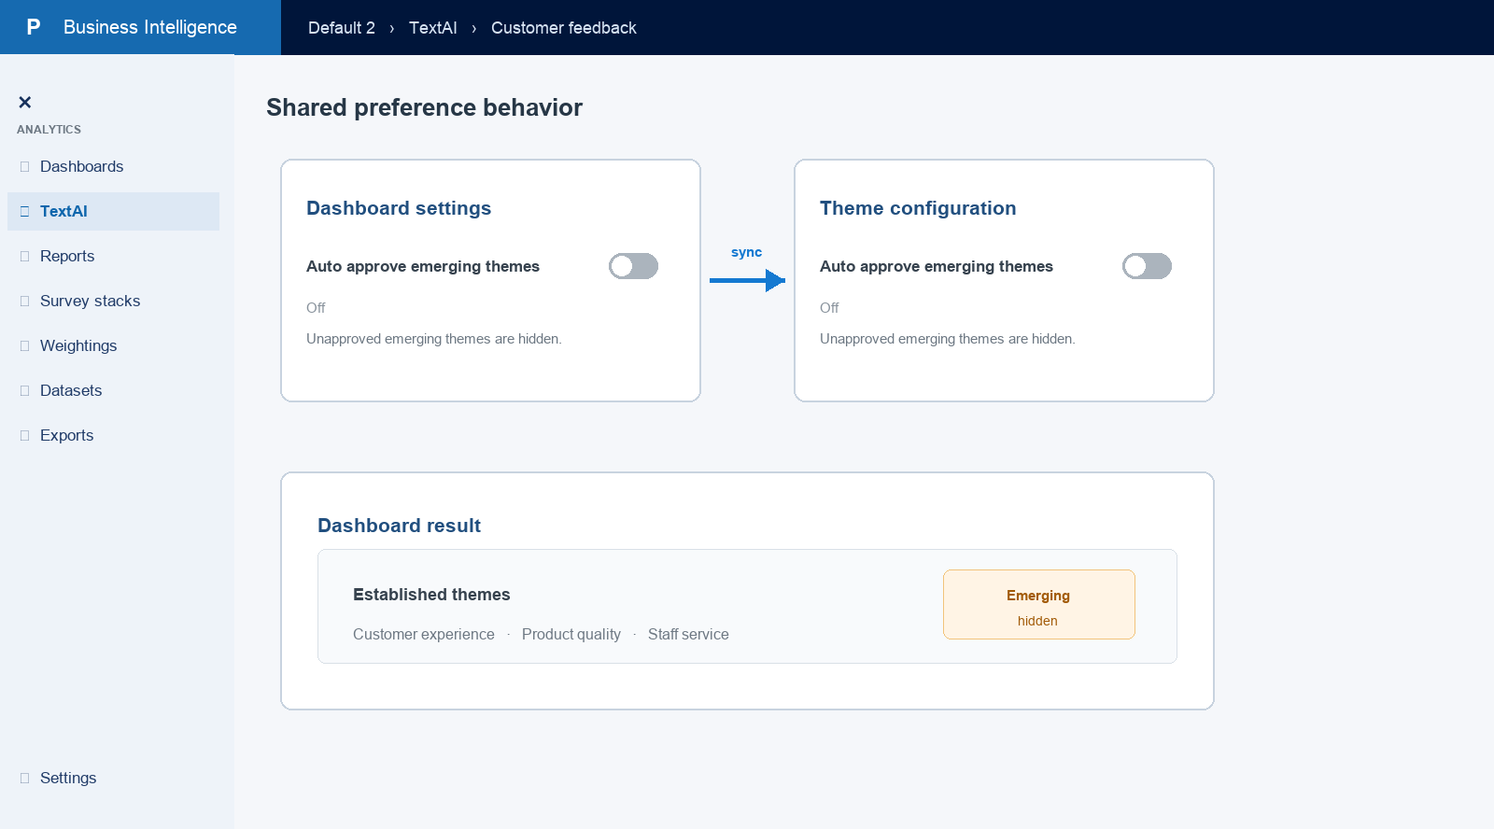
Figure 3. One per-dashboard preference keeps both controls synchronized and hides unapproved emerging themes when off.

Prototype link
https://survey-re.vercel.app/text-ai

